**SMS Spam Detection System Using NLP**

A Project Report

submitted in partial fulfillment of the requirements

of

AICTE Internship on AI: Transformative Learning

with

TechSaksham – A joint CSR initiative of Microsoft & SAP

by

**Sourav Paul, souravpaul01032002@gmail.com**

Under the Guidance of

**Jay Rathod**

**ACKNOWLEDGEMENT**

I am expressing my thanks to all of them who supported me in doing this project.

First of all, I want to thank my project guide Jay Rathod. I would thank him for all the guidance and advice he has provided me while working on this project. He has constantly motivated me throughout this project period, and it is his constructive criticism that helped me in delivering this work so well. I consider it a proud privilege to work under his mentorship.

I also extend my appreciation to my family, friends, and colleagues for all their support and encouragement throughout the undertaking.

#### **ABSTRACT**

The development of an SMS Spam Detection System on the basis of NLP techniques is what this project is all about. That's to say, it aims to correctly classify SMS messages as either spam or legitimate. Utilizing a dataset of labeled SMS messages, the project applies the machine learning models for the detection of patterns that look like spam.

This paper aims to extract meaningful features from the dataset, preprocess textual data, and train models for classification purposes with high accuracy. For doing that, techniques like tokenization, stopword removal, and TF-IDF were used for feature extraction. The system was implemented using Python and libraries such as Scikit-learn and NLTK, evaluated on metrics such as accuracy, precision, recall, and F1 score.

The results demonstrate the effectiveness of NLP and machine learning in spam detection, achieving a high classification accuracy. This system can significantly enhance automated filtering of spam messages, improving user experience and security.

**TABLE OF CONTENT**

**Abstract I**

**Chapter 1.**  **Introduction 1**

1.1 Problem Statement 1

1.2 Motivation 1

1.3 Objectives 2

1.4. Scope of the Project 2

**Chapter 2.**  **Literature Survey 3**

**Chapter 3.**  **Proposed Methodology**

**Chapter 4.**  **Implementation and Results**

**Chapter 5. Discussion and Conclusion**

**References**

**CHAPTER 1**

**Introduction**

* 1. **Problem Statement:**

The problem of this project is the identification of unwanted and harmful spam messages in valid SMS messages. These spam messages often lead to phishing attacks, fraudulent activities, and privacy breaches; therefore, an efficient detection system is very much needed.

* 1. **Motivation:**

With the massive scale of usage for SMS, communication has been exploited by spammers. Therefore, this project is chosen based on the increased requirements for the system that will identify spam automatically for the safety of users against dangerous messages. There are many real-world applications related to such an implementation to further enhance security as well as a better user experience.

* 1. **Objective:**
* To design an accurate system for spam and non-spam SMS message classification.
* Pre-processing of textual data and extraction of features through NLP techniques.
* Training and evaluation of machine learning models for spam detection.
* To provide an extensible solution for real-world applicability.
  1. **Scope of the Project:**

The project focuses on the detection of spam messages within SMS datasets using NLP and machine learning techniques. Its limitations include dependency on labeled datasets and inability to detect spam in languages or formats not covered in the training data.

**CHAPTER 2**

**Literature Survey**

**Most of the previous work on spam detection is mainly focused on SMS spam detection systems. Bayesian filtering, Support Vector Machines (SVM), and ensemble models have been used quite extensively. However, SMS spam detection is challenging because messages are shorter in length and written in informal language.**

**Previous works reflect the need for strong feature extraction techniques and models able to handle spam patterns in different forms. The project addresses such gaps by relying on NLP for feature extraction and training effective machine learning models.**

**CHAPTER 3**

**Proposed Methodology**

* 1. **System Design**

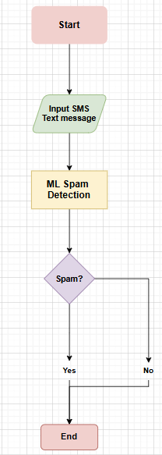

1. **Data Preprocessing**: This step involves cleaning the SMS data by applying tokenization, removing stop-words, and using stemming or lemmatization to standardize the text.
2. **Feature Extraction**: Textual data is transformed into numerical representations using techniques like TF-IDF vectorization, capturing the importance of words across messages.
3. **Model Training and Evaluation**: Machine learning models such as Naive Bayes, Logistic Regression, and Random Forest are trained on the extracted features. The models are evaluated using performance metrics like accuracy, precision, recall, and F1-score to determine the best-performing model.
   1. **Requirement Specification**
      1. **Hardware Requirements:**

* Processor: Intel Core i5 or higher
* RAM: 8 GB or more
* Storage: 1 GB for dataset and dependencies
  + 1. **Software Requirements:**
* Python 3.8+
* Libraries: Scikit-learn, Pandas, NLTK, NumPy

**CHAPTER 4**

**Implementation and Result**

* 1. **Snap Shots of Result:**

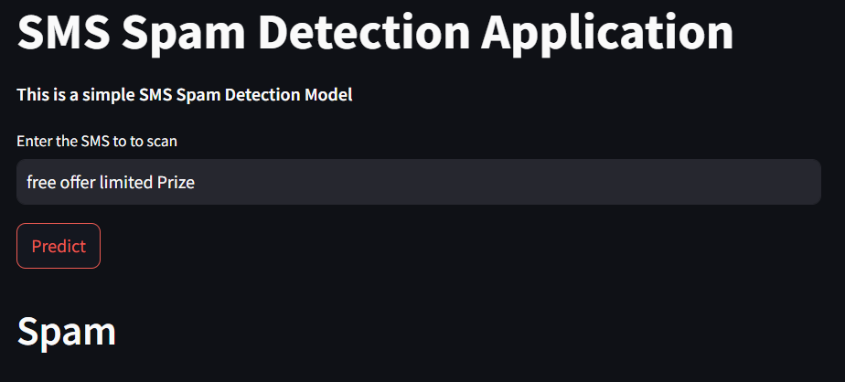.

The message is collected from a spam SMS and the SMS Spam detection application able to identify it.

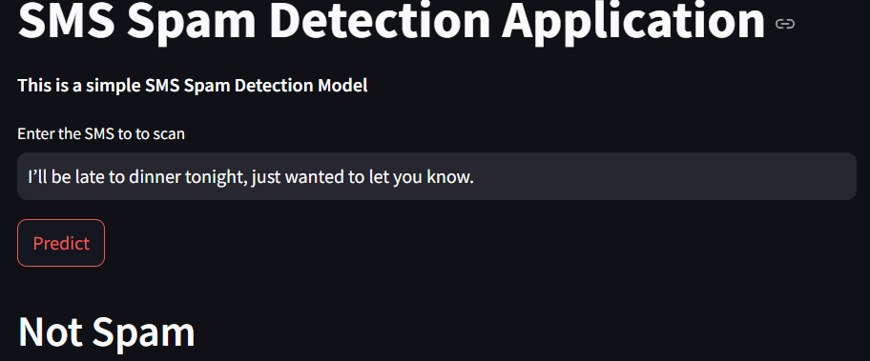

The message is here a normal SMS message and the SMS spam detection application is able to identify that it is not a spam.

* 1. **GitHub Link for Code:**

[SMS Spam Detection System](https://github.com/SouravPaul-01/email-spam-app)

**CHAPTER 5**

**Discussion and Conclusion**

* 1. **Future Work:**
* Extending the system to support multilingual spam detection.
* Using deep learning models for better accuracy.
* Deploying the system as a web or mobile application for real-time spam filtering.
  1. **Conclusion:**

This system classifies messages effectively using NLP and machine learning techniques. The project, therefore, presents the potential of automated systems in combating spam and ensuring secure communication.

**REFERENCES**

1. Ming-Hsuan Yang, David J. Kriegman, Narendra Ahuja, “Detecting Faces in Images: A Survey”, IEEE Transactions on Pattern Analysis and Machine Intelligence, Volume. 24, No. 1, 2002.
2. **Joshi, A., & Shah, S. (2017).** "SMS Spam Detection Using Machine Learning Algorithms: A Survey." International Journal of Computer Applications, 161(4), 28–35. DOI: 10.5120/ijca2017913037.
3. **Saha, S. (2015).** "An Overview of Text Classification Algorithms in Spam Filtering." International Journal of Computer Science and Mobile Computing, 4(1), 45–56.
4. **García, J. R., & García-Serrano, A. (2013).** "A Comparative Study of Text Classification Methods for SMS Spam Filtering." Proceedings of the International Conference on Information Science and Technology (ICIST), 25–30.