 



**SECOND EDITION**

Have patience for election

Yunus urges people in address marking

100 days of interim government

STAFF CORRESPONDENT



‘The train to the election has started rolling. It will not stop.’

PROF MUHAMMAD YUNUS

Election may be delayed by

a few months for reform

Govt to demand repatriation of Hasina from India

Ensure justice for misdeeds committed in last 15 years

Chief Adviser Prof Muhammad Yunus yesterday said the government would issue a roadmap to the election as soon decisions on electoral reforms are made.

In a televised address to the nation, marking 100 days of the interim government, Yunus said that the reforms may delay the election by a few months.

Several reform commissions are working, and they will hopefully submit their reports between December and January. The government will then discuss the recommendations with political parties.

“The reform proposals will be finalised based on…

DHAKA WEDNESDAY NOVEMBER 18, 2024

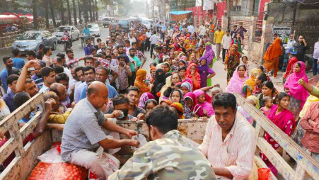

**People from low-income groups waiting in line, while some scramble to get their share of kitchen essentials at a subsidised rate from TCB truck on the Darus-Salam Road in the capital. Though each TCB truck brings in packages of essentials for 350 consumers, more people appear, which often leads to fights and many leaving empty handed. Traders said that some people cut the lines and infuriates those who wait for hours for their packages.** PHOTO: **PRABIR DAS**

CA’S SPEECH

‘No mention of election roadmap unacceptable’

Says BNP’s Khasru; Jamaat for giving govt time for reforms

STAFF CORRESPONDENT

Three political parties gave mixed reactions to Chief Adviser Prof Muhammad Yunus’ speech urging people to have patience and promising a polls roadmap as soon as electoral reforms are carried out.

“It’s unclear to me what he meant by ‘additional time’. It is not a roadmap, rather an open-ended statement, which is unacceptable when it comes to state affairs,” Amir Khasru Mahmud Chowdhury, BNP standing committee member, told The Daily Star.

Bad loans hit alarming record

AL-linked groups’ loans turn sour after Hasina’s fall

MD MEHEDI HASAN *and* AM JAHID

**\*AS OF SEPT**

**SOURCE: BB**

**DEFAULTED LOANS DURING AL’S 15-YEAR RULE** (IN TK CR)

Awami League-affiliated businesses had already put the country’s banking sector in trouble with huge bad debts, but the loans disbursed through irregularities to these companies turned sour even at a more alarming pace after the party’s ouster.

|  |  |  |  |
| --- | --- | --- | --- |
| *2024 | **2,84,977** | 2016 | **62,172** |
| 2023 | **1,45,633** | 2015 | **59,400** |
| 2022 | **1,20,656** | 2014 | **50,160** |
| 2021 | **1,03,273** | 2013 | **40,580** |
| 2020 | **88,734** | 2012 | **52,730** |
| 2019 | **94,331** | 2011 | **22,640** |
| 2018 | **93,911** | 2010 | **22,710** |
| 2017 | **74,303** | 2009 | **22,480** |

The result: bad debts in Bangladesh’s banks hit a record Tk 284,977 crore at the end of September, less than two months after the fall of the Sheikh

London to help Dhaka retrieve laundered money

UK minister tells Yunus

DIPLOMATIC CORRESPONDENT

Britain expects the interim government to lay out the vision of how it will restore peace, democratic governance, and

INTERVIEW

The wrongs of past 15yrs must be righted

Says Mirza Fakhrul

*Having been the main opposition camp over the last 15 years, the BNP has been advocating for quick reforms followed by elections. The Daily Star’s Golam Mortoza caught up with the party’s Secretary General Mirza Fakhrul Islam Alamgir to talk about a host of issues ranging from elections to media freedom.*

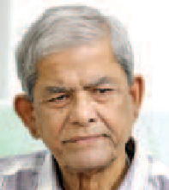

Hasina-led government on August 5.

The figure includes a staggering Tk 73,586 crore defaulted in just three months. Between July and September, bad debts soared by 34.8 percent,

promote national

reconciliation, said UK Minister for the Indo- Pacific Catherine West.

**Catherine West**

TDS: As the secretary general of one of Bangladesh’s largest political parties, what

rule destroyed the bureaucratic and political structures of Bangladesh. The institutions essential

according to data from the Bangladesh Bank.

When compared with last year’s figure, the picture is even grimmer: soured loans increased by an eyewatering 83.4 percent.

Some large borrowers, including S Alam Group, Beximco Group and Bashundhara Group, defaulted heavily after the Awami League’s fall, pushing up the total to an unprecedented level.

Of Beximco’s Tk 23,000 crore loans with Janata Bank, Tk 19,000 crore turned bad during the July-September quarter, The Daily Star has learnt from the state-run bank’s officials, who

spoke on the condition of anonymity.

Hasina’s close collaborator Salman F Rahman, who advised the former prime minister on private industry and investment, is the vice-chairman of Beximco Group.

“We expect Prof Yunus to lay out his

vision for how all that will unfold. The UK will seek to support the people of Bangladesh as they move forward in the next phase,” she told reporters after a meeting with Foreign Adviser Touhid Hossain at the foreign ministry.

West, who arrived in Dhaka on Saturday for a two-day visit, is the first UK minister to visit Bangladesh since the formation of the interim government following the ouster of the Awami League regime.

are your thoughts on the current political situation. A successful mass uprising has taken place, and an interim government has taken over. Your party has been calling for elections within a timeframe that is

both “quick” and “reasonable.” Could you clarify what you mean by “quick” and “reasonable”?

Fakhrul: Over 15 years of authoritarian

for a democratic state have been systematically ruined. As a result, following the student-led mass uprising, public expectations have skyrocketed. The primary expectation now is that this government will hold a fair

and credible election, enabling people to form a parliament and government of their choice.

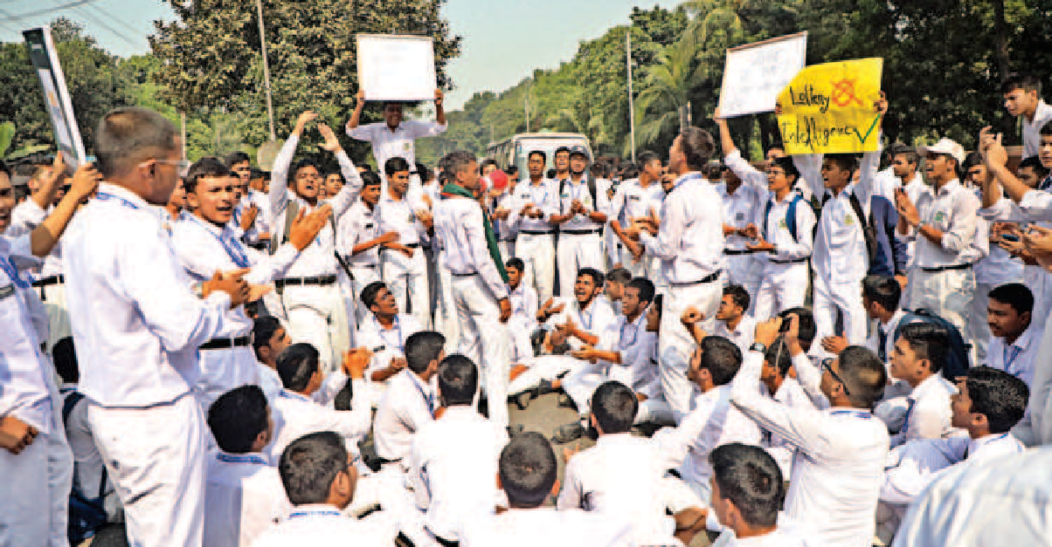

**Students of Dhaka Residential Model School and College yesterday blocked the Mirpur Road in front of their institution to demand the admissions from classes three to 11 be done on merit instead of by lottery. The protests went on for around 45 minutes.** PHOTO: **PRABIR DAS**

Indo-Bangla ties can’t be limited to a single issue

Graft biggest obstacle to doing business

More than 16 percent of businesses identified corruption as the biggest obstacle to their operations, found

a survey conducted by the Centre for Policy Dialogue (CPD) between April and July of this year.

Foreign currency instability, inefficient

bureaucracy, high inflation and limited access to finance are other top hindrances, it said.

Indian envoy tells session of Bay of Bengal Conversation

STAFF CORRESPONDENT

The mutual cooperation between Bangladesh and India is multidimensional and cannot be restricted to a single issue, said Indian High Commissioner to Bangladesh Pranay Kumar Verma.

He made the remark yesterday addressing the second session of the Bay of Bengal Conversation symposium, organised by the Centre for Governance Studies at the Pan Pacific Sonargaon in Dhaka.

“Our relations can’t be restricted to a single agenda or a single issue. The reality of our interdependence and mutual benefit will keep asserting itself

over and over again regardless of the change in political will.

“Regardless of how it [the relations] may be characterised, we [India] believe it’s a people-centric relationship … India will continue to seek a stable relationship for the sake of the people,” he said.

“We issue more visas than any other diplomatic missions here,” Verma said, additionallynoting that visa operations arecurrently limited.

He added that Bangladesh’s zero tolerance for terrorism and refusal to harbour Indian anti-insurgency elements areimportant to India.

SEE PAGE 7 COL 1

STORY ON B1

the seventh China International Import Expo in……. Shanghai last week….

**Name : Sourav Saha**

**Roll No.: 15**

**CF&OA: 34**