Agenda:
- Introduction
- The ways to define, instantiate and start a new thread
- Getting and setting name of thread
- Thread priorities
- The methods of prevent thread execution
  - yield ()
  - join ()
  - sleep ()
- Synchronization
- Inter-thread communication
- Deadlock
- Daemon threads
- Introduction:
Multi-tasking:
- Executing several tasks simultaneously is the concept of multi-tasking.
- There are two types of multi-tasking
- process based multi-taking
- thread based multi-tasking
Process based multi-tasking:
- Executing several tasks simultaneously where each task is separate independent process is called “process based multi-tasking”.
- Eg: while typing a java program in the editor we can download a file from the net. At the same time we can able to listen Mp3 audio songs from the same systems. All these tasks are executing simultaneously and these are independent each to other and hence its process is called “process based multi-tasking”.
- “Process based multi-tasking” is best suitable at OS level.
- At programmatic level process-based multi-tasking is not used.
Eg: while executing project, we listen Mp3, download but is not need. For
That we go for thread-based.
- Process based multi-tasking all tasks are different.

Thread based multi-tasking:

- Executing several tasks simultaneously there each task is separate independent part of the same program is called thread-based multi-tasking and each independent part is called a “thread”.
- Thread based multi-tasking is best suitable at ‘programmatic’ level
- When compared with c++ developing multi-threading applications is very easy because java language will provide in built support for multi-threading through a rich library (Thread, ThreadGroup, ThreadLocal, Runnable….)
- Multi-threading is one feature of java. In c++ we write to related multi-threading, for this we have to write nearly 60,000 to 70,000 lines.
- In java multi-threading applications 90% of the work will be done by java API and programmer is responsible just for 10% of the work.
- The main important applications areas of multi-threading are
  - To develop multi-media graphics
  - To implement animations
  - To develop video games
  - To develop multi-user applications like chatting applications, online reservation etc …
- Whether it is Process-based or Thread-based. The main advantage of multi-tasking is performance is improved by reducing response time.
- The ways to defines instantiates and start a new thread:
We can define a thread by using the following 2 ways
  - By extending Thread class
  - By implementing Runnable interface
Defining thread by extending Thread class:
Eg:
class MyThread extends Thread{

public void run() {
for (int i = 0; i < 10; i++) {
System.out.println("child thread");
}
}
}

public class ThreadDemo {
public static void main(String[] args) {
MyThread t=new MyThread();
t.start();
for (int i = 0; i < 10; i++) {
System.out.println("main thread");

}
}

}

Output:
main thread
main thread
main thread
main thread
main thread
main thread
main thread
main thread
main thread
main thread
child thread
child thread
child thread
child thread
child thread
child thread
child thread
child thread
child thread
child thread

case 1: Thread scheduler:

- If multiple threads are waiting for execution then which thread will get chance first is decided by thread scheduler, which is component of JVM.
- We can’t expect exact behavior of thread scheduler (like which algorithm (SJF, Round Robin, FCFS) it is following). It is JVM vendor dependent hence in multi-threaded examples we can’t tell exact o/p but we can tell possible outputs.
- The following are various possible outputs for the above program.

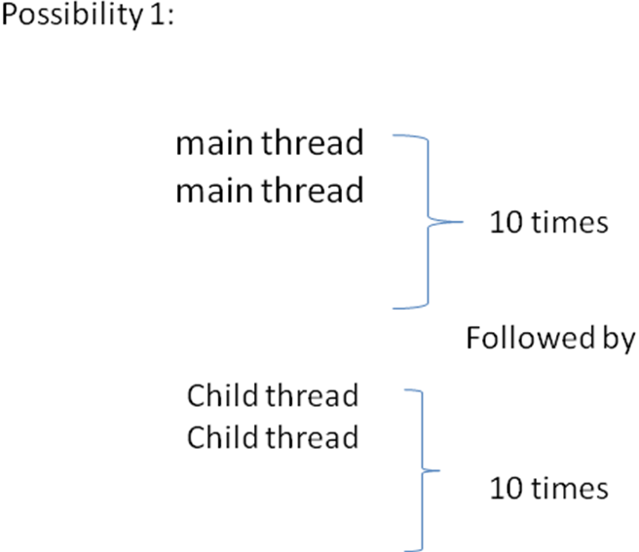

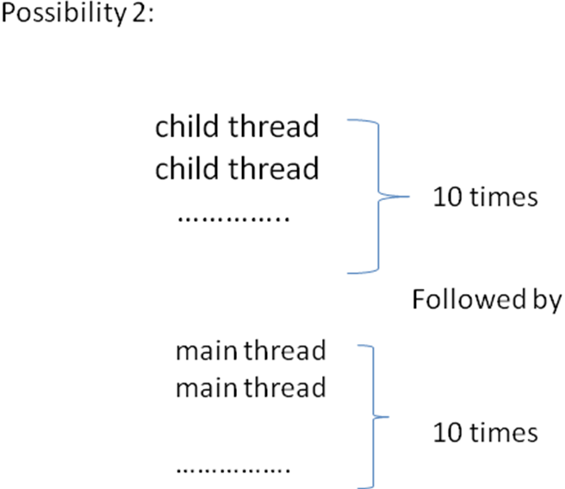

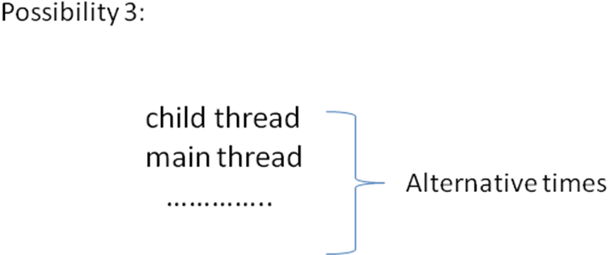
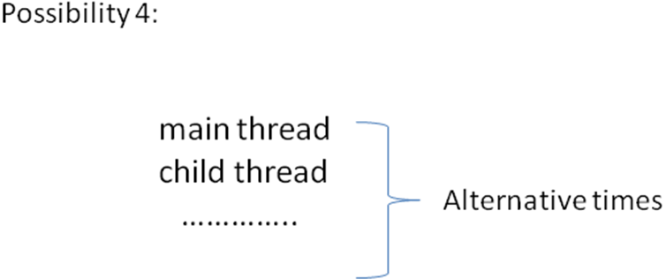
Case 2: Difference between t.start() and t.run():

- In the case of t. start () a new thread will be created which is responsible for the execution of run() method.
- But in the case of t.run () no new thread will be created and run() will be executed just like a normal method call by the “main” thread.
- In the above program if we are replacing t.start () with t.run () the following is..
- 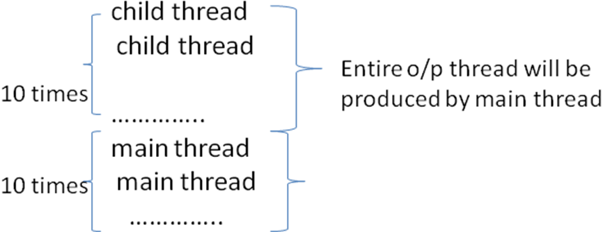

Case 3: Impotance of Thread class start() method:

- For every thread the required mandatory activities (like registering the thread with thread scheduler) will takes care by thread class start() method so that the programmer is required to concentrate only on the job of the thread( run()).
class Thread{
….

start(){
1. Register this thread with thread scheduler
2. All other mandatory formalities
3. Invoke run ()
}
….
}

- .i.e. start () acts as a big assistant to the programmer without executing thread class start () there is no chance to of starting a new thread in java.

Case 4: Overloading of run() method:

- We can overload run () method but thread class start () will always call no argument run () method only.
- The other overloaded method we have to call explicitly then only it will be executed.

Eg:

class MyThread extends Thread{

public void run() {
System.out.println("no arg");
}
public void run(int i){
System.out.println("int arg");
}
}

public class Test {
public static void main(String[] args) {
MyThread t = new MyThread();
t.start();
}

}
Output:
no arg

Case 5: If we are not overriding run() method:

- If we are not overriding run () method then thread class run () method will be executed which has empty implementation hence we won’t get any output.

Eg:
class MyThread extends Thread {

}

public class Test {
public static void main(String[] args) {
MyThread t = new MyThread();
t.start();
}

}

Output: no output will be displayed

NOTE: its highly recommended to override run() method to define job. Otherwise don’t go for multi-threading concept.

Case 6: If I override start() method:

- If we override start () method then our own start() method will be executed just like a normal method call and no new thread will be created.
Eg:
class MyThread extends Thread {
public void start() {
System.out.println("start");
}

public void run() {
System.out.println("run");
}

}

public class Test {
public static void main(String[] args) {
MyThread t = new MyThread();
t.start();
System.out.println("main");
}
}
Output:
start
main

Case 8:
Eg:
class MyThread extends Thread {
public void start() {
super.start();
System.out.println("start");
}

public void run() {
System.out.println("run");
}

}

Output: possibilities:
1. start 2.run 3.start
main start main
run main run.

Case 7: lifecycle of thread:

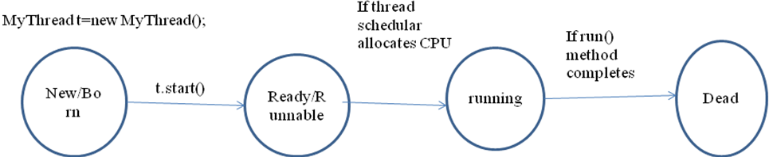
Case 8:
- After starting a thread we are not allowed to restart the same thread once again otherwise we will get runtime exception saying “IllegalThreadStateException”.
Eg:
MyThread t = new MyThread();
t.start();
//some stements.........
t.start();// RE:IllegalThreadStateException
Defining a thread by implementing Runnable interface:
- We can define a thread even by implementing Runnable interface also
- Runnable interface present in java.lang package and contains only one method i.e. run() method.

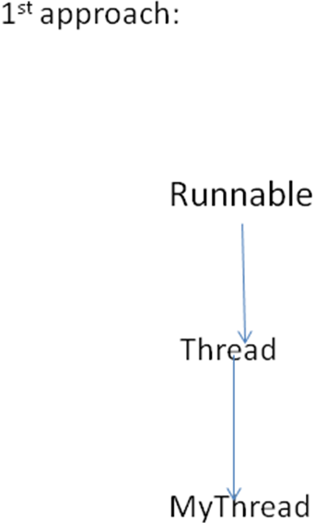
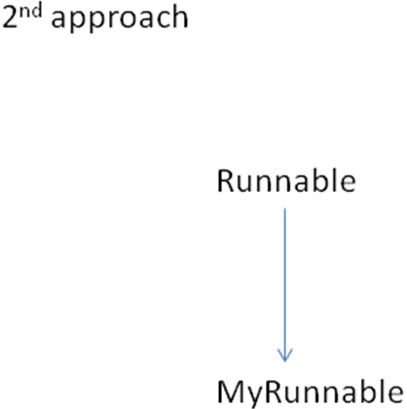
Eg:
public class MyRunnable implements Runnable{
public void run(){
for (int i = 0; i < 10; i++) {
System.out.println("child thread");//job of thread

}
}

}

public class Test {
public static void main(String[] args) {
MyRunnable r=new MyRunnable();
Thread t=new Thread(r);
//r is target Runnable, if we are passing reference of MyRunnable then
thread class run() will executed but no implementation
t.start();
System.out.println("main method");
}
}

Case Study:
MyRunnable r =new MyRunnable();
Thread t1=new Thread ();
Thread t2=new Thread (r);
Case1: t1.start ();
A new thread will be created which is responsible for execution of thread class run () which has empty implementation.
Case 2: t1.run ()
No new thread will be created and thread class run () will be executed just like a normal method call.
Case 3: t2.start ()
A new thread will be created which is responsible for the execution of MyRunnable run () method.
Case 4: t2.run ()
No new thread will be created and MyRunnable run () will be executed just like a normal method call
Case 5: r. start ()
We will get compile time error saying MyRunnable class doesn’t contain any start () method

CE: cannot find symbol
Symbol: method start
Location: class MyRunnable

Case 6: r.run ()
No new thread will be created and MyRunnable run () will be executed just like a normal method call.

Best approach to define a thread:
- Among the two ways of defining a thread implements Runnable interface approach always recommended to use.
- In the first approach our class is always extending thread class, there is no chance of extending any other class. Hence, we are missing the benefits of inheritance.
- But in the second approach in-addition to implement Runnable interface. We can extend any other class also. Hence, there is no chance of missing inheritance benefits.
- Because of this implements Runnable approach is always recommended to use to define a thread.
Constructors in multi-threading:
- Thread t =new Thread();
- Thread t =new Thread(Runnable r);
- Thread t =new Thread(String name);
- Thread t =new Thread(Runnable r, String name);
- Thread t =new Thread(ThreadGroup r, String name);
- Thread t =new Thread(ThreadGroup r, Runnable r);
- Thread t =new Thread(ThreadGroup g, Runnable r, String name);
- Thread t =new Thread(ThreadGroup g, Runnable r, String name, long stackSize);

XXXX approach to define a thread (not recommended to use):
class MyThread extends Thread {

public void run() {
System.out.println("child method");
}

}

public class Test {
public static void main(String[] args) {
MyThread t = new MyThread(t);
Thread t1 = new Thread();
t1.start();
System.out.println("main method");
}
}

Output:
main method
child method

or
child method
main method
- Getting and setting name of a thread:
- Every thread in java has some name it may be default name generated by JVM or explicitly provided by the programmer.
- We can get and set name of a thread by using the following two methods of thread class.
- Public final String getName ();
- Public final void setName (String name);

Eg:
class MyThread extends Thread {

}

public class Test {
public static void main(String[] args) {
System.out.println(Thread.currentThread().getName());
MyThread t = new MyThread();
System.out.println(t.getName());
Thread.currentThread().setName("hi");
System.out.println(Thread.currentThread().getName());

}
}
Output:
main
Thread-0
hi

NOTE: we can get current executing thread reference by using

Thread. currentThread ();

- Thread priorities:

- Every thread in java has some priority it may be default priority generated by JVM or explicitly provided by the programmer.

- The valid range of thread priorities is 1 to 10 but not 0 to 10. Where 1 is the least priority and 10 is the highest priority.

- Thread class defines the following constants to represent some standard priorities.
1. Thread. MIN_PRIORITY--------->1
2. Thread. MAX_PRIORITY-------->10
3. Thread. NORM_PRIORITY--------->5

But there are no constants like Thread. LOW_PRIORITY
Thread. HIGH_PRIORITY

- Thread scheduler uses these priorities while allocating CPU. The thread which is having highest priority will get chance for execution.

- If two threads having the same priority then we can’t expect exact execution order it depends on thread scheduler whose behavior is vendor dependent.

- We can get and set priority of a thread by using the following methods

- public final int getPriority();
- public final void setPriority(int p);
// int p: the allowed values are 1 to 10 .if we are passing more than 10 number then it gives RE. i.e. IllegalArgumentException.

Default priority:
- The default priority only for the main thread is 5. But for all remaining threads the default priority will be inheriting from parent to child.

- Whatever the priority, parent thread has by default the same priority will be given for the child thread also.

Eg:
class MyThread extends Thread {

}

public class Test {
public static void main(String[] args) {
System.out.println(Thread.currentThread().getPriority());

Thread.currentThread().setPriority(9);
MyThread t = new MyThread();
System.out.println(t.getPriority());

}
}

Output:
5
9
- If we have a number threads more than 10 then we have to give the priority must be 1 to 10. That time we give same priority to number of thread.
Eg:

class MyThread extends Thread {
public void run() {
for (int i = 0; i < 10; i++) {
System.out.println("child thread");

}
}

}
public class Test {
public static void main(String[] args) {
MyThread t = new MyThread();
/* t.setPriority(10); */------------------>line 1
t.start();
for (int i = 0; i < 10; i++) {
System.out.println(" main thread");

}
}
}

- If we are commenting line 1 then both main and child threads will have same priority 5 and hence we can’t expect exact execution order.

- If we are un commenting line 1 then child thread has the priority 10 and main thread has the priority 5. Hence, child thread will get chance for first execution and after completing child thread main thread will get the chance.
- In this the output is child thread 10 times followed by main thread 10 times.

NOTE: some OS may not provide proper support for thread priorities we have to install separate patches provided by vendor to provide support for priorities.

- The methods to prevent a thread from execution:

We prevent a thread execution by using the following methods.
yield ();
join ();
sleep ();

yield ():

- yield () method causes to pause the current executing thread for giving the chance of remaining waiting threads of same priority.
- If all waiting that threads have the low priority or if there is no waiting thread then the same thread will be continued its execution.
- The thread which is yielded when it will get chance once again for execution is depends on “MERCY” of thread scheduler.

Public static native void yield();

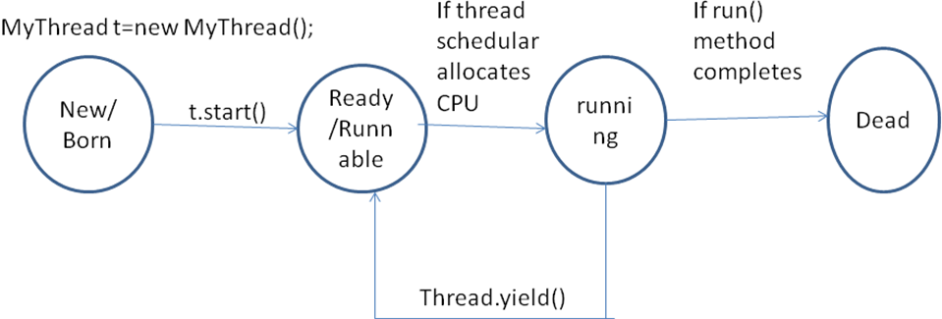
Eg:
class MyThread extends Thread {
public void run() {
for (int i = 0; i < 10; i++) {
Thread.yield();
System.out.println("child thread");

}
}

}

public class ThreadYieldDemo {
public static void main(String[] args) {
MyThread t = new MyThread();
t.start();
for (int i = 0; i < 10; i++) {
System.out.println(" main thread");

}
}
}

Output:
main thread
main thread
main thread
main thread
main thread
main thread
main thread
main thread
main thread
main thread
child thread
child thread
child thread
child thread
child thread
child thread
child thread
child thread
child thread
child thread

- In the above example the chance of completing main thread first is high because child thread always calling yield () method.
join ():

- If a thread wants to wait until completing some other thread then we should go for join () method.
- Eg:
If a thread t1 executes t2.join () then t1 should go for waiting state until completes t2.

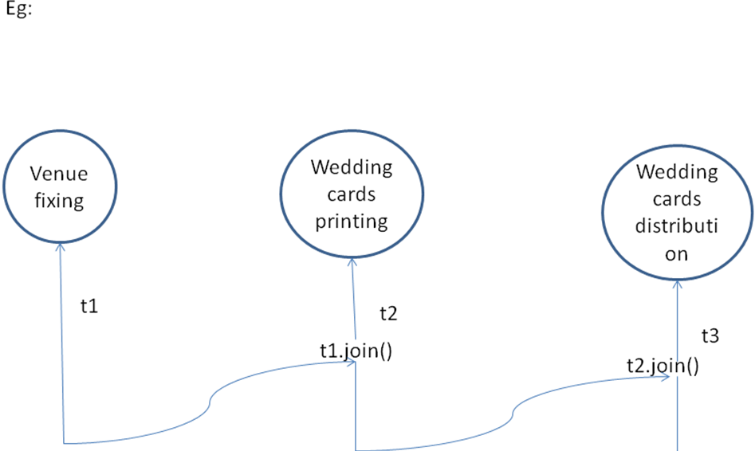

- Public final void join() throws InterruptedException.

- Public final void join(long ms) throws InterruptedException.

- Public final void join(long ms, int ns) throws InterruptedException.

Eg 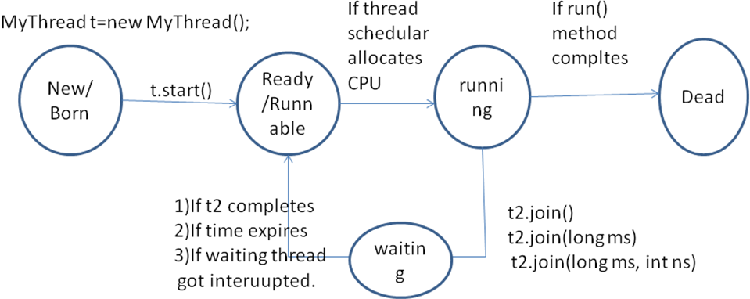
Eg:

class MyThread extends Thread {
public void run() {
for (int i = 0; i < 10; i++) {
System.out.println("seetha thread");
try{
Thread.sleep(2000);
}catch (InterruptedException e) {

}
}
}

}

public class ThreadJoinDemo {
public static void main(String[] args) {
MyThread t = new MyThread();

t.start();
//t.join();//line 1
for (int i = 0; i < 10; i++) {
System.out.println(" rama thread");

}
}
}

Output:
rama thread
rama thread
rama thread
rama thread
rama thread
rama thread
rama thread
rama thread
rama thread
rama thread
seetha thread
seetha thread
seetha thread
seetha thread
seetha thread
seetha thread
seetha thread
seetha thread
seetha thread
seetha thread

- If we are commenting line 1 then both threads will be executed simultaneously and we can’t expect exact execution order.
- If we are not commenting line 1 then main thread will wait until completing child thread. In this case the output is

Seetha thread
---------->10 times
Rama thread
--------> 10 times
sleep ():

If a thread don’t want to perform any operation for a particular amount time then we should go for ‘sleep ()’ method.

- public static native void sleep(long ms) throws InterruptedException

- public static native void sleep(long ms, int ns) throws InterruptedException.

Eg:
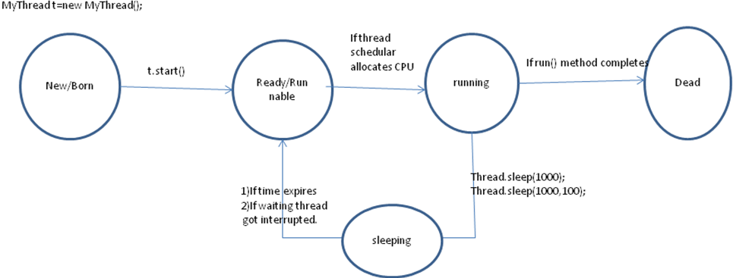

Eg:
public class Test {
public static void main(String[] args) throws InterruptedException {
System.out.println("m");
Thread.sleep(30000);
System.out.println("e");
Thread.sleep(30000);
System.out.println("g");
Thread.sleep(30000);
System.out.println("a");
Thread.sleep(30000);
}

}
Output:
m
e
g
a

How a thread can interrupt another thread:

- A thread can interrupt another sleeping or waiting thread by using interrupt() method of thread class.

public void interrupt ();

Eg:

class MyThread extends Thread {
public void run() {
try {
for (int i = 0; i < 5; i++) {
System.out.println("lazy thread" + i);
Thread.sleep(2000);
}
} catch (InterruptedException e) {
System.out.println("got interrupted");
}

}
}

public class ThreadSleepDemo {
public static void main(String[] args) {
MyThread t = new MyThread();
t.start();
//t.interrupt();//line 1
System.out.println(" end of main thread");

}
}

Output:
end of main thread
lazy thread0
lazy thread1
lazy thread2
lazy thread3
lazy thread4

- if we are commenting line 1 then main thread won’t interrupt a child thread and hence child thread will be continued until its completion.

- If we are not commenting line 1 then main thread interrupts child thread and child thread will be terminated immediately without executing further.

- In this case the output is:
Output:
end of main thread
lazy thread0
got interrupted

Note:
- Once we call interrupt () method we may not the effect immediately. If the target thread is in sleeping or waiting thread it will be interrupted immediately.
- If the target thread is not sleeping or waiting state then there is no impact of interrupt call immediately. It will wait until target thread entered into sleeping or waiting state.
- Once target thread entered into sleeping or waiting state immediately interrupt call interrupts target thread.
- If the target thread never entered into sleeping or waiting state then there is no impact of interrupt call i.e. interrupts call simply wasted.
Eg:

class MyThread extends Thread {
public void run() {
try {
for (int i = 0; i < 50; i++) {
System.out.println("lazy thread" + i);
Thread.sleep(2000);
}
} catch (InterruptedException e) {
System.out.println("got interrupted");
}

}
}

public class ThreadSleepDemo {
public static void main(String[] args) {
MyThread t = new MyThread();
t.start();
t.interrupt();
System.out.println(" end of main thread");

}
}

- In the above example main thread invoked interrupt call waited until target thread enters into sleeping state.

Comparison of yield(), join(), sleep():

Property | yield() | join() | sleep()
1.purpose  2. Is it static?  3. Is it final?  4. Is it overloaded?  5. Is it throws InterruptedException?  6. Is it native? | To pause current executing thread for giving the chance of remaining waiting threads of same priority.  Yes  No  No  No  Yes | If a thread wants to wait until completing some other thread then we should go for join () method.  No  Yes  Yes  Yes  No | If a thread don’t want to perform any operation for a particular amount of time then we should go for sleep ().  Yes  No  Yes  Yes  sleep(long ms)→native  sleep(long ms, int ns)→ non-native.

- Synchronization:

- ‘synchronized’ is a keyword applicable
- methods
- blocks
But not for classes and variables.
- If a method or block declared as a synchronized then at a time only one thread is allowed to execute that method or block on that given object.

- The main advantage of synchronized keyword is we can resolve Data Inconsistency Problems. But the main disadvantage of synchronized keyword is it increases waiting time of the threads and creates performance problems. Hence, if there is no specific requirement then it is never recommended to use synchronized keyword.

- Every object in java has a unique lock. Internally synchronization concept is implemented by using lock concept.

- Whenever we are using synchronization then only lock concept will comes into the picture.

- If a thread wants to execute any synchronized method on the given object first it has to get the lock of that object once a thread got the lock then it is allowed to execute any synchronized method on the given object. After completing that synchronized method execution thread releases the lock automatically.

- While a thread executing a synchronized method on the given object the remaining threads are not allowed to execute synchronized method on the same object simultaneously.

- But remaining threads are allowed to execute any non-synchronized method simultaneously.

- ANOLOGY: general example: Telephone booth

- Before entered the mobiles, land-lines or telephone booths place important role. On that time when we want to communicate with any other through phone. We must go to telephone booths for that.

- Who one entered into telephone booths those are commonly lock the door. If his conversation is important or not. At that time we must wait for some time up to who entered into the booth previous. When that person is revel.

- Eg:
Class X {
Synchronized m1 ();
Synchronized m2 ();
m3 ();
}
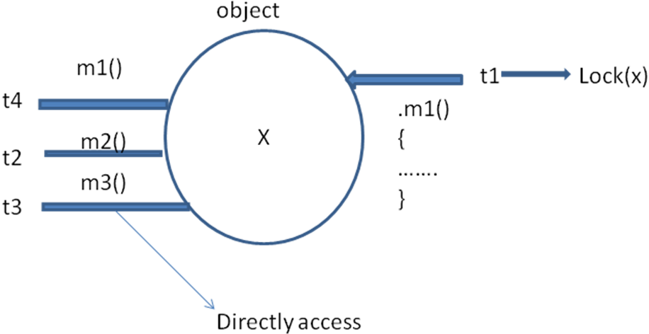

( lock concept is implemented based on the object but not based on the method.)

If synchronized keyword is not at method:

Eg:
public class Display {
public synchronized void wish(String name) {
for (int i = 0; i < 10; i++) {
System.out.println("good evening sekhar");
try {
Thread.sleep(2000);
} catch (InterruptedException e) {
}
System.out.println(name);
}

}
}

class MyThread extends Thread {
Display d;
String name;

MyThread(Display d, String name) {
this.d = d;
this.name = name;
}

public void run() {
d.wish(name);
}
}

public class ThreadJoinDemo {
public static void main(String[] args) {
Display d1 = new Display();
Display d2 = new Display();
MyThread t1 = new MyThread(d1, "somu");
MyThread t2 = new MyThread(d2, "sekhar");
t1.start();
t2.start();

}
}

- If we are not declaring wish() method as synchronized then the both threads will be executed simultaneously and we will get irregular output.

Output:

good evening sekhar
good evening sekhar
sekhar
good evening sekhar
somu
good evening sekhar
sekhar
good evening sekhar
somu
good evening sekhar
sekhar
good evening sekhar
somu
good evening sekhar
sekhar
good evening sekhar
somu
good evening sekhar
sekhar
good evening sekhar
somu
good evening sekhar
sekhar
good evening sekhar
somu
good evening sekhar
sekhar
good evening sekhar
somu
good evening sekhar
sekhar
good evening sekhar
somu
good evening sekhar
sekhar
good evening sekhar
somu
good evening sekhar
sekhar
somu

- There is no relationship between object lock and class level lock both are independent concept.

Synchronized Block:

- If very few lines of code required synchronization then it is never recommended to declare entire method as synchronized we have to declare those few lines of the code by using synchronized block.

The main advantage of synchronized block over synchronized method is, it reduces waiting time of threads and improves performance of the system.

- To get lock of current object we can declare synchronized block as follows.
synchronized (this){
………………
……………..

}
Eg2: To get lock of particular object ‘b’ we can declare a synchronized block as
Block as follows…
synchronized (b)
{
……….
……….
}
Eg3: To get class level lock we can declare synchronized block as follows

synchronized (Display.class){
………………….
………………….
}

Note: lock concept is applicable only for objects and classes but not for primitives. Hence we can’t pass primitive as argument to synchronized block otherwise we will get compile time error.

Eg: int x=10;
synchronized(x){
………………….
…………………..
}

CE: unexpected type
found: int
required: reference

Q)
- Explain about synchronized keywords advantages and disadvantages?
- Explain about object lock and when a thread required object lock?
- Explain about class level lock and when a thread required it?
- What is the difference between object lock and class level lock?
- What is the advantage of synchronized block over synchronized method?
- How to declare a synchronized block to get class level lock?
- Why the thread executing synchronized method on the given object is the remaining threads are allowed to execute the any synchronized method on the same object simultaneously?

Is a thread can acquire more than one lock at a time?-------->yes

Q) What is synchronized statement?
The statements present inside synchronized block are called synchronized statements ------------→according to Sun there is no this type.

- Inter thread communication:
Two threads can communicate with each other by using methods
- wait ();
- notify ();
- notifyAll ();

The thread which is explicit updating it has to call wait () on the object. The thread which is updating that object is responsible to call notify () on that object then waiting thread will get that notification and continue its operation with that updating.
- wait ();
- notify ();
- notify ();
- These methods are available in object class but not in thread class. Because threads can call these methods on a common object.

- To call wait (), notify (), notifyAll () compulsory the thread should be owner of that object that is compulsory thread should be in the synchronized area otherwise we get
RE: saying----> IllegalMonitorStateException.
Hence we call wait ();
notify();
notifyAll ();
The methods only from the synchronized area.

- Once a thread calls wait () on any object. First it releases the lock of that object immediately and entered into waiting state.
- Once a thread calls notify () or notifyAll () methods it releases the lock of that object but may not immediately.
- Except wait (), notify (), notifyAll() methods .there is no chance to release the lock and there is no other place where the lock release is happening.

Method | Is thread release the lock
1. yield()  2.join()  3.sleep()  4.wait()  5.notify()  6.notifyAll() | No  No  No  Yes  Yes  Yes

- Once a thread calls wait(), notify (), notifyAll() method. It releases the lock of only that particular object but not all locks whatever it has…..

- Methods:
- public final void wait() throws InterruptedException
- public final native void wait(long ms)n throws InterruptedException
- public final native void wait(long ms, int ns)n throws InterruptedException.
- Public final native void notify ();
- Public final native void notifyAll ();

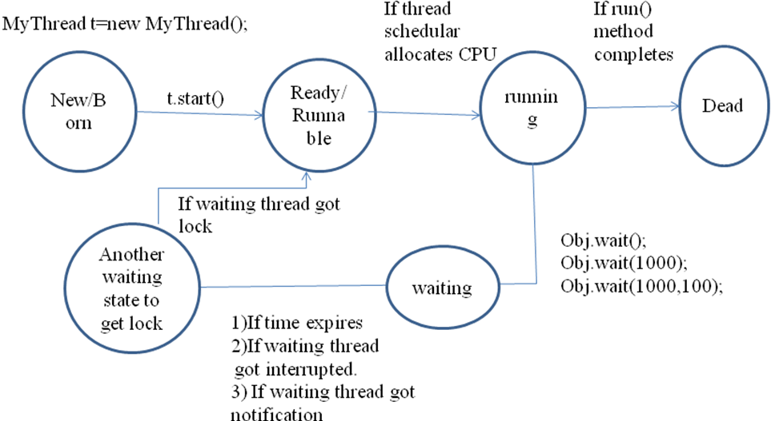.

Eg:
public class ThreadA{
public static void main(String[] args)throws InterruptedException {

ThreadB b=new ThreadB();
b.start();
synchronized (b) {
System.out.println("main thread trying to call wait()");
b.wait();
System.out.println("main thread got notified");
System.out.println(b.tot);
}
}
}

public class ThreadB extends Thread{
int tot=0;
public void run(){
synchronized (this) {
System.out.println("child thread starts calculation");
for (int i = 0; i < 100; i++) {
tot+=tot;

}
System.out.println("child thread giving notification");
this.notify();

}
}
}

Output:
main thread trying to call wait()
child thread starts calculation
child thread giving notification
main thread got notified
0

PRODUCER CONSUMER PROBLEM:

- Producer will produce the items to queue and consumer will consume items from the queue.
- If the queue is empty then consumer has to call wait () method on the queue object
- After producing the items producer thread can call notify () method on the queue so that all waiting consumer will get those updations.

Eg:

public class Producer {
//..............
produce() {
synchronized(q){
//produce item to the queue
q.notify();
//...........
}
}

}

public class Consumer {
consume(){
synchronized(q){
//if Q is empty...
q.wait();
//...........
}
}

}

notify () vs notifyAll() :
- We can use notify () to give the notification for only the thread. If multiple threads are waiting then which thread will get chance? We won’t expect exactly it depends on JVM. But only one thread will get notification and the remaining threads have to wait for further notification.
- We can use notifyAll () to give the notification for all waiting threads. All waiting threads will get notification but execution should be done
One by one.

Note: on which object we are calling wait () method that corresponding object lock we have to get. But not other objects locks.

- DeadLocks:

- If two threads are waiting for each other forever such type of situation is called deadlock.
- For the deadlock there are no resolution techniques but several prevention techniques are possible
- ‘synchronized’ keyword is the only reason for deadlock. Hence while using synchronized keyword we should take special care.

Eg:
public class A {
public synchronized void foo(B b) {
System.out.println("thread starts execution of foo() method");
try {
Thread.sleep(6000);

} catch (InterruptedException e) {
}
System.out.println("thread 1 trying to call b.last()");
b.last();

}

public synchronized void last() {
System.out.println("inside A this is last() method");
}
}

public class B {
public synchronized void bar(A a) {
System.out.println("thread 2 starts execution of bar() method");
try {
Thread.sleep(6000);
} catch (InterruptedException e) {
}
System.out.println("thread 2 trying to call a.last()");
a.last();
}

public synchronized void last() {
System.out.println("inside b, this is last() method");
}
}

public class DeadLock implements Runnable {
A a = new A();
B b = new B();

DeadLock() {
Thread t = new Thread(this);
t.start();
a.foo(b);// main
}

public void run() {
b.bar(a);
}

public static void main(String[] args) {
new DeadLock();
}
}

Output:
thread starts execution of foo() method
thread 2 starts execution of bar() method
thread 1 trying to call b.last()
thread 2 trying to call a.last()
public class Demo {
public static void main(String[] args) {
final Object resource1 = "resource1";
final Object resource2 = "resource2";
// t1 tries to lock resource1 then resource2
Thread t1 = new Thread() {
public void run() {
// Lock resource 1
synchronized (resource1) {
System.out.println("Thread 1: locked resource 1");

try {
Thread.sleep(50);
} catch (InterruptedException e) {
}

synchronized (resource2) {
System.out.println("Thread1:locked resource 2");
}
}
}
};

// t2 tries to lock resource2 then resource1
Thread t2 = new Thread() {
public void run() {
synchronized (resource2) {
System.out.println("Thread 2: locked resource 2");

try {
Thread.sleep(50);
} catch (InterruptedException e) {
}

synchronized (resource1) {
System.out.println("Thread 2: locked resource 1");
}
}
}
};

// If all goes as planned, deadlock will occur,
// and the program will never exit.
t1.start();
t2.start();
}
}

Deadlock vs Starvation:
- A long waiting of a thread which never ends is called DeadLock.
- A long waiting of a thread which ends somewhere is called starvation.

Eg: a low priority thread as to wait until completing all higher priority threads but this long waiting should ends somewhere is called starvation.

- Daemon of Threads:

- The threads which are executing in the background are called daemon threads. The main purpose of threads is to provide support for non-Daemon Threads.
- We can check whether thread is daemon or not by using isDaemon() method.
  - public final Boolean isDaemon();

- Main thread is always non-Daemon.
- We can change Daemon nature of a thread by using setDaemon() method.

public final void setDaemon(Boolean b);

- But we can change daemon nature only before starting the thread otherwise we will get RuntimeException saying IllegalThreadStateexception.
- main thread is always non-daemon and even we can’t change its daemon nature because its already started at the beginning only.
- By default main thread is always non-Daemon but for all remaining threads Daemon nature will be inherited from parent to child i.e. if the parent thread is Daemon. Child is also daemon and vice versa.
- Once the last non-Daemon thread terminates automatically all daemon threads will be terminated automatically.

Eg:
public class MyThread extends Thread {
public void run() {
for (int i = 0; i < 10; i++) {
System.out.println("lazy thread");
try {
Thread.sleep(2000);
} catch (InterruptedException e) {

}

}
}
}

public class DaemonThreadDemo {
public static void main(String[] args) {
MyThread t = new MyThread();
t.setDaemon(true);// line 1
t.start();
System.out.println("end of main");

}

}

Output:
end of main
lazy thread

- If we are commenting line1 then both main and child threads will be non-daemon and hence both threads will be executed simultaneously until there completion.
- If we are not commenting line 1 then main thread will become non-Daemon and child thread will become Daemon. Hence whenever main thread terminates automatically child thread will be terminated.

Q) How to stop a thread in middle?

- We can stop a thread explicitly by using stop () method then the thread will be entered to dead state automatically.

public void stop ();

- But this thread is deprecated and hence not recommended to use.

Q) suspend () and resume() methods?

- A thread can suspend other thread by using suspend() method.

- A thread can resume a suspended thread by using resume() method.

  - public void suspend();
  - public void resume();

- Both suspend() and resume() methods are deprecated and not recommended to use.

Q) race condition?

- If multiple threads access same object simultaneously and hence there may be a chance of causing data-inconsistency problems. This is called race condition and we can resolve these by using ‘synchronized’ keyword.
