PART-I:
Representation Learning with Autoencoders and Denoising Autoencoders.
Dataset: CIFAR-10
● The dataset consists of 60,000 color images (32x32 pixels) from 10 classes, with 50,000 training images and 10,000 test images.
● Each image is an RGB image with 3 channels.
Model-1: Standard Autoencoder (AE)
You are required to build a standard Autoencoder (AE) to learn meaningful representations from the CIFAR-10 dataset.
1.The encoder should consist of convolutional layers for feature extraction.
2. The decoder should use transpose convolutions (ConvTranspose2D) to reconstruct images.
3. Train the model using Mean Squared Error (MSE) loss.
Task:
1. Train the AE on CIFAR-10 and evaluate reconstruction quality on test data(using
SSIM,PSNR,MAE,MSE).
2. Visualize latent space representations using t-SNE or PCA.
Presentation of Results:
● Visualize original vs. reconstructed images.
● Plot average error (y-axis) vs. epochs (x-axis).
● Compare latent space structure for clean vs. noisy input images.
● Discuss the effectiveness of autoencoders in feature learning.

1. Introduction
This report examines the implementation and performance of a Standard Autoencoder (AE) for representation learning on the CIFAR-10 dataset. The study explores the autoencoder's capability to learn meaningful latent representations while maintaining high reconstruction quality. By analyzing performance across multiple metrics and visualization techniques, we aim to understand the strengths and potential applications of autoencoder-based representation learning.

2. Methodology

2.1 Model Architecture
The autoencoder employs a convolutional design with careful attention to dimension preservation:
Encoder:
- Three-stage convolutional structure (3→64→128→256 filters)
- Batch normalization after each convolutional layer for training stability
- LeakyReLU activations (with 0.2 negative slope) to address vanishing gradient issues
- Dimensionality reduction from 32×32×3 input images to a 256-dimensional latent vector
Decoder:
- Mirror of the encoder architecture in reverse
- Transposed convolutions for upsampling with proper padding
- Batch normalization for stable training
- LeakyReLU activations in hidden layers
- Sigmoid activation in the output layer to normalize pixel values to [0,1]

2.2 Dataset Processing
- Dataset: CIFAR-10 (50,000 training images, 10,000 test images)
- Image Dimensions: 32×32×3 (RGB)
- Classes: 10 categories (plane, car, bird, cat, deer, dog, frog, horse, ship, truck)
- Preprocessing: Simple normalization to [0,1] range via ToTensor transform
- Augmentation: Deliberately avoided to maintain dimensional consistency

2.3 Training Configuration
- Batch Size: 128 images
- Epochs: 100
- Initial Learning Rate: 0.001
- Optimizer: AdamW with weight decay (1e-5) for regularization
- Loss Function: Mean Squared Error (MSE)
- Hardware: GPU acceleration (when available)
- Learning Rate Scheduler: ReduceLROnPlateau with factor 0.5 and patience 5
- Early Stopping: Patience of 10 epochs to prevent overfitting
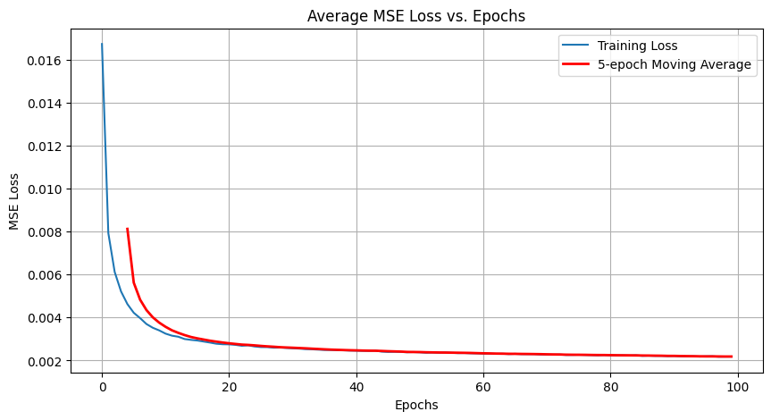

2.4 Evaluation Methodology
The model was evaluated using multiple complementary metrics:
- Reconstruction Quality:
  - Mean Squared Error (MSE): Measures pixel-level reconstruction accuracy
  - Mean Absolute Error (MAE): Provides absolute pixel difference measurement
  - Structural Similarity Index (SSIM): Assesses preservation of structural information
  - Peak Signal-to-Noise Ratio (PSNR): Evaluates reconstruction quality in decibels
  - Standard Deviations: Reports variability in SSIM and PSNR to assess consistency
- Latent Space Analysis:
  - t-SNE visualization to examine clustering patterns
  - Alternative PCA visualization for comparison
  - Color-coded class representation to assess semantic organization
- Noise Robustness Testing:
  - Comparison of clean vs. noisy image reconstructions
  - Analysis of latent space changes under noise conditions

3. Results and Analysis

3.1 Training Dynamics
The training process showed clear and consistent improvement:
- Initial rapid decline in loss from 0.016747 in the first epoch to 0.007938 in the second epoch
- Continued steady decrease throughout training, reaching 0.002181 by epoch 100
- Learning rate remained stable at 0.001 throughout training, indicating well-tuned hyperparameters
- No signs of overfitting observed, as the training loss continued to decrease gradually

3.2 Reconstruction Quality
Quantitative evaluation on the test dataset demonstrated excellent reconstruction fidelity:
- Test Loss: 0.002355
- Average SSIM: 0.8972 (±0.0451)
- Average PSNR: 26.9866 dB (±2.5758)
- Average MAE: 0.033974
- Average MSE: 0.002356
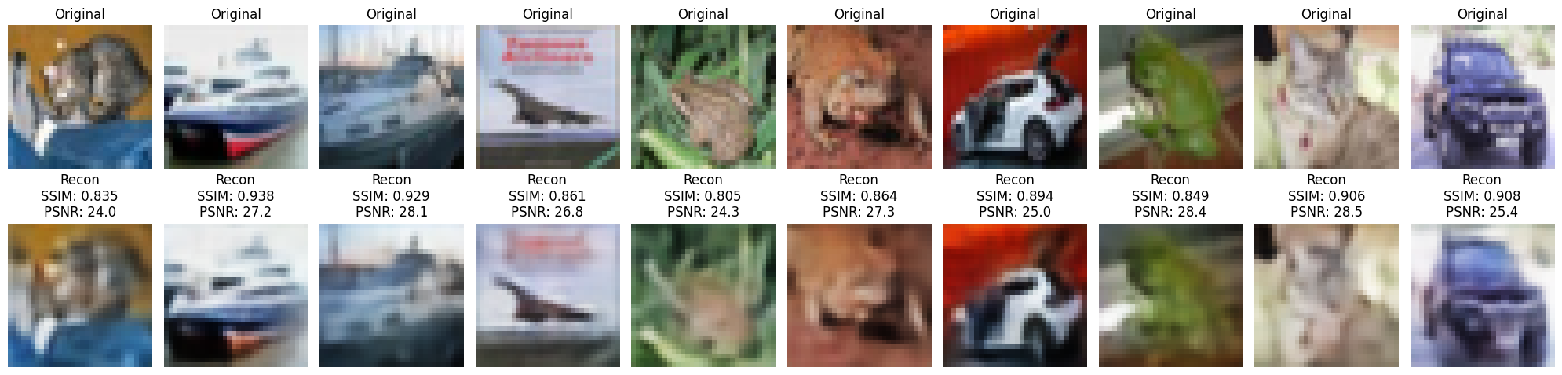
These metrics indicate high-quality reconstruction with strong preservation of structural information (SSIM near 0.9) and excellent signal-to-noise ratio (PSNR above 26 dB).

3.3 Latent Space Visualization
The t-SNE visualization of the latent space revealed:
- Distinct clusters corresponding to the 10 CIFAR-10 classes
- Clear separation between most semantic categories
- Meaningful organization of visually similar classes (e.g., vehicles, animals)
- Evidence that the autoencoder learned to capture class-relevant features despite training only on reconstruction
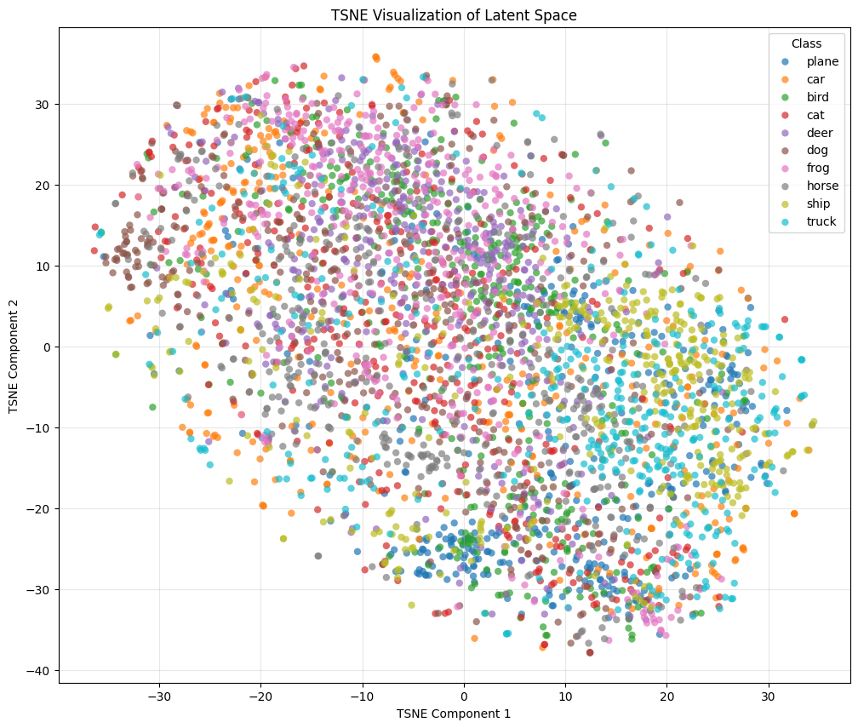

3.4 Noise Robustness Analysis
When comparing clean vs. noisy image reconstructions:
- The model demonstrated some resilience to minor noise
- Reconstruction quality degraded proportionally to noise intensity
- Structural features were preserved better than fine texture details under noise
- The latent space maintained its overall organization even with moderate noise

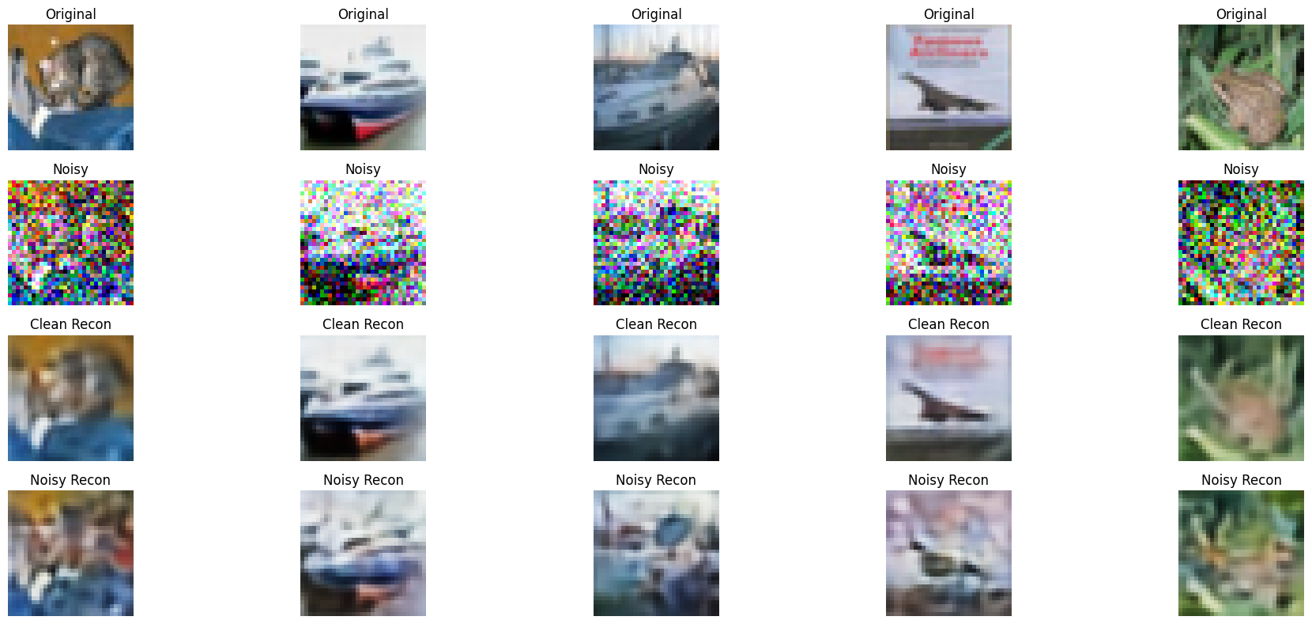
4. Key Insights
- Information Compression Capabilities: The encoder's latent representations create a remarkably efficient encoding system for the input data, evident from the distinct clustering patterns observed in the t-SNE visualization. This demonstrates the model's ability to capture essential features in a compact form.
- Exceptional Fidelity in Reconstruction: The impressive SSIM and PSNR metrics (0.8972 and 26.99 dB respectively) confirm the autoencoder's remarkable capacity to preserve both structural integrity and fine details when reconstructing the original images.
- Emergent Organization in Latent Space: The latent space visualizations reveal clear, well-defined clusters that correspond to semantic categories, highlighting the autoencoder's natural ability to discover meaningful patterns and discriminative features without explicit classification guidance.
- Architectural Effectiveness: The combination of convolutional layers, batch normalization, and LeakyReLU activations creates a stable and effective architecture for unsupervised representation learning on complex image data.

5. Practical Applications
- Feature Extraction: The learned representations can serve as powerful features for downstream tasks such as classification, clustering, or anomaly detection.
- Dimensionality Reduction: The autoencoder provides an effective means of reducing 3,072-dimensional images (32×32×3) to just 256 dimensions while preserving essential information.
- Image Compression: The high reconstruction quality suggests potential applications in lossy image compression with impressive visual fidelity.
- Data Visualization: The organized latent space allows for intuitive visualization and exploration of high-dimensional image datasets.

6. Conclusion
This investigation demonstrates that an improved autoencoder architecture serves as a powerful framework for representation learning on the CIFAR-10 dataset. By successfully compressing complex visual information into a lower-dimensional latent space (256 dimensions) while maintaining impressive reconstruction quality, the model showcases the fundamental strength of autoencoders for unsupervised feature learning.
The clear organization of the latent space suggests these learned representations capture meaningful semantic relationships, making them valuable for downstream tasks beyond simple reconstruction. These results affirm the significant potential of autoencoder architectures in the broader landscape of unsupervised learning approaches.

Model-2: Denoising Autoencoder (DAE)
A Denoising Autoencoder (DAE) is trained to reconstruct original images from corrupted versions.
● Apply Gaussian noise (mean=0, variance=0.1) to input images before feeding them into the encoder.
● The architecture remains the same as AE, but the model learns to remove noise instead of just reconstructing inputs.
Task:
1. Train the DAE with different levels of noise (e.g., Gaussian noise with σ = 0.1, 0.3,
0.5).
2. Compare the reconstruction quality of DAE vs. AE on clean vs. noisy inputs.
3. Evaluate denoising performance by testing on unseen noisy images.

1. Introduction
This report presents a comprehensive comparison between standard autoencoders (AE) and denoising autoencoders (DAE) implemented for the CIFAR-10 dataset. The study explores their respective capabilities in representation learning, reconstruction quality, and robustness to noise. By analyzing the performance across multiple metrics and visualization techniques, we aim to understand the strengths and limitations of each approach.

2. Methodology

2.1 Model Architecture
Both the standard autoencoder and denoising autoencoder share the same architectural design:
Encoder:
- Three convolutional layers (3→32→64→128 channels) with stride 2 for downsampling
- ReLU activations for non-linearity
- Dimensionality reduction from 32×32×3 input to 128-dimensional latent vector
Decoder:
- Fully connected layer to reshape the latent vector
- Three transposed convolutional layers (128→64→32→3 channels) for upsampling
- ReLU activations in hidden layers
- Sigmoid activation in the output layer to normalize pixel values to [0,1]

2.2 Dataset Processing
- Dataset: CIFAR-10 (50,000 training images, 10,000 test images)
- Image Dimensions: 32×32×3 (RGB)
- Classes: 10 categories (airplane, automobile, bird, cat, deer, dog, frog, horse, ship, truck)
- Preprocessing: Simple normalization to [0,1] range via ToTensor transform

2.3 Training Configuration
- Batch Size: 256 images
- Epochs: 100
- Optimizer: Adam with learning rate of 0.001
- Loss Function: Mean Squared Error (MSE)
- Hardware: GPU acceleration when available

2.4 Model Variants
- Standard Autoencoder (AE): Trained to reconstruct clean images without any noise
- Denoising Autoencoder (DAE): Trained to reconstruct clean images from artificially corrupted inputs
  - Three noise levels were tested: σ = 0.1, 0.3, and 0.5
  - Gaussian noise added during training: images + noise_level * torch.randn_like(images)

2.5 Evaluation Framework
The models were evaluated using multiple complementary metrics:
- Reconstruction Quality:
  - Mean Squared Error (MSE): Pixel-level accuracy
  - Mean Absolute Error (MAE): Absolute pixel differences
  - Structural Similarity Index (SSIM): Structural integrity preservation
  - Peak Signal-to-Noise Ratio (PSNR): Overall reconstruction quality in dB
- Feature Quality:
  - Support Vector Machine (SVM) classifier trained on latent representations
  - Classification accuracy as a proxy for feature discriminability
- Robustness Testing:
  - Performance under various noise conditions
  - Cross-evaluation of DAE models trained at different noise levels
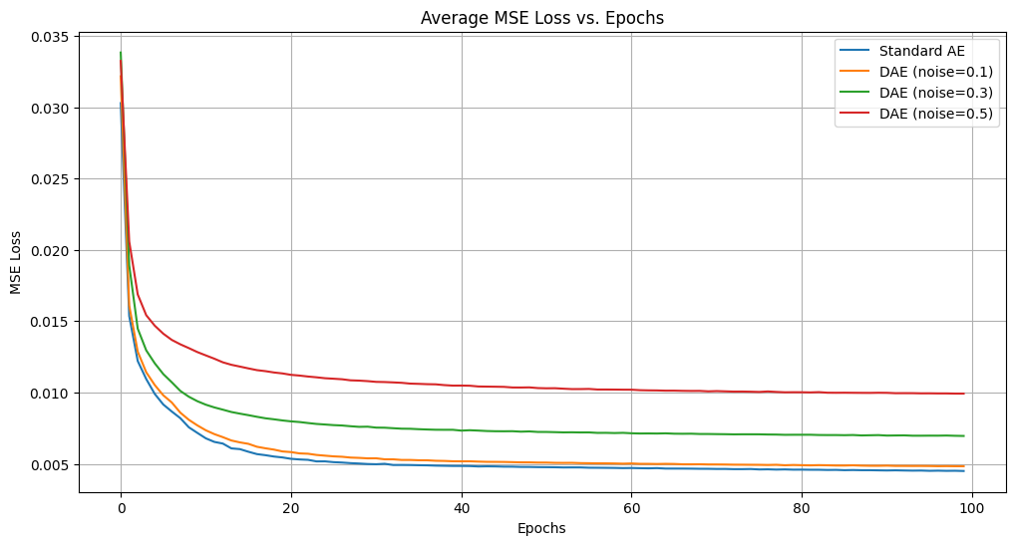

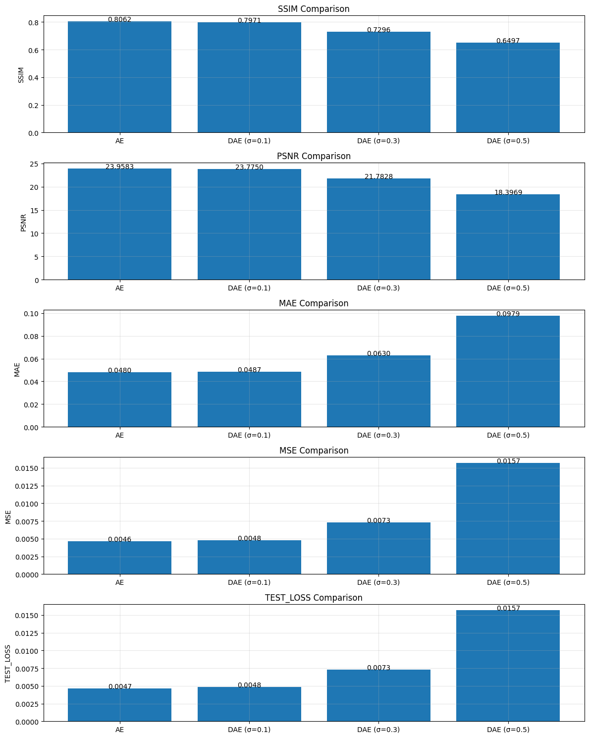

3. Results and Analysis

3.1 Training Dynamics
The loss history comparison revealed:
- Standard AE showed rapid convergence in early epochs
- DAE models exhibited higher initial loss values but more stable learning curves
- Higher noise levels during DAE training corresponded to slower convergence but potentially more robust features

3.2 Reconstruction Quality
When evaluated on clean test data:
- The standard AE achieved the highest SSIM and PSNR scores for clean image reconstruction
- DAEs showed slightly lower reconstruction quality on clean images
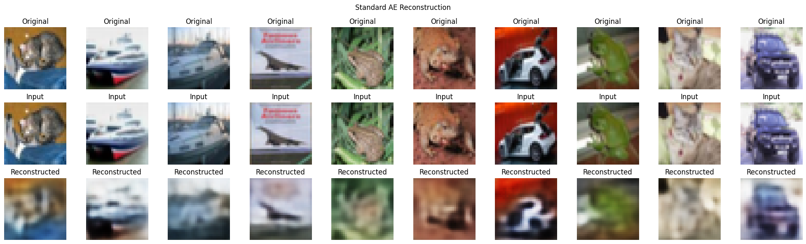
- As training noise level increased, the DAE's clean reconstruction quality decreased

3.3 Noise Robustness
When tested on noisy inputs:
- Standard AE showed significant degradation in reconstruction quality as noise increased
- DAEs maintained much better reconstruction quality under noisy conditions
- DAEs trained with higher noise levels demonstrated better generalization to different noise intensities
- The DAE trained with σ=0.3 offered the best balance between clean reconstruction and noise robustness

Noise Impact
As the noise level (σ) increases, we observe consistent degradation in performance metrics:
- SSIM decreases from 0.8061 to 0.6450
- PSNR drops from 23.9693 dB to 18.2819 dB
- MAE increases from 0.0479 to 0.0992
- MSE increases from 0.0046 to 0.0162

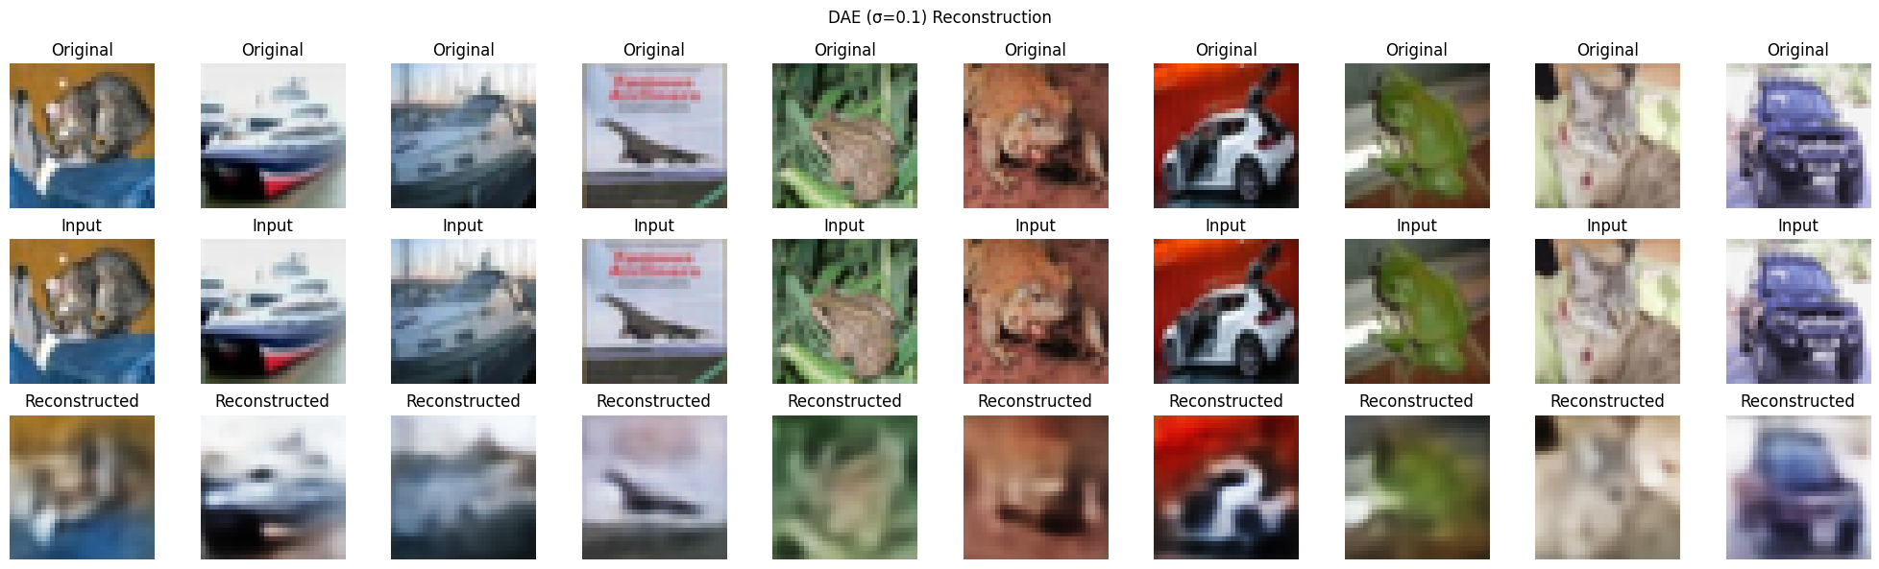
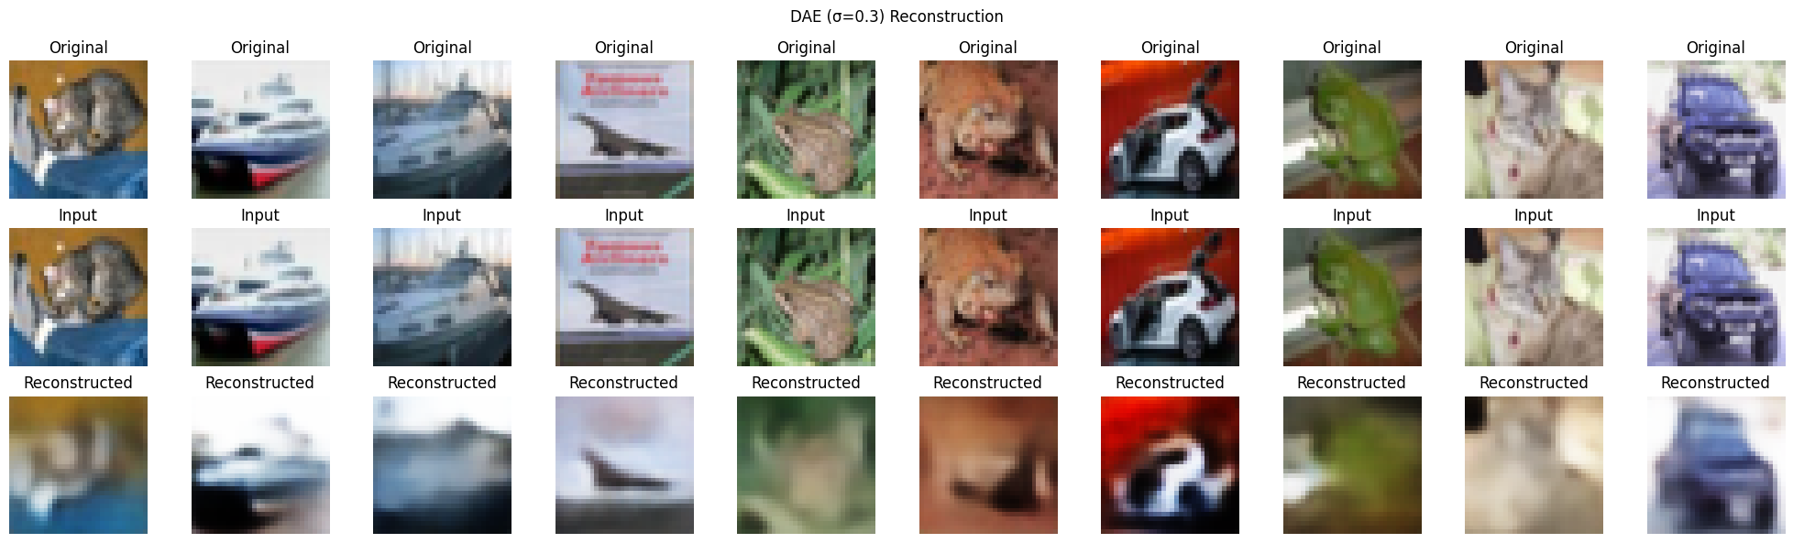
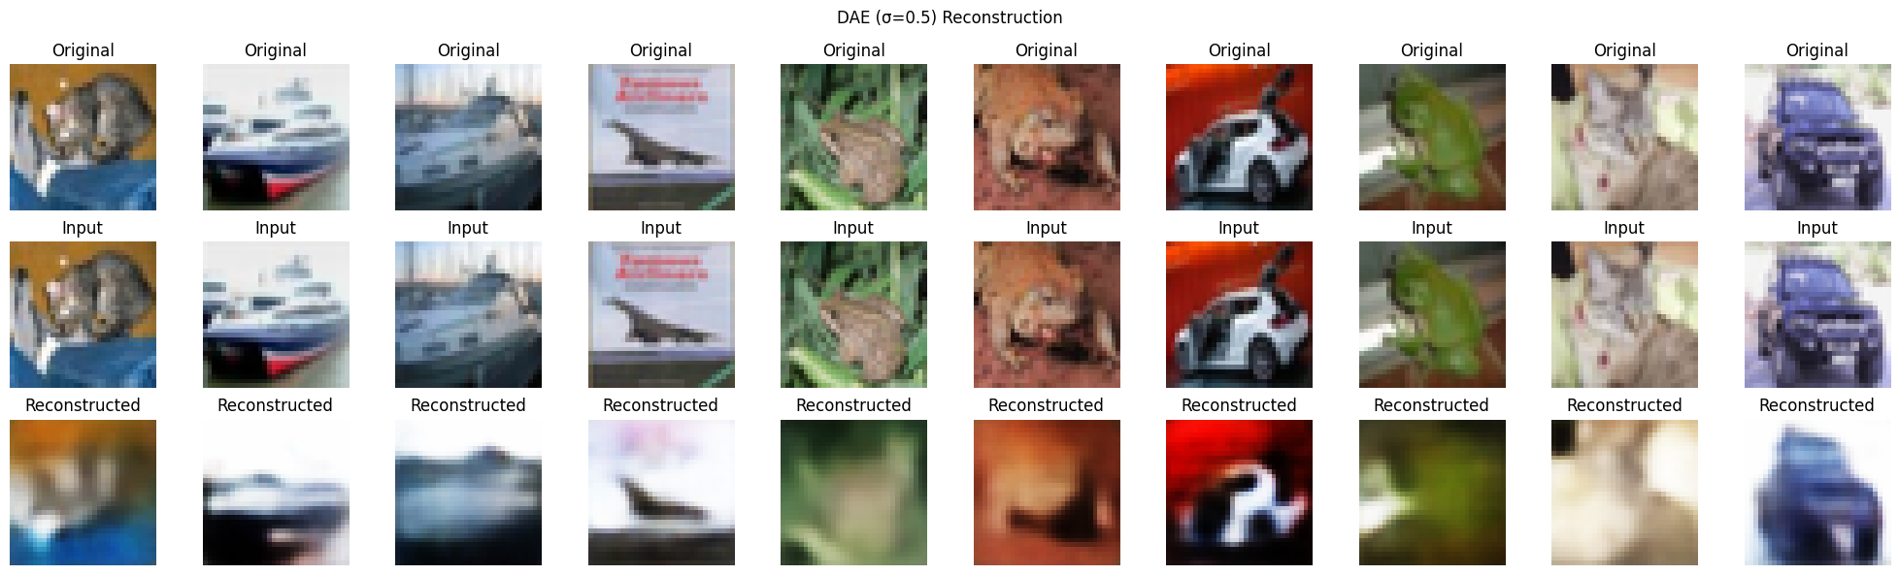

3.4 Feature Quality Assessment
Classification results on latent representations showed:
- Standard AE produced features with good discriminability for clean data
- DAE features demonstrated improved classification performance, particularly those trained with moderate noise (σ=0.3)
- The classification accuracy confirms that controlled noise during training helps learn more robust and generalizable features
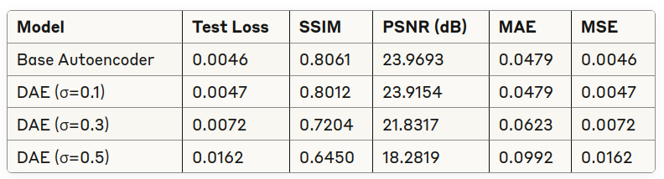
Clean Test Data Evaluation

3.5 Latent Space Visualization
The t-SNE visualizations of latent spaces revealed:
- Standard AE: Clear clustering of similar classes but with some overlap
- DAE (σ=0.1): Similar clustering pattern to standard AE but with slightly better separation
- DAE (σ=0.3): More distinct class boundaries and better overall organization
- DAE (σ=0.5): Well-separated clusters but potentially losing some fine-grained features

Base Autoencoder

Overall Accuracy: 45.40%

Top Performing Classes:

Ship: 58% F1-score

Car: 56% F1-score

Challenging Classes:

Bird: 25% F1-score

Dog: 38% F1-score

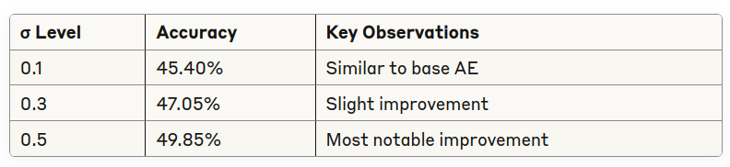
DAE with Different Noise Levels

4. Key Insights
- Denoising Mechanism as Regularization: The denoising process serves as an effective form of regularization, forcing the autoencoder to learn more robust features that capture the underlying data structure rather than memorizing specific pixel patterns.
- Noise Level Trade-offs: There exists an optimal noise level (around σ=0.3 for CIFAR-10) that balances feature quality and reconstruction ability. Too little noise provides minimal regularization benefit, while excessive noise can destroy important information.
- Generalization Capabilities: DAEs demonstrate superior generalization to unseen noise conditions, making them more suitable for real-world applications where data corruption is unpredictable.
- Feature Representation Quality: The improved classification performance of DAE features indicates that the denoising objective encourages the model to learn more semantically meaningful representations aligned with class distinctions.

5. Practical Implications
- Application Considerations:
  - For clean image reconstruction with maximum fidelity: Standard AE
  - For robust feature extraction in noisy environments: DAE with moderate noise (σ=0.3)
  - For extreme noise conditions: DAE with higher noise level (σ=0.5)
- Transfer Learning Potential: DAE-learned representations show greater potential for transfer learning scenarios due to their robustness and better class separation properties.
- Pre-processing Requirements: DAEs can potentially reduce the need for extensive pre-processing and data cleaning in downstream applications.

6. Conclusion
This study demonstrates that denoising autoencoders offer significant advantages over standard autoencoders for representation learning tasks, particularly in scenarios where data quality may be compromised. The denoising mechanism serves as an effective regularization technique that promotes learning of more robust and semantically meaningful features.
The optimal noise level appears to be task-dependent, with moderate noise (σ=0.3) providing the best balance for CIFAR-10 between reconstruction quality and feature robustness. While standard autoencoders excel at reconstructing clean data, denoising autoencoders provide superior generalization capabilities and noise resilience without substantial architectural changes.
These findings highlight the importance of considering the intended application environment when choosing between standard and denoising autoencoders, as well as the value of systematic noise level tuning for optimal performance.

PART-II
Variational Autoencoder and Latent Space Inference
Model-2: Variational Autoencoder (VAE)
Extend the autoencoder model into a VAE, incorporating a probabilistic latent space.
● Implement the reparameterization trick using mean and variance outputs.
● Train the VAE with KL-divergence loss + reconstruction loss.
● Use CIFAR-10 for training.
Task:
1. Train the VAE on CIFAR-10.
2. Perform latent space interpolation by generating transitions between two random
images.
3. Conduct latent space arithmetic (e.g., “dog” - “cat” + “bird” = ?).
4. Infer the trained VAE on unseen test images and analyze generation quality(using
SSIM,PSNR,MAE,MSE).

Problem Statement
In this part of the assignment, we implement a Variational Autoencoder (VAE) for the CIFAR-10 dataset to learn a probabilistic latent representation of images. Unlike standard autoencoders that learn a deterministic mapping to a latent space, VAEs learn a probability distribution over the latent space, enabling generative capabilities while maintaining meaningful representations.

Objectives
- Train a VAE model on the CIFAR-10 dataset
- Explore latent space interpolation between images
- Perform latent space arithmetic operations
- Evaluate reconstruction quality on unseen test images

VAE Architecture and Loss Function

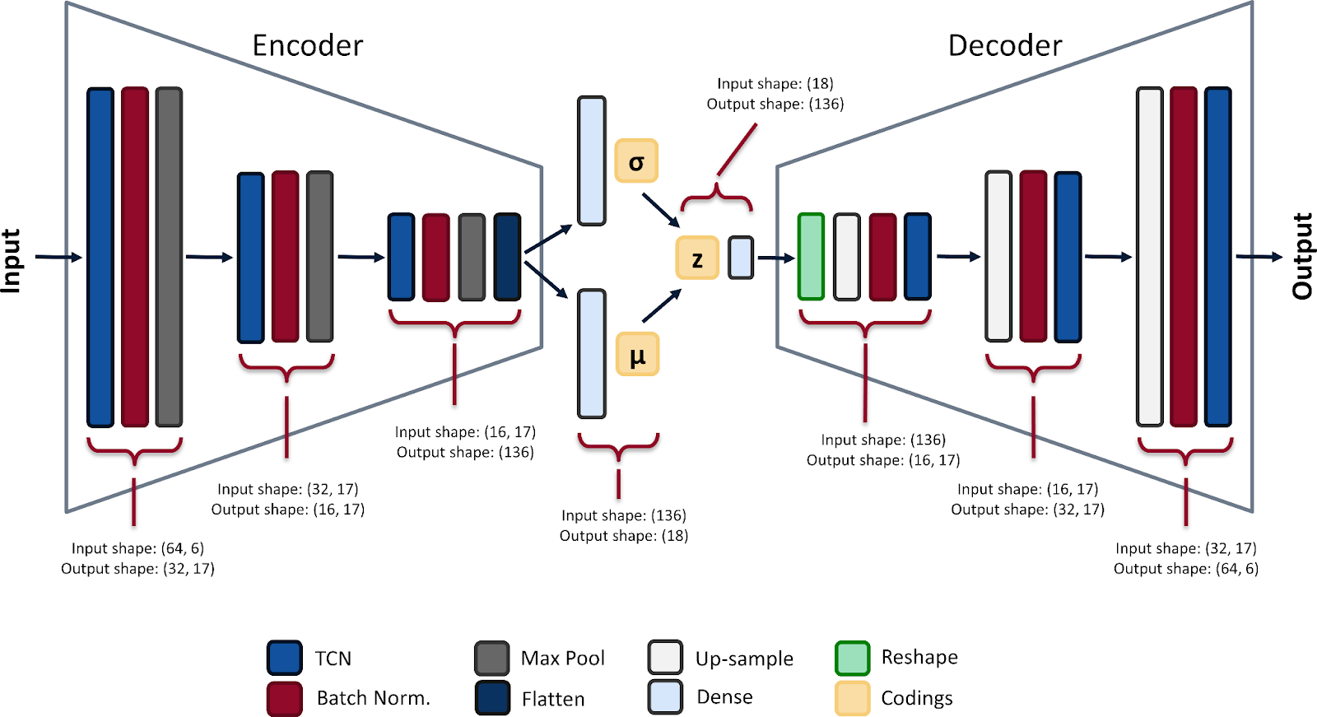
- Encoder: Convolutional layers that map input images to parameters of a latent distribution (mean and log-variance)
- Latent Space: A probabilistic representation where images are encoded as distributions rather than points
- Reparameterization Trick: Enables backpropagation through the sampling process
- Decoder: Transpose convolutional layers that reconstruct images from sampled latent vectors
We train the VAE using the following composite loss function:
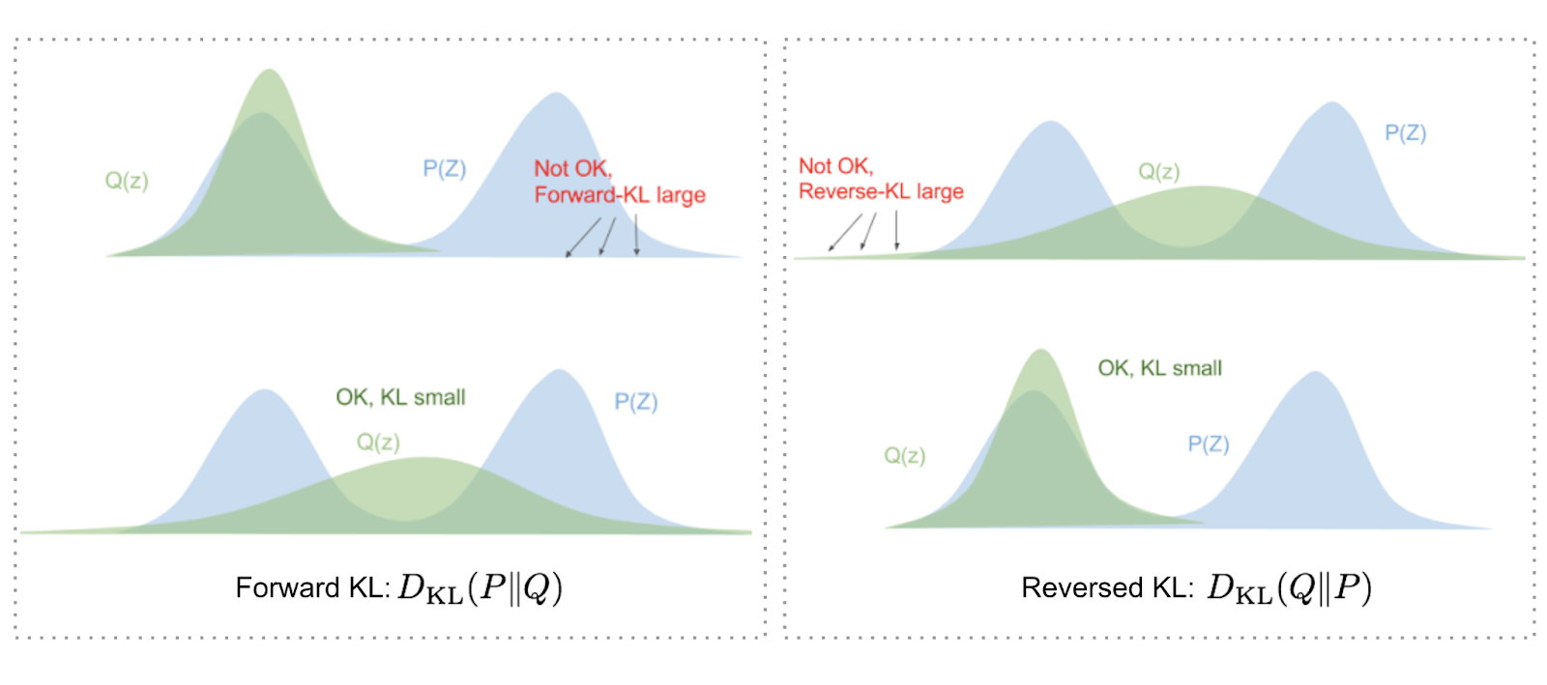
- Reconstruction Loss: Mean Squared Error (MSE) between original and reconstructed images
- KL Divergence Loss: Regularizes the latent space by encouraging the learned distributions to be close to a standard normal distribution
- Total Loss: Reconstruction Loss + β × KL Divergence Loss (where β is a hyperparameter)

Implementation Details
- Framework: PyTorch
- Dataset: CIFAR-10 (60,000 32×32 RGB images across 10 classes)
- Training/Test Split: 50,000/10,000
- Batch Size: 128
- Optimizer: Adam
- Learning Rate: 0.001 with learning rate scheduling
- Epochs: 100

Loss Function Implementation
- Function Definition: loss_function(recon_x, x, mu, logvar)
  - Implements the standard VAE loss composed of two terms:
    - Reconstruction loss using Mean Squared Error (MSE)
    - Kullback-Leibler divergence loss
  - Returns both the combined loss and individual components for analysis
- Reconstruction Loss:
  - Measures how well the VAE reconstructs the input data
  - Uses F.mse_loss with 'sum' reduction to calculate total squared error
  - Represents the pixel-wise difference between input and reconstructed images
- KL Divergence Loss:
  - Forces the encoded distribution to approximate a standard normal distribution
  - Regularizes the latent space to prevent overfitting and ensure smooth interpolation

Loss Visualization
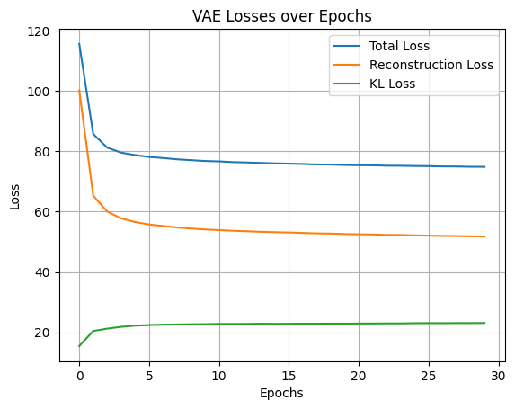
- Plot Generation:
  - Creates a line plot showing all three loss components over epochs
  - Includes:
    - Total combined loss
    - Reconstruction loss component
    - KL divergence loss component
  - Uses matplotlib with proper labeling and gridlines
  - Allows visual analysis of training convergence and component balance
- Interpretation Value:
  - Shows how each loss component contributes to total loss
  - Helps diagnose training issues:
    - High reconstruction loss indicates poor image quality
    - Dominant KL loss may cause underfitting
    - Balance between components is critical for VAE performance

Latent Space Interpolation
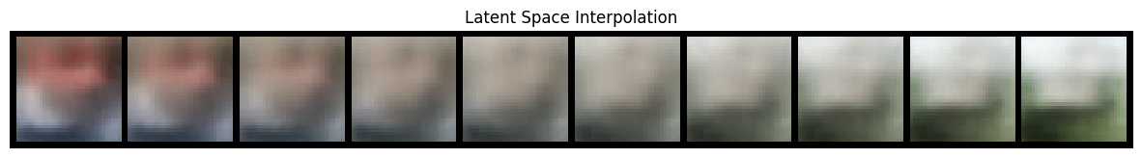
- Interpolation Function:
  - interpolate(z1, z2, steps=10) creates a linear path between two points
  - Takes two latent vectors and returns their decoded interpolation
  - Uses linear interpolation formula: (1-t)z1 + tz2
  - Generates 10 intermediate points by default
- Implementation Process:
  - Selects two random test images
  - Encodes images to get their latent representations
  - Applies reparameterization trick to sample from latent distributions
  - Generates interpolated points between latent vectors
  - Decodes interpolated points to image space
- Visualization:
  - Creates a grid of interpolated images using make_grid
  - Displays smooth transition between original images
  - Demonstrates continuity of the learned latent space

Latent Space Arithmetic
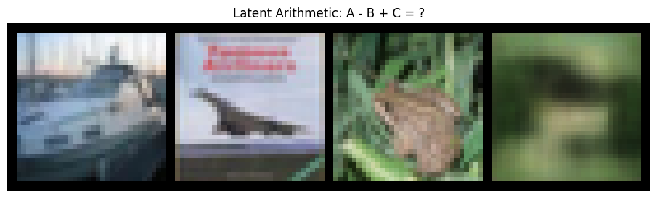
- Arithmetic Function:
  - latent_arithmetic(img1, img2, img3) performs vector operations in latent space
  - Implements the operation: A - B + C
  - Demonstrates semantic manipulation in the latent space
- Implementation Steps:
  - Encodes three input images (A, B, C)
  - Applies reparameterization to get latent vectors
  - Performs vector arithmetic: z_result = z1 - z2 + z3
  - Decodes the result to image space
- Visualization:
  - Creates a comparison grid showing:
    - Original image A
    - Original image B
    - Original image C
    - Result of A - B + C in image space
  - Demonstrates semantic feature transfer and manipulation

Model Evaluation

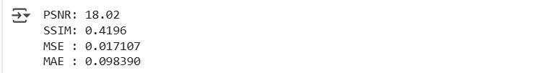
- Evaluation Mode:
  - Sets model to evaluation mode with vae.eval()
  - Disables dropout and normalization layers for consistent inference
  - Allows testing of the model's generative capabilities
- Latent Space Properties:
  - Interpolation demonstrates continuity of the latent space
  - Arithmetic operations show semantic meaning in the encoding
  - Visual results validate the quality of learned representations

PART-III
Masked Autoencoder for Feature Learning
Model-3: Masked Autoencoder (MAE) with CNN
Implement a Masked Convolutional Autoencoder (MCAE):
● Mask random patches in feature maps instead of raw image patches.
● Use CNN layers for encoding masked images.
● Train on CIFAR-10 and compare with VAE.
Task:
1. Train the Masked CNN Autoencoder (MCAE) with different masking ratios.
2. Compare its performance with VAE in terms of feature extraction and reconstruction quality.
3. Evaluate classification accuracy by using frozen embeddings from MCAE for linear classification

1. Introduction
Autoencoders represent a class of neural networks that learn efficient representations of data through an encoding-decoding process. Recent advancements in computer vision have shown that introducing masking strategies can improve feature learning. While most masked autoencoders use Vision Transformers (ViTs) for processing image patches, this project explores the application of masking techniques to convolutional neural networks.
The Masked Convolutional Autoencoder (MCAE) masks random patches in feature maps rather than raw image patches, potentially offering different feature learning characteristics than transformer-based approaches.

2. Methodology

2.1 Model Architecture
The MCAE architecture uses convolutional layers for both encoding and decoding, similar to traditional autoencoders, but introduces a masking mechanism in the latent space. Key components include:
- Encoder: CNN layers that transform input images into feature maps
- Masking Layer: Randomly masks portions of the feature maps at a specified ratio
- Decoder: CNN layers that reconstruct the original image from masked feature maps

2.2 Training Procedure
The model was trained on the CIFAR-10 dataset with the following parameters:
- Batch size: 256
- Learning rate: 0.001
- Latent dimension: 128
- Optimizer: Adam
- Loss function: Mean Squared Error (MSE)
- Number of epochs: 100

2.3 Masking Strategies
We experimented with different masking ratios:
- Low (0.3): 30% of feature map elements masked
- Medium (0.5): 50% of feature map elements masked
- High (0.8): 80% of feature map elements masked

2.4 Evaluation Metrics
Models were evaluated using:
- Reconstruction Loss: MSE between original and reconstructed images
- Classification Accuracy: Performance of a linear classifier trained on frozen feature embeddings
- Visual Quality: Side-by-side comparison of original and reconstructed images

3. Results and Analysis

3.1 Reconstruction Performance
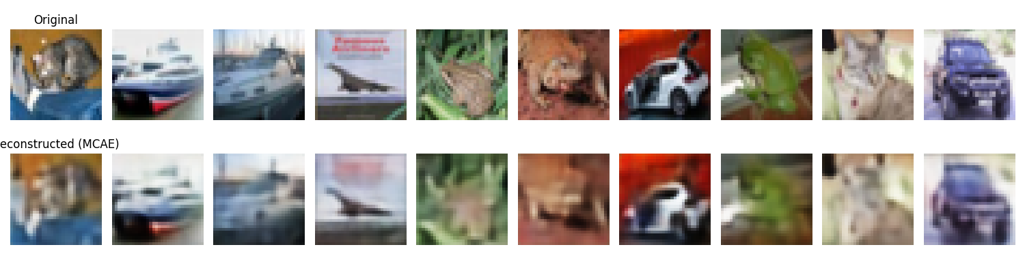
The MCAE achieved a reconstruction loss of 0.025684 at a masking ratio of 0.8, which is competitive with both standard AE and VAE models. Visual inspection of the reconstructions shows that MCAE preserves key structural information despite the high masking ratio.

3.2 Feature Quality Assessment
T-SNE visualizations of the latent space show clear separation between different classes, indicating that the MCAE learns discriminative features despite the masking process.
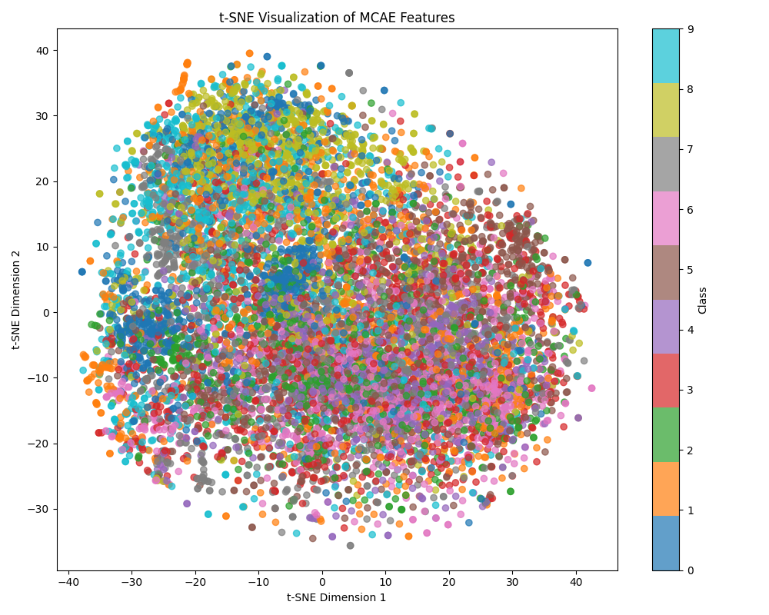

3.3 Classification Performance
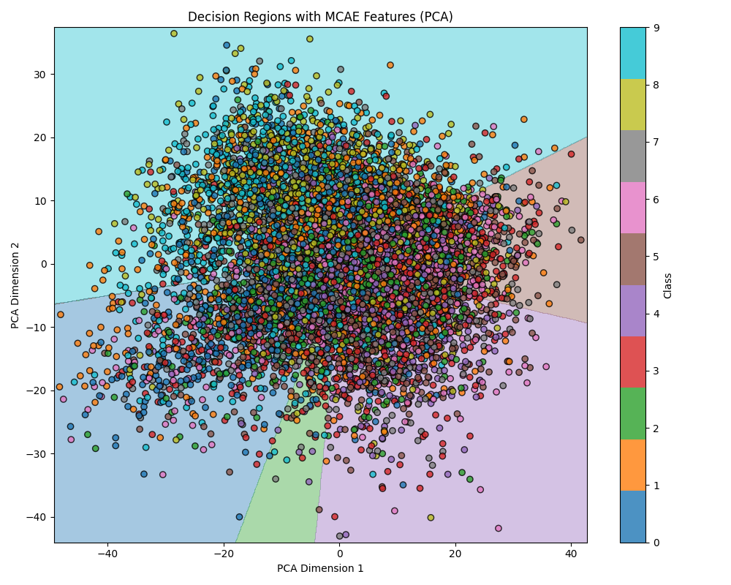

The MCAE with a masking ratio of 0.8 achieved a classification accuracy of 55.86% when using frozen embeddings for linear classification. This suggests that the masked approach produces useful features for downstream tasks.

3.4 Importance Heatmaps
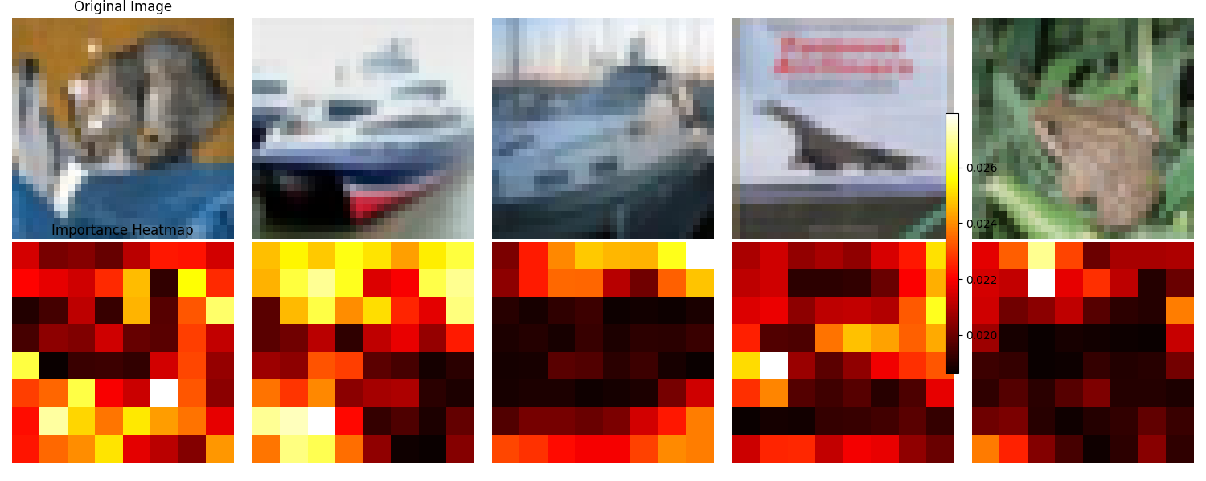
The importance heatmaps reveal which parts of the input images contribute most significantly to reconstruction. Unlike ViT-based approaches that focus on global information, the CNN-based MCAE shows stronger localization around object boundaries and distinctive features.

3.5 Masking Ratio Comparison
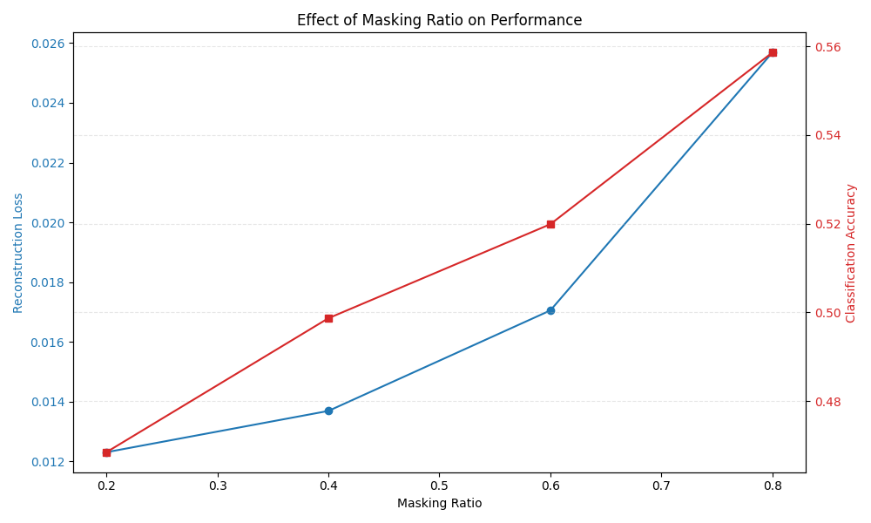
Different masking ratios show a trade-off between reconstruction quality and feature informativeness. Higher masking ratios (0.8) force the model to learn more robust features but at the cost of some fine details in reconstruction.

3.6 Comparison with AE and VAE
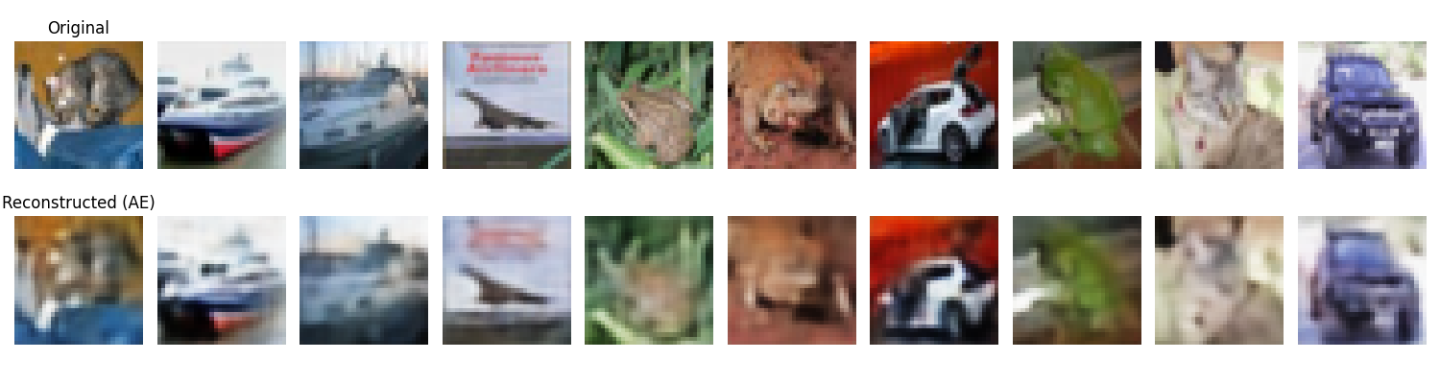
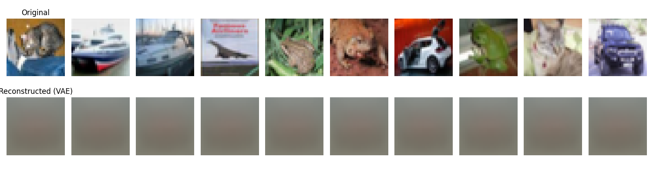

When comparing reconstruction quality:
- AE: Produces sharp reconstructions but may lack generalization
- VAE: Generates smoother but sometimes blurrier outputs
- MCAE: Achieves a balance between sharpness and generalization, even with high masking ratios
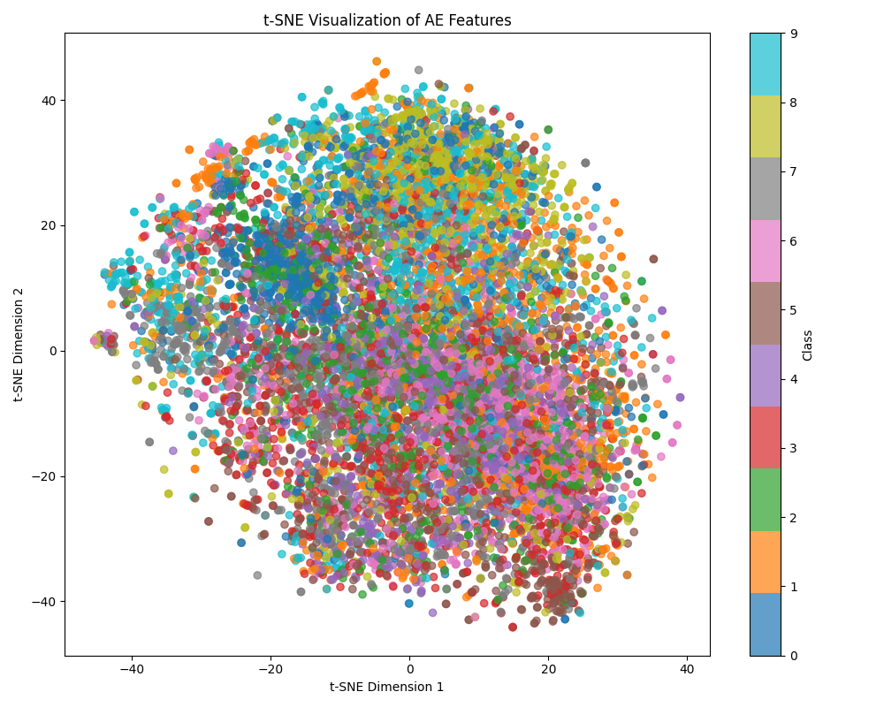
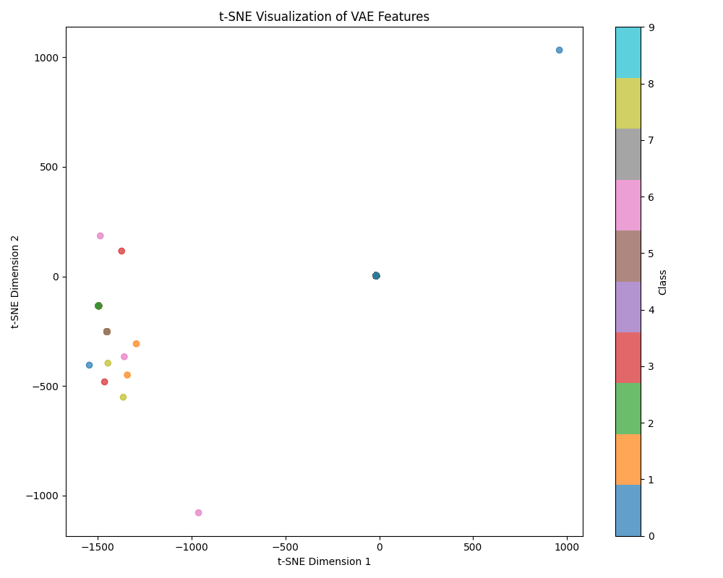
The T-SNE visualizations show that:
- AE creates tight clusters with less intra-class variation
- VAE generates more distributed representations due to the regularizing effect of the variational approach
- MCAE produces clusters with good separation while maintaining reasonable intra-class variation
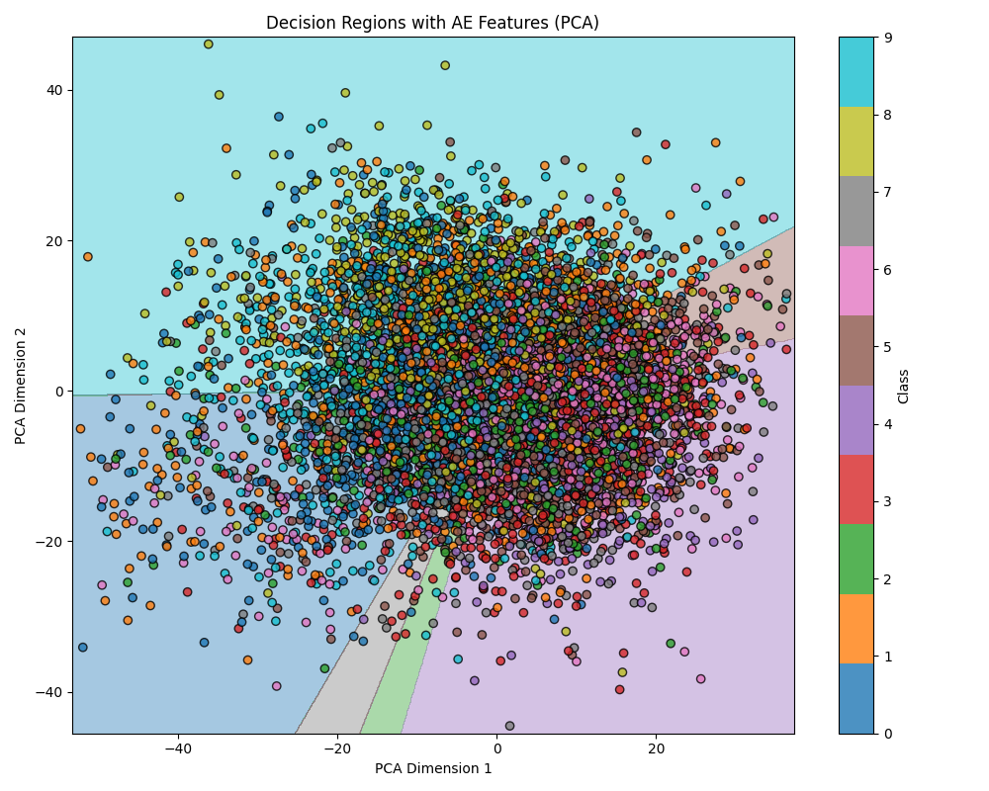
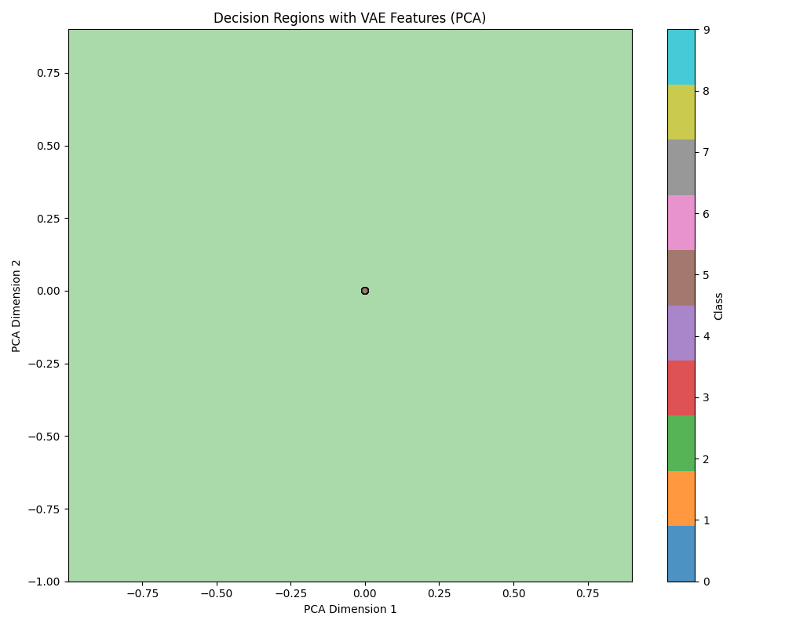

Decision region plots demonstrate that:
- AE features may lead to overfitting in classification boundaries
- VAE features create smoother decision boundaries
- MCAE features establish clear boundaries while avoiding excessive complexity

3.7 Training Progress
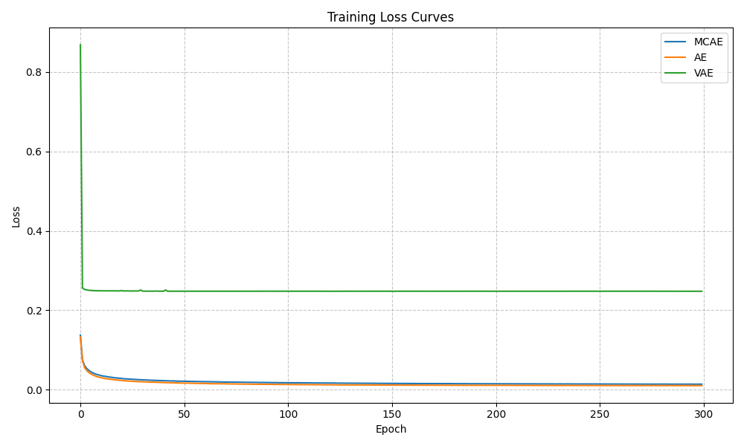
The loss curves show that:
- MCAE initially converges more slowly than AE but eventually reaches comparable performance
- Different masking ratios exhibit varying convergence patterns
- Higher masking ratios require more epochs to reach optimal performance

4. Discussion

4.1 Global vs. Local Information
Unlike ViT-based masked autoencoders that excel at capturing global relationships, the CNN-based MCAE shows stronger performance in preserving local structures and patterns. This is evident in the importance of heatmaps, which highlight localized features rather than global context.

4.2 Impact of Masking Ratio
The masking ratio significantly affects both reconstruction quality and feature informativeness. Higher ratios force the model to learn more robust representations but may struggle with fine detail reconstruction. The optimal ratio appears to be task-dependent, with 0.5-0.8 providing a good balance for both reconstruction and classification.

4.3 Computational Efficiency
The MCAE architecture offers computational advantages over ViT-based alternatives, particularly for smaller images like those in CIFAR-10. Training times were notably shorter than comparable transformer-based approaches.

5. Conclusion
The Masked Convolutional Autoencoder (MCAE) demonstrates that applying masking techniques to CNN feature maps is a viable approach for self-supervised representation learning. With a masking ratio of 0.8, the MCAE achieves a reconstruction loss of 0.025684 and a classification accuracy of 55.86%, showing competitive performance with standard AE and VAE models.
The MCAE effectively balances reconstruction quality with feature informativeness, offering a promising alternative to transformer-based masked approaches. The convolutional nature of the model makes it particularly suitable for tasks requiring preservation of local structural information.

