Work Done in March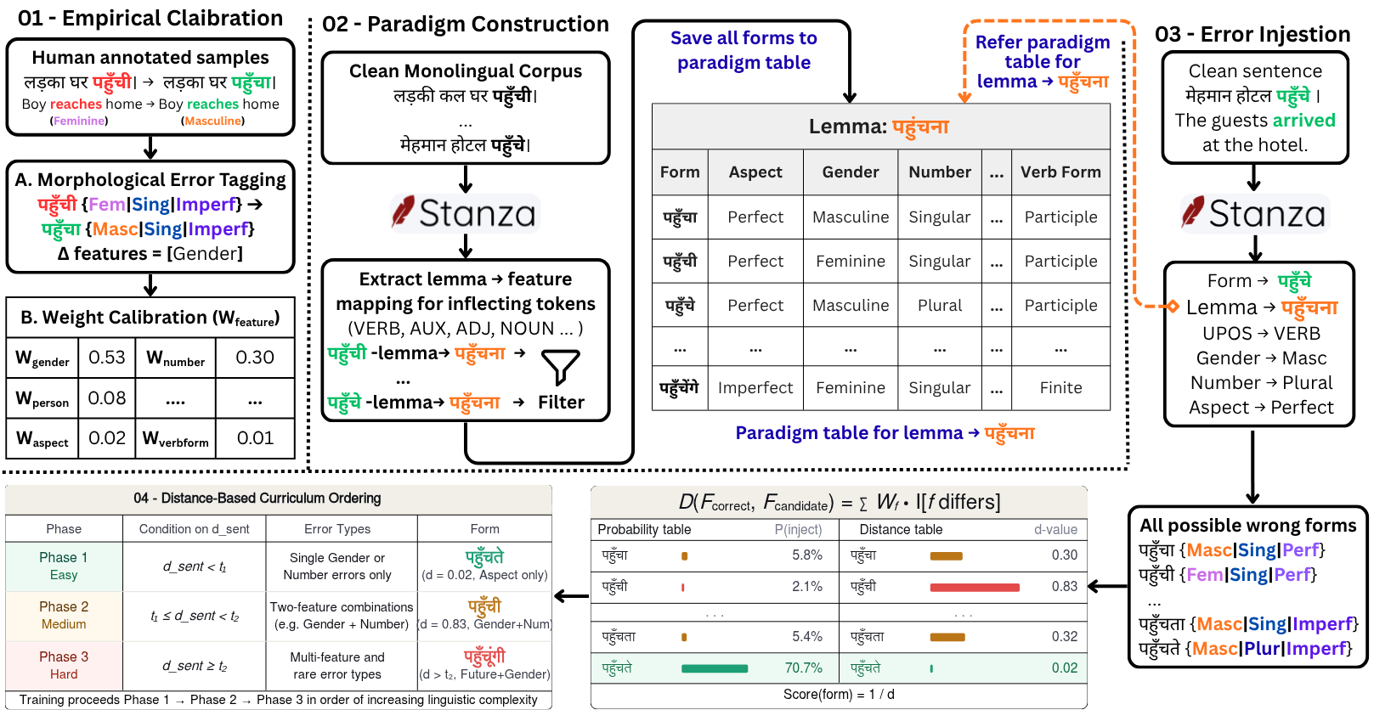
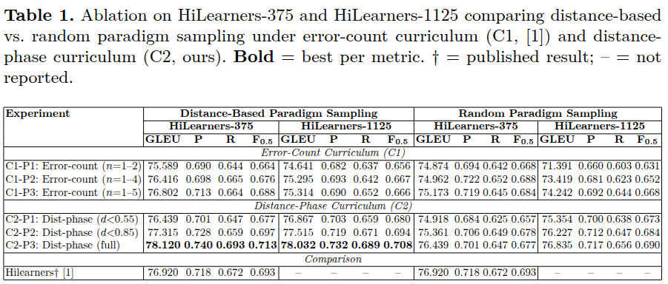
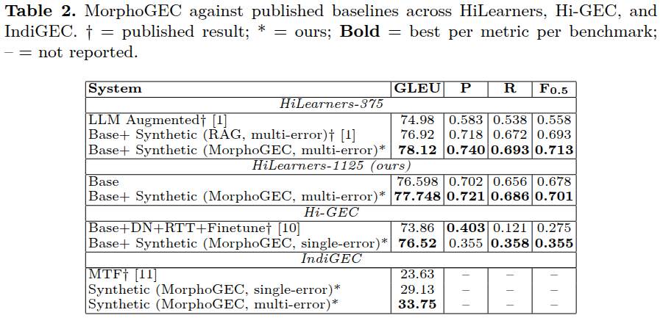

Enhancing Hindi OCR Accuracy Using Color-Driven
Sub-Character Segmentation
Sourava Kumar Behera - S24131
Indian Institute of Technology Mandi

Abstract: Hindi script contains numerous sub-characters whose combinations form complex conjuncts with shapes that differ substantially from their individual components. Conventional OCR models trained on grayscale images often fail to capture this internal structure, leading to persistent errors on conjunct characters. We introduce a two-stage OCR framework designed to make this structure explicit: (a) a segmentation model, trained entirely on synthetic data, that predicts color-coded sub-character layouts from grayscale text; and (b) an OCR model trained on the same synthetic colored images, which reads text directly from the predicted colorized outputs of the first stage. This approach provides explicit sub-character cues without requiring any manually colored real data. The proposed framework achieves 98.85\% character accuracy and 96.12\% word accuracy on the Mozhi benchmark. On a challenging unseen dataset of 1,000 words containing 58.1\% conjunct characters, it attains 96.62\% character accuracy representing a 16.6\% improvement over a fine-tuned grayscale baseline. These results demonstrate that incorporating sub-character structure through color-coded supervision substantially improves robustness in Hindi OCR.

Methodology: The goal of the study is to make the sub-character structure of Devanagari text explicit to the OCR model by converting grayscale word images into color-coded representations where each character component is visually distinguished. This section describes the complete pipeline used to generate these representations and train models on them.
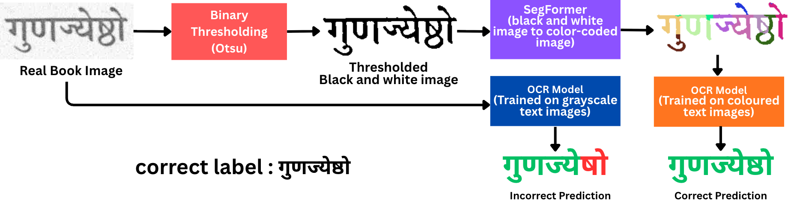
Figure 1: Overview of the proposed training and inference pipeline. Synthetic grayscale-color pairs are used to train a segmentation model and a color-aware OCR model. At inference, real grayscale text is first colorized by the segmentation model and then recognized by the OCR model. The overall pipeline does not require manual coloring of the text image.

Figure 1 provides an overview of our approach. During training, the system operates in three stages: (a) generation of a large synthetic dataset containing paired grayscale and color-coded images, (b) training a segmentation model to predict color-coded layouts from grayscale inputs, and (c) training a color-aware OCR model on the synthetic colored text. During inference, real grayscale text images are first mapped to their color-coded layouts by the segmentation model and then recognized by the OCR model. This enables explicit part-level cues without requiring any manually colored real images.

