**NATIONAL INSTITUTE OF TECHNOLOGY, HAMIRPUR (H.P.)**



MODELLING AND SIMULATION LAB PROJECT

**TEAM MEMBERS:** **SUBMITTED TO:**

Sourav Sahoo 15MI502 Mr. Pankaj

Gaurav Kandoria 15MI523

Lalit Yadav 15MI505

Aniket Bhardwaj 15MI508

Graphical representation of Maxwell-Boltzmann Equation

**Aim**: To graphically plot the probability distribution of a particular gas using Maxwell-Boltzmann equation and analyse the graphs at

different temperature of a particular molecule and of graphs of gases at different masses.

**Software used**: MATLAB

**Prerequistes:** We have to first know the Maxwell-Boltzmann Equation.

The Maxwell-Boltzmann distribution is given by:

$f\left(c\right)=4Πc^{2}{\left(\frac{m}{2Πk_{b}t}\right)}^{32}e^{\frac{−{mc}^{2}}{2k_{b}T}}$

**Procedure**:

1. First we took the mass of different molecules. For eg. Here in our program we took the mass of molecules of Oxygen, Helium, Neon, Argon, Xenon.

2. Then we first created the distribution graph of Oxygen at different random velocities at 300 K by putting it in Maxwell-Boltzmann Equation. The graph produced was:

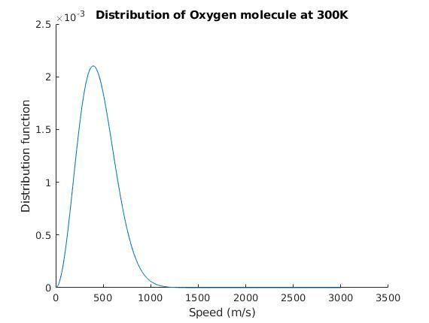

3. Then we plotted the graph of Oxygen molecule at two different temperatures.

4. At last, we plotted the graph of Noble gases at the same temperature.

**Analysis:**

1. **Maxwell-Boltzman Equation is affected by temperature**: When we plotted the graph of Oxygen molecule at different temperature, we found that at lower temperatures, the molecules had less energy. Therefore, the speeds of the molecules were lower and the distribution had a smaller range. As the temperature of the molecules increased, the distribution flattened out.So, the molecules have greater energy at higher temperature and the molecules move faster.

The figure plotted was:

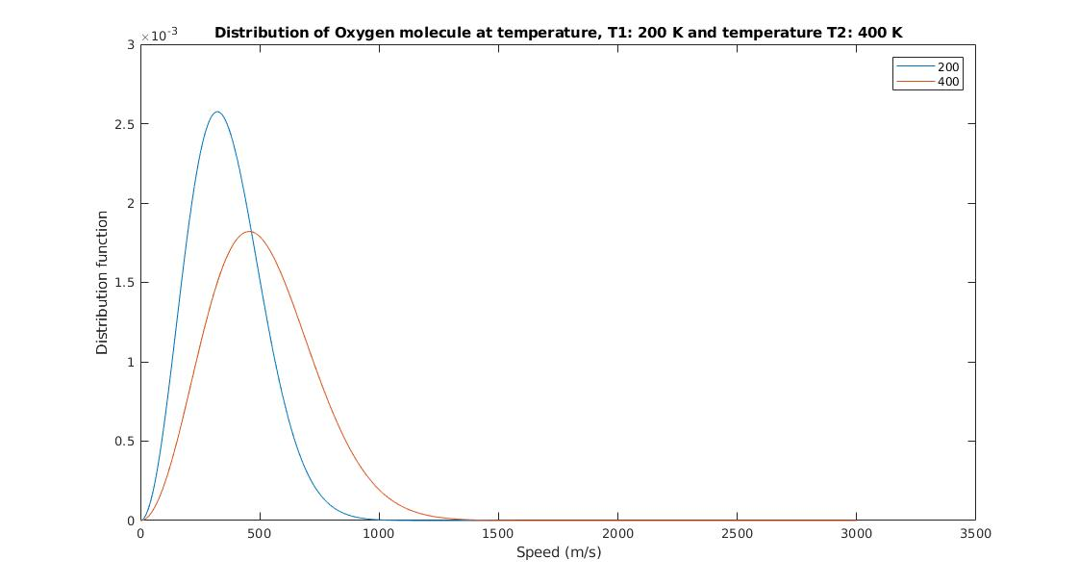

**2. Maxwell-Boltzmann Equation is affected by molecular mass:** When we plotted the graph of different noble gases at the same temperature, we found that heavier molecules moved more slowly than lighter molecules. Therefore, heavier molecules had a smaller speed distribution, while lighter molecules had a speed distribution that is more spread out.

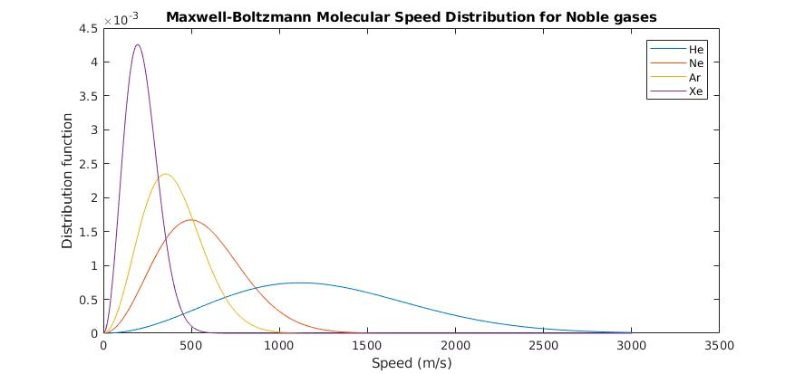

**Source Code:**

clear all, close all;

n = input('Enter the number of random speed you want to enter:');

rndNum = [];

for i = 1:n

num = 1+(3000*rand(1));

rndNum(i) = num;

end

rndNum = sort(rndNum);

mass = 5.312967e-26;

massHe = 6.6455288e-27;­

massXe = 2.1798605e-25;

massAr = 6.6336765e-26;

massNe = 3.3509963e-26;

temp = 300;

k = 1.38065e-23;

const = mass/(2*pi*k*temp);

const = 4*pi*(const)^1.5;

constHe = massHe/(2*pi*k*temp);

constHe = 4*pi*(constHe)^1.5;

constXe = massXe/(2*pi*k*temp);

constXe = 4*pi*(constXe)^1.5;

constAr = massAr/(2*pi*k*temp);

constAr = 4*pi*(constAr)^1.5;

constNe = massNe/(2*pi*k*temp);

constNe = 4*pi*(constNe)^1.5;

final = [];

finalHe = [];

finalXe = [];

finalAr = [];

finalNe = [];

for i = 1:n

expPower = ((-1*mass)/(2*k*temp));

final(i) = const * (rndNum(i) ^ 2) * exp(expPower*(rndNum(i)^2));

expPower = ((-1*massHe)/(2*k*temp));

finalHe(i) = constHe * (rndNum(i) ^ 2) * exp(expPower*(rndNum(i)^2));

expPower = ((-1*massXe)/(2*k*temp));

finalXe(i) = constXe * (rndNum(i) ^ 2) * exp(expPower*(rndNum(i)^2));

expPower = ((-1*massAr)/(2*k*temp));

finalAr(i) = constAr * (rndNum(i) ^ 2) * exp(expPower*(rndNum(i)^2));

expPower = ((-1*massNe)/(2*k*temp));

finalNe(i) = constNe * (rndNum(i) ^ 2) * exp(expPower*(rndNum(i)^2));

end

temp1 = input('Please enter Temperature T1 (in Kelvin):');

temp2= input('Please enter Temperature T2 (in Kelvin):');

const1 = mass/(2*pi*k*temp1);

const1 = 4*pi*(const1)^1.5;

const2 = mass/(2*pi*k*temp2);

const2 = 4*pi*(const2)^1.5;

final2 = [];

final3 = [];

for i = 1:n

expPower = ((-1*mass)/(2*k*temp1));

final2(i) = const1 * (rndNum(i) ^ 2) * exp(expPower*(rndNum(i)^2));

hold on;

expPower = ((-1*mass)/(2*k*temp2));

final3(i) = const2 * (rndNum(i) ^ 2) * exp(expPower*(rndNum(i)^2));

hold on;

end

figure(1);

plot(rndNum, final,'-');

xlabel('Speed (m/s)');

ylabel('Distribution function');

title( sprintf('Distribution of Oxygen molecule at 300K') );

figure(2);

plot(rndNum, final2,'-');

hold on;

plot(rndNum, final3,'-');

xlabel('Speed (m/s)');

ylabel('Distribution function');

title( sprintf('Distribution of Oxygen molecule at temperature, T1: %d and temperature T2: %d', temp1, temp2') );

figure(3);

plot(rndNum, finalHe,'-');

hold on;

plot(rndNum, finalNe,'-');

hold on;

plot(rndNum, finalAr,'-');

hold on;

plot(rndNum, finalXe,'-');

legend('He', 'Ne', 'Ar', 'Xe');

xlabel('Speed (m/s)');

ylabel('Distribution function');

title( sprintf('Maxwell-Boltzmann Molecular Speed Distribution for Noble gases') );

**Conclusion**:

After the plotting different graphs related to Maxwell-Boltzmann equation, we found that the molecules move faster at higher temperature. Also, lighter molecules have higher velocity than heavier molecules.