B. TECH. PROJECT REPORT
on
URBAN FLOOD MODELLING USING BIG HYDROCLIMATIC DATA

by
GARVIT GUPTA



DISCIPLINE OF CIVIL ENGINEERING
INDIAN INSTITUTE OF TECHNOLOGY INDORE
November 2023
URBAN FLOOD MODELLING USING BIG HYDROCLIMATIC DATA

A PROJECT REPORT

Submitted in partial fulfilment of the requirements for the award of the degree
of
BACHELOR OF TECHNOLOGY
in
Civil ENGINEERING

Submitted by:
GARVIT GUPTA

Guided by:
Dr. Priyank J. Sharma
(Assistant Professor, Civil Engineering)

DISCIPLINE OF CIVIL ENGINEERING
INDIAN INSTITUTE OF TECHNOLOGY INDORE
November 2023
CANDIDATE’S DECLARATION

I hereby declare that the project entitled “Urban Flood Modelling using Big Hydroclimatic Data” submitted in partial fulfilment for the award of the degree of Bachelor of Technology in ‘Civil Engineering’ completed under the supervision of Dr. Priyank J. Sharma, Assistant Professor, Civil Engineering IIT Indore is an authentic work.
Further, I declare that I have not submitted this work for the award of any other degree elsewhere.

Signature and name of the student(s) with date

________________________________________________________________
CERTIFICATE by BTP Guide(s)

It is certified that the above statement made by the students is correct to the best of my/our knowledge.

Signature of BTP Guide(s) with dates and their designation

Preface

This is a report on “Urban Flood Modelling using Big Hydroclimatic Data” prepared under the guidance of Dr. Priyank J. Sharma, submitted as a part of the academic requirement for the Bachelor of Technology in Civil Engineering.

This report analyses trends in urban floods with the help of modern-day computer techniques such as big data and machine learning. Urban Floods are a massive problem in developing and developed cities due to cement cover on the ground, and cities get flooded with very little rain.
To the best of my abilities and knowledge, I have explained the content lucidly. I have also added tables and figures to make the report more illustrative.

Garvit Gupta
B.Tech. IV Year
Discipline of Civil Engineering
IIT Indore

Acknowledgments

I thank Dr. Priyank J. Sharma for his kind support and valuable guidance. It is through his help and support that I became able to progress in experimental and technical reports. I would also like to thank Dr. Mayur Jain (DUGC CE) and Dr. Abhishek Rajput (HOD CE) for their constant support. Without their support, this report would not have been possible.

I also thank Ms. Achala Singh and Mr. Harshvardhan Solanki for providing their valuable support during the analysis.

Garvit Gupta

Abstract

Urban floods are a common problem in developed and developing cities as they have high cement cover, leading to flooding in significantly less rainfall. Our study aims to analyse the rainfall data from observed gauge of the previous 50 years (1971-2020) to derive relations between urban floods and rainfall intensities with the help of Big Data techniques. The study is performed for Ahmedabad city by collecting precipitation measurements from the India Meteorological Department (IMD) Data and Tropical Rainfall Monsoon Mission (TRMM), followed by filling, and cleaning data and analysing it with the help of Python, Pandas, NumPy, and Matplotlib. Using IMD data, the Intensity Duration Frequency (IDF) curves for various return periods (2-, 5-, and 10-year) considering a minimum duration of 30 years are derived. The sliding window technique is adopted to derive the hourly maximums from IMD hourly data, which were further used to derive IDF curves. The IDF curves are derived from TRMM data using five approaches and the best TRMM approach is assessed based on the percentage bias to use it as a substitute for filling gaps in IMD data. IMD data analyses progressed to derivation 3-D mesh IDF curves, which can be used to derive further insights into the non-stationarity of IDF Curves. The distribution fitting to the moving window maxima series is carried out to assess the non-stationarity of the parameters. Also, the diurnal changes in the extreme rainfall characteristics are investigated.

Table of Contents

1. Introduction 1
1.1 Background of the study 1
1.2 Objectives of study 1
2. Material and Methods 2
2.1 Data Sources 2
2.2 Study Area 4
2.3 Methods.. 6
2.3.1 Grouping Data and Analysis 6
2.3.2 Sliding Window Technique 6
2.3.3 Intensity-Duration-Frequency 6
2.3.4 Gumbel’s extreme value distribution 7
2.3.5 CWC IMD Approach 7
2.3.6 Inverse distance weighing method 8
2.4 Methodology 8
2.4.1 Deriving IDF Curves 8
2.4.2 Deriving IDF Curves from TRMM Dataset 100
2.4.3 Diurnal Analysis 12
2.4.4 3-D mesh IDF Curve 12
2.5 Literature Review 13
3. Results and Analysis 16
3.1 Maximum Hourly Depths 16
3.2 Deriving IDF Curves (1971-2020) using IMD Data 16
3.3 Time-varying IDF Curves 16
3.4 Sliding and Overlapping Time Windows-based IDF Curves 17
3.5 Percentage Change in Maximum Rainfall Intensity 19
3.6 Diurnal Extreme Rainfall Analysis 20
3.7 Comparative Assessment of IMD- vis-à-vis TRMM-derived IDF curves 21
3.8 Combined 3-D Mesh for the IDF Curves 23
3.9 TRMM versus IMD data: Bias Estimation 24
4. Conclusions and Future Scope 26
4.1 Key Conclusions 26
4.2 Future Scope 26
References 27

List of Figures

Figure 1 Format of IMD self-recording rain gauge (SRRG) data.….…...…………………………….02
Figure 2 Map of Ahmedabad….……………….……………………………………………………...05
Figure 3 Map of Ahmedabad District and Ahmedabad City……….…………………………………05
Figure 4 Sliding Window Technique for estimating hourly maximums…...…………………………06
Figure 5 Plotting the rainfall IDF curve for the initial cumulative intensities obtained…….………...09
Figure 6 Plotting after extrapolating initial intensities…………………….…………………………..09
Figure 7 Location of IMD station with reference to Ahmedabad district and city…….……………...10
Figure 8 TRMM Dataset Approach - 1……………………………….……………………………….11
Figure 9 TRMM Dataset Approach - 2…………………………….………………………………… 11
Figure 10. 3-D mesh IDF curves generated by considering Return Period as third dimension...…….12
Figure 11 Combined Graphs for 30-year Duration for a Return Period of 2 Years…………………..18
Figure 12 Combined Graphs for 30-year Duration for a Return Period of 5 Years…………………..18
Figure 12 Combined Graphs for 30-year Duration for a Return Period of 10 Years..……………..…19
Figure 14 Hourly rainfall distribution derived from IMD dataset……………….....……...…….........21
Figure 15 Diurnal rainfall depth comparison for five-year moving and overlapping time ...………...21
Figure 16 IMD- vis-à-vis TRMM ( Return Period = 2 Years )………….…….………....……….......22
Figure 17 IMD- vis-à-vis TRMM ( Return Period = 5 Years )……….………….……....……….......22
Figure 18 IMD- vis-à-vis TRMM ( Return Period = 10 Years )……….……….................……….....23
Figure 19 Multivariate IDF curve ………………………….……………………………….………...23
Figure 20 Percentage Bias graph for Return Period = 2 Years…………………….………………….24
Figure 21 Percentage Bias graph for Return Period = 5 Years…………………….………………….24
Figure 22 Percentage Bias graph for Return Period = 10 Years………………….…………………...22

List of Tables

Table 1 Evaluation of missing data at Indore station………………………………………………….03
Table 2 Assessment of missing data at Ahmedabad station…………………………………………....04
Table 3 1-,2-,3-,4-,6-,12- and 24- Hourly Maximums for 1971-1975………………………………... 16
Table 4 1-, 2-, 3-, 4-, 6-, 12- and 24- Hourly Intensities for a Return Period of 2, 5, 10 years.………16
Table 5 Rainfall Intensities obtained for 30-year durations for a return period of 2 years……………17
Table 6 Rainfall Intensities obtained for 30-year durations for a return period of 5 years……………17
Table 7 Rainfall Intensities obtained for 30-year durations for a return period of 10 years……………17
Table 8 Percentage change in rainfall intensities w.r.t. baseline (Return Period = 2 Years)……………19
Table 9 Percentage change in rainfall intensities w.r.t. baseline (Return Period = 5 Years)……………20
Table 10 Percentage change in rainfall intensities w.r.t. baseline (Return Period = 10 Years)…………20

Introduction
India has suffered an estimated average loss of USD 54.3 billion due to floods between 1953 and 2016. Urban floods occur in cities and towns due to heavy rainfall, stormwater runoff, or other factors. Unlike rural or natural floods, which primarily affect rural and undeveloped areas, urban floods specifically impact urban environments characterized by buildings, roads, pavements, and other infrastructure. Due to increasing cement cover, urban floods are becoming more frequent.

1.1 Background of the Study
Urban floods are an increasing phenomenon in many parts of India, including major cities like Ahmedabad, Bengaluru, Indore, etc. Rapid urbanization is one of the primary reasons for this, as urbanization leads to more construction and increasing cement cover, preventing rainwater from penetrating and enriching groundwater. Recently, Ahmedabad faced massive floods in July 2023 (https://timesofindia.indiatimes.com/city/ahmedabad/amc-adopts-sponge-city-plan-to-tackle-urban-flooding/articleshow/103944500.cms) and a loss to health and economy. Also, about 1,200 crores are estimated to be loss in the July 2022 Ahmedabad Floods (https://timesofindia.indiatimes.com/city/ahmedabad/flooding-losses-estimated-to-be-1200cr/articleshow/92840687.cms).

This, combined with the increasing population of India, makes it an even more significant challenge for authorities. Poor infrastructure and less maintenance of drainage systems increase the chance of urban floods even with little rainfall. India faces a massive loss of wealth and health due to floods yearly. Due to climate change, India has experienced changes in its rainfall patterns, Leading to extreme weather events. These changes can lead to more intense and frequent rainfall, resulting in urban flooding and inadequate drainage systems.

1.2 Objectives of the Study
The present study aims to accomplish the following objectives:
a) Derive the Intensity-Duration-Frequency (IDF) curves for Ahmedabad city using field-based and satellite-derived fine temporal resolution data.
b) Analyse the diurnal variability of the extreme rainfall intensities.
c) Derive multi-variate IDF curves to quantify non-stationarity in urban flood characteristics.
d) Compare the satellite-derived vis-à-vis gauge-based IDF curves for the Ahmedabad city.

Material and Methods

Data Sources
In this study, two precipitation datasets have been collected to derive IDF curves. The field-based rainfall observations are collected from the self-recording rain gauge (SRRG), established by the India Meteorological Department (IMD), for the Ahmedabad city (Latitude - 23.0225° North and Longitude - 72.5714° East). This data is available at hourly timescale and was collected for the duration 1971-2020. The Tropical Rainfall Measurement Mission (TRMM) data is a satellite-based precipitation dataset which is available at https://disc.gsfc.nasa.gov/datasets/WC_MULTISEN_PREC_025_001/summary. This is a 3-hourly gridded-data available at 0.25° × 0.25° resolution for the period 1971-2019. However, the presented analysis is based on the IMD rainfall data. This data is available in the following format as shown in Figure 1.

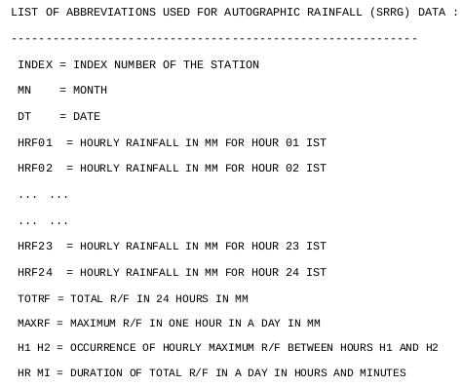

Figure 1 Format of IMD self-recording rain gauge (SRRG) data.

This data contains some missing rows and needs to be continuous. Grouping in Jupyter Notebook is performed on this data for 13 stations to identify the most suitable location for further analysis (Table 1). It is determined by finding the stations with the least percentage of missing fields.

Table 1 Evaluation of missing data at Indore station
YEAR | MN | HRF01 | Issue
1971 | 9 | 29 | 1 entry missing
1974 | 8 | 31 | 1974, 9 missing
1978 | 7 | 31 | 1978, 6 missing
1981 | 7 | 31 | 1981, 8 missing
1986 | 6 | 17 | 13 entries missing
1986 | 7 | 26 | 5 entries missing
1986 | 9 | 29 | 1 entry missing
1989 | 6 | 29 | 1 entry missing
1989 | 7 | 30 | 1 entry missing
1989 | 8 | 30 | 1 entry missing
1990 | 8 | 29 | 2 entries missing
1994 | 1 | 31 | 1991,1992,1993 missing
1998 | 4 | 30 | 1995,1996,1997 missing
1999 | 7 | 31 | 1999 8 missing
2001 | 7 | 31 | 2001 8 missing
2007 | 1 | 31 | 2003,2004,2005,2006 missing
2008 | 8 | 31 | 2008 6,7 missing
2011 | 1 | 31 | 2010 missing

This data contains some missing rows and needs to be continuous. Grouping in Jupyter Notebook is performed on this data for 13 stations to identify the most suitable location for further analysis (Table 1). It is determined by finding the stations with the least number of missing fields.

Ahmedabad is chosen as the study area after the analysis. Further analysis showed that the amount of data missing from Ahmedabad is approximately 3.07%. As the missing data is less than 5%, we can fill the missing values by average and 0 depending on the data missing in the adjacent days (Table 2).

Table 2 Assessment of missing data at Ahmedabad station
Condition | No. | Month Name | No. of Days | Years Considered (1971-2020) | Data Required | Total data | Data Present | Data Missing | Total Missing data | Missing Percentage (%)
Include 2019 | 6 | June | 30 | 50 | 1500 | 6100 | 1465 | 35 | 187 | 3.07
Include 2019 | 7 | July | 31 | 50 | 1550 | 6100 | 1493 | 57 | 187 | 3.07
Include 2019 | 8 | August | 31 | 50 | 1550 | 6100 | 1488 | 62 | 187 | 3.07
Include 2019 | 9 | September | 30 | 50 | 1500 | 6100 | 1467 | 33 | 187 | 3.07
Exclude 2019 | 6 | June | 30 | 49 | 1470 | 5978 | 1465 | 5 | 65 | 1.09
Exclude 2019 | 7 | July | 31 | 49 | 1519 | 5978 | 1493 | 26 | 65 | 1.09
Exclude 2019 | 8 | August | 31 | 49 | 1519 | 5978 | 1488 | 31 | 65 | 1.09
Exclude 2019 | 9 | September | 30 | 49 | 1470 | 5978 | 1467 | 3 | 65 | 1.09

The Tropical Rainfall Measurement Mission (TRMM) is a collaborative effort between National Aeronautics and Space Administration (NASA) and the Japanese Aerospace Exploration Agency (JAXA). The TRMM observatory, which housed the first-ever precipitation radar in space, was launched in 1997 into a near circular orbit of approximately 350 kilometers with a period of 92.5 minutes (15.6 orbits per day). The data product, TRMM Multi-Satellite Precipitation Analysis (TMPA) Rainfall Estimate Product 3B42 Version 7 (V7), combines satellite rainfall (S) and gauge data (G). Initially, the 3B42 algorithm integrates calibrated microwave precipitation estimates from low-earth-orbiting satellites to TRMM products TMI (2A12) and TCI (2B31). This process yields a 3-hourly microwave-only estimate. Infrared precipitation estimates from geosynchronous satellites are then calibrated to the microwave data, filling regional gaps, and producing a combined satellite rainfall estimate every 3 hours. Monthly scaling and recalibration with a gauge analysis result in the final SG-merged precipitation estimate, a Level 3 (L3) 3-hourly 0.25° * 0.25° quasi-global gridded SG-rainfall database, with provided root-mean-square (RMS) precipitation error estimates.

Study Area
Ahmedabad is chosen as the study area for urban flood analysis. Ahmedabad is the largest city of Gujrat and located near the Gulf of Khambhat (refer Figure 2). The exact geographical coordinates of Ahmedabad are approximately, Latitude: 23.0225 degrees North, Longitude: 72.5714 degrees East. Ahmedabad has a rich historical heritage dating back centuries. The geographical areas of Ahmedabad district and city are 8,087 km² and 505 km² respectively.

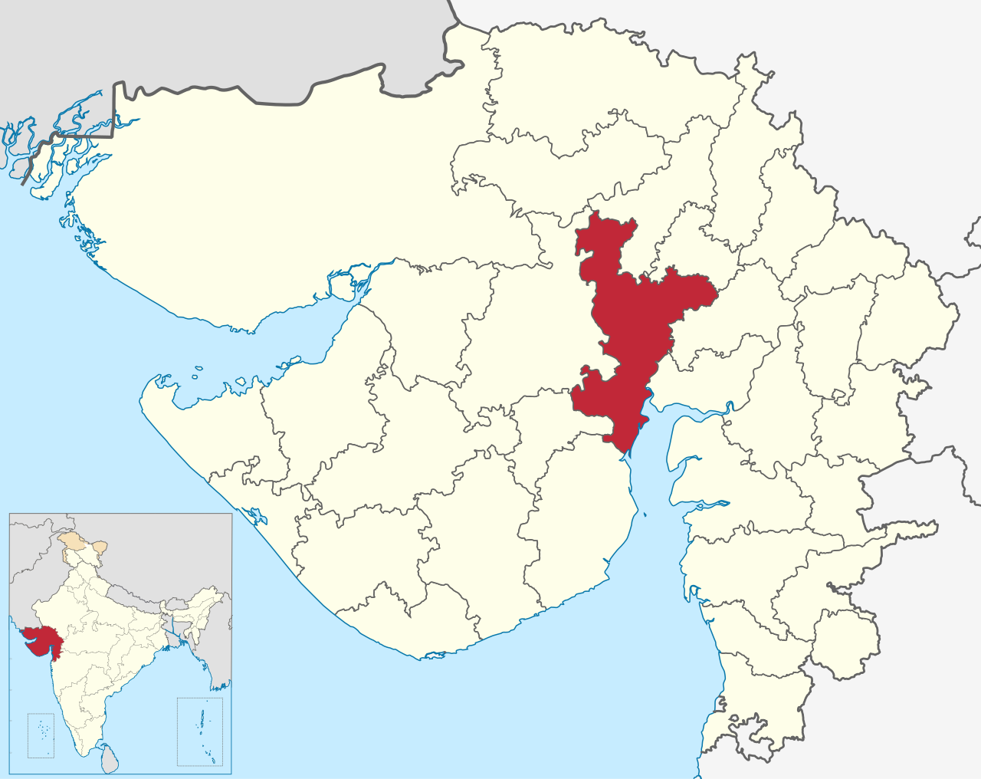

Figure 2 Map of Ahmedabad district

Ahmedabad is an important cultural, industrial, and commercial centre. It faces frequent urban floods with the most recent being July 2023. Also, only monsoon months i.e., June, July, August, and September are used for analysis. Ahmedabad has a long history of textile production, and it played a crucial role in India's textile industry during the 19th and 20th centuries. Ahmedabad is renowned for its unique and diverse cuisine.

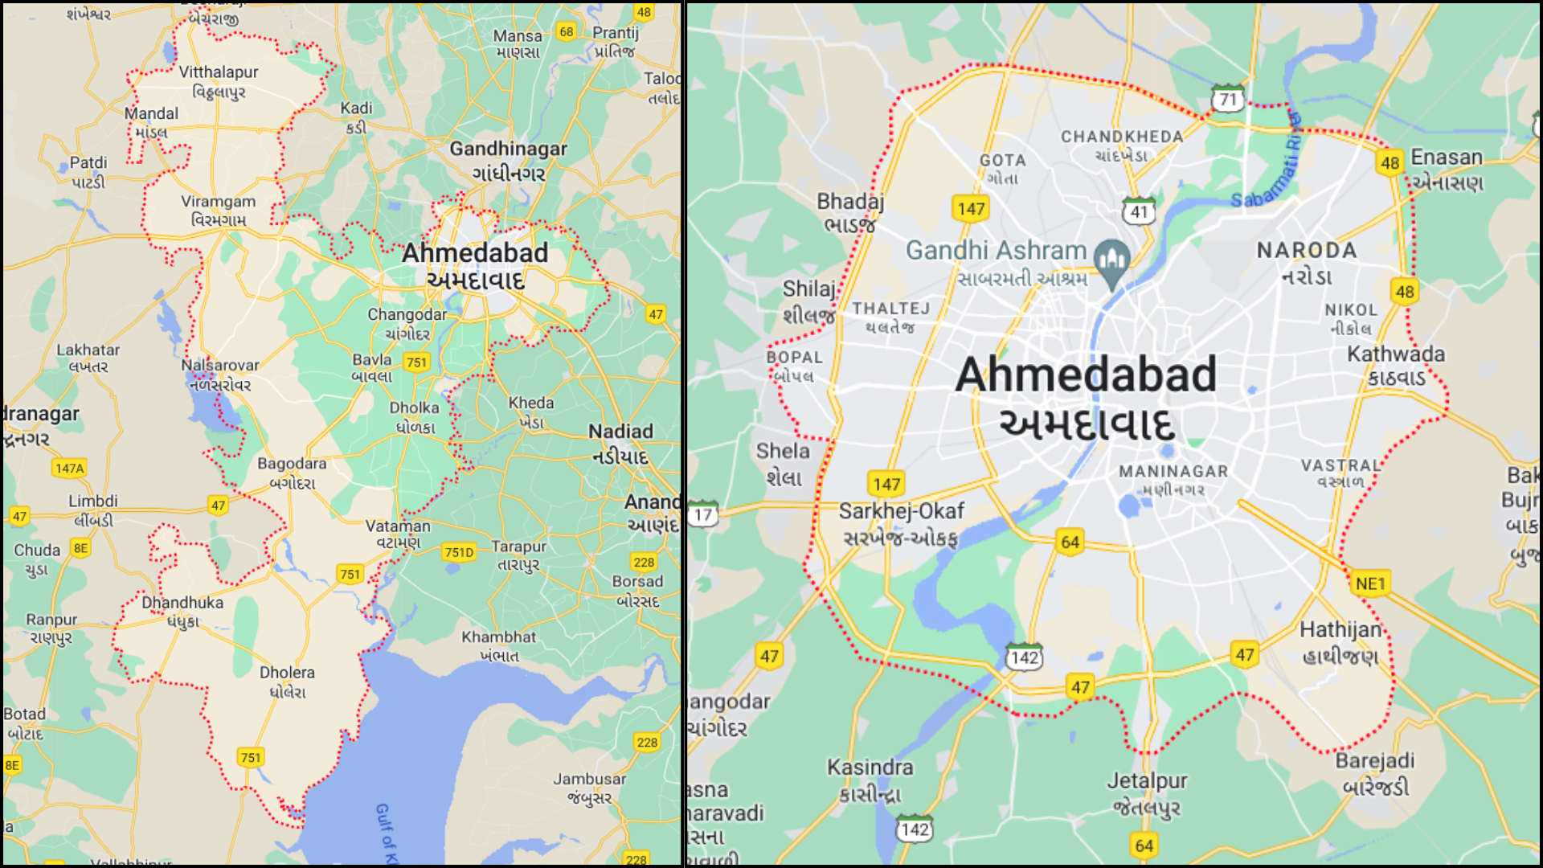
Figure 3 Map of Ahmedabad district and city

For the TRMM approach, Ahmedabad district is used in the first approach and the Ahmedabad city is used in 2, 3, 4 and 5th approach respectively. The map of Ahmedabad District and Ahmedabad City is shown in Figure 3.

Methods

Grouping Data and Analysis
IMD Data is collected for 13 stations and then group by operation is performed after cleaning the data. All the dates from the monsoon months are identified which were missing from the data and a table is formed for all the stations (Table 1). Ahmedabad is identified as the station with the least breakpoints in data and is chosen as the study area for further analysis. Further analysis showed that the amount of data missing from Ahmedabad is approximately 3.07%. As the missing data is less than 5%, we can fill the missing values by average and 0 depending on the data missing in the adjacent days (Table 2).

Sliding Window Technique
The Sliding Window algorithm is a method for finding a subset of elements that satisfy a specific condition in issues. This method maintains a window containing elements from an array or string while advancing the window in a particular direction until the required subset is found. This is used directly on IMD data to identify the hourly maximum depths for 1, 2, 3, 4, 6, 12, and 24 hours, respectively.
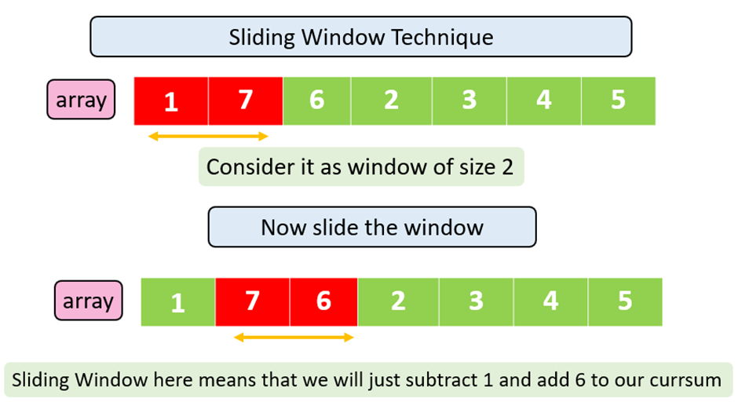
Figure 4 Sliding window technique for estimating hourly maximums.

Intensity-Duration-Frequency (IDF) curve
IDF (Intensity-Duration-Frequency) curves are graphical representations of rainfall. These curves are critical in hydrology as they give insights into rainfall intensity, duration, and frequency simultaneously. There are three components of IDF Curves:
- Intensity (I): The rainfall rate in millimetres per hour (mm/hr) or inches per hour (in/hr).
- Duration (D): The time the rainfall intensity occurs, typically in hours.
- Frequency (F): A rainfall event's return period or recurrence interval. It represents the average number of years between events of a given magnitude.
IDF curves in hydrology are essential tools for analysing flood risks in a specific area. They help estimate the rainfall intensity that could lead to urban floods. They are used in various domains such as:
- Analysing Floods
- Derive flood mitigation plans
- Urban Planning and Design
- Infrastructure Design
- Water Resource Management
- Risk Assessment

Gumbel’s extreme value distribution
The precipitation depth is calculated for a given return period as:
$X_{T}= \overline{X}+ K_{T}s$ (1)
where, $X_{T}=$precipitation depth/intensity for a given return period, $\overline{X}=$mean precipitation depth/intensity, $s=$standard deviation of precipitation depth/intensity, and $K_{T}=$frequency factor for return period $T$
$K_{T}= - \frac{\sqrt{6}}{π} \left\{ 0.5772+ln \left(ln \left(\frac{T}{T-1}\right)\right) \right\}$ (2)

CWC-IMD approach
In this approach, the rainfall depth is first obtained from the flood estimation report of various sub-zones published by CWC. This rainfall depth can be converted to the corresponding rainfall depth for other return periods through various conversion factors in IRC SP-42. These depths so obtained can be converted to their related intensity for the different smaller durations by following the formula given in IRC SP-42:
$i= \frac{F}{T} \left(\frac{ T + 1 }{t+1}\right)$ (3)
where, i = intensity of rainfall within a shorter period of t hours within a storm, F = total rainfall in a storm in cm falling in the duration of the storm of T hours, t = smaller time interval in hours within the storm duration of T hours.

Inverse distance weighing method
This method involves computing weights of the surrounding rain gauges based on their distances from the rain gauge with missing data. These distances are computed by establishing a set of axes running through this rain gauge, its location $(x_{0},y_{0})$ and the location of $i^{th}$ rain guage is $(x_{i},y_{i})$, then the distance $D_{i}$ is given as:
$D_{i}= \sqrt{{( x_{i}- x_{o} )}^{2}+ {( y_{i}- y_{0} )}^{2}}$, i = 1,2,3 …. n (4)
The weight of $i^{th} station is$:
$a_{i}= \frac{{D_{i}}^{-2}}{\sum_{i=1}^{i=n}{{D_{i}}^{-2}}}$ (5)
Missing rainfall $P_{A} can be given as :$
$P_{A}= \sum{P_{i}}*a_{i}$ (6)
In this method for India Meteorological Department station of Ahmedabad, which is in between the grid points for which we can calculate precipitation for TRMM data. Corresponding precipitation at the IMD centre is obtained by using this method and various techniques.

Methodology

2.4.1 Deriving IDF Curves

2.4.1.1 Preparation of annual maximum data series for different durations
The annual maximum in windows for years 1, 2, 3, 4, 6, 12, and 24 years are plotted. Initially, we have a data frame with all dates and hourly rainfall depths. We stack each row one after the other and use the sliding window technique to derive the hourly maximums. For example, to derive 6 hourly maximums for the years 1971-2020, we stack all the 24-hour data frames one after another after the first row. Then we make a sliding window of length of 6 hours, we take the sum of all the elements in the current window and traverse the window over 50 years window. This result denotes the maximum rainfall in a continuous window of 6 hours.

2.4.1.2 Determining the rainfall depths
The frequency factor method is used to determine the rainfall depths. The formula is used to calculate all the depths based on a return period. The return period is chosen and then we can find the frequency factor $K_{T}$. With the help of the frequency factor and the mean and the standard deviation of depths, we calculate the depth for an hour.

2.4.1.3 Deriving intensity from rainfall depths
The rainfall intensity is derived by dividing the cumulative depths derived from the frequency factors method with the respective hours for which it was calculated. The intensities thus derived from this method can be used to plot primarily IDF curves, as shown in Figure 5. However, for a detailed analysis of floods, shorter durations are also required. Hence, we need to extrapolate the data and plot other figures.

2.4.1.4 Extrapolating the data for shorter durations
After extrapolating the data obtained in the previous step by the CWC IMD Approach, we can generate rainfall intensities for a 5-minute duration gap and from 5 minutes to 1 hour. We plot it on the graph as shown in Figure 6. All the results are plotted with the help of MatplotLib.
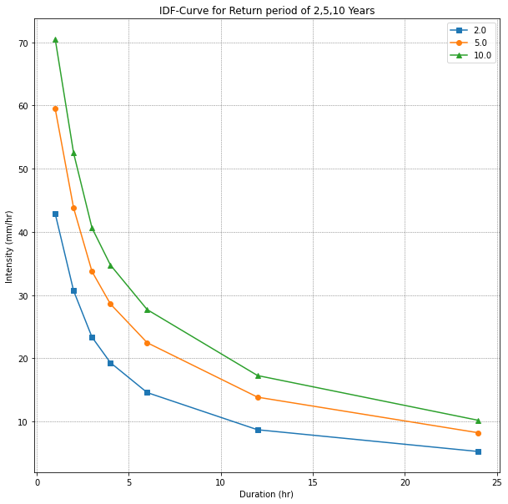
Figure 5 Plotting the rainfall IDF curve for the initial cumulative intensities obtained

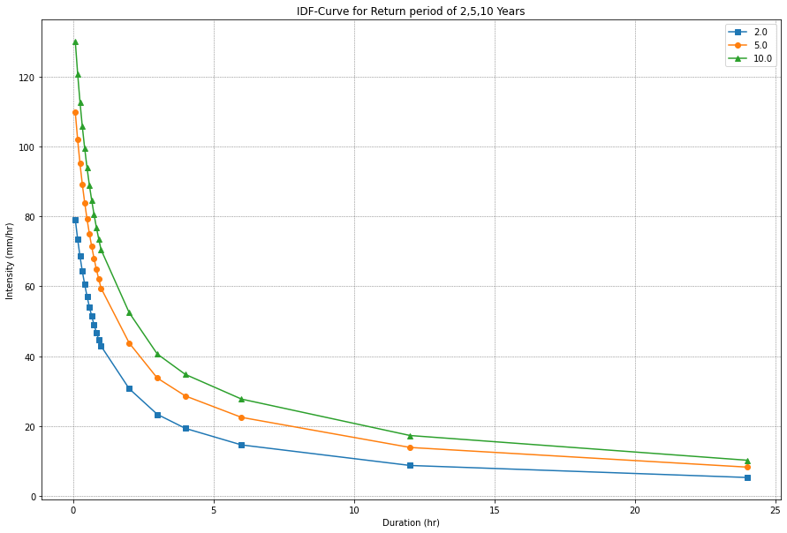
Figure 6 Plotting data after extrapolating initial intensities

2.4.2 Deriving IDF curves from TRMM dataset
For all the approaches used to derive IDF curves from TRMM dataset, the approach used for IDF curves is the same as discussed in Section - 2.4.1. The difference arises in calculating the precipitation at the India Meteorological Department station located in the middle of the Ahmedabad City (Refer Figure 7).
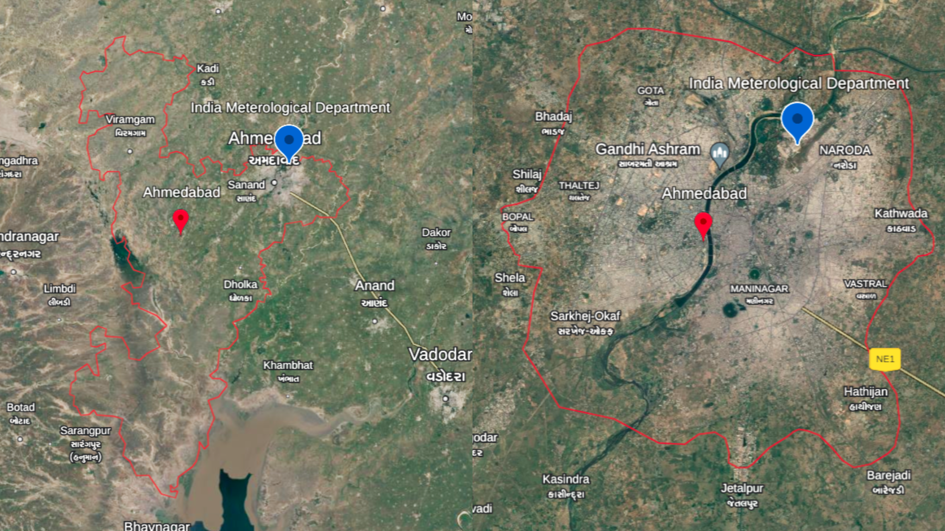
Figure 7 Location of IMD station with reference to Ahmedabad district and city.

2.4.2.1 TRMM Approach - 1
In the first approach, we mapped the overall Ahmedabad district and took the average precipitation of all the points for which the following conditions are met:
- The TRMM data for the corresponding latitude and Longitude is available
- Lies between the approximate extreme latitude in range [22.125 N,23.375 N] and longitude in range [71.875 E,72.625 E] of Ahmedabad district. (Refer Figure 8)

2.4.2.2 TRMM Approach-2
In this approach, we try to get the corners of the Ahmedabad City and try to use the Inverse Distance Method to get precipitation at the IMD Station. Due to lack of precipitation data available for all the latitude and longitude, we use the nearest available coordinates. However, this approach is not effective due to very less availability of TRMM Grids.

2.4.2.3 TRMM Approach-3
In this approach, we take all the points which are surrounding the Ahmedabad district and use Inverse Distance Method to identify the precipitation at the IMD Station (Refer Figure 9).

2.4.2.4 TRMM Approach - 4
To give more correction to Approach 3, we only take the grid points surrounding the IMD station, which is Corner 3, 4, 5, and 6 (Refer to Figure 9). We again use the Inverse Distance Method and draw the IDF curve.
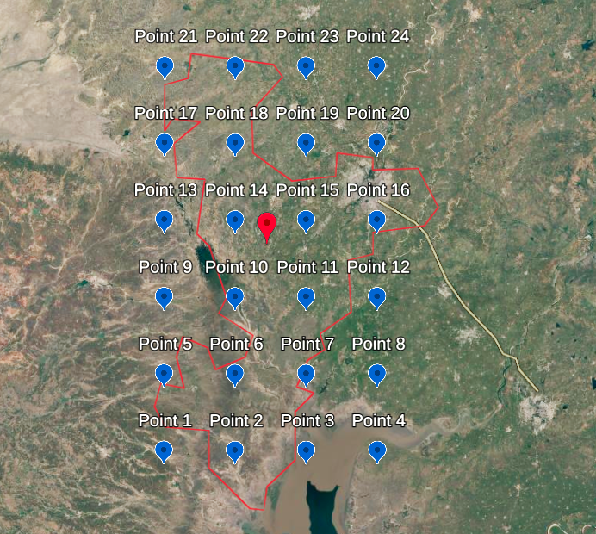
Figure 8 Schematic of TRMM Approach–1

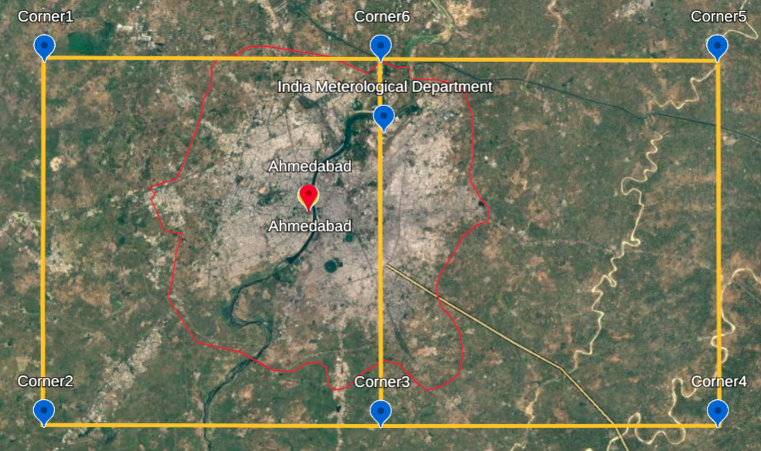
Figure 9 Schematic of TRMM Approach – 2

2.4.2.5 TRMM Approach - 5
As we can observe in Figure 9, the IMD station is very near to Corner 6 (approx. 5.3 kms), so we assume that precipitation at IMD station is equal to precipitation at Corner 6 without any correction. This approach among all the approaches gives the closest IDF curve to that obtained by IMD dataset. The comparison for all the approaches are discussed in the results section.

2.4.3 Diurnal analysis
In this analysis, we calculated the hourly sum of all the values available IMD Dataset values, to get a complete view of how the precipitation rate varies during the day. It is necessary as authorities have a different response rate and measures during day compared to night which might affect the rate of urban floods.

2.4.4 3-D mesh IDF curve
The IDF curves are obtained for 30 years duration and a gap of one year and plotted to identify the non-stationarity of the IDF curves. All the IDF curves obtained are placed adjacently and a 3-D graph is formed. This graph, when joined together to form a mesh, gives us the time variation of Intensity-Duration-Frequency, and can be used to identify non-stationarity of precipitation.
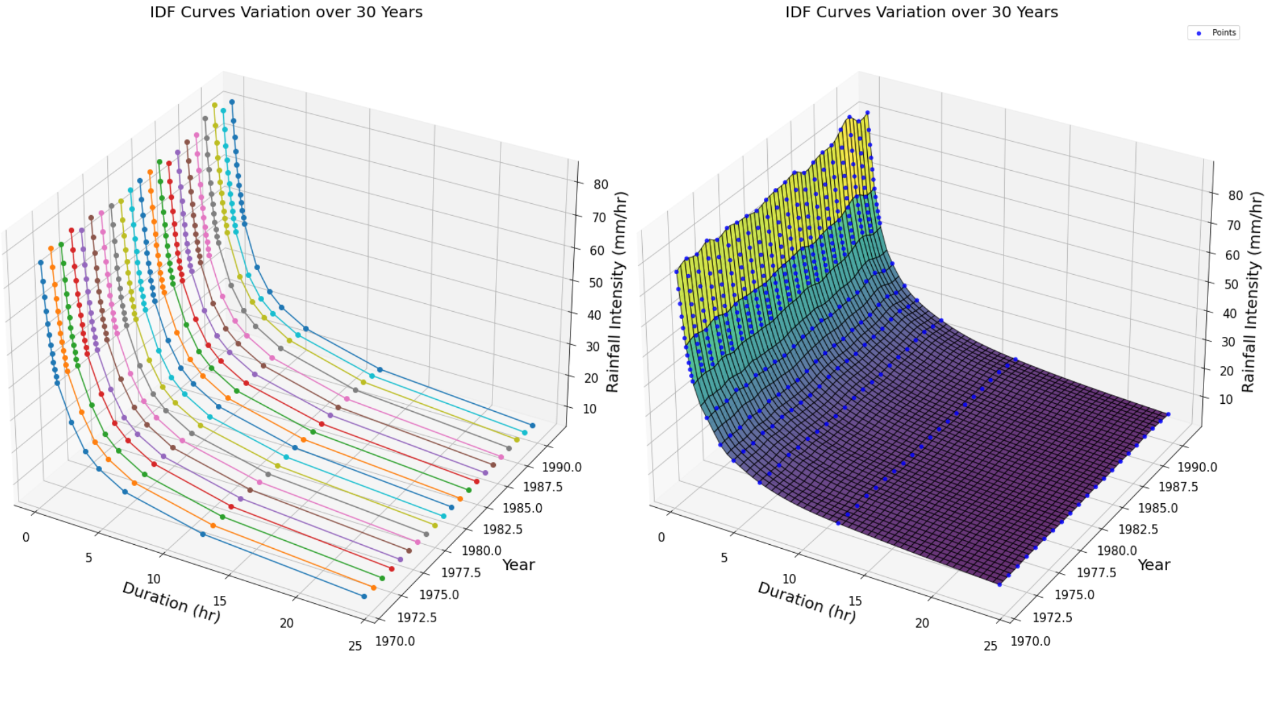
Figure 10 3-D mesh IDF curves generated by considering Return Period as third dimension

Literature Review
Cheng et al. (2014) exposes the limitations of current infrastructure design based on stationary precipitation Intensity-Duration-Frequency (IDF) curves in the face of increasing extreme climatic events due to climate change. It reveals potential underestimation of precipitation extremes by up to 60%, proposing a Bayesian inference-based framework for nonstationary IDF curve estimation to enhance infrastructure preparedness for evolving climate challenges.

Rafiq et al. (2016) reviewed urban flood events in India. He stated that urbanization in developing countries doubled from less than 25% in 1970 to more than 50% in 2006. By 2020, seven of the world’s ten largest economies will be from Asia. At the same time, Asia in one of the fastest urbanization regions in the world. In 2000, 37% of its population lived in cities and the proportion is projected to reach more than 50% by 2025. This is in correlation with the increasing trends of Urban floods in India.

Bose et al. (2016) had studied the changing regime of temperature and rainfall patterns for Ahmedabad to understand the implications on stormwater management. The analysis suggested increased rainfall intensity for the data period from 1901 to 2003. Also, there had been a substantial change in the coefficient of runoff due to changing urban land cover estimated as per the Normalised Difference Vegetation Index.

Hu et al. (2016) said that climate change intensifies extreme precipitation, impacting drainage systems and flooding. He introduced a machine learning-based temporal downscaling method to project short-duration precipitation intensity, enhancing IDF curve computations. He trained this model on US data from thousands of stations and predicted future IDF curve projections.

Silva et al. (2016) the inadequacies of stationary assumptions in Intensity-Duration-Frequency (IDF) curves for infrastructure design in the face of changing climate extremes. It introduces a Bayesian-inference-based framework for non-stationary IDF curve estimation, emphasizing the limitations of existing methodologies. The work contributes by evaluating the publicly accessible IDF_CC tool and proposes a revised equidistant quantile matching (EQM) method to incorporate non-stationarity into future IDF generation, specifically in the context of Canada's severe precipitation events.

Quarda et al. (2018) addresses non-stationarity in rainfall intensity-duration-frequency (IDF) curves for water resources infrastructure design. Unlike existing approaches focused on specific durations, the proposed methodology develops a single model with parameters dependent on time and climate oscillations, offering simplicity and increased effective sample size. The method is applied to case studies in Ontario, Canada, and California, USA, demonstrating superior performance over stationary counterparts, particularly for short rainfall records, enhancing the robustness of IDF modeling in non-stationary conditions.

Padulano et al. (2021) said urban flooding is a significant climate change-related risk, but literature lacks focus on rainfall's role in flood models. He uses multiple climate projections to assess flood hazards in Naples (city of Italy) under different scenarios. Flood impacts increase linearly with rainfall but slower, emphasizing climate change effects. His results can guide urban planning and adaptation strategies.

Schlef et al. (2021) underscores the imperative to revise IDF curve estimation methodologies in the face of global climate change, addressing non-stationarity challenges on a global and regional scale. He succinctly covers known and projected changes in extreme precipitation, methods for non-stationary IDF estimation, and highlights areas for research.

Badou et al. (2023) discusses the impacts of climate change on the coastal city of Cotonou in Benin, particularly through recurrent floods, and the need to assess return periods and hydroclimatic parameters to improve stormwater drainage systems. The authors suggest statistical analysis of extreme events and regular updates in response to climate change.

Zheng et al. (2023) present a data-driven and real-time monitoring approach to predicting urban flooding, which is becoming increasingly common due to global climate change and urbanization. The proposed method uses machine learning algorithms to deduce the urban global real-time water level from a small number of monitoring points, providing a foundation for effective urban flood emergency management.

Ndulue et al. (2023) used machine learning models such as (Linear Regression (LR), Random Forest (RF) and Decision Tree (DT)) to predict floods. The average recall obtained for LR is 99.146%, the average accuracy of flood detection is 91.87% and the average ROC result which is the probability of correct flood detection is 83.23%.

Subah et al. (2023) researched urban floods in Dhaka and found that urban floods plague Dhaka, Bangladesh, due to encroachment of natural drainage channels and poor management. He estimated Intensity–Duration–Frequency (IDF) curves for various rainfall return intervals. Land use changed from 2004 to 2020 showed significant reductions in the Baunia Khal area. Runoff coefficient: 0.76; average runoff: 103.41 $m^{3}$/hr.

Papacharalampous et al. (2023) introduced 11 new ensemble learners to enhance the accuracy of satellite precipitation products by combining six machine learning regression algorithms. The ensemble learners, particularly a sophisticated stacking method using linear regression, significantly outperform individual base learners. The comparison is conducted on PERSIANN and IMERG datasets spanning 15 years across the contiguous United States, showcasing the potential of ensemble techniques for improved satellite precipitation predictions.

Results and Analysis

Maximum Hourly Depths
The maximum hourly depths are generated annually for Ahmedabad Station. This maximum depth is generated for 1-, 2-, 3-, 4-, 6-, 12- and 24-hourly windows respectively. These hourly maximums are then used to compute the IDF Curves. The generated data is shown in Table 3.

Deriving IDF Curves (1971-2020) using IMD Data
The IDF Curves drawn show a relationship between the Intensity-Duration-Frequency curves. We have derived the IDF Curve for the window of 50 years, 1971-2020, for a return period of 2, 5, and 10 years. The data is shown in Table 4 and the plotted results are shown in Figure 5.

Table 3 1-, 2-, 3-, 4-, 6-, 12- and 24-hourly maximums depths for 1971-1975 (in mm)
Year | 1-Hourly-Max | 2-Hourly-Max | 3-Hourly-Max | 4-Hourly-Max | 6-Hourly-Max | 12-Hourly-Max | 24-Hourly-Max
1971 | 27.5 | 37.0 | 46.0 | 53.5 | 60.2 | 67.3 | 80.5
1972 | 48.8 | 48.8 | 48.8 | 48.8 | 48.8 | 48.8 | 48.8
1973 | 28.3 | 40.5 | 48.5 | 65.0 | 72.3 | 99.1 | 131.2
1974 | 84.0 | 124.0 | 128.0 | 128.0 | 128.3 | 128.3 | 128.3
1975 | 64.0 | 71.8 | 80.6 | 97.8 | 139.1 | 172.9 | 202.6

Table 4 1-, 2-, 3-, 4-, 6-, 12- and 24-hourly intensities for a return period of 2, 5 and 10 years (mm/hr)
Return Period | Maximum rainfall intensity (mm/hr) for given time duration in hours
Return Period | 1 | 2 | 3 | 4 | 6 | 12 | 24
2 | 42.8 | 30.6 | 23.3 | 19.3 | 14.5 | 8.6 | 5.2
5 | 59.4 | 43.7 | 33.7 | 28.5 | 22.4 | 13.8 | 8.2
10 | 70.4 | 52.4 | 40.6 | 34.7 | 27.6 | 17.2 | 10.1

Time-varying IDF Curves
The IDF Curves are drawn to show a relationship between the Intensity-Duration-Frequency curves. We have derived the IDF Curve for the window of 50 years, 1971-2020, for a return. For a 2-year, 5-year and 10-year return period, the data is shown in Tables 5, 6, and 7, respectively and results are plotted.

Table 5 Rainfall Intensities obtained for 30-year durations for a return period of 2 years
Starting year | Ending year | Rainfall Intensities in (mm/hr) for the given time range
Starting year | Ending year | 1-hourly | 2-hourly | 3-hourly | 4-hourly | 6-hourly | 12-hourly | 24-hourly
1971 | 2000 | 41.4 | 30.4 | 22.6 | 18.6 | 13.8 | 8.4 | 5.2
1976 | 2005 | 42.4 | 31.2 | 23.6 | 19.5 | 14.6 | 8.9 | 5.5
1981 | 2010 | 42.6 | 31.1 | 23.8 | 19.7 | 14.9 | 9.1 | 5.5
1986 | 2015 | 43.0 | 31.0 | 24.2 | 20.3 | 15.7 | 9.5 | 5.7
1991 | 2020 | 44.1 | 31.0 | 24.3 | 20.3 | 15.6 | 9.3 | 5.5

Table 6 Rainfall Intensities obtained for 30-year durations for a return period of 5 years
Starting year | Ending year | Rainfall Intensities in (mm/hr) for the given time range
Starting year | Ending year | 1-hourly | 2-hourly | 3-hourly | 4-hourly | 6-hourly | 12-hourly | 24-hourly
1971 | 2000 | 57.5 | 44.2 | 33.4 | 28.1 | 21.5 | 13.5 | 8.2
1976 | 2005 | 59.4 | 45.1 | 34.8 | 29.8 | 23.3 | 14.8 | 8.8
1981 | 2010 | 59.8 | 45.4 | 35.4 | 30.3 | 23.9 | 15.0 | 8.8
1986 | 2015 | 59.6 | 44.9 | 35.7 | 31.0 | 24.9 | 15.5 | 9.1
1991 | 2020 | 61.0 | 44.8 | 35.8 | 30.9 | 24.6 | 14.9 | 8.6

Table 7 Rainfall Intensities obtained for 30-year durations for a return period of 10 years
Starting year | Ending year | Rainfall Intensities in (mm/hr) for the given time range
Starting year | Ending year | 1-hourly | 2-hourly | 3-hourly | 4-hourly | 6-hourly | 12-hourly | 24-hourly
1971 | 2000 | 68.2 | 53.3 | 40.6 | 34.4 | 26.5 | 16.9 | 10.3
1976 | 2005 | 70.7 | 54.3 | 42.3 | 36.6 | 29.1 | 18.7 | 11.1
1981 | 2010 | 71.2 | 54.8 | 43.1 | 37.4 | 29.9 | 19.0 | 11.0
1986 | 2015 | 70.5 | 54.1 | 43.4 | 38.1 | 31.1 | 19.6 | 11.3
1991 | 2020 | 72.3 | 54.0 | 43.4 | 37.9 | 30.6 | 18.7 | 10.7

Sliding and Overlapping Time Windows-based IDF Curves
The IDF curves are drawn to show a relationship between the Intensity-Duration-Frequency curves. The combined results are also plotted as shown in Figures 11, 12, and 13, respectively. The IDF curves are drawn to show a relationship between the Intensity-Duration-Frequency curves. We have derived the IDF curve for the window of 50 years, 1971-2020, for a return period of 2, 5, and 10 years. Similarly, IDF curves are drawn for the window of 30 years for 1971-2000, 1975-2005, 1980-2010, 1985-2015, and 1990-2020 for the return period of 2, 5, and 10 years respectively. These curves give us a brief idea of how the rainfall is spread across the region with intensity.

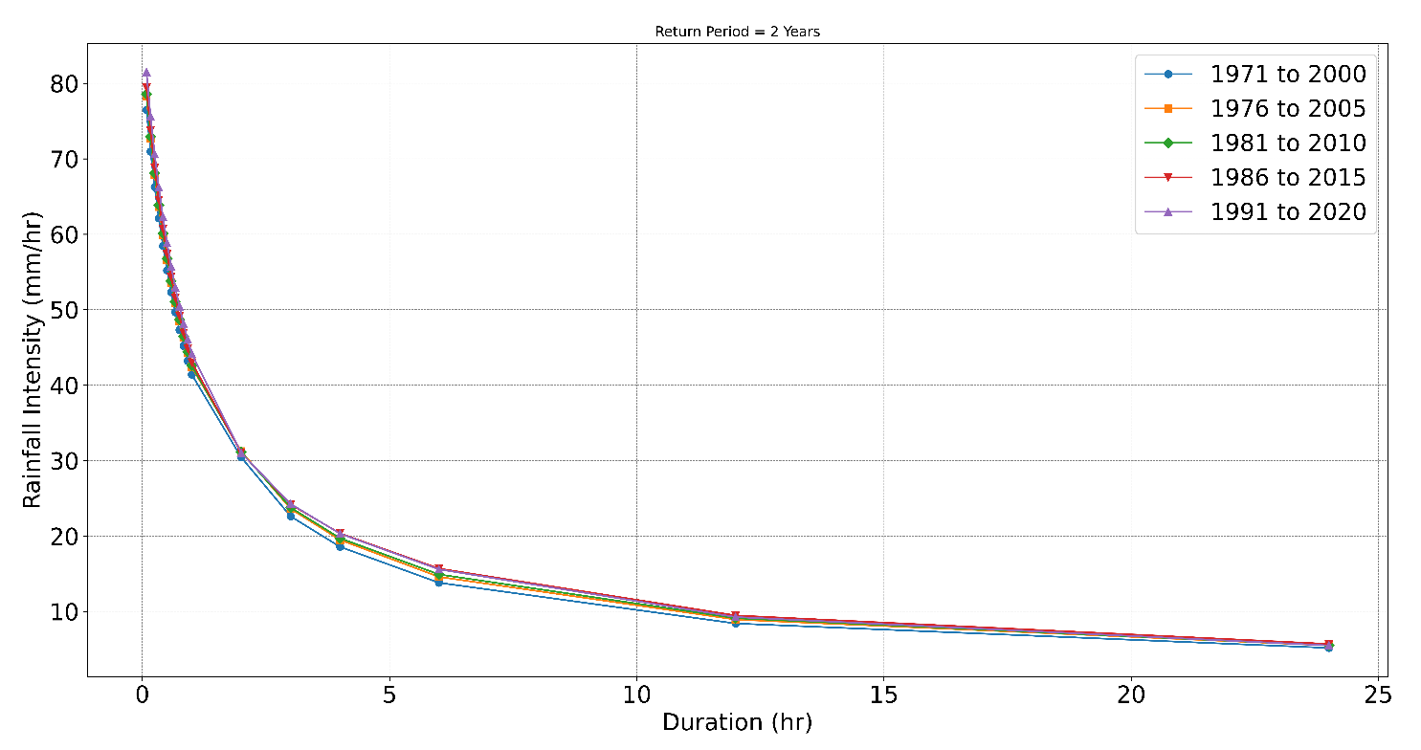
Figure 11 IDF curves for five-year sliding and overlapping time windows of 30 years for a return period of 2 years

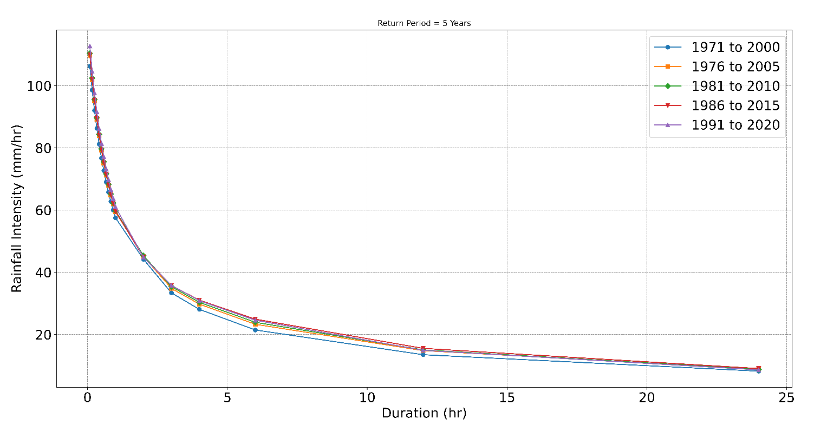
Figure 12 IDF curves for five-year sliding and overlapping time windows of 30 years for a return period of 5 years
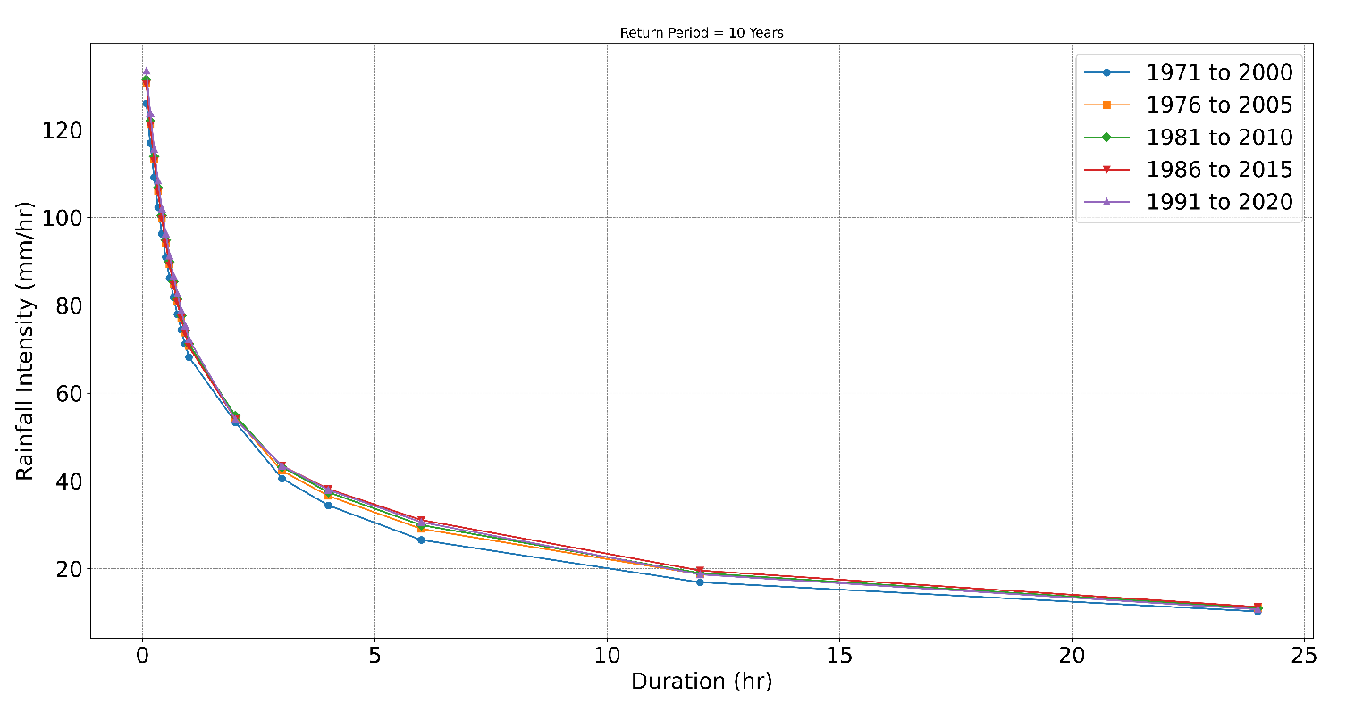
Figure 13 IDF curves for five-year sliding and overlapping time windows of 30 years for a return period of 10 years

Percentage Change in Maximum Rainfall Intensity
The Percentage change in rainfall with respect to 1971-2000 duration rainfall is shown in the Tables 8, 9, and 10 for return periods of 2, 5, and 10 years respectively.

Table 8 Percentage change in rainfall intensities w.r.t. baseline (Return Period = 2 Years)
Time (hours) | Baseline (BL, 1971-2000) rainfall intensity (mm/hr) | % change in rainfall intensity for 1976-2005 w.r.t. BL | % change in rainfall intensity for 1980-2010 w.r.t. BL | % change in rainfall intensity for 1985-2015 w.r.t. BL | % change in rainfall intensity for 1990-2020 w.r.t. BL
0.5 | 55.2 | 2.4 | 2.7 | 3.8 | 6.5
1 | 41.4 | 2.4 | 2.7 | 3.8 | 6.5
2 | 30.4 | 2.6 | 2.2 | 2.0 | 1.9
3 | 22.6 | 4.4 | 5.1 | 6.9 | 7.3
4 | 18.5 | 4.9 | 6.1 | 9.6 | 9.3
6 | 13.8 | 5.6 | 8.0 | 13.6 | 12.8
12 | 8.4 | 6.2 | 8.3 | 12.6 | 10.1
24 | 5.1 | 6.3 | 6.5 | 10.0 | 6.2

Table 9 Percentage change in rainfall intensities w.r.t. baseline (Return Period = 5 Years)
Time (hours) | Baseline (BL, 1971-2000) rainfall intensity (mm/hr) | % change in rainfall intensity for 1976-2005 w.r.t. BL | % change in rainfall intensity for 1980-2010 w.r.t. BL | % change in rainfall intensity for 1985-2015 w.r.t. BL | % change in rainfall intensity for 1990-2020 w.r.t. BL
0.5 | 76.7 | 3.3 | 3.8 | 3.5 | 6.1
1 | 57.5 | 3.3 | 3.8 | 3.5 | 6.1
2 | 44.1 | 2.0 | 2.6 | 1.5 | 1.3
3 | 33.3 | 4.3 | 6.0 | 7.0 | 7.1
4 | 28.0 | 5.9 | 8.0 | 10.5 | 10.0
6 | 21.4 | 8.5 | 11.5 | 16.2 | 14.6
12 | 13.5 | 9.7 | 11.4 | 15.0 | 10.4
24 | 8.2 | 7.4 | 6.8 | 10.1 | 5.0

Table 10 Percentage change in rainfall intensities w.r.t. baseline (Return Period = 10 Years)
Time (hours) | Baseline (BL, 1971-2000) rainfall intensity (mm/hr) | % change in rainfall intensity for 1976-2005 w.r.t. BL | % change in rainfall intensity for 1980-2010 w.r.t. BL | % change in rainfall intensity for 1985-2015 w.r.t. BL | % change in rainfall intensity for 1990-2020 w.r.t. BL
0.5 | 90.9 | 3.6 | 4.3 | 3.4 | 5.9
1 | 68.2 | 3.6 | 4.3 | 3.4 | 5.9
2 | 53.3 | 1.8 | 2.7 | 1.3 | 1.1
3 | 40.5 | 4.3 | 6.3 | 7.0 | 7.1
4 | 34.4 | 6.3 | 8.7 | 10.8 | 10.3
6 | 26.5 | 9.4 | 12.7 | 17.1 | 15.2
12 | 16.8 | 10.9 | 12.3 | 15.8 | 10.5
24 | 10.2 | 7.8 | 6.8 | 10.0 | 4.6

Diurnal Extreme Rainfall Analysis
The Diurnal analysis shows the hour-wise distribution of rainfall over the day. The distribution obtained is plotted as a line chart shown in Figure 14. Now we assume that the daytime is between 07:00 A.M. IST to 07:00 P.M. IST. For a duration of 5 years, we obtain total day and night rainfall and compare them in the form of a bar graph, as shown in Figure 15.

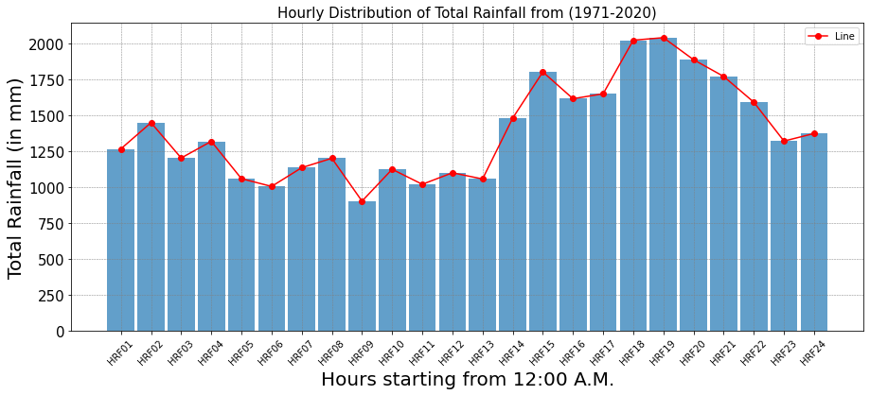Figure 14 Hourly rainfall distribution derived from IMD dataset

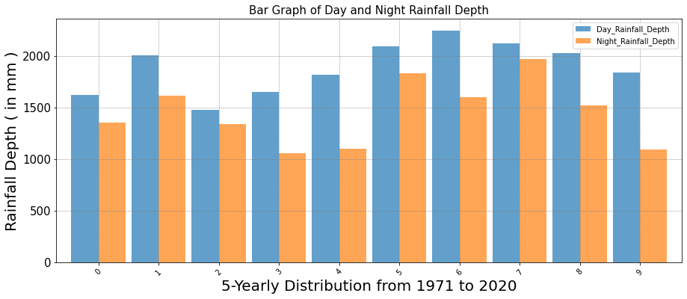Figure 15 Diurnal rainfall depth comparison considering five-year moving and overlapping time windows of 30 years.

Comparative Assessment of IMD- vis-à-vis TRMM-derived IDF curves
All the approaches to obtain IDF Curves from TRMM dataset discussed previously are plotted on the same plot as the IMD IDF curves for Return Period 2, 5, and 10 years respectively to obtain the IDF curves. The IDF curves are shown in Figure 16, 17, 18 for return period 2, 5, and 10 years respectively.
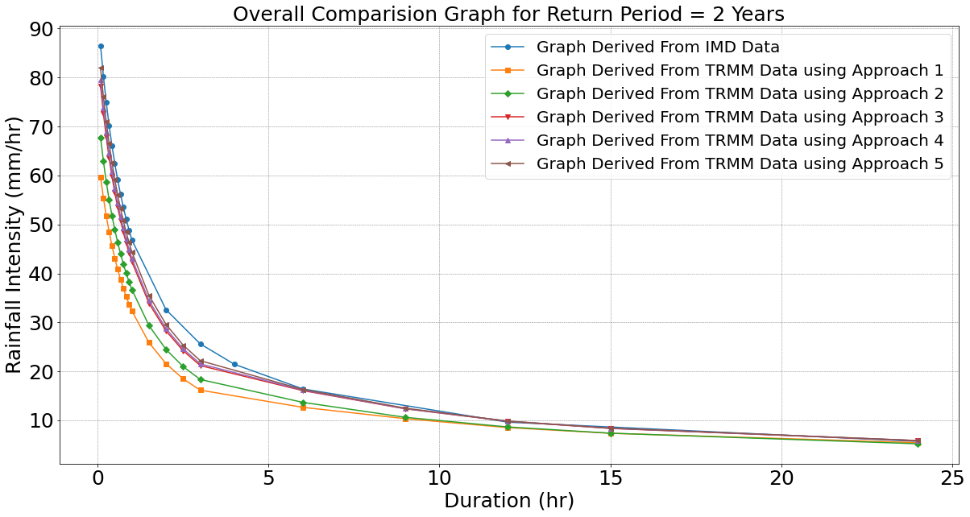
Figure 16 IMD- vis-à-vis TRMM-derived IDF curves for return period of 2 years

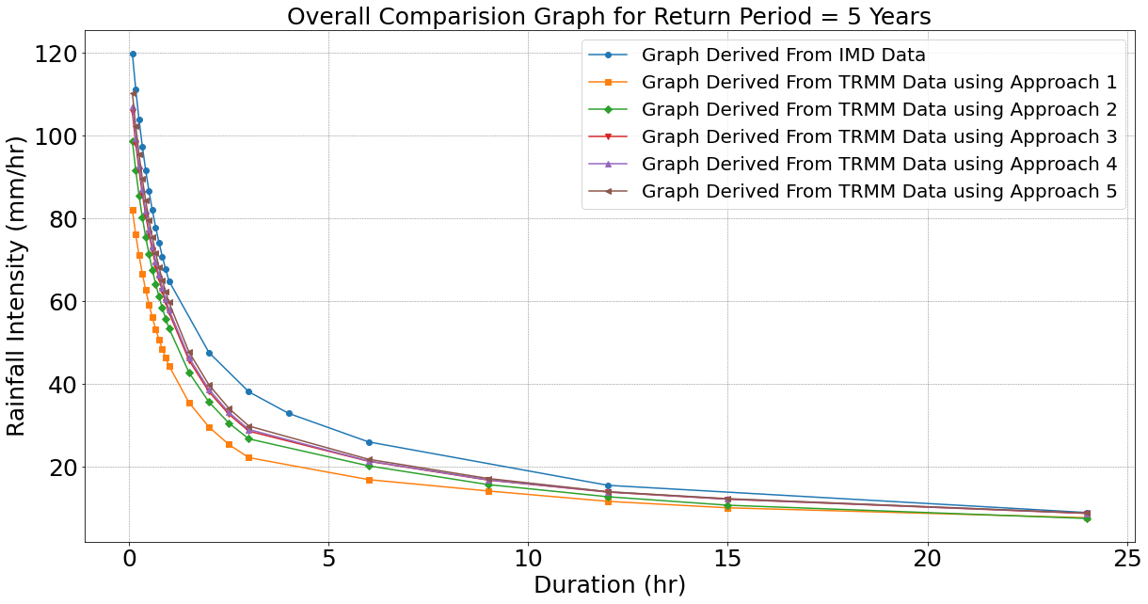
Figure 17 IMD- vis-à-vis TRMM-derived IDF curves for return period of 5 years

The figures 16, 17, and 18 clearly demonstrates that the order for best approximation by TRMM approaches are,
Approach 1 < Approach 2 < Approach 3 < Approach 4 < Approach 5
With approach 5 giving the best approximation and 1 giving the worst. This aligns with the fact that we used the whole Ahmedabad district to approximate in approach 1 and then narrowed it down closer to the IMD station in the subsequent approaches.

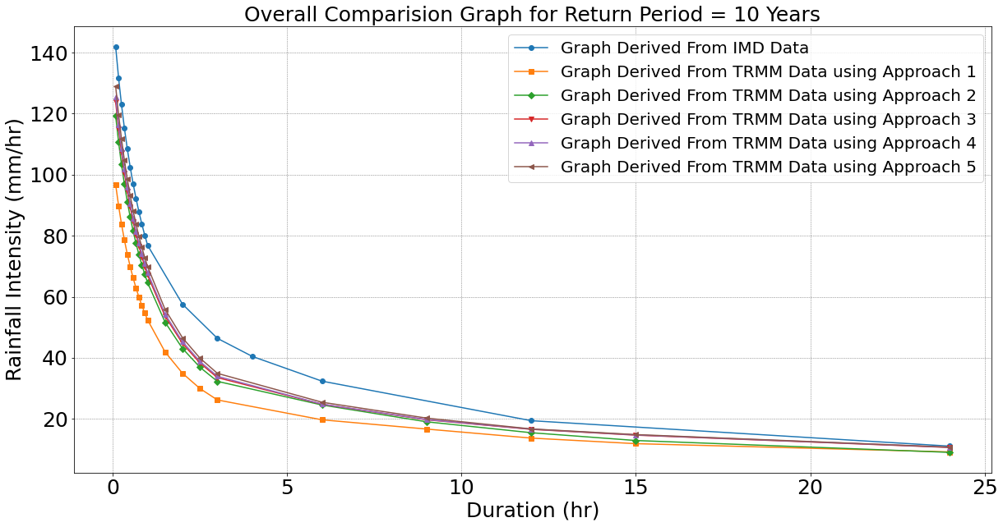
Figure 18 IMD- vis-à-vis TRMM-derived IDF curves for return period of 10 years

Combined 3-D Mesh for the IDF Curves
The 3-D Mesh generated was plotted for return periods 2, 5, and 10 years to get a comparison between the 3 graphs. The results are shown in Figure 19.

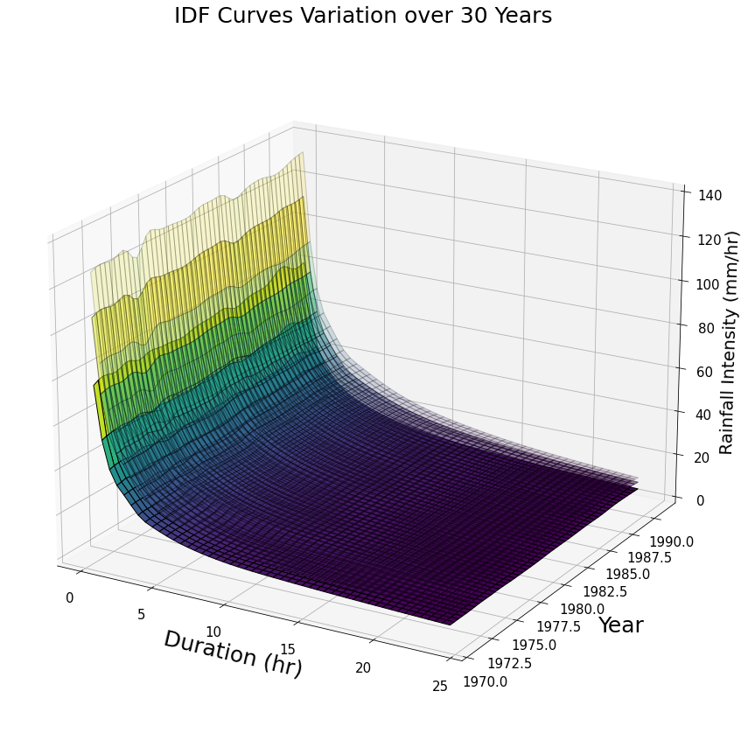
T = 2 years
T = 5 years
T = 10 years
Figure 19 Multivariate IDF curve (from IMD data) considering five-year moving and overlapping time windows of 30 years duration for return periods of 2, 5, and 10 years.

TRMM versus IMD data: Bias Estimation
The percentage bias gives us an idea of how much the TRMM data is related with TRMM data and the correction which needs to be applied to correct the TRMM data after which it can be used to substitute IMD data. The percentage bias is calculated by:
$\% Bias= \frac{i_{IMD}- i_{TRMM}}{i_{IMD}}*100$ (7)
$$i_{IMD}=rainfall intensity (mm/hr) observed by IMD Rain Guage$$
$$i_{TRMM}=rainfall intensity (mm/hr) observed by TRMM dataset$$
The percentage bias in rainfall intensity for various return periods are shown in Figures 20-22.
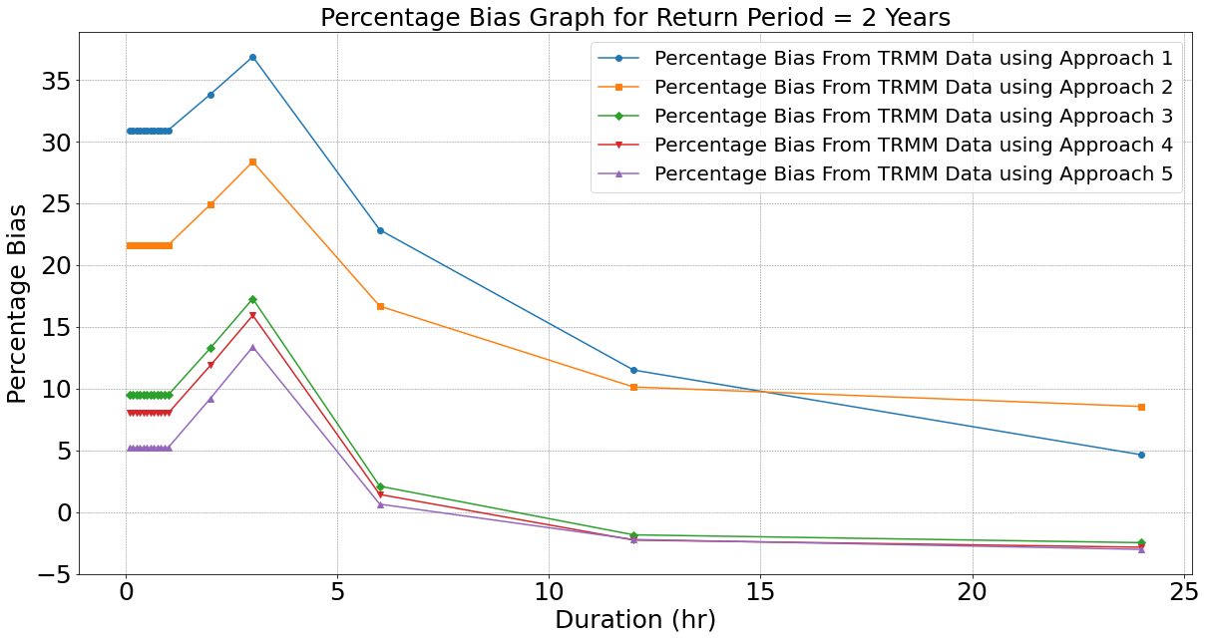
Figure 20 Percentage bias in IMD versus TRMM rainfall intensities for various time durations for a return period of 2 years
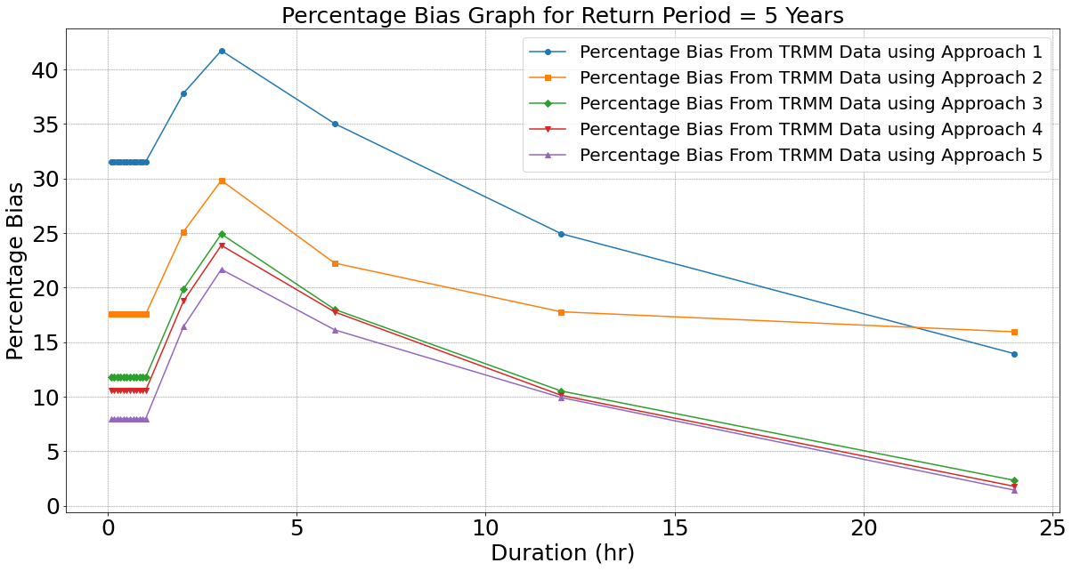
Figure 21 Percentage bias in IMD versus TRMM rainfall intensities for various time durations for a return period of 5 years

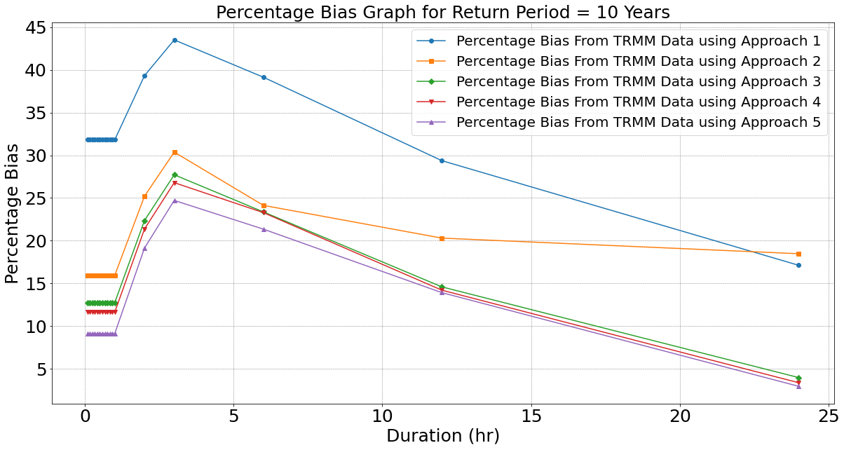
Figure 22 Percentage bias in IMD versus TRMM rainfall intensities for various time durations for a return period of 10 years

Conclusions and Future Scope

Key Conclusions
The following key conclusions are derived from the present study:
- The IDF curves generated for the Ahmedabad city for the baseline period (i.e., 1971-2000) indicated the maximum hourly rainfall intensities of 41.2 mm/hr, 57.5 mm/hr and 68.2 mm/hr corresponding to 2-, 5- and 10-year return periods, respectively.
- Using the sliding window approach, it was found that the rainfall intensities have increased to the tune of 5 – 15% for different durations for all return periods in the recent period (i.e., 1991-2020) vis-à-vis the baseline period (i.e., 1971-2000). Thus, the changes in the rainfall intensities hint towards plausible presence of non-stationarity, which needs detailed investigations.
- From diurnal analysis, it is observed that the day-time rainfall is more than the night-time rainfall, with most of the rain falling in the evening hours.
- The TRMM Approach 5 is recommended as a suitable proxy in absence of the IMD data for deriving IDF curves by applying suitable bias correction.

Future Scope
The gaps in IMD data can be filled from TRMM data using Approach 5, and IDF Curves can be generated more accurately than before. The 3-D mesh IDF curves need to be explored more and used to derive the non-stationarity factor for the Ahmedabad city, which might be contributing significantly to problems of managing urban floods.

References

Badou, D. F., Hounkanrin, J., Hounkpè, J., Sintondji, L. O., and Emmanuel Lawin, A. (2023). Assessing the Return Periods and Hydroclimatic Parameters for Rainwater Drainage in the Coastal City of Cotonou in Benin under Climate Variability. Advances in Meteorology.
Bose, T., Bandyopadhyay, S., and Rawal, D. (2016). Impacts of climate variability on urban floods—A case of Ahmedabad. Environment and Urbanization ASIA, 7(2), 234-242.
Cheng, L., and AghaKouchak, A. (2014). Nonstationary Precipitation Intensity-Duration-Frequency Curves for Infrastructure Design in a Changing Climate. Scientific Reports, 4, 7093.
Hu, H., and Ayyub, B. M. (2019). Machine learning for projecting extreme precipitation intensity for short durations in a changing climate. Geosciences, 9(5), 209.
Ndulue, C., Vincent, C. C., Edward, C. A., and Eneh, J. N. (2023). Modeling of a Data-Driven Flood Detection and Early Warning System Using Machine Learning Technique. International Journal of Advances in Engineering and Management, 5(8), 400-409.
Ouarda, T. B., Yousef, L. A., and Charron, C. (2019). Non‐stationary intensity‐duration‐frequency curves integrating information concerning teleconnections and climate change. International Journal of Climatology, 39(4), 2306-2323.
Padulano, R., Rianna, G., Costabile, P., Costanzo, C., Del Giudice, G., and Mercogliano, P. (2021). Propagation of variability in climate projections within urban flood modeling: A multi-purpose impact analysis. Journal of Hydrology, 602, 126756.
Papacharalampous, G., Tyralis, H., Doulamis, N., and Doulamis, A. (2023). Ensemble learning for blending gridded satellite and gauge-measured precipitation data. Remote Sensing, 15(20), 4912.
Rafiq, F., Ahmed, S., Ahmad, S., and Khan, A. A. (2016). Urban floods in India. International Journal of Scientific and Engineering Research, 7(1), 721-734.
Schlef, K. E., Kunkel, K. E., Brown, C., Demissie, Y., Lettenmaier, D. P., Wagner, A., and Yan, E. (2022). Incorporating non-stationarity from climate change into rainfall frequency and intensity-duration-frequency (IDF) curves. Journal of Hydrology, 128757.
Silva, D. F., Simonovic, S. P., Schardong, A., and Goldenfum, J. A. (2021). Assessment of non-stationary IDF curves under a changing climate: A case study of different climatic zones in Canada. Journal of Hydrology: Regional Studies, 36, 100870.
Subah, Z., Bala, S. K., and Ryu, J. H. (2023). Assessing Urban Flooding Extent of the Baunia Khal Watershed in Dhaka, Bangladesh. Water, 15(6), 1183.
Zheng, Y., Jing, X., Lin, Y., Shen, D., Zhang, Y., Yuan, D. and Zhou, Y. (2023). Research on nowcasting prediction technology for flooding scenarios based on data-driven and real-time monitoring. Natural Hazards, pre-print.

