#### Learning Outcomes

* Using the CloudFormation CLI
* Observe the JSON structure used in CloudFormation
* Observe the process of stack creation in CloudFormation

#### How to do it.

* Download the file *CF1.json* and *CF2.json* provided along with this DIY
* Open the AWS Console and navigate to the VPC section
* Note down the ID of the default VPC already created
* Navigate to the subnet section by clicking on “Subnets” on the left side.
* Note down the subnet ID of the default subnet already created for the default VPC
* Click on “Create Subnet” at the top of the screen
* Fill in the form as shown below and click on Create

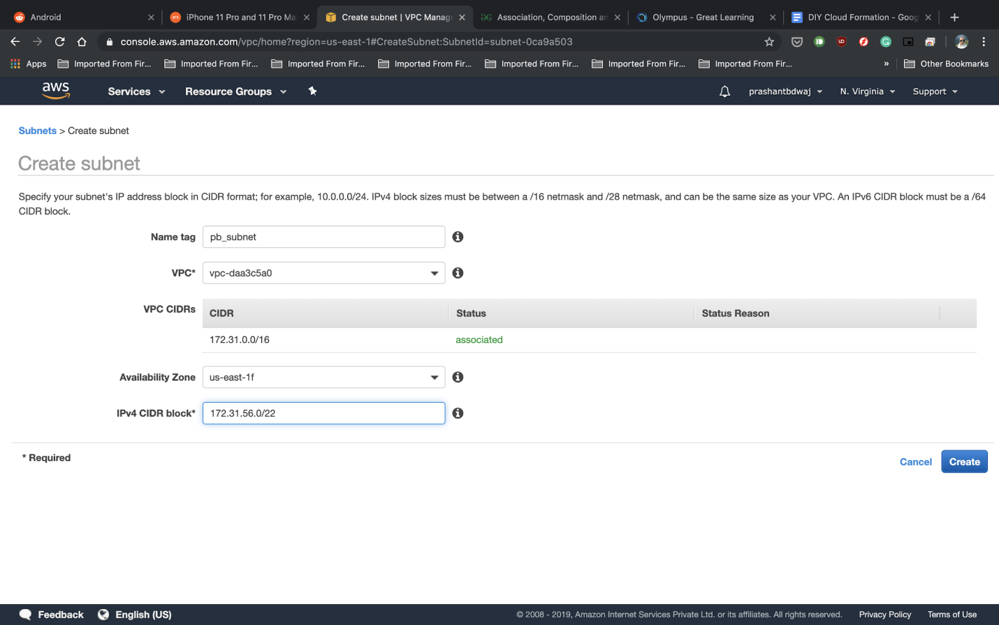

Make sure the IPv4 CIDR block is not being used by any subnet already created, and that the availability zone is a different one than that used by the default subnet.

* Note down the Subnet ID of the subnet just created.
* Open the CF1.json file in your preferred text editor
* Change the values marked below in lines 18,23 and 28, with the values of the default VPC ID, default subnet ID and the ID of the created subnet respectively
* Repeat the above step for the file CF2.json as well i.e. open CF2.json and replace the appropriate values on lines 18,23, and 28.

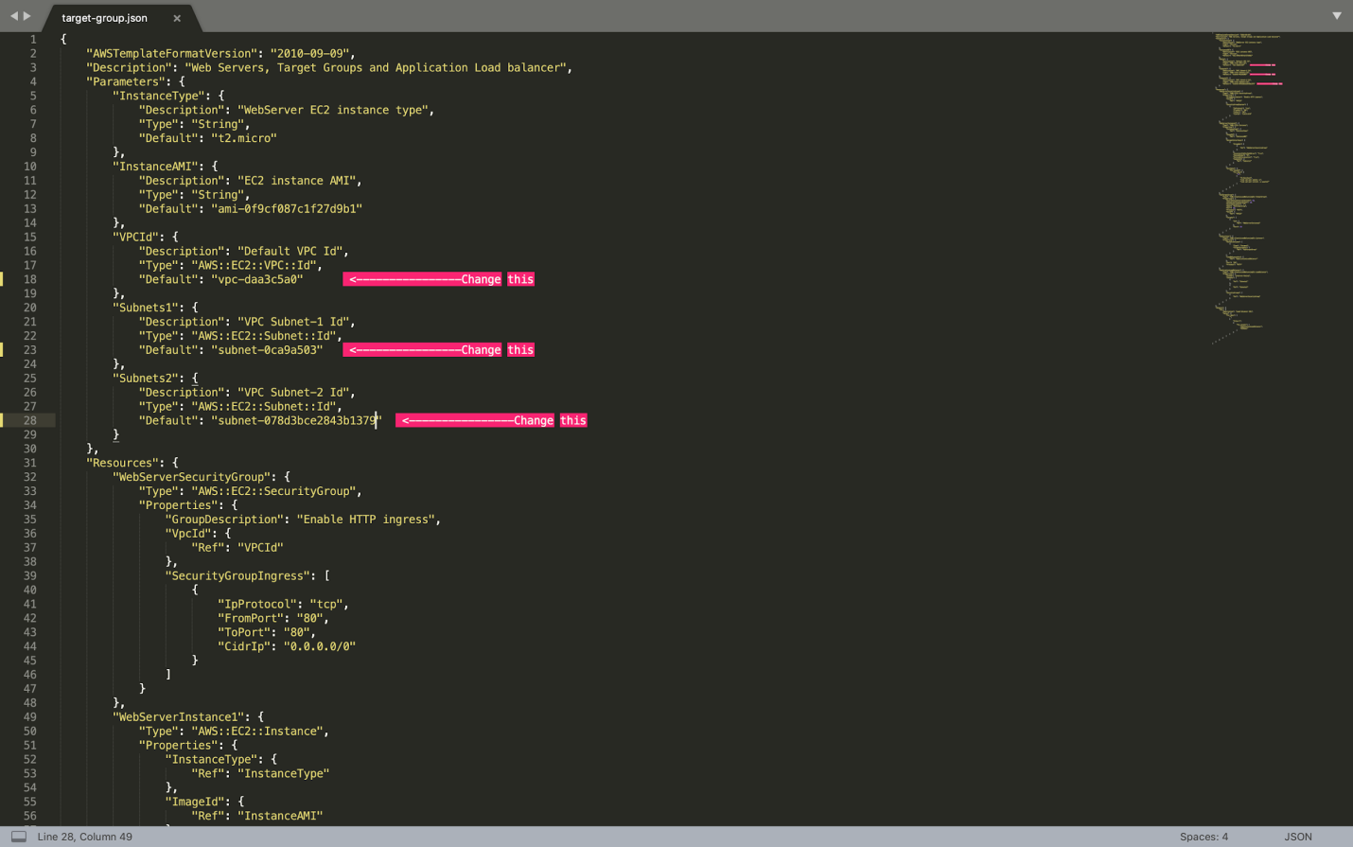

* Save and close the file
* Open your terminal (assuming AWS CLI is already installed and configured)
* Navigate to the folder where the JSONs file are stored
* Enter the following command and press Enter  
  *aws cloudformation create-stack --stack-name gltest-stack --template-body file://CF1.json*

Whoops! You should encounter the following error

*An error occurred (ValidationError) when calling the CreateStack operation: Template format error: Unresolved resource dependencies [NoSecGroup] in the Resources block of the template*

Let’s open the file and navigate to line 183. As you can see, the security group for the Load Balancer has been set to “NoSecGroup”. However, there is no security group as such created in the JSON file. If you navigate to line 32, you will see that the name of the security group created is “WebServerSecurityGroup”.

* Go back to the terminal and type the command   
  *aws cloudformation create-stack --stack-name gltest-stack --template-body file://CF2.json*

If you open this file and check, you can see that the security group for the load balancer has been correctly set.

* Go back to the AWS console and navigate to CloudFormation
* Click on the stack and follow the steps of its creation. Wait for a few minutes for stack creation to finish.
* When stack creation is completed, navigate to the Outputs tab.
* Click on the URL value to confirm that Apache was installed and hence the load balancer was created successfully using the CloudFormation Template.
* Navigate back to the CloudFormation console, select the stack and click on Delete to delete the stack.

**Screenshots**

Screenshot #1

* + - **Response of the CF create stack command with CF1.json**

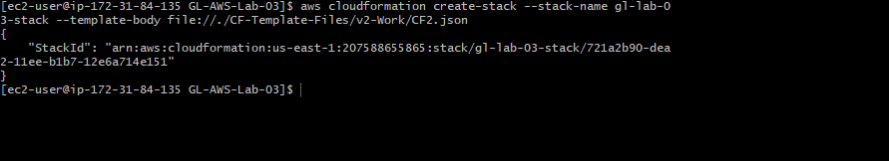

Screenshot #2

* + - **Response of the CF create stack command with CF2.json**



Screenshot #3

* + - **Events log of CF showing security group name as 'WebServerSecurityGroup'**

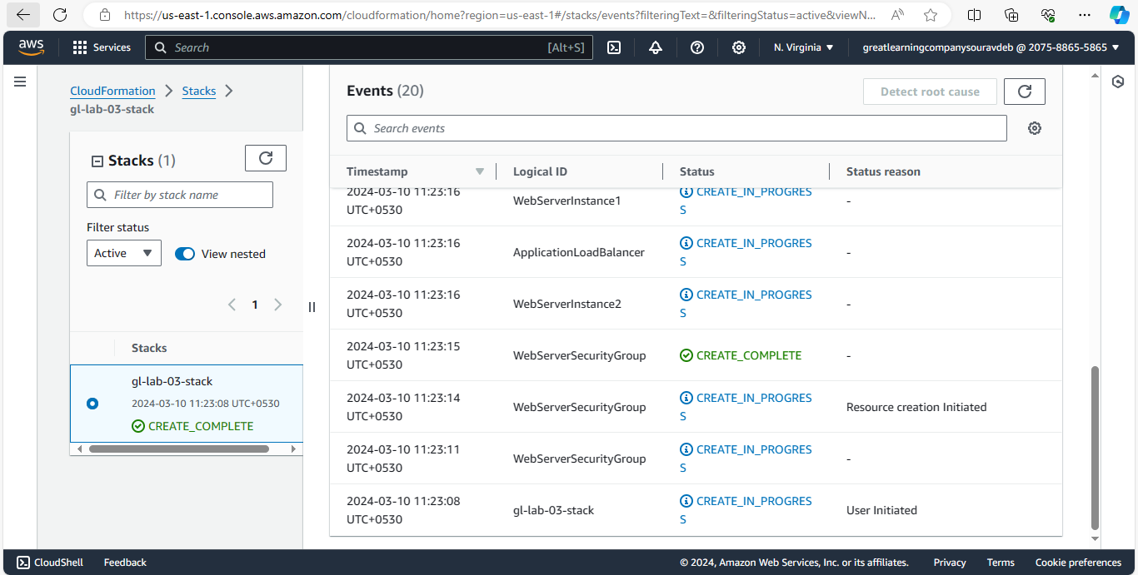

Screenshot #4

* + - **Response from EC2 Server 1**

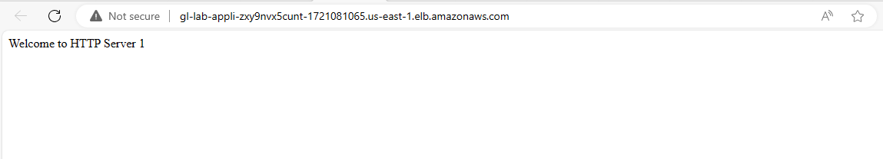

Screenshot #5

* + - **Response from EC2 Server 2**

