**Lab Brief**

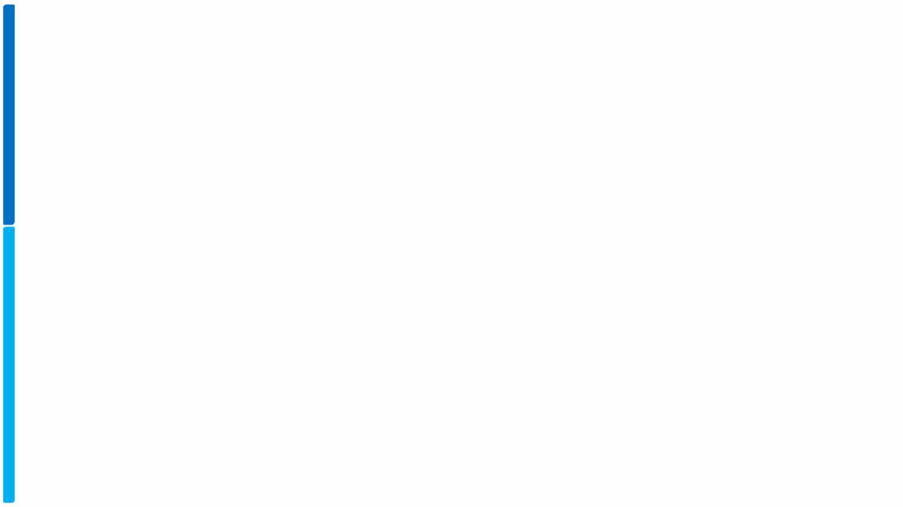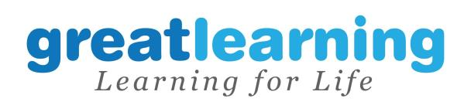

Course: Cloud Computing on AWS

**Storage**I**Volumes, S3, CLI**

(Addvolumesto EC2 instance, migratedatafromonevolumetotheother, writea CLI touploaddocumentstoS3fromlocalmachine)

Proprietary content. ©Great Learning. All Rights Reserved. Unauthorized use or distribution prohibited

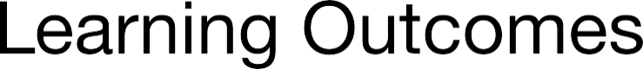

1.

2.

3.

4.

5.

Proprietary content. ©Great Learning. All Rights Reserved. Unauthorized use or distribution prohibited

AWS (N Virginia)

Mech



EC2

Laptop SSD

SSH

CLI

Script

Browser

Snapshots

S3

AWS(Oregon)

S3

Proprietary content. ©Great Learning. All Rights Reserved. Unauthorized use or distribution prohibited

**What is needed?**

1. AWS Account Credentials

2. EC2 Instances(Linux)

3. Shell script environment (any text editor of your choice)

4. Full access to - Volumes, Snapshots, S3, EFS, 1AM

5. Access to create anS3 bucket in 1 other region (Oregon) with cross region replication access

Proprietary content. ©Great Learning. All Rights Reserved. Unauthorized use or distribution prohibited

**Commandreference**

1

The 1volume11 lab set of commands are as follows To elevate your privileges to root

1. sudo su

All following commands require you to be root 1.lsblk

2. file -s /dev/xvdf

3. mkfs -t ext4 /dev/xvdf 4. mkdir /appdata

5. mount /dev/xvdf /appdata

6. echo 11Thisis a sample file11 > /appdata/sample.txt 7. umount /dev/xvdf

The CLI set of commands are as follows

1. aws s3 cp [file] s3://[bucket/folder/file] 2. aws s3 Is [bucket]

3. aws s3 rm s3://[bucket/file]

Note - umount will not work if the pwd is /appdata.

Proprietary content. ©Great Learning. All Rights Reserved. Unauthorized use or distribution prohibited



1. 2.



a) b)

3.

a) b) c) d) e)

4.

a) b) c)

Proprietary content. ©Great Learning. All Rights Reserved. Unauthorized use or distribution prohibited



1. 2.

a) b) c)

3. 4. 5. 6.

**7.**

Proprietary content. ©Great Learning. All Rights Reserved. Unauthorized use or distribution prohibited

**1.Region is set to”N Virginia”**

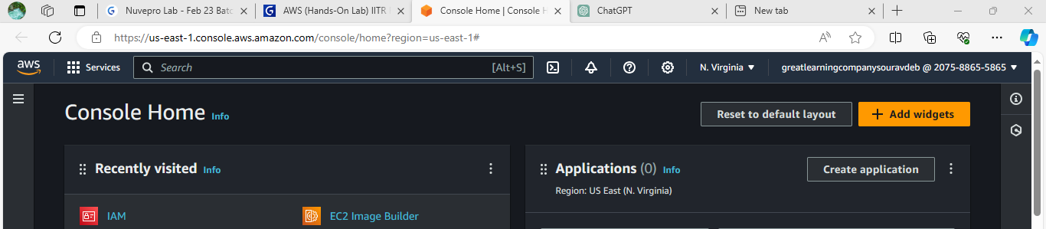

**2.a Create a EC2 instance**

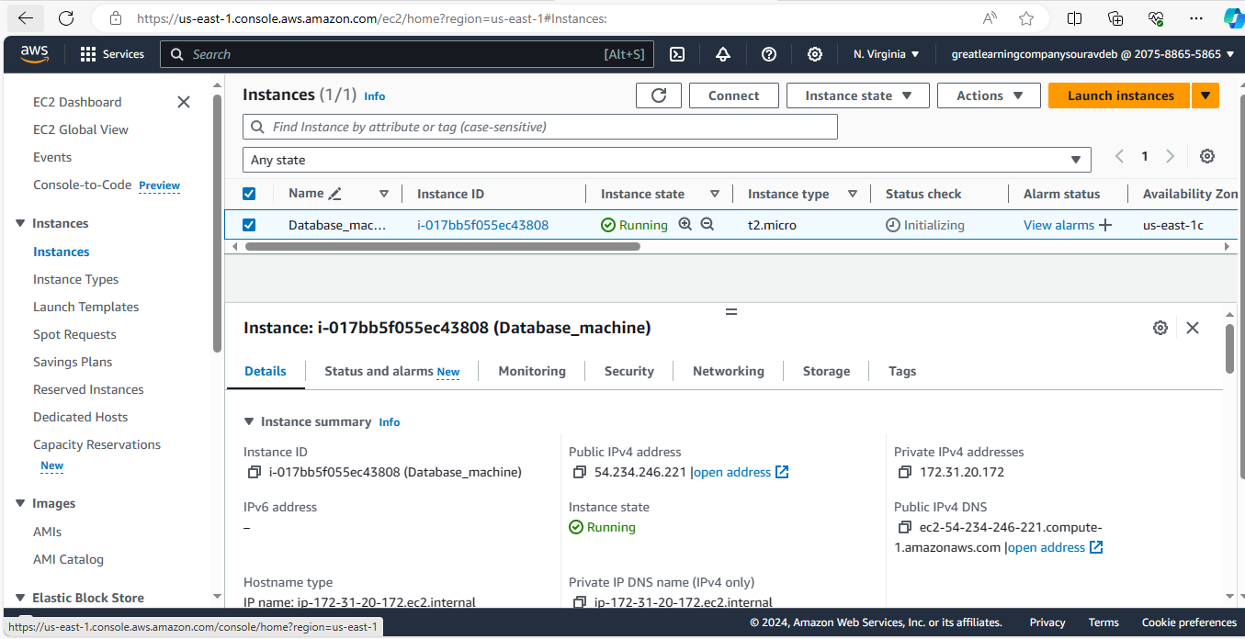

**2.b Download a PEM file**

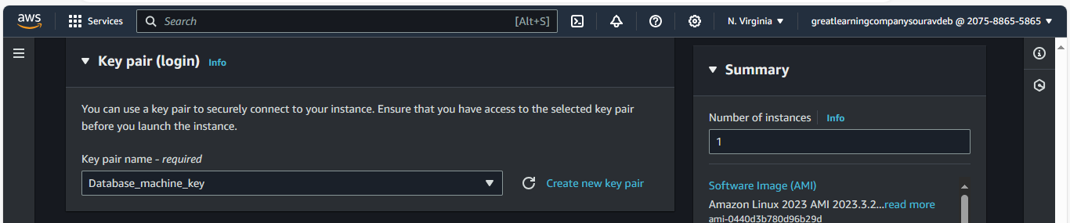

1. **a 10G magnetic volume**

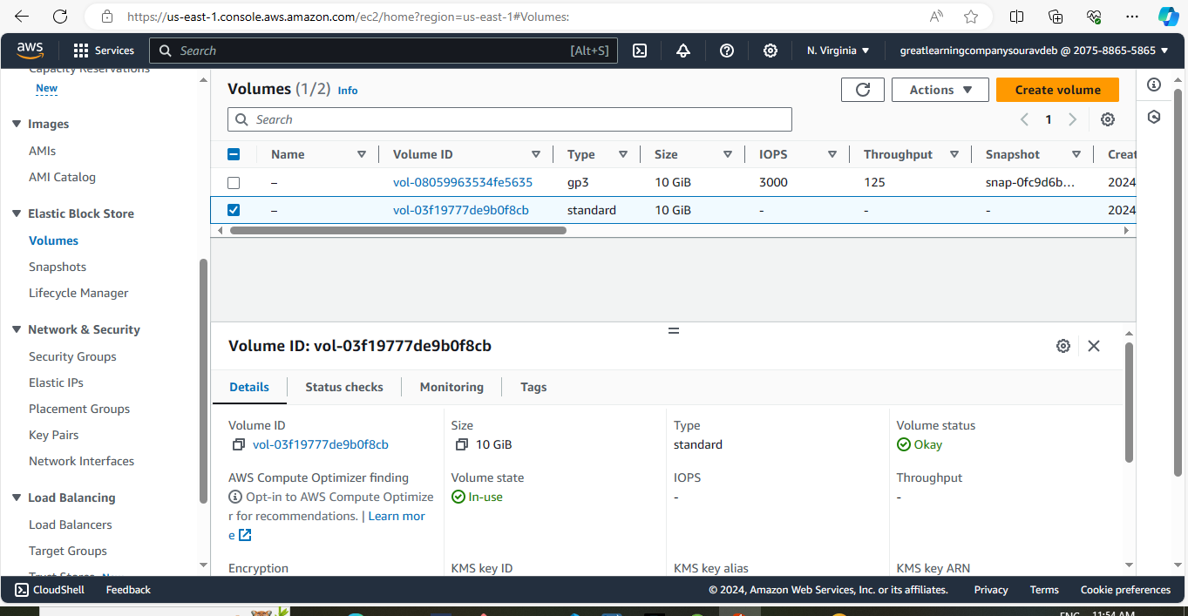

**3.b attach the volume to the instance**

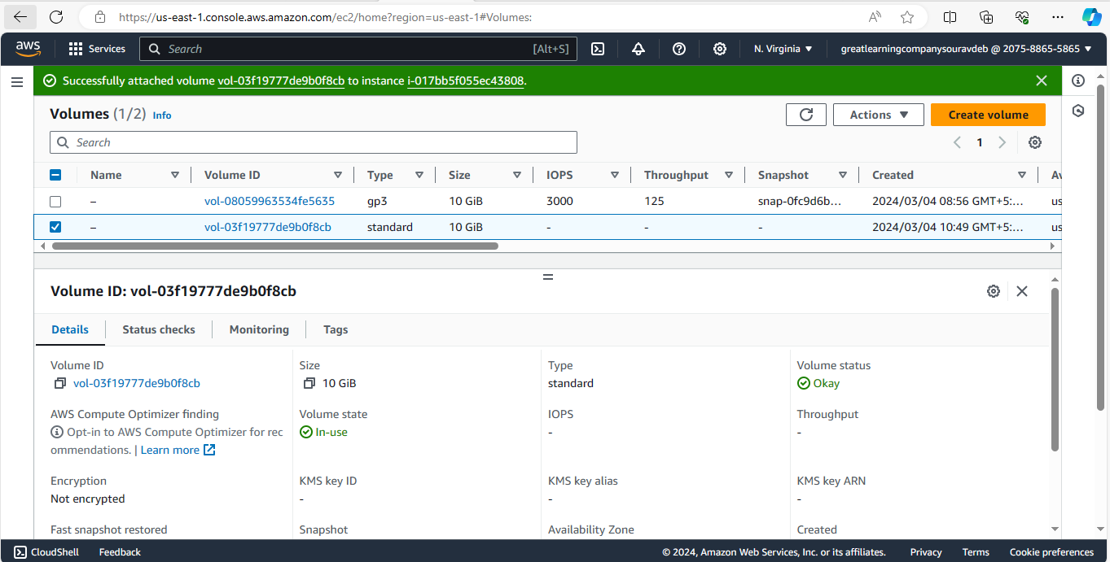

**3.c Format the volume and mount it**

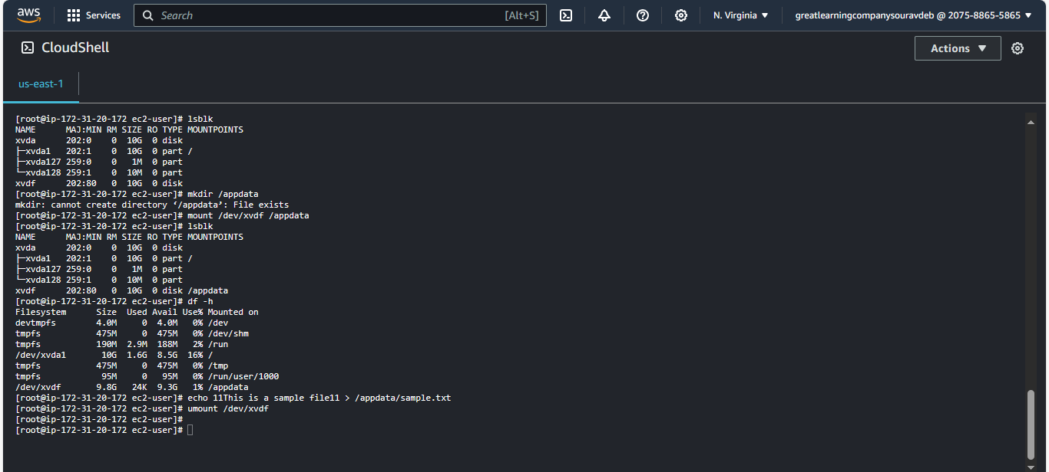

**3.d create a sample text file in the volume and to simulate data creation**



**3.e Unmount, detach the volume**



1. **a create a snapshot volume**

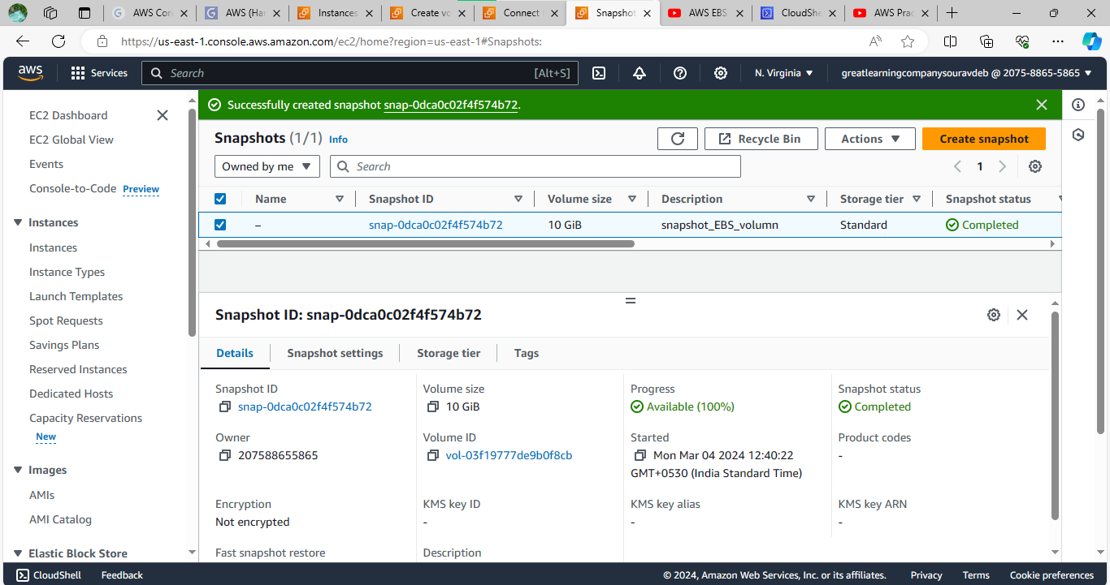

**4.b create new SSD volume 15GB**

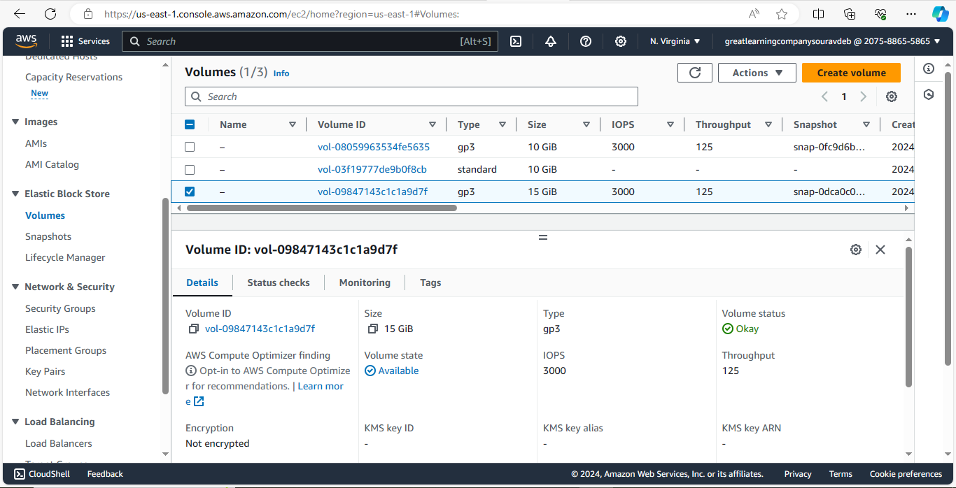

1. **c Attach, mount** 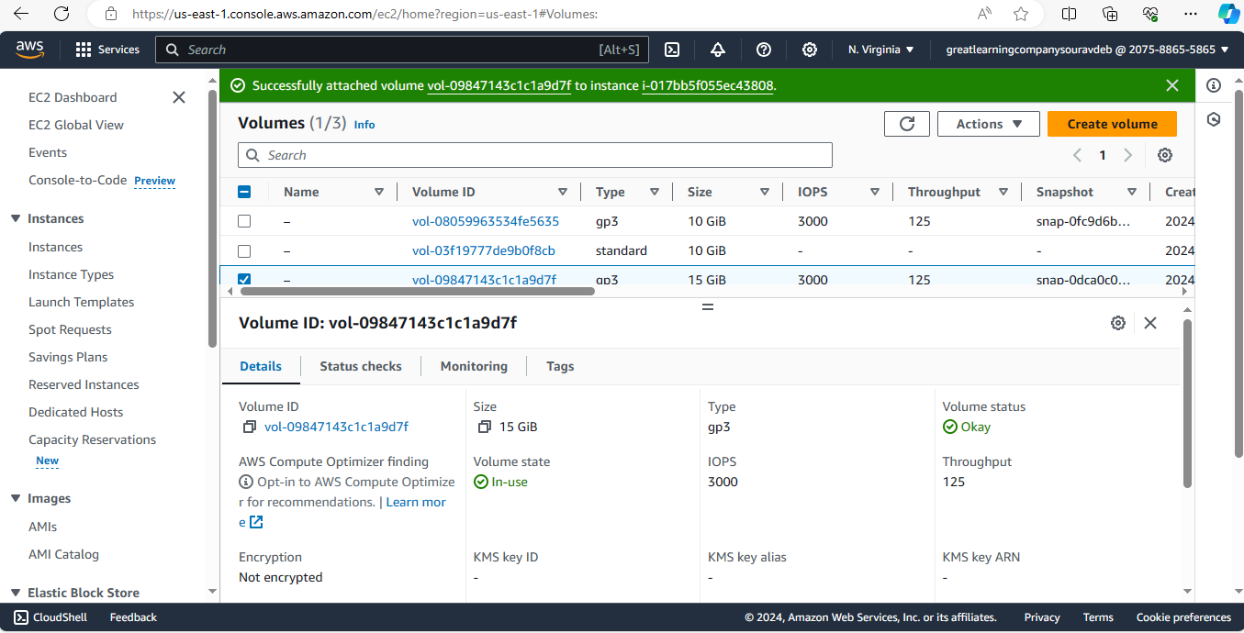

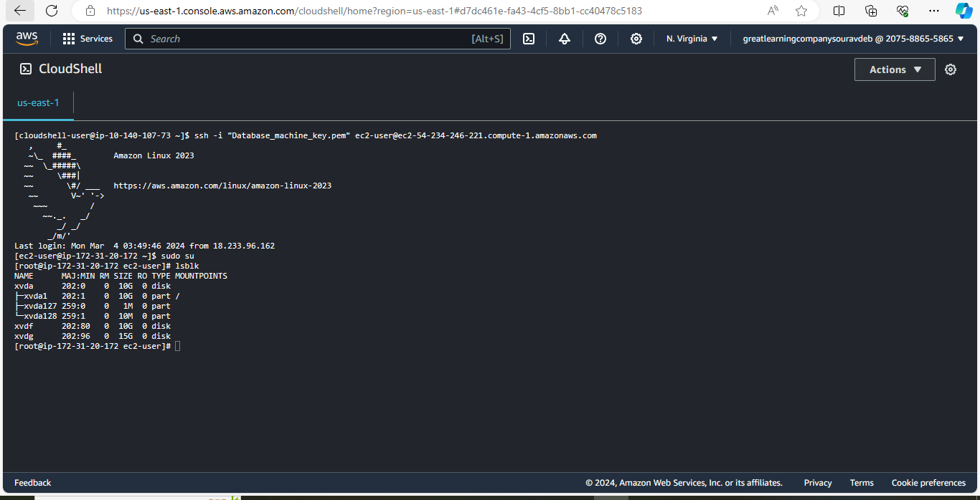

**4.c check if data is there**

