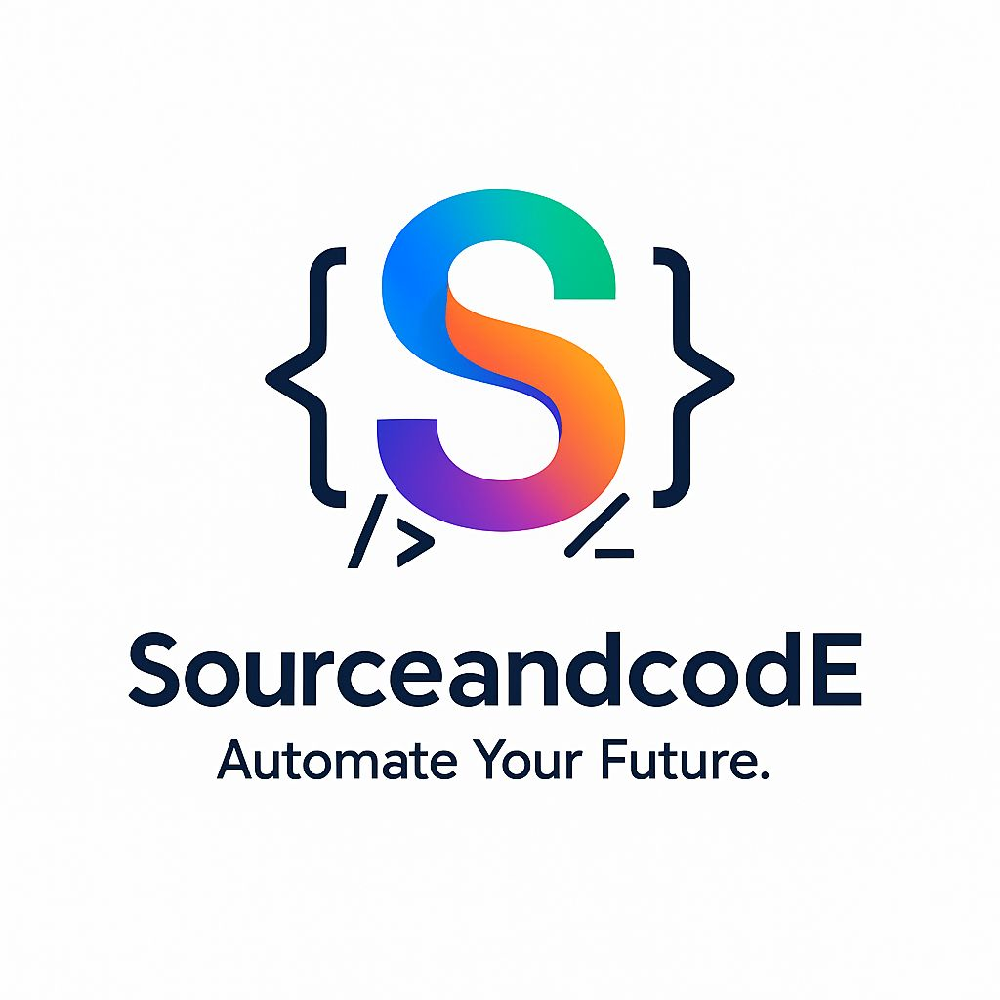
SOFTWARE TESTING &
AUTOMATION ENGINEERING PROGRAM
Build Real-World QA Skills with Modern Automation Tools
Manual Testing | JavaScript | Playwright | API Testing | Cypress
Git & GitHub | CI/CD | Playwright MCP | AI-Assisted Testing

PROGRAM OVERVIEW
A practical, industry-focused program designed to build skills required for modern Software Testing and QA Automation roles.
The learning journey moves from testing fundamentals to automation, API testing, CI/CD, Playwright MCP, AI-assisted testing, real-time project work, and interview preparation.

TRAINING APPROACH
- Concept-based learning
- Hands-on practical sessions
- Real-world testing scenarios
- Automation framework development
- Git & GitHub workflow
- CI/CD implementation
- AI-assisted testing
- Real-time project experience
- Interview preparation

LEARNING PATH
01 Testing Foundation
02 Automation Foundation
03 Playwright Engineering
04 API Testing
05 Cypress Engineering
06 CI/CD with GitHub Actions
07 Playwright MCP
08 AI-Assisted Testing
09 Real-Time Project
10 Career & Interview Preparation

01 | TESTING FOUNDATION/ MANUAL TESTING
Build a strong foundation in Software Testing and understand how QA teams work in real-world Agile projects.
Core Testing Concepts
- Introduction to Software Testing
- QA, QC & Testing
- Verification & Validation
- SDLC & STLC
- Testing Principles
- Role of a QA Engineer
Testing Types
- Functional Testing
- Non-Functional Testing
- Smoke Testing
- Sanity Testing
- Regression Testing
- Retesting
- Integration Testing
- System Testing
- End-to-End Testing
- Exploratory Testing
- Usability Testing
- Compatibility Testing
Test Case Design
- Requirement Analysis
- Test Scenarios
- Test Cases
- Test Data
- Test Execution
- Test Results
- Test Summary

Defect Management
- Defect Identification
- Defect Life Cycle
- Severity & Priority
- Bug Reporting
- Defect Reproduction
- Root Cause Analysis
- Retesting & Closure
Agile & Scrum
- Agile Methodology
- Scrum Framework
- Sprint
- Product Backlog
- User Stories
- Acceptance Criteria
- Daily Stand-up
- Sprint Planning
- Sprint Review
- Sprint Retrospective
- QA Role in Agile
Hands-on: Create test scenarios, test cases, bug reports, smoke test suites, regression test suites, and exploratory testing scenarios.
Learning Outcome: Analyze requirements, design test cases, execute tests, report defects, and work within an Agile QA team.

02 | AUTOMATION FOUNDATION
Build the programming and version-control foundation required for automation projects.
JavaScript Essentials for Automation
- Variables & Data Types
- Functions
- Arrays & Objects
- Conditions & Loops
- Arrow Functions
- Promises
- Async/Await
- Modules
- JSON
Git & GitHub
- Git Overview
- Repository
- Working Directory
- Staging Area
- Commit
- Push
- Pull
- Clone
- Fetch
- Branches
- Merge
- Merge Conflicts
- Pull Requests
- Code Reviews
- README
- .gitignore
Hands-on: Create an automation repository, manage branches, commit code, create pull requests, and resolve merge conflicts.
Learning Outcome: Understand JavaScript fundamentals for automation and manage automation projects using Git and GitHub.

03 | PLAYWRIGHT ENGINEERING
Build modern end-to-end web automation and a maintainable Playwright framework.
Playwright Fundamentals
- Playwright Overview
- Architecture
- Installation & Setup
- Project Structure
- Browser
- Browser Context
- Page
- Locators
Locators & Browser Automation
- Role, Text, Label, Placeholder and Test ID Locators
- CSS Selectors
- XPath
- Locator Chaining
- Dynamic Elements
- Navigation
- Click
- Fill & Type
- Dropdowns
- Checkboxes
- Radio Buttons
- File Upload
- File Download
- Frames
- Popups
- Multiple Tabs & Windows
- Dialog Handling
Assertions & Synchronization
- Text Validation
- Visibility
- Element State
- URL Validation
- Attribute Validation
- Auto-Waiting
- Explicit Waiting
- Wait for URL
- Wait for API Response
- Dynamic Elements
Test Runner & Framework
- Test Structure
- Hooks
- Fixtures
- Configuration
- Tags
- Annotations
- Retries
- Timeouts
- Parallel Execution
- Parameterized Testing
- Data-Driven Testing
- Page Object Model
- Base Page
- Reusable Methods
- Utility Functions
- Environment Management
- Reporting
- Framework Scalability
Authentication, Debugging & Reporting
- Login Automation
- Authentication State
- Storage State
- Session Reuse
- Multiple User Roles
- Playwright Inspector
- Debug Mode
- Screenshots
- Videos
- Trace Viewer
- HTML Reports
- Failure Analysis
Hands-on: Build a complete Playwright automation framework from scratch and automate real-world application scenarios.
Learning Outcome: Design, develop, debug, execute, and maintain a professional Playwright automation framework.
04 | API TESTING
Understand application communication through APIs and validate API behavior independently and with UI automation.
API Fundamentals
- What is an API?
- Client-Server Architecture
- REST APIs
- HTTP & HTTPS
- Request & Response
- Headers
- Query Parameters
- Path Parameters
- Request Body
- Response Body

HTTP Methods & Validation
- GET
- POST
- PUT
- PATCH
- DELETE
- Status Codes
- JSON
- Response Body
- Headers
- Response Time
- Schema Validation

UI + API Testing
- Create Test Data through API
- Validate UI Data through API
- API Setup & Cleanup
- Hybrid UI + API Automation
Hands-on: Create and automate API test scenarios and integrate API testing with UI automation.
Learning Outcome: Test APIs effectively and use APIs to make UI automation faster and more reliable.

05 | CYPRESS ENGINEERING
Learn Cypress automation and understand how it compares with Playwright.
Cypress Fundamentals
- Cypress Overview
- Architecture
- Installation
- Project Setup
- Project Structure
- Cypress Runner
- Configuration
Commands, Locators & Assertions
- Visit
- Get
- Contains
- Click
- Type
- Select
- Check / Uncheck
- Clear
- CSS Selectors
- Chaining
- Dynamic Elements
- Implicit Assertions
- Explicit Assertions
- Visibility
- Text
- Value
- URL
Cypress Features
- Fixtures
- Aliases
- Custom Commands
- Hooks
- Intercepts
- Network Stubbing
- Request Validation
- File Upload
- Screenshots
- Videos
Advanced Cypress
- API Requests
- API Validation
- UI + API Integration
- Page Object Model
- Reusable Commands
- Test Data
- Environment Configuration
- Utilities
- Reporting
- Parallel Execution
Playwright vs Cypress
- Architecture
- Execution Model
- Browser Support
- Locators
- Auto-Waiting
- API Testing
- Debugging
- Parallel Execution
- CI/CD
- Use Cases
Hands-on: Build Cypress automation suites and compare implementation approaches with Playwright.
Learning Outcome: Work with Cypress confidently and understand when Cypress or Playwright is the better fit.

06 | CI/CD WITH GITHUB ACTIONS
Integrate automated testing into the software delivery pipeline.
CI/CD Fundamentals
- Continuous Integration
- Continuous Delivery
- Continuous Deployment
- QA in DevOps
- Automation in CI/CD
GitHub Actions & YAML
- GitHub Actions
- Workflows
- Jobs
- Steps
- Runners
- Actions
- Events
- Triggers
- YAML Fundamentals
- Environment Variables
- Secrets
Automation Pipeline
- Checkout Repository
- Setup Node.js
- Install Dependencies
- Install Browsers
- Execute Tests
- Generate Reports
- Upload Artifacts

Advanced CI/CD
- Push
- Pull Request
- Manual Execution
- Scheduled Execution
- Multiple Environments
- Parallel Jobs
- Job Dependencies
- Test Artifacts
- Failure Handling
- Retry Strategies
- Scheduled Regression
Hands-on: Create a GitHub Actions pipeline for the automation framework with automated execution, reports, artifacts, and scheduled regression.
Learning Outcome: Run automated tests through CI/CD and execute regression testing automatically.

07 | PLAYWRIGHT MCP
Explore how Model Context Protocol can connect AI capabilities with browser automation.
MCP Fundamentals
- What is MCP?
- Why MCP?
- MCP Architecture
- MCP Client
- MCP Server
- Tools
- Resources
- AI + MCP Workflow
Playwright MCP
- Playwright MCP Overview
- MCP Setup
- Browser Interaction
- Page Exploration
- Element Identification
- Browser Actions
- Automation Workflows
Practical Use Cases
- Explore Applications using AI
- Identify UI Elements
- Understand Application Behavior
- Generate Test Scenarios
- Assist Automation Development
- Debug Browser Workflows
- Accelerate Test Creation
Hands-on: Use Playwright MCP to explore an application and assist in creating browser automation workflows.
Learning Outcome: Understand how MCP can enhance modern browser automation and AI-assisted testing.

08 | AI-ASSISTED TESTING
Use modern AI tools to improve QA productivity and automation development.
AI in Software Testing
- AI in QA
- Requirement Analysis
- Test Scenario Generation
- Test Case Generation
- Test Data Generation
- Bug Analysis
- Test Documentation
- Test Optimization
Cursor
- AI-Assisted Coding
- Code Generation
- Code Explanation
- Refactoring
- Debugging
- Test Script Generation
- Framework Assistance
GitHub Copilot
- Code Completion
- Test Generation
- Test Case Generation
- Code Explanation
- Refactoring
- Debugging
- Automation Assistance
AI + Automation
- Generate Test Scripts
- Generate Locators
- Generate Assertions
- Generate Page Objects
- Generate Test Data
- Improve Existing Tests
- Debug Failed Tests
- Refactor Automation Code
Hands-on: Use Cursor and GitHub Copilot to analyze requirements, create tests, generate automation, debug failures, and improve code.
Learning Outcome: Use AI as a productivity tool while maintaining control over test quality and automation design.
09 | REAL-TIME PROJECT
Apply the complete learning journey to an end-to-end QA automation project.
Project Lifecycle
- Requirement Analysis
- Test Planning
- Manual Testing
- Defect Reporting
- Automation
- API Testing
- Framework Development
- Git & GitHub
- CI/CD
- AI-Assisted Testing
- Test Reporting
Project Deliverables
- Test Plan
- Test Scenarios
- Test Cases
- Defect Reports
- Automation Framework
- UI Test Suite
- API Test Suite
- GitHub Repository
- CI/CD Pipeline
- Test Reports
- Project Documentation
Hands-on: Build and maintain a complete QA project from requirement analysis through automated CI/CD execution.
Learning Outcome: Gain practical experience working through a QA automation project from requirement analysis to delivery.

10 | CAREER & INTERVIEW PREPARATION
Prepare to explain your testing knowledge, project, framework, and technical decisions with confidence.
Technical Preparation
- Manual Testing
- Playwright
- Cypress
- JavaScript
- API Testing
- Git & GitHub
- CI/CD
- Playwright MCP
- AI-Assisted Testing
Project Preparation
- Project Explanation
- Framework Architecture
- Challenges & Solutions
- Automation Strategy
- Real-Time Scenarios
Interview Practice
- Scenario-Based Questions
- Coding Questions
- Debugging
- Automation Assignments
- Mock Interviews
- Real-Time QA Scenarios
Hands-on: Practice project explanation, framework walkthroughs, scenario-based questions, coding exercises, debugging discussions, and mock interviews.
Learning Outcome: Explain your project, automation framework, testing approach, and technical skills confidently during QA Automation interviews.

FINAL LEARNING OUTCOME
By the end of the program, you will be able to:
- Perform professional Manual Testing
- Analyze requirements and create test cases
- Report and manage defects
- Work in an Agile/Scrum environment
- Build Playwright automation frameworks
- Build Cypress automation suites
- Perform API Testing
- Manage projects using Git & GitHub
- Create CI/CD pipelines using GitHub Actions
- Execute automation through CI/CD
- Design scalable automation frameworks
- Work with Playwright MCP
- Use Cursor and GitHub Copilot for QA automation
- Apply AI to everyday testing activities
- Work on a complete real-time automation project
- Explain your project confidently in interviews

TECHNOLOGY STACK
Manual Testing | JavaScript | Playwright | API Testing | Cypress
Git | GitHub | GitHub Actions | Playwright MCP | Cursor | GitHub Copilot

CAREER DIRECTION
Manual Tester
↓
QA Tester
↓
Automation Tester
↓
QA Automation Engineer
↓
Modern QA / SDET
Learn → Practice → Build → Automate → Integrate → Deliver

