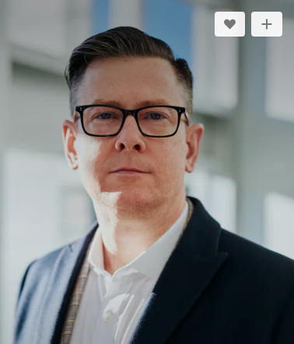

|  |  |  |
| --- | --- | --- |
|  | CHRISTOPHER MORGAN  SENIOR WEB DEVELOPER |
|  | **CONTACT**   |  | +44 (0)20 7666 8555 | | --- | --- | |  | 177 Great Portland Street, NY W5W 6PQ | |  | christoper.m@gmail.com |   **EDUCATION**  **Bachelor of Science:**  2009- 2011  *Columbia University, NY*  **Bachelor of CS:**  2011- 2014  *Columbia University, NY*  **CERTIFICATION**  PHP Framework (certificate): Zend, Codeigniter, Symfony.  PROGRAMMING  LANGUAGE  JavaScript, HTML5, PHP OOP, CSS, SQL, MySQL. | **ABOUT ME**  Senior Web Developer specializing in front end development. Experienced with all stages of the development cycle for dynamic web projects. Well-versed in numerous programming languages including HTML5, PHP OOP, JavaScript, CSS, MySQL. Strong background in project management and customer relations.    **WORK EXPERIENCE**    **Web Developer**  *DEO Company New York* JAN 2016 - DEC 2018    Cooperate with designers to create clean interfaces and simple, intuitive interactions and experiences.Develop project concepts and maintain optimal workflow.Work with senior developers to manage large, complex design projects for corporate clients.  **Senior Developer**  *DEO Company New York* JAN 2019 - DEC 2020    Cooperate with designers to create clean interfaces and simple, intuitive interactions and experiences.Develop project concepts and maintain optimal workflow.Work with senior developers to manage large, complex design projects for corporate clients.  **SKILLS**   | Project management  Strong decision maker  Complex problem solver | Creative design  Innovative  Service-focused | | --- | --- | |