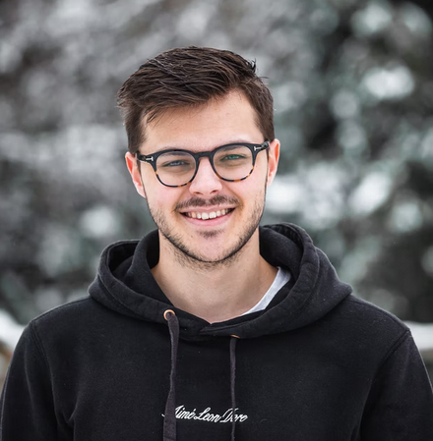

| |  | | | --- | --- | | **PROFILE ……………………………** | | | Senior Web Developer specializing in front end development. Experienced with all stages of the development cycle for dynamic web projects. | | | **SOFTWARE SKILLS ……….………….** | | | PHOTOSHOP |  | | HTML5&CSS |  | | PHP |  | | OOP |  | | SQL |  | | **LANGUAGE …………………….……** | | | English |  | | French |  | | German |  | | **BEST AWARD …….……………….** | | | **UX DESIGN AWARD**  **UX Media Company**  The UX Design Awards honor the huge impact of accomplished experience design on shaping a positive living environment for all. | | | **INTERESTS …………………..….** | | | |  |  |  |  | | --- | --- | --- | --- | | TRAVEL | GAMING | CHATTING | COFFEE | | | | | **MICHAEL**  **JOHN SMITH**  **GRAPHIC AND WEB DESIGNER** | | | --- | --- | | 177 Great Portland Street, NY W5W 6PQ | | | +34345 3434 344 | +43 3434 3443 | | youremail@emai.com | www.website.com |  | **EXPERIENCE** | **…………………………...……….** | | --- | --- | | **WEB DEVELOPER**  Apr-2021 - Present | **Your Company**  Cooperate with designers to create clean interfaces and simple, intuitive interactions and experiences. | | **ENGINEER**  Apr-2015 - 2019 | **Your Company**  Cooperate with designers to create clean interfaces and simple, intuitive interactions and experiences. | | **GRAPHICS DESIGNER**  Apr-2011 - 2015 | **Your Company**  Cooperate with designers to create clean interfaces and simple. |  | **EDUCATION** | **…………………………...……….** | | --- | --- | | **BACHELOR OF SCIENCE**  Apr-2015 - 2019 | **Columbia University, NY**  Cooperate with designers to create clean interfaces and simple. | | **BACHELOR OF CS**  2011- 2014 | **Columbia University, NY**  Cooperate with designers to create clean interfaces and simple. |  | **REFERENCES** | **…………………………...……….** | | --- | --- |  | **ROBERT SMITH**  CEO. Founder  **Phone** : +33434343  **Email** : john@email.com  **Address** : 777 Main Street  Newyork, USA | **JOHN DOE**  Chairman  **Phone** : +33434343  **Email** : john@email.com  **Address** : 777 Main Street  Newyork, USA | | --- | --- | |
| --- | --- | --- | --- | --- | --- | --- | --- | --- | --- | --- | --- | --- | --- | --- | --- | --- | --- | --- | --- | --- | --- | --- | --- | --- | --- | --- | --- | --- | --- | --- | --- | --- | --- | --- | --- | --- | --- | --- | --- | --- | --- | --- | --- | --- | --- | --- | --- | --- | --- | --- | --- | --- | --- | --- | --- | --- | --- | --- | --- | --- | --- | --- | --- | --- | --- | --- | --- | --- | --- |