attackers combine elementary attacks to launch multistage attacks against critical assets

These elementary attacks exploit vulnerabilities of individual hosts and may be either remote or local

Intrusion Detection Systems, either network or host based, can detect those elementary attacks but cannot report whether they are part of a larger attack chain or not

Using attack graphs, network administrators can understand how an attacker can combine vulnerabilities in multiple hosts in a multi-stage attack to compromise critical resources in a network

Moreover the size of an attack graph has direct impact on the perceived risk. Intuitively, a larger attack graph can mean more number of vulnerabilities that can be exploited or more number of attack paths to a resource or more attack spread; all implying less security and hence more risk. An exhaustive attack graph of a network provides global view of its security posture, enabling quantitative assessment（定量评价） of the same

In its earlier days, dedicated security teams (called Red teams) used to determine overall security of networks by hand-drawing gigantic attack graphs and then analysing them
tedious, error prone and did not scale up as the network size grew
- need for automated methods of attack graph generation
- guarantee that the generated attack graph is exhaustive and succinct
- An exhaustive attack graph contains all possible attack paths and a succinct attack graph contains only those initial network states from where the attacker can reach the goal

ATTACK GRAPH GENERATION
privilege graph: Each node in a privilege graph represents a set of privilege owned by a user or a set of users
each edge represents a vulnerability
In an attack tree each path to a leaf node represents sequence of attacks by which an attacker can reach goal state from its initial state
An attack graph essentially is a consolidated representation of an attack tree where some or all common nodes across different attack paths are merged
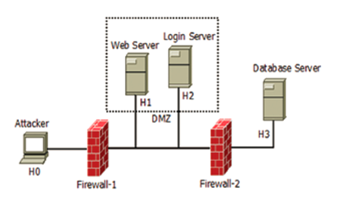
Host H1 is running a vulnerable version of Apache web server, which has vulnerability (CVE-2006-3747) that allows a remote attacker to exploit and gain user privilege on the Web Server
The ssh service on H2 has a vulnerability (CVE-20020640), which allows remote attackers to gain user privilege.
Database server H3 is a Linux box running MySQL database which has a remotely exploitable vulnerability (CVE-20092446), enabling attacker to gain user privilege.
The Linux kernel in host H3 also has vulnerability (CVE-2004-0495) that allows local user to gain root privilege.
Objective: Attacker’s objective is to gain root privilege on the database server.
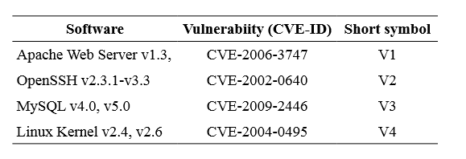
State Enumeration Based Approach（基于状态枚举的方法）
These approaches are based on either custom algorithms or based on model checking techniques

custom algorithms
nodes represent possible system state during execution of an attack. A system state comprises of information on host(s), user access levels and effects of the attack so far
Edges represent a change of state, caused by a single action of the attacker and may be weighted（赋权值）based on the attacker’s effort required or the time to succeed.
自动生成攻击图需要三种信息：attack templates, a configuration file and an attacker profile.
Attack templates represent attacks (both known and hypothesised) in the form of a sub-graph describing conditions necessary for successful execution of the attack and also any new conditions that it may enable.

A configuration file contains information about the network system under consideration. This information includes network topology, configuration of network elements such as hosts, routers, firewalls, etc.

Attacker profile contains information about attacker’s capabilities.

The attack graph generation algorithm starts from the initial state. It matches attack templates to the configuration of the network system and attacker’s profile in a forward exploration manner and generates the graph iteratively.

The generation method addressed the issues of redundant path, node and directed cycle elimination（去除有向环）.

But the authors have not provided any complexity analysis; only empirical results on small examples are given. The obvious problem with this kind of formalism is the issue of state-space explosion（状态空间爆炸）.
the state enumeration graph

Model checking
Model checking in general is a technique which checks whether a formal model M of a system satisfies a given property p or not.
If the property p is false in the model M, then the model checker outputs a counter example（反例） describing a sequence of state transitions which ends in violation of the property.
One benefit of using model checking techniques over custom algorithms for attack graph generation is that users need not worry about the problem of handling large state space, which is otherwise elegantly handled by standard model checking software.
The first step in this approach is to build a model of the system under analysis. This model includes information on hosts along with their vulnerabilities, host connectivity, current view of the attacker and exploits that change the model’s state.
host connectivity information—>connectivity between hosts
The current view of the attacker—> attacker profile
the exploits—>attack templates
Performance of attack graph generation techniques based on model checking is dependent on the efficiency of the model checker tools themselves, which are specifically designed for handling large state spaces. These techniques encode network state information in number of state variables which increase considerably with increasing network size, number of atomic attacks and vulnerabilities.

Each state is labelled with a propositional formula. This network model includes (i) host connectivity information expressed as a ternary relation R(h1, h2, p) meaning that host h1 can reach host h2 on port p (ii) trust relationship Tr(h1, h2) meaning that a user of host h2 can log into h1 without any authentication i.e. host h1 trusts host h2 (iii) intruder privilege levels on hosts (none/user/root) (iv) Intrusion detection systems (IDS) as a relationship ids(h1, h2, a)={s, d, b} meaning that an attack a from host h1 to h2 is stealthy/detectable/both by an IDS sensor.

Each atomic attack is specified as rules and has four components: intruder preconditions, network preconditions, intruder effects and network effects.

Safety property of the system is specified in computation tree logic (CTL). If the safety property is not satisfied, the NuSMV model checker generates all possible counter examples

They termed the resulting graph as a scenario graph.(场景图)

Performance of attack graph generation techniques based on model checking is dependent on the efficiency of the model checker tools themselves, which are specifically designed for handling large state spaces.
They also face significant exponential state-space problems even for moderate-sized networks.
TVA Approach（Topological vulnerability analysis）
The monotonicity assumption on attacker’s behaviour, first introduced by Ammann, et al. was a key enabler in handling this issue（assumed full exponential state-space.）

This assumption says that preconditions of an attack are never invalidated by successful execution of another attack.

the monotonicity assumption helps in reducing the complexity of analysis from exponential（指数级）to polynomial（多项式级）.

The resulting graph which enumerates all such possible exploit sequences is known as the exploit dependency graph.

In exploit dependency attack graph, each exploit or dependency appears only once and there are no edges between independent exploits.
（Whereas, in a state enumeration attack graph, there may be edges between exploits even though there are no dependency relationships between them.）
TVA attack graph generation engine uses the algorithm proposed by Ammann, et al. for attack graph generation. It has O(n6) computational complexity, which was later improved to O(n3) Ammann, et al.; n being the number of hosts in the network.

The attack graph model used in TVA uses two types of nodes, exploit nodes and security condition nodes.

Exploit nodes represent attacks (exploitation of certain vulnerabilities) and security condition nodes represent either the attack post-condition or pre-condition.

An advantage of exploit dependency graphs is that instead of modelling hosts, exploits on hosts are modeled, thus reducing the computational complexity.
On the other hand, this model requires information on low-level attack details. Vulnerability information are based on pre- and post-conditions.

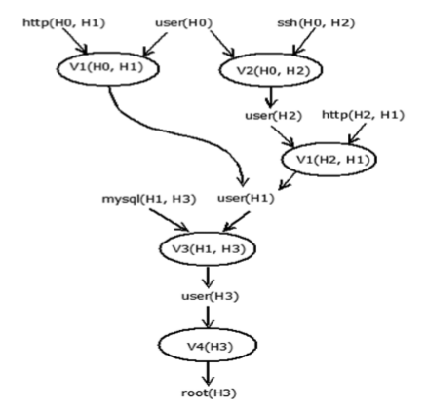
there are two attack paths leading to attacker gaining root privilege on H3. They are V1(H0, H1) → V3(H1, H3) → V4(H3) and V2(H0, H2) → V1(H2, H1) → V3(H1, H3) → V4(H3) respectively.

Logic Programming Based Approach
Multi host, multistage vulnerability analysis (MulVAL) is a logic-programming based approach to network security analysis.
It uses a representation of attack graph known as logical attack graph which shows logical dependencies among attack goals and configuration information.

A node in the logical attack graph is a logical statement which encodes only some part of network state.
Edges represent the causality relationships between various network configurations.
Size of a logical attack graph is polynomial to the network being analysed.
A logical attack graph is a directed graph. It can also be represented as a tree.
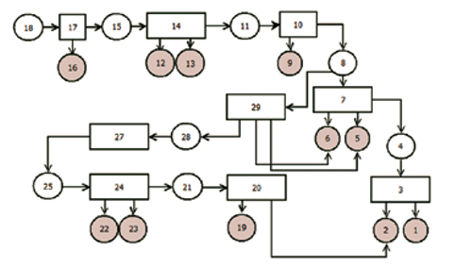
Rectangles and circles represent derivation nodes and fact nodes respectively. Derivation nodes are labeled with interaction rules. Fact nodes are labeled with logical statements in the form of a predicate applied to its arguments. Shaded circles are primitive fact nodes i.e. facts that hold true in the initial state. Un-shaded circles represent derived fact nodes, i.e. new facts that are generated as a result of application of interaction rules over existing facts.
Edges in a logical attack graph represent a ‘depends on’ relationship.
To describe system properties MulVAL uses Datalog, which is a syntactic subset of the Prolog programming language.

MulVAL uses Prolog logic engine XSB as reasoning engine for evaluating rules on input facts. XSB computes all possible paths to satisfy a defined goal.

Rule 1: Remote exploit of a privilege-escalation vulnerability in a service program
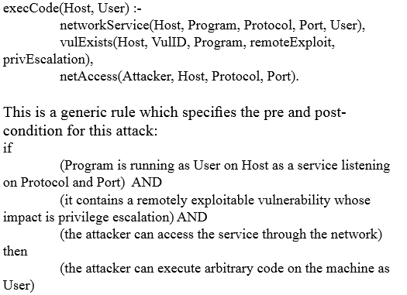
Network (router and firewalls) configurations are modeled as abstract host access-control lists (HACL) in form of logical statements using the predicate hacl. Predicate vulExists encodes output of vulnerability scanner tool.
The MulVAL logic programming based approach has O(n2) complexity under the assumption of constant table lookup time. Empirical results show that, worst case running time varies between O(n2) to O(n3) for number of hosts upto 1000 with up to 100 vulnerabilities.

NetSPA Approach
The network security planning architecture (Net SPA) attack graph generation system is based on a new representation of attack graph, i.e. the multiple prerequisites graph （多前驱图）which scales linearly to the size of the network.

This tool uses readily available source of data to automatically compute network reachability, classify vulnerabilities, build the graph and recommend actions to improve network security.

A multiple-prerequisite attack graph consists of three types of nodes, i.e. state nodes, prerequisite nodes, and vulnerability instance nodes.

State nodes represent attacker’s level of access on a given host. Prerequisite nodes represent either a reachability group or preconditions of one or several attacks. Vulnerability instance nodes represent particular vulnerabilities.
Directed edges from state nodes to prerequisite nodes represent the capabilities those states enable for the attacker. Prerequisite nodes point to vulnerability instance nodes that represent the set of attacks that the prerequisite node enables. Directed edge from vulnerability instance nodes to a single state node represent the state the attacker can reach by successfully exploiting the vulnerability.

总结：a state provides prerequisites, which allow exploitation of vulnerability instances, which in turn provide more states to the attacker.

Circles represent state nodes, rectangles represent prerequisite nodes, and triangles represent vulnerability instance nodes.
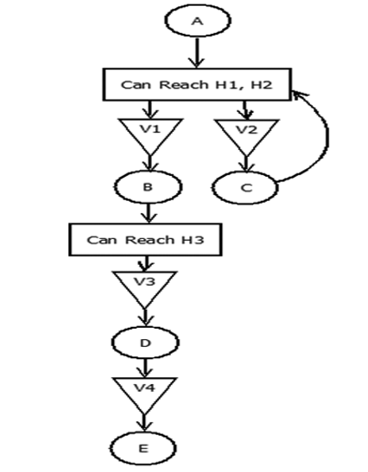
State nodes A, B, C, D, E represent attacker’s level of access on different hosts i.e. user(H0), user(H1), user(H2), user(H3), and root(H3) respectively. Directed edge from state node A i.e. user(H0) to prerequisite node ‘Can Reach H1, H2’ represent the capability of attacker that is enabled by this state. Directed edge from prerequisite node ‘Can Reach H1, H2’ to vulnerability instance nodes V1 and V2 represent attacks enabled by this prerequisite. Only when the attacker is in state B, it enables reachability to host H3. The attacker can now gain state D via exploitation of vulnerability V3.
NetSPA generation method scales roughly as O(n log n).
ATTACK GRAPH BASED SECURITY ANALYSIS
IDS Alert Correlation and Sensor Placement
Intrusion detection system alert correlation techniques help in deciding whether an isolated alert is part of an ongoing multi-step network intrusion. It also helps in attack scenario reconstruction.

Popular alert correlation techniques use prior knowledge about attack strategies or alert dependencies. Other techniques aggregate alerts with similar attributes (such as alerts with same destination addresses) or statistical patterns.

Almost all these techniques use nested loop approach where each new alert is compared with previously received alerts to mark those which prepare for the new one.

use of attack graphs in minimising the effect of false alarms by correlating isolated intrusion alerts as part of multistep attack paths.

Their alert correlation method is based on the shortest distance between exploits in the attack graph.

