Assignment ID: 1910090826
Advanced Analytics & Forecasting
Formal Executive Report

Option A — Public Sector: Healthcare Infrastructure & Resource Planning
Optimising operational staffing and bed capacity from socio-demographic indicators and seasonal health trends

Units covered: Unit 4 (EDA & Descriptive Analytics) · Unit 5 (Predictive Analytics I – Regression) · Unit 6 (Predictive Analytics II – Time Series)
Dataset: public_health_2021_2024.csv — 48 monthly observations, January 2021 – December 2024
Companion analytical files: 1910090826_Analytics_Workbook.xlsx and 1910090826_Analytics_Workbook.ipynb

Student name: ____________________ Student ID: ____________________ Date of submission: ____________

Executive Summary
This report analyses four years of monthly public-health data (emergency room (ER) visits, ICU bed utilisation, public health expenditure, a population density index, vaccination coverage and flu/respiratory infection counts). The aim is to plan staffing, bed capacity and budget for 2025. The work follows the three analytical units in the brief: exploratory analysis, regression modelling and time-series forecasting. Every figure can be reproduced from the accompanying Excel workbook (live formulas and native PivotTables) and the executed Python notebook.
Key findings.
- Demand is growing and strongly seasonal. ER visits rose 21.8% from 50,980 (2021) to 62,080 (2024). Every year the winter peak runs about 1.48 times the summer trough. January and December carry 25% and 20% more than an average month, and June 17% less.
- ICU capacity is the binding constraint. Mean ICU utilisation climbed from 69.9% to 81.2%. Months above the 85% safe-occupancy threshold rose from one in 2021 to four in 2024, and December 2024 reached 97.9%.
- Respiratory infection drives demand. On its own, the flu/respiratory case count explains 97.5% of the month-to-month variation in ER visits. In the multiple regression, each extra respiratory case brings 1.64 ER visits. Each one-point rise in the population density index adds 31 visits a month, regardless of season. Once flu cases are known, the winter calendar adds nothing significant.
- Holt-Winters is the most accurate forecaster. Tested on 2024 (data the model had not seen), multiplicative Holt-Winters missed by 0.79% on average (MAPE; RMSE 43 visits). The comparison models did much worse: seasonal naïve 5.0%, the 6-month SMA 11.7–16.4% and the 3-month SMA 12.1–15.0%.
- 2025 outlook. Expect about 65,600 ER visits (+5.6%), with peaks of 6,655 in January and 6,699 in December and a June trough of 4,539. ICU utilisation is forecast above 85% for six months (October–March) and above 100% of current staffed beds in January (101.4%) and December (102.3%).
Priority recommendations: (1) set a flexible winter workforce that rises to 1.29 times average staffing in December–January; (2) open about 20% more staffed ICU capacity for December–January and about 11% for November and February; (3) use flu surveillance as an early-warning trigger; (4) hold a $0.79m winter-surge reserve plus a $0.92m severe-season contingency within a forecast budget of $16.7m.

Section 1 — Exploratory Data Analysis & KPIs (Unit 4)

1.1 Data preparation
The supplied file stores comma-separated text in a single spreadsheet column. It was parsed into a tidy 48 × 7 table with no missing values, duplicates or gaps in the monthly sequence. Several fields were then derived: Year, Quarter, Season, a Winter dummy (December–February), a time index, and calculated KPIs (expenditure per ER visit, ER visits per respiratory case and an ICU>85% breach flag).

1.2 Central tendency, dispersion and distribution
Table 1. Descriptive statistics (n = 48)
Variable | Mean | Median | Std Dev | CV % | IQR | Skew | Ex. kurt. | Shapiro p | IQR outliers
ER visits | 4,745 | 4,585 | 739 | 15.6 | 1,118 | 0.47 | -0.69 | 0.084 | 0
ICU % | 75.92 | 74.35 | 10.47 | 13.8 | 15.35 | 0.43 | -0.80 | 0.076 | 0
Spend $ | 1,249,167 | 1,215,000 | 148,164 | 11.9 | 207,500 | 0.60 | -0.47 | 0.044 | 0
Pop. density | 107.93 | 107.75 | 3.56 | 3.3 | 6.05 | 0.12 | -1.22 | 0.045 | 0
Vacc. % | 79.65 | 79.85 | 7.25 | 9.1 | 10.93 | -0.51 | -0.29 | 0.119 | 0
Flu cases | 1,253 | 1,180 | 417 | 33.3 | 665 | 0.60 | -0.77 | 0.004 | 0

Every demand variable has a mean above its median and positive skew: ER visits 0.47, ICU utilisation 0.43, expenditure 0.60 and flu cases 0.60. This is the signature of winter surges stretching the upper tail (Figure 1). ER visits and ICU sit just inside the conventional ±0.5 "approximately symmetric" band, while expenditure and flu cases are moderately right-skewed. Excess kurtosis is negative throughout (platykurtic). That reflects a two-regime pattern, summer low and winter high, rather than heavy tails. Flu cases are the most volatile series (CV 33%) and the only one that clearly fails the Shapiro-Wilk normality test (p = 0.004). Vaccination coverage is the only left-skewed variable (−0.51), because of the rapid roll-out from 61% in early 2021. No observation breaches the 1.5 × IQR fences (Figure 2). The extremes are therefore systematic seasonal peaks, not data errors, and none were removed.
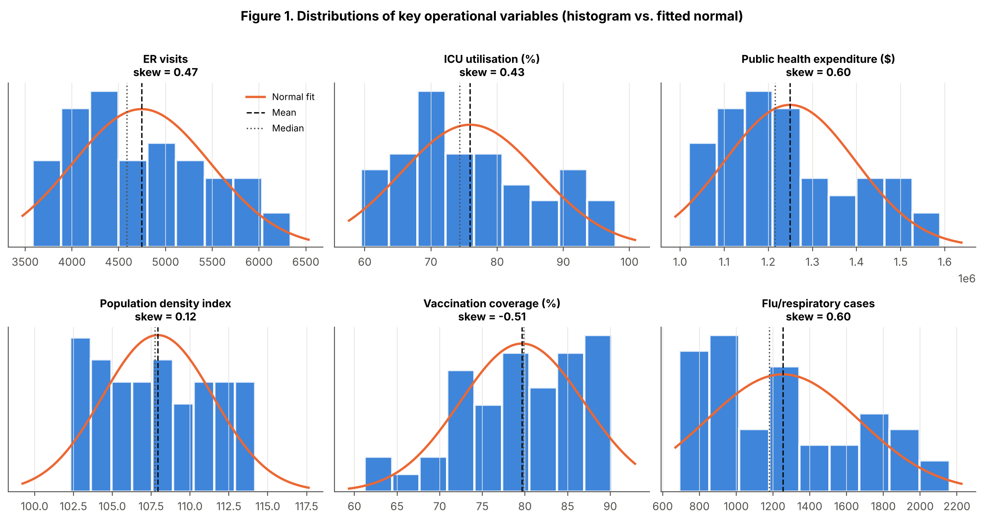
Figure 1. Histograms with fitted normal curves; dashed = mean, dotted = median.

1.3 Multi-dimensional pivot analysis and KPIs
Table 2. Annual KPI pivot with calculated fields and year-over-year growth
Year | ER visits | YoY % | Flu cases | Expenditure $m | $ per ER visit | ER visits per flu case | Mean ICU % | Peak ICU % | Months ICU > 85%
2021 | 50,980 | – | 12,590 | 13.76 | 269.91 | 4.05 | 69.9 | 86.2 | 1
2022 | 55,740 | 9.3 | 14,630 | 14.69 | 263.55 | 3.81 | 74.5 | 90.1 | 2
2023 | 58,960 | 5.8 | 15,820 | 15.39 | 261.02 | 3.73 | 78.0 | 94.0 | 4
2024 | 62,080 | 5.3 | 17,110 | 16.12 | 259.66 | 3.63 | 81.2 | 97.9 | 4

Table 3. Pivot: share of annual ER visits by quarter (% of column total) and mean ICU % by season
Dimension | 2021 | 2022 | 2023 | 2024
Q1 share of visits | 26.5% | 27.6% | 27.7% | 27.8%
Q2 share of visits | 22.0% | 21.7% | 21.7% | 21.6%
Q3 share of visits | 22.6% | 22.3% | 22.3% | 22.3%
Q4 share of visits | 28.9% | 28.3% | 28.3% | 28.3%
Winter mean ICU % | 79.6 | 87.2 | 91.3 | 95.2
Summer mean ICU % | 61.1 | 64.1 | 67.1 | 69.9

The pivots (Tables 2–3; workbook sheets Pivot_Tables and Pivot_Formulas) give four operational KPIs. First, volume growth is slowing but persistent: ER visits grew 9.3% in 2022, then 5.8% and 5.3%. Second, demand is concentrated in Q1 and Q4, which now carry 56% of annual visits, against 44% in Q2–Q3. Third, winter ICU pressure is rising faster than demand. Winter mean ICU utilisation rose 15.6 percentage points (79.6% to 95.2%), while summer rose only 8.8 points, so the surge is eroding the safety margin precisely when it is most needed. Fourth, unit cost is falling. Expenditure per ER visit fell 3.8%, from $269.91 to $259.66, which shows economies of scale. ER visits per respiratory case also fell 10%, from 4.05 to 3.63, which is consistent with rising vaccination reducing the severity of each infection.

1.4 Correlation structure
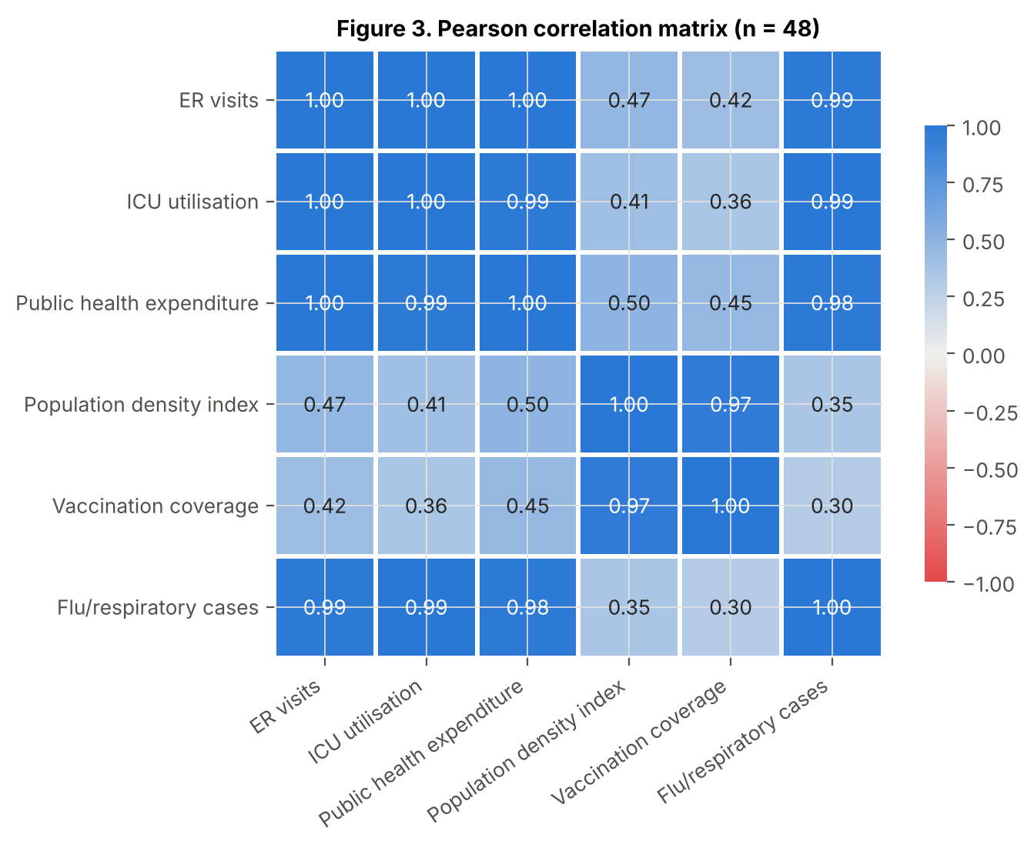
Figure 3. Pearson correlation heat map.
The heat map (Figure 3) reveals two clusters. The seasonal-demand cluster (ER visits, ICU utilisation, expenditure and flu cases) is almost perfectly correlated (r = 0.983–0.998). The structural-trend cluster (population density and vaccination coverage, r = 0.973) consists of two variables that rise steadily over time. Correlations between the clusters are moderate (0.30–0.50) but still significant at α = 0.05. Two implications follow. ICU utilisation and expenditure are *consequences* of patient volume, so using them to "predict" ER visits would be circular; they are excluded as predictors in Section 2. And population density and vaccination coverage are likely to be collinear in any joint model.

1.5 Pattern recognition and anomaly detection
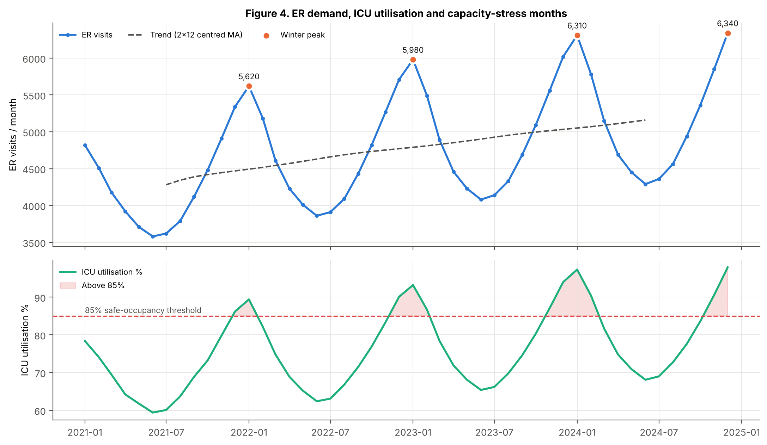
Figure 4. ER visits with trend and winter peaks (top); ICU utilisation and months above the 85% threshold (bottom).
Anomalies were screened in three ways: raw z-scores, the irregular component left after the seasonal decomposition, and operational thresholds. Five patterns stand out.
- No crisis or supply-chain shocks. The largest irregular deviation is only 0.55% of the expected level. Two months, July 2021 and April 2022, are statistically flagged (|z| > 2) but differ by only about 20–25 visits, which is operationally immaterial.
- Capacity-stress anomaly. ICU utilisation exceeded 85% in 11 months, exceeded 90% in seven, and reached 97.3% (January 2024) and 97.9% (December 2024). The literature associates sustained occupancy above about 85% with bed shortages and access delays (Bagust, Place and Posnett, 1999).
- Vaccination regime change. Coverage rose 2.6 percentage points a month in early 2021 (the campaign roll-out), then settled at about 0.45 points a month.
- Post-pandemic rebound. In 2022, flu cases rose 16.2% and ER visits 9.3%, about double the later rates. This suggests that 2021 was a suppressed base year.
- Recurrent summer bump. July exceeds June every year (+1.1% to +1.6%), a small secondary peak in an otherwise quiet period.

Section 2 — Predictive Regression Analysis (Unit 5)

2.1 Simple linear regression
The target is monthly ER visits, the primary operational volume that drives staffing. Among the exogenous continuous drivers, flu/respiratory cases are the most correlated (r = 0.988). Ordinary least squares gives:
ER_Visits = 2,552.71 + 1.7495 × Flu_Resp_Cases
The slope is highly significant (t = 42.66, p < 0.001). R² = 0.9753, Adjusted R² = 0.9748, F = 1,819.5 and the standard error is 117.4 visits. Each additional respiratory case is associated with about 1.75 additional ER visits. The intercept, about 2,553 visits, is the non-respiratory baseline. It is a structural floor of demand that exists even in a flu-free month (Figure 5). However, the Breusch-Pagan test (p = 0.013) and Durbin-Watson statistic (0.19) show heteroscedastic, autocorrelated residuals. The single predictor leaves a systematic, trending component unexplained, and that motivates the multiple model.
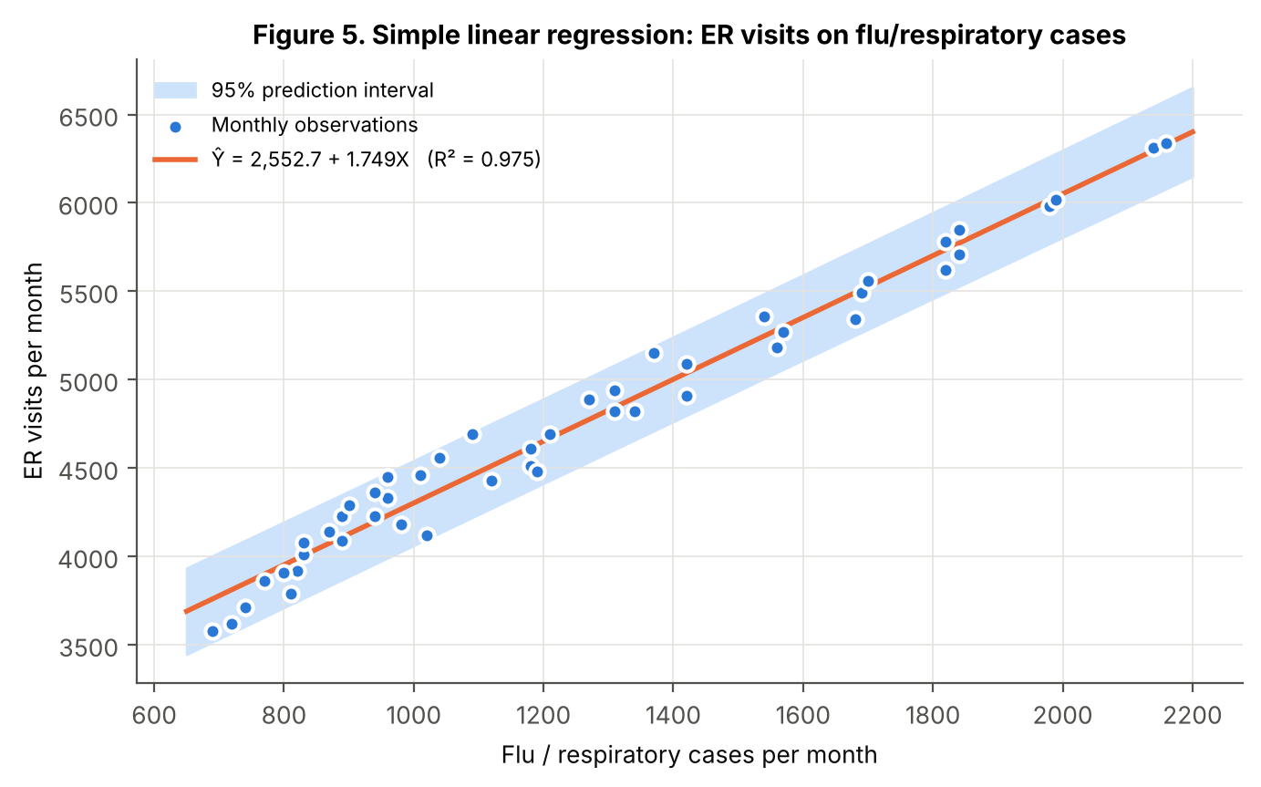
Figure 5. Simple linear regression with 95% prediction interval.

2.2 Multiple linear regression
The full specification adds population density and vaccination coverage as socio-demographic predictors, plus a categorical baseline dummy (Winter = 1 for December–February; the baseline is the other nine months):
ER_Visits = β₀ + β₁·Flu + β₂·PopDensity + β₃·Vaccination + β₄·Winter + ε
Table 4. Multiple linear regression results (dependent variable: monthly ER visits)
Term | Full: β | Full: SE | Full: p | Full: VIF | Refined: β | Refined: SE | Refined: p | Refined: VIF
Intercept | -1,750.13 | 742.66 | 0.023 | – | -697.62 | 292.99 | 0.022 | –
Flu/resp. cases | 1.6461 | 0.0352 | < 0.001 | 3.09 | 1.6391 | 0.0354 | < 0.001 | 3.04
Pop. density idx | 47.06 | 10.61 | < 0.001 | 20.48 | 31.35 | 2.90 | < 0.001 | 1.48
Vaccination % | -8.15 | 5.30 | 0.131 | 21.11 | (dropped) |  |  | –
Winter dummy | 8.07 | 32.68 | 0.806 | 2.93 | 22.70 | 31.75 | 0.478 | 2.68
Adjusted R² | 0.9940 |  |  |  | 0.9938
F-statistic (p) | 1,947.6 (<0.001) |  |  |  | 2,517.9 (<0.001)
Std error of estimate | 57.3 |  |  |  | 58.2

2.3 Assumption testing
Table 5. Regression assumption diagnostics
Assumption / test | SLR | MLR full | MLR refined | Decision (α = 0.05)
Normality — Shapiro-Wilk p | 0.623 | 0.580 | 0.394 | Normal residuals
Normality — Jarque-Bera p | 0.507 | 0.895 | 0.848 | Normal residuals
Homoscedasticity — Breusch-Pagan p | 0.012 | 0.732 | 0.517 | Constant variance in MLR
Homoscedasticity — White p | 0.036 | 0.064 | 0.075 | Not rejected in MLR
Multicollinearity — max VIF | 1.00 | 21.11 | 3.04 | Full model fails (VIF > 10)
Independence — Durbin-Watson | 0.19 | 0.64 | 0.70 | Positive autocorrelation → HAC SEs

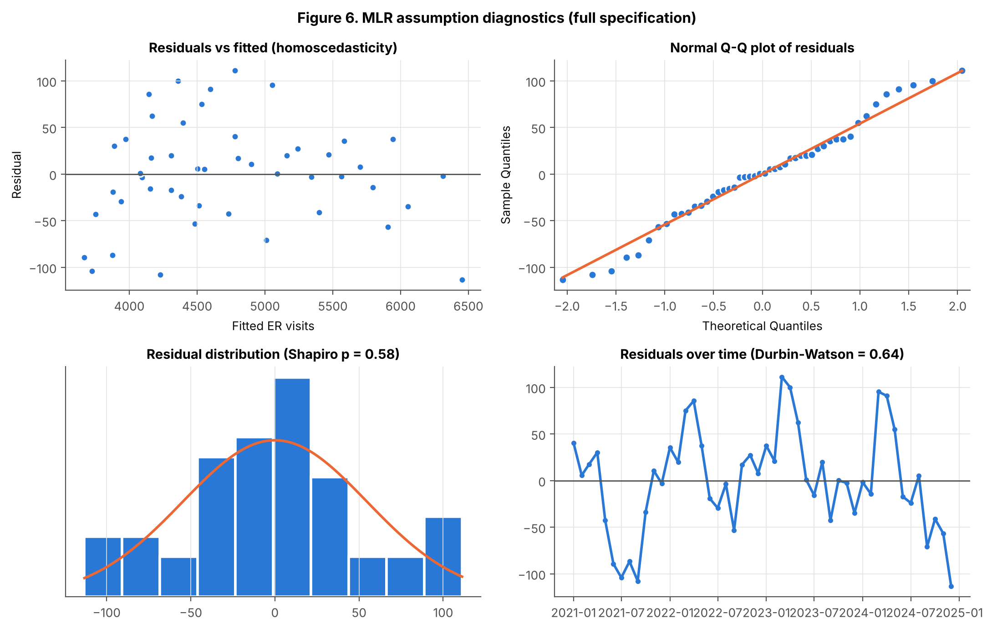
Figure 6. Residual diagnostics for the full MLR.
The residuals of both multiple models pass both normality tests (Shapiro-Wilk p ≥ 0.39; Jarque-Bera p ≥ 0.85) and the Breusch-Pagan homoscedasticity test (p ≥ 0.52). The Q-Q plot and residual-versus-fitted plot (Figure 6) show no funnel or curvature. Adding population density removed the heteroscedasticity seen in the simple model. Multicollinearity is the material violation. Population density and vaccination coverage have VIFs of 20.5 and 21.1 (tolerance < 0.05) because they share a common upward trend. Collinearity inflates their standard errors, which is why vaccination coverage appears non-significant (p = 0.131) despite its plausible protective sign. The refined model drops vaccination coverage, the weaker of the pair. All VIFs then fall below 3.1 and Adjusted R² barely changes (0.9940 to 0.9938), which confirms that the dropped variable carried redundant information. The Durbin-Watson statistics (0.64–0.70) show positive serial correlation, which is typical of monthly data. Re-estimating with Newey-West HAC standard errors (Newey and West, 1987) leaves every significance conclusion unchanged: flu and population density p < 0.001, Winter p = 0.33.

2.4 Interpretation of coefficients and model fit
In the refined model, Adjusted R² = 0.9938. The predictors explain 99.4% of the variation in monthly ER visits, and the F-statistic (2,517.9, p < 0.001) rejects the null hypothesis that all slopes are zero. The standard error falls from 117 visits (simple model) to 58, halving typical prediction error. At α = 0.05:
- Flu/respiratory cases (β = 1.639, p < 0.001; standardised β = 0.93). Holding population density and season constant, every 100 extra respiratory cases bring about 164 extra ER visits. This is by far the dominant driver. A 10% flu increase at the January 2024 peak (2,140 cases) would add about 351 visits a month.
- Population density index (β = 31.35, p < 0.001). Each one-point rise adds about 31 visits a month, independent of infection levels. The index rises about 3.05 points a year, so this implies about 96 extra visits a month every year, roughly 1,150 a year or 1.9% of 2024 volume. This growth is structural and permanent, not seasonal.
- Winter dummy (β = 22.7, p = 0.48). Not significant, so the null hypothesis cannot be rejected. Once infection levels are known, the calendar has no extra explanatory power. Winter pressure works *through* respiratory illness, so monitoring infections gives a better planning signal than the calendar.
- Vaccination coverage (full model β = −8.15 per percentage point, p = 0.131). The sign suggests protection (fewer visits as coverage rises), but the effect cannot be statistically separated from population growth with 48 observations. It should be read as suggestive, not proven.
Implications for leadership. First, the coefficients set a quantitative staffing rule: each 1,000 forecast respiratory cases implies about 1,640 ER visits, or about 53 visits a day, which supports flu-indexed rostering. Second, population growth calls for a permanent annual uplift in baseline ER capacity of about 2%, funded through the recurrent budget rather than winter contingencies. Third, a supplementary regression of expenditure on ER visits (R² = 0.996) gives a marginal cost of about $200 per ER visit. This converts volume forecasts into budget lines and lets each avoided visit be valued, for example when appraising vaccination outreach.

Section 3 — Time Series Forecasting (Unit 6)

3.1 Decomposition and structural components
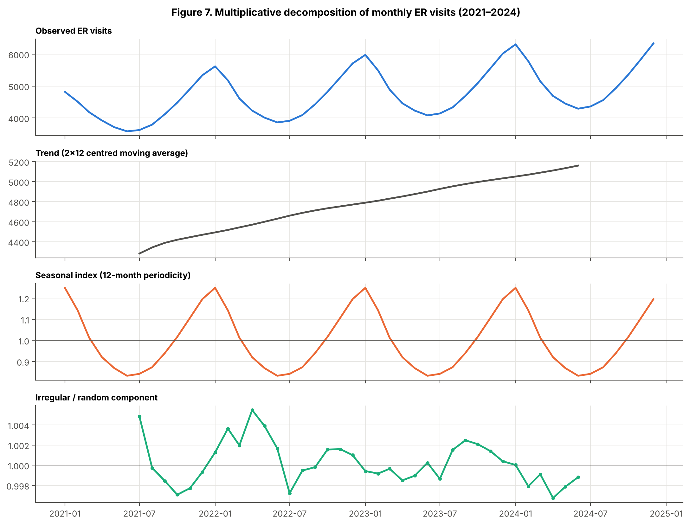
Figure 7. Multiplicative decomposition of ER visits into trend, seasonal and irregular components.
A classical decomposition (Figure 7) split the 48-month ER series into three parts. The trend, a 2×12 centred moving average, rises steadily from about 4,280 to about 5,160 visits, and its slope eases after 2022. The seasonality has a 12-month periodicity: the indices peak in January (1.249) and December (1.196), bottom out in June (0.832), and show a small July shoulder (0.841). The irregular component is very small, with a residual standard deviation of just 10 visits under the multiplicative form. Business-cycle effects were not separately identifiable over four years and are absorbed into the trend.
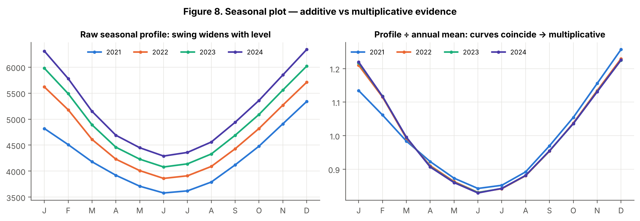
Figure 8. Seasonal plot: raw profiles (left) and profiles divided by the annual mean (right).
Additive or multiplicative? The line graphs (Figure 8) show the seasonal swing widening as the level rises: the peak-to-trough range grows from 1,760 to 1,850, 1,940 and 2,050 visits. Meanwhile, the peak-to-trough *ratio* stays almost constant (1.492, 1.479, 1.475, 1.478). Once each year is divided by its annual mean, the four curves sit on top of one another. Seasonal fluctuations are therefore proportional to the level, which makes them multiplicative. This is confirmed by the irregular-component standard deviation: 10.0 visits for the multiplicative form against 35.7 for the additive.

3.2 Moving averages
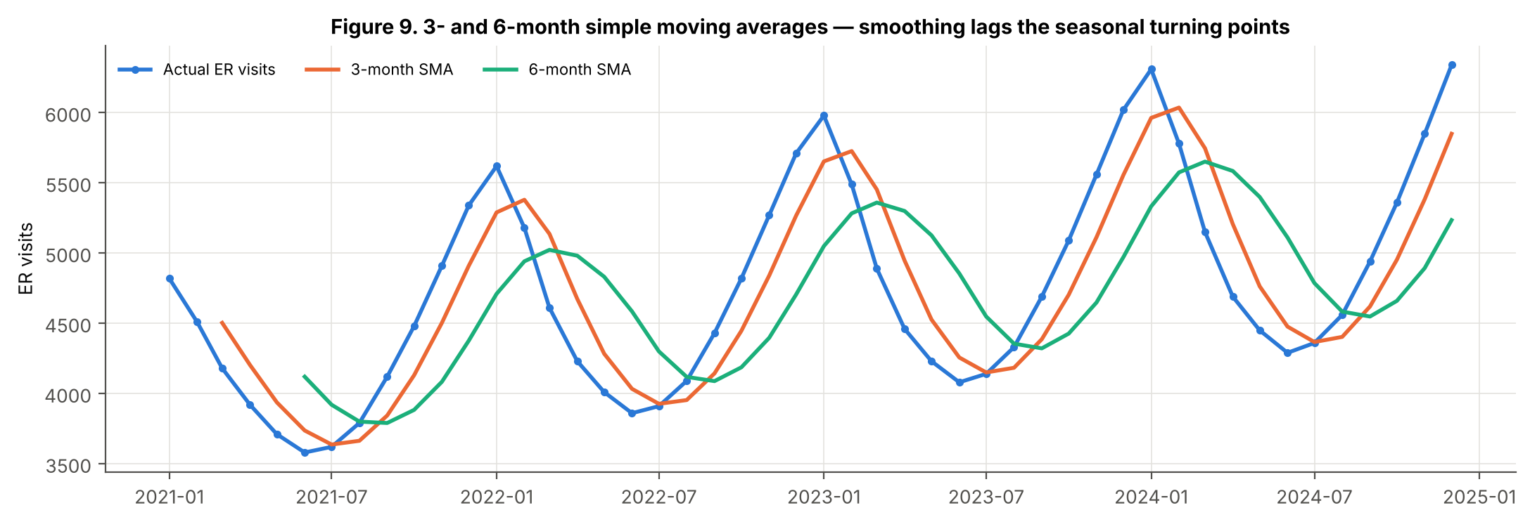
Figure 9. 3-month and 6-month simple moving averages.
The 3-month and 6-month SMAs (Figure 9) smooth the noise but, by construction, lag the turning points by about one and three months. The 6-month SMA almost flattens the seasonal cycle. Used as one-step-ahead forecasts, they under-predict every autumn ramp-up and over-predict every spring decline. These are exactly the months when staffing decisions matter most.

3.3 Holt-Winters exponential smoothing
A multiplicative Holt-Winters model (Winters, 1960) updates three components each month: level (α), trend (β) and seasonality (γ). Initial seasonal indices came from the ratio-to-moving-average decomposition, and the initial level and trend from a linear fit to the deseasonalised series. The parameters were chosen to minimise the in-sample one-step-ahead sum of squared errors. The fitted values are α = 0.99, β = 0.01 and γ = 0.44 on the training window (γ = 0.19 on the full series). In practice this means the level tracks each new observation almost fully, the trend slope is very stable at about +25 visits a month, and the seasonal shape adapts gradually. These values suit a low-noise, highly persistent series. The workbook reproduces the full recursion with cell formulas (sheets HW_Holdout and HW_Final_2025), so Excel Solver can re-optimise the parameters.

3.4 Out-of-sample evaluation
Table 6. Forecast accuracy on the 12-month 2024 hold-out
Model (trained 2021–2023, tested 2024) | MAPE % | RMSE | MAE | Bias
HW multiplicative (selected) | 0.79 | 43.4 | 40.4 | 40.4
HW multiplicative (statsmodels) | 0.95 | 57.2 | 49.5 | -14.8
Seasonal naïve | 5.02 | 262.9 | 260.0 | -260.0
HW additive (statsmodels) | 5.24 | 274.6 | 253.0 | 250.5
SMA6 (flat, 12-step) | 11.65 | 743.4 | 625.0 | -201.7
SMA3 (rolling 1-step) | 12.07 | 701.6 | 629.2 | -50.3
SMA3 (flat, 12-step) | 14.95 | 811.7 | 725.6 | 383.3
SMA6 (rolling 1-step) | 16.40 | 936.6 | 850.0 | -81.7

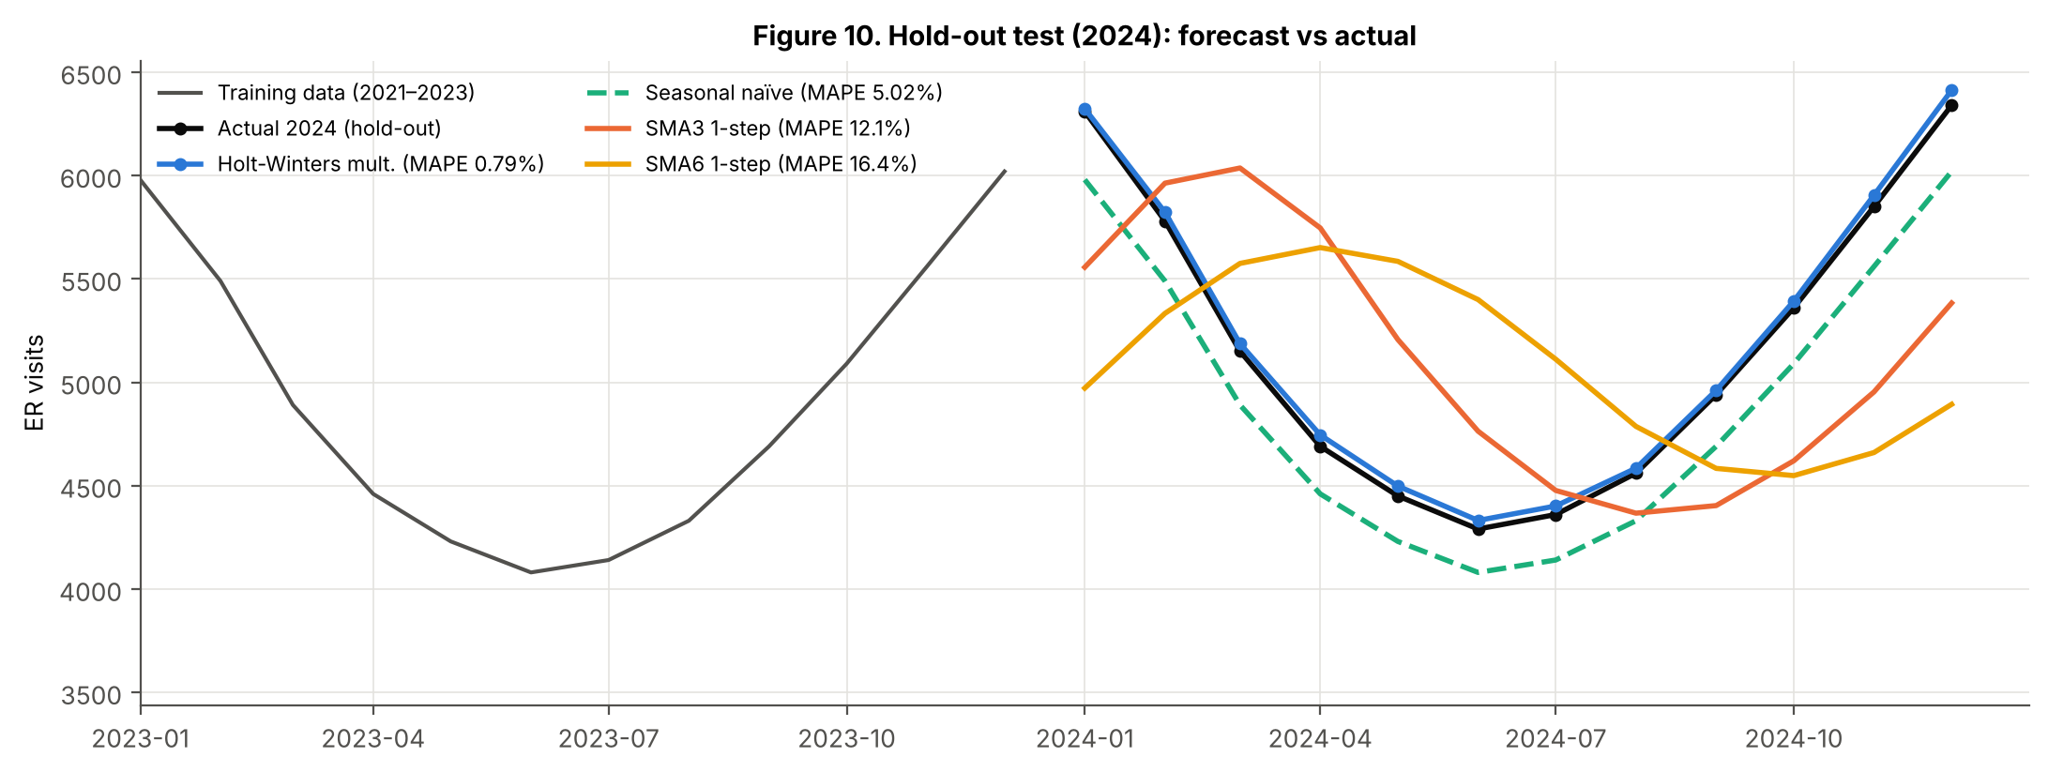
Figure 10. 2024 hold-out: actual versus forecasts.
Every model was trained on 2021–2023 and asked to forecast 2024 (Table 6, Figure 10). Multiplicative Holt-Winters is decisively the best model: MAPE 0.79% and RMSE 43 visits, about 1.3 visits a day. The library (statsmodels) implementation confirms the result (0.95%). The additive Holt-Winters variant is more than six times worse (MAPE 5.2%), which empirically confirms the multiplicative diagnosis. Seasonal naïve (5.0%) captures the shape but misses the growth, so it under-forecasts by 260 visits a month on average. The SMAs are unsuitable for seasonal planning (MAPE 11.7–16.4%; RMSE 700–940 visits). Even with the advantage of being re-estimated every month, they are about 15–21 times less accurate than Holt-Winters. Holt-Winters is therefore selected. Its small positive bias (+40 visits) is a prudent direction for capacity planning.

3.5 2025 forecast
Table 7. 2025 forecast and capacity translation (Holt-Winters multiplicative; intervals from rolling-origin cross-validation)
2025 | ER forecast | 95% PI | Daily visits | Staffing index | ICU forecast % | Extra ICU beds for 85% | Spend above flat budget $k
Jan | 6,655 | 6,613–6,697 | 215 | 1.29 | 101.4 | +19.3% | 238
Feb | 6,116 | 6,054–6,177 | 218 | 1.18 | 94.0 | +10.5% | 130
Mar | 5,447 | 5,375–5,519 | 176 | 1.05 | 85.2 | +0.2% | –
Apr | 4,974 | 4,892–5,055 | 166 | 0.96 | 78.2 | – | –
May | 4,714 | 4,630–4,798 | 152 | 0.91 | 74.1 | – | –
Jun | 4,539 | 4,451–4,626 | 151 | 0.88 | 71.0 | – | –
Jul | 4,609 | 4,501–4,717 | 149 | 0.89 | 72.0 | – | –
Aug | 4,804 | 4,689–4,919 | 155 | 0.93 | 75.9 | – | –
Sep | 5,198 | 5,063–5,332 | 173 | 1.00 | 81.4 | – | –
Oct | 5,645 | 5,482–5,809 | 182 | 1.09 | 87.1 | +2.5% | 36
Nov | 6,175 | 5,971–6,380 | 206 | 1.19 | 94.7 | +11.4% | 142
Dec | 6,699 | 6,450–6,948 | 216 | 1.29 | 102.3 | +20.3% | 247
Total | 65,574 |  |  |  |  |  | 793

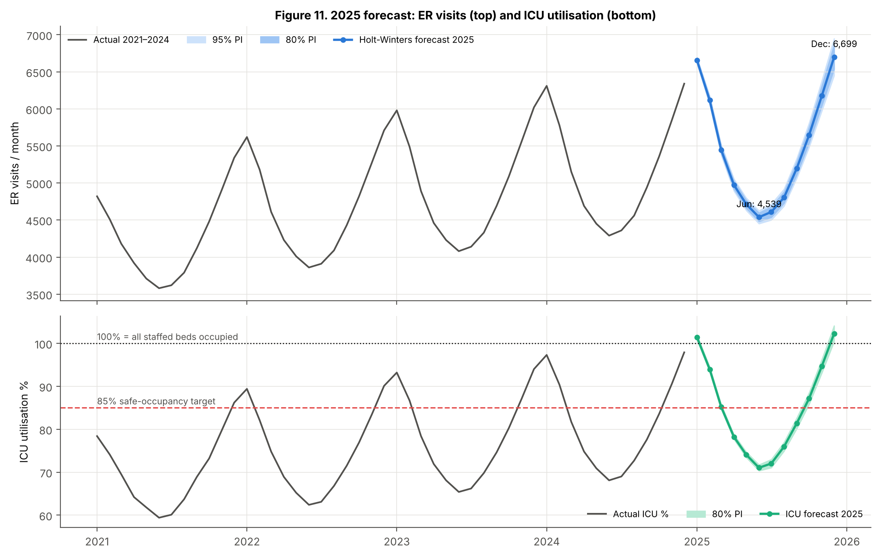
Figure 11. 2025 forecasts with prediction intervals: ER visits (top) and ICU utilisation (bottom).
Refitted on all 48 months, the model projects 65,574 ER visits in 2025 (+5.6%) (Table 7, Figure 11). The year has twin winter peaks, January (6,655) and December (6,699), and a June trough (4,539). The peak-to-trough staffing ratio is 1.48. The prediction intervals come from rolling-origin cross-validation (Hyndman and Athanasopoulos, 2021): the model was refitted at 24 forecast origins. The 95% interval widens from ±0.6% in January to ±3.7% in December. Applying the same method to ICU utilisation gives readings above 85% from October to March, and above 100% of current staffed beds in January (101.4%) and December (102.3%). Values above 100% do not mean patients will occupy beds that do not exist. They mean demand will exceed staffed capacity, causing boarding in the ER, transfers or cancelled elective admissions unless capacity is added. February has the highest *daily* ER load (218 a day, because it has only 28 days), and July the lowest (149 a day).

Section 4 — Strategic Recommendations & Action Plan
The recommendations below link each action to a specific model output.
- R1. Flexible seasonal workforce. Size permanent ER rosters to the summer base (staffing index 0.88–0.93, about 150 visits a day). Then build a bank/agency and overtime pool covering a 29% uplift in December–January, 18–19% in November and February, and 9% in October. Approve annual leave mainly in May–August. Begin winter recruitment by August, before the September ramp-up (index 1.00 rising to 1.09).
- R2. ICU surge capacity. Hold ICU occupancy at the 85% target by commissioning about 20% more staffed ICU capacity for December–January and 10–11% for November and February. Do this by converting step-down/HDU beds, cross-training theatre recovery nurses and agreeing mutual-aid transfers with neighbouring hospitals. Schedule elective surgery that needs ICU into April–September, when utilisation is forecast at 71–81%.
- R3. Flu-indexed early warning. Use the regression coefficient (1.64 visits per case) as a trigger. When monthly respiratory cases exceed the forecast by 10% (about 230 cases in a winter month), activate surge level 1, which means about 380 extra visits that month. At 15%, activate level 2. A 2022-style severe season (+15% flu) would add about 4,580 visits over the year, raise peak-month ER demand to about 7,270 and push ICU utilisation to about 111%.
- R4. Budget and emergency reserves. The 2025 expenditure forecast is $16.72m (+3.7%). Because of seasonality, a flat monthly allocation of $1.39m would be overspent from October to February, so ring-fence a $0.79m winter-surge reserve. Add a $0.92m severe-season contingency sized on the +15% flu scenario. The combined $1.71m (about 10% of budget) should be released in stages linked to the R3 triggers.
- R5. Prevention. Run vaccination outreach in September–October, before the October rise in infections, and target 92% coverage. ER visits per infection have fallen 10% since 2021, and each avoided ER visit is worth about $200. Collect data on age-specific coverage and severity to test the effect formally.
- R6. Structural growth and model governance. Add about 2% a year to recurrent ER capacity to absorb population-driven growth (about 96 visits a month each year). Re-run the Holt-Winters model monthly, track a rolling MAPE, and re-estimate if it exceeds 2% for two consecutive months. Record staffed bed counts so that utilisation can be converted into absolute numbers of beds.
Table 8. Implementation action plan
Timing | Action | Owner | KPI / target
Immediately (Jan–Feb 2025) | Winter roster at 1.29× (Jan) and 1.18× (Feb); ICU +20% / +11% staffed capacity; ring-fence the reserves | Chief operating officer / CFO | ICU ≤ 85%; no unplanned elective cancellations
Apr–Sep 2025 | Concentrate elective ICU work, annual leave and training in the trough | Clinical directors | ICU 71–81%; leave uptake ≥ 70% in May–Aug
Aug–Sep 2025 | Recruit bank/agency pool; launch vaccination campaign; agree ICU mutual-aid protocol | Workforce & public-health leads | Pool covers +29% hours; coverage ≥ 92%
Oct 2025 | Activate surge level 0; open first ICU flex beds (+2.5%); start flu-trigger monitoring | Operations director | ICU ≤ 85%; forecast MAPE < 2%
Nov–Dec 2025 | Full winter roster (1.19–1.29×); ICU +11% to +20%; release reserve against R3 triggers | Chief operating officer / CFO | ER wait targets met; reserve variance within plan
Quarterly | Refresh forecasts; review the budget variance against the $200 per-visit marginal cost | Analytics & finance | Variance within ±5%

Limitations
The series has only 48 observations and is very smooth, so prediction intervals may understate real-world shocks such as a pandemic wave or industrial action; the stress test partly compensates for this. The ICU data are rates without bed counts, so recommendations are expressed in relative terms. Regression results are associations, not proven causal effects, and the effect of vaccination cannot be isolated from population growth with these data.

Conclusion
Demand for emergency and critical care is growing by about 5–6% a year, driven by respiratory infection and population density, with a stable multiplicative seasonal pattern. Holt-Winters forecasts this pattern with sub-1% error. The forecasts show that ICU capacity, not ER volume, will be the binding constraint in winter 2025. A flu-triggered, seasonally flexed workforce, about 20% winter ICU surge capacity and a $1.7m staged reserve address that constraint directly.

References
Bagust, A., Place, M. and Posnett, J.W. (1999) ‘Dynamics of bed use in accommodating emergency admissions: stochastic simulation model’, BMJ, 319(7203), pp. 155–158.
Breusch, T.S. and Pagan, A.R. (1979) ‘A simple test for heteroscedasticity and random coefficient variation’, Econometrica, 47(5), pp. 1287–1294.
Durbin, J. and Watson, G.S. (1950) ‘Testing for serial correlation in least squares regression: I’, Biometrika, 37(3/4), pp. 409–428.
Holt, C.C. (2004) ‘Forecasting seasonals and trends by exponentially weighted moving averages’, International Journal of Forecasting, 20(1), pp. 5–10 (reprint of 1957 ONR memorandum).
Hyndman, R.J. and Athanasopoulos, G. (2021) Forecasting: Principles and Practice. 3rd edn. Melbourne: OTexts. Available at: https://otexts.com/fpp3/.
Jarque, C.M. and Bera, A.K. (1980) ‘Efficient tests for normality, homoscedasticity and serial independence of regression residuals’, Economics Letters, 6(3), pp. 255–259.
Montgomery, D.C., Peck, E.A. and Vining, G.G. (2021) Introduction to Linear Regression Analysis. 6th edn. Hoboken, NJ: Wiley.
Newey, W.K. and West, K.D. (1987) ‘A simple, positive semi-definite, heteroskedasticity and autocorrelation consistent covariance matrix’, Econometrica, 55(3), pp. 703–708.
Shapiro, S.S. and Wilk, M.B. (1965) ‘An analysis of variance test for normality (complete samples)’, Biometrika, 52(3/4), pp. 591–611.
Winters, P.R. (1960) ‘Forecasting sales by exponentially weighted moving averages’, Management Science, 6(3), pp. 324–342.
Wooldridge, J.M. (2020) Introductory Econometrics: A Modern Approach. 7th edn. Boston, MA: Cengage.

Appendix A — Analytical file guide
Table A1. Where each brief requirement is evidenced
Brief requirement | Excel workbook sheet | Notebook section
Mean, median, SD, IQR, skewness | Descriptive_Stats | 1.1
Frequency distributions & histograms | Frequency | 1.2
Multi-dimensional pivots, % of column, YoY, calculated fields | Pivot_Tables (native), Pivot_Formulas | 1.3
Correlation heat map | Correlation | 1.4
Anomaly detection | Anomalies | 1.5
Simple linear regression & equation | SLR | 2.1
MLR (3 continuous + 1 dummy), VIF, normality, homoscedasticity | MLR_Full, MLR_Refined | 2.2–2.3
Decomposition, additive vs multiplicative | Decomposition | 3.1
3- and 6-month SMA | SMA | 3.2
Holt-Winters (level, trend, seasonality) | HW_Holdout, HW_Final_2025 | 3.3
MAPE & RMSE comparison | Model_Comparison | 3.4
12-month 2025 forecast & recommendations | Forecast_2025 | 3.5, 4

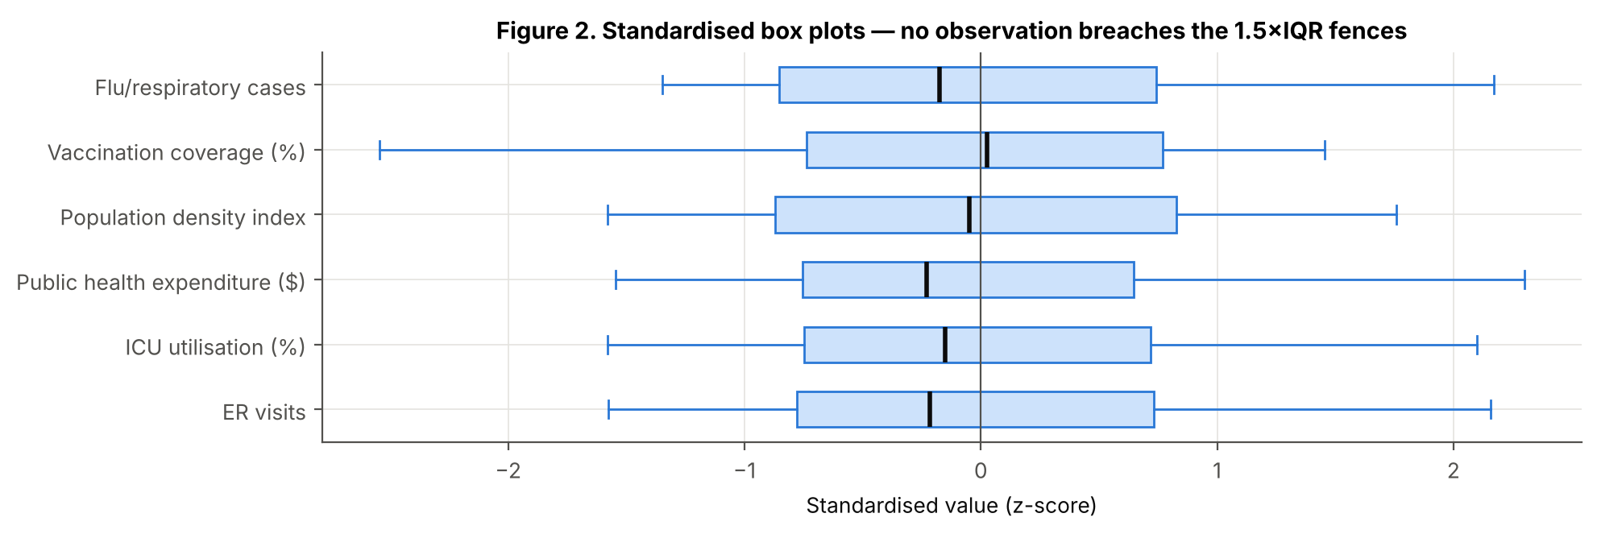
Figure 2 (appendix). Standardised box plots: no values breach the 1.5×IQR fences.
Holt-Winters equations (multiplicative): Lₜ = α·Yₜ/Sₜ₋₁₂ + (1−α)(Lₜ₋₁+Tₜ₋₁); Tₜ = β(Lₜ−Lₜ₋₁) + (1−β)Tₜ₋₁; Sₜ = γ·Yₜ/Lₜ + (1−γ)Sₜ₋₁₂; Ŷₜ₊ₕ = (Lₜ + h·Tₜ)·Sₜ₊ₕ₋₁₂. Accuracy: MAPE = (100/n)Σ|Aₜ−Fₜ|/Aₜ; RMSE = √[(1/n)Σ(Aₜ−Fₜ)²].

