## ZERO OVER HEAD LOOP FIR PROCESSOR

**Sourindu Chatterjee**

**Dr. Uwe Meyer Baese**

**Department of Electrical and Computer Engineering**

**EEL - 5722**

**Florida State University**

**Spring 2016**

## Brief Description

The reason for this project is to actualize the hardware specific strategy found in most DSP processors, ZERO OVER HEAD LOOPING towards the improvement of a FIR microprocessor. The design filter coefficients are continuous and are supplied to the processor as a signal input [5]. The design has an innovative approach to adaptive filtering thus providing a way to change the filter length in real-time during execution of different processor states. The input value are loaded in before the initiation of a full convolution cycle and then again another convolution initiates repeating the same process. The key objective of the design is to provide a way for the microprocessor to have a single embedded multiplier for any number of filer coefficients.

## Definition of the Problem

Well the execution of Zero Overhead Loop (ZOL) for different embedded DSP chips is different in perspective when comparison is drawn between hardware and software implementation of the same [1]. As discussed earlier this project is about usage of Zero Overhead Loop control in Hardware thus coded in Very Fast Hardware Description Language (VHDL) for the outline of a ZOL FIR microprocessor, such that the execution of cyclic ‘Multiply and Accumulate’ for each convolution phase takes only one cycle for each execution and furnishes the final convolution result after n number of cycles where n is the number of coefficients in the FIR system. There is another challenge connected with the advancement of this FIR microprocessor [2], which is to make the loading of the coefficients in real-time as an input signal. Well this problem is addressed and in addition to this there has been an additional enhancement to the design which enables the microprocessor to load in filter length or the number of coefficients through an input signal. This makes the design more robust, dynamic and adaptive [3].

## Solution to the Problem

We realize that the most crucial mathematical equation in FIR microprocessor development is the Sum-Of-Product (SOP) evaluation, y[n] = ∑h[k] ∗ x [n−k] [6] [5], which can be likewise termed as convolution in the time domain of data value x and filter impulse response h. This is the reason ZOL is paramount to the execution, because this bit of mathematical statement requires multiple Embedded Multiplier blocks in any Digital Signal Processors or FPGA`s. The convolution under ordinary microprocessors require and information to be executed in a loop over n number of times, each time a piece comparison is made [6][1][3] inside a convolution phase.

The issue identifying with ZOL is critical and now and again crucial to the proficiency of the DSP microchip. In this anticipation the projects purpose is to build up a FIR chip with ZOL support. This is completely genuine on the grounds that the vast majority of the tasks performed by DSP chip are on real-time systems where the cycles per convolution should be as less as possible expected under these dynamic circumstances, whether it is ALU performance or cyclic guideline, the reduction in the execution time is essential and a basic component in deciding efficiency of the framework [4].

Thus the design of the ZOL Fir microprocessor is implemented with the soul target that the number of embedded multiplier blocks in the design should be equal to 1 and that the design should produce convolution output in n number of cycles where n will be equal to the number of coefficients in the coefficient array.

## Code Procedure & Flow

The project is coded in VHDL code composed and arranged with Quartus II programming. The simulations are done with ModelSim. The utilization of Matlab is likewise there to create channel coefficients set and determine the correctness of the output.

The design can be broadly classified into five sections: reset, start, mac, trans & done. The proceedings of these sections will be briefly described.

**reset** : In this section the system first enter it is the default section at the beginning of the program. The “**reset**” signal is an external asynchronous reset and sets all registers and register arrays to ‘0’. There is also an internal reset signal, “**rst**” associated with section which gets triggered the filter length “**L_in**” or the coefficient input switch “**Load_c**” gets changed from previous values. After completion of these state the design enter the synchronous section.

**start** : This stage basically sets the base for the whole execution cycle to proceed. The primary aim of this section is loading of input coefficients and input data and placing them is respective integer register arrays. This state depends on coefficient loading signal “**Load_c**” and data loading control signal “**Load_x**”.

**trans** : This stage is there to make the input of the next data feasible without hampering the existing output of the processor. This makes use of the input loading switch “**Load_x**” to load the new input data. These stage also shift the previous values one position to fit in the newest data in the stream.

**mac** : This is the most important stage in the execution cycle. This is the section where the ZOL is implemented in order to get the best performance out of any hardware in which this processor will be implemented. In this stage the product of each elements in the coefficient array and data array is computed and the accumulator “**d**” is modified in each clock cycle to display the current accumulated value. At the end of each “**mac**” stage this accumulated value is transferred to a register “**a_temp**” which is then furnished to the output “**y_out**”. These stage which in the middle of MAC execution cycle does not care to check any changes in the parameter, only at the end of the execution these checks are resumed.

**done** : These stage signifies the end of one convolution cycle and the control remains in this stage until any changes to switching signals like “**L_in**”, “**Load_x**” or “**Load_c**”. On the onset of such a change the control moves to ‘trans” state in case of change in “**Load_x**” or “**start**” state in case of changes to other switching signal.

Code Segment

PACKAGE n_bit_int IS -- User defined type

SUBTYPE S15 IS INTEGER RANGE -2**14 TO 2**14-1;

TYPE STATE_TYPE IS (start, trans, mac, done);

END n_bit_int;

LIBRARY ieee;

USE ieee.std_logic_1164.ALL;

USE ieee.std_logic_arith.ALL;

USE ieee.std_logic_signed.ALL;

LIBRARY ieee_proposed;

USE ieee_proposed.fixed_float_types.ALL;

USE ieee_proposed.fixed_pkg.ALL;

USE ieee_proposed.float_pkg.ALL;

LIBRARY work;

USE work.n_bit_int.ALL;

ENTITY firzol IS

GENERIC (W1 : INTEGER := 9; -- Input bit width

W2 : INTEGER := 18;-- Multiplier bit width 2*W1

W3 : INTEGER := 19;-- Adder width = W2+log2(L)-1

W4 : INTEGER := 11;-- Output bit width

L : INTEGER := 7 -- Filter length

);

PORT(

clk : IN STD_LOGIC; -- System clock

reset : IN STD_LOGIC; -- Asynchronous reset

Load_x : IN STD_LOGIC; -- data input/loading switch

Load_c : IN STD_LOGIC; -- coefficients input switch

L_in : IN INTEGER RANGE 1 TO L; --The actual number of coefficients

x_in : IN STD_LOGIC_VECTOR(W1-1 DOWNTO 0);-- System input

c_in : IN STD_LOGIC_VECTOR(W1-1 DOWNTO 0);-- Coefficient data input

y_out : OUT STD_LOGIC_VECTOR(W3-1 DOWNTO 0));--System Output result

END firzol;

ARCHITECTURE fpga OF firzol IS

SUBTYPE SLVW1 IS STD_LOGIC_VECTOR(W1-1 DOWNTO 0);

SUBTYPE SLVW2 IS STD_LOGIC_VECTOR(W2-1 DOWNTO 0);

SUBTYPE SLVW3 IS STD_LOGIC_VECTOR(W3-1 DOWNTO 0);

TYPE A0_L1SLVW1 IS ARRAY (0 TO L-1) OF SLVW1;

TYPE A0_L1SLVW2 IS ARRAY (0 TO L-1) OF SLVW2;

TYPE A0_L1SLVW3 IS ARRAY (0 TO L-1) OF SLVW3;

SIGNAL x_count_ini : INTEGER RANGE -1 TO L := 0; -- counting register for input data array

SIGNAL d_out : S15 := 0; -- temporary accumulator result in each cycle

SIGNAL a_temp : SLVW3; -- final result of the accumulator variable

SIGNAL x_ar_out : A0_L1SLVW1 ; -- array for data input

SIGNAL c_ar : A0_L1SLVW1 ; -- Coefficient array

SIGNAL p : A0_L1SLVW2 ; -- Product array

SIGNAL state : STATE_TYPE; --state type variable

SIGNAL rst : STD_LOGIC := '0'; --Internal reset

BEGIN

St : PROCESS(clk, reset, c_in, x_in, Load_x, Load_c, state, p, L_in, rst)

VARIABLE L_current : INTEGER := L_in; -- actual number of coefficients

VARIABLE d : INTEGER := 0; -- temporary accumulator result in each cycle

VARIABLE x_ar : A0_L1SLVW1; -- array for data input

VARIABLE x,c : SLVW1; -- Just to make the Multipliction.

VARIABLE c_count : INTEGER RANGE -1 TO L := 0; -- counting variable for coefficient array.

VARIABLE count : INTEGER RANGE -1 TO L := 0; -- counting variable for MAC state.

VARIABLE x_count_ini : INTEGER RANGE -1 TO L := 0; -- counting variable for data input array.

BEGIN ------> Load data or coefficients after resetting

IF reset = '1' OR rst = '1' THEN

rst <= '0';

L_current := L_in;

x := (OTHERS => '0'); --resetting data array.

c := (OTHERS => '0'); --resetting coefficient array.

count := 0;

c_count := 0;

x_count_ini := L_current-1;

state <= start;

FOR K IN 0 TO L-1 LOOP

EXIT WHEN K = L_current; --for making length adaptive .

c_ar(K) <= (OTHERS => '0');

x_ar(K) := (OTHERS => '0');

END LOOP;

ELSIF rising_edge(clk) THEN

CASE state IS

--start state

WHEN start =>

IF Load_c = '1' THEN

c_ar(c_count) <= c_in;-- Store coefficient in register.

IF c_count = L_current-1 THEN

c_count := 0;

ELSE

c_count := c_count+1;--increase index

END IF;

END IF;

IF Load_x = '1' THEN

IF x_count_ini = -1 THEN

x_count_ini := L_current-1;

END IF;

x_ar(x_count_ini) := x_in; -- Get one data sample at a time.

x_count_ini := x_count_ini-1;

END IF;

IF L_current /= L_in THEN

L_current := L_in;

rst <= '1';

state <= start;

ELSIF Load_x = '0' AND Load_c = '0' THEN

x_count_ini := L_current-1;

state <= trans;

END IF;

x_ar_out <= x_ar; -- Store input data in register.

--trans state

WHEN trans =>

IF Load_x = '1' THEN

-- Shifting elements as in circular buffer

FOR K IN 0 TO L-2 LOOP

EXIT WHEN K = L_current-1;

x_ar(x_count_ini-K):=x_ar(x_count_ini-K-1);

END LOOP;

x_ar(0) := x_in;--input in least significant place.

END IF;

x_ar_out <= x_ar;

IF L_current /= L_in THEN

L_current := L_in;

rst <= '1';

state <= start;

ELSE

d := 0; -- Resetting temporary accumulator.

state <= mac;

END IF;

--MAC state

WHEN mac =>

x := x_ar(count);

c := c_ar(count);

d := d + CONV_INTEGER(c*x); --placing value in temporary acc.

count := count+1;

d_out <= d;

IF count = L_current THEN

-- Pushing accumulator to a register.

a_temp <= CONV_STD_LOGIC_VECTOR(d,19);

d := 0;

count := 0;

IF L_current /= L_in OR Load_c = '1' THEN

L_current := L_in;

rst <= '1';

state <= start;

ELSIF Load_x = '1' THEN

x_count_ini := L_current-1;

state <= trans;

ELSE

state <= done;

END IF;

ELSE

state <= mac;

END IF;

--done state

WHEN done =>

IF L_current /= L_in OR Load_c = '1' THEN

L_current := L_in;

rst <= '1';

state <= start;

ELSIF Load_x = '1' THEN

x_count_ini := L_current-1;

state <= trans;

END IF;

x_ar_out <= x_ar;

END CASE;

END IF;

END PROCESS St;

y_out <= a_temp;

END fpga;

## Simulations

1. This is the first of the simulations where we can see that the filter length is depending on a control signal “L_in” and is not using the generic length of the filter. Also the loading of data and coefficints in respective arrays is showcased. The MAC cycle for ZOL implementation is evident where in order to furnish the first output the processor takes 3 number of cycles which is equal to the dynamic filter length. Also a second input data is processed by switching the “Load_x” signal and we can a set of convolution cycle to get the final output of “-20”.
2. Here the processor after furnishing a set of MAC cycles is subjected to a change in the coefficient array length and as evident the control returns to the start stage and begins execution again.
3. In this simulation a change in the dynamic filter length is processed but no change in the coefficients and data switches thus furnishes an output of ‘0’.
4. Here there has been a change in the control signal “Load_c” and also a input of coefficient “9” but no change in data array is evident.
5. This is the final Simulation, where we see that there has been a change in the filter length determining switch “L_in” from 3 to 4. Then there is again initiation of “start” state and an impulse response of the filter coefficient which furnishes the last input coefficient “7” to the output.

## Simulations Outputs

The outputs are in the same order as the above described segments

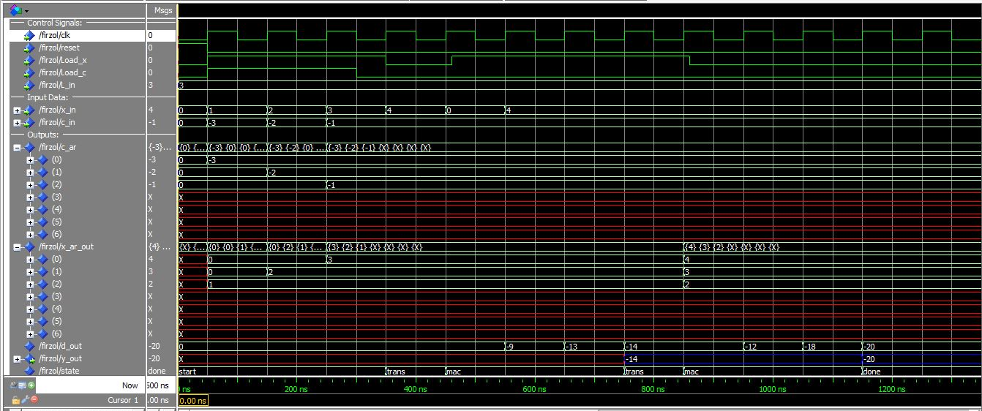

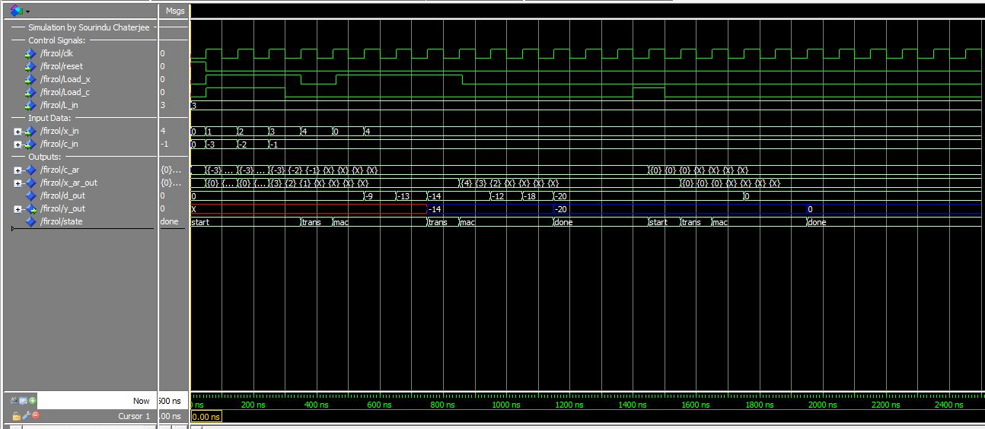

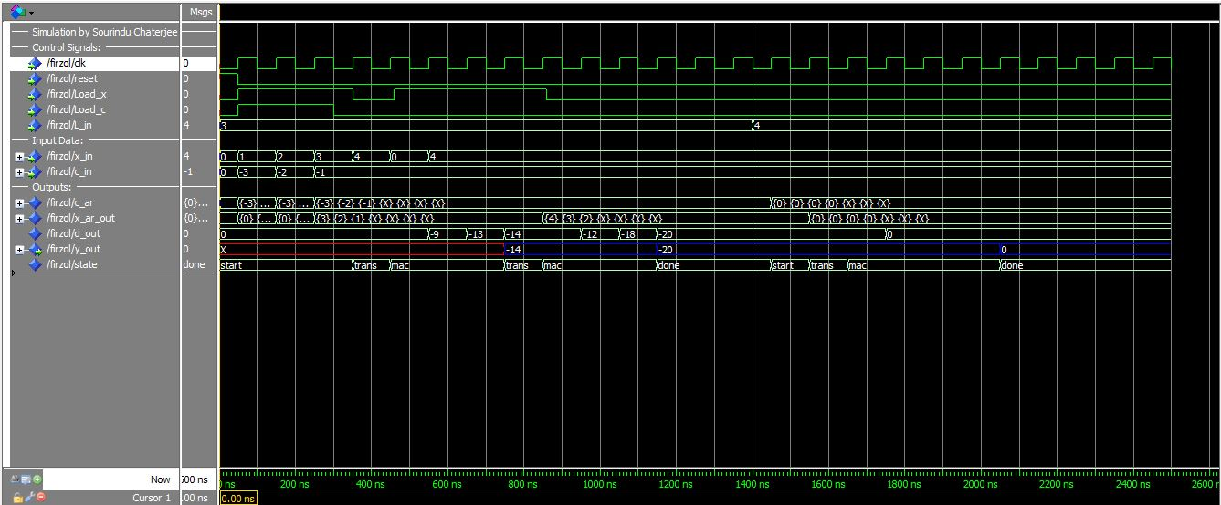

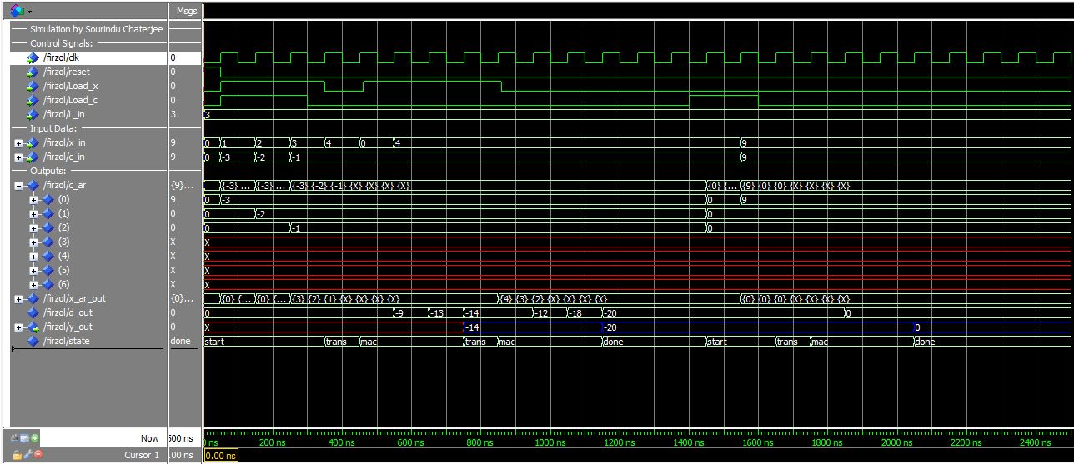

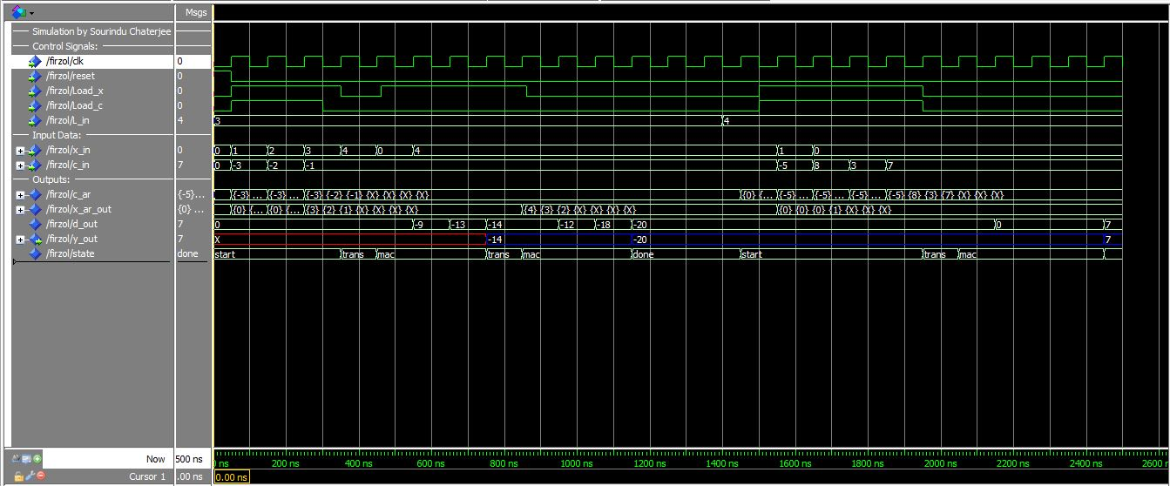

## Time and Work Schedule



QuatrusII, ModelSim and Matlab software would be used for doing the project work.

## Conclusion

This has been a challenging project and I am really grateful to my professor Dr. Meyer Baese for helping me with this endeavor. Well though ZOL implementation is successful in the MAC stage of the microprocessor execution cycle, further development to the design can be made by implementing ZOL in other stages of the design.

## REFERENCES

[1] U. Meyer-Baese: Digital Signal Processing with Field Programmable Gate Arrays (Springer, 4th edition, 2014).

[2] Zero-overhear loop controller for implementing multimedia algorithms

Nikolaos Kavvadias and Spiridon Nikolaidis,Section of Electronics and Computers, Department of Physics  
Aristotle University of Thessaloniki.

[3] Effective Exploitation of a Zero Overhead Loop Buffer

YuhongWang, David Whalleyt, Department of Computer Science, Florida State University

Gang-RyungUh, SanjayJinturkar, Chris Bums, Vincent Cao, Lucent Technologies,Allentown

[4] Application of Zero Overhead Loop and Address Generator in General Purpose Computing

Jinyung Namkoong.

[5] EEL 5722 DSP with FPGA lecture Notes.

[6] <http://microchip.wikidot.com/dsp0201:zero-overhead-loops>

## APPENDIX

## Design Specification

This is for generic length of 50.

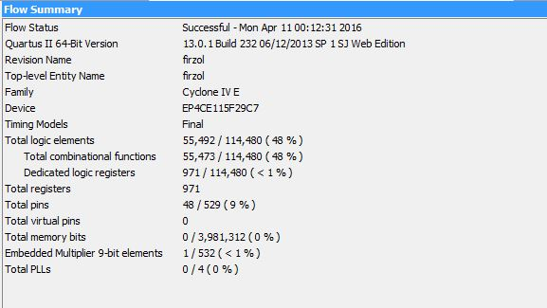

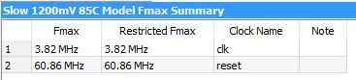

This is for generic length of 7

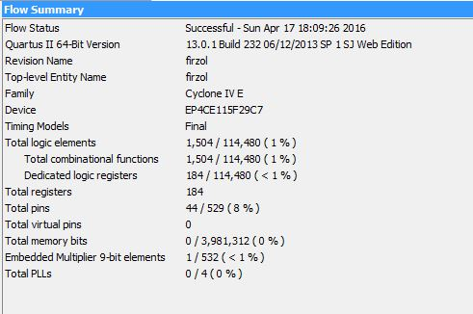

## Simulation Files .do

1. The first do file firzolfinalv1.do

set project_name "firzol"

vlib ieee_proposed

vcom -work ieee_proposed fixed_float_types_c.vhdl

vcom -work ieee_proposed fixed_pkg.vhd

vcom -work ieee_proposed float_pkg_c.vhdl

vlib work

vcom $project_name.vhd

vsim work.${project_name}(fpga)

########## Add I/O signals to wave window

add wave -divider "Simulation by Sourindu Chaterjee"

add wave -divider "Control Signals:"

add wave clk reset Load_x Load_c L_in

add wave -divider "Input Data:"

radix -decimal

add wave x_in c_in

add wave -divider "Outputs:"

add wave -radix decimal c_ar x_ar_out d_out

add wave -color Blue y_out

add wave state

######### Add stimuli data

force clk 0 0ns, 1 50ns -r 100ns

force reset 1 0ns, 0 50ns

force Load_x 0 0ns, 1 50ns, 0 350ns, 1 460ns, 1 760ns, 1 770ns, 0 860ns

force Load_c 0 0ns, 1 50ns, 0 300ns

radix -decimal

force L_in 3 0ns

force x_in 0 0ns, 1 50ns, 2 150ns, 3 250ns, 4 350ns, 0 450ns, 4 550ns

force c_in 0 0ns, -3 50ns, -2 150ns, -1 250ns

########## Run the simulation

run 2500ns

wave zoomfull

configure wave -gridperiod 10ns

configure wave -timelineunits ns

1. Now the defining part of the do files is the same only the “signal force” part will vary thus will be furnishing that, firzolfinalv2.do

######### Add stimuli data

force clk 0 0ns, 1 50ns -r 100ns

force reset 1 0ns, 0 50ns

force Load_x 0 0ns, 1 50ns, 0 350ns, 1 460ns, 1 760ns, 1 770ns, 0 860ns

force Load_c 0 0ns, 1 50ns, 0 300ns, 1 1400ns, 0 1500ns

radix -decimal

force L_in 3 0ns

force x_in 0 0ns, 1 50ns, 2 150ns, 3 250ns, 4 350ns, 0 450ns, 4 550ns

force c_in 0 0ns, -3 50ns, -2 150ns, -1 250ns

1. The file firzolfinalv3.do

######### Add stimuli data

force clk 0 0ns, 1 50ns -r 100ns

force reset 1 0ns, 0 50ns

force Load_x 0 0ns, 1 50ns, 0 350ns, 1 460ns, 1 760ns, 1 770ns, 0 860ns

force Load_c 0 0ns, 1 50ns, 0 300ns

radix -decimal

force L_in 3 0ns, 4 1400ns

force x_in 0 0ns, 1 50ns, 2 150ns, 3 250ns, 4 350ns, 0 450ns, 4 550ns

force c_in 0 0ns, -3 50ns, -2 150ns, -1 250ns

1. The file firzolfinalv4.do

######### Add stimuli data

force clk 0 0ns, 1 50ns -r 100ns

force reset 1 0ns, 0 50ns

force Load_x 0 0ns, 1 50ns, 0 350ns, 1 460ns, 1 760ns, 1 770ns, 0 860ns

force Load_c 0 0ns, 1 50ns, 0 300ns, 1 1400ns, 0 1600ns

radix -decimal

force L_in 3 0ns

force x_in 0 0ns, 1 50ns, 2 150ns, 3 250ns, 4 350ns, 0 450ns, 4 550ns, 9 1550ns

force c_in 0 0ns, -3 50ns, -2 150ns, -1 250ns, 9 1550ns

1. This is the final simulation file fizolfinal.do

####### Add stimuli data

force clk 0 0ns, 1 50ns -r 100ns

force reset 1 0ns, 0 50ns

force Load_x 0 0ns,1 50ns,0 350ns,1 460ns,1 760ns,1 770ns,0 860ns,1 1500ns,0 1950ns

force Load_c 0 0ns, 1 50ns, 0 300ns, 1 1500ns, 0 1950ns

radix -decimal

force L_in 3 0ns, 4 1400ns

force x_in 0 0ns, 1 50ns, 2 150ns, 3 250ns, 4 350ns, 0 450ns, 4 550ns, 1 1550ns, 0 1650ns

force c_in 0 0ns, -3 50ns, -2 150ns, -1 250ns, -5 1550ns, 8 1650ns, 3 1750ns, 7 1850ns