DSP | Audio Handling |Assignment 3

* Sourish Chatterjee (EE22MTECH02002)

**Aim**: Sample Audio Signal Decimation and Interpolation

**Implemented System Diagram**:

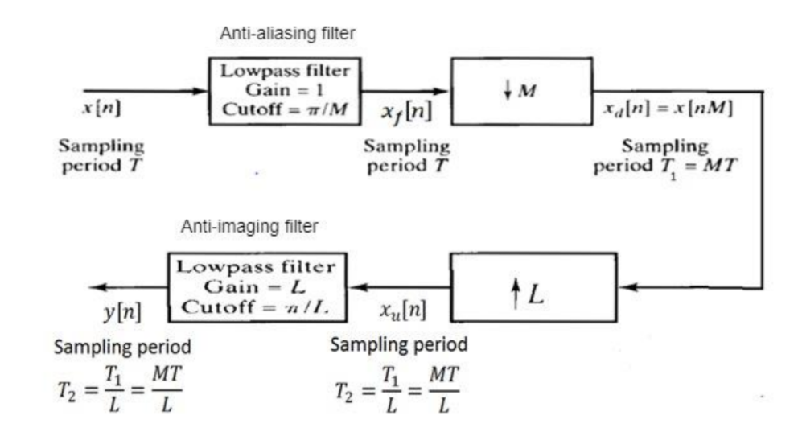

**Procedure:**

1. Audio file is loaded into MATLAB using “audioread()” function.

2. M, L are declared and calculation of cut-off frequency “fc” using r/2*M where r is sampling frequency of audio signal.

3. Use the system model built in assignment 2 to pass the audio signal

4. Save decimated & interpolated output using “audiowrite()” function.

4. Get decimated and interpolated spectrograms for M = L = [2,4,8]

**Observations:**

1. After iterating same process various M,L values we see that higher frequencies are getting clipped.
2. Above mentioned iterative method leads to decrease in the audio quality.
3. The original spectrogram shows that the audio file has frequencies are up to 10Khz
4. Cut-off frequency = sampling frequency

|  |  |
| --- | --- |
| M/L Values | Fc (Cut-off Frequencies) Hz |
| 2 | 5512 |
| 4 | 2756 |
| 8 | 1378 |

1. Above mentioned Cut-off Frequencies can be seen in the spectrogram.

**Spectrograms:**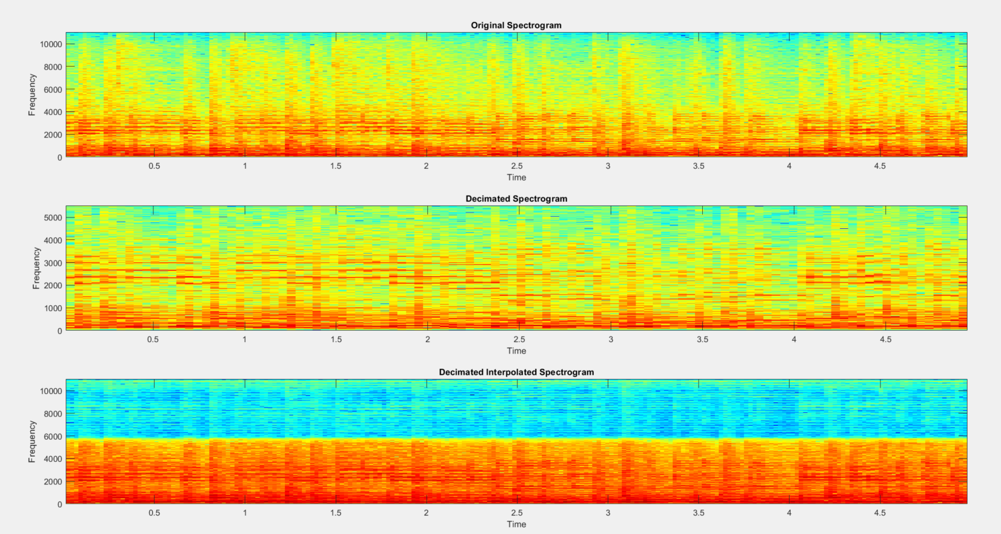

Figure M=L=2

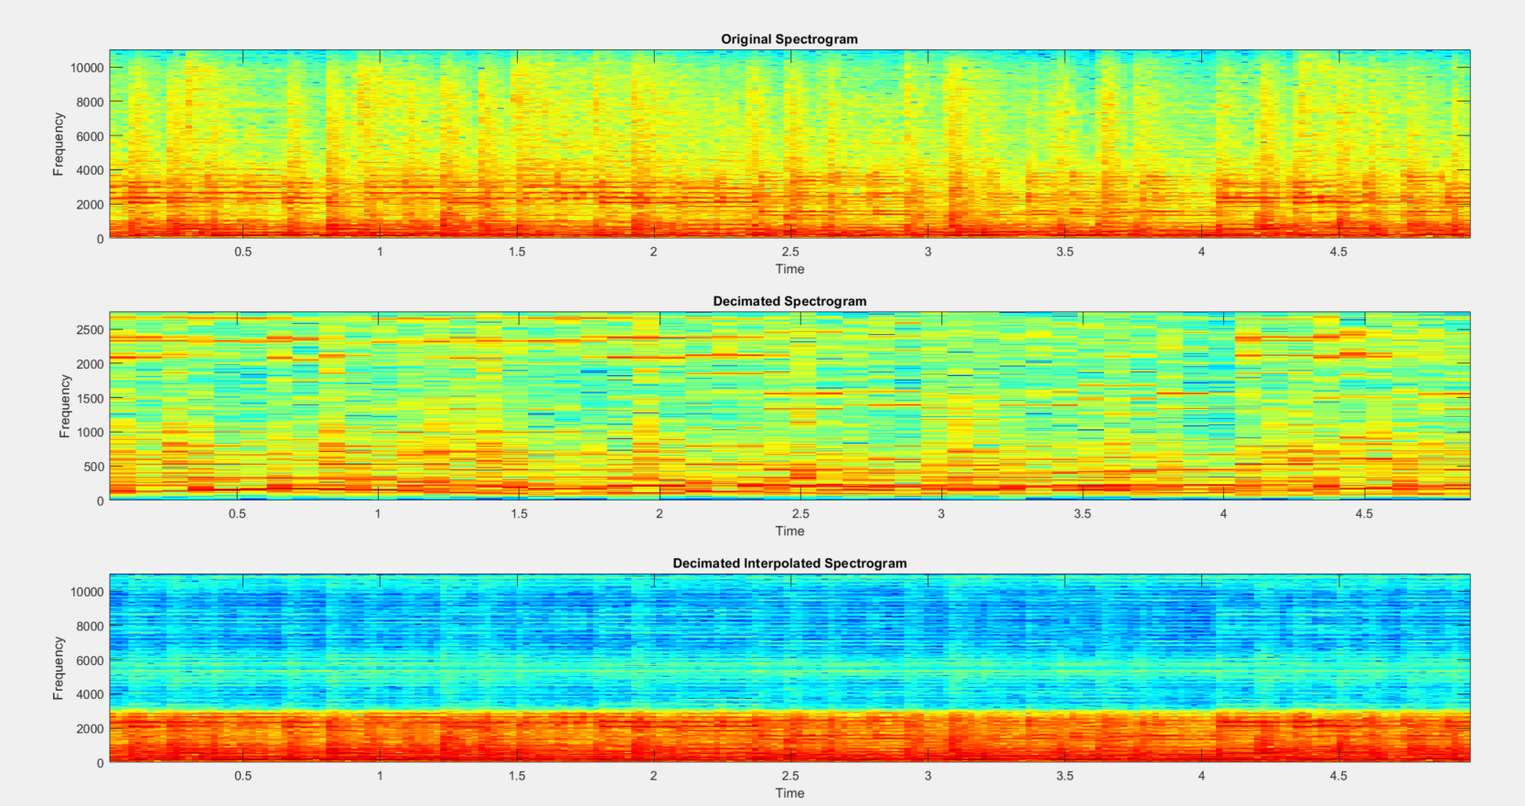

Figure : M=L=4

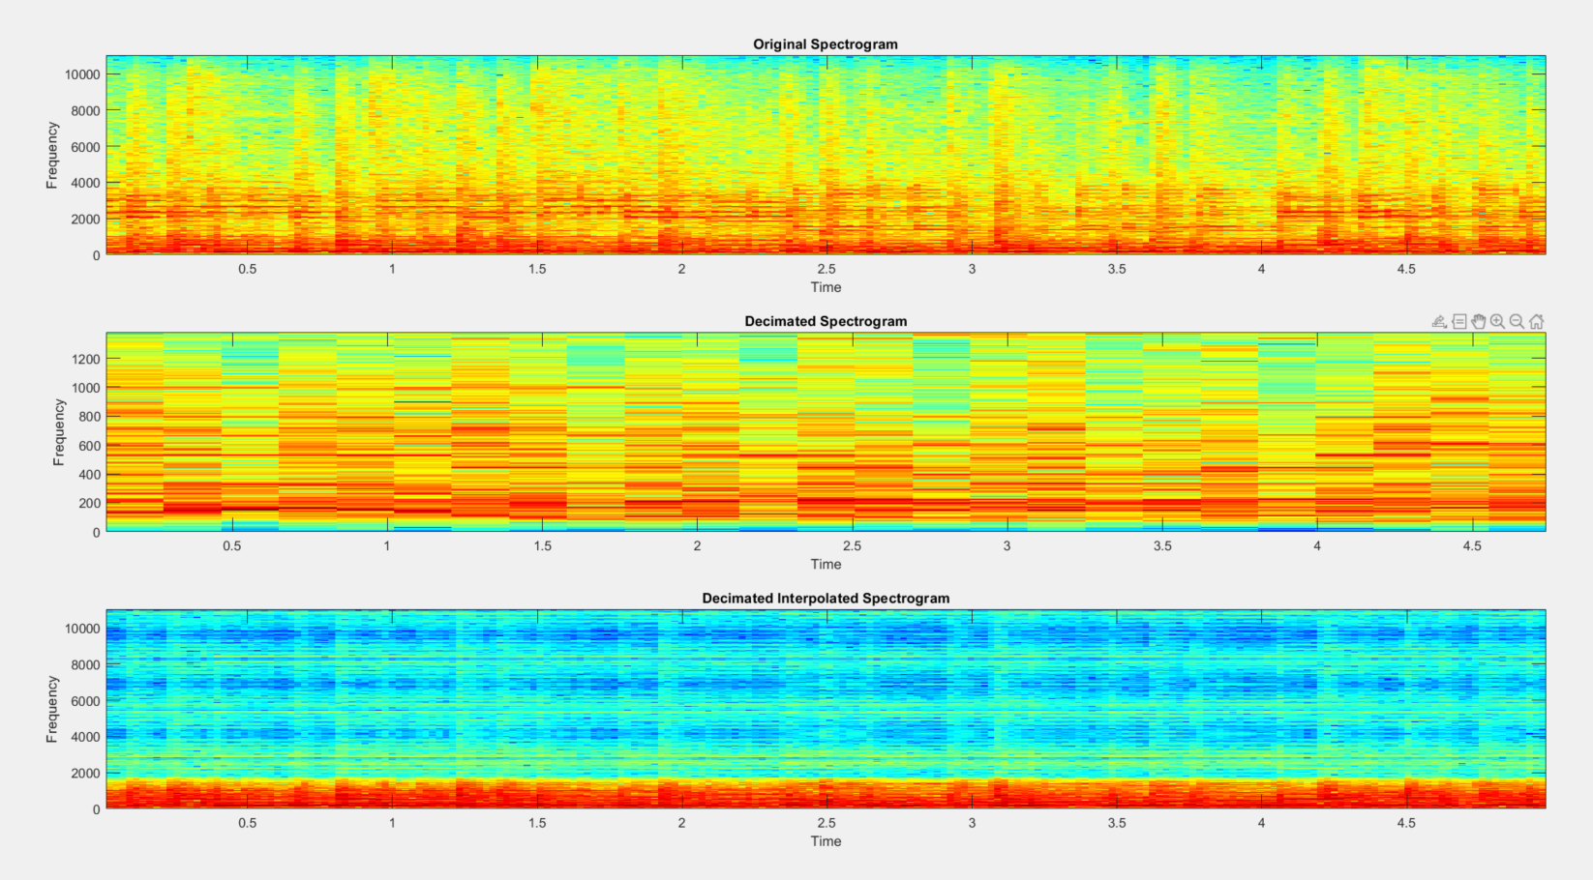

Figure : M=L=8