Real Time Food Monitoring & Analysis

*Vrinda Parkhi1, Sourjadip Pramanik(35)2, Vishal Phonde (56)3, Vishal Gurudasani (55)4,  Vijay Singh (53)5, Vaibhav Kadam(50)6*

1 2 3 4 5 6Department of Multidisciplinary Engineering

VISHWAKARMA INSTITUTE OF TECHNOLOGY

**Abstract:** *Food safety has become a significant issue in the decade but the rapid growth in internet of things (IOT) will surely help this field and it will be more advance in coming years. In this paper you are going to get the information about a prototype which we develop with the help of sensors which gives information if the food is rotten or there’s something in it or how much time the food is good for eating i.e., the food is refresh above things happen because of the different temperature throughout the supply chain and this all will be detect with the help of sensors. In current era of technological development, everything wants monitoring. This paper food proposes an IoT framework for ease food monitoring for protection of the food, to make sure that food will not contaminate due to surrounding conditions while transportation.* *Thingspeak cloud server is used for storage and display of data values sensed in real time and google colab is used for analysis of results . A Streamlit server platform is used for visualizing all the data and predictions made using ML .*

***Key Words****:* ***IoT, Machine Learning, Supply Chain, Streamlit, Thingspeak, Google colab,***

1. **INTRODUCTION**

IoT is an emerging technology advancement in this era, which can help create advancements in the Information and Communication Technology (ICT) sectors in the existing world and the future. The term IoT, or Internet of Things, refers to the collective network of connected devices and the technology that facilitates communication between devices and the cloud, as well as between the devices themselves.

In food manufacturing industries, IoT can be equipped to reduce waste drastically by controlling row materials and inventory. Statistics reveal that, in the EU alone, 88 million tonnes of food are wasted every year, and the UN’s 12th Sustainable Development Goal commits to the reduction of this by 50% over the next decade. It is estimated that around 11% of food waste occurs in production and 9% during processing, meaning that food manufacturers account for around 20% of food waste overall. With the help of IoTs, food stocks can be tracked in real-time and orders for new ingredients or supplies can be placed based on actual needs rather than estimates. Furthermore, food manufacturers can also harness IoT technology to automate these to ensure more efficiency.

With the help of IoTs, food manufacturers can access and make use of real-time food safety data, such as carbon dioxide, heavy metals, humidity and temperature, or shipping times and storage conditions. This is often classified as Active Cold Chain Management. Recent advancements in information and communication technologies (ICT) show promise in addressing these challenges. This paper proposes food security and storage in supply chain efficiency using ICT tools such as Internet of Things and Big Data analytics. In order to avoid loss in food supply, a food monitoring system is developed through Smart monitoring and analysis system is proposed.

1. **LITERATURE REVIEW**

[1]Real-time monitoring of food quality has emerged as a viable solution that can benefit all stages of the food supply chain, starting from farmers to end consumers like us. It helps reduce significant economic losses which occur due to food spoilage and wastage while retaining quality and nutritional value. A novel integrated ‘smart digital platform’ is being developed to estimate and predict the food quality. This will enable all the stakeholders of the food supply chain to make decisions dynamically regarding altering supply chain logistics and storage conditions, for repurposing and minimizing food spoilage and wastage. TCS’ platform (Figure 2) for predicting food quality is built using a collection of IoT-enabled sensors which senses Galvanic Skin Resistance (GSR), Near Infrared (NIR) imaging, ultrasound, pH, air quality, gas composition (CO2 , NH3 , C2 H4 , O2 , etc.), weight, Volatile Organic Compound (VOC) content, camera feeds, and chemically analyzed food parameters. This is coupled with data analytics, image processing, and cloud computing. This platform allows provision for variation of environmental conditions such as temperature, humidity light intensity, etc

[2]Temperature is the main factor affecting quality, but other factors like relative humidity and gas concentrations (mainly C2H4, O2 and CO2) also play an important role in maintaining the postharvest quality of horticultural products. The patented monitoring system is based on the real-time control of the most influencing environmental variables to estimate the shelf life of the products during the whole supply chain. Small, flexible and a long-life of the battery are the main characteristics system nodes, which can be divided into two types depending on the role in the system: ‘Gateway’ and ‘Slave’. All of them can monitor, process, save, and wirelessly transmit the data to a web server where the users can consult them in real-time and with programmable sampling time.

[3]4 The human workforce plays an essential role in the smooth execution of the production and packaging of food products. Due to the involvement of humans, the food industries are failing to maintain the demand-supply chain and also lacking in food safety. To overcome these issues of food industries, industrial automation is the best possible solution. Automation is completely based on artificial intelligence (AI) or machine learning (ML) or deep learning (DL) algorithms. By using the AI-based system, food production and delivery processes can be efficiently handled and enhance the operational competence. AI could significantly improve packaging, increasing shelf life, a combination of the menu by using AI algorithms, and food safety by making a more transparent supply chain management system. With the help of AI and ML, the future of food industries is completely based on smart farming, robotic farming, and drones.

[4] Food quality is commonly modelled using the Arrhenius equation. However, generic approaches are time-consuming when many experiments are needed. Therefore, a real-time measuring system supported by prediction models is required. Storage or in-transit temperature is the most important environmental factor affecting perishable food quality. Therefore, the actors involved in the supply chain must deliver the commodities preserving the cold chain to avoid inappropriate food loses and waste, while preserving quality and safety. By controlling this parameter, a longer shelf life for perishable food products will be ensured, but it represents a difficult puzzle to solve due to the many factors involved.

[5] Evolution of multipurpose sensors over last decades grows significant advances over last decades including food industry. Integrating this sensors into food packaging will provide reliable information about food products during their transportation. Now in order to achieve this various food parameters has been recorded such as pathogen agent, gaseous, temperature, humidity, storage period etc. System builds upon the IoT concept and is able to create a network of interconnected devices. By using this approach, we are able to combine actuators and sensing devices also providing a common operating picture (COP) by sharing information over the platforms. System has been divided into two modules, first module consists of data acquisition board while second one is for user interface, the acquired data will provides information about the status of food and storage conditions. The experimental results showed that by maintaining very low moisture content and limiting the injuries that accelerate oxidative degradation, the onion slices dried under vacuum can be kept for a longer period of time compared with conventional drying. The chances of contamination of the product are minimized, because the whole process takes place in a closed chamber.

The following section explains the methodology used for our proposed system. The proposed system collaborates idea of interfacing IoT with sensors and ML.

1. **Methodology:**

* NODEMCU based food monitoring system has been proposed having website for user interface with real time prediction about food quality.
* Proposed system deals with food monitoring system using NODEMCU based intelligent tool which aid us to predict food quality based upon previously sensor data. As shown in Fig1].
* First step for designing mentioned system is to gather sensor data form food deterioration data about some specific food material. Thereafter we conclude about optimal conditions for food degradation based upon various observations and analysis. Various parameters regarding food saturation have been measured like humidity, temperature, gaseous. Collected data has been analysed using K-Means clustering algorithm which will predict best optimal cluster for given data.
* Website has been made using streamlit as a open source framework for building application. For analysing food sensors data graphical user interface will be shown by using thing-speak. Website interface using STREAMLIT as a building tool is used in order to establish connection between client and server. STREAMLIT helps in creating web apps for data science and ml in short time. User will give input as humidity, temperature and gas sensor reading into websites-text-area by collecting it through hardware interface. As shown in Fig2].
* In order to build predictive model first step was to collect sensor data from sensors. Google app script which is rapid application building platform is used for connecting hardware assembly with google sheet. Google-Colab is used for running our ml algorithms on sensor data. K-means is used to label all gas sensor values as 0,1 and 2. K-means clustering uses “centroids”, K different randomly-initiated points in the data, and assigns every data point to the nearest centroid. After every point has been assigned, the centroid is moved to the average of all of the points assigned to it.
* KNN which is a clustering model will run predictive algorithm in order to predict class for this input data. It will assign label which will lies in range between [0-2]. Now based upon this label, website will shows alert message about food quality.
* Fig 3 shows the complete flow considering proposed system.

|  |
| --- |
|  |

Fig 1] Set-up for the proposed system

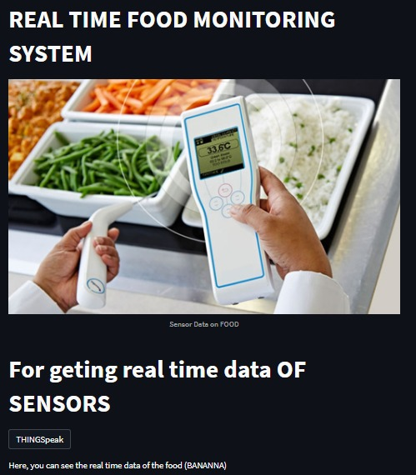

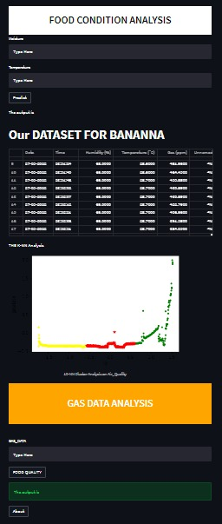

Fig2]Website interface Condition Analysis

**Components Requirement**:

Sensors used in our prototype:

**MQ135 gas sensor:**

When it comes to measuring or detecting a particular Gas, the MQ series Gas sensors are the most inexpensive and commonly used ones. MQ135 is available as a module or as just the sensor alone. If you are trying to only detect (not measuring PPM) the presence of a gas. Gas sensors are used in air quality control appliances and are suitable for detecting or measuring of NH3, NOx, Alcohol, Benzene, Smoke, CO2. The MQ-135 sensor module comes with a Digital Pin which makes this sensor to operate even without a microcontroller and that comes in handy when you are only trying to detect one particular gas.

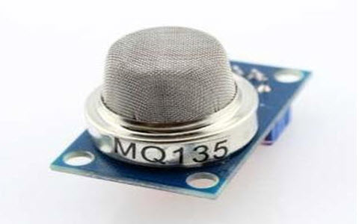

**DHT11 humidity sensor:**

DHT11 is a low-cost digital sensor for sensing temperature and humidity. This sensor can be easily interfaced with any micro-controller such as Arduino, Raspberry Pi etc… to measure humidity and temperature instantaneously.DHT11 humidity and temperature sensor is available as a sensor and as a module. The difference between this sensor and module is the pull-up resistor and a power-on LED. DHT11 is a relative humidity sensor. To measure the surrounding air this sensor uses a thermistor and a capacitive humidity sensor.

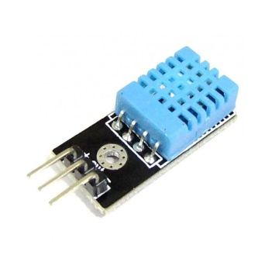

**L35 temperature sensor:**

LM35 is an analog, linear temperature sensor whose output voltage varies linearly with change in temperature. LM35 is three terminal linear temperature sensor from National semiconductors. It can measure temperature from-55 degree celsius to +150 degree celsius. The voltage output of the LM35 increases 10mV per degree Celsius rise in temperature. LM35 can be operated from a 5V supply and the stand by current is less than 60uA.

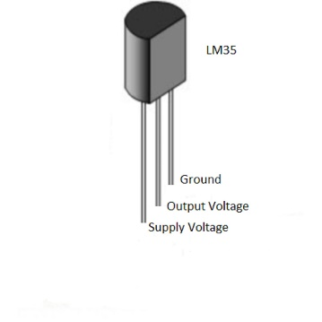

**Flowchart:**

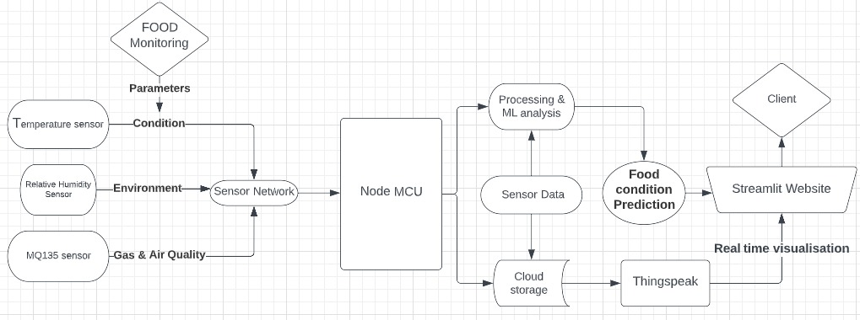

Fig3] Complete block digram of our project

1. **Result & Discussion:**

For performing experimental calculations given system was kept with banana inside

it. Deterioration pattern about it has been observed up to approximately 4-5 days and

simultaneously reading has been recorded on google sheet which is connected with Arduino ide. After performing several experiments we obtained unique pattern for optimal temperature and humidity values for banana. With this we can compare our given readings whether it exceeds this range our not. This is implemented through the Streamlit Website for the client to get the prediction of food quality.

For gas-data after taking actual readings from same excel sheet, dataset has been divided into 4 different categories as food is same, food is in between stage, food is about to rotten and finally food becomes rotten.

The client will be able to monitor the real time data from sensors on thingspeak cloud as shown in Fig4] ,Fig5] and Fig6] .The website helps to give a platform where client can enter the real time food data for the model to predict its quality. A systematic order is maintained while making the website presenting the dataset and also the analysis for food (banana) .

Various graphs which are obtained for sensor values with time series is as follows:

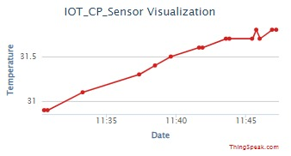

Fig4] Time series chart for temperature

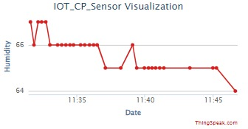

Fig5] Time series chart for humidity

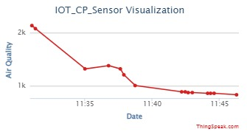

Fig6] Time series chart for air quality

1. **Conclusion :**

In present scenario, proposed work is carried out for sensed values which has been recorded and complete analysis has been carried out. In this report, we provided an account of what is Supply-Chain Management, how it works, its characteristics, examples, challenges it faced prior to integration with IoT. IoT is the most promising technologies to control and improve the performance of supply chains; warehouses are key parts of supply chain that contribute to the success of any industrial organization. Moreover , in our project you can see the result through blynk app and we also had the real time data of banana when it is rotten and not suitable for eating we achieve this with the help of sensors of which we have given the description.

1. **Future scope:**

Currently data obtained for analysis is just for single food but we can extend it for other food as well. The environment under which the sensor data is obtained can be varied accordingly with more parameters. Different ml models can be used for further analysis. A proper real time location based monitoring and analysis based on images could be included. The sensor can be interfaced wirelessly and a complete system can be made food storage to its delivery.

1. **References:**

[1]An Intelligent IoT-Based Food Quality Monitoring Approach Using Low-Cost Sensors.A: Alexandru Popa,Mihaela Hnatiuc,Mirel Paun,Oana Geman, D. Jude Hemanth,Daniel Dorcea, Le Hoang Son ,and Simona Ghita. Published: 13 March 2019

[2] A: Torres-Sánchez R, Martínez-Zafra MT, Castillejo N, Guillamón-Frutos, Artés-Hernández F. Real-Time Monitoring System for Shelf Life Estimation of Fruit and Vegetables. Sensors (Basel). 2020;20(7):1860. Published 2020 Mar 27. doi:10.3390/s20071860

[3]Amani, Pegah & Gadde, Lars-Erik, 2015. "Shelf life extension and food waste reduction," 2015 International European Forum (144th EAAE Seminar), Febru.ary 9-13, 2015, Innsbruck-Igls, Austria 206209, International European Forum on System Dynamics and Innovation in Food Networks.

[4]Indrajeet Kumar, Jyoti Rawat, Noor Mohd, Shahnawaz Husain, "Opportunities of Artificial Intelligence and Machine Learning in the Food Industry", Journal of Food Quality, vol. 2021, Article ID 4535567, 10 pages, 2021.

[5]Patel, Priya & Doddamani, Abdulgaffar. (2019). Role Of Sensor In The Food Processing Industries. 10. 10. 10.15515/iaast.0976-4828.10.1.1018.

[6]Amani, Pegah & Gadde, Lars-Erik, 2015. "Shelf life extension and food waste reduction," 2015 International European Forum (144th EAAE Seminar), February 9-13, 2015, Innsbruck-Igls, Austria 206209, International European Forum on System Dynamics and Innovation in Food Networks

[7] Torres-Sánchez R, Martínez-Zafra MT, Castillejo N, Guillamón-Frutos A, Artés-Hernández F. Real-Time Monitoring System for Shelf Life Estimation of Fruit and Vegetables. Sensors (Basel). 2020;20(7):1860. Published 2020 Mar 27. doi:10.3390/s20071860

[8] Patel, Priya & Doddamani, Abdulgaffar. (2019). Role Of Sensor In The Food Processing Industries. 10. 10. 10.15515/iaast.0976-4828.10.1.1018

[9] TY - JOUR AU - Xiangsheng, Kong PY - 2014/11/01 SP - 1241 EP - 1248 T1 - Design and Implementation of Food Monitoring System Based on WSN VL - 6 DO - 10.19026/ajfst.6.190JO Advance Journal of Food Science and Technology

[10]TY - JOUR AU-Kaushal, Rajes,T,Harini- D, Pavithra- T, Sandhya - P, Soniya PY - 2019/06/01 SP - 73 EP - 76 T1 - IOT BASED SMART FOOD MONITORING SYSTEM VL - 6 DO - 10.21276/ijcesr.2019.6.6.14 JO - International Journal of Current Engineering and Scientific Research

[11] TY - JOUR, AU - Krishna, Arjun, PY - 2019/04/30, SP - 4015, EP - 4019, T1 - Food Monitoring and Control System using IoT, VL - 7, DO - 10.22214/ijraset.2019.4671, JO - International Journal for Research in Applied Science and Engineering Technology

[12] TY - BOOK, AU - Ying, Fu, Fengquan, Li, PY - 2013/06/01, SP - 296, EP - 298, T1 - Application of Internet of Things to the Monitoring System for Food Quality Safety, DO - 10.1109/ICDMA.2013.71, JO - Proceedings - 2013 4th International Conference on Digital Manufacturing and Automation, ICDMA 2013