🧬 Nirvana Smart-Chain
Decentralized Pharmaceutical Supply Chain & Verification Platform
Product Specification & Visual Documentation

1. Executive Summary
Nirvana Smart-Chain (NSC) is a next-generation decentralized pharmaceutical supply chain ecosystem engineered to completely eliminate counterfeit drugs, introduce strict end-to-end traceability, and ensure trust across pharmaceutical manufacturers, wholesalers, retail dispensaries, and end consumers. Powered by blockchain smart contracts, ERC-20 tokenized settlement, dual-camera computer vision QR validation, and real-time inventory management, the platform guarantees that every medicine batch remains tamper-proof and publicly auditable throughout its lifecycle.

2. Visual Interface & Product Showcase

A. Nirvana Health Chain — Web3 Gateway & Landing Interface
The initial gateway provides an editorial, cyber-biomedical aesthetic that introduces users to the Nirvana Smart-Chain network. Stakeholders authenticate with their decentralized identity (DID) or verified institutional credentials, accessing role-specific operational dashboards.
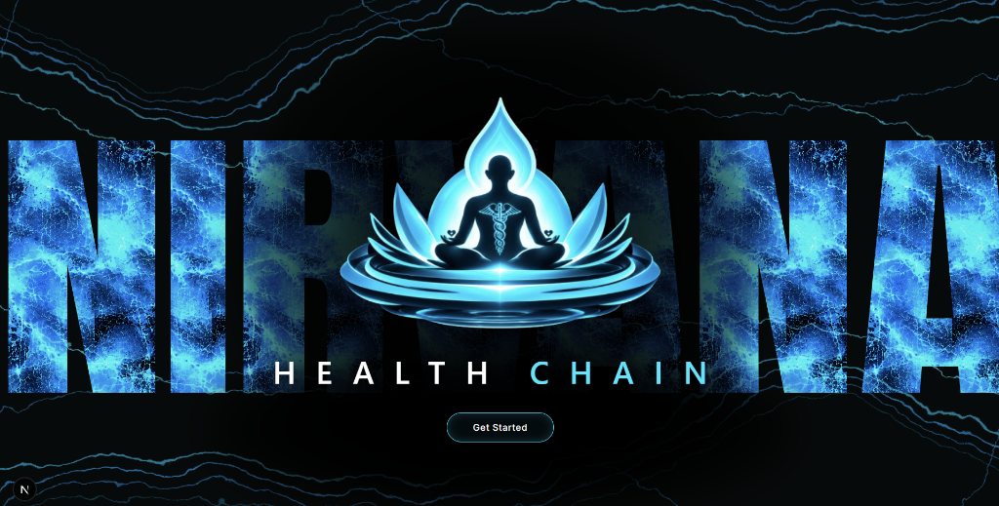
Figure 1: Nirvana Health Chain decentralized gateway and authentication entry point.

B. Retail Pharmacy Operations & Analytics Dashboard
The Pharmacy Dashboard serves as the central mission control for retail dispensary operators. It provides high-level telemetry on total medicines in store, catalog valuation (e.g., ₹6,10,992.10), order fulfillment status, stock purchase metrics, and interactive sales trend visualizations.
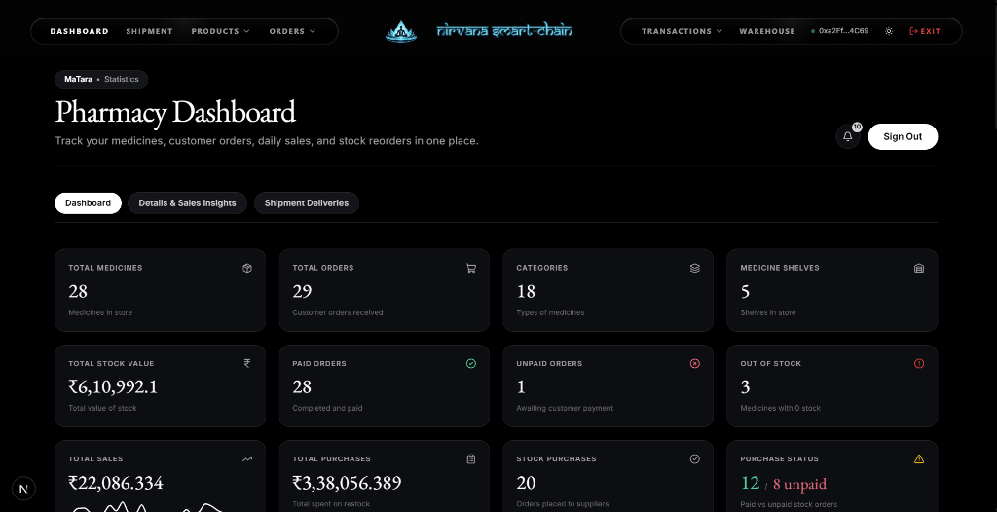
Figure 2: Real-time pharmacy dashboard tracking medicine stock, valuation, orders, and sales trends.

C. Dispensary Storage & Warehouse Shelf Kiosk
The Warehouse Kiosk bridges physical pharmacy storage with digital inventory. It features 3D product visualization, bay-by-bay shelf organization, real-time SKU formulation balances, and rapid order dispatch mechanisms.
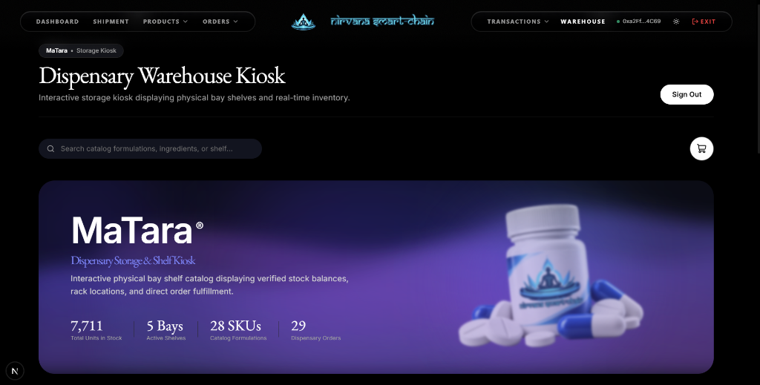
Figure 3: Interactive dispensary warehouse kiosk displaying physical bay shelves and real-time stock balances.

D. Nirvana Smart Coin Verification & Dual-Camera Shipment Settlement
The shipment settlement protocol ensures zero fraud during consignment handovers. Retailers inspect Nirvana Smart Coin (NSC) balances and pre-approved verification allowances, scan package QR codes via either built-in webcam or IP webcam, and trigger automated smart contract verification combined with integrated fiat/crypto settlement.
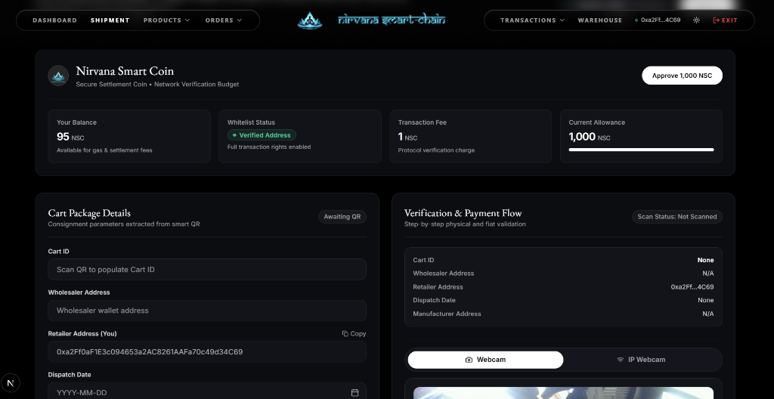
Figure 4: Smart contract settlement protocol with dual-camera QR verification and gas allowance telemetry.

3. Key Technical Capabilities
- Decentralized Traceability: Every drug consignment is minted with unique cryptographic parameters on the Nirvana Smart Chain.
- Smart Contract Settlement: Automated verification between Wholesaler and Retailer wallets via verified token allowances.
- Dual-Stream Computer Vision: High-speed QR code decoding supporting both physical browser webcams and network IP cameras.
- Hybrid Financial Architecture: Seamless integration between on-chain ERC-20 verification and secure fiat payment gateways.
- Role-Based Stakeholder Portals: Dedicated tailored workflows for Manufacturers, Wholesalers, Retailers, and Regulatory Auditors.

