A MINI PROJECT REPORT
ON
“Hostel Allocation Management System”

Submitted in partial fulfilment of the
requirements for the award of the degree of

BACHELOR OF TECHNOLOGY
IN
COMPUTER SCIENCE AND ENGINEERING



Submitted By
Group 6

1. Sourodip Roy Roll No: 108250600261
2. Soheli Mondal Roll No: 108250600248
3. Sneha Kumari Roll No: 108250600243
4. Shabbir Raza Roll No: 108250600218

Year: 1st, Section: IV, Semester: 1st

Academic Year
2025 – 2026

Under the Guidance of
Mr. Bikram Saha
Assistant Professor

Department of Computer Science and Engineering
Asansol Engineering College

CERTIFICATE

This is to certify that the mini project entitled “Hostel Allocation Management System” is a record of the genuine work carried out by the following students of B.Tech 1st Year, Department of Computer Science and Engineering, Asansol Engineering College:

1. Sourodip Roy Roll No: 108250600261
2. Soheli Mondal Roll No: 108250600248
3. Sneha Kumari Roll No: 108250600243
4. Shabbir Raza Roll No: 108250600218

under my supervision and guidance during the academic year 2025–2026, in partial fulfilment of the requirements for the award of the degree of Bachelor of Technology in Computer Science and Engineering.
This project work is original and has not been submitted previously, either in part or in full, to this or any other institution for the award of any degree, diploma, or certification.

The project demonstrates a sincere effort by the students to apply the fundamental concepts of C programming, including structures, functions, and file handling, to develop a real-world application.

--------------------------------- ---------------------------------
Mr. Bikram Saha Mr. Monish Chatterjee
(Assistant Professor) (Head of the Department)
Department of CSE Department of CSE
Asansol Engineering College Asansol Engineering College

Date:

Place: Asansol, West Bengal

ACKNOWLEDGEMENT

We take this opportunity to express our sincere gratitude and respect towards our project guide, Mr. Bikram Saha, Assistant Professor, Department of Computer Science and Engineering, Asansol Engineering College, for his/her valuable guidance, constant encouragement, constructive suggestions, and continuous support throughout the successful completion of this mini project.

We are also thankful to the Head of the Department, Dr.(prof.) Monish Chatterjee, Department of Computer Science and Engineering, for providing the necessary facilities, infrastructure, and academic environment to carry out this project work effectively.

We extend our sincere thanks to all the faculty members of the Department of Computer Science and Engineering for their guidance and cooperation during the course of this project.

Finally, we express our heartfelt gratitude to our parents and friends for their moral support, motivation, and encouragement, which played a vital role in the successful completion of this project.

- Sourodip Roy Signature: ________________________
- Soheli Mondal Signature: ________________________
- Sneha Kumari Signature: ________________________
- Shabbir Raza Signature: ________________________

Hostel Management System - Project Index

Project Overview
Menu-driven C application for hostel management with role-based authentication (Admin/Student), file handling, and secure operations.

File Structure
Hostel-Management-System/
├── main.c # Main entry point and menus
├── README.md # Project documentation
├── TASKS.md # Development tasks
├── build_error.txt # Build logs
├── data/ # Data files (.dat)
├── headers/ # Header files
│ ├── admin.h # Admin structures/functions
│ ├── complaint.h # Complaint structures/functions
│ ├── fee.h # Fee structures/functions
│ ├── room.h # Room structures/functions
│ ├── security.h # Password hashing
│ ├── student.h # Student structures/functions
│ └── ui.h # UI utilities
└── helpers/ # Implementations
├── admin.c # Admin operations
├── complaint.c # Complaint handling
├── fee.c # Fee management
├── room.c # Room allocation
├── security.c # Security functions
├── student.c # Student operations
└── ui.c # UI helpers

File Descriptions
Core Files
- main.c: Entry point, login, menus, authentication routing
- README.md: Documentation, features, user roles
- TASKS.md: Development progress tracking

Headers (headers/)
- admin.h: Admin struct (ID, name, password) and CRUD functions
- complaint.h: Complaint struct (ID, student, room, date, desc, status) and management functions
- fee.h: Fee struct (student ID, amount, payment status) and payment functions
- room.h: Room struct (number, capacity, type, charges, occupancy) and allocation functions
- security.h: Password hashing utilities
- student.h: Student struct (ID, name, password, room) and CRUD functions
- ui.h: ANSI colors and UI helper functions

Implementations (helpers/)
- admin.c: Admin CRUD with file persistence
- complaint.c: Complaint submission/viewing with file ops
- fee.c: Fee calculation and payment tracking
- room.c: Room management and assignment logic
- security.c: Password hashing implementation
- student.c: Student CRUD and authentication
- ui.c: Console UI enhancements

Data Storage
- data/: Binary .dat files for persistent storage

Key Features
- Role-based access (Admin/Student)
- Secure login with hashing
- File-based persistence
- Console menus
- Room allocation
- Fee tracking
- Complaint system
- Search/view functions

Development Phases
- Core System (menus, login, files)
- Hostel Logic (rooms, fees, structures)
- Role Control (permissions, security)
- Complaints (submission/viewing)
- Testing & Documentation

Hostel Management System - Project Report
Project github repo : https://github.com/Sourodip-1/Hostel-Management-System

Abstract

The Hostel Management System is a comprehensive C-based application designed to automate hostel operations through a menu-driven interface. It addresses the challenges of manual record-keeping by providing secure, role-based access for administrators and students. The system utilizes file handling for data persistence, password hashing for security, and modular programming using the structures and functions. Key features include student registration, room allocation, fee management, and complaint handling, which make hostel administration more efficient and secure.

Introduction

In traditional hostel management, manual processes lead to data loss, security risks, and operational inefficiencies. This project addresses these issues by developing a digital system that automates all hostel activities. Real-world problems include poor record-keeping, lack of security, and difficulty in tracking student information, fees, and complaints. Our solution provides a user-friendly console application with separate interfaces for wardens (administrators) and students, ensuring data integrity and easy access to information.

Objectives

The primary objectives of this project are as follows:
- Technical Objectives: Implement modular C programming with file handling, structures, and secure authentication
- Functional Objectives: Provide complete hostel management capabilities including student registration, room allocation, fee tracking, and complaint resolution
- Security Objectives: Ensure role-based access control and secure password storage
- User Experience Objectives: Create intuitive menu-driven interfaces for both admin and student users
- Data Management Objectives: Achieve persistent data storage and retrieval using binary file operations

Software & Hardware Requirements

Software Requirements
- Programming Language: C
- Compiler: GCC (GNU Compiler Collection) or any C compiler
- Operating System: Windows/Linux/macOS (with terminal/console support)
- Development Environment: Any text editor or IDE (VS Code, Code::Blocks, etc.)
- Libraries: Standard C libraries (stdio.h, stdlib.h, string.h)

Hardware Requirements
- Processor: Intel/AMD x86 or compatible (1 GHz or higher)
- RAM: Minimum 512 MB (recommended 1 GB)
- Storage: 50 MB free space for source code and data files
- Display: Console/terminal with ANSI color support

System Design

Program Flow
The system follows a hierarchical menu structure.
- Main Entry: User selects role (Admin/Student)
- Authentication: Login with ID and password
- Dashboard: Role-specific menu options
- Operations: CRUD operations based on permissions
- Data Persistence: All operations save to binary files

Menu Options
- Admin Dashboard: Add/view/edit students, manage rooms, view fees, handle complaints
- Student Dashboard: View personal data, pay fees, submit/view complaints

User Interaction
- Console-based interface with colored output
- Input validation and error handling
- Clear screen and animated displays for better UX

Header Files Structure
- admin.h: Admin management functions
- student.h: Student CRUD operations
- room.h: Room allocation logic
- fee.h: Fee calculation and tracking
- complaint.h: Complaint submission and resolution
- security.h: Password hashing utilities
- ui.h: User interface enhancements

Flowchart

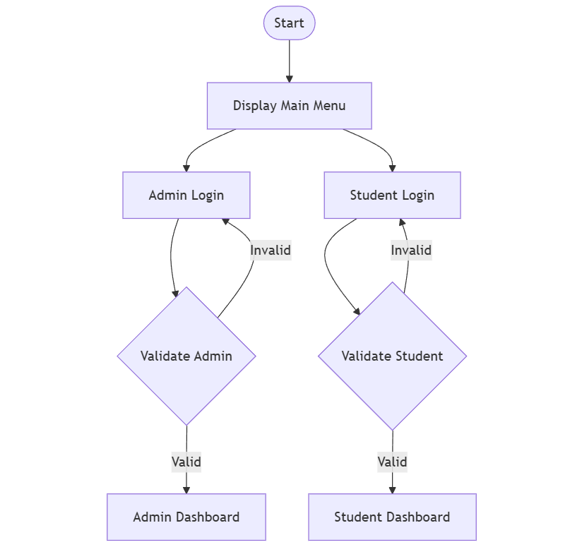

Admin Dashboard
│
├─► Student Management (Add/View/Edit/Delete)
├─► Room Management (Add/Assign/View)
├─► Fee Management (View Status)
├─► Complaint Management (View/Resolve)
└─► Logout

Student Dashboard
│
├─► View Personal Data
├─► Pay Fees
├─► Submit Complaint
├─► View My Complaints
└─► Logout

Algorithm

Admin Login Algorithm
- Display login prompt
- Accept admin ID and password
- Hash input password
- Read admin data file
- Compare ID and hashed password
- If match, grant access to admin dashboard
- Else, display error and retry

Student Registration Algorithm
- Get student details (name, password)
- Generate unique student ID
- Hash password for storage
- Create student record
- Save to student data file
- Confirm successful registration

Room Allocation Algorithm
- Check room availability
- Verify room capacity not exceeded
- Update room occupancy count
- Assign room number to student record
- Update both room and student data files
- Display allocation confirmation

Implementation (Code Explanation)

Structures Usage
The project uses C structures to represent the entities.
- struct student: Stores ID, name, password, room number
- struct admin: Stores ID, name, hashed password
- struct room: Stores number, capacity, type, charges, occupancy
- struct fee: Stores student ID, amount, payment status
- struct complaint: Stores ID, student ID, room, date, description, status

Functions Implementation
- Modular Design: Each header file declares functions implemented in corresponding .c files
- File Handling: Binary files (.dat) used for data persistence using fread/fwrite
- Authentication: Password hashing ensures secure storage
- Menu System: Switch-case statements handle user choices
- Input Validation: Prevents invalid data entry

Control Statements
- Conditional Statements: if-else for decision making (login validation, permission checks)
- Loops: for/while loops for data iteration and menu repetition

RESULT:

Sample Execution Output

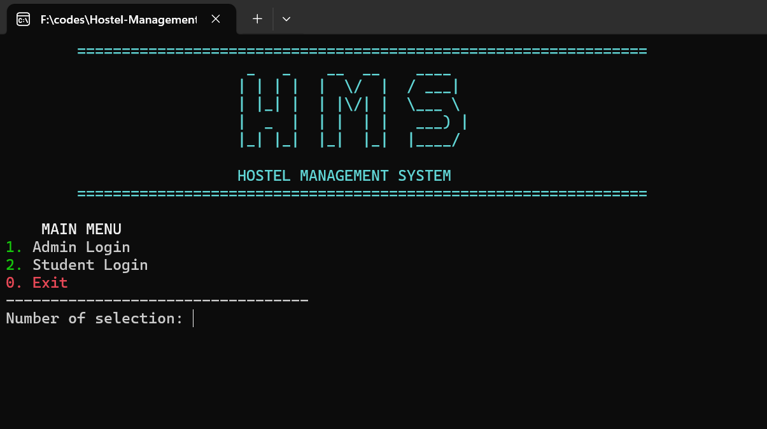

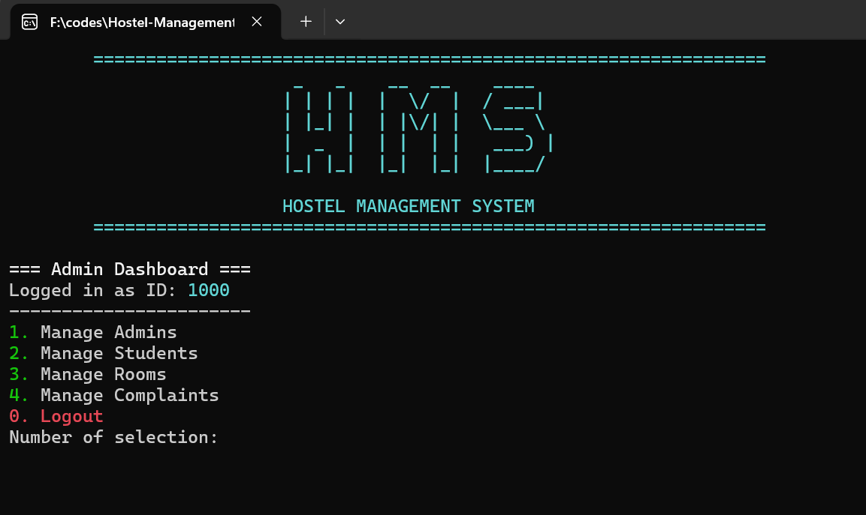

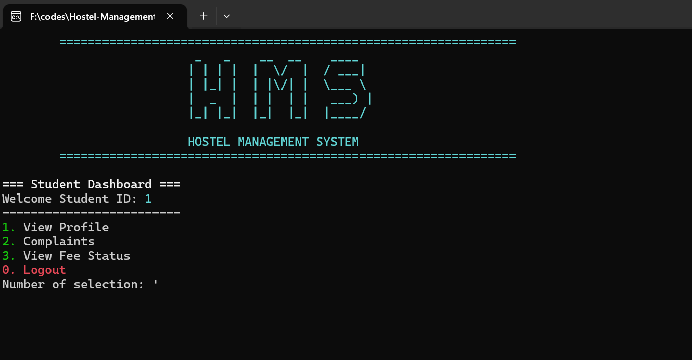

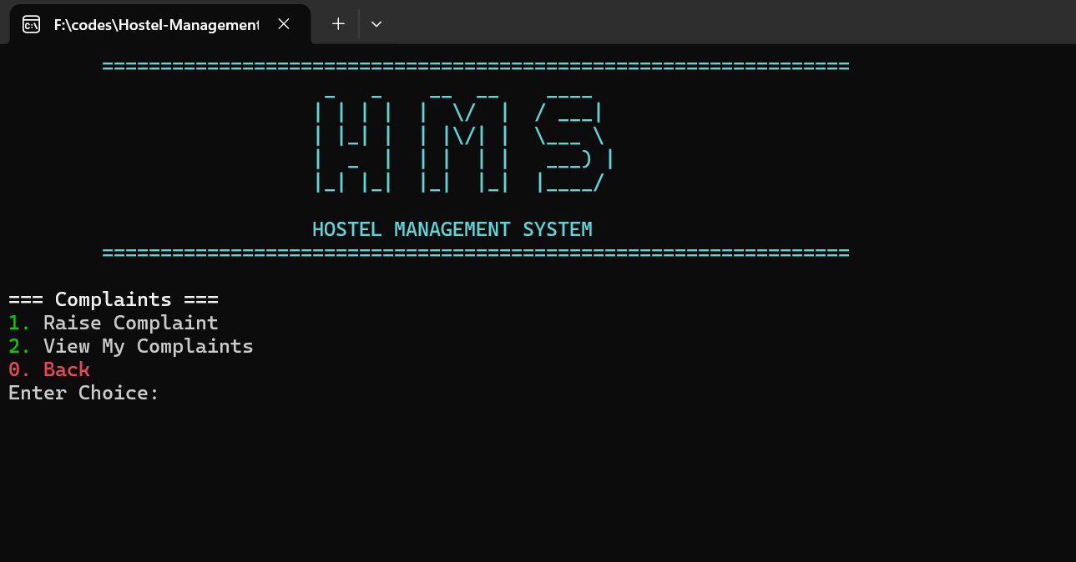
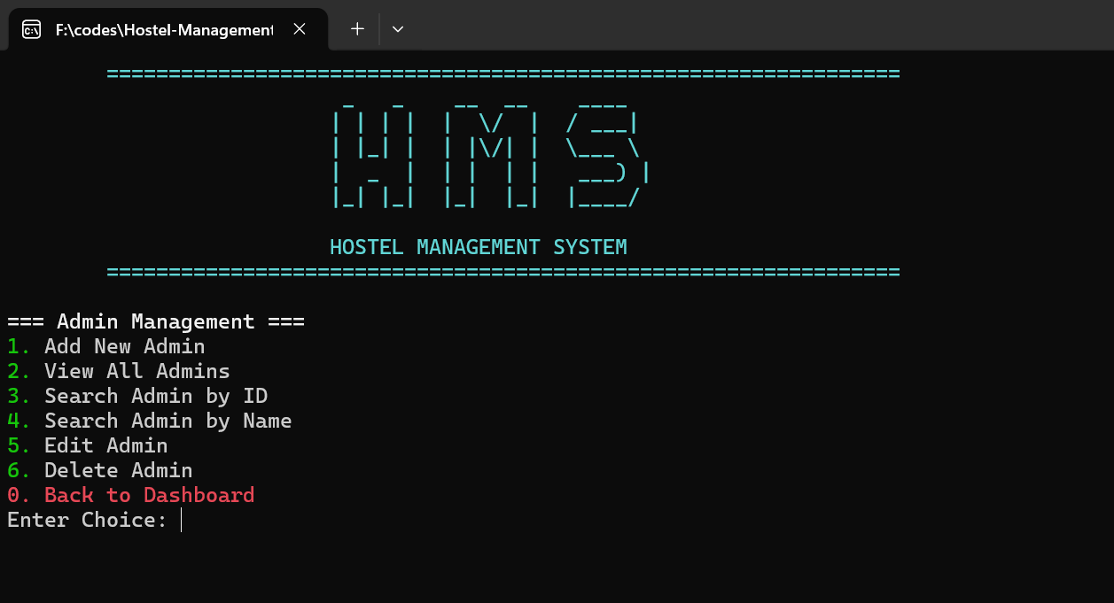

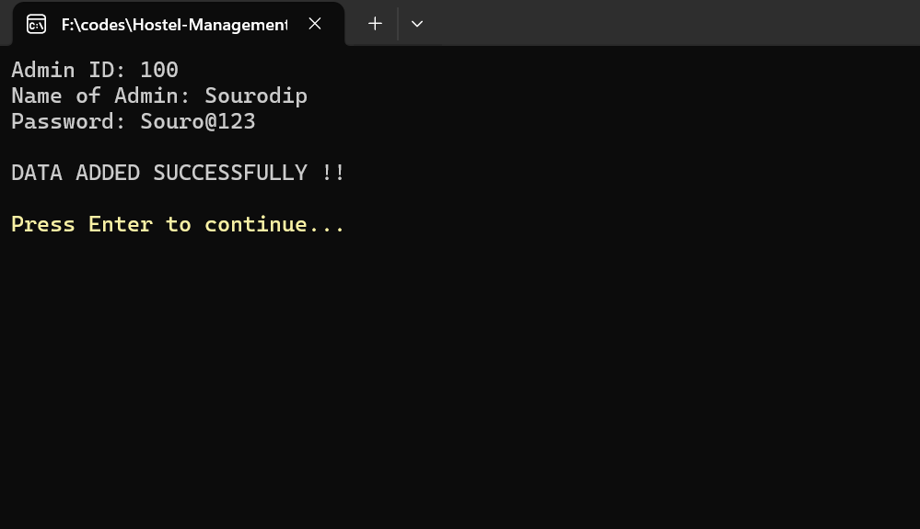

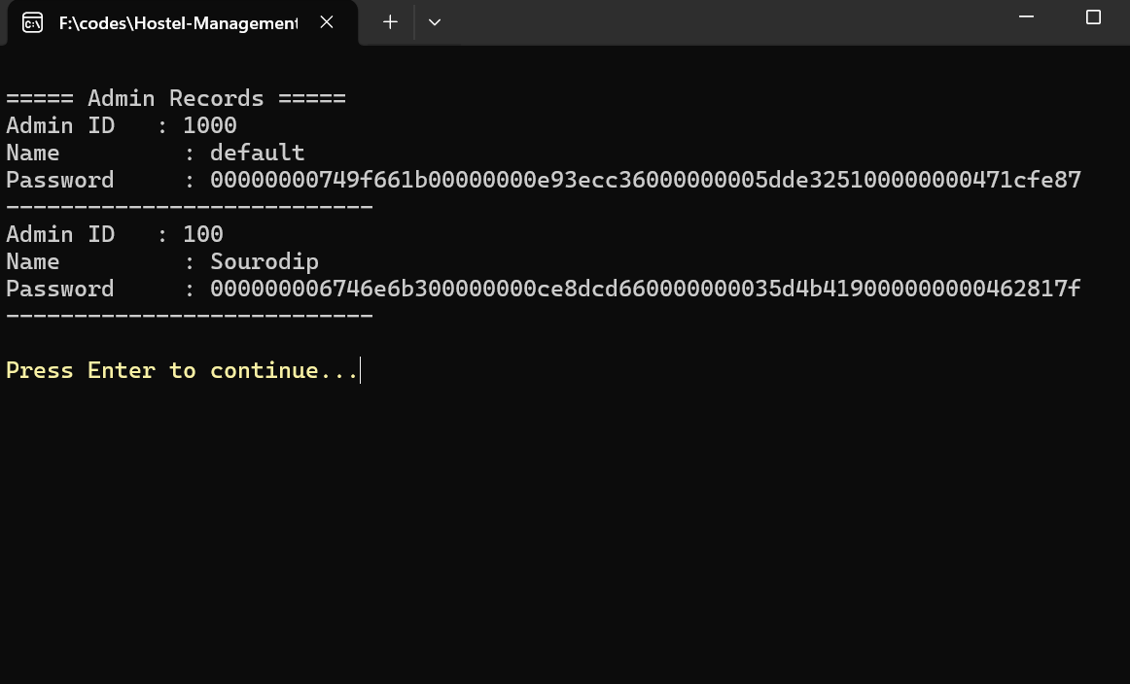

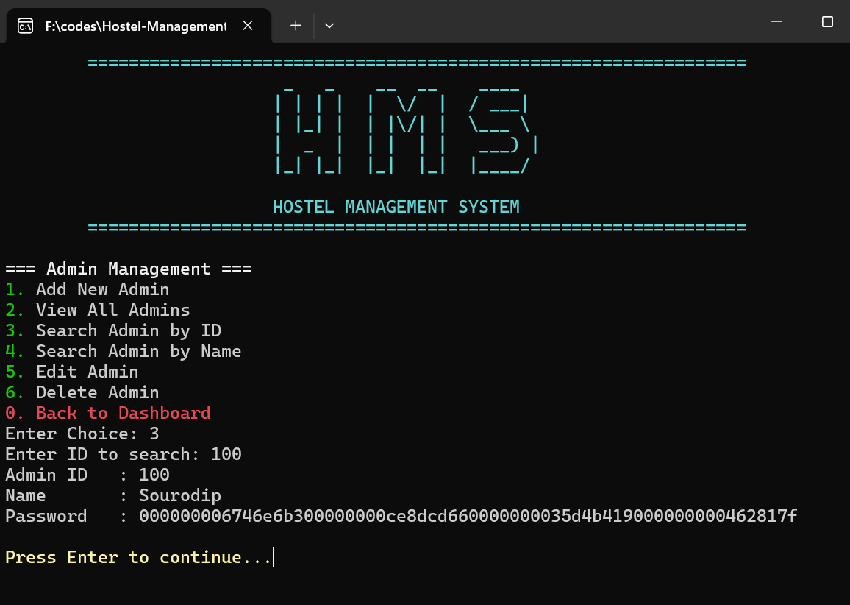
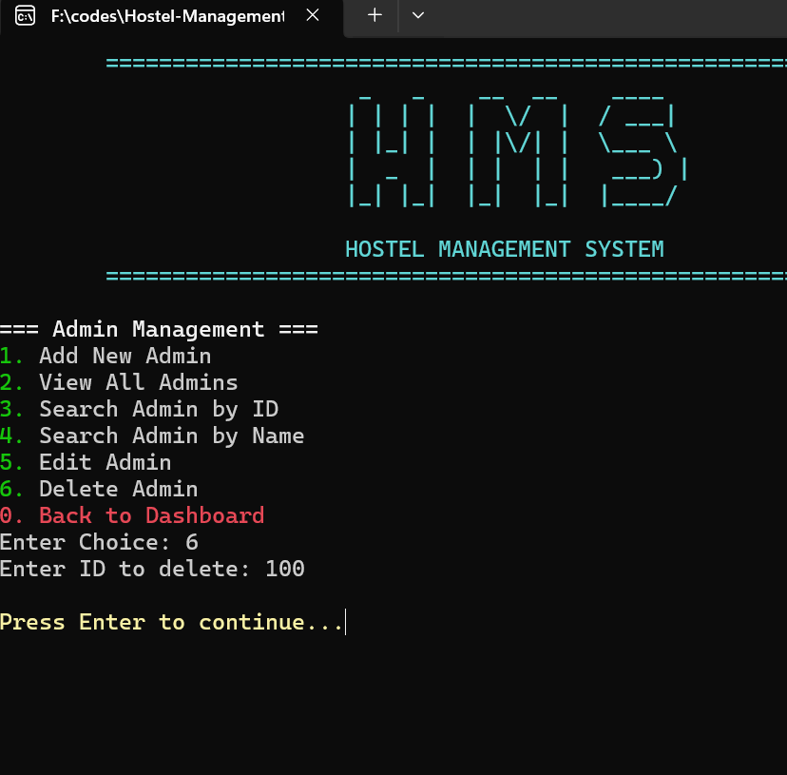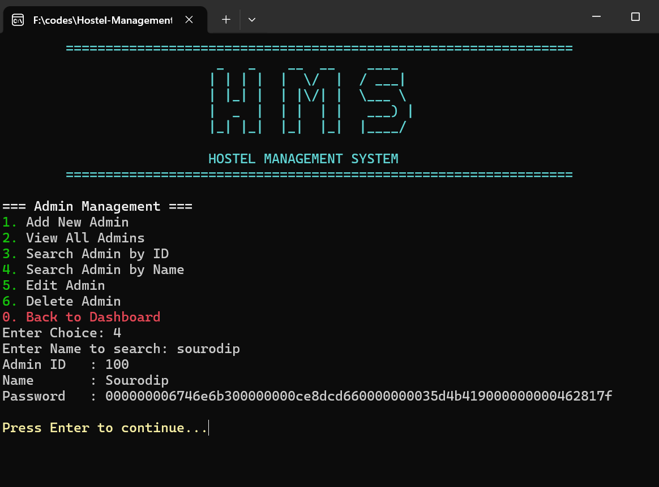

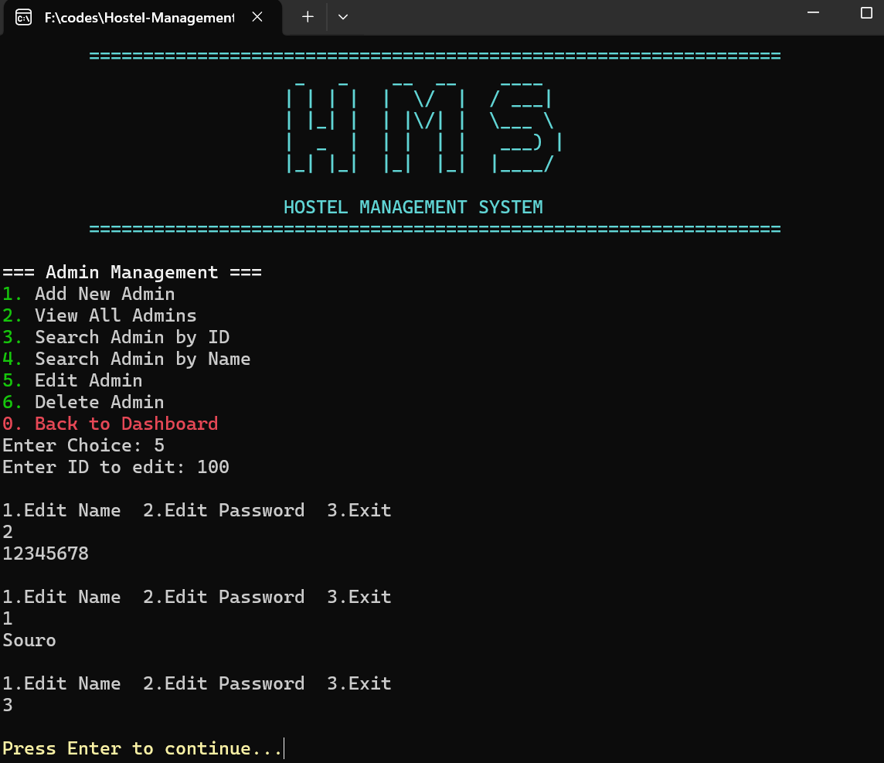

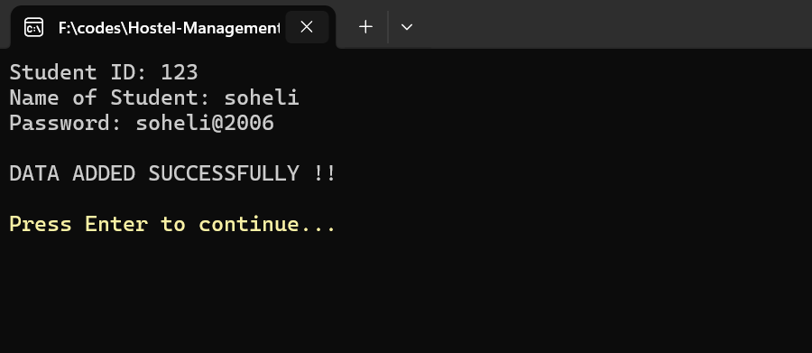
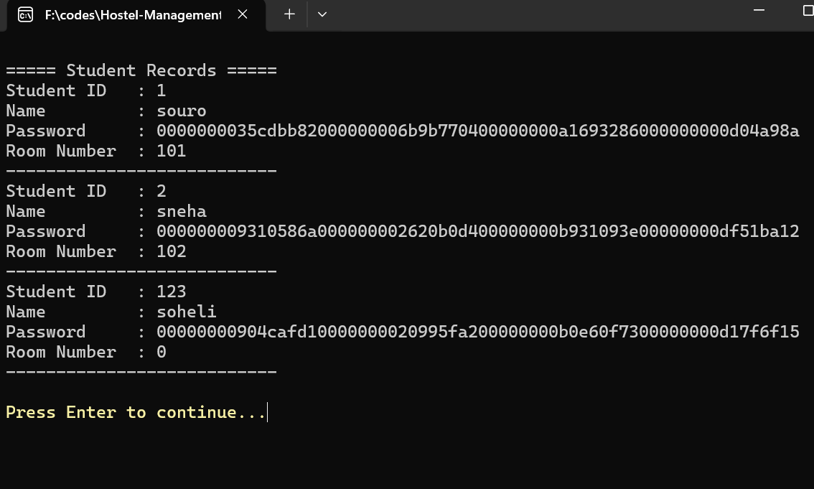

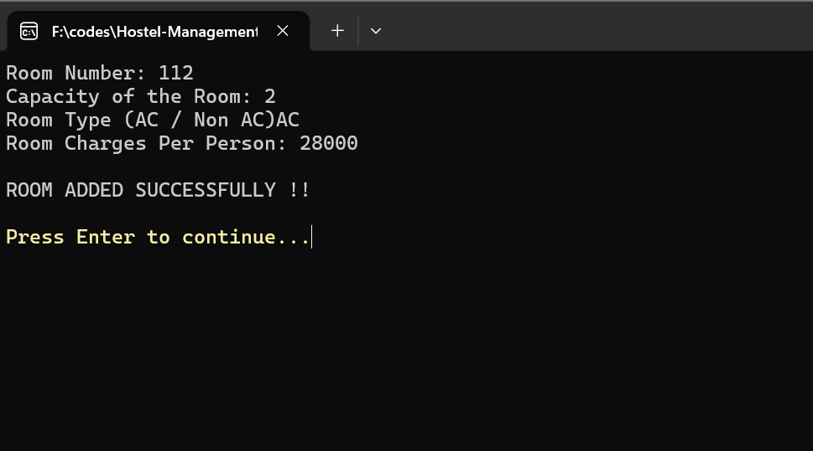

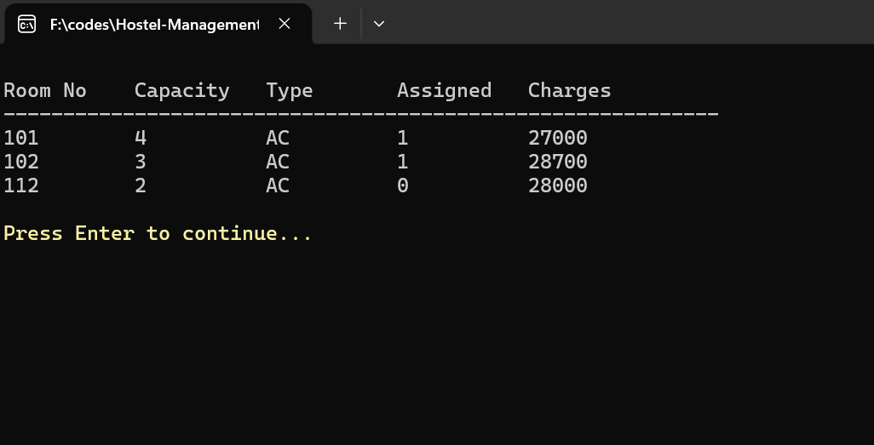

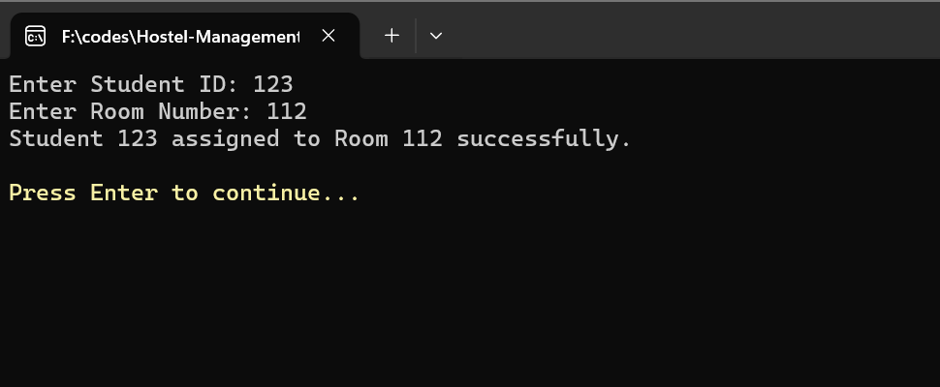

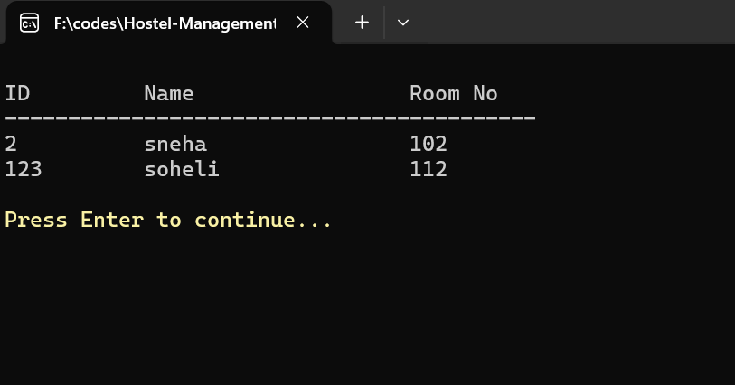

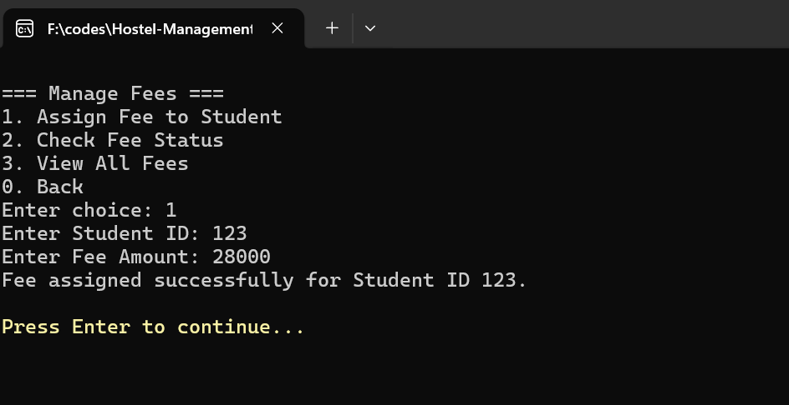

Advantages & Disadvantages

Advantages
- Security: Role-based access and password hashing prevent unauthorized access
- Efficiency: Automated operations reduce manual work and errors
- Persistence: File-based storage ensures data survives program termination
- Modularity: Well-organized code structure for easy maintenance
- User-Friendly: Menu-driven interface requires no technical knowledge
- Cost-Effective: No additional software licenses required

Disadvantages
- Console-Based: Limited graphical interface compared to GUI applications
- Single-User: Cannot handle concurrent access (file locking issues)
- Memory Constraints: All data loaded into memory for operations
- No Backup System: Relies on manual file backups
- Platform Dependent: ANSI colors may not work on all terminals
- Limited Scalability: File-based approach may slow with large datasets

Conclusion
This project successfully demonstrates the implementation of a complete hostel management system using the C programming language. We achieved all major objectives, including secure authentication, modular design, and comprehensive functionality for both admin and student users. The system effectively solves the problem of manual hostel record-keeping by providing automated, secure, and efficient operation. Through this project, we gained valuable experience in file handling, data structures, security concepts, and user interface design using C programming.

Future Enhancements
- GUI Interface: Develop a graphical user interface using libraries like GTK or Qt
- Database Integration: Replace file system with SQL database for better concurrency and querying
- Web Interface: Create a web-based version for remote access
- Multi-Hostel Support: Extend to manage multiple hostels simultaneously
- Email Notifications: Automated notifications for fee dues and complaint resolutions
- Mobile App: Develop companion mobile application for students
- Advanced Reporting: Generate PDF reports and analytics
- Cloud Backup: Automatic data backup to cloud storage
- Multi-language Support: Add support for multiple languages
- Biometric Authentication: Integrate fingerprint or facial recognition for enhanced security

Biblography

[1] RabaDabaDoba, “ANSI Color Codes,” GitHub Gist. [Online]. Available: https://gist.github.com/RabaDabaDoba/145049536f815903c79944599c6f952a. Accessed: Jan. 29, 2026.

[2] GeeksforGeeks, “Cryptography – Hash Functions,” GeeksforGeeks. [Online]. Available: https://www.geeksforgeeks.org/competitive-programming/cryptography-hash-functions/. Accessed: Jan. 29, 2026.

[3] GeeksforGeeks, “Basics of File Handling in C”. [Online]. Available: https://www.geeksforgeeks.org/c/basics-file-handling-c/. Accessed: Jan. 29, 2026.

[4] Stack Overflow, “Why are #ifndef and #define used in C header files?” Stack Overflow. [Online]. Available: https://stackoverflow.com/questions/1653958/why-are-ifndef-and-define-used-in-c-header-files. Accessed: Jan. 29, 2026.

-------------------------------------------------------xxxxxxxxxxxxxxxxxx-------------------------------------------------------

