INTRODUCTION

PYTHON

About python:
- Python is a high-level, general-purpose, open source, strictly typed programming language. The language provides constructs intended to enable clear programs on both a small and large scale.
- Python was created By Guido van Rossum.
- The Python Software Foundation (PSF) is the organization behind Python.

Python Versions:
- First released in 1991.
- Python 2.0 was released on 16th October 2000.
- Python 3.0 was released on 3rd December 2008.

Current Versions:
- 3.6.3
- 2.7.14

Python Features:
Some of the features of python include:
- Easy to understand
- Dynamic
- Object Oriented
- Multi-purpose
- Strongly typed
- Open source

Python is mainly used in many domains:
- Web Development
- Data Analysis
- Machine Learning
- Internet of Things
- GUI Development
- Image Processing
- Data Visualization
- Game Development

IDLE:
IDLE is an integrated development environment for Python, which has been bundled with the default implementation of the language.

ANACONDA
Anaconda is an open source Distribution for data science and machine learning using python. It includes hundreds of popular data science packages and the conda package and virtual environment manager for Windows, Linux, and MacOS. Conda makes it quick and easy to install, run, and upgrade complex data science and machine learning environments like scikit-learn, TensorFlow, and SciPy. Anaconda Distribution is the foundation of millions of data science projects as well as Amazon Web Service Machine Learning AMIs and Anaconda for Microsoft on Azure and Windows.

PACKAGES

Numpy:
NumPy is the fundamental package for scientific computing with Python.
It contains among other things:
- a powerful N-dimensional array object
- sophisticated (broadcasting) functions
- tools for integrating C/C++ and Fortran code
- useful linear algebra, Fourier transform, and random number capabilities

Besides its obvious scientific uses, NumPy can also be used as an efficient multi-dimensional container of generic data. Arbitrary data-types can be defined. This allows NumPy to seamlessly and speedily integrate with a wide variety of databases.

Matplotlib:
Matplotlib is a Python 2D plotting library which produces publication quality figures in a variety of hardcopy formats and interactive environments across platforms. Matplotlib can be used in Python scripts, the Python and IPython shell, the jupyter notebook, web application servers, and four graphical user interface toolkits.

Matplotlib tries to make easy things easy and hard things possible. You can generate plots, histograms, power spectra, bar charts, error charts, scatterplots, etc., with just a few lines of code.
For simple plotting the pyplot module provides a MATLAB-like interface, particularly when combined with IPython. For the power user, you have full control of line styles, font properties, axes properties, etc, via an object oriented interface or via a set of functions familiar to MATLAB users.

Scikit-learn:
Scikit-learn provides machine learning libraries for python.Some of the features of Scikit-learn includes:
  - Simple and efficient tools for data mining and data analysis
  - Accessible to everybody, and reusable in various contexts
  - Built on NumPy, SciPy, and matplotlib
  - Open source, commercially usable - BSD license

Pandas:
Pandas is an open source, BSD-licensed library providing high-performance, easy-to-use data structures and data analysis tools for the Python programming language.
Pandas library is well suited for data manipulation and analysis using python. In particular, it offers data structures and operations for manipulating numerical tables and time series.

Seaborn:
Seaborn is a Python visualization library based on matplotlib. It provides a high-level interface for drawing attractive statistical graphics. E.g:-
Heatmap
Violinplot

TRAINING WORK UNDERTAKEN

Collecting data from Kaggle:
Kaggle is a platform for predictive modelling and analytics competitions in which statisticians and data miners compete to produce the best models for predicting and describing the datasets uploaded by companies and users. This crowd sourcing approach relies on the fact that there are countless strategies that can be applied to any predictive modelling task and it is impossible to know beforehand which technique or analyst will be most effective.
On 8 March 2017, Google announced that they were acquiring Kaggle. They will join the Google Cloud team and continue to be a distinct brand. In January 2018, Booz Allen and Kaggle launched Data Science Bowl, a machine learning competition to analyze cell images and identify nuclei.

Data Science:
Data science is an interdisciplinary field that uses scientific methods, processes, algorithms and systems to extract knowledge and insights from data in various forms, both structured and unstructured, similar to data mining. Data science is a "concept to unify statistics, data analysis, machine learning and their related methods" in order to "understand and analyze actual phenomena" with data. It employs techniques and theories drawn from many fields within the context of mathematics, statistics, information science, and computer science.
Turing award winner JiGray imagined data science as a "fourth paradigm" of science (empirical, theoretical, computational and now data-driven) and asserted that "everything about science is changing because of the impact of information technology" and the data deluge. When Harvard Business Review called it "The Sexiest Job of the 21st Century" the term became a buzzword, and is now often applied to business analytics, business intelligence, predictive modeling, or any arbitrary use of data, or used as a glamorized term for statistics. In many cases, earlier approaches and solutions are now simply rebranded as "data science" to be more attractive, which can cause the term to become "dilute[d] beyond usefulness." While many university programs now offer a data science degree, there exists no consensus on a definition or suitable curriculum contents. Because of the current popularity of this term, there are many "advocacy efforts" surrounding the field. To its discredit, however, many data science and big data projects fail to deliver useful results, often as a result of poor management and utilization of resources.

SOURCE CODE

STOCK PREDICTION PROGRAM USING PYTHON

The Data Set (.csv file) used here is: Amazon Stock data
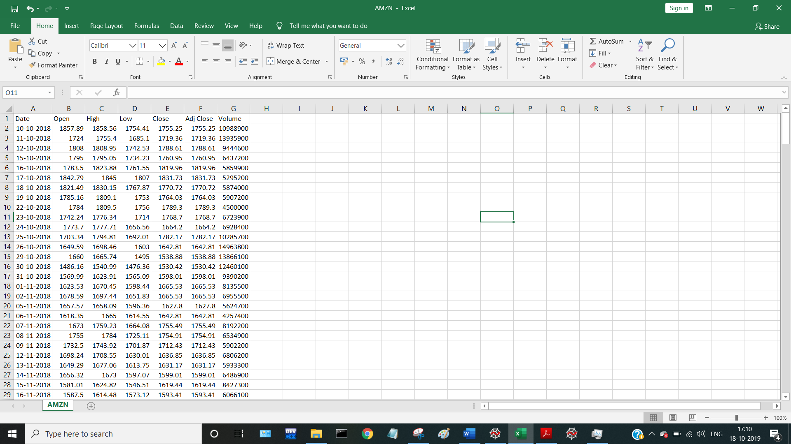

1. Import packages
Python library is a collection of functions and methods that allows you to perform lots of actions without writing your own code. These libraries can be imported and this enables us to work on our code a lot faster.
The wheel can be taken as an example to understand this. It has been already invented, so the person who invented the car didn’t waste his time reinventing the wheel. Here, the car is an invention which has imported the wheel. So, the wheel is a module which can be used in other inventions as it is.
The libraries that we’ll be using here are numpy, matplotlib.pyplot(will be used in the later chapters) and pandas. The pandas library is used to import and manage the datasets.
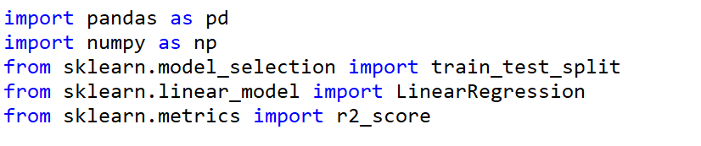

2. Load the Dataset
First, we need to set the appropriate working directory using the file explorer. You’ll find this on the top right of the Spyder window. The working directory is the directory in which your dataset is stored.
Here, we’ll be using the pandas library for importing the dataset
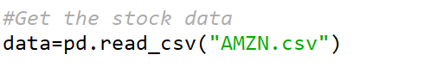

3. Create the independent Dataset
The first ‘:’ stands for the rows which we want to include, and the next one stands for the columns we want to include. By default, if only the ‘:’ (colon) is used, it means that all the rows/columns are to be included. In case of our dataset, we need to include all the rows (:) and all the columns but the first(Date) and last one (1:6).
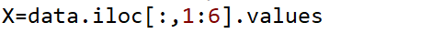

4. Create the dependent Dataset
To create the dependent variable vector ‘y’, the only change to be done here is the columns which we want in y. As in the matrix of features, we’ll be including all the rows. But from the columns, we need only the last. Therefore, the code the same will look as follows:
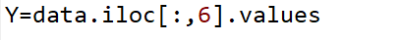

5. Split the data into training and testing data

Why split the data?
Creating a Supervised Machine Learning model is all about making a program that is able to generalize to input samples that it has never seen before. This task requires exposing the model — during training — to a certain number of variations of input examples, which is likely to lead to sufficient accuracy. This includes multiple steps that the model has to go through before it is available for use:
Step 1: Making the model examine data.
Step 2: Making the model learn from its mistakes.
Step 3: Making a conclusion on how well the model performs.
Since these steps are fairly different, then the data in each of which will be treated differently. Therefore, we need to decide which data point in the data set plays a role in which of the steps.
Training Set
This dataset corresponds to Step 1 in the previous section. It includes the set of input examples that the model will be fit into — or trained on — by adjusting the parameters (i.e. weights in the context of Neural Networks).
Test Set
This corresponds to the final evaluation that the model goes through after the training phase (utilizing training and validation sets) has been completed. This step is critical to test the generalizability of the model (Step 3). By using this set, we can get the working accuracy of our model.
The code will look as follows:

6. Create the train and Multilinear Regression model
The library we have imported is the same as for a simple linear regression. By running this piece of code, we have created an object of the class LinearRegression. ‘MLR’ is an object of this very class.
At this point, we’re supposed to fit this object to our training set. Fitting an object to a training set means that we need to create the MLR object and then run the .fit method on it.
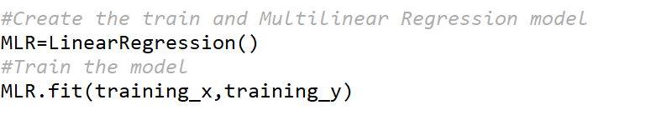

7. Print the Original and Predicted Data
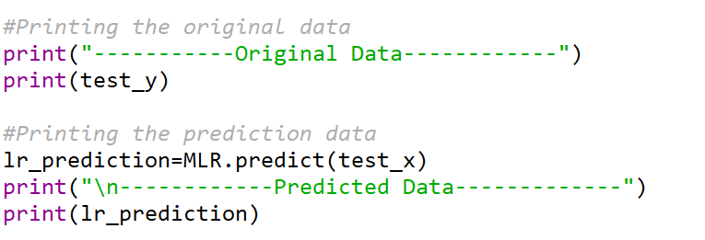

8. Print the r2 score Accuracy
The R^2 (or R Squared) metric provides an indication of the goodness of fit of a set of predictions to the actual values. In statistical literature, this measure is called the coefficient of determination.
This is a value between 0 and 1 for no-fit and perfect fit respectively.
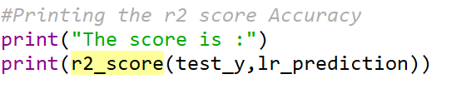

The overall program, therefore, looks like:

import pandas as pd
import numpy as np
from sklearn.model_selection import train_test_split
from sklearn.linear_model import LinearRegression
from sklearn.metrics import r2_score

#Get the stock data
data=pd.read_csv("AMZN.csv")

#Create the independent data set
X=data.iloc[:,1:6].values

#Create the dependent data set
Y=data.iloc[:,6].values

#Split the data into training and testing data
training_x,test_x,training_y,test_y=train_test_split(X,Y,test_size=0.3,random_state=1)

#Create the train and Multilinear Regression model
MLR=LinearRegression()
#Train the model
MLR.fit(training_x,training_y)

#Printing the original data
print("-----------Original Data------------")
print(test_y)

#Printing the prediction data
lr_prediction=MLR.predict(test_x)
print("\n------------Predicted Data-------------")
print(lr_prediction)

#Printing the r2 score Accuracy
print("The score is :")
print(r2_score(test_y,lr_prediction))

OUTPUT

The output of the above program is:
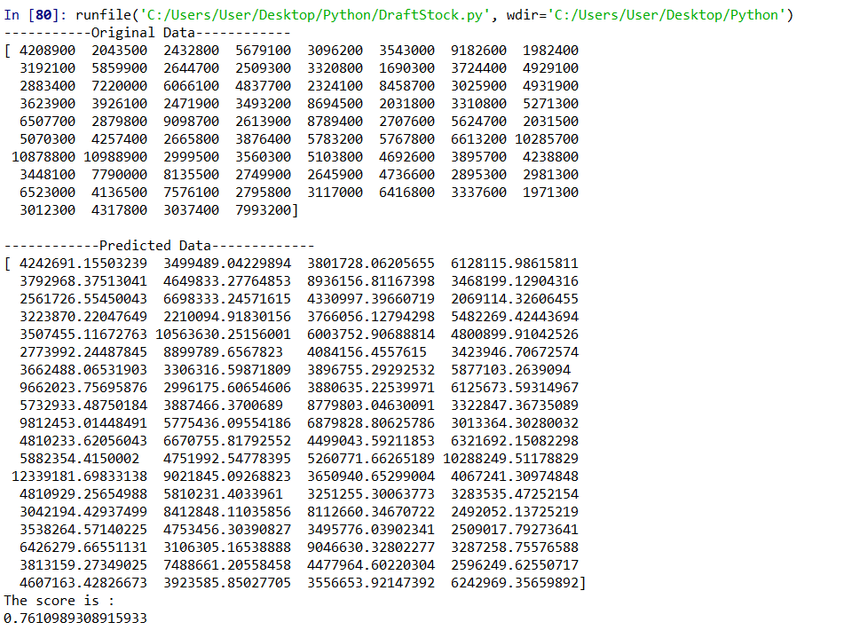

With Multilinear Regression, we got an accuracy of 76%.

CONCLUSION
This program is predicting the stock price of Amazon Stock Data. By this program, we can conclude that Linear Regression package of Machine Learning in Python can be used effectively to predict the stock market prices of different stock data-sets. Linear Regression is a machine learning algorithm based on supervised learning. It performs a regression task. Regression models a target prediction value based on independent variables. It is mostly used for finding out the relationship between variables and forecasting. Different regression models differ based on – the kind of relationship between dependent and independent variables, they are considering and the number of independent variables being used.

Applications of Machine Learning:
Machine learning is one of the most exciting technologies that one would have ever come across. As it is evident from the name, it gives the computer that which makes it more similar to humans: The ability to learn. Machine learning is actively being used today, perhaps in many more places than one would expect. We probably use a learning algorithm dozens of time without even knowing it. Applications of Machine Learning include:
Web Search Engine: One of the reasons why search engines like google, bing etc work so well is because the system has learnt how to rank pages through a complex learning algorithm.
Photo tagging Applications: Be it facebook or any other photo tagging application, the ability to tag friends makes it even more happening. It is all possible because of a face recognition algorithm that runs behind the application.
Spam Detector: Our mail agent like Gmail or Hotmail does a lot of hard work for us in classifying the mails and moving the spam mails to spam folder. This is again achieved by a spam classifier running in the back end of mail application.

BIBLIOGRAPHY

- https://www.geeksforgeeks.org
- https://medium.com
- https://www.quora.com
- https://github.com

