1.Define a function named “triple_and” that takes three parameters and returns True only if they are all True and False otherwise
2. Write a python program to sort a string alphabetically and print the count of each character.
3. Write a python program to check if given number is a hill number
4. Write a python function to perform selection sort on a given string.
5. Find the fibonacci of a given number using recursion.
6. Create a function that takes two strings as input and checks whether they are anagrams of each other.
7. Write a program to print the Fibonacci Sequence till n-values where n is user input.
8. Write a python program to divide a given string into equal parts containing n(user input) characters of same sequence. Example: string=“abcdabcdabcdabcd” n=4 output: “abcd”, “abcd”, “abcd”, “abcd” If the division is not possible or the sequence cannot be same, print out the appropriate error.
9. Write a python function to encrypt a string using Ceasar’s Cipher
10. Write a python function to check if a given credit card number is valid or not using Luhn’s Algorithm
11. Write a Python program that prints the grade level of a given text using Coleman-Liau formula.
12. WAP a code to print the following patters.
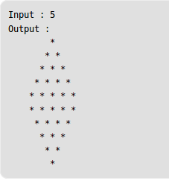
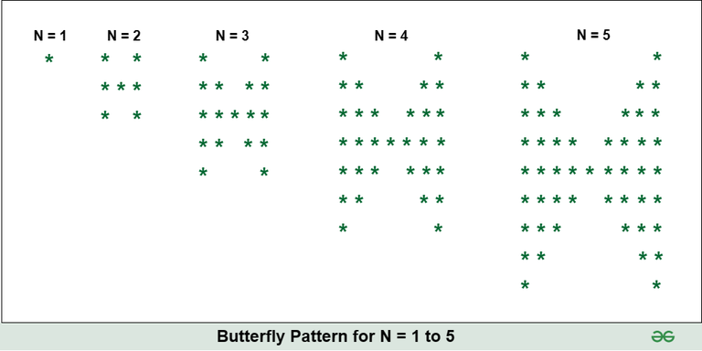
13. Implement the following classes to understand abstraction in Python :
Note: Driver code makes all the function calls and print statements

Class Name: Shape (Abstract Class)
Attributes: color (String)
Constructor: Shape(c) -> assign value of c to color attribute
Methods: get_color() -> returns value of color
get_area() -> abstract method with float return type
Class Name: Square (extends Shape)
Attributes: side (float)
Constructor: Square(c, side) -> calls super(c) to initialize the color and assigns the value to side.
Methods: get_area() -> returns the area of the square (side * side)
14. Given an array arr[], find the first repeating element. The element should occur more than once and the index of its first occurrence should be the smallest.
15. Rotate an n*n matrix by 90° clockwise.Take a user input for a matrix and print the elements in spiral order

