Documentation VLBA II – System Architectures
Your Topic
Your Name
Student ID
Magdeburg, 30. Mai 2018

Table of contents
Table of contents I
Table of figures II
1. Introdcution 1
2. Etc. 1
3. References 1

Table of figures
Figure 1 - KDD 1

Introduction
Some random text.
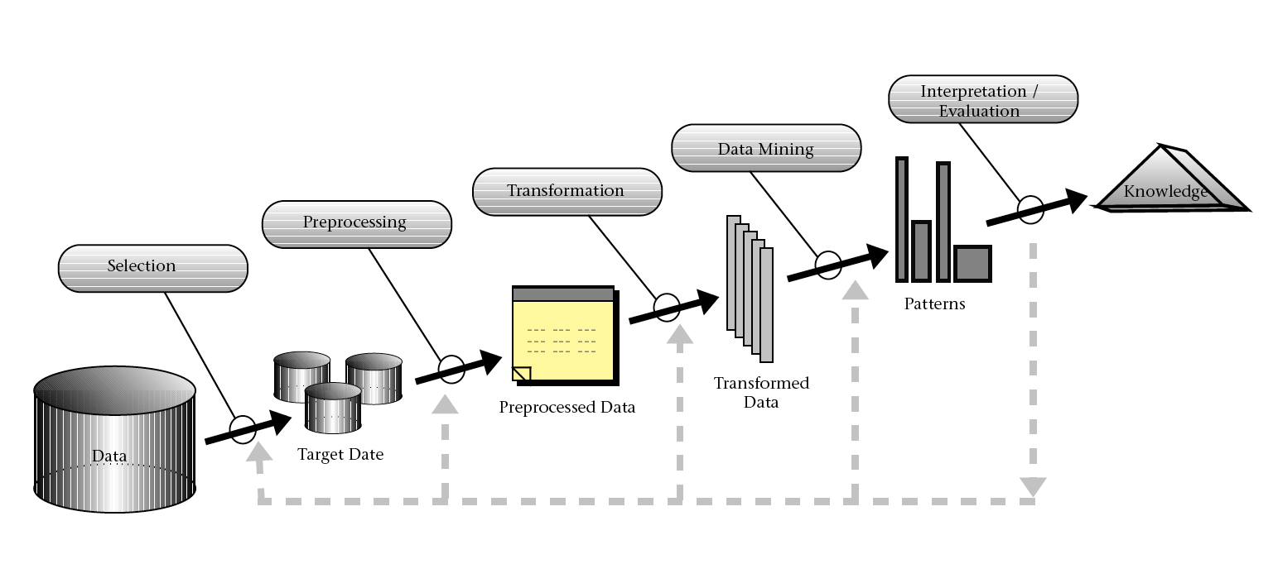
Figure 1 – KDD [1]

Etc.
“Lorem ipsum dolor sit amet, consectetur adipiscing elit, sed do eiusmod tempor incididunt ut labore et dolore magna aliqua. Ut enim ad minim veniam, quis nostrud exercitation ullamco laboris nisi ut aliquip ex ea commodo consequat. Duis aute irure dolor in reprehenderit in voluptate velit esse cillum dolore eu fugiat nulla pariatur. Excepteur sint occaecat cupidatat non proident, sunt in culpa qui officia deserunt mollit anim id est laborum” [2]

References
[1] Fayyad, U., Piatetsky-Shapiro, G., and Smyth, P. 1996. “From Data Mining to Knowledge Discovery in Databases,” AI Magazine (17:3), p. 37.
[2] Ebers, Robert 2018. Lorem Ipsum. https://www.lipsum.com/. Accessed on: 30.05.2018

