SECTION 1:
Lecture 4:
Remix IDE
This is an IDE (Integrated Development Environment), a powerful tool used to build and develop smart contracts in Solidity. It helps to easily visualize and interact with our smart contracts.
- Remove all the existing files and folders
- Create a new file, e.g., SimpleStorage.sol. The .sol extension tells the compiler that this is a Solidity file.
Compiler directive
The pragma directive specifies the version of the Solidity compiler that you want to use to build your source file. When the compiler encounters this line, it will check its version against the one you specified here. If the compiler version is different, Remix will automatically adjust accordingly to your specifications.
You can specify the compiler version(s) in the following ways:
1. use exactly one version
2 . use versions that fall within a lower and upper range
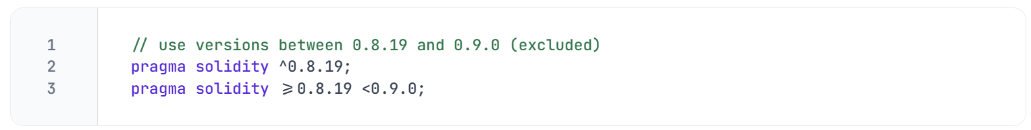 NOTE
Remember to write comments in your code for you to refer to later on.

SPDX License Identifier
It's a good practice (even not mandatory) to start your smart contract with an SPDX License Identifier. It helps in making licensing and sharing code easier from a legal perspective.
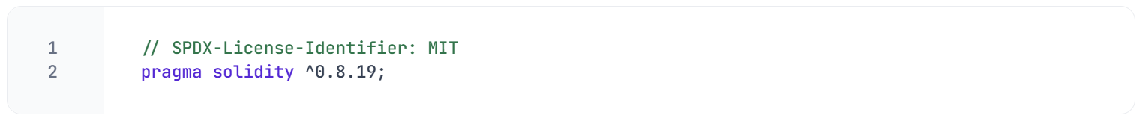 Purpose:
- SPDX License Identifier tells which license your code is under. The above code is licensed under the MIT License (a very permissive open-source license).
Why is it useful?
- It helps automated tools and repositories (like GitHub, npm, or blockchain explorers) automatically detect the license of your smart contract.
- It makes legal compliance easier and clearer.
- The Solidity compiler expects this SPDX identifier at the top of files to encourage open-source licensing clarity.
If you omit it:
- The compiler won’t throw an error, but it will usually warn you that no license identifier is specified.
- Without this, it's not clear what legal terms govern the contract.

Writing the Smart Contract
You can start writing your contract using the keyword contract followed by a name, e.g., SimpleStorage. All the code inside the curly brackets will be considered part of this contract.
If you are familiar with Object Oriented Programming languages, you can think of a contract as a concept similar to a class.
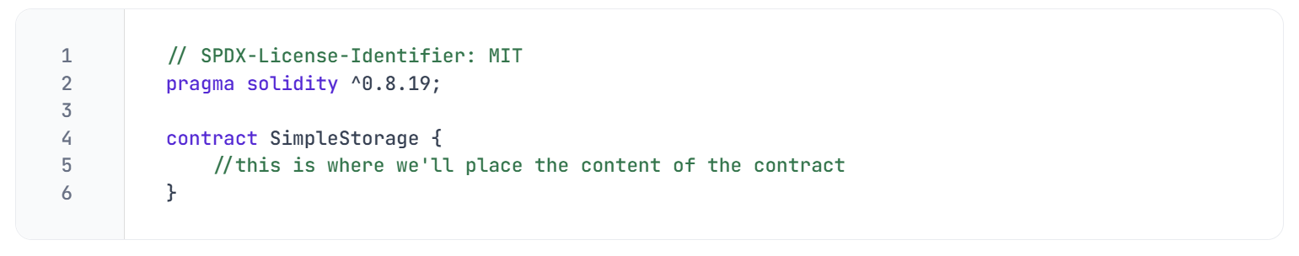Compiling
- In Remix IDE, select the Solidity Compiler.
- Choose the version of the compiler that matches the version specified in your Solidity file.
- Hit the Compile button.
Compiling your code means taking human-readable code and transforming it into computer-readable code or bytecode.
If you see a green checkmark, it means your compilation was successful. If there is any error, Remix will point out where the error is, and you can debug it accordingly.

LECTURE 6:
Solidity Types
Solidity supports various elementary types that can be combined to create more complex ones. You can read more about them in the Solidity documentation.
🕵️‍♂️ For now, let's focus on the most commonly used
- Boolean (bool): true or false
- Unsigned Integer (uint): unsigned whole number (positive)
- Integer (int): signed whole number (positive and negative)
- Address (address): 20 bytes value. An example of an address can be found within your MetaMask account.
- Bytes (bytes): low-level raw byte data
Variables definition
Variables are just placeholders for values. A value can be one data type described in the list above. For instance, we could create a Boolean variable named hasFavoriteNumber, which would represent whether someone has a favourite number or not (constant true or false).
It's possible to specify the number of bits used for uint and int. For example, uint256 specifies that the variable has 256 bits. uint is a shorthand for uint256.
🗒️ NOTE
It's always advisable to be explicit when specifying the length of the data type.
# The semicolon at the end of each line signifies that a statement is completed.

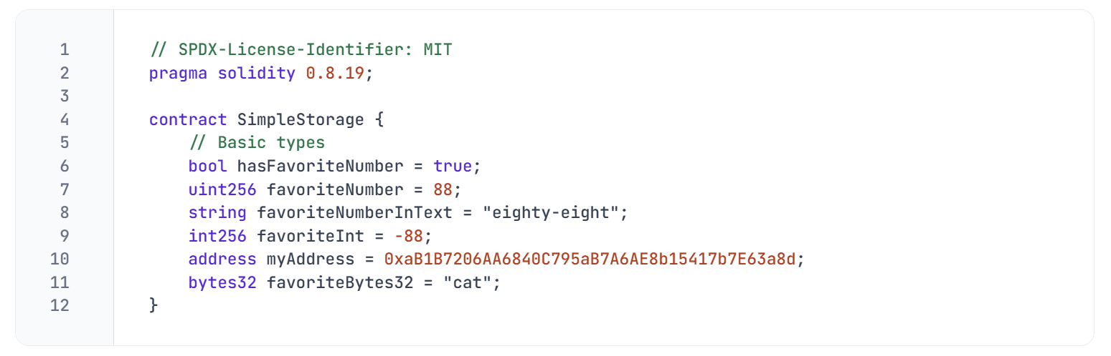

Bytes and strings
Bytes are a collection of characters written in hexadecimal representation.
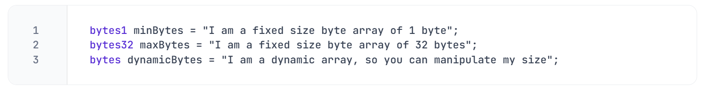Bytes can be allocated in size (up to bytes32). However, bytes and bytes32 represent distinct data types.

Strings are internally represented as dynamic byte arrays (bytes type) and designed specifically for working with text. For this reason, a string can easily be converted into bytes.

The contract logic
📋 Let's explore a scenario where there is a task involving the storage of a favourite number. For this purpose, we can start storing the variable favoriteNumber of type uint:
uint256 favoriteNumber;
IMPORTANT
Every variable in Solidity comes with a default value. Uninitialized uint256 for example, defaults to 0 (zero) and an uninitialized boolean defaults to false.
Type | Default Value | Explanation
bool | false | The default value for booleans is false.
uint (or uint256) | 0 | All unsigned integers default to zero.
int256 | 0 | Signed integers default to zero as well.
string | "" (empty string) | Strings default to an empty string.
address | 0x0000000000000000000000000000000000000000 | The default address is the zero address.
bytes | "" (empty dynamic byte array) | Dynamic bytes default to empty.
bytes32 | 0x000...000 (32 zero bytes) | Fixed-size byte arrays are initialized to all zeros.

🧑‍💻 Test yourself
- 📕 Describe the default value of the following types: bool, uint, int256, string, address, bytes, bytes32
- 📕 How does uint differ from bytes?

LECTURE 7:
Building the store FUNCTION
To store the favoriteNumber variable, we need to implement a new function. In Solidity, functions - or methods, are portions of code designed to execute specific tasks within the overall codebase.
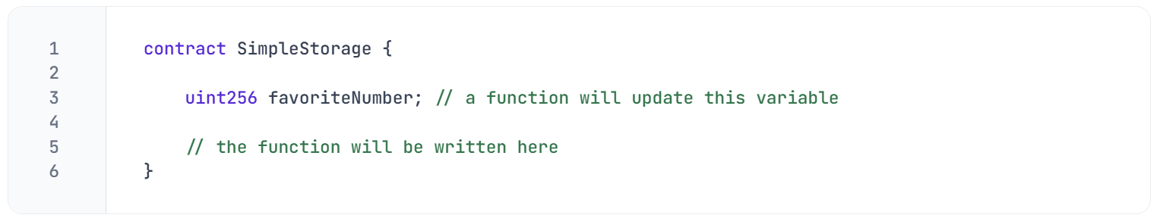Functions are identified by the keyword function, followed by a custom name and any additional parameters
enclosed in rounded parentheses (). These parameters represent the values sent to our function.
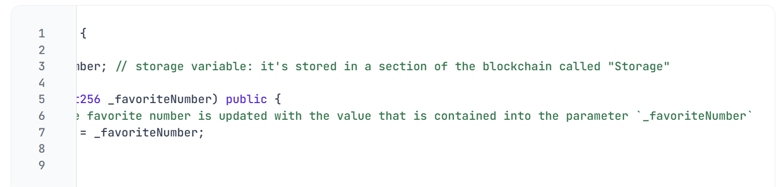
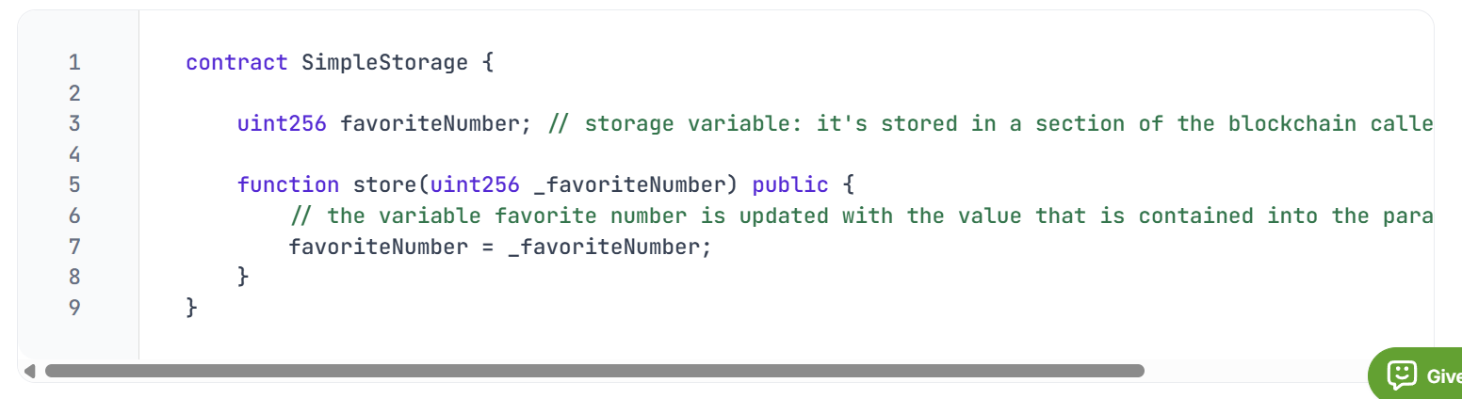
The content of the function is placed within the c

urly brackets {}. The

prefix ”_” before “favoriteNumber” is used to emphasize that the local variable “_favoriteNumber” is a different variable from the state variable “favoriteNumber”. This is just a naming convention

Deploying the smart contract
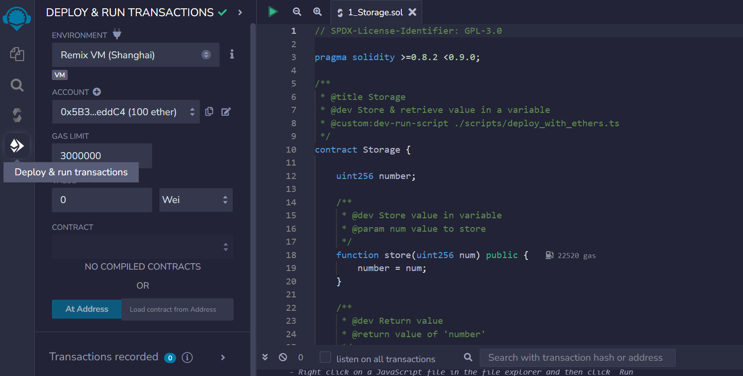
You can test out this function in the Remix VM environment. At this stage, you can compile your code by navigating to the compile tab and hitting Compile. After compiling, navigate to the tab Deploy and Run Transactions to test your function.

The Deploy and Run Transactions tab holds a variety of parameters that are used during the deployment process. You'll be assigned an account with some ETH to deploy your smart contract.

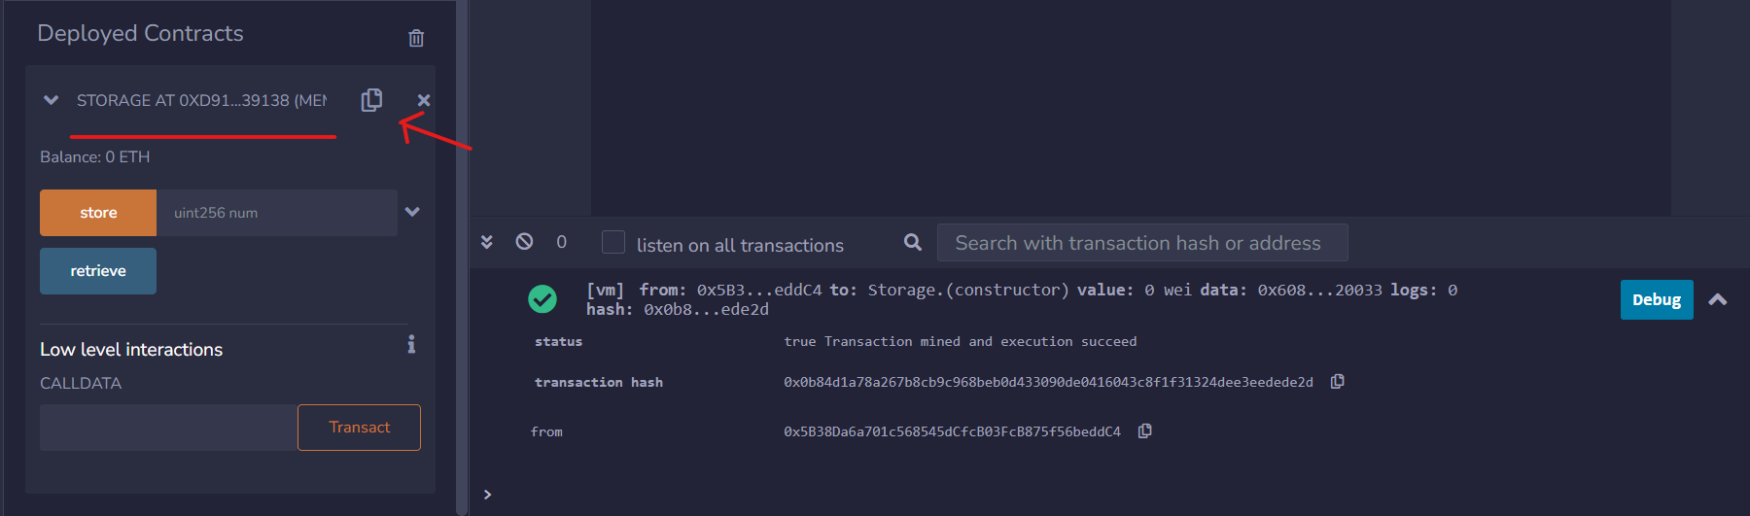
In this environment, your contract is assigned a unique address. You can re-access your deployed contract by expanding the Deployed Contracts interface and simultaneously opening the terminal, which shows log data of all contract deployments and transactions.

If we open the Remix terminal we can see that deploying the contract has just sent a simulated transaction on the Remix environment. You can check out its details such as status, hash, from, to and gas.
IMPORTANT
The process of sending a transaction is the same for deploying a contract and for sending Ethers. The only difference is that the machine-readable code of the deployed contract is placed inside the data field of the deployment transaction.

Transactions creation
Let's send a transaction to the store function to change the value of the variable favoriteNumber: you can insert a number and press the store button in Remix. A transaction is initiated and after some time, its status will change from pending to complete.
💸 From the accounts section, it becomes visible that ETH is being consumed every time a transaction is submitted. When the state of the blockchain is modified (e.g. deploying a contract, sending ETH, ...), is done by sending a transaction that consumes gas. Executing the store function is more expensive than just transferring ETH between accounts, with the rising gas expenses primarily associated (though not exclusively) with the code length.

Verifying the stored value
This contract is missing a way to check if the number has been updated: now we can store a value but we cannot be sure if the transaction actually changed the variable value.
The default visibility of the favoriteNumber variable is internal, preventing external contracts and users from viewing it.
NOTE
Appending the public keyword next to a variable will automatically change its visibility and it will generate a
getter function (a function that gets the variable's value when called).

After completing compilation and deployment, a button labelled favoriteNumber will become visible. When pressed, it should return the most recent stored value of the variable favoriteNumber.

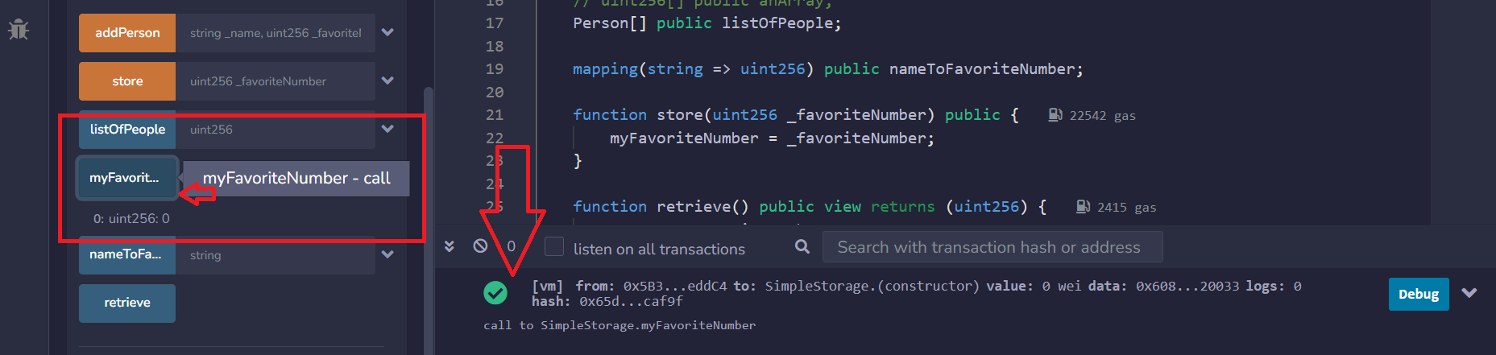

Visibility
In Solidity, functions and variables can have one of these four visibility specifiers:
- 🌎 public: accessible from both inside the contract and from external contracts
- 🏠 private: accessible only within the current contract. It does not hide a value but only restricts its access
- 🌲 external: used only for functions. Visible only from outside the contract
- 🏠🏠 internal: accessible by the current contract and any contracts derived from it

If a visibility specifier is not given, it defaults to internal.

- // SPDX-License-Identifier: MIT
- pragma solidity ^0.8.19;

- contract VisibilityExample {
- // public variable: accessible from inside and outside the contract
- uint public publicVar = 1;
- // private variable: accessible only inside this contract
- uint private privateVar = 2;
- // internal variable: accessible in this contract and derived contracts
- uint internal internalVar = 3;

- // public function: can be called internally and externally
- function getPublicVar() public view returns (uint) {
- return publicVar;
- }
- // private function: can be called only inside this contract
- function getPrivateVar() private view returns (uint) {
- return privateVar;
- }
- // internal function: can be called inside this contract and by derived contracts
- function getInternalVar() internal view returns (uint) {
- return internalVar;
- }
- // external function: can only be called from outside the contract
- function externalFunction() external pure returns (string memory) {
- return "Called external function";
- }

- // Example of internal usage inside this contract
- function internalUsage() public view returns (uint) {
- // can call private function inside contract
- uint privateVal = getPrivateVar();
- // can call internal function inside contract
- uint internalVal = getInternalVar();

- return privateVal + internalVal;
- }
- }

Pure and View keywords
The terms view and pure are used when a function reads values from the blockchain without altering its state. Such functions will not initiate transactions but rather make calls, represented as blue buttons in the Remix interface. A pure function will prohibit any reading from the state or storage.

1. view
- A view function can read state variables but cannot modify them.
- It guarantees that no state will be changed.
2. pure
- A pure function cannot read or modify any state variables.
- It can only use local variables or function parameters.
- It is purely computation based.

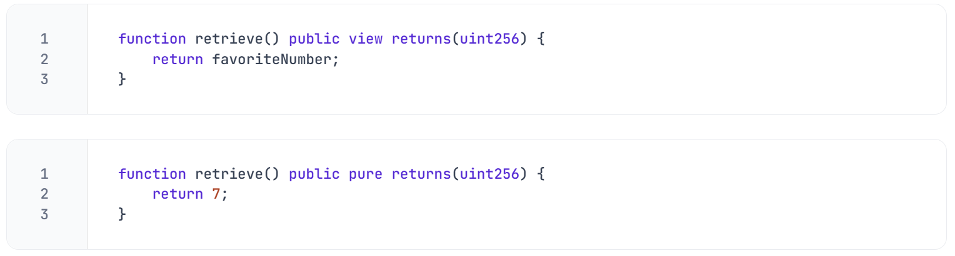
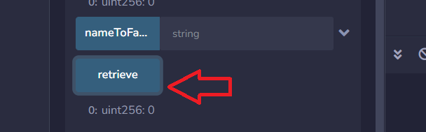
The keyword returns specifies the type(s) of value a function will return.

🚧 WARNING
While calling view or pure functions doesn’t typically require gas, they do require it when called by another function that modifies the state or storage through a transaction. This cost is called execution cost and it will add up to the transaction cost.

The scope of a variable
The scope of a variable refers to the context within which it is defined and accessible. This context is usually determined by the block of code, typically enclosed in curly braces {}, where the variable is declared. To access the same variable across different functions, it should be declared inside the scope of the main contract.
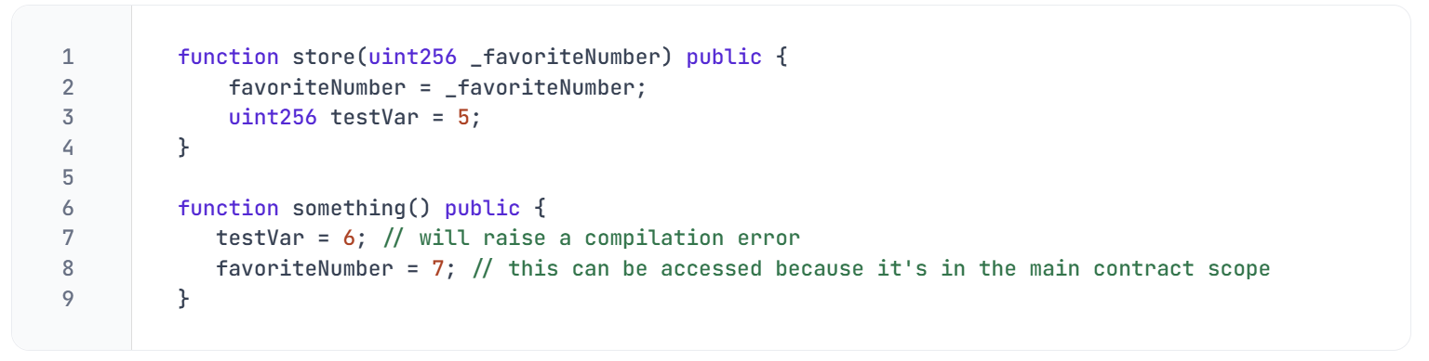

🧑‍💻 Test yourself
- 📕 What's the difference between a transaction that deploys a contract and a transaction that transfers ETH?
- 🧑‍💻 Write a contract that features 3 functions:
  - a view function that can be accessed only by the current contract
  - a pure function that's not accessible within the current contract
  - a view function that can be accessed from children's contracts

Lecture 8:
Arrays and struct
First we need to replace the uint256 favoriteNumber with a list of uint256 numbers:
The brackets indicate that we have a list of uint256, an array of numbers. If we want to initialize this array we can do so by specifying its content:
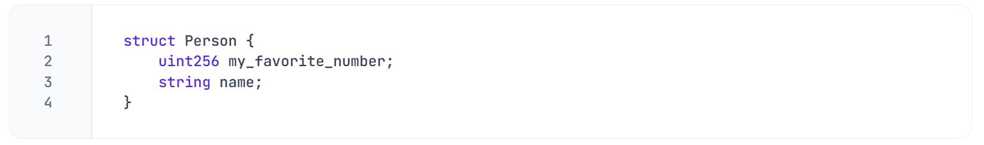
The issue with this data structure is that we cannot link the owner with its favorite
🗒️ NOTE
Arrays are zero-indexed: the first element is at position zero (has index 0), the second element is at position one (has index 1), and so on.

value. One solution is to establish a new type using the struct keyword, named
Person, which is made of two attributes: a favorite number and a name.

From this struct, we can instantiate a variable my_friend that has the type Person, with a favorite number of seven and the name 'Pat'. We can retrieve these details using the getter function that was generated by the public keyword.
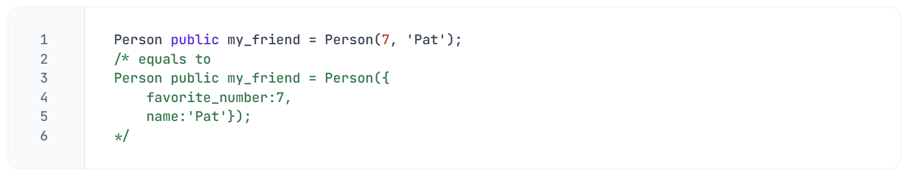

Array of struct
Creating individual variables that represent several people might become a tedious task, due to the repetitive steps of the process. Instead of manually instantiating a variable for each person, we can combine the two concepts we just learned about: arrays and structs.
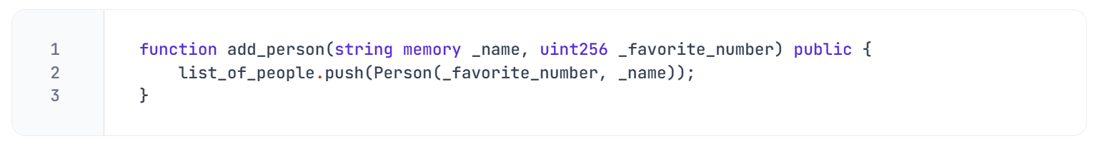
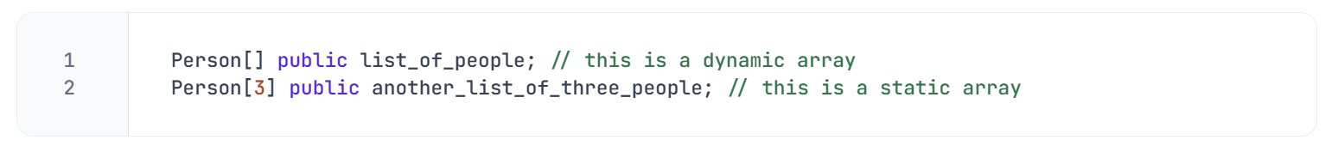
When using a dynamic array, we can add as many Person objects as we like

add_person is a function that takes two variables as input - the name and favourite number of the person. It creates first a new Person object and then it pushes it to our list_of_people array.

Common Array Operations in Solidity
1. Length
- You can get the length of a dynamic array using .length.

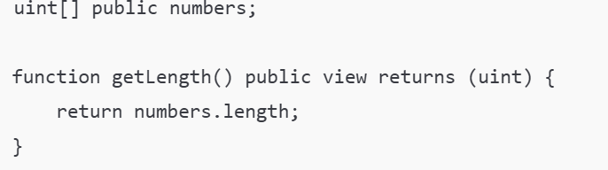
2. Push
- Only available for storage dynamic arrays
- Adds an element to the end of the array.

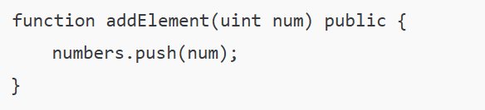
- You can also use push() without an argument (only for struct types).
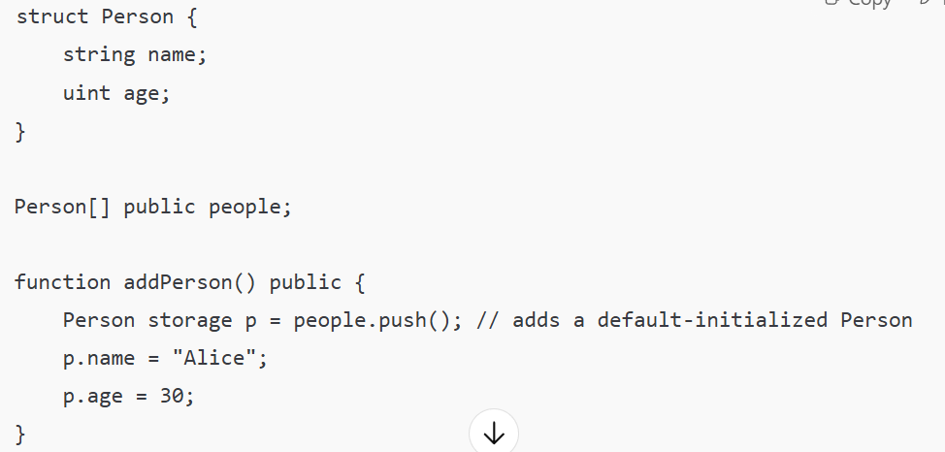
3. Pop
- Removes the last element of a dynamic storage array.
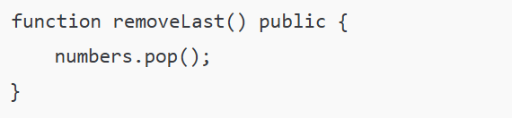
4. Delete
- Sets the element at the given index to its default value.
- It doesn't resize the array.
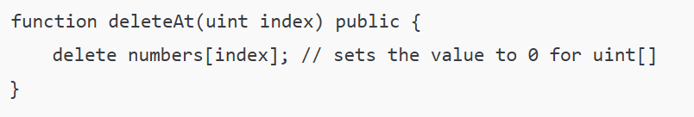
5. Accessing Elements
- Using indexing like other languages.

Lecture 9:
Errors and Warnings
If we remove a semicolon from the code and then try to compile it, you'll encounter some 🚫 error messages. They will prevent the compiler from converting the code into a machine-readable form.

Restoring the semicolon to its correct position will prevent any errors, enabling us to proceed with deploying the code to the Remix VM.
On the other hand, if we delete the SPDX license identifier from the top of our code and recompile, we will receive a yellow box showing a ⚠️ warning.

Unlike errors, warnings allow the code to be compiled and deployed but it's wise to take them seriously and aim to remove them entirely. They point out poor or risky practices in your code and sometimes indicate potential bugs.

Lecture 10:
Data Locations
Solidity can store data in six different locations. In this lesson, we will focus on the first three:
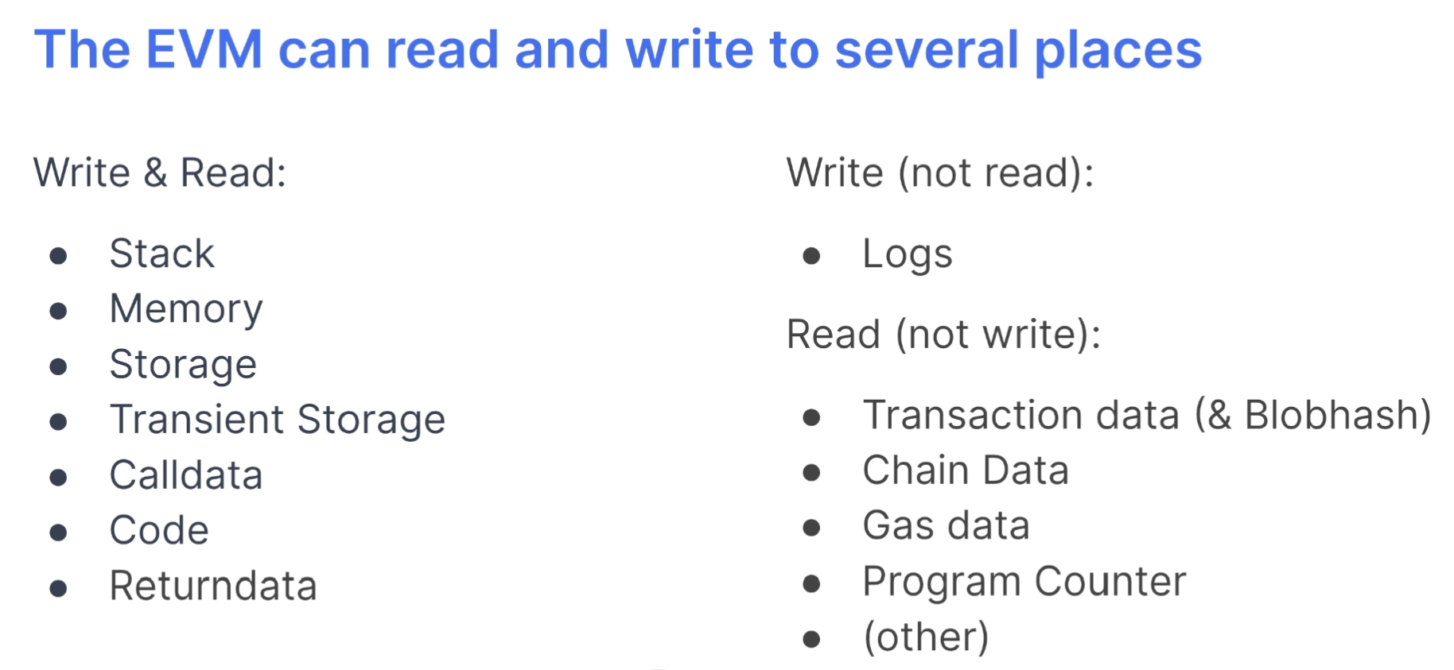
Calldata and Memory
In Solidity, calldata and memory are temporary storage locations for variables during function execution.
=> “calldata” is read-only, used for function inputs that can't be modified.
=> In contrast, “memory” allows for read-write access, letting variables be changed within the function. To modify calldata variables, they must first be loaded into memory.
🚧 WARNING
Most variable types default to memory automatically. However, for strings, you must specify either memory or calldata due to the way arrays are handled in memory.

Calldata
Calldata variables are read-only and cheaper than memory. They are mostly used for input parameters.
In the following example, if we try to replace the keyword memory with calldata, we receive an error because calldata variables can't be manipulated.

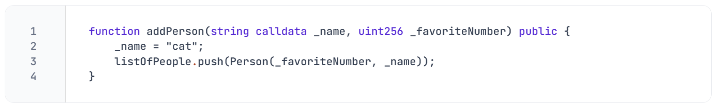
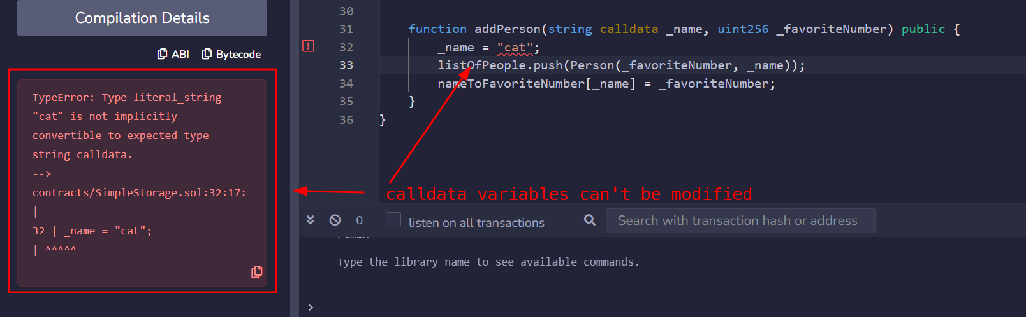

Storage
Variables stored in storage are persistent on the blockchain, retaining their values between function calls and transactions.
In our contract, the variable myFavoriteNumber is a storage variable. Variables which are declared outside any function are implicitly converted to storage variables.

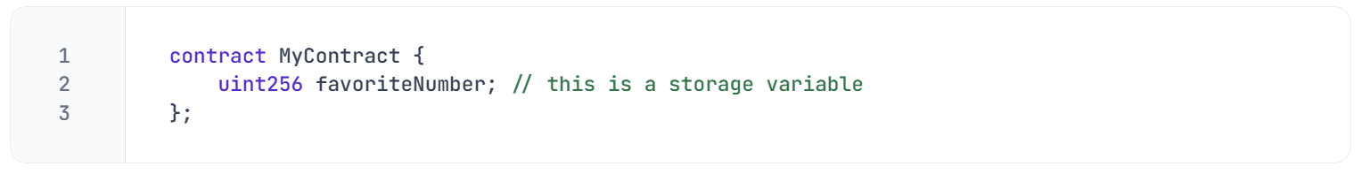

Simple Use of storage Keyword
Here's an example using a struct to demonstrate how storage allows you to modify state variables directly:

- // SPDX-License-Identifier: MIT
- pragma solidity ^0.8.0;

- contract StorageExample {

- struct User {
- string name;
- uint age;
- }
- User[] public users;
- function addUser(string memory _name, uint _age) public {
- users.push(User(_name, _age));
- }
- function updateUser(uint index, string memory newName, uint newAge) public {
- // Access the user at given index in storage
- User storage user = users[index];
- user.name = newName;
- user.age = newAge;
- }
- }
- Explanation:
- User storage user = users[index];
  - This creates a reference to the users[index] struct in storage.
  - Any changes to user are permanently written to the blockchain.
- If we used User memory user = users[index]; -> changes to user would be temporary and discarded after the function ends.

KEYWORD | MEANING | BEHAVIOR
storage | Reference to persistent blockchain state | Changes are permanent
memory | Temporary variable for internal computations | Discarded after function call
calldata | Read-only data from external function parameters | Cheaper and read-only

Strings and primitive types
If you try to specify the memory keyword for an uint256 variable, you'll encounter this error:
In Solidity, a string is recognized as an array of bytes. On the other hand, primitive types, like uint256 have built-in mechanisms that dictate how and where they are stored, accessed and manipulated.

🚧 WARNING
You can't use the storage keyword for variables inside a function. Only memory and calldata are allowed here, as the variable only exists temporarily.
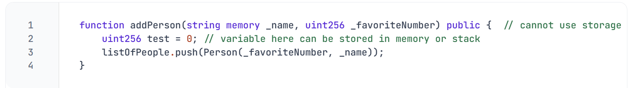

🧑‍💻 Test yourself
- 📕 How does the Solidity compiler handle primitive types and strings in terms of memory ma nagement?
- 📕 Why can't the storage keyword be used for variables inside a function?
- 🧑‍💻 Write a smart contract that uses storage, memory and calldata keywords for its variables.

Lecture 11:
Avoiding Costly Iterations
If we want to know just one person's favorite number (e.g. Chelsea's) but our contract holds a (long) array of Person, we would need to iterate through the whole list to find the desired value:
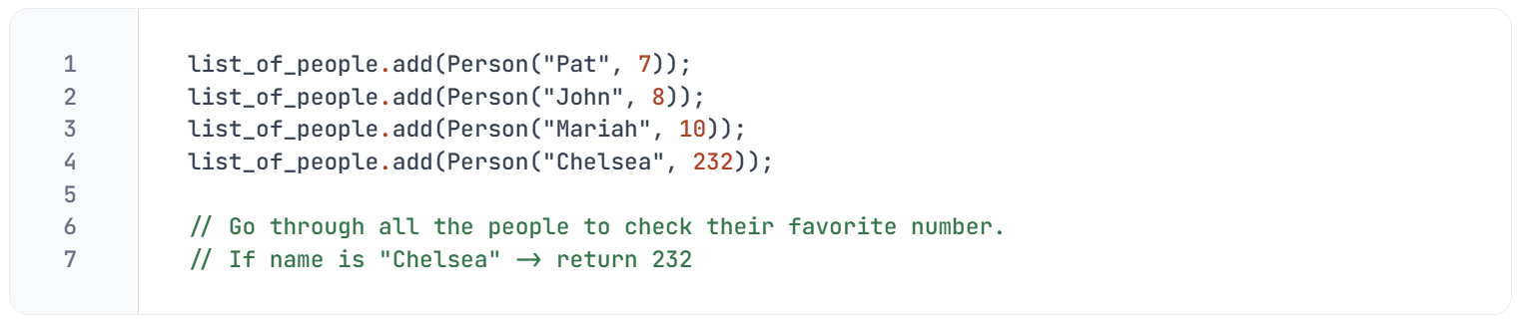
Iterating through a long list of data is usually expensive and time-consuming, especially when we do not need to access elements by their index.
Mapping
To directly access the desired value without the need to iterate through the whole array, we can use mappings. They are sets of (unique) keys linked to a value and they are similar to hash tables or dictionaries in other programming languages. In our case, looking up a name (key) will return its correspondent favorite number (value).
A mapping is defined using the mapping keyword, followed by the key type, the value type, the visibility, and the mapping name. In our example, we can construct an object that maps every name to its favorite number.
Previously, we created an addPerson function that was adding a struct Person to an array list_of_people. Let's modify this function and add the struct Person to a mapping instead of an array:
👀❗IMPORTANT
Mappings have a constant time complexity for lookups, meaning that retrieving a value by its key is done in constant time.
🗒️ NOTE
The default value for all key types is “0”. Also for a key we have not added to the mapping value is “0”

🧑‍💻 Test yourself
- 📕 In which cases is better to use an array instead of a mapping?
- 🧑‍💻 Create a Solidity contract with a mapping named addressToBalance. Implement functions to add and retrieve data from this mapping.

Lecture 12:
Before deploying, be always sure to make a compilation check. This ensures that the contract has no errors or warnings, and is fit for deployment.
Deployment on a testnet
We can start the deployment process by going into the deployment tab and switching from the local virtual environment (Remix VM) to the Injected Provider - MetaMask. This action will allow Remix to send requests and interact with your MetaMask account.
MetaMask account.
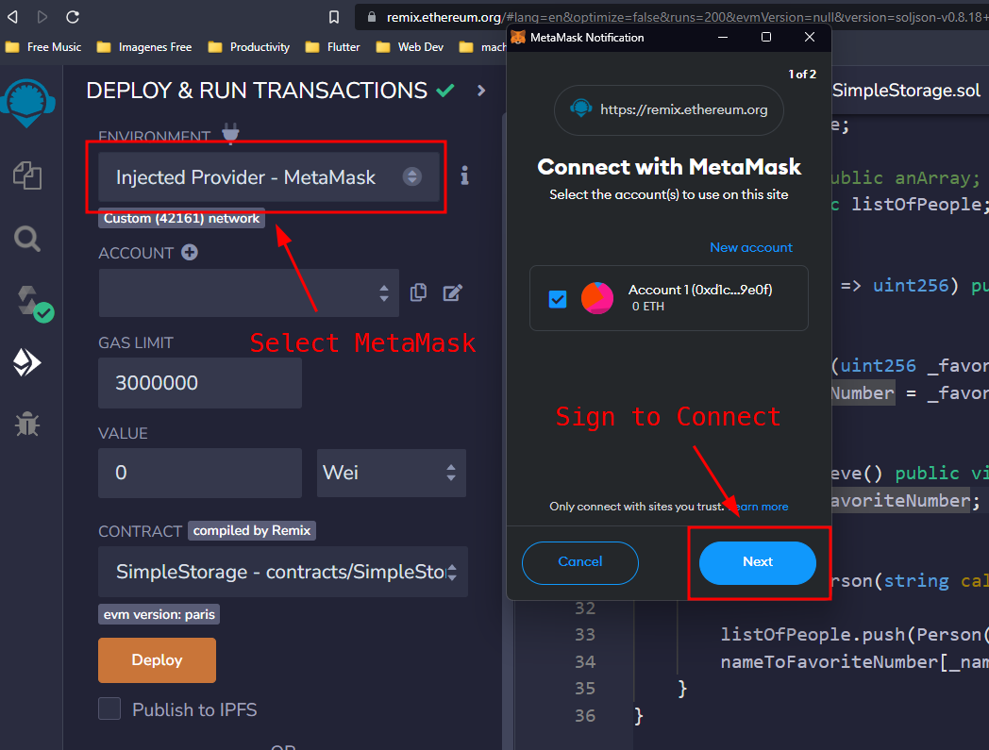
You will be then prompted to select an account from your MetaMask wallet. Once you've connected that account to Remix, you should see a confirmation that the account is properly linked and that you are using the Sepolia testnet.

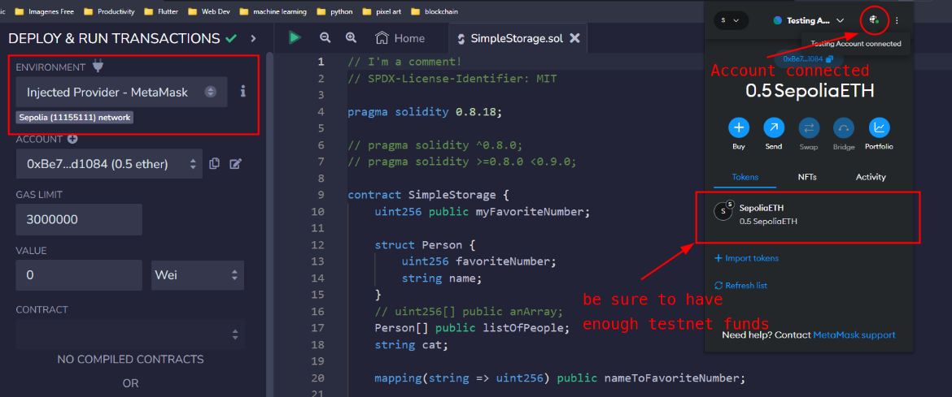

Ensure you have enough Sepolia ETH in your account, which you can obtain from a faucet. Once your balance is sufficient, you can proceed by clicking the "Deploy" button.
After that, MetaMask will ask to sign and send the transaction on the testnet.

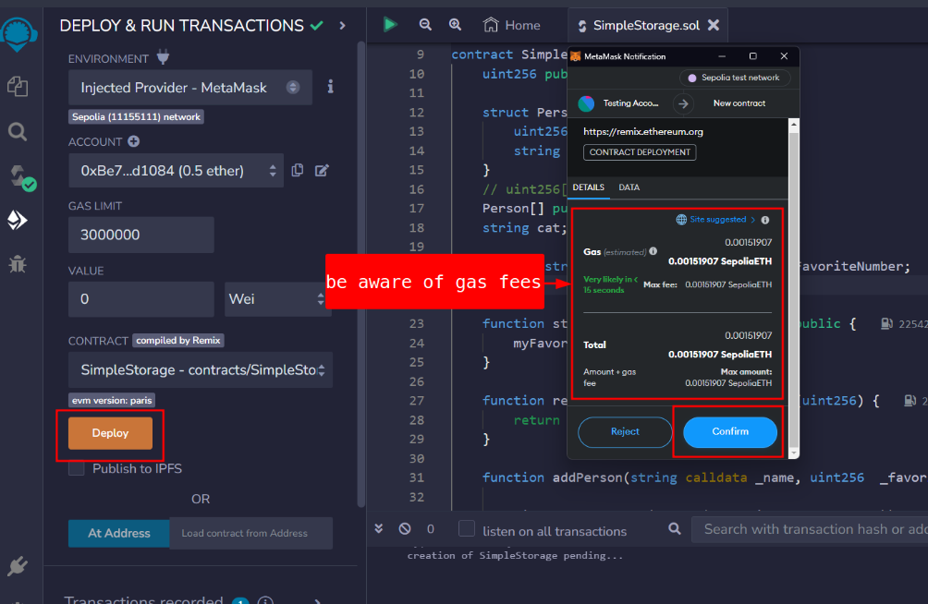

Once the transaction is executed, the contract address will be listed under deployed contracts, along with the transaction details. This is how the deployment transaction is displayed on Etherscan.
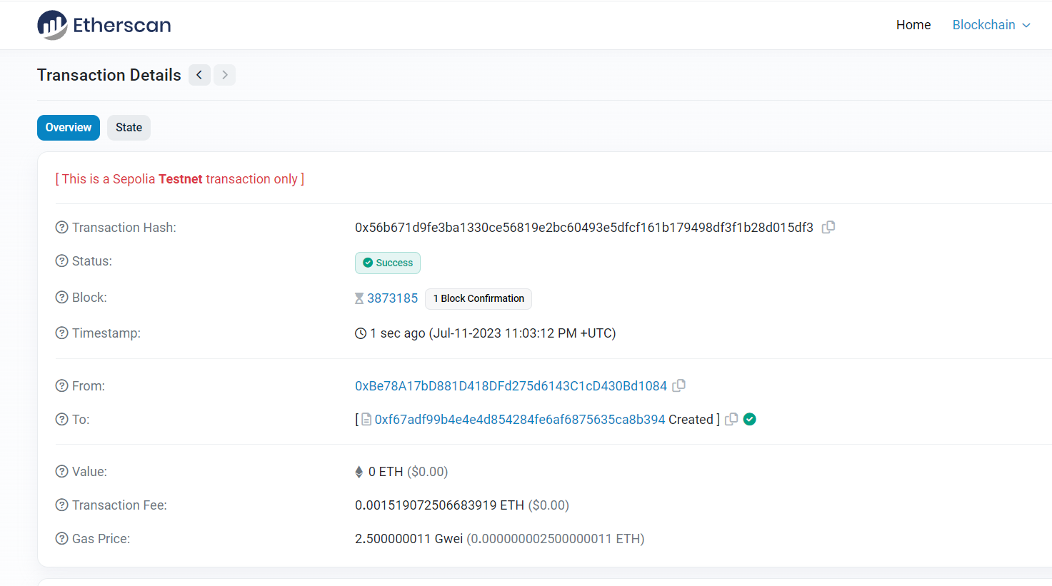
Contract interaction
Since the contract has been deployed, we can now interact with it and update the blockchain. For example, if you want to store a number, you can do so by clicking the button 'store': MetaMask will ask for another transaction confirmation, that will update the favorite number. We can check the details on etherscan at the deployed address:
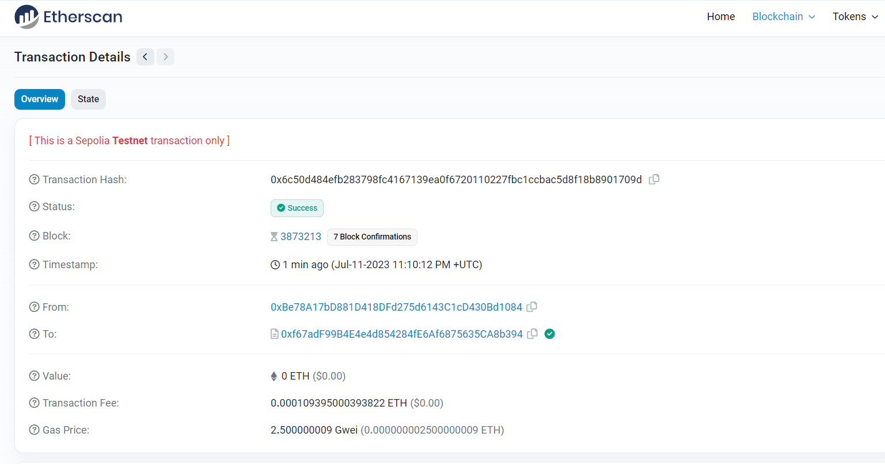
👀❗IMPORTANT
View and pure functions will not send transactions

Lecture 14:
Testnet Funds
To deploy contracts on zkSync L2, you'll need testnet funds. There are two methods to obtain them:
- zkSync Faucet: similar to using a Sepolia faucet, this method allows you to request testnet funds directly.
- zkSync Bridge: this method involves transferring funds from Ethereum testnet to zkSync testnet. While free faucets can sometimes be unreliable, bridging offers a more consistent solution.

Lecture 15:
Wallet Connection
You can begin by navigating to the zkSync Bridge app and clicking on the "Connect Wallet" button. Select MetaMask, and when prompted, enter your password. After connecting, ensure you are on the Sepolia Test Network. If you lack Sepolia ETH, can’t use any faucett o get testnet as they require having 0.001 mainnet currency so beg from ssomeone
Bridging Sepolia
To bridge Sepolia ETH to zkSync, select the "zkSync" button at the top right of the zkSync bridge page and switch to the "zkSync Sepolia Testnet". The interface will display the option to bridge from the Ethereum Sepolia Testnet.
Transferring Funds
Next, return to MetaMask and make a small transfer of Sepolia ETH to zkSync Sepolia (even 0.001 ETH is sufficient to deploy a smart contract).
👀❗ IMPORTANT
Be sure to use a testnet wallet, where no real money is present.
Select "Continue," and proceed to bridge your funds. Confirm the transaction on MetaMask, and your funds will be transferred within 15 minutes.
While waiting, you can add the zkSync Sepolia Testnet to MetaMask. Go to Chainlist, search for "zkSync Sepolia" while including testnets, and connect your wallet. Approve the network addition and switch to the zkSync Sepolia Testnet.
Once the transaction completes, you will see the funds appear in your MetaMask wallet under the zkSync Sepolia Testnet. With the correct funds in your wallet, you can now proceed to deploy contrat

Lecture 16:
Introduction
In this lesson, you're about to learn the same type of layer 2 or rollup deployment that professional developers are using. On Remix, we can start by activating the zkSync plugin in our environment. In the plugin manager, search for "zkSync" and activate the zkSync module. You'll notice that a new zkSync tab on the left side will appear.
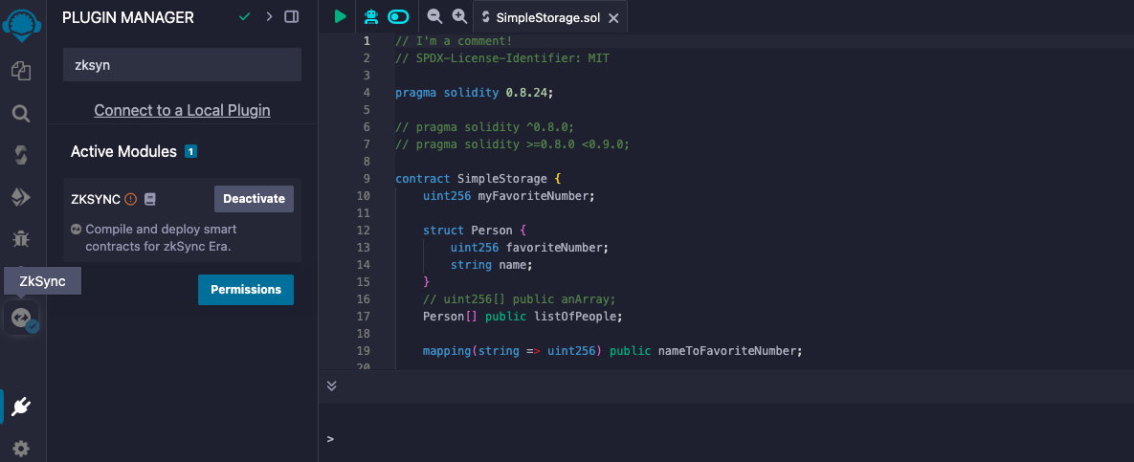
This module is made of sections for compiling, deploying, and interacting with contracts on zkSync.
👀❗IMPORTANT
Ensure that the Solidity Compiler Version in the contract matches the zkSync compiler requirements. As of this recording, the required version is 0.8.24.
Deploying
After compilation, you can go to the environment tab to connect your MetaMask wallet, ensuring it is set to the zkSync Sepolia testnet. Once connected, you can deploy and verify the SimpleStorage contract.
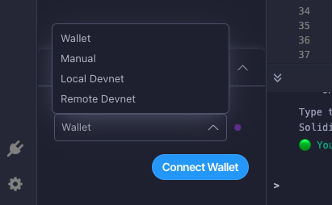
Verifying Deployment
After hitting the deploy button, MetaMask will request a signature. Approve it, and after a short delay, a detailed output will appear indicating the deployment status. If the terminal output shows a green "verification successful" message, it means that your contract has been both deployed and verified correctly.

Verification might fail solution will be discussed in the next video(also check the compiler version in your code
Checking the Deployment
To check our deployment, you can copy the contract address and paste it into the zksync Sepolia explorer. Here, you can view the contract details.

Lecture 17:
zkSync Remix plugin minor bug
Ensure that your SimpleStorage.sol smart contract is on Remix. Then, you can enter the zkSync plugin and compile the file. However, even after a successful compilation, the deploy tab will still display the message no smart contracts ready for deployment.
This issue arises due to a small bug in the plugin, which requires your smart contracts to be inside a contracts folder. To resolve this, you can create a new folder named 'contracts' and move your smart contract into it. You can then proceed to compile the contract again, and you should be able to deploy it without any issues.

SECTION 2:
Lecture 1:
You can find the code for this section in the Remix Storage Factory Github repository. In these nine lessons, we'll work with three new contracts:
- SimpleStorage.sol - the contract we build in the previous section, with some modifications
- AddFiveStorage.sol - a child contract of SimpleStorage that leverages inheritance
- StorageFactory.sol - a contract that will deploy a SimpleStorage contract and interact with it
Section overview
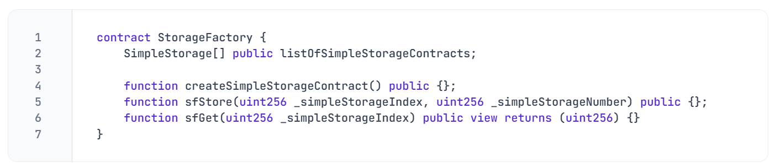

Lecture 2:
StorageFactory setup
SimpleStorage contract allows to store a favorite number, a list of people with their favorite number, a mapping and different functionalities to interact with them. This lesson aims to create a new contract that can deploy and interact with SimpleStorage.
👀❗IMPORTANT
One of the fundamental aspects of blockchain development is the seamless and permissionless interaction between contracts, known as composability. This is particularly crucial in decentralized finance (DeFi), where complex financial products interact effortlessly through common smart contract interfaces.
Let's set up the backbone of the code, that contains the function createSimplestorageContract. This function will deploy a SimpleStorage contract and save the result into a storage variable:
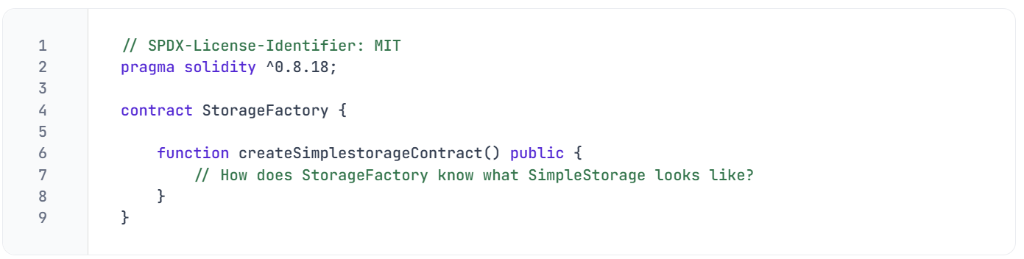We need to establish a connection between the two contracts, since StorageFactory needs to have a complete knowledge of SimpleStorage. One first approach could be copying the SimpleStorage contract above StorageFactory.
🗒️ NOTE
It's allowed to have multiple contracts in the same file. As best practice, however, it's recommended to use only one file for each contract
💡 TIP
You can avoid confusion by keeping open only the file(s) you're currently working on.
Conclusion
In this setup, we'll delve into the concept of composability and develop the StorageFactory contract, which will be capable of deploying and interacting with a SimpleStorage contract.
Lecture 3:
Introduction
This lesson covers the process of programmatically deploying a SimpleStorage contract and saving it to a storage or state variable. By the end of this lesson, you will have a comprehensive understanding of how one contract can seamlessly deploy and manage another one.
Creating a new variable
Following the format type-visibility-name, we can declare a new state variable of type SimpleStorage.
(Before doing this paste the whole SimpleStorage contract in the file for now)
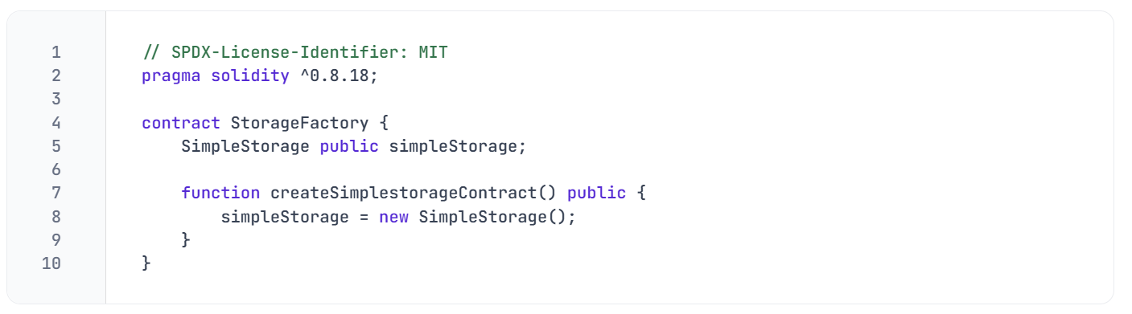IMPORTANT
=> Simple Storage refers to the contract type while simpleStorage refers to the variable name.
=> When the new keyword is used, the compiler recognizes the intention to deploy a new contract instance. After compiling, we can proceed to deploy it.
In Remix, you'll then notice two buttons: an orange createSimpleStorageContract and a blue one, SimpleStorage, generated by the public keyword. If we call both, first createSimpleStorageContract and then SimpleStorage, the address that appears below confirms that our SimpleStorage contract has been deployed.

Lecture 4:
Introduction
In the previous lesson, we integrated the SimpleStorage code directly into the StorageFactory contract. This allowed StorageFactory to have full access to the SimpleStorage contract’s functionality. In this lesson, we will explore a more efficient way to arrange and organize the code by using the import statement.
Importing code
The import keyword enables a contract to utilize code from other files without needing to include the entire codebase directly within the contract.
- No cluttering: it prevents your current file from being cluttered with numerous lines of code, keeping it clean and organized.
- Simplified maintenance: by keeping the code in separate files, it becomes easier to maintain and update individual components without affecting the entire codebase. For example, if we change some lines inside SimpleStorage, we would have also to constantly copy-paste the modified content into StorageFactory
You can now remove the previously added SimpleStorage code and replace it with the import shorthand:
WARNING
All the solidity contracts should be compiled together using the same compiler version. It's important to ensure consistency between compiler versions across files since each one will have its own pragma statement.
Named Imports
Let's assume for a moment that SimpleStorage would contain multiple contracts, e.g. SimpleStorage, SimpleStorage1, SimpleStorage2, which are quite extensive in size. If we import the whole file as we did before, the statement will replace the import directive with all the code contained in SimpleStorage.sol. This will result in an unnecessary expensive deployment of the StorageFactory contract.
This can be prevented with named imports, which allow you to selectively import only the specific contracts you intend to use:
You can also use named imports to import multiple contracts:
IMPORTANT
Try to always default to named imports instead of importing the entire file.

Lecture 6:
Introduction
In this lesson, the StorageFactory contract will be upgraded to keep track of all deployed SimpleStorage contracts. This will allow us also to interact with each deployed contract individually.
Storing the deployed contracts
In the current StorageFactory version, every time createSimpleStorageContract is called, a new SimpleStorage contract is deployed and overridden inside the variable SimpleStorage. Past deployments are not being tracked down.
To solve this issue we can create a variable listOfSimpleStorageContracts, which is an array of SimpleStorage contracts. In this way, whenever a contract is created, it gets added to a dynamic array.
We can then modify the function createSimpleStorageContract, pushing the newly deployed contract to this variable.
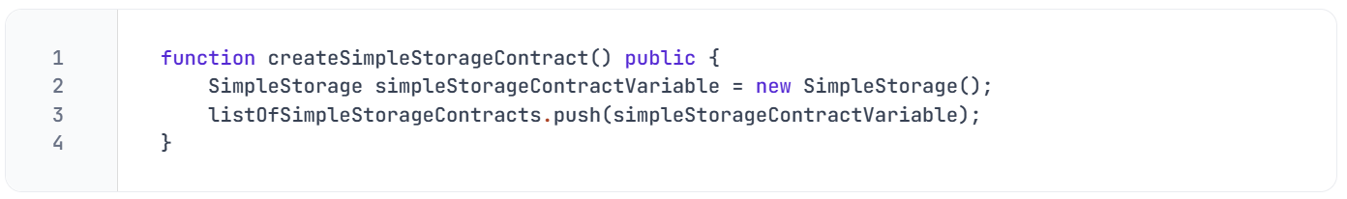In Remix, you can access listOfSimpleStorageContracts via the index of type uint256, which refers to the position of the deployed contract inside the dynamic array.

Simple Storage interaction
StorageFactory can interact with the deployed contracts by calling their store function. To do this we need to create a function sfStore:
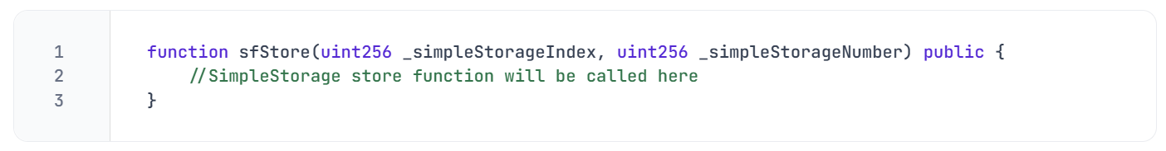IMPORTANT
Every time you have to interact with another contract, you need:
- the contract address
- the contract ABI (Application Binary Interface): a standardized way for interacting with the binary version of a smart contract deployed on the blockchain. It specifies the functions, their parameters, and the structure of the data that can be used to interact with the contract. It's generated by the compiler.
🗒️ NOTE
If you do not have the full ABI available, a function selector will suffice (see later in the course).
If you go to Solidity's compile tab, you will find a button that lets you copy the ABI to the clipboard.
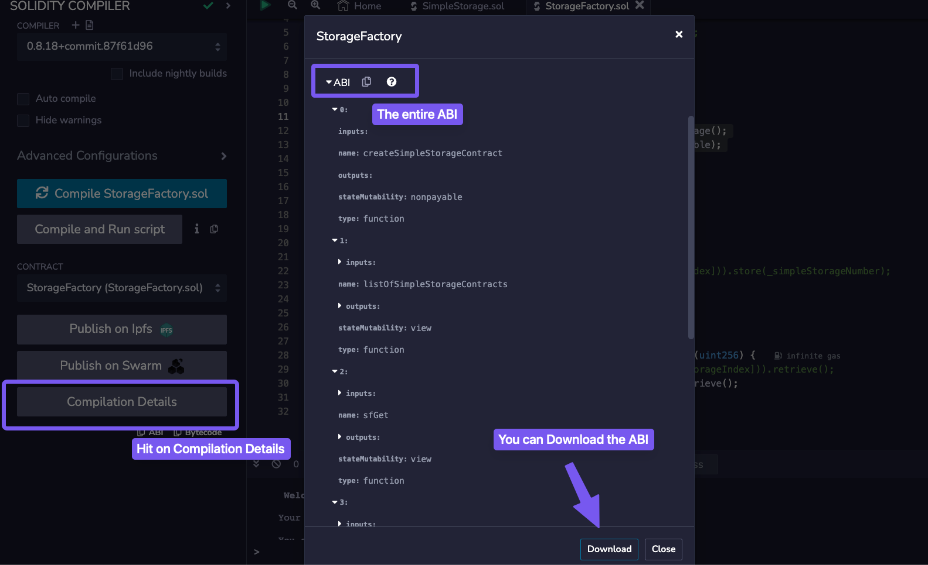
🗒️ NOTE
In Solidity, it's possible to type cast an address to a type contract
We can now proceed to store a new number on a SimpleStorage contract:
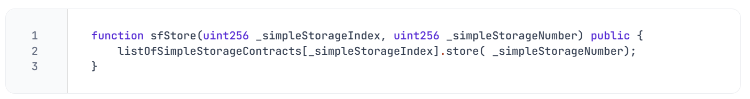We can then retrieve the stored value with a get function:
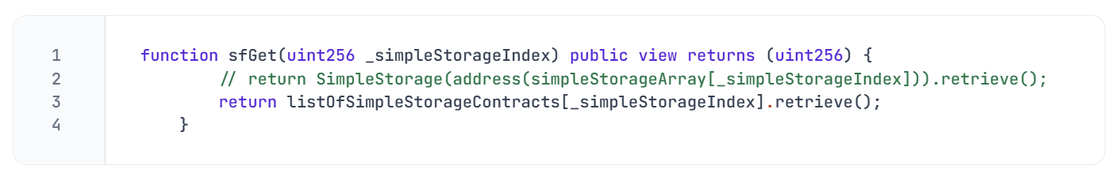

Lecture 7:
Introduction
In this lesson, we are going to introduce the concept of inheritance and overriding, two powerful tools that allow developers to create more modular, maintainable, and reusable smart contracts. By leveraging these techniques, you can build upon existing contracts and customize their functions.
Inheritance
We are going to enhance the SimpleStorage contract by adding a new functionality: the ability to add five (5) to the stored favoriteNumber. To achieve this, we could duplicate the existing SimpleStorage contract and make changes to the new version. However, this approach leads to redundant code. A better practice could be to utilize inheritance, which is the mechanism that allows the AddFiveStorage contract to derive all the functionalities of SimpleStorage.
Let's begin by creating a new file AddFiveStorage.sol and name-importing SimpleStorage.sol:
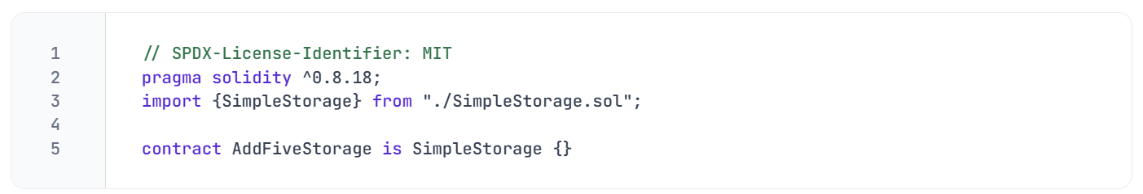The is keyword signifies inheritance and links the parent contract SimpleStorage to its child contract, AddFiveStorage.
Override and virtual
The AddFiveStorage contract now inherits all methods from SimpleStorage. It's possible to add new functions to it, for example:
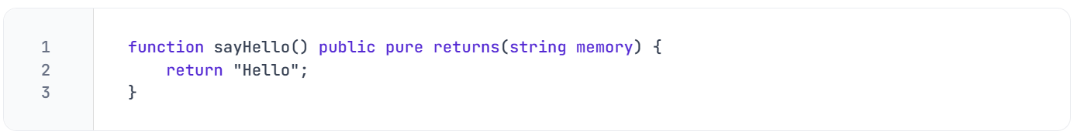We can also modify existing functions from SimpleStorage by using the override keyword. Let's say that we want to modify the store function, adding '5' to the favorite number being stored. If we copy the exact signature of the store function, an error will occur:
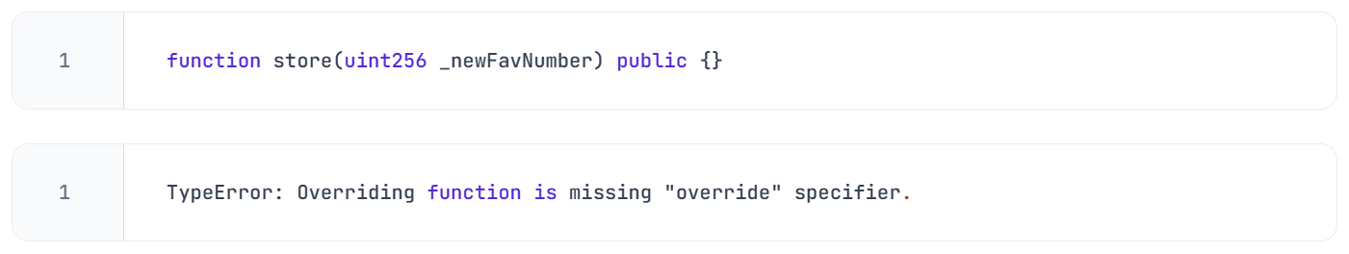🗒️ NOTE
To override a method from the parent contract, we must replicate the exact function signature, including its name, parameters and adding the visibility and the override keyword to it:
Yet, another error will pop up:
To address this, we need to mark the store function in SimpleStorage.sol as virtual, enabling it to be overridden by child contracts:
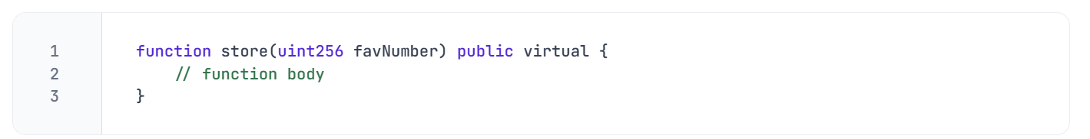Finally, we can add the new functionality to the store function in AddFiveStorage, allowing it to add '5' to the stored favoriteNumber:
