FAKTURAMA IMAGE-TO-CASH AUTOMATION
Annotated Screenshots
Every screen the automation passed through, in order, with the clause of the written procedure it satisfies.

This document is generated from run run-20260919-174148 (status ok, 68 steps). Part A is the desktop front end: the input image and the two extraction screens. Part B is the Fakturama run itself, one figure per captured step, in execution order. Part C is the final verification.
The captions name the spec clause each screen satisfies, so a reviewer can check the screen against the procedure rather than against a description of it.

Part A · The desktop front end

A.0 — the input
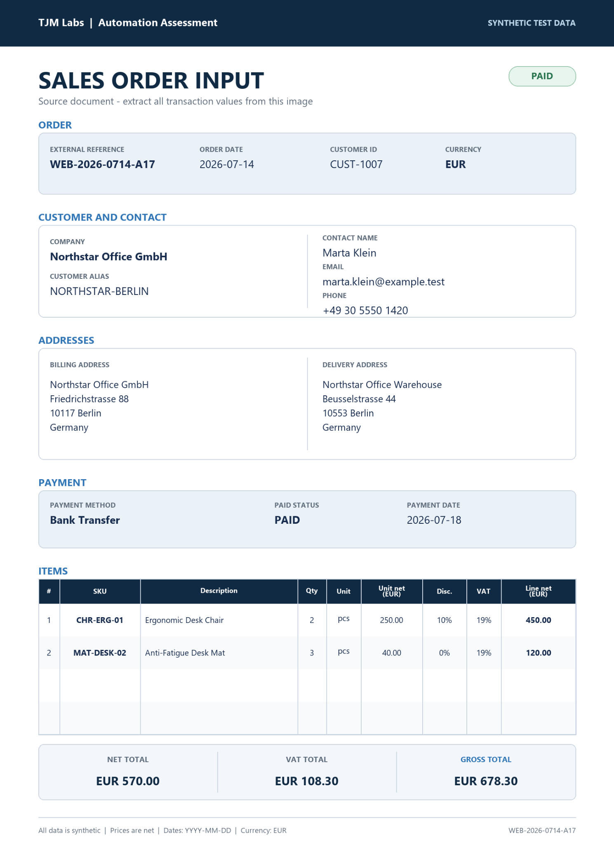
The one input: a single order image. Nothing else is supplied.
Everything that follows — the customer, the two products, the VAT rate, the payment method, the Order and the Invoice — comes from this picture.

A.1 — The front end with the order image loaded
The only input the system gets. The left column is the pipeline; nothing has run yet.
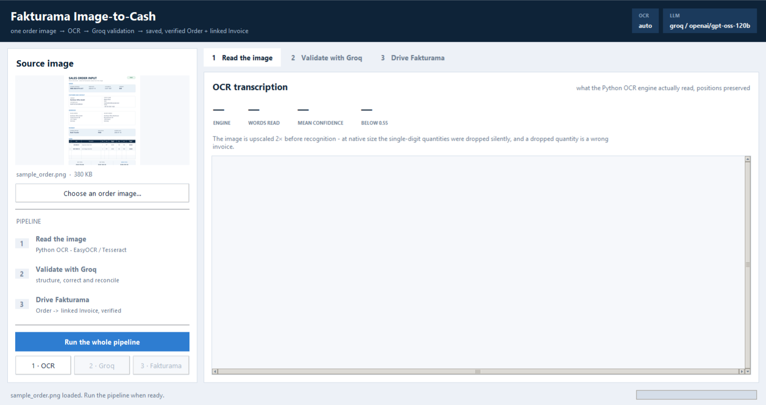
Figure A.1. The front end with the order image loaded

A.2 — Stage 1 · what the OCR actually read
The transcription with its horizontal positions preserved, so the item table is still a table. The strip above it gives the engine, the word count and the mean confidence - this is the ground truth the language model is given.
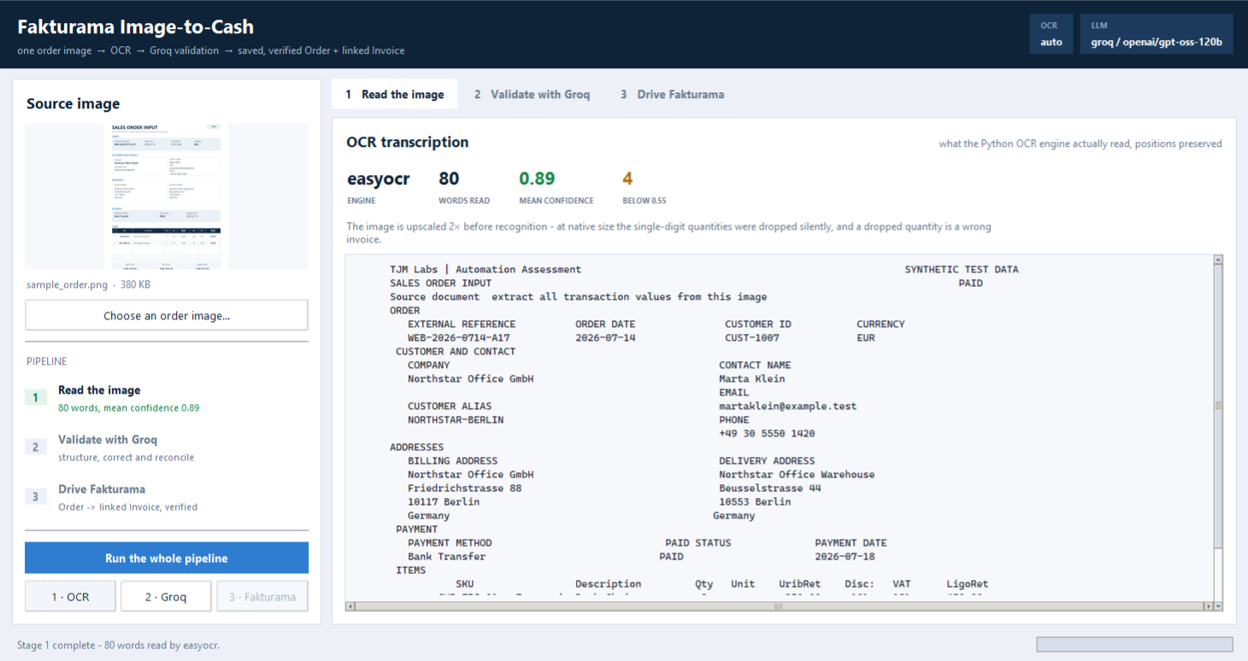
Figure A.2. Stage 1 · what the OCR actually read

A.3 — Stage 2 · the Groq validation
Left: the structured fields the model returned, typed and reconciled. Right: the arithmetic recomputed in Decimal, and the values the model had to correct because they are not in the OCR reading character for character.
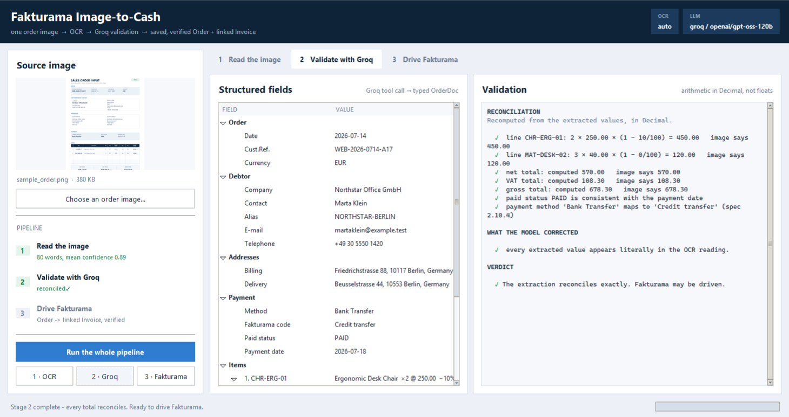
Figure A.3. Stage 2 · the Groq validation

A.4 — Stage 3 · the automation in control of Fakturama
A frame from the screen recording, mid-run. The Order PO000001 is open and stays open; the Product picker has been re-opened after the creation detour and now offers CHR-ERG-01 at the gross price the automation calculated — 250.00 × (1 + 19/100) = 297.50 — against the VAT 19% rate it created a few steps earlier. The front end is behind this window, filling in its step list.
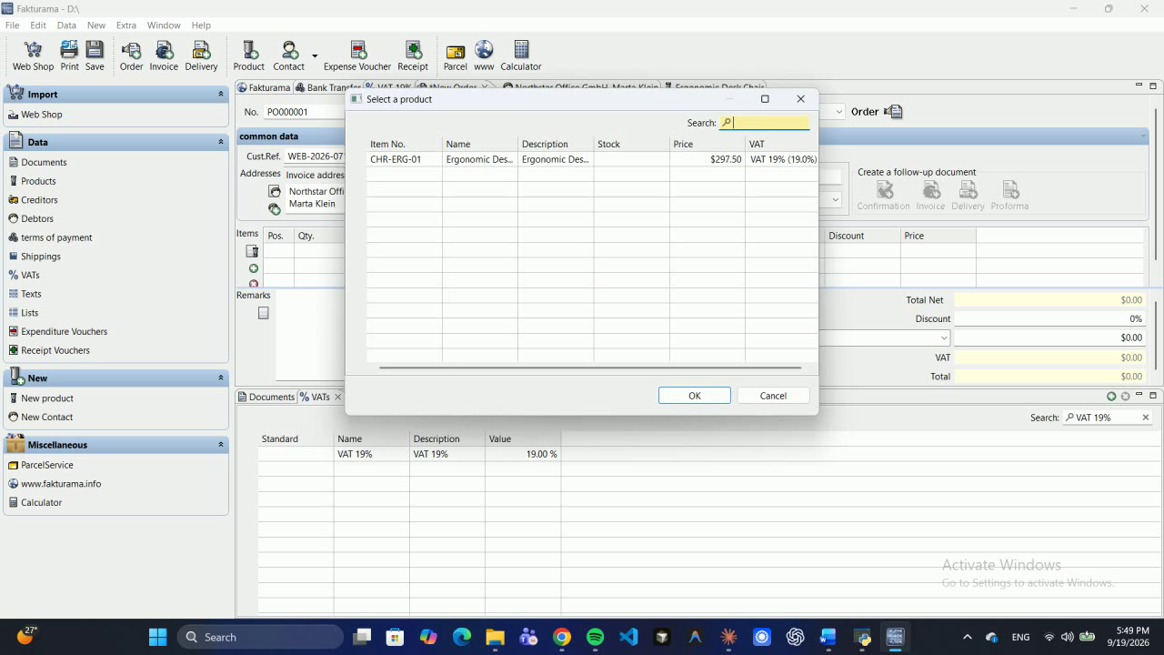
Figure A.4. Stage 3 · the automation in control of Fakturama

A.5 — The finished run
Every stage green, every step ok, and the final verification step selected — its evidence screenshot shows the Documents list carrying both the paid Invoice and the still-open source Order, with the same Cust.Ref. and the same total.
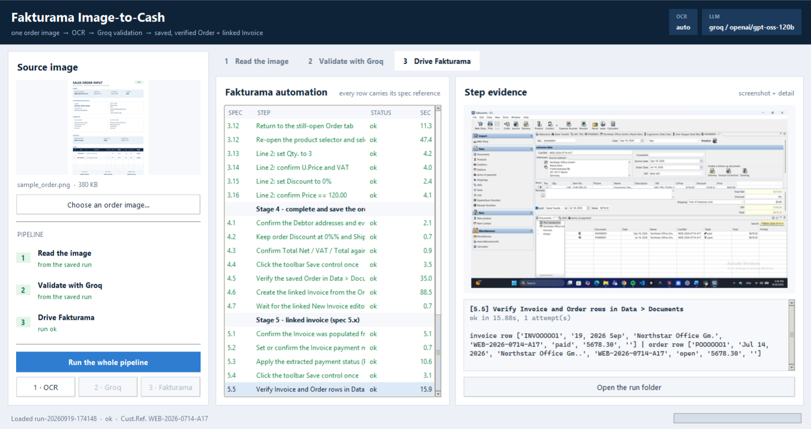
Figure A.5. The finished run

Part B · The Fakturama run, step by step

B.1 — [2.10.6] Save the new Payment Method once
Spec 2.10.3-2.10.6. Name and Description are the exact extracted method; the payment code follows the 2.10.4 mapping; the day and discount fields are zeroed and 'Set as standard' is not touched.
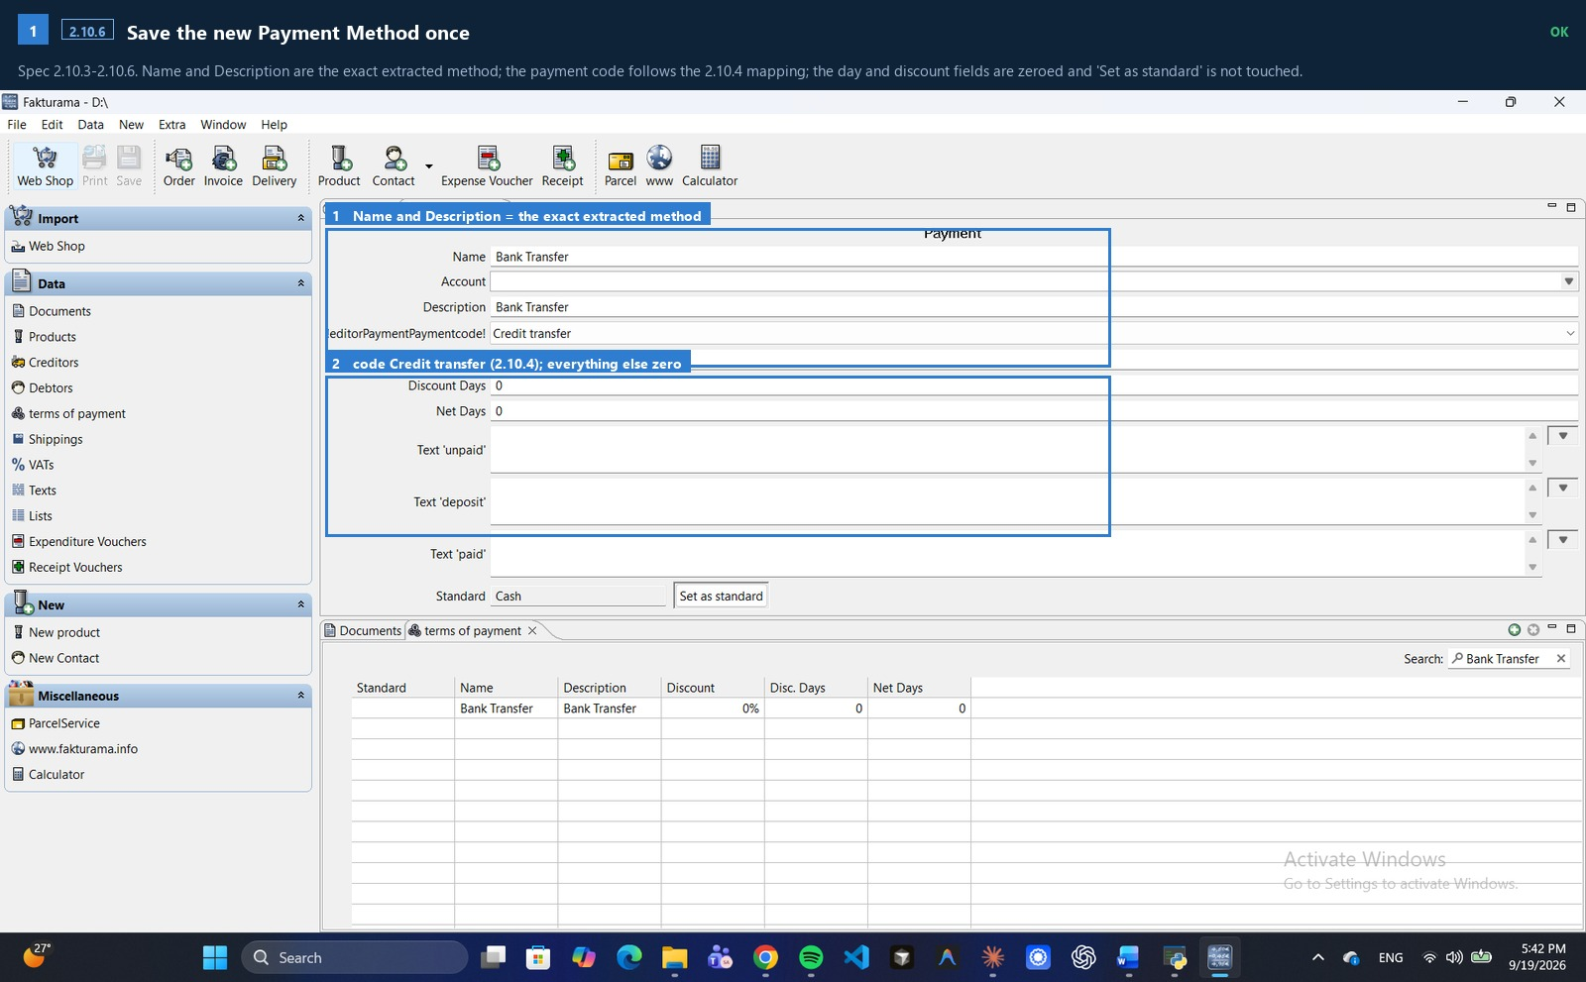
Figure B.1 · spec 2.10.6 · ok

B.2 — [3.6] Fill a new VAT 19% with the Standard rate code
Spec 3.6. Name and Description are 'VAT' plus the extracted percentage, the value is that percentage, and the e-invoice code stays S (Standard rate).
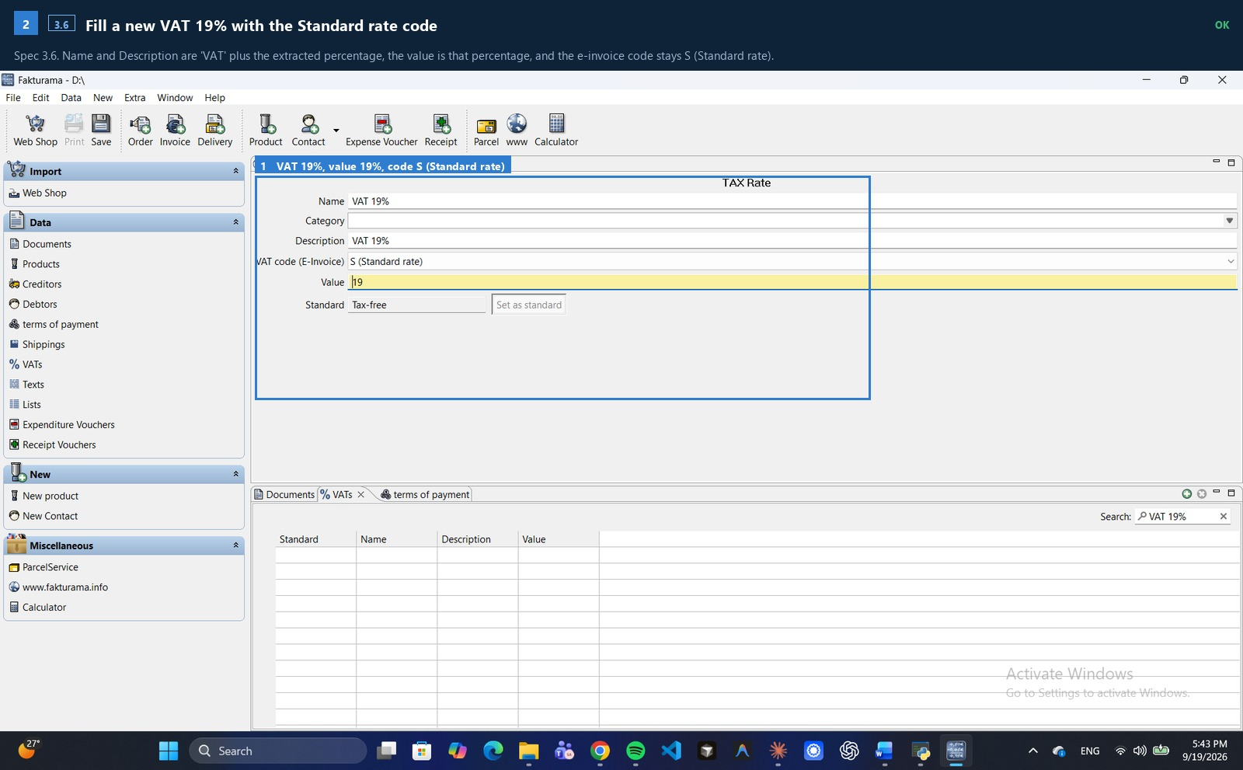
Figure B.2 · spec 3.6 · ok

B.3 — [1.3] Open a New Order from the top toolbar
Spec 1.3. The New Order editor, opened from the top toolbar. It is opened first and stays open for the whole run - every master-data detour comes back to this tab.
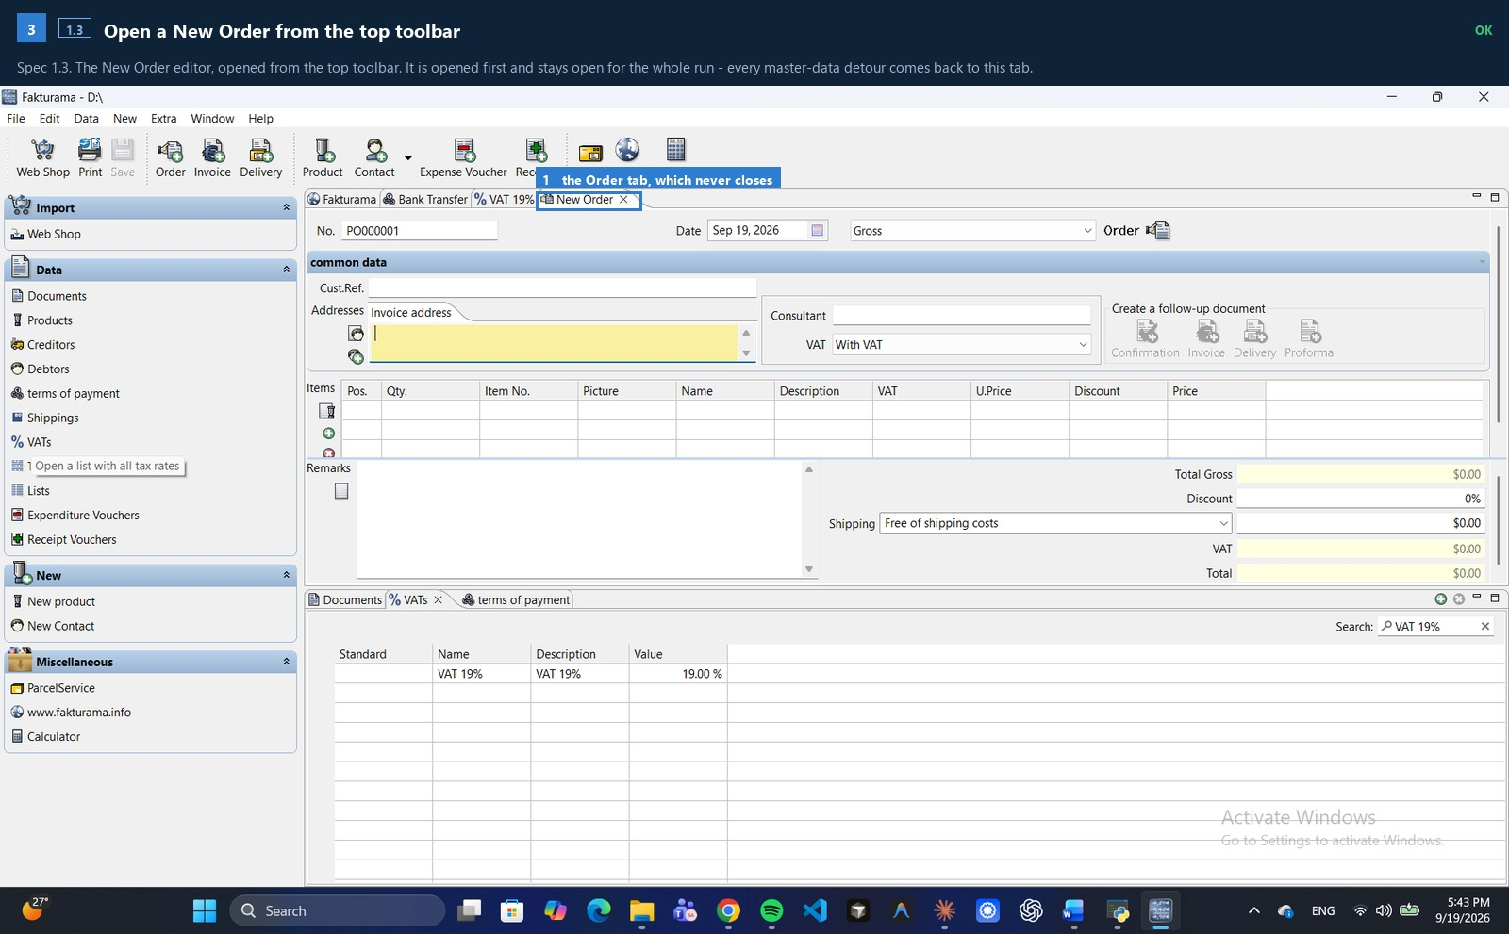
Figure B.3 · spec 1.3 · ok

B.4 — [1.7] Set price mode to Net and keep VAT as With VAT
Spec 1.4-1.7. The proposed No. is read and left alone, the Date and Cust.Ref. come from the image, the price mode is Net and VAT stays 'With VAT'.
Recorded: price mode 'Gross' -> 'Net'; VAT mode 'With VAT'
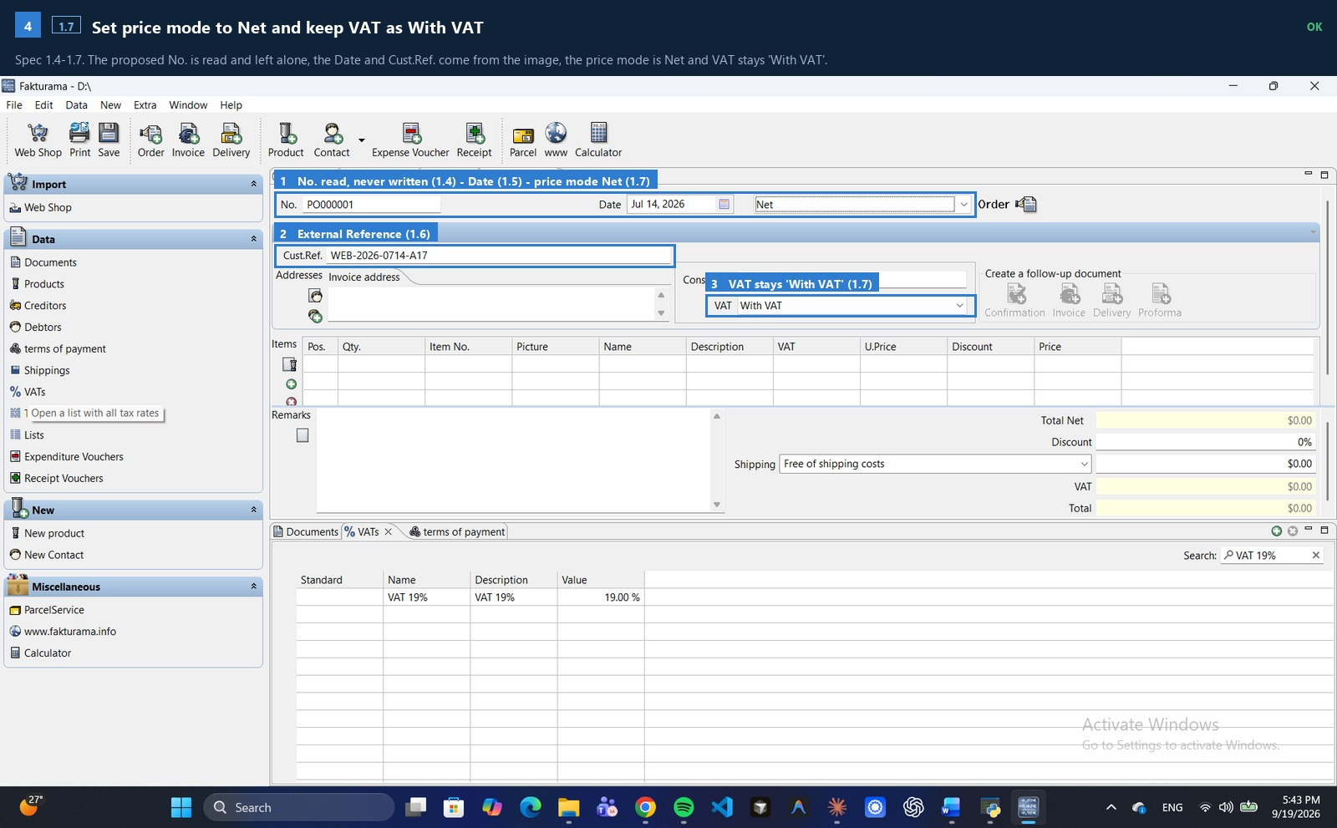
Figure B.4 · spec 1.7 · ok

B.5 — [2.1-2.3] Try to select the Debtor from the Order
Spec 2.1-2.3. The Order's own address picker is the existence check. A row counts as an exact match only when Company, First Name, Name, ZIP and City all agree; conflicting rows stop the run, and no row sends it to the creation branch.
Recorded: no exact debtor found (0 rows)
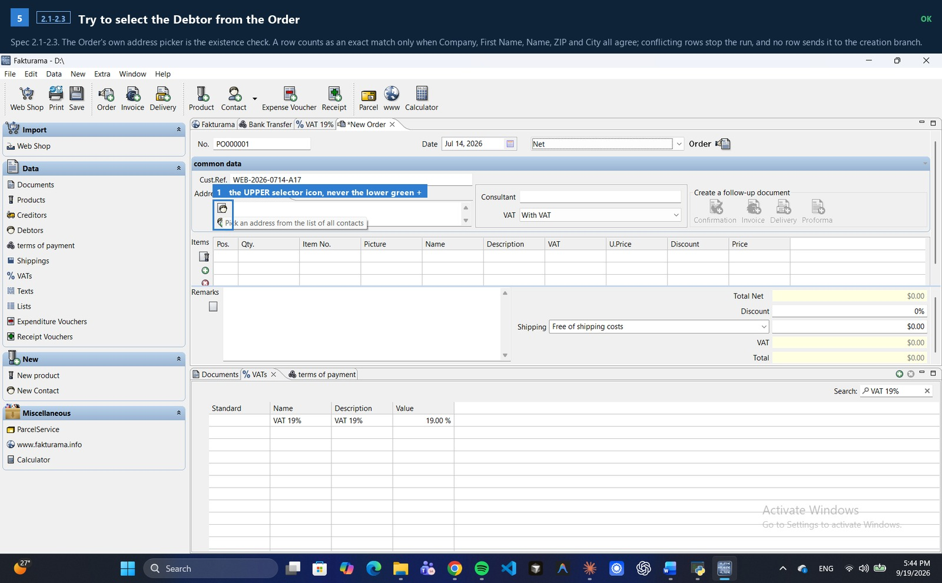
Figure B.5 · spec 2.1-2.3 · ok

B.6 — [2.8] Assign address roles
Spec 2.7-2.8. The billing address from the image, on Addresses > Main address.
Recorded: address-role control not drivable in this Fakturama version; Main address keeps its default roles (recorded as a deviation) | billing != delivery: the separate delivery address is NOT created (see README, known gaps)
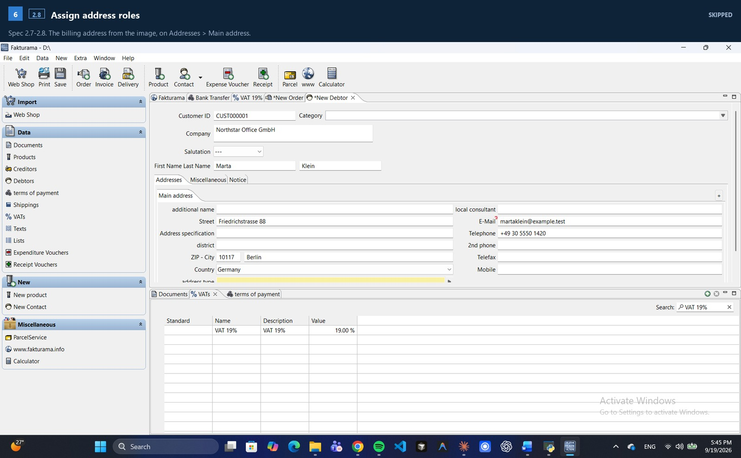
Figure B.6 · spec 2.8 · skipped

B.7 — [2.11] Save the Debtor once
Spec 2.9-2.11. Alias, 0% discount and Net on Miscellaneous; the exact payment method on Payment; then one save.
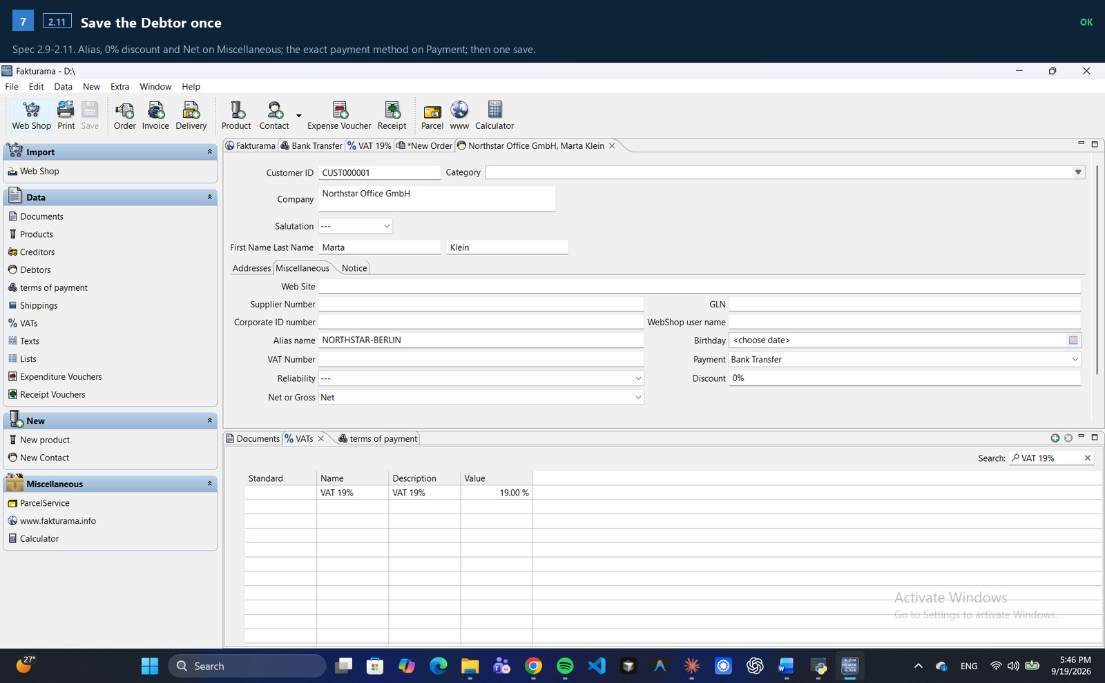
Figure B.7 · spec 2.11 · ok

B.8 — [2.12] Re-open the address selector and select the newly saved Debtor
Spec 2.12-2.13. Back in the still-open Order, the picker is re-opened and the new Debtor selected there - which is what proves the record was really saved.
Recorded: selected existing debtor: ['1 CUSTOOOOO1', 'Marta', 'Klein', 'Northstar Office', '10117', 'Berlin']
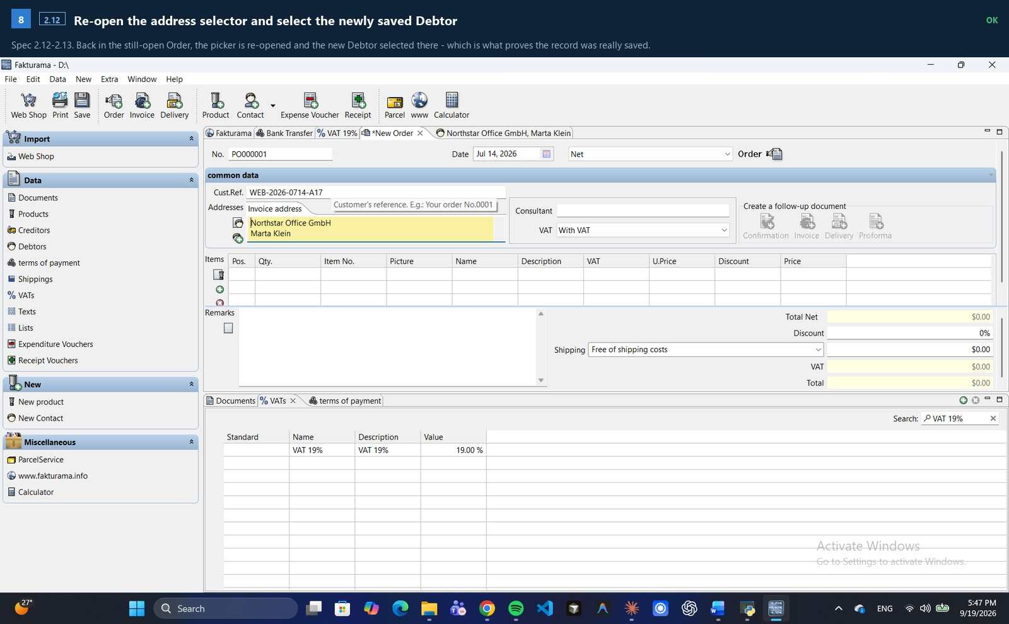
Figure B.8 · spec 2.12 · ok

B.9 — [2.4] Confirm the populated Invoice and Delivery addresses
Spec 2.4 / 2.13. The Invoice and Delivery addresses populated from the selected Debtor, checked against the source image before the run moves on to the products.
Recorded: invoice/delivery addresses match the source
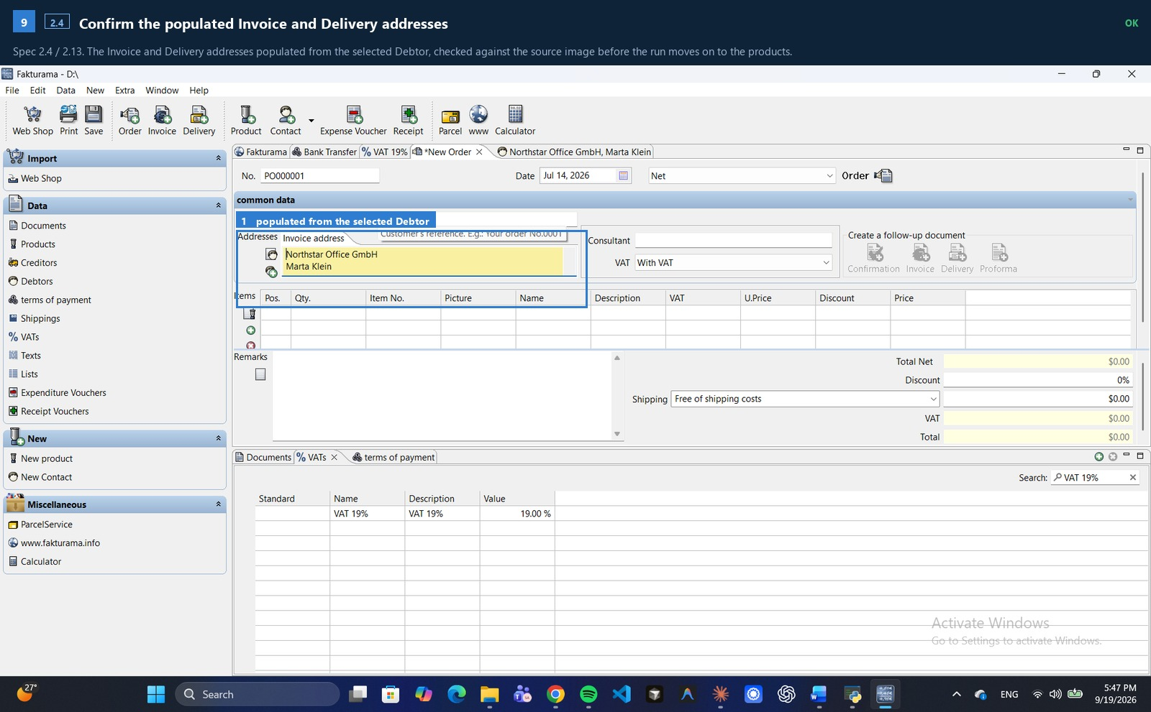
Figure B.9 · spec 2.4 · ok

B.10 — [3.2-3.3] Try to select CHR-ERG-01 from the Order
Spec 3.2-3.3. The Product picker, searched on the exact SKU. When no exact row appears the run cancels out, creates the Product, and comes back to this dialog.
Recorded: no exact SKU CHR-ERG-01 (0 rows)
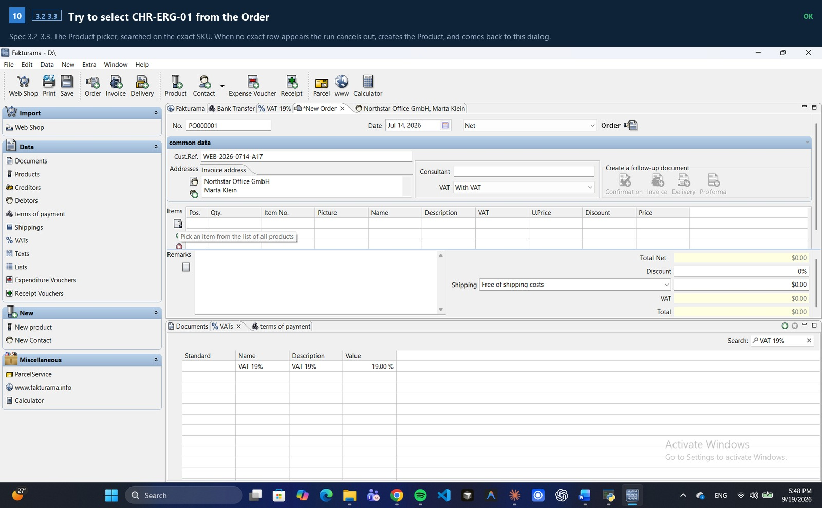
Figure B.10 · spec 3.2-3.3 · ok

B.11 — [3.10] cost price 0.00, exact VAT, Stock 0.00
Spec 3.8-3.10. Item Number is the SKU and both Name and Description are the item description. Price (gross) is the 3.9 calculation - and the transaction line's discount is deliberately NOT applied to a master price.
Recorded: VAT 'VAT 19%', cost 0.00, stock 0.00
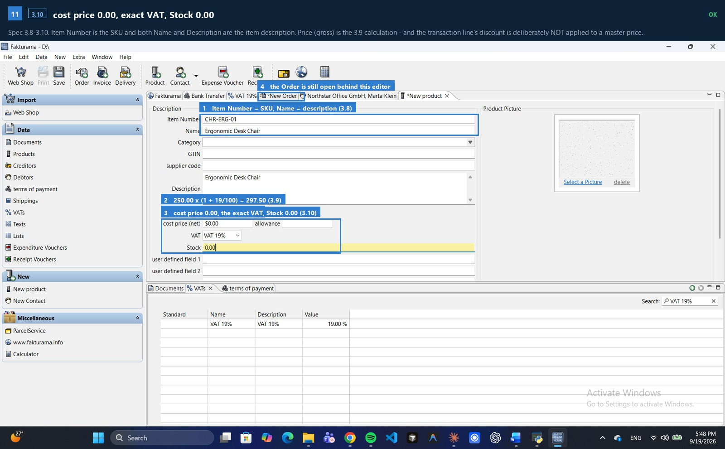
Figure B.11 · spec 3.10 · ok

B.12 — [3.12] Re-open the product selector and select the newly saved CHR-ERG-01
Spec 3.12. The newly saved Product, selected from the same picker in the same still-open Order. If it did not appear here, the run would stop for review.
Recorded: selected existing product: ['Ergonomic Des_', 'Ergonomic Des_', '', '5297.50'] [SKU column unreadable; accepted the single row returned by an exact-SKU search because its name matches the extracted description]
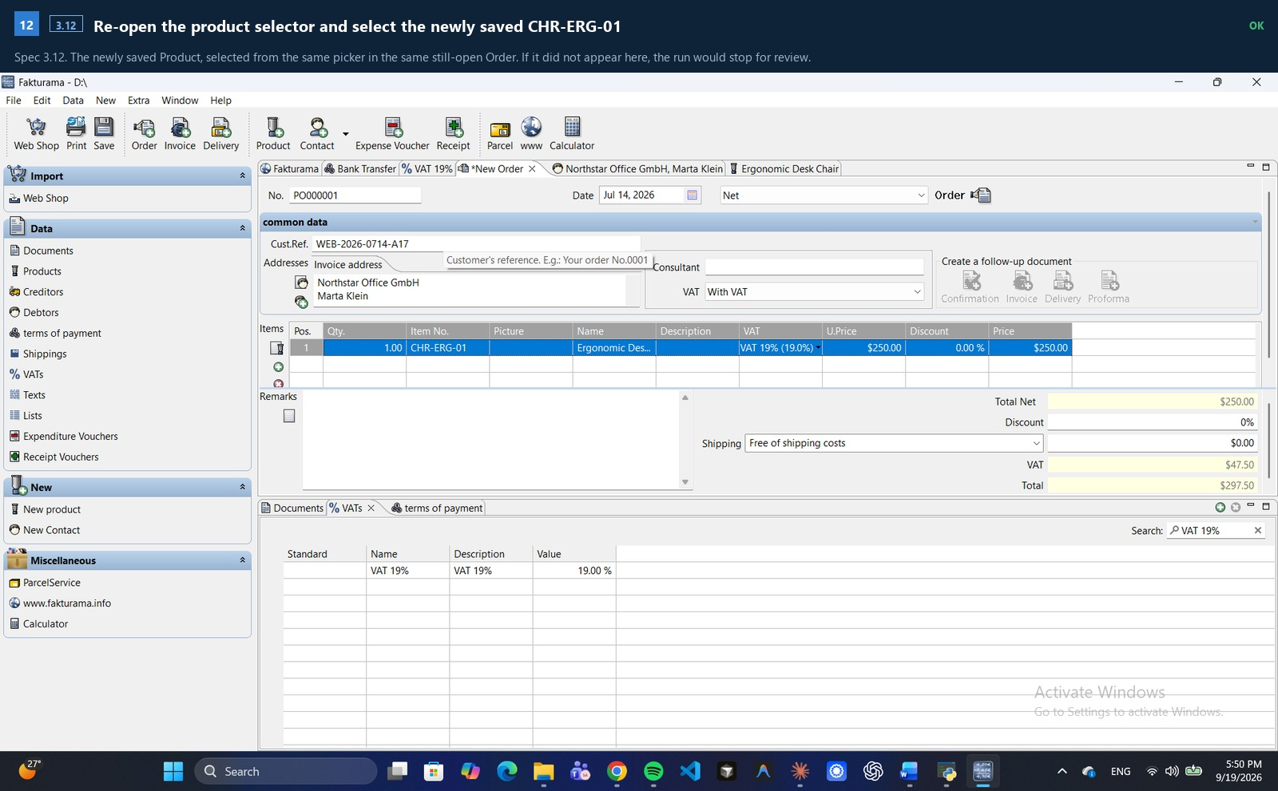
Figure B.12 · spec 3.12 · ok

B.13 — [3.2-3.3] Try to select MAT-DESK-02 from the Order
Spec 3.2-3.3. The Product picker, searched on the exact SKU. When no exact row appears the run cancels out, creates the Product, and comes back to this dialog.
Recorded: no exact SKU MAT-DESK-02 (0 rows)
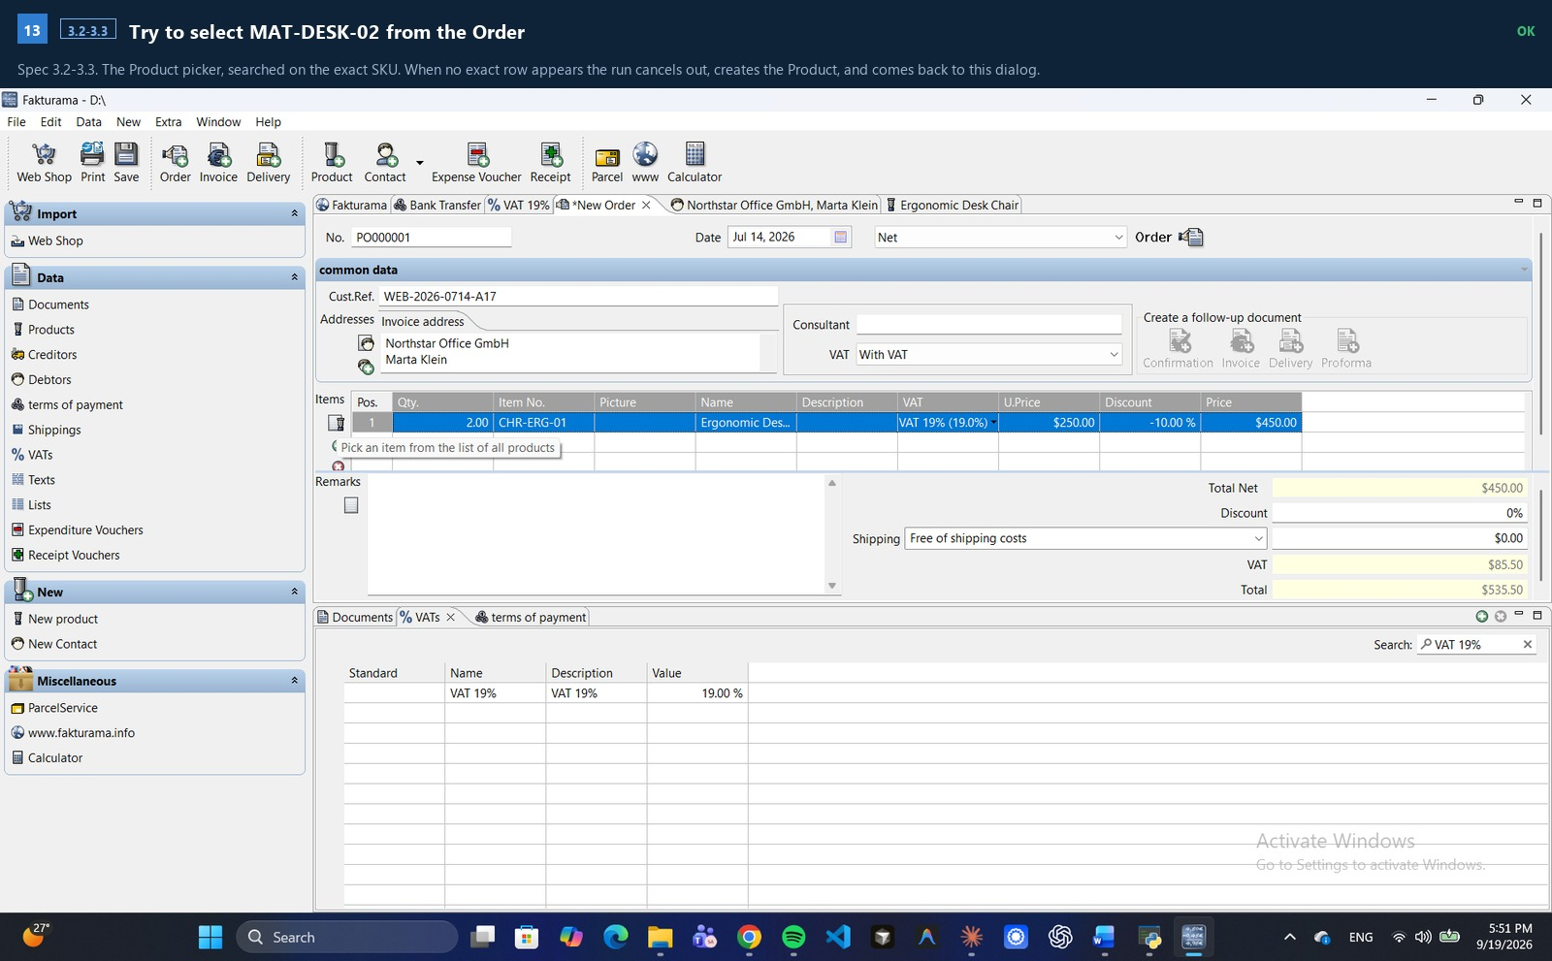
Figure B.13 · spec 3.2-3.3 · ok

B.14 — [3.10] cost price 0.00, exact VAT, Stock 0.00
Spec 3.8-3.10. Item Number is the SKU and both Name and Description are the item description. Price (gross) is the 3.9 calculation - and the transaction line's discount is deliberately NOT applied to a master price.
Recorded: VAT 'VAT 19%', cost 0.00, stock 0.00
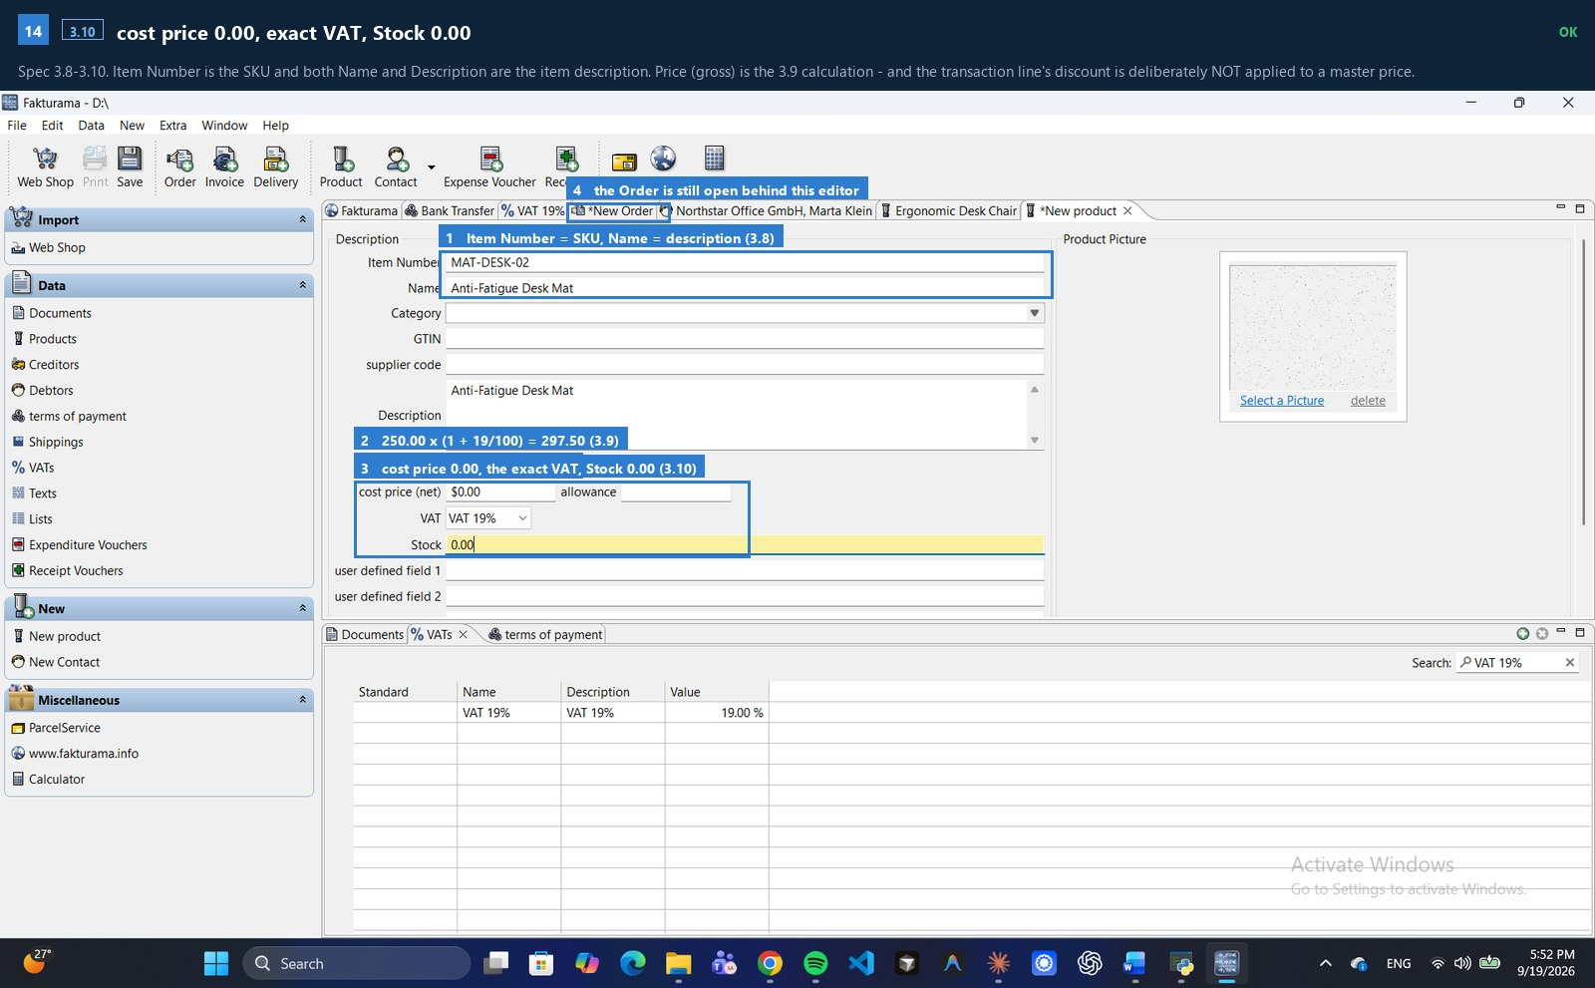
Figure B.14 · spec 3.10 · ok

B.15 — [3.12] Re-open the product selector and select the newly saved MAT-DESK-02
Spec 3.12. The newly saved Product, selected from the same picker in the same still-open Order. If it did not appear here, the run would stop for review.
Recorded: attempt 1 reached the goal before it failed; not repeating it
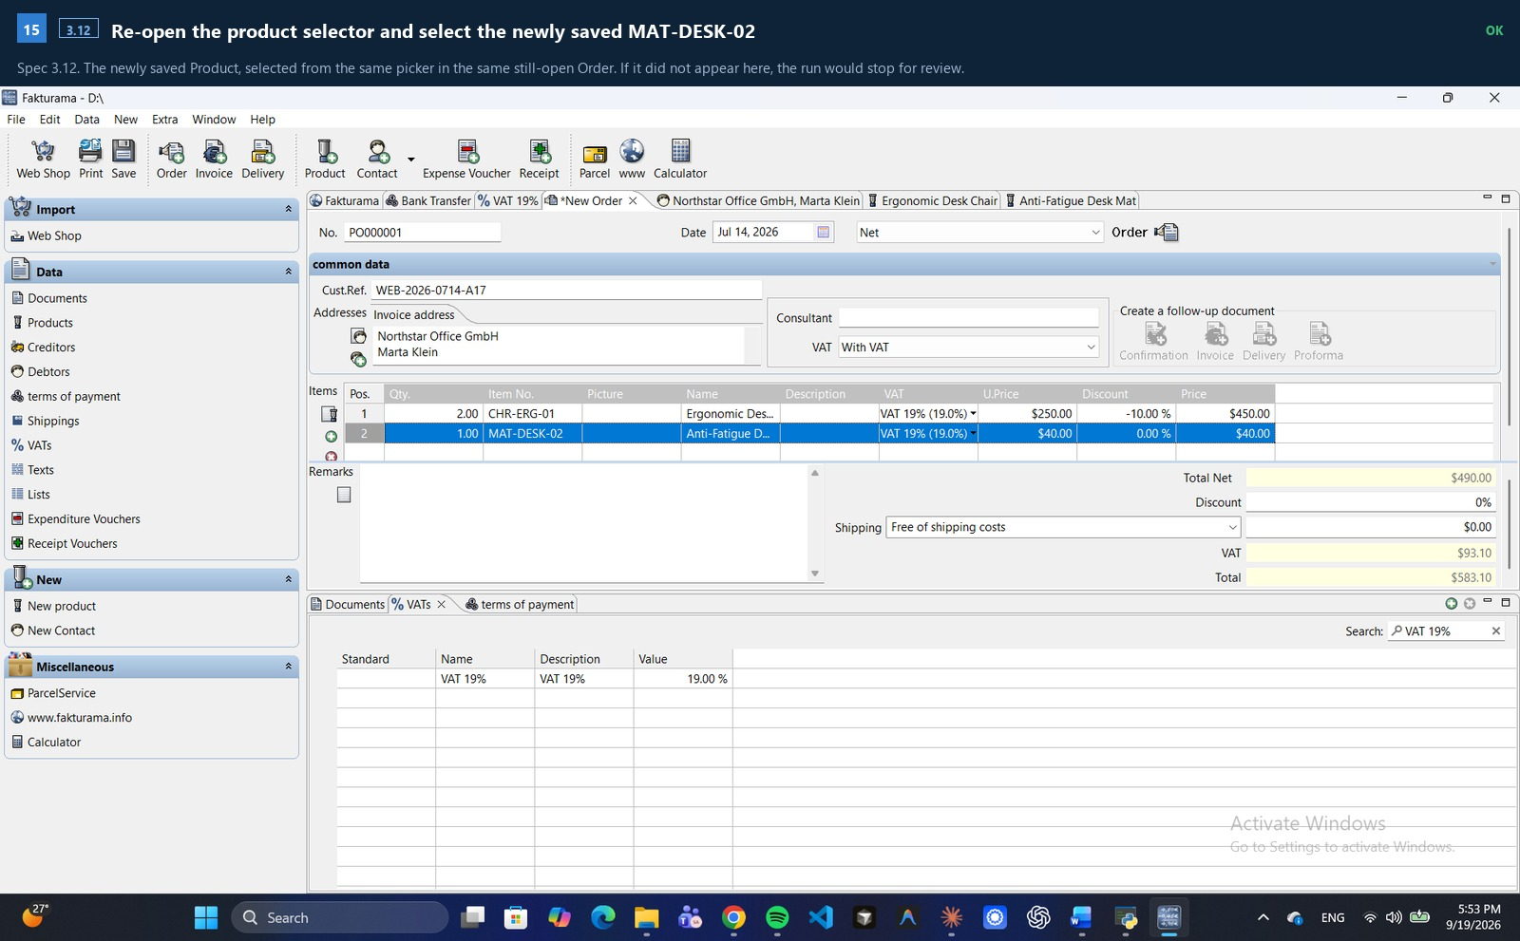
Figure B.15 · spec 3.12 · ok

B.16 — [4.1] Confirm the Debtor addresses and every Product line
Spec 4.1-4.3. Both item lines complete, and the footer totals about to be checked against the image's own net, VAT and gross.
Recorded: 2 item line(s) entered
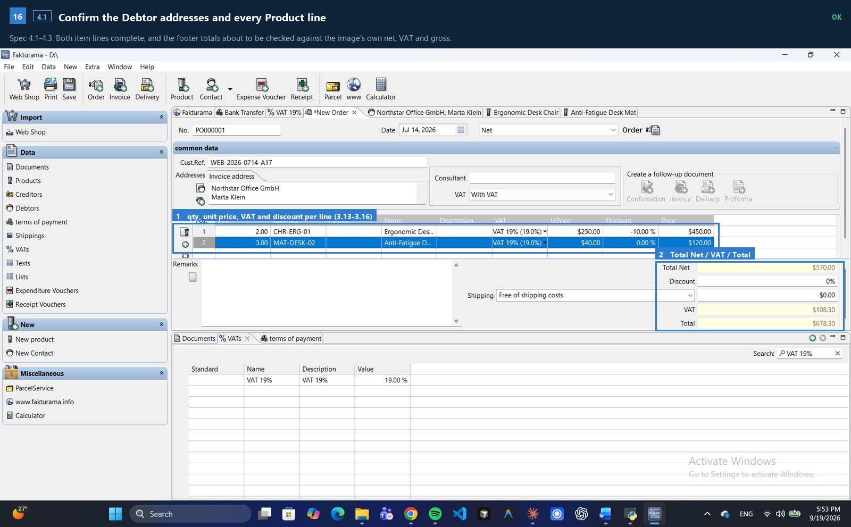
Figure B.16 · spec 4.1 · ok

B.17 — [4.4] Click the toolbar Save control once
Spec 4.4. One click on the toolbar Save. This step is deliberately not replayable: a repeat would mean a second saved record.
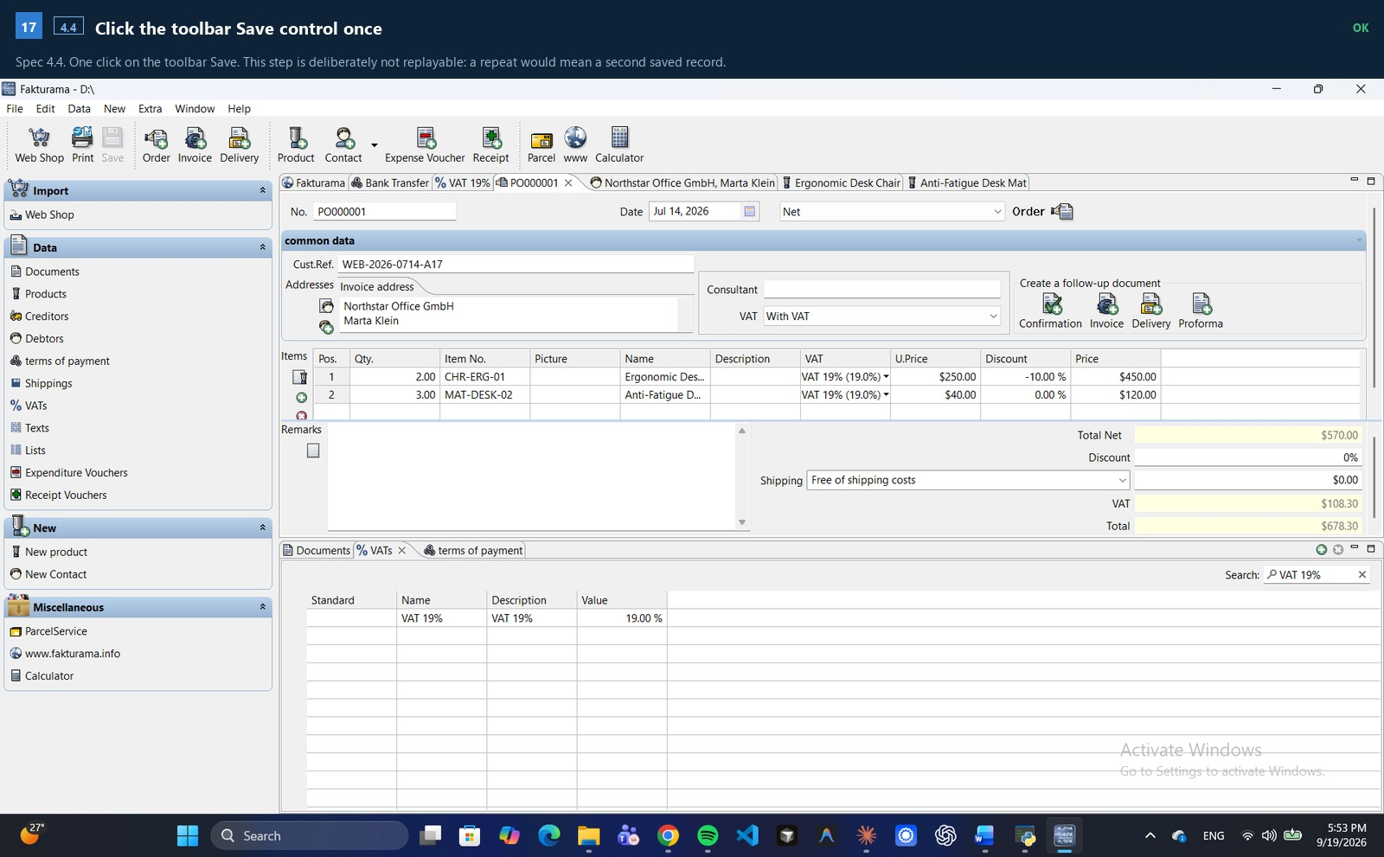
Figure B.17 · spec 4.4 · ok

B.18 — [4.5] Verify the saved Order in Data > Documents
Spec 4.5. Exactly one Order row, carrying the extracted Cust.Ref., in the open state, with the expected total - and the follow-up area the next step will use.
Recorded: order row: POOOOOO1 Jul 14, 2026 Northstar Office Gm.. WEB-2026-0714-A17 open 5678.30
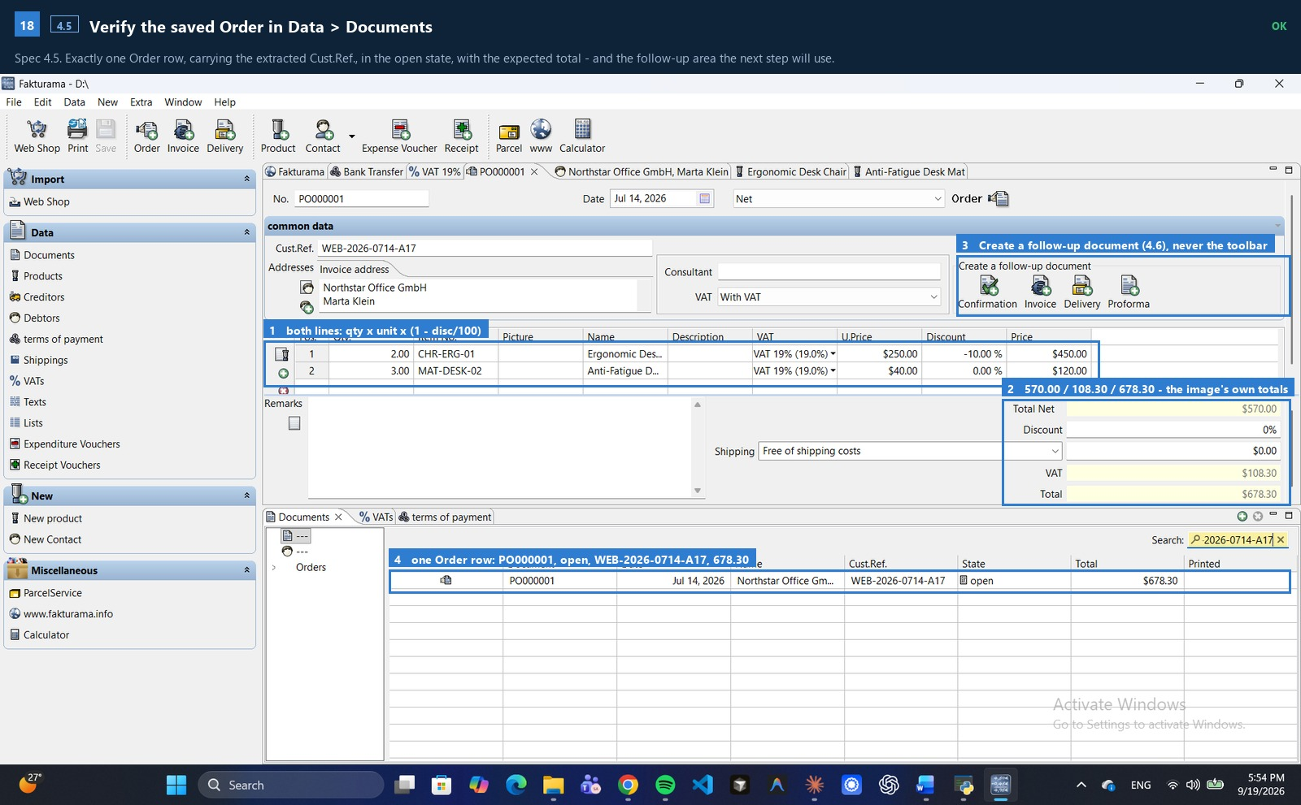
Figure B.18 · spec 4.5 · ok

B.19 — [4.6] Create the linked Invoice from the Order's follow-up area
Spec 4.6-4.7. The Invoice is created from the saved Order's own follow-up area. The toolbar Invoice button is deliberately not used, because only the follow-up action preserves the Order relationship.
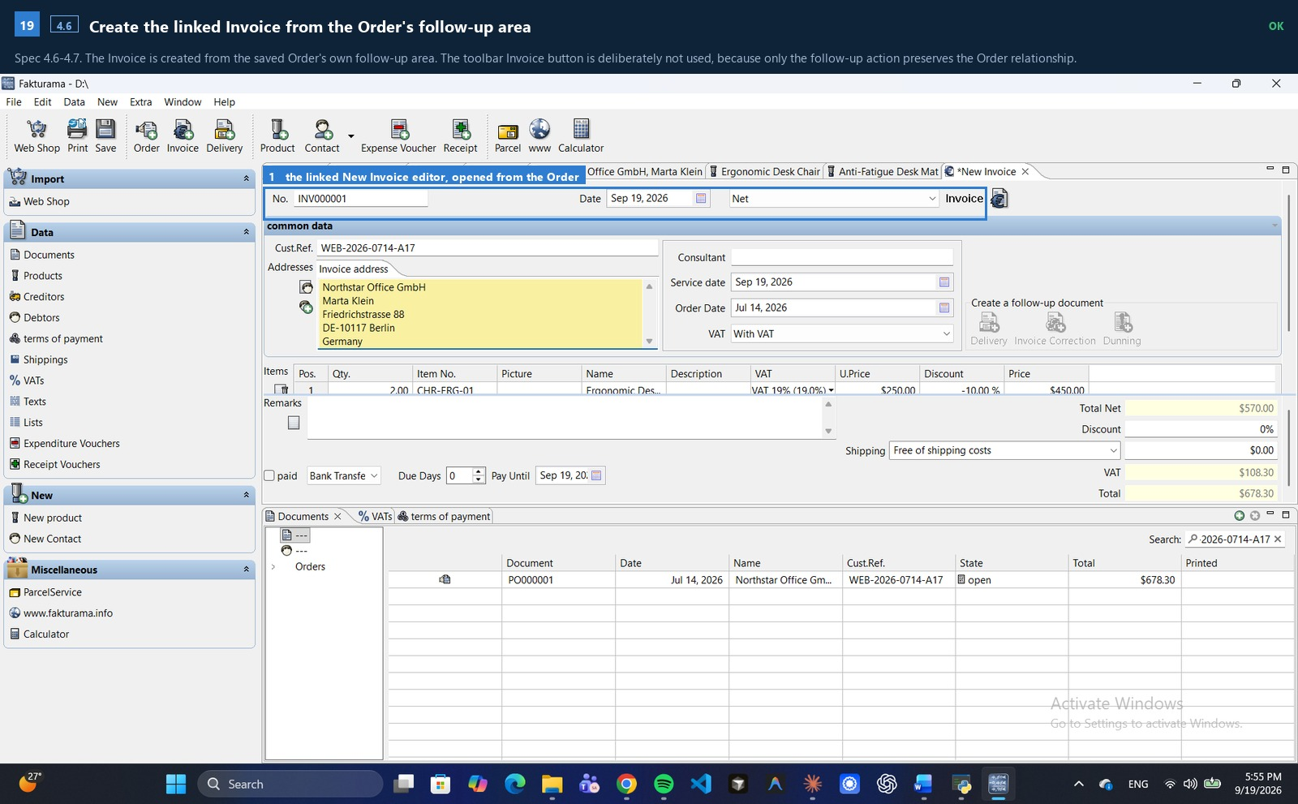
Figure B.19 · spec 4.6 · ok

B.20 — [5.1] Confirm the Invoice was populated from the Order
Spec 5.1. Cust.Ref., both addresses, the Order Date, the VAT mode, the item lines and the totals were all copied from the Order. The proposed Invoice No., Invoice Date and Service date are left exactly as generated.
Recorded: invoice No. 'INV000001' (unchanged), Cust.Ref. 'WEB-2026-0714-A17', total 678.30
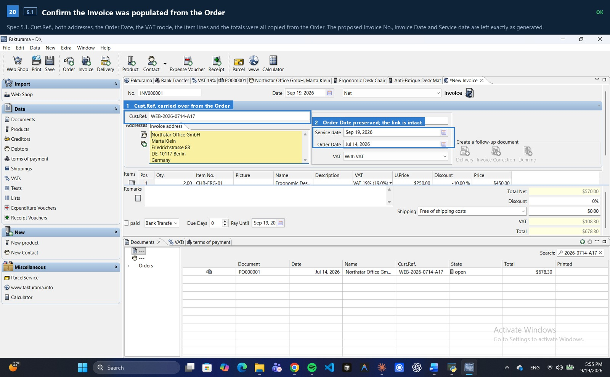
Figure B.20 · spec 5.1 · ok

B.21 — [5.3] Apply the extracted payment status (PAID)
Spec 5.2-5.3. The payment method matches the image; because the extracted status is PAID, 'paid' is set with the extracted payment date and the full invoice total. Had the status not been PAID, the flag would have been left clear and no date invented.
Recorded: paid on 2026-07-18 for the full invoice total 678.30
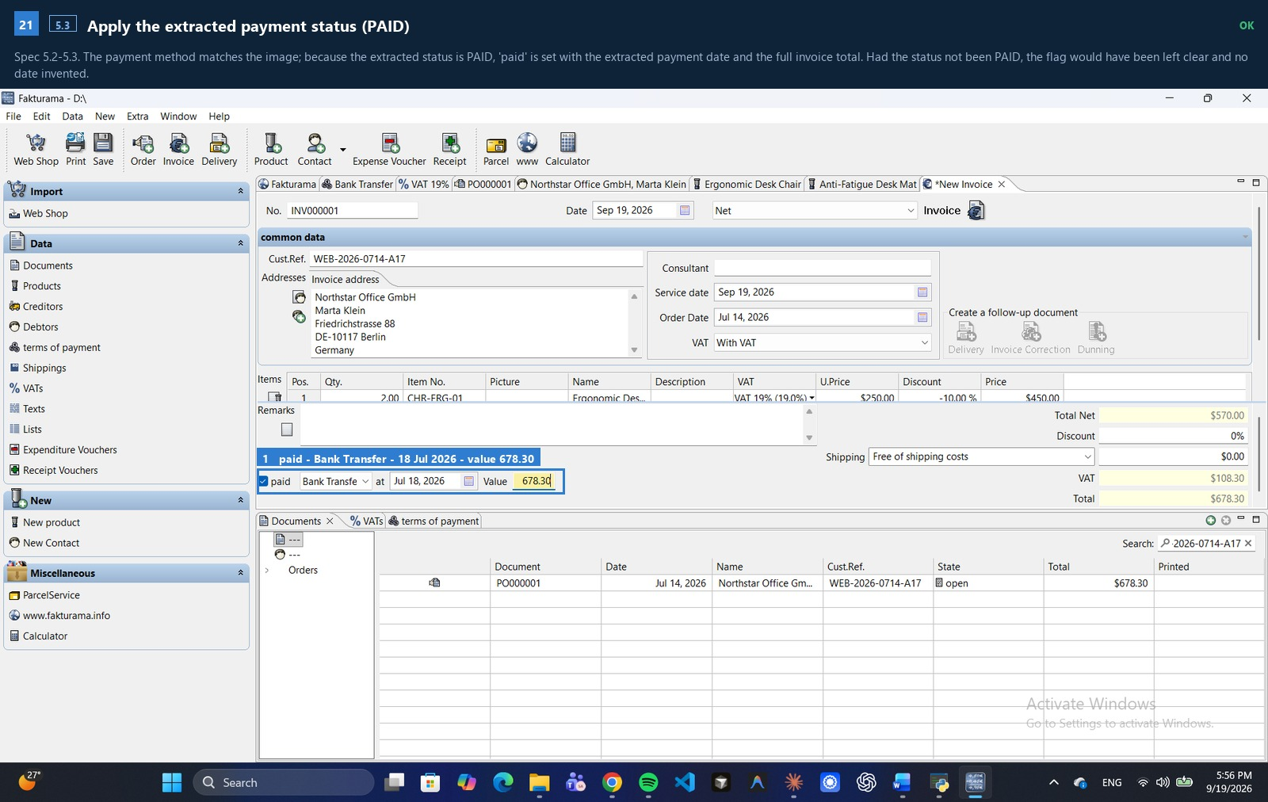
Figure B.21 · spec 5.3 · ok

B.22 — [5.4] Click the toolbar Save control once
Spec 5.4. One save.
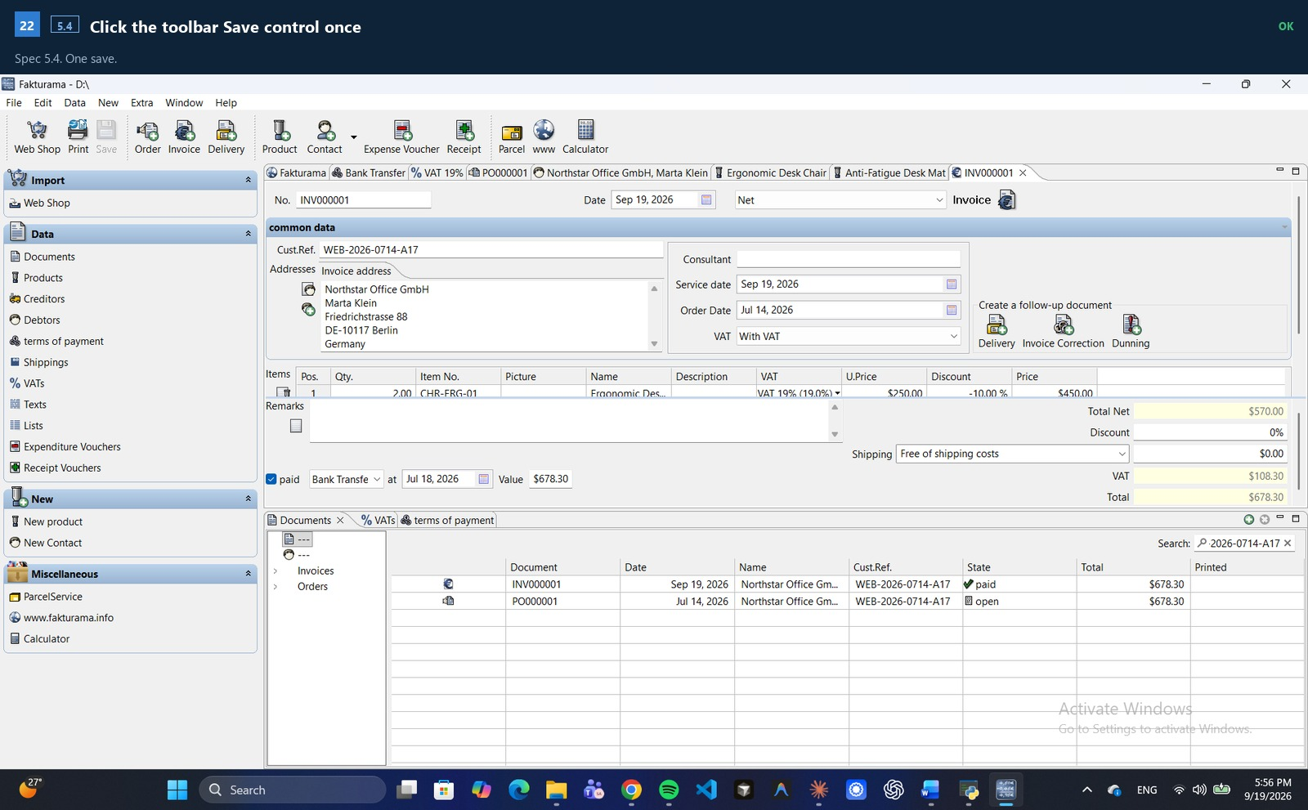
Figure B.22 · spec 5.4 · ok

B.23 — [5.5] Verify Invoice and Order rows in Data > Documents
Spec 5.5. The final state: the Invoice row with its total and paid state, and the source Order still open with the same Cust.Ref. and the same total. The list is a custom-drawn canvas read by OCR, so rows are matched by document number with confusable glyphs folded - it renders INV000001 and OCR returns INVOOOOO1.
Recorded: invoice row ['INVOOOOO1', '19, 2026 Sep', 'Northstar Office Gm.', 'WEB-2026-0714-A17', 'paid', '5678.30', ''] | order row ['POOOOOO1', 'Jul 14, 2026', 'Northstar Office Gm..', 'WEB-2026-0714-A17', 'open', '5678.30', '']
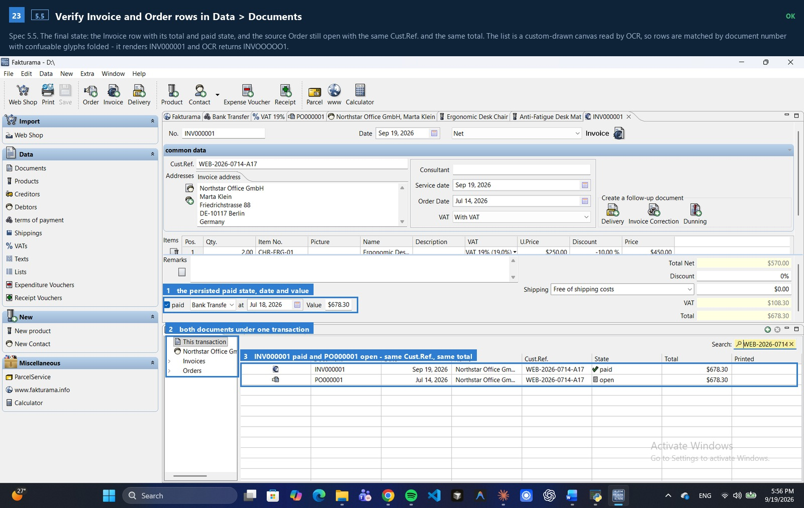
Figure B.23 · spec 5.5 · ok

Part C · What was actually saved
Read back from Fakturama's own stored data, not from the screen:
PAYMENT Bank Transfer code = Credit transfer (spec 2.10.4)
VAT VAT 19% value = 19% code = S (Standard rate)
CONTACT Northstar Office GmbH Marta Klein alias NORTHSTAR-BERLIN
PRODUCT CHR-ERG-01 created from the Order's picker
PRODUCT MAT-DESK-02 created from the Order's picker
ORDER PO000001 Cust.Ref. WEB-2026-0714-A17 net 570.00 / gross 678.30
INVOICE INV000001 linked to the Order, paid 2026-07-18, value 678.30

Step index
# | SPEC | STEP | STATUS | TRIES | S
1 | 0.1 | Launch or attach to Fakturama | ok | 1 | 13.9
2 | 0.2 | Ensure the payment method exists before any editor opens | ok | 1 | 33.0
3 | 2.10.1 | Open Data > terms of payment and search 'Bank Transfer' | ok | 1 | 10.3
4 | 2.10.2 | Decide whether an exact Payment Method already exists | ok | 1 | 0.0
5 | 2.10.2 | Click the green + in the terms-of-payment list | ok | 1 | 6.9
6 | 2.10.3 | Set Name and Description; leave Account blank | ok | 1 | 2.6
7 | 2.10.4 | Set the payment code to 'Credit transfer' | ok | 1 | 4.0
8 | 2.10.5 | Zero the discount/day fields; leave the texts blank | ok | 1 | 6.2
9 | 2.10.6 | Save the new Payment Method once | ok | 1 | 2.8
10 | 0.3 | Ensure every VAT rate on the order exists | ok | 1 | 35.0
11 | 3.4 | Open Data > VATs and search 'VAT 19%' | ok | 1 | 7.8
12 | 3.5 | Decide whether an existing VAT row can be reused | ok | 1 | 0.0
13 | 3.6 | Fill a new VAT 19% with the Standard rate code | ok | 1 | 24.1
14 | 3.6 | Save the new VAT rate once | ok | 1 | 2.8
15 | 1.3 | Open a New Order from the top toolbar | ok | 1 | 30.5
16 | 1.4 | Leave the proposed order No. unchanged | ok | 1 | 2.0
17 | 1.5 | Set Date to the extracted Order Date | ok | 1 | 2.4
18 | 1.6 | Enter the External Reference in Cust.Ref. | ok | 1 | 3.6
19 | 1.7 | Set price mode to Net and keep VAT as With VAT | ok | 1 | 2.0
20 | 2.1-2.3 | Try to select the Debtor from the Order | ok | 1 | 31.3
21 | 2.5 | Keep the Order open and click New Contact | ok | 1 | 21.4
22 | 2.6 | Enter Company / First Name / Last Name; leave the ID and Salutation | ok | 1 | 6.4
23 | 2.7 | Fill Addresses > Main address from the billing address | ok | 1 | 37.4
24 | 2.8 | Assign address roles | skipped | 1 | 7.5
25 | 2.9 | Miscellaneous: alias, 0%% discount, Net | ok | 1 | 11.9
26 | 2.10 | Select the Payment Method 'Bank Transfer' | ok | 1 | 10.3
27 | 2.11 | Save the Debtor once | ok | 1 | 3.1
28 | 2.12 | Return to the still-open Order tab | ok | 1 | 10.6
29 | 2.12 | Re-open the address selector and select the newly saved Debtor | ok | 1 | 52.6
30 | 2.4 | Confirm the populated Invoice and Delivery addresses | ok | 1 | 12.8
31 | 3.1 | Item 1 of 2: CHR-ERG-01 | ok | 1 | 186.2
32 | 3.2-3.3 | Try to select CHR-ERG-01 from the Order | ok | 1 | 23.2
33 | 3.7 | Open New product (the required VAT now exists) | ok | 1 | 31.6
34 | 3.8 | Set Item Number, Name and Description | ok | 1 | 5.8
35 | 3.9 | Price (gross) = 250.00 x (1 + 19/100) = 297.50 | ok | 1 | 3.7
36 | 3.10 | cost price 0.00, exact VAT, Stock 0.00 | ok | 1 | 11.2
37 | 3.11 | Save the Product once | ok | 1 | 3.0
38 | 3.12 | Return to the still-open Order tab | ok | 1 | 10.9
39 | 3.12 | Re-open the product selector and select the newly saved CHR-ERG-01 | ok | 1 | 36.4
40 | 3.13 | Line 1: set Qty. to 2 | ok | 1 | 11.2
41 | 3.14 | Line 1: confirm U.Price and VAT | ok | 1 | 4.0
42 | 3.15 | Line 1: set Discount to 10% | ok | 1 | 2.5
43 | 3.16 | Line 1: confirm Price == 450.00 | ok | 1 | 4.2
44 | 3.1 | Item 2 of 2: MAT-DESK-02 | ok | 1 | 190.6
45 | 3.2-3.3 | Try to select MAT-DESK-02 from the Order | ok | 1 | 23.6
46 | 3.7 | Open New product (the required VAT now exists) | ok | 1 | 28.1
47 | 3.8 | Set Item Number, Name and Description | ok | 1 | 7.7
48 | 3.9 | Price (gross) = 40.00 x (1 + 19/100) = 47.60 | ok | 1 | 3.7
49 | 3.10 | cost price 0.00, exact VAT, Stock 0.00 | ok | 1 | 11.7
50 | 3.11 | Save the Product once | ok | 1 | 3.1
51 | 3.12 | Return to the still-open Order tab | ok | 1 | 11.3
52 | 3.12 | Re-open the product selector and select the newly saved MAT-DESK-02 | ok | 1 | 47.4
53 | 3.13 | Line 2: set Qty. to 3 | ok | 1 | 4.2
54 | 3.14 | Line 2: confirm U.Price and VAT | ok | 1 | 4.0
55 | 3.15 | Line 2: set Discount to 0% | ok | 1 | 2.4
56 | 3.16 | Line 2: confirm Price == 120.00 | ok | 1 | 4.1
57 | 4.1 | Confirm the Debtor addresses and every Product line | ok | 1 | 2.1
58 | 4.2 | Keep order Discount at 0%% and Shipping free | ok | 1 | 0.7
59 | 4.3 | Confirm Total Net / VAT / Total against the source | ok | 1 | 0.9
60 | 4.4 | Click the toolbar Save control once | ok | 1 | 3.5
61 | 4.5 | Verify the saved Order in Data > Documents | ok | 1 | 35.0
62 | 4.6 | Create the linked Invoice from the Order's follow-up area | ok | 1 | 88.5
63 | 4.7 | Wait for the linked New Invoice editor | ok | 1 | 0.7
64 | 5.1 | Confirm the Invoice was populated from the Order | ok | 1 | 5.1
65 | 5.2 | Set or confirm the Invoice payment method | ok | 1 | 0.7
66 | 5.3 | Apply the extracted payment status (PAID) | ok | 1 | 10.6
67 | 5.4 | Click the toolbar Save control once | ok | 1 | 3.1
68 | 5.5 | Verify Invoice and Order rows in Data > Documents | ok | 1 | 15.9

