FAKTURAMA IMAGE-TO-CASH AUTOMATION
Code Walkthrough
What every file in the package does, why it is shaped that way, and which live-application failure taught it that shape.

1 What this project does
2 How the parts fit together
3 The core files
4 Reading the image — src/f2c/extract/
5 The desktop front end — src/f2c/gui/
6 Driving the screen — src/f2c/ui/
7 The business steps — src/f2c/flow/
8 Checking the work — src/f2c/verify/
9 Supporting files
10 One complete run, traced through the code
11 The bugs that shaped the code

1. What this project does

The job in one sentence
Given one picture of a sales order, produce a saved Order and a linked, paid Invoice inside Fakturama — creating the customer, the payment method, the VAT rate and the products if they do not already exist — by driving the application's real user interface, and verify every step before taking the next one.

The whole pipeline in one picture
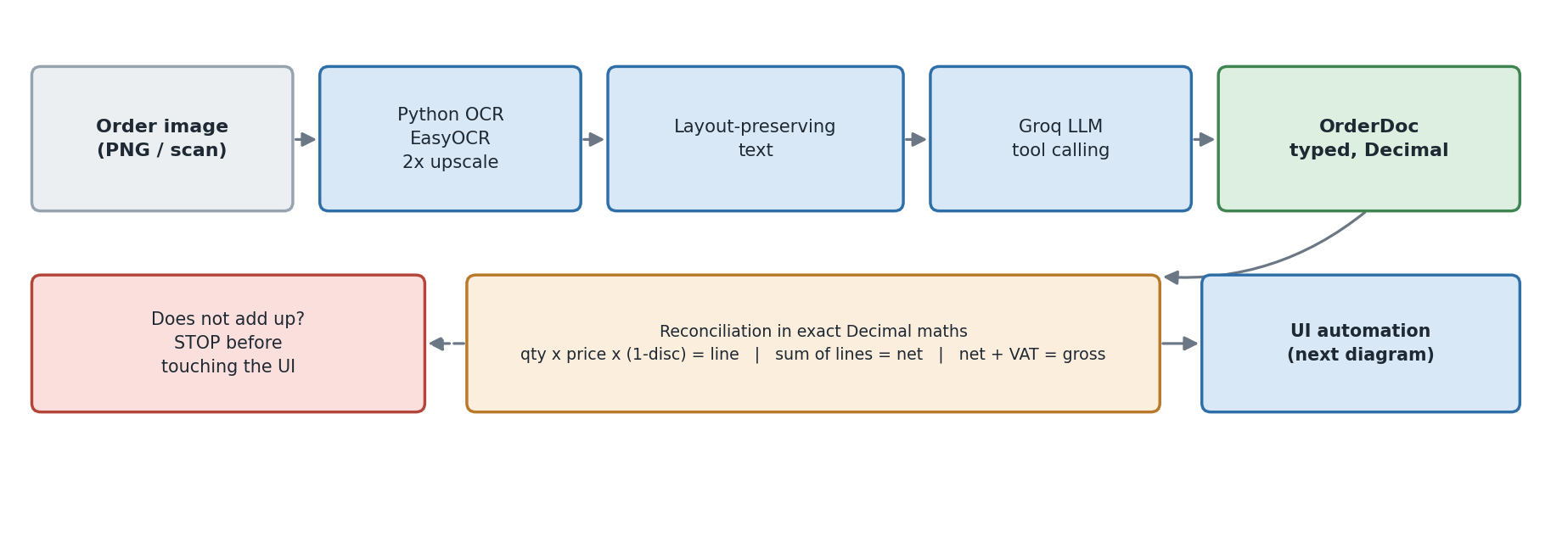
Image → OCR → Groq → a typed, reconciled OrderDoc.
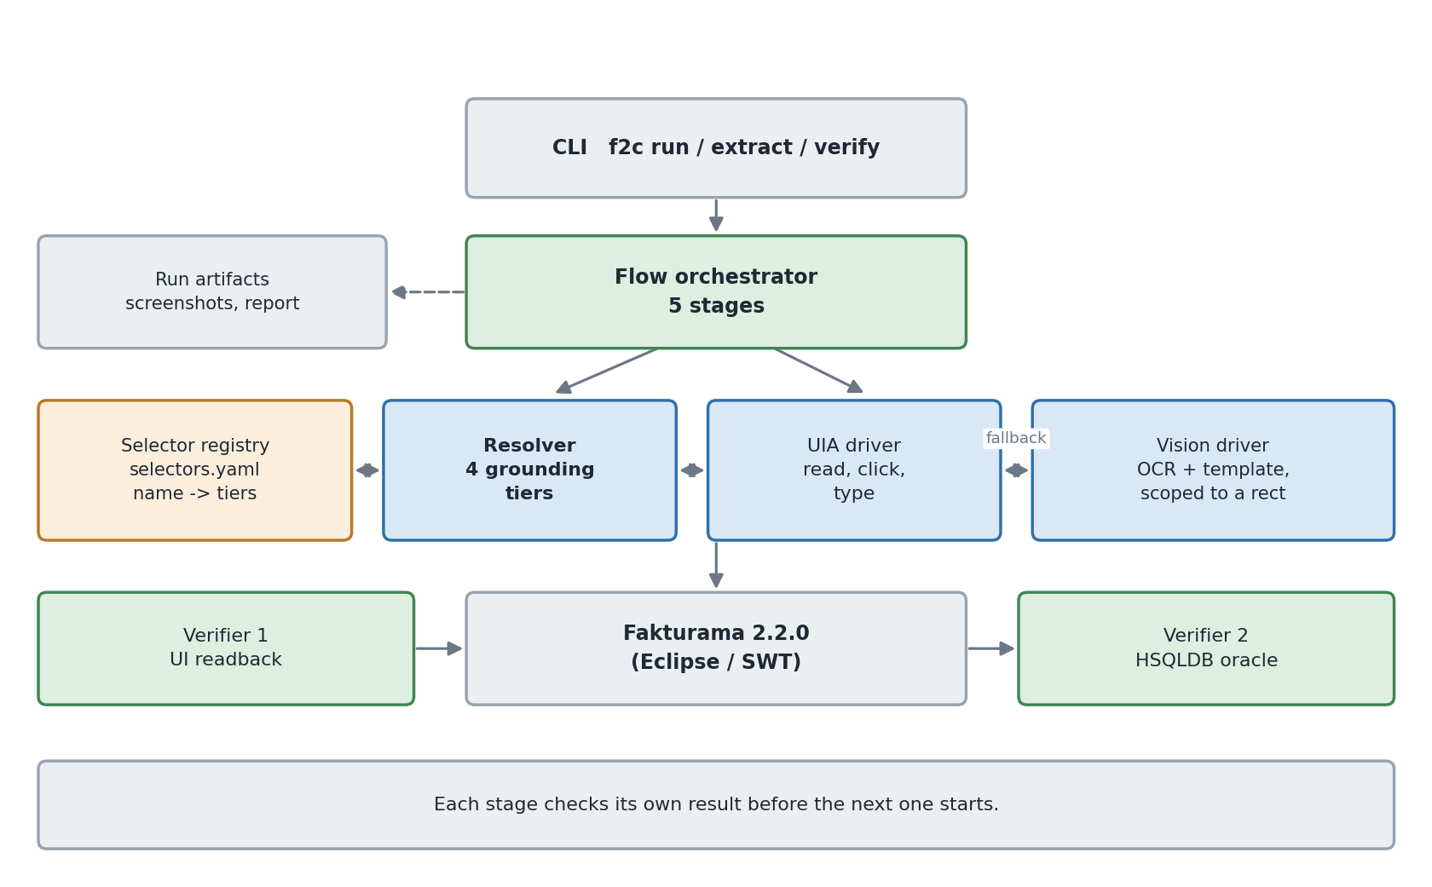
The layers, and what each one is allowed to talk to.

2. How the parts fit together
Five packages, each with one job, and a strict direction of dependency: flow talks to ui, never the other way round; ui knows about widgets and nothing about orders; extract knows about orders and nothing about widgets; gui knows about both but is known by neither.

Folder map
PATH | JOB | SIZE
src/f2c/models.py | The typed shape of an order. All money is Decimal. | 232 lines
src/f2c/extract/ | Image → OrderDoc. OCR, the LLM tool call, and the arithmetic gate. | 1047 lines
src/f2c/gui/ | The desktop window: upload, OCR, validation, live run. | 1442 lines
src/f2c/ui/ | Finding and operating Fakturama's controls. Knows no business rules. | 3009 lines
src/f2c/flow/ | The five stages of the written procedure, one module each. | 2892 lines
src/f2c/verify/ | Two independent oracles: the screen, and the stored data. | 423 lines
src/f2c/artifacts.py | The evidence folder: steps, screenshots, reports, the live listener. | 211 lines
src/f2c/cli.py | run, extract, verify, gui, inspect, resolve, doctor. | 311 lines
tests/ | 155 tests. No Fakturama required. | 1285 lines

3. The core files

models.py — the shape of an order
OrderDoc is the one object the two halves of the system share. Extraction produces it; the flow consumes it; nothing else crosses that line.
Three derived properties encode arithmetic the spec defines, so it is written once:
- Item.computed_line_net — spec 3.16: qty × unit_net × (1 − discount/100).
- Item.product_gross_price — spec 3.9: unit_net × (1 + VAT/100), two decimal places, half-up. The line discount is deliberately not applied: this is the product master price, not a transaction price.
- Item.vat_name — spec 3.4/3.6: the string VAT 19%, which is both what is searched for and what is created.
money() quantises to two places with ROUND_HALF_UP — commercial rounding, not Python's default banker's rounding. Floats appear nowhere in this package.

errors.py — the different kinds of failure
The hierarchy exists to separate 'try again or try another route' from 'stop and fetch a human'. LocatorError and TimeoutError_ are the first kind. ManualReviewRequired is the second, and it carries a context dictionary — the rows it saw, the value it expected — that lands in the run report. ReconciliationError is raised before any window opens.

config.py, logging_setup.py
Settings is one frozen read of the environment: provider, model, OCR engine, the Fakturama executable, the workspace, and the timing ceilings. Every timeout in the package is a ceiling on a condition, never a sleep. logging_setup gives rich output when it is installed and plain output when it is not.

artifacts.py — the evidence folder
RunArtifacts opens out/run-<timestamp>/ and records a StepRecord per step: the spec clause, the title, the status, how long it took, how many attempts it needed, and the screenshot. It writes report.json and a report.md whose screenshot column makes it readable on its own.
It also carries an optional listener. That is the hook the desktop window uses to fill its step list while the run is still going; the rest of the package neither knows nor cares that a front end exists, and a listener that raises is logged and ignored rather than being allowed to take a run down.
artifacts.py
def emit(self, kind, payload):
if self.listener is None:
return
try:
self.listener(kind, payload)
except Exception as exc: # a broken front end must not fail the run
log.debug('run listener raised on %s: %s', kind, exc)

4. Reading the image — src/f2c/extract/

ocr.py — turning pixels into positioned words
EasyOCR is the primary engine, Tesseract the fallback, and the choice is per-run (F2C_OCR_ENGINE=auto|easyocr|tesseract). Both produce the same OcrWord objects, so nothing downstream knows which one ran.

What it does, step by step
- Upscale 2× with LANCZOS and lower the detection thresholds. At native size EasyOCR silently dropped both single-digit quantities; at 2× it reads them at confidence 1.00.
- Divide every coordinate back down by the upscale factor, so positions are in the original image's frame and can be compared to anything else.
- Cluster words into visual lines (group_lines) by vertical proximity, with the tolerance scaled to the word's own height rather than fixed.
- Re-render at scaled horizontal positions (render_layout) to about 110 characters wide, so the item table still looks like a table.
- Expose the confidence — mean_confidence() and low_confidence_words() — which is what the desktop window's statistics strip shows.
cross_check() is the reverse direction, used when a vision model did the extraction: it asserts that every value in the OrderDoc literally appears in the OCR text, and reports the ones that do not.

schema.py — the form the model must fill in
ORDER_TOOL is a JSON schema handed to the model as a tool definition, so the response shape is enforced by the API rather than by a parser. Every numeric field is typed string, on purpose: the model transcribes digits, and pipeline._num parses them into Decimal. A JSON float would silently destroy cents.
SYSTEM_PROMPT says the thing that matters most: transcribe, never compute. If a printed total is wrong, the model must report the wrong total — because the reconciliation step is what is supposed to notice, and a model that quietly 'fixes' the document destroys the only check that exists.

llm.py — asking the model
Two providers behind one interface. groq posts to the OpenAI-compatible chat-completions endpoint with tools and a forced tool_choice; anthropic uses the Messages API with the same tool. Both have a text path (structure) and an image path (structure_from_image); the default here is Groq over OCR text, because the Groq account in use serves no vision model.
- temperature=0, and a retry loop that does not retry a 4xx — a bad request will not fix itself.
- _loads_loose recovers JSON from the message content, because some models answer with JSON in content instead of a tool call.
- The raw tool payload is cached under out/extraction-cache/<image-hash>.json, next to <hash>.ocr.txt, so a disputed field can be traced back to what was actually read.

validate.py — the arithmetic gate
Runs before any window opens, entirely in Decimal, and raises rather than proceed:
per line qty x unit_net x (1 - disc/100) == the printed line total (exact)
sum sum(lines) == the printed net total (1 cent)
VAT sum(line x vat/100) == the printed VAT total (1 cent)
gross net + VAT == the printed gross total (1 cent)
payment PAID <=> a payment date exists (spec 5.3)
mapping the payment method has a Fakturama code (spec 2.10.4)

Lines are exact; the totals get one cent of slack because some source documents round per line and some round on the sum.

pipeline.py — tying extraction together
extract_order() is the public entry point: cache lookup by image hash, the configured mode (ocr or vision), normalisation, the optional OCR cross-check, then reconciliation. _num is the quiet workhorse — it strips currency symbols, percent signs and non-breaking spaces, and resolves 1.234,56 against 1,234.56 by comparing where the last separator is.

5. The desktop front end — src/f2c/gui/
Three files, and one rule that shapes all of them. Tkinter is not thread safe: a background thread touching a widget takes the interpreter down rather than raising. So everything slow runs on a worker thread that communicates only by putting messages on a queue.Queue, and App._pump — scheduled every 60 ms on the main loop — is the single place in the module that touches a widget.
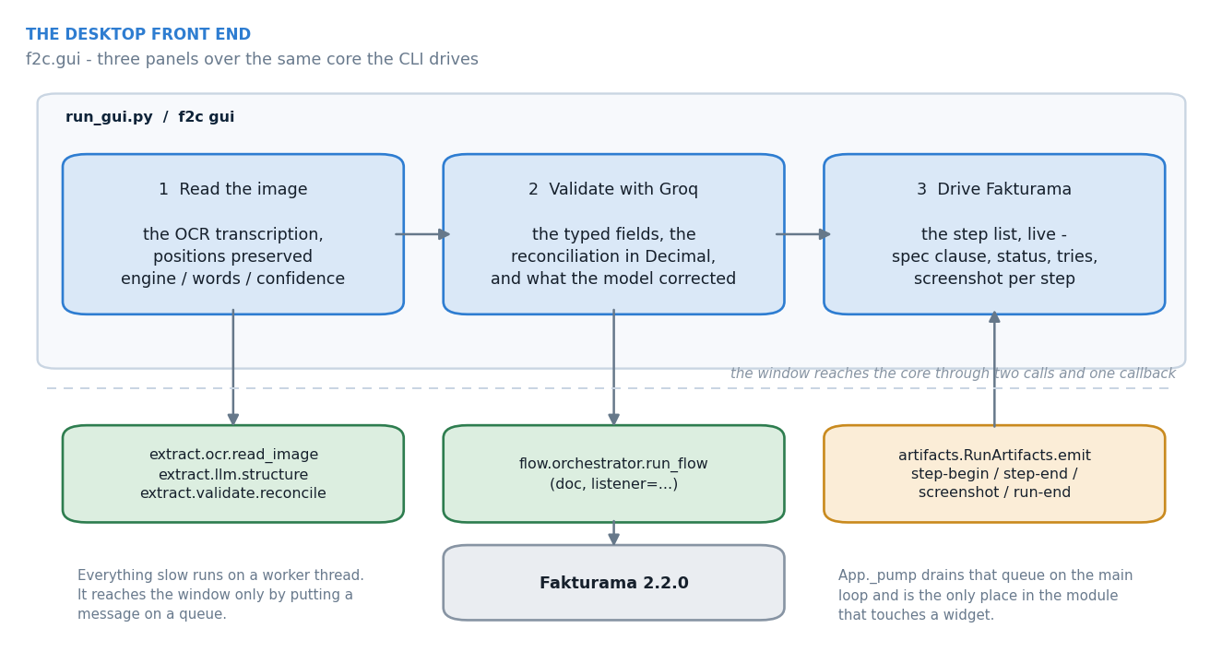
The window, and the narrow surface it uses to reach the core.
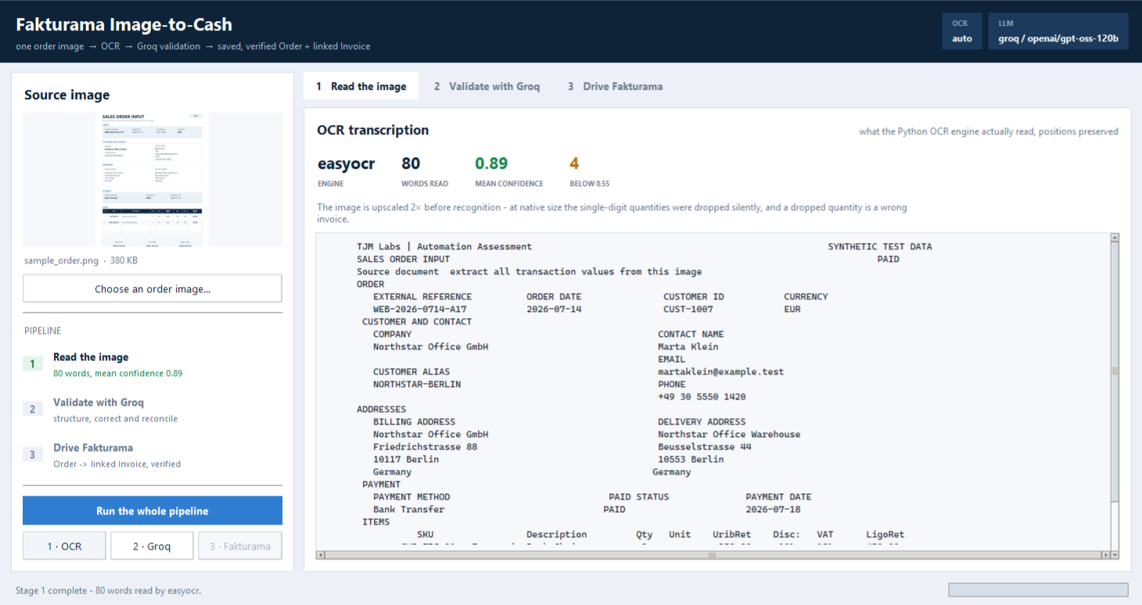
Panel 1: the OCR transcription, with its positions preserved.
FILE | WHAT IS IN IT | SIZE
theme.py | The palette, the resolved fonts and every ttk style. One vocabulary of colour — the status colours used by the stage badges are the same ones the step rows use. | 173 lines
widgets.py | The composites Tkinter does not have: Card, Chip, StageItem, MonoPanel, Metric. | 175 lines
app.py | The window, the three panels, the worker bodies and _pump. | 1083 lines

The three panels
- Read the image. extract.ocr.read_image on the worker thread; the panel shows the layout-preserving transcription plus engine, word count, mean confidence and how many words fell below 0.55.
- Validate with Groq. llm.structure → pipeline.normalise → validate.reconcile(strict=False). The panel shows the structured fields as a tree, the reconciliation recomputed line by line, and the corrections list.
- Drive Fakturama. flow.orchestrator.run_flow(..., listener=...). Every step-begin / step-end / screenshot message becomes a row, and selecting a row shows that step's screenshot and detail.

The corrections list, and why it is not a badge
App._corrections normalises the whole OCR reading into one string and asks, of every extracted value, whether it appears there character for character. The ones that do not are what the model contributed — and they are exactly what a reviewer should be shown.
On the sample document the list comes back empty, and that is informative rather than dull. The OCR reads the e-mail as martaklein@example.test — the dot between the given and family name is a few pixels and falls below the detector's threshold — and the model, told never to invent or repair a value, returns exactly that. The empty list is how a reviewer can see that the model added nothing at all: no silent fix to the e-mail, and equally no silent fix to a total.
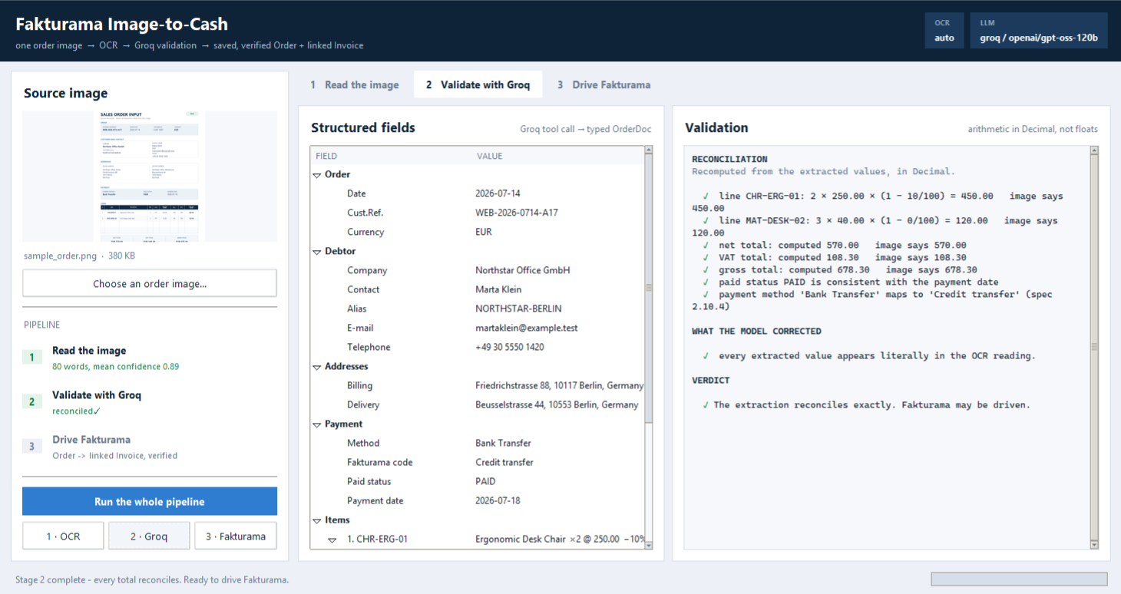
Panel 2: fields, reconciliation, and what the model corrected.

6. Driving the screen — src/f2c/ui/

The four-tier approach to finding a control
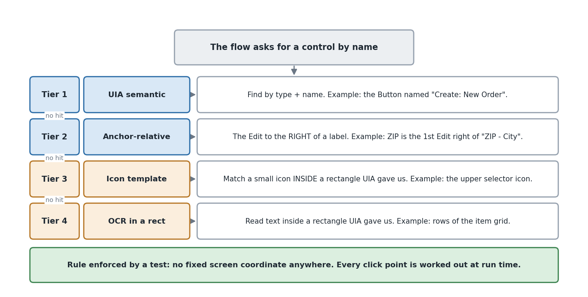
Tried in order; the winning tier is recorded per resolution.

selectors.yaml — the address book of controls
115 logical control names, 235 strategies. Re-grounding for a new Fakturama version is a data change, not a code change, and the file is the single place where 'what the control is called' lives.
two entries from selectors.yaml
order.custref_field: # spec 1.6 (this Edit is named)
- {tier: uia, type: Edit, name: "Cust.Ref.", scope: order_editor}
- {tier: anchor, anchor_text: "Cust.Ref.", direction: right, type: Edit, scope: order_editor}

order.address_select_icon: # spec 2.1 - the UPPER icon
- {tier: uia, type: Image, scope: order.addresses_group, pick: topmost}
- {tier: template, image: "icons/select_contact.png", scope: order.addresses_group,
pick: topmost, threshold: 0.86}

Scopes are themselves logical names, so a control can be declared relative to a container that is itself resolved by four tiers. tests/test_selectors.py proves that every name the flow uses exists, that every scope resolves, and that a pixel tier is never a control's first strategy.

resolver.py — the engine that does the finding

Special abilities it grew, each for a real reason
- `{order_number}` placeholders. Fakturama renames a document editor when it is saved: New Order becomes PO000001. Every selector that identifies the editor by name therefore stops matching at the exact moment the Order starts to exist. Ctx.remember puts the number — read from the form in step 1.4 — into Resolver.values, and a strategy whose placeholder is not yet known is dropped rather than matched as an empty name.
- A scope cache with an on-screen check. Resolving a container is expensive, so it is cached — but a container that has since been parked (an editor that is no longer the active tab) must not keep serving its children, or writes go into a window nobody can see.
- A short timeout when resolving a scope. A scope is resolved inside the caller's own polling loop, so a full-length wait there would spend the entire budget inside a single poll. One run timed out 'after 20.0s (1 polls)' — it never got a second look at a dialog that was merely slow.
- `pick:` — topmost, bottommost, largest, smallest. This is how the spec's 'upper icon, not the lower green +' is expressed without a coordinate.
- Tier statistics. Every resolution records which tier won, and the counts go into the run report: uia 237, anchor 53.

uia.py — the wrapper around Windows automation

The most important thing in this file
PARKED_COORDINATE. Eclipse does not destroy the widgets of a background editor — it moves them off-screen, to a large negative coordinate, and they keep answering UIA queries perfectly happily. An automation that does not know this will read from and type into an editor that is not on screen, and every write will silently do nothing.
So Element.on_screen treats a parked rectangle as not-on-screen, and the resolver refuses to return a parked control unless a strategy explicitly asks for one. That single rule is what makes Ctx._activate able to prove an editor came to the front: resolving anything inside it is the proof.
text_of() is the other workhorse. An SWT Text widget's value is often reachable only through LegacyIAccessiblePattern, not ValuePattern, so it tries every route in order.

waits.py — never sleep, always wait for a condition
There is no sleep(2) anywhere in the package. wait_until polls a predicate against a ceiling; wait_stable waits for a list to return the same signature twice, which is how 'wait for the results to stabilise' in spec 2.2 is implemented; wait_gone waits for a dialog to close.

vision_locator.py — pixels, but only inside a known box
Every function takes a Rect that came from a UIA element and returns Rects in screen coordinates. Nothing here knows a constant screen position: the search region is always resolved at run time from the accessibility tree, and offsets are always relative to it. That is what satisfies 'no hardcoded coordinates, no fixed UI layout' while still being able to reach a canvas with no accessibility children.

grid.py — reading and writing table-like controls
Two very different situations share this file.
- read_uia_rows handles the dialog lists, which are SWT Table widgets backed by native Win32 list-views. UIA sees real rows and cells, so they are read semantically.
- CanvasGrid handles the item grid in the document editor, which is a custom-drawn NatTable: a single Canvas with no accessibility children. The table is reconstructed geometrically from the control's own rendered rulings (preferred) or from clustered OCR text (fallback), and cells are addressed by (row, column) in coordinates derived at run time from the canvas rectangle.
The way through the canvas is that clicking a cell makes the application create a real editor control for it, which does appear in the accessibility tree. So every value in an item line is typed into a genuine SWT control and read back from that same control — OCR is used to find the cell, never to write it or to check it.

app.py, dpi.py
FakturamaApp launches or attaches, and identifies the window by process plus shell class, not by title — a File Explorer window showing a folder called fakturama-image-to-cash matched a title check and produced a memorably confusing failure. normalise_window restores a minimized window before grounding, because a minimized window reports an empty rectangle for every control. dpi.py sets per-monitor DPI awareness before the first UIA call, or every rectangle is silently scaled.

7. The business steps — src/f2c/flow/
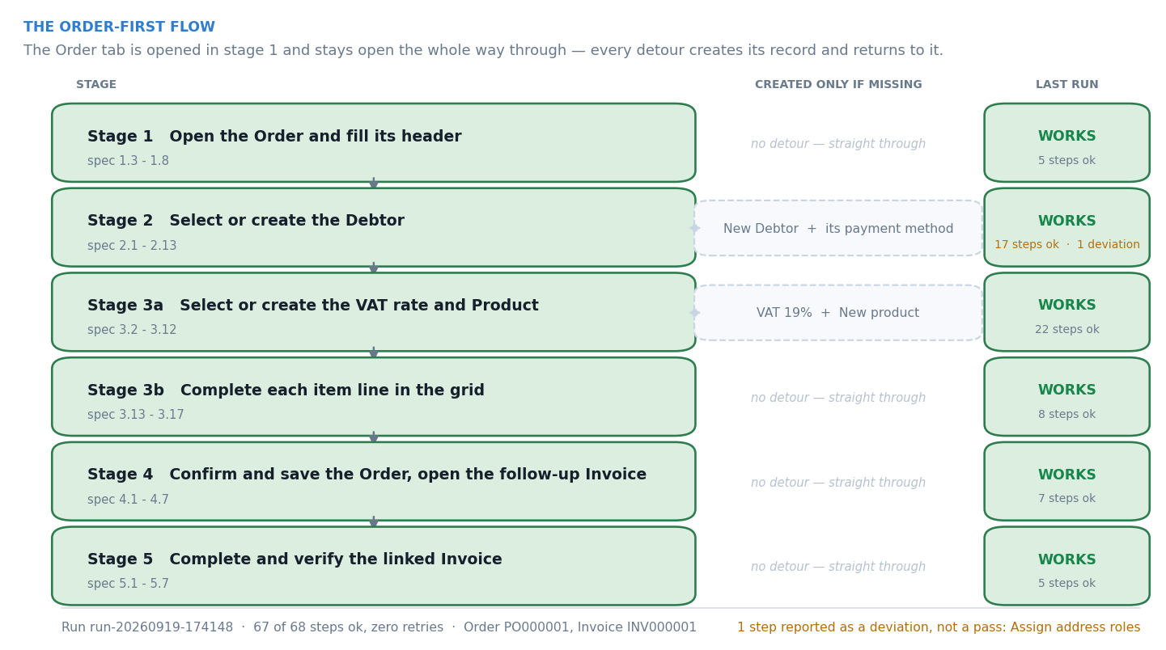
The stages and their detours.

context.py — the shared toolbox
Ctx holds the document, the application, the resolver and the artifacts, and exposes the small vocabulary a stage is allowed to use: el, maybe, click, type_into, select, expect, expect_contains, stop_for_review, activate_order, open_editor, save. Keeping the verbs here rather than letting stages talk to the resolver directly is what makes every interaction logged, screenshotted and — where it writes — read back.

`step` versus `retried_step`
step runs a body once. retried_step runs it until it works. The distinction is a safety property, not a convenience: a body may only be replayed if running it twice is indistinguishable from running it once. Setting a field, choosing from a dropdown, opening a dialog that is checked for first, reading a value back — all replayable. Anything that creates a record or presses Save uses step and gets exactly one attempt.

`precondition`
For the harder case: a body whose goal may already have been reached by the attempt that failed. The Product picker appends an item line rather than setting one, so an attempt that selected the product and then failed on the way out had already done its job; replaying it put the same product on the Order twice. The check runs before every retry, never before the first attempt, and a true answer finishes the step.

`_activate` — and why it proves rather than assumes
Every master-data detour opens an editor on top of the Order, and the spec is explicit that the Order tab stays open and is returned to. _activate clicks the tab and then resolves something inside the editor as proof it arrived. Because the resolver refuses parked controls, a tab click that the platform swallowed shows up here immediately, instead of as a silent write into an invisible editor.

formats.py — speaking the application's language
Fakturama renders dates and decimals according to the JVM locale, which is not knowable ahead of time. Rather than assume, the field is read before it is written and its existing content is used to pick the format. That is why order.date_field is read first.

dialogs.py — the two pickers, and the matching rules
Type the query, wait for the list to stop changing, read the rows, decide. The deciding is where the care is.

Three matching rules, each added because of a real failure
- A cell may be clipped by its column. A list column that is too narrow renders Northstar Office G…. A clipped cell is allowed to match a prefix of the expected value, but only when it is actually shorter — never as a blanket prefix rule.
- `Berlin` must not match `Berlin-Mitte`. The blanket prefix rule that would have allowed it is the reason the previous point is worded so carefully, and there is a test named after it.
- OCR confusables are folded. 0/O, 1/l/I, 5/S are folded before comparing a canvas-read cell — and a test proves the fold does not merge two distinct SKUs.

order_header.py — Stage 1
Opens the New Order, reads the proposed number and hands it to Ctx.remember (this is where {order_number} comes from), sets the Date and the Cust.Ref., sets the price mode to Net and leaves VAT as With VAT. The proposed No. is read and never written.

debtor.py — Stage 2, the most involved one
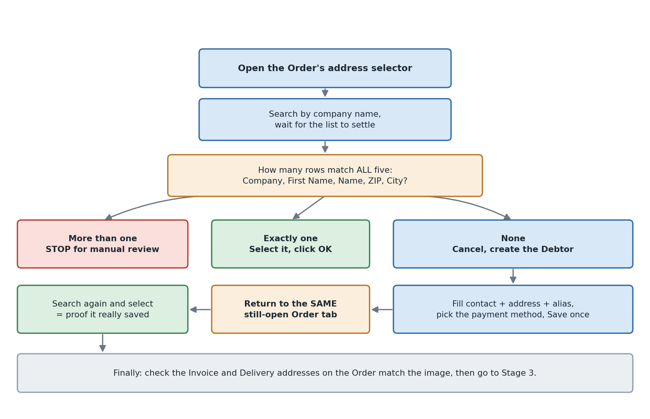
Select, or create and then select.
The selector is the existence check. An exact match needs Company, First Name, Name, ZIP and City to agree. One exact row is selected; conflicting rows stop the run; no row goes to the creation branch — which ends by going back to the same picker and selecting the new Debtor there, because that is both what the spec says and the only proof the record was really saved.

prerequisites.py — Stage 0, and an honest deviation
The spec creates missing master data while the document editor is open. This build's dropdowns are filled once, when the editor opens, and a record created afterwards is simply not offered — verified directly: after creating Bank Transfer, the Debtor's Payment dropdown still listed only the pre-existing entry, and a Product created after VAT 19% existed still saved against Tax-free.
So the same checks, with the same matching and the same manual-review gates, run first. Nothing is created that the spec would not have created; only the moment differs, and the run report records that a prerequisite was made here rather than mid-flow.

payment.py and vat.py — creating supporting records
Both follow the same shape: search the exact name, reuse one unambiguous exact row, stop for review on a conflict, create on absence. payment.py applies the spec 2.10.4 mapping (Bank Transfer → Credit transfer); vat.py only reuses a row when the name, the value and the e-invoice code S (Standard rate) all agree.

product.py and items.py — Stage 3
product.py runs the selection branch per item in source order, creates the Product with the spec 3.9 gross price when the SKU is absent, and returns to the Order to select it. items.py then completes the line: quantity, unit price, VAT, discount, and a check that the line price equals qty × unit × (1 − disc/100).

finalize_order.py and invoice.py — Stages 4 and 5
Stage 4 confirms the totals against the image, saves once, verifies the row in Data › Documents, and opens the Invoice from the Order's follow-up area — never from the top toolbar, because only the follow-up action preserves the Order relationship. That step begins by bringing the Order back to the front, since verifying in Data › Documents leaves the Documents list covering the editor.
Stage 5 confirms the Invoice was populated from the Order, sets the payment method, and — only when the extracted status is PAID — marks it paid with the extracted date and the full total. If the status is not PAID it leaves the flag clear and invents nothing.

orchestrator.py — the conductor
Launches or attaches, builds the Ctx, runs the six stage functions in order, and guarantees that a report is written whatever happens — ManualReviewRequired becomes status manual-review, any other exception becomes failed, and both still get the closing screenshot, the flow state and the tier statistics.

8. Checking the work — src/f2c/verify/
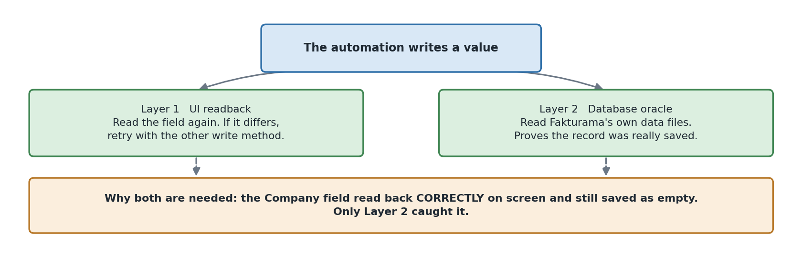
Two oracles that can disagree with each other.

ui_readback.py — reading the screen back
Used inside the flow, where each stage verifies its own post-condition, and available standalone through f2c verify, which re-opens Data › Documents and confirms a completed run without repeating it.

db.py — reading Fakturama's own data files
Fakturama 2.2.0 ships HSQLDB 2.7.4, not H2. HSQLDB keeps MEMORY tables as plain-text SQL in Database.script and everything committed since the last checkpoint as plain-text SQL in Database.log. So the oracle is a parser, not a driver: no JDBC jar, no JPype, no exclusive-lock problem, and rows that have not yet been checkpointed are still visible.
This is the layer that proved the NULL company bug. The screen read back correctly and the save reported success; the stored row had NULL. Only an independent oracle could have caught it.

9. Supporting files

scripts/
- snapshot_workspace.py / reset_workspace.py — make runs repeatable. Only Database/ and Templates/ are copied, so the workspace may be a drive root, and the current workspace is always moved aside rather than deleted.
- record_screen.py — records the demo to mp4 using mss and OpenCV, both of which are already dependencies. The encoder runs on its own thread with a bounded queue, so a slow encode drops frames rather than stretching the wall-clock time of what is being recorded.
- docx_style.py, build_design_report.py, build_code_walkthrough.py, build_screenshot_guide.py — the Word deliverables are generated from the repository and from a run report, so the prose cannot claim something the code no longer does.

tests/ — 155 tests, no Fakturama required
FILE | WHAT IT PROTECTS
test_extraction.py | Normalisation and reconciliation, including deliberately corrupted totals.
test_matching.py | Exact-match and VAT-reuse decisions; clipped columns; OCR confusables.
test_geometry.py | Anchor-relative resolution and grid addressing, with no live application.
test_formats.py | Locale-tolerant date and decimal formatting.
test_selectors.py | Registry integrity: every name used exists, every scope resolves, pixels are never first.
test_retry.py | The replay harness: attempt counts, preconditions, and that a non-replayable step is never repeated.
test_no_hardcoded_coords.py | Parses the AST of every module to prove no pointer call receives a numeric literal.

10. One complete run, traced through the code
WHERE | WHAT HAPPENS
cli.run / gui.App._work_ui | reads .env, extracts, calls run_flow
extract.pipeline.extract_order | OCR → Groq tool call → OrderDoc → reconcile
flow.orchestrator.run_flow | launches Fakturama, builds Ctx, runs the stages
flow.prerequisites | creates Bank Transfer and VAT 19% before any editor opens
flow.order_header | New Order; reads PO000001; Date, Cust.Ref., Net, With VAT
flow.debtor | picker → absent → New Debtor → save → back to the picker → selected
flow.product × 2 | picker → absent → New product (gross 297.50 / 47.60) → save → selected
flow.items × 2 | qty, unit price, VAT, discount; line price verified
flow.finalize_order | totals confirmed, saved once, verified in Data › Documents
flow.invoice | follow-up Invoice, payment method, paid + date + value, saved, verified
artifacts.RunArtifacts.finish | report.md, report.json, screenshots, tier statistics

What the run produced
status ok
steps 68, of which 67 ok
grounding tiers uia 237, anchor 53
order / invoice PO000001 / INV000001

11. The bugs that shaped the code
The first one shaped the entire write path. Every value the automation types goes through the loop below, and a write is not considered finished until it has been read back.
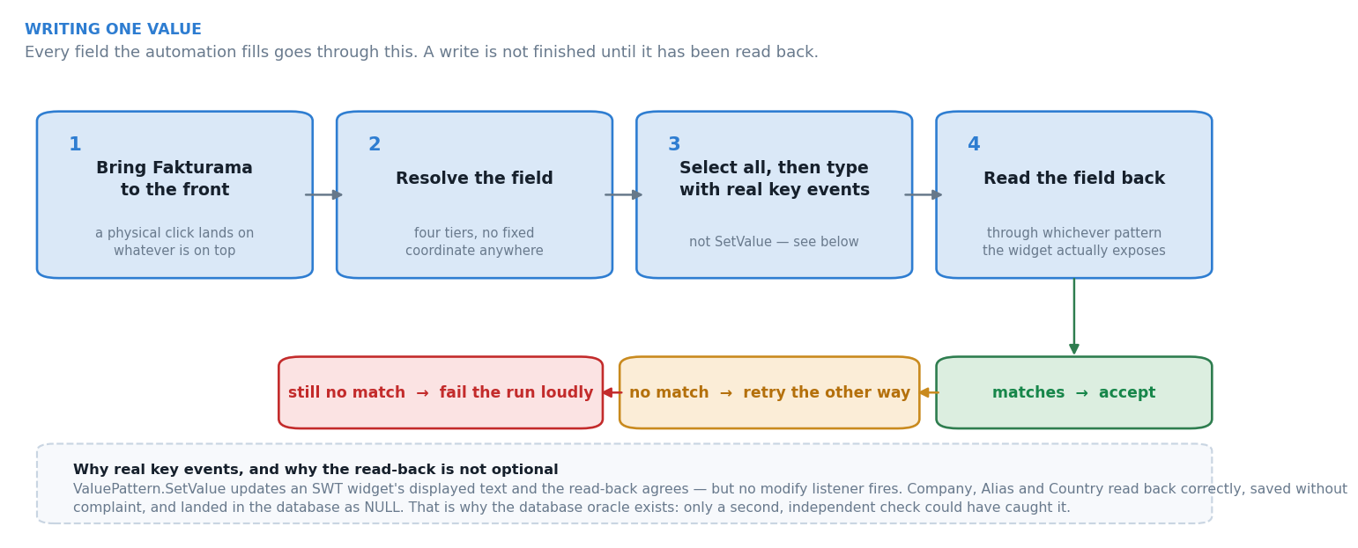
Writing one value: bring the application forward, resolve, type with real keys, read back.
Each of these was found against the live application, and each is commented at its fix site.
SYMPTOM | CAUSE | WHAT CHANGED
Company, Alias and Country read back correctly, saved without complaint, and stored as NULL. | ValuePattern.SetValue updates an SWT widget's text without firing its modify listener. | Writes are real key events by default; the database oracle exists to catch the class.
Company saved as "Northstar Office GmbH\t". | A commit {Tab} is inserted as content by multi-line fields. | The generic commit key was removed — real keystrokes already fire the listener.
Jul 14, 2026 typed into the date field became Sep 20, 0026. | The date control is segmented and re-parses on every keystroke. | A continuous digit run is typed from the first segment, in the widget's own order.
Clicks on the selector icons did nothing at all. | SWT image buttons swallow a press that arrives in the same instant as the cursor. | The click moves, settles, then presses; dialog opening retries.
The automation drove File Explorer. | A window-title match — the Explorer tab was titled fakturama-image-to-cash. | Identification is by process plus shell class.
Every control reported an empty rectangle. | A minimized window. | normalise_window restores before grounding.
Writes went into an editor that was not on screen, silently. | Eclipse parks a background editor's widgets off-screen; they keep answering UIA. | PARKED_COORDINATE; the resolver refuses parked controls; _activate proves arrival.
A run timed out after 20.0s (1 polls) on a dialog that was merely slow. | A full-length scope resolution inside the caller's own polling loop. | Scope resolution fails fast so the outer loop can poll.
The same product appeared on the Order twice. | The picker appends a line; a retry after a late failure appended a second one. | precondition on the replay harness.
Step 4.6 could not find the follow-up area. | 4.5 verifies in Data › Documents, which leaves that list in front of the editor — and the saved editor has been renamed from New Order to its document number. | 4.6 activates the Order first; order_editor carries the {order_number} strategy.

