FAKTURAMA IMAGE-TO-CASH AUTOMATION
Design and Implementation Report
One order image → a saved, verified Order and its linked Invoice, driven through Fakturama's own user interface.

1 Summary
2 The desktop front end
3 Image extraction: OCR first, then the LLM
4 Control discovery and grounding
5 The Order-first flow
6 Verification
7 Trade-offs
8 What is not done
9 Running the system
10 If I had three more hours

1. Summary
The system takes a single order image and ends with a saved Order and a linked, paid Invoice inside Fakturama 2.2.0, having created whatever master data was missing on the way. Nothing is written to the database directly and nothing is imported: every record exists because the automation drove the same controls a person would.
Two halves, joined by one typed object. Extraction turns pixels into an OrderDoc and refuses to hand it on unless its own arithmetic reconciles. Automation takes that OrderDoc and performs the five-stage procedure, verifying each step before the next.

Where it got to
SPEC STAGE | WHAT IT COVERS | RESULT
1 (1.1–1.8) | Extract the image, open New Order, fill the header | Works
2 (2.1–2.13) | Select or create the Debtor, incl. the payment method | Works
3 (3.1–3.17) | VAT, Product create/select, every item line | Works
4 (4.1–4.7) | Confirm, save and verify the Order; follow-up Invoice | Works
5 (5.1–5.7) | Linked Invoice, paid status, final verification | Works

The run this document was built from is run-20260919-174148: 67 of 68 steps completed, final status ok.
The procedure is followed literally. The Order tab is opened first and never closed; the Debtor and Product selectors are the existence checks, not a database query; master data is created only when an exact selection is unavailable; and the Invoice is created from the saved Order's follow-up area, never from the top toolbar, because only the follow-up action preserves the Order relationship.

Records the automation created
Read back out of Fakturama's own stored data rather than off the screen, so this is what was persisted, not what a widget happened to be displaying:
CONTACT Northstar Office GmbH · Marta Klein · alias NORTHSTAR-BERLIN
PAYMENT 'Bank Transfer' code = Credit transfer (spec 2.10.4)
VAT 'VAT 19%' value = 19% code = S (Standard rate)
PRODUCT 'CHR-ERG-01'
PRODUCT 'MAT-DESK-02'
ORDER PO000001 Cust.Ref. WEB-2026-0714-A17 net 570.00 / gross 678.30
INVOICE INV000001 linked to the Order, paid on 2026-07-18

The Product master prices are the spec 3.9 calculation performed by the automation: 250.00 × (1 + 19/100) = 297.50 and 40.00 × (1 + 19/100) = 47.60, with the 10% transaction-line discount correctly not applied to the master price.

Extraction accuracy, and the one thing it gets wrong
Every transaction value on the sample document was read correctly: both SKUs, both descriptions, both quantities — including the two single digits that the first OCR configuration silently dropped — every price, both discounts, the VAT rate, all three totals, the order date, the external reference, the payment method and the payment date. The reconciliation is exact, not within tolerance.
One field is wrong, and it is worth dwelling on because it is the honest shape of this design. The OCR reads the e-mail address as martaklein@example.test: the dot between the given and family name is a few pixels and falls below the detector's threshold. The model is instructed never to invent or repair a value — transcribe, never compute — so it faithfully returns what it was given, and the Debtor is created with the shortened address.
That is the trade working as designed, not a bug in the prompt. The same instruction that lets the model quietly fix an e-mail would let it quietly fix a total, and the reconciliation gate exists precisely because a model that repairs the document destroys the only check there is. The fix belongs in the OCR stage: a confidence-weighted second pass over the regions that scored low, handed to the model as "these characters are uncertain", which improves what is transcribed without licensing invention.
The front end's what the model corrected panel is where a repair of this kind would appear. On this run it reports that every extracted value appears in the OCR reading character for character — which is exactly how a reviewer can tell that the model added nothing, for better and for worse.

2. The desktop front end
The automation is usable from the command line, but the thing a reviewer actually wants to see is what the machine read before it starts typing into an accounting system. The desktop window makes the pipeline's three stages inspectable in the order they run.
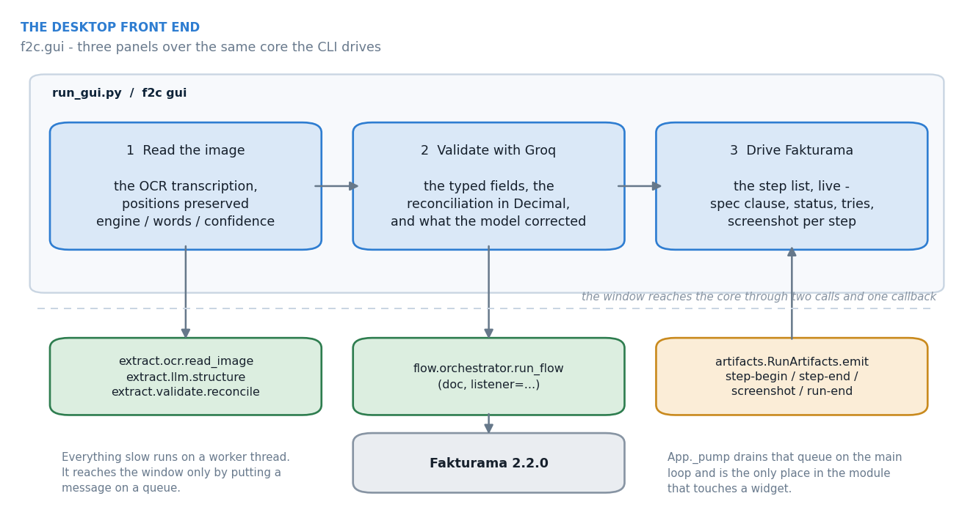
Figure 1. The window, and the two calls and one callback it reaches the core through.
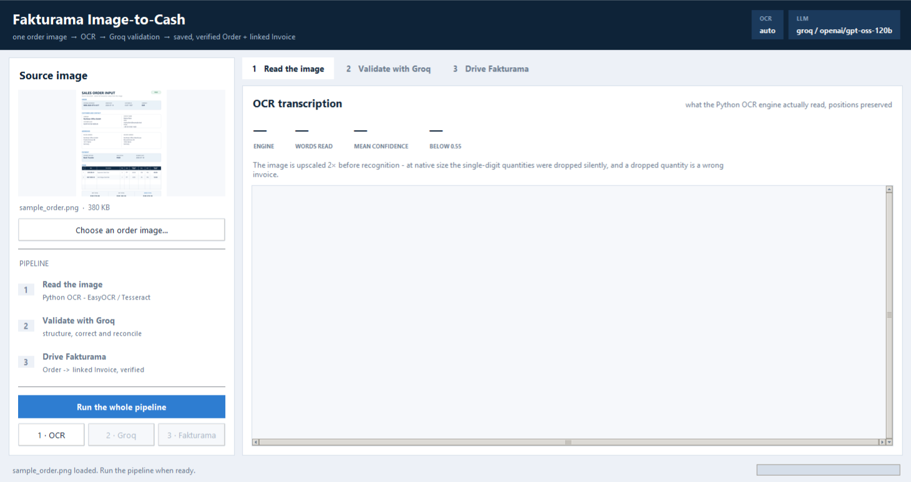
The window with the sample order loaded, before anything has run.
PANEL | WHAT IT SHOWS | WHY IT IS ON SCREEN
1 · Read the image | The OCR transcription with horizontal positions preserved, plus the engine, the word count and the mean confidence. | This is the ground truth the model is given. If a value is wrong later, this panel says whether the pixels or the model were at fault.
2 · Validate with Groq | The structured fields, the reconciliation recomputed in Decimal, and the list of values the model had to correct because they are not in the OCR reading character for character. | The corrections list is the honest version of 'validated'. A reviewer can see the model's contribution instead of trusting it.
3 · Drive Fakturama | The step list filling in live, each row carrying its clause from the written procedure, its status, its retry count and its screenshot. | The run is auditable while it happens, and each row can be checked against the spec.

Tkinter is not thread safe, and a background thread touching a widget takes the interpreter down rather than raising. Everything slow therefore runs on a worker thread that talks to the window only by putting messages on a queue; f2c.gui.app._pump drains it on the main loop and is the only place in the module that touches a widget. The flow reports itself through RunArtifacts.emit, a listener hook that the rest of the package neither knows nor cares about.

3. Image extraction: OCR first, then the LLM
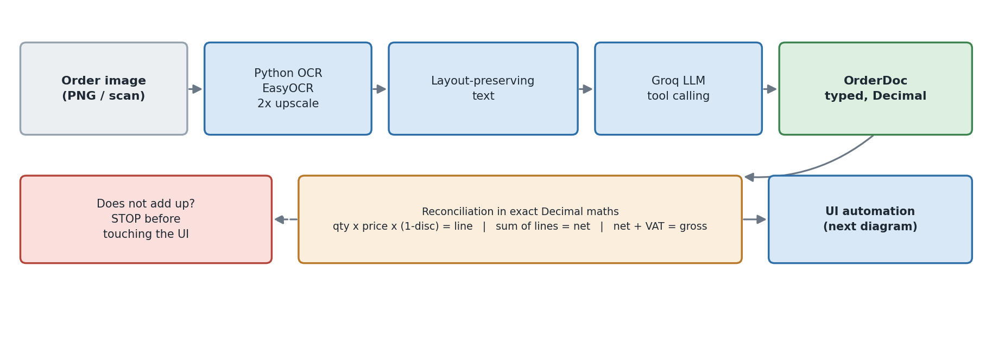
Figure 2. Image to a reconciled OrderDoc.

Why OCR first rather than a vision model
The Groq account in use serves no vision model, so OCR was the available route — but it is the better engineering regardless. Transcription becomes a reproducible, inspectable artifact that is saved next to the extraction, so a disputed field can be traced to what was actually read; and the model never sees pixels it could hallucinate over, only text it can be caught misreading. The vision path is still implemented (llm.structure_from_image, F2C_EXTRACTION_MODE=vision) for a provider that offers one.

Three decisions that carry the accuracy

Upscale before recognising
At native resolution EasyOCR silently dropped both single-digit quantities — the 2 and the 3. At 2× with lowered detection thresholds it reads them at confidence 1.00. A dropped quantity is a wrong invoice, so this is a correctness fix, not a tuning nicety.

Keep the coordinates
A flat OCR string destroys the item table: the discount, the VAT and the line total become an ambiguous run of numbers. ocr.group_lines clusters words into visual lines and ocr.render_layout re-renders them at their scaled horizontal positions, so a value under the Disc. heading still sits under the Disc. heading. Reading the table becomes a reading question rather than a guessing one.
the item table as the model receives it — note the misread headings, which do not matter because the columns still line up
SKU Description Qty Unit UribRet Disc: VAT LigoRet
1 CHR-ERG-01 Ergonomic Desk Chair 2 pcs 250.00 10% 19% 450.00
2 MAT-DESK-02 Anti-Fatigue Desk Mat 3 pCs 40.00 0% 19% 120.00

Tool calling, and strings for every number
The model is called with a tool schema rather than being asked for free-form JSON, so the response shape is enforced by the API instead of by a parser. Every numeric field is typed string: the model transcribes digits and f2c parses them into Decimal itself, because a JSON float destroys cents.

The arithmetic gate
extract/validate.py recomputes the document before any window is opened, and raises rather than proceed. Per line qty × unit_net × (1 − disc/100); the sum of lines against the stated net total; VAT per line, summed; net + VAT against gross; and the paid-status/payment-date consistency rule the spec depends on in 5.3.
Writing an order whose own arithmetic disagrees is worse than writing no order at all. The gate is the reason the automation is allowed to be confident once it starts typing.

4. Control discovery and grounding

What the application actually is
Fakturama 2.2.0 is an Eclipse/SWT application. Recon against the live accessibility tree, not assumption, established the constraints the whole grounding strategy answers to:
- Every composite is a SWT_Window0 with no useful AutomationId.
- Toolbar buttons do carry real names (Create: New Order, Save the current contents), and a few Edits do too (Cust.Ref., Discount, Total).
- The left navigation is not a tree — it is a pane of plain Text controls.
- The record selectors beside Addresses and Items are unnamed Image controls stacked vertically; the spec's 'upper icon, not the lower green +' has to be expressed geometrically.
- Every list is a custom-drawn canvas — the item grid and the address, product and document lists. UIA reports their position and nothing else.
- SWT dialogs are child shells of the main window, not desktop siblings.
- One caption can front two fields (First Name Last Name, ZIP - City).
- A saved document editor is renamed: New Order becomes its document number, so every selector that identifies it by name stops matching at the moment the Order starts to exist.

A four-tier resolver
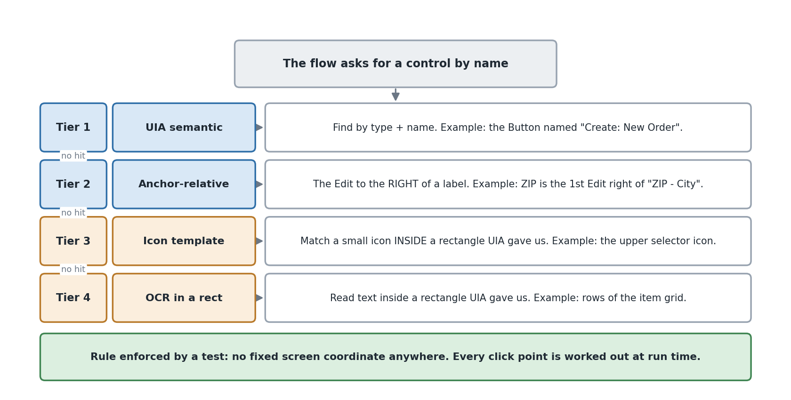
Figure 3. The four grounding tiers, tried in order per control.
Each logical control is declared in src/f2c/ui/selectors.yaml as an ordered list of strategies. The resolver tries them in turn and records which one won, so the run report shows how much of the flow the accessibility tree actually carried.
TIER | HOW IT FINDS THE CONTROL | DECLARED
uia | ControlType + Name, scoped to an ancestor. Semantic and stable. | 153
anchor | Geometric: the Edit to the right of, or below, a given label. Carries most of the forms, because SWT Text widgets have no AutomationId. | 69
template | An icon image matched inside a UIA-resolved rectangle. | 7
ocr | Text found inside a UIA-resolved rectangle. The only tier that reaches a custom-drawn canvas. | 5

115 logical controls, 235 strategies in total. The pixel tiers are never a control's first strategy — tests/test_selectors.py enforces that — so a UI that exposes itself properly is always driven semantically.
No absolute coordinate exists anywhere in the package. Every click point is derived at run time from a resolved rectangle, and tests/test_no_hardcoded_coords.py parses the AST of every module to prove that no pointer call receives a numeric literal.
Tier usage in run run-20260919-174148: uia 237, anchor 53.
The accessibility tree carries almost the whole flow; pixels are the exception rather than the rule, which is the outcome the tier ordering is designed to produce.

Handling the two stacked icons
Spec 2.1 and 3.2 both say the same thing: click the upper selector icon, never the lower green +, which starts a new record. Both are unnamed Image controls in the same unnamed composite. The rule is expressed as pick: topmost within the smallest enclosing composite that contains the section's label, and a guard refuses to click if the resolved selector is not actually above the resolved creation control — so a layout change makes the run stop rather than silently create a duplicate Debtor.

5. The Order-first flow
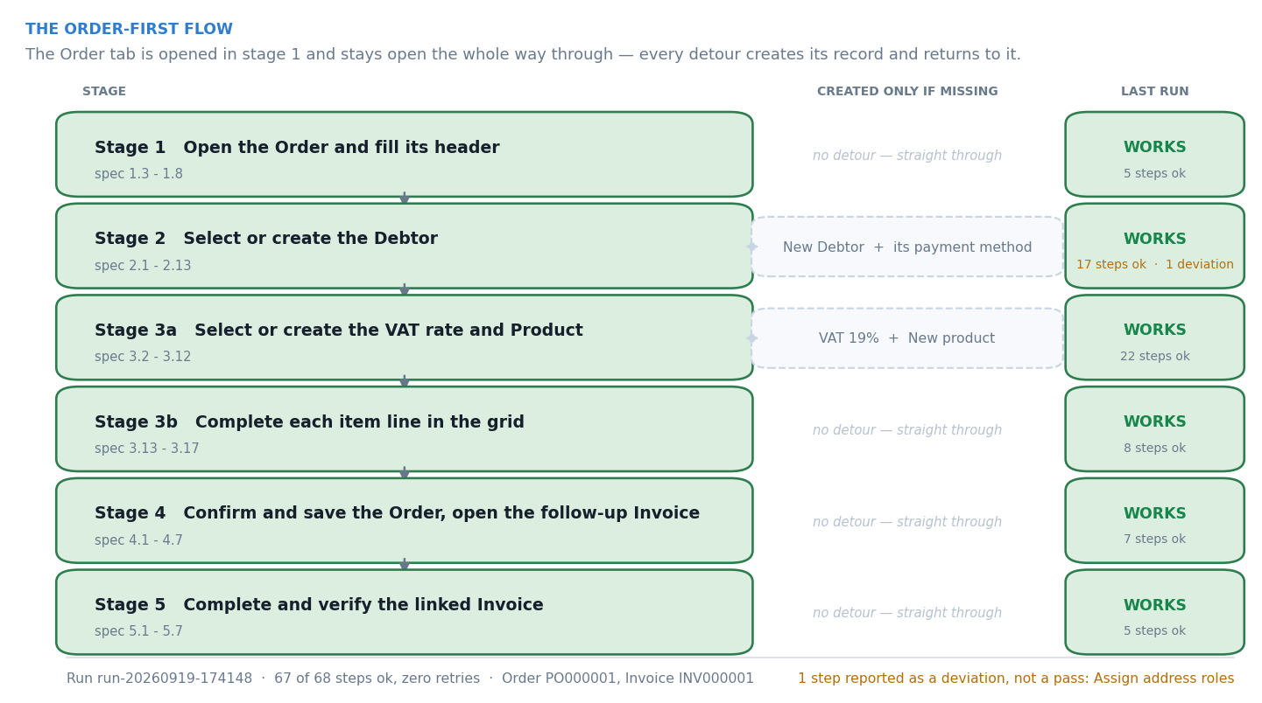
Figure 4. The five stages, and the detours each may take.
One continuous flow. The Order editor is opened in stage 1 and stays open: every master-data detour opens its own editor on top of it and returns by clicking the Order's tab, never by re-opening it.

Stage 2 in detail — the pattern the whole system follows
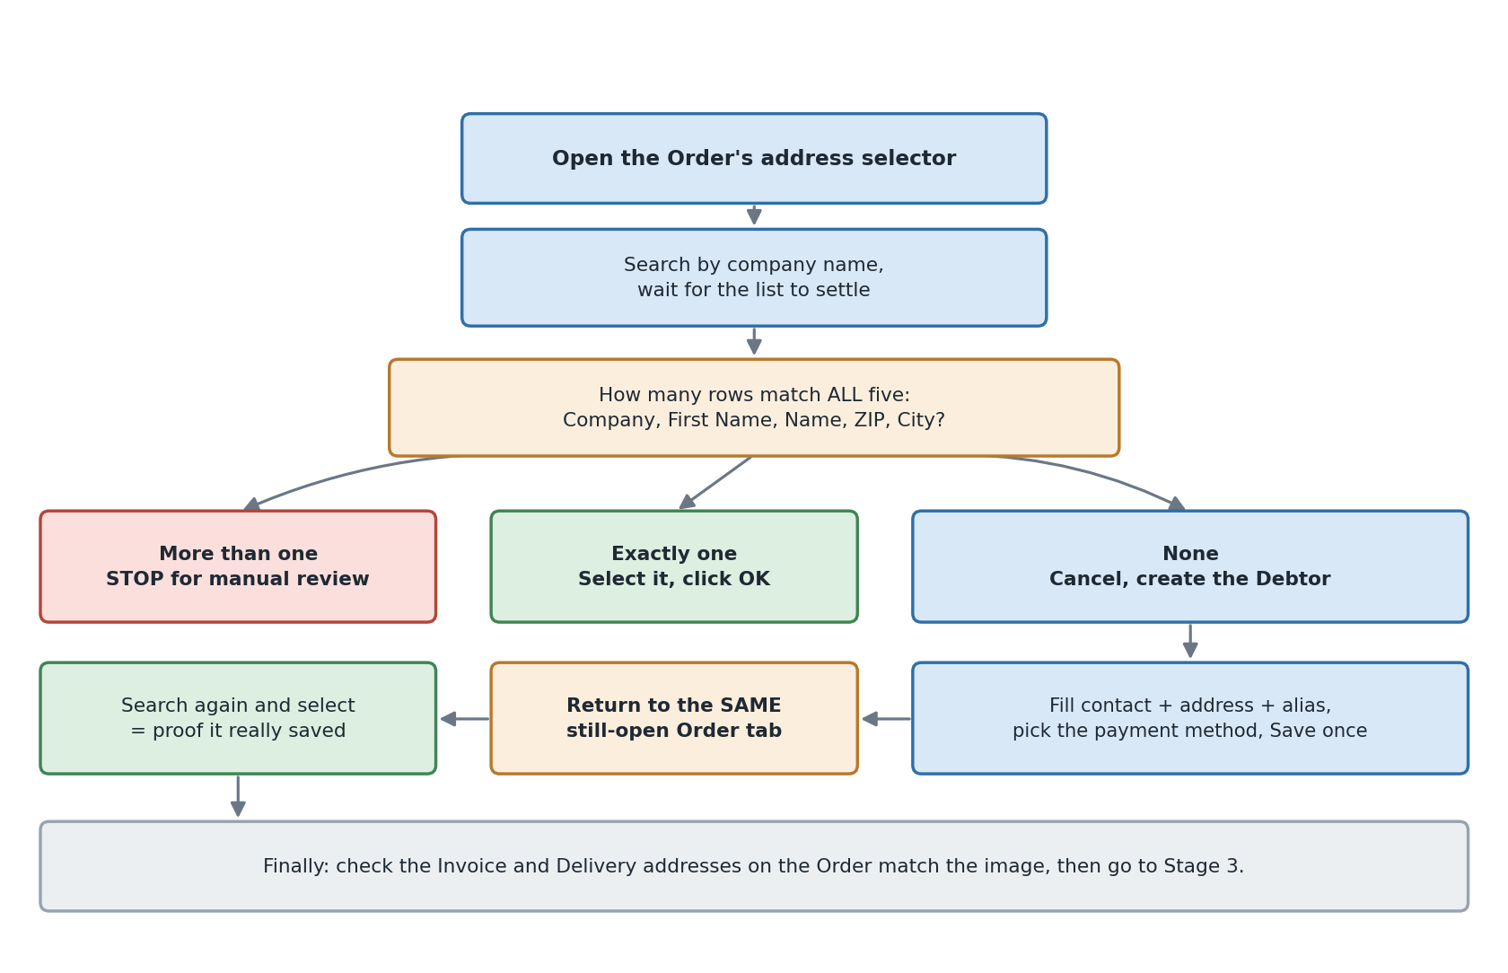
Figure 5. Debtor: select, or create and then select.
The selector is the existence check. The flow searches the address picker for the extracted company; a row counts as an exact match only when Company, First Name, Name, ZIP and City all agree. One exact row is selected; conflicting rows stop the run for manual review; no row sends it down the creation branch. And after creating the Debtor it goes back to the same picker and selects it there — which is both what the spec says and the only proof that the record really was saved.

Where it stops for a human
The flow raises ManualReviewRequired — with a screenshot, a UIA tree dump and the expectation that failed — rather than guessing, for:
- ambiguous or conflicting Debtor rows in the address picker;
- multiple or conflicting payment methods with the same name;
- a VAT row whose name, value or e-invoice code disagrees with the required definition;
- a Product that does not reappear in the selector after being saved;
- an Invoice payment method that is not available;
- any totals mismatch between the Order footer and the source image.

What makes a long run survivable
Nearly every failure seen against the live application has the same shape: a control needs the foreground, keyboard focus and a settled layout, and if any of the three is not true at the instant a keystroke lands, the operation does nothing and says nothing. Chasing them one at a time was the wrong approach.
flow.context.StepAttempts recovers the whole class. Between attempts it re-asserts the foreground, throws away cached container elements and runs the step's own recovery — usually 'bring the document editor back to the front'. It is deliberately opt-in per step: a body may only be replayed if running it twice is indistinguishable from running it once. Anything that creates a record or presses Save uses the plain, single-attempt Ctx.step, because a repeat would mean a second saved record — the one failure this automation must never produce.
precondition covers the harder case in between. The Product picker appends an item line rather than setting one, so an attempt that selected the product and then failed on the way out had already done its job; repeating it put the same product on the Order twice. The precondition runs before every retry and a true answer finishes the step instead of replaying it.

6. Verification
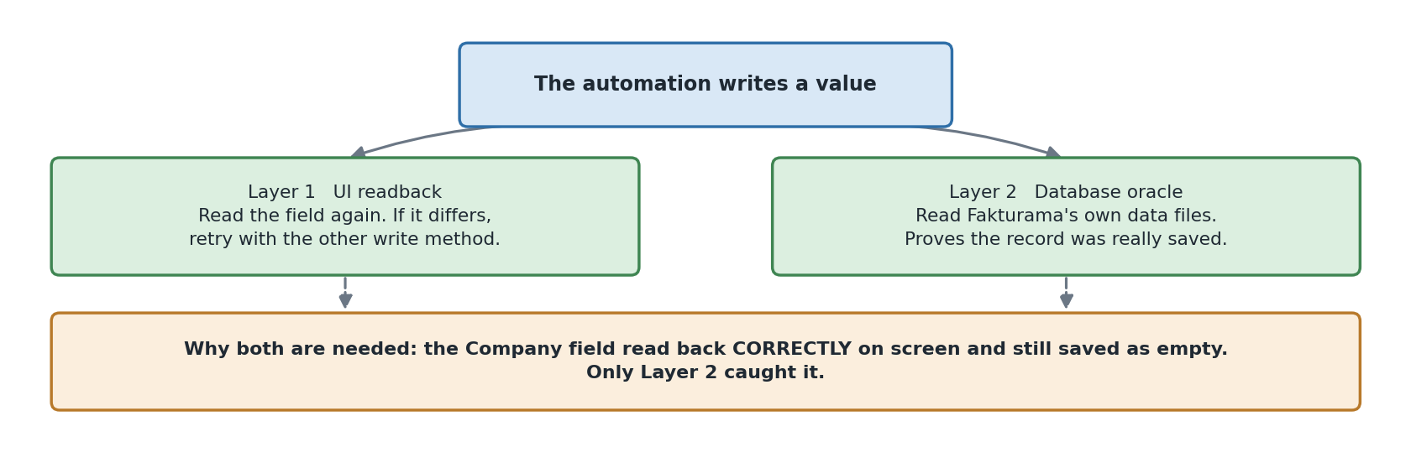
Figure 6. Two independent layers.

Layer 1 — read the screen back
Every write is read back, and a value that did not take is retried through the other write path before it is accepted. Every stage verifies its own post-condition: the Debtor's addresses populate the Order, the item line's computed price matches qty × unit × (1 − disc/100), the Order footer matches the image's three totals, the Documents list gains exactly one row with the expected Cust.Ref.

Layer 2 — read the stored data
Fakturama 2.2.0 ships HSQLDB, not H2, and HSQLDB keeps its data as plain-text SQL (Database.script plus the uncheckpointed Database.log). So verify/db.py is a parser, not a JDBC client: no driver, no jar, no file-lock problem, and rows committed since the last checkpoint are still visible.
This layer earned its place. ValuePattern.SetValue updates an SWT widget's displayed text — and the read-back agrees — without firing the modify listener, so Company, Alias and Country read back correctly, saved without complaint, and landed in the database as NULL. Only a second, independent oracle could catch that. Writes are now real key events by default.

7. Trade-offs
DECISION | BOUGHT | PAID FOR WITH
OCR + text LLM rather than a vision model | A reproducible, inspectable transcription; traceability from a disputed field to the pixels. | Two failure points instead of one; layout reconstruction has to be good enough to keep the table readable.
Declarative selectors in YAML | Re-grounding for a new Fakturama version is a data change, not a code change; the tier that won is measurable. | A layer of indirection between the flow and the widget.
UIA first, pixels last | Resilience to theme, DPI and window size; 237 of the resolutions in the recorded run were semantic. | Custom-drawn canvases still need OCR, and that is where the remaining fragility lives.
Retry only where a replay is safe | Long runs survive the transient focus failures that dominate real-world UI automation. | Every step had to be classified by hand as replayable or not.
Stop for manual review rather than guess | The automation never invents an accounting record. | A run can end without a document and need a human.
Drive the UI rather than the database | Fakturama's own validation, numbering and document linking all apply. | Slow — a full run is minutes, not seconds.

8. What is not done
- The OCR drops the dot in the e-mail address, and the model is correctly forbidden from inventing it back, so the Debtor is created with martaklein@example.test. The fix is a confidence-weighted second OCR pass, not a looser prompt.
- A differing delivery address is not created as a second address. The sample's delivery address differs from billing; only the Main address is created and given the Invoice role. The flow records this as a deviation rather than silently proceeding.
- Address roles are set through this version's address-type control; when it cannot be driven, the Main address keeps Fakturama's defaults and the step is reported as skipped, not ok.
- Alias and Country occasionally need a second write. The read-back catches it and retries through the other write path, but the underlying widget event has not been found.
- The Product selector's SKU column cannot be reconstructed from its canvas. A documented, narrow fallback accepts the single row returned by an exact-SKU search when its name also matches the extracted description, and records in the report that it did so.
- Icon templates are not committed — capture them per machine with f2c capture-icon. Every template selector has a UIA fallback, so their absence degrades rather than breaks a run.
- One document. The extraction has been proven against one order image; how much of the accuracy is general and how much is this document is not yet known.

9. Running the system

Setup
python -m venv .venv && .venv\Scripts\activate
pip install -r requirements.txt
pip install -e . # optional: gives the `f2c` command
copy .env.example .env # then edit it

.env
F2C_PROVIDER=groq
GROQ_API_KEY=gsk_...
F2C_MODEL=openai/gpt-oss-120b
F2C_FAKTURAMA_EXE=D:\Fakturama2\Fakturama.exe
F2C_WORKSPACE=D:/ # the folder holding Database/ and Templates/

The workspace is the folder Fakturama's own title bar names (Fakturama - D:\), not the install directory. f2c doctor checks all of it — dependencies, the executable, the workspace, the selector registry and the icon templates — before a run is attempted.

Running it
python run_gui.py # the desktop front end
f2c gui # the same window, if pip install -e . was run

f2c extract --image fixtures/sample_order.png # OCR + LLM only, no UI
f2c run --image fixtures/sample_order.png --verify-db
f2c verify --image fixtures/sample_order.png --database
f2c inspect --dump out/tree.txt # calibration aid
f2c resolve order.custref_field # resolve one control, report the tier

Repeatable runs
The flow creates master data, so a second run against the same workspace takes the 'already exists' branch and stops exercising the creation paths. Snapshot once, restore before each run:
python scripts/snapshot_workspace.py --allow-running
python scripts/reset_workspace.py

Only Database/ and Templates/ are copied, so the workspace is allowed to be a drive root; the current workspace is always moved aside rather than deleted.

What each run leaves behind
out/run-<timestamp>/ — the evidence folder, which is also the screenshots deliverable:
- report.md and report.json — every step with its spec clause, status, retry count, duration and screenshot, plus the grounding tier usage and the final flow state;
- screenshots/ — numbered in execution order;
- a UIA tree dump and a full traceback for any failure.

Tests
python -m pytest -q # 155 passed

Pure logic, no UI required: extraction normalisation and reconciliation (including deliberately corrupted totals), the exact-match and VAT-reuse decision rules, clipped-column and OCR-confusable matching, anchor-relative geometry, grid addressing, locale-tolerant formatting, the selector registry's integrity, and the no-hardcoded-coordinates rule.
Two of them exist because they caught real mistakes while writing this: a blanket prefix rule that would have matched Berlin against Berlin-Mitte, and an OCR fold that had to be proven not to merge two distinct SKUs.

10. If I had three more hours
A second and third order image. The flow is complete; what is not yet known is how much of the extraction accuracy is genuine and how much is this one document. A different layout, a gross-priced document and a multi-VAT document would tell me more than any further work on the happy path.
Resume from a failed step. The run already records enough state to know what it created; FlowState was written with this in mind. A run that fails at stage 4 should be restartable without re-creating the Debtor and the Products.
The remaining grid dependency on OCR. The item lines are written and verified, but the canvas is still read with OCR. Driving it purely from the keyboard and verifying through the Order's named total Edit controls would remove pixels from the write path entirely.
The Alias and Country persistence bug, properly. The read-back catches it and the retry fixes it, which is a workaround. Finding the event those two widgets actually listen for would be a fix.
Create the differing delivery address. It is the one part of the written procedure that is reported as a deviation rather than performed.

