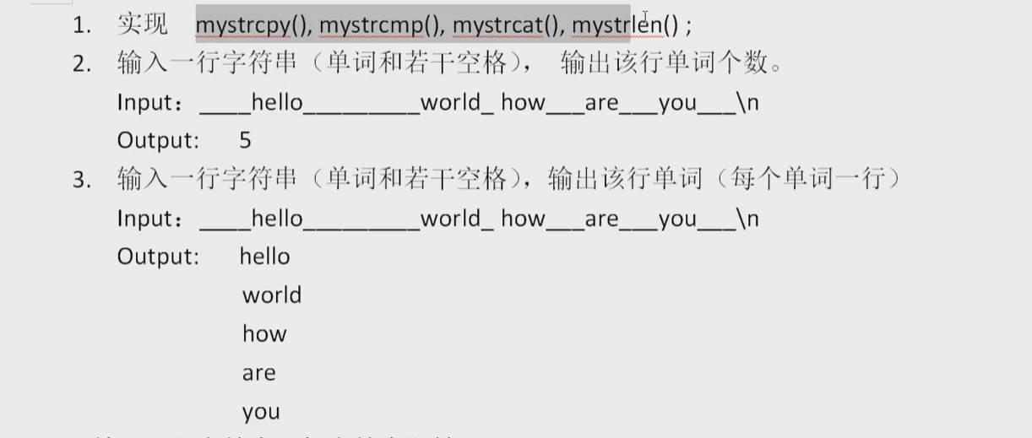

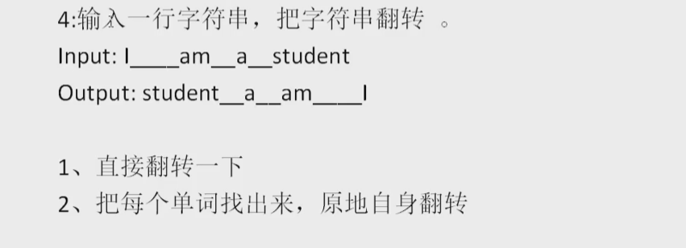

1.

//strcpy()会把尾巴的\0随之拷贝

void mystrcpy(char *dest,char *sour) {

int i = 0;

while (*(sour + i)) {

//printf("%c\n", *(sour+i));

dest[i] = sour[i];

i++;

}

dest[i] = '\0';

}

//简化一下，小于返回-1，等于0，大于1

int mystrcmp(const char *arr1,const char *arr2) {

int i = 0;

while (arr1[i] || arr2[i]) {

if (arr1[i] < arr2[i]) {

return -1;

}

else if(arr1[i]>arr2[i]) {

return 1;

}

i++;

}

return 0;

}

void mystrcat(char *des,const char *src) {

char* ptr;

ptr = des;

while (*ptr) {

ptr++;

}

while (*src) {

*ptr++ = *src++;

}

*ptr = '\0';

}

int mystrlen(const char* str) {

int length = 0;

while (*str) {

length++;

str++;

}

return length;

}

2.

//处理思想，记录当前字符为单词但下一个是空格的位置，count++，并特殊处理末尾有可能的空格

void word_count(const char* str) {

int count = 0;

while (*str !='\n') {

if (*str != ' ' && *(str+1) == ' ') {

count++;

}

str++;

}

if (*--str != ' ') {

count++;

}

printf("%d\n", count);

}

3.

void word_output(const char* str) {

while (*str != '\n') {

if (*str != ' ') {

printf("%c", *str);

}

else if (*str == ' ' && *(str + 1) != ' ') {

printf("\n");

}

str++;

}

}

4.

//字符串反转，单词不反转

void sent_reverse(char* str) {

int length = strlen(str);//包括了最后的\n在内

char* p = &str[length - 2];

char* ptr = str;

while (ptr < p) {

char temp = *ptr;

*ptr = *p;

*p = temp;

p--; ptr++;

}

ptr = str;

while (*str != '\n') {

if (*str != ' ' && ( * (str + 1) == ' ' || *(str+1) == '\n')) {

p = str+1;

while (ptr <str && *ptr !=' ') {

char temp = *ptr;

*ptr = *str;

*str = temp;

str--; ptr++;

}

str = p;

ptr = p;

}

else if (*str != ' ' && *(str-1) == ' ') {

ptr = str;

str++;

}

else {

str++;

}

}

}