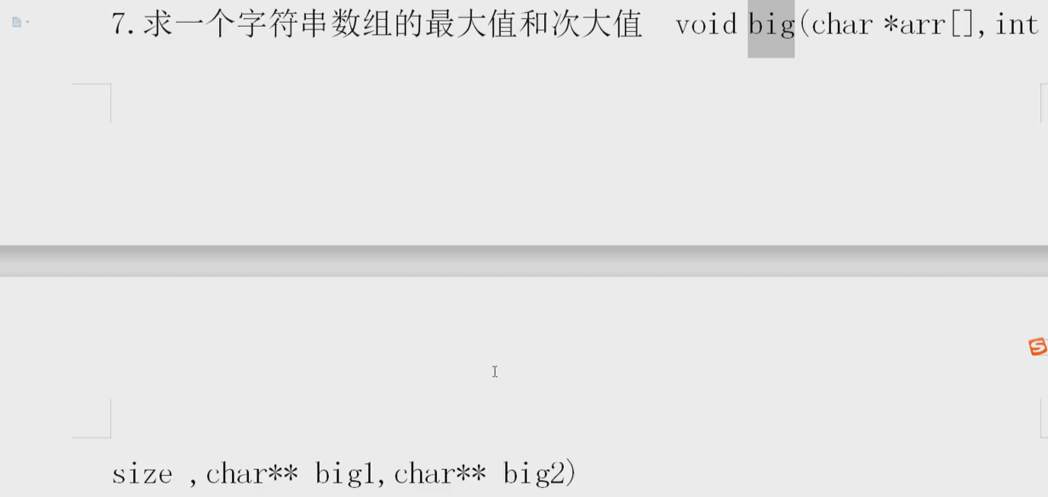

Const char \*p[5] = {“lili”,”lilei”,”hanmeimei”xxx}