**Capstone Project Report: Recommendation for Coworking Spaces in Tunisia**

**Presented by: Aymen Soussi, Data Scientist**

**1.Motivation:**

Coworking spaces is a new concept in Tunisia, those places offer to any new start up the chance to meet other startups in the same place so that they can communicate with each other’s and exchange experiences between each other’s when they need.

Another important factor is that those places try to provide startups with all what their needs (private desktops, imprints, meetup rooms, cafés, drinks and foods.

**2.Research Question:**

Can we provide a recommendation system to new startups so that they can find the best coworking space for them based on the governorate in which they are?

**3. Dataset details:**

We will use Foursquare API to search for venues and make the call to the Foursquare database and in return, We will use K-means clustering to do classification for coworking spaces: https://api.foursquare.com/v2/venues/search?client_id={}&client_secret={}&ll={},{}&v={}&query={}&radius={}&limit={}'.format(CLIENT_ID, CLIENT_SECRET, latitude, longitude, VERSION, ***_query, radius, LIMIT)

**4. Example of Dataset:**

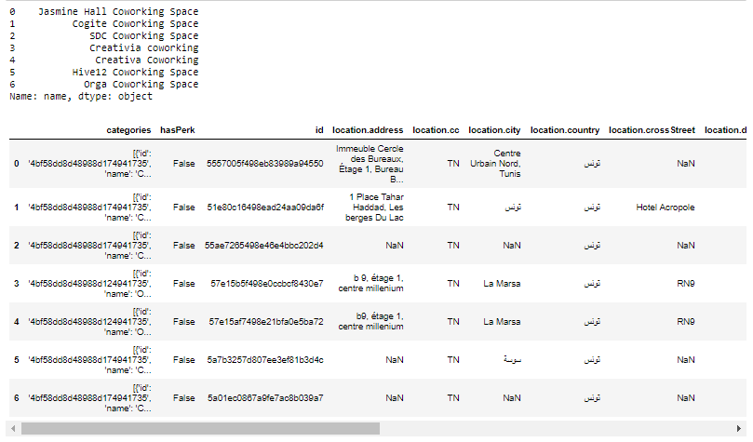

**5. Map of coworking spaces in tunisie:**

This is the Map of coworking spaces in Tunisia based on the data we have

We have marked up Tunis city center with a green point and the coworking spaces with blue point

(they are marked with blue points)

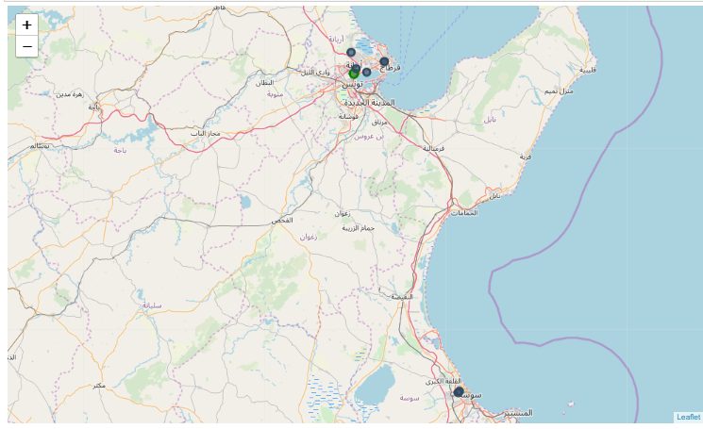

**6.Distribution of data between gouvernements**

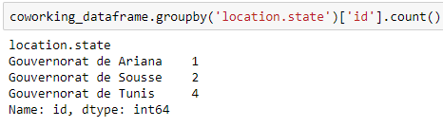

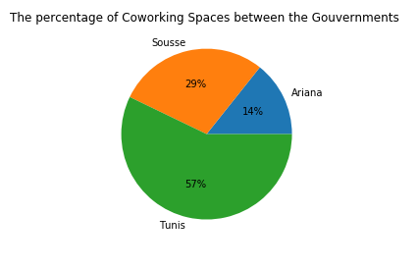

We have found only 7 coworking spaces distributed by 1 (14%) in Ariana, 2 (29%) in Sousse and 4 (57%) based in Tunis government .

**7. Conclusion:**

For those who’s are in Tunis government they have more chances to get to a coworking space (4 coworking spaces are in Tunis government) as you see in the map (try to zoom the map in the notebook so that the vision will be clearer for you)

The data was very limited and we need more data so that we can make better analyses about coworking spaces because in origin we have more than 70 coworking spaces based in this country but we have found only 7 coworking (less than 10%)

**8.References:**

Foursquare API for developers: <https://developer.foursquare.com/>

Matplotlib documentation: https://matplotlib.org/