**Supplemental Information**

**Supplementary Data**

**Data S1 Source data.** It contains 55604, 58617, 56888 sgRNAs with activity (represented by insertion/deletion (indel)) for WT-SpCas9, eSpCas9(1.1) and SpCas9-HF1, respectively.

**Data S2 The performance of each model in ten independent experiments.** The model performance is expressed by Spearman correlation coefficient.

**Data S3 Output of spatial attention module at global level.** We input every sgRNA into the spatial AttCRISPR, in order to obtain the  from the spatial attention module and take its mean value. Then we standardize it through Z-score.

**Data S4 The scores at each position of sgRNA with index of 8493 obtained by the temporal AttCRISPR.** We input this sgRNA into the temporal AttCRISPR, in order to obtain the  from the spatial attention module, where  denotes element-wise multiplication.

**Data S5 Output of temporal attention module at local level.** We input the sgRNA with index of 8493 into the temporal AttCRISPR, in order to obtain the  from the temporal attention module.

**Supplementary Figures**

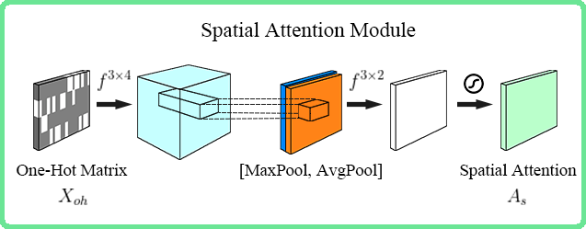

**Fig. S1 Details of spatial attention module.** A convolution layer is used to generate multi-channel map from . Then concatenated the output of both max-pooling and average-pooling method and forward it to the last convolution layer. A sigmoid function is used to map the final result to a range of zero to one at last, which generates the spatial first-order preference matrix .

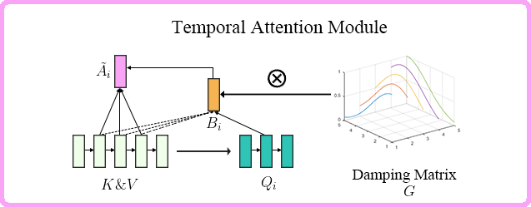

**Fig. S2 Details of temporal attention module.**

To generate the first order preference vector in the  position of sgRNA . First, the -th row vector of the queries matrix  is multiplied by the transpose of the keys matrix , and apply a softmax function to obtain a preliminary weights vector on the values.

Second, to favor the alignment points near , the weights vector obtained is multiplied element-by-element by the -th row vector of the damping matrix .  can be regarded as the result of place a Gaussian distribution centered around , then sampling the position  (a scaling factor is used to ensure the sum of  is 1).

Then we achieve the second-order preference matrix , it is also a weights matrix on the values. So the first-order preference matrix  come from the product of  and values matrix . Temporal attention module generates the temporal first-order preference matrix  and the temporal second-order preference matrix .

**C:\Users\50683\Desktop\AttCRISPR\SupplementaryMaterials\FigS3.tifFigS3**

**Fig. S3 In the absence of hand-crafted biological features, performance of different algorithms for sgRNA activity prediction.**

(a)-(c) The performance of Temporal AttCRISPR, Spatial AttCRISPR and Ensemble AttCRISPR.

The half-violin plots show the mean and distribution of the Spearman correlation coefficient between predicted and measured sgRNA activity scores over all tests.

(d)-(f) In the absence of hand-crafted biological features, the performance of all prediction methods in these datasets as far as we know.

The  of the Spearman correlation coefficient between predicted and measured sgRNA activity scores are shown in the bar plots.

C:\Users\50683\Desktop\AttCRISPR\SupplementaryMaterials\FigS4.tifFigS4

**Fig. S4 Performance comparisons for the methods before and after integrating with hand-crafted biological features.**

where DeepHF is the RNN integrated with hand-crafted biological features,

and StAC is the EnAC integrated with hand-crafted biological features.

The box plot show the mean and distribution of Spearman correlation coefficient between predicted and measured sgRNA activity scores over all tests.

**Supplementary Tables**

**Tab. S1 Three sgRNA and their activity.** *Activity* of sgRNA represents the activity reported in the WT-SpCas9 dataset (Supplementary Data 1).

|  |  |  |
| --- | --- | --- |
| Index | sgRNA | Activity |
| 8493 | ACATGACTTTGGATTTCCCCAGG | 0.831 |
| 8492 | ACATGACTTTGGATTCCCCCAGG | 0.869 |
| 8491 | ACATGACTTTGGACTTCCCCAGG | 0.861 |