OSPF:

* Describe OSPF

1. Network design using area.
2. Network relationship with adjacent router in the same area.
3. Using Dijikstra’s open shortest path first algorithm.
4. Classless routing protocol.
5. It can support VLSM.
6. Do not support summarization. (But we can do manual summarization at any point.)
7. Support authentication.
8. Administrative distance – 110.
9. Sent update using :
10. 224.0.0.5 -All ospf routes.
11. 224.0.0.6 -Designated routes.
12. Ospf uses cost as its matric, which is calculated based on the bandwidth of the link.
13. Ospf has no hop count limit.

* OSPF Area

1. Area 0 is must require for ospf. So it is also known as “Backbone Area”.
2. As ospf rule, all other areas must have a connection with area 0.

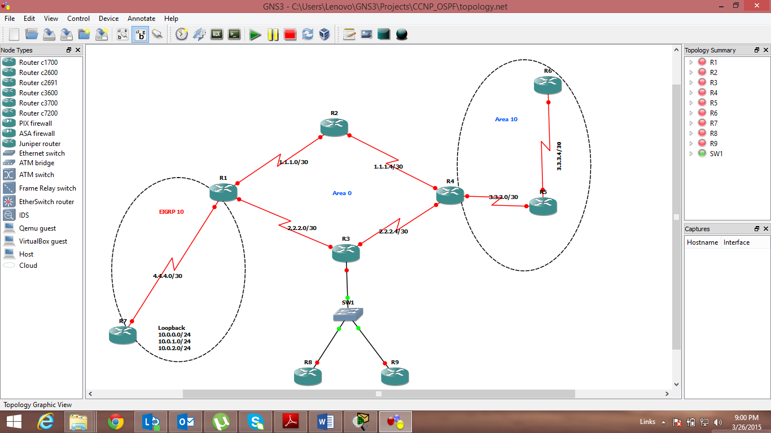

1. Considering the above fig. Router R2 and R3 are fully belong to Area 0, and Router R5 and R6 are fully belong to Area 10. So these routers are Internal Routers.
2. Router R4 is belongs to Area 0 and area 10. So it is Area Border Router (ABR).
3. Router R1 is redistributing another routing protocol into the ospf. So it is Autonomous System Border Router (ASBR).
4. Router R4 have two interfaces in Area 0. So it is Backbone Router.

* Type of ospf LSA:

1. Router LSA:

It contains a list of all links of router and it status & cost. And it is generated by routers in ospf.

1. Network LSA:

It contains a list of all routers attached to the designated router. And it is generated by designated routers in ospf.

1. Network Summary LSA:

It contains a list of all destination network with in a area. And it is generated by ABR in ospf.

1. ASBR Summary LSA:

It contains a routes to any ASBRs in the ospf system. And it is generated by ABRs in ospf.

1. External LSA:

It contains routs to destination network outside the local Autonomous.

1. Multicast ospf LSA
2. NSSA LSA

* Exact LSA type you can see in different areas

1. Network Summary LSA (Type – 3)

* Ospf neighbor ship:

Ospf form neighbor relationships called adjacencies with the routers in the same area by exchanging hello packets using to multicast address 224.0.0.5.

The following parameters with in hello packets are must be identical on each ospf routers.

1. Area ID
2. Area Type
3. Prefix
4. Subnetmask
5. Hello interval
6. Dead interval
7. Network type
8. Authentication

Ospf neighbor Status:

1. Down
2. Init
3. 2-way
4. Exstart
5. Exchange
6. Loading
7. Full
8. Full/DR
9. Full/BDR
10. Full/OtherDR

* OSPF behavior in broadcast and nonbroadcast

1. Broadcast
2. Ospf elect DR and BDR
3. Traffic to DR and BDR through 224.0.0.5
4. Traffic from DR and BDR to other router through 224.0.0.6
5. Don’t need to specify neighbor manually.
6. Non broadcast
7. Ospf elect DR and BDR
8. Ospf neighbor must be manually define
9. Multicast hello not allowed.

* Route redistribution and summarization



1. Redistributing Eigrp routes to Ospf & Ospf routes Eigrp:

Eigrp to Ospf:

R1(config)# router ospf 10

R1(config-router)# redistribute eigrp 5 subnet

Ospf routes Eigrp:

R1(config)# router eigrp 5

R1(config-router)# redistribute ospf 1 metric 1500 20000 255 1 1500

1. Summarize Eigrps Loopbacks to Ospf:

Loopbacks : 10.0.0.0/24

10.0.1.0/24

10.0.2.0/24

10.0.3.0/24

R1(config-router)# summary-address 10.0.0.0 255.255.252.0