TropGene Model documentation

@base <http://www.southgreen.fr/agrold/tropgene> .
@prefix rdf:<http://www.w3.org/1999/02/22-rdf-syntax-ns#> .
@prefix rdfs:<http://www.w3.org/2000/01/rdf-schema#> .
@prefix dc:<http://dublincore.org/documents/dces/> .
@prefix xsd:<http://www.w3.org/2001/XMLSchema#> .
@prefix owl:<http://www.w3.org/2002/07/owl#CLass> .
@prefix agrold_vocabulary:<http://www.southgreen.fr/agrold/vocabulary/> .
@prefix study:<http://www.southgreen.fr/study/> .
@prefix population:<http://www.southgreen.fr/tropgene.population/> .
@prefix qtl:<http://www.southgreen.fr/tropgene.qtl/> .
@prefix obo:<http://purl.obolibrary.org/obo/> .
@prefix edam:<http://edamontology.org/data_1865> .
@prefix trait:<http://www.southgreen.fr/tropgene.trait/> .
@prefix mapfeature:<http://www.southgreen.fr/tropgene./mapfeature/> .

Predicates to be used:

rdfs:label
rdf:type
rdfs:subClassOf
obo:IDO_0100549
obo:ID0_0100550
dc:description
agrold_vocab:chromosome
agrold_vocab:name
agrold_vocab:observation
agrold_vocab:has_trait
agrold_vocab:has_population
agrold_vocab:has_mapfeature

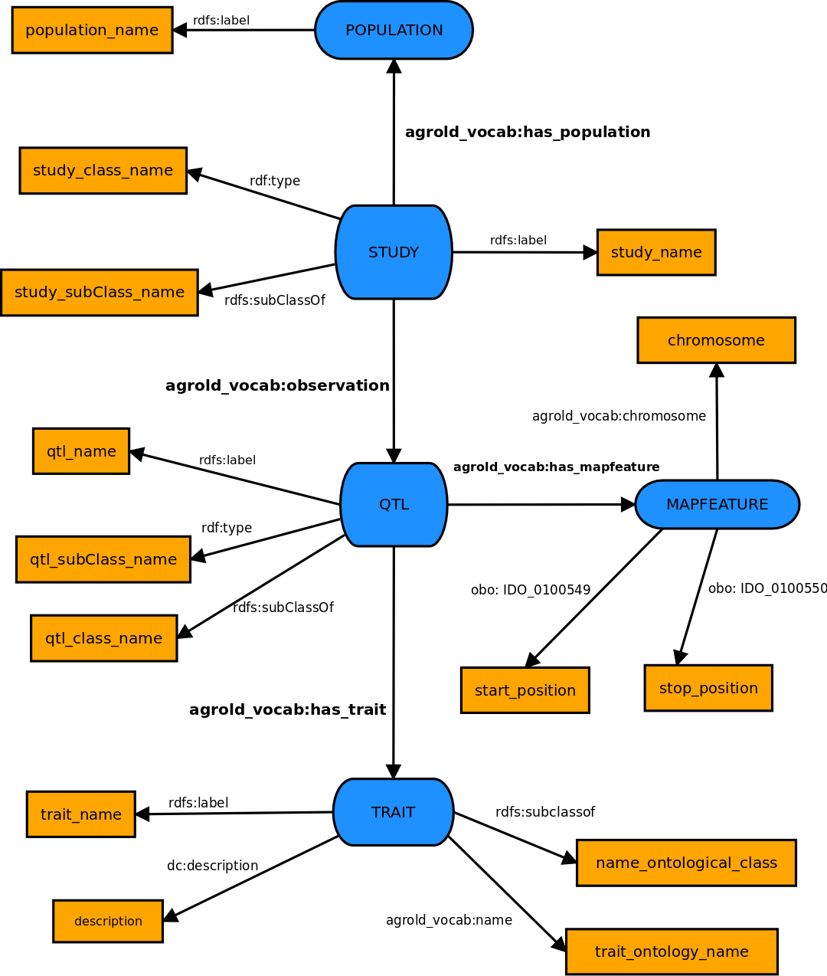
The graphique model tropGene

properties

population_name
Identified by | definition
rdf:label | The name of the population

study_name
Identified by | definition
rdf:label | The name of the study

study_class_name
Identified by | definition
rdf:type | The class type to which the study is associated

study_subClass_name
Identified by | definition
rdfs:subClassOf | the sub class to which the study is associated

qtl_name
Identified by | definition
rdf:label | The name of the qtl

qtl_class_name
Identified by | definition
rdf:type | The class type to which the qtl is associated

qtl_subClass_name
Identified by | definition
rdfs:subClassOf | the sub class to which the qtl is associated

chromosome
Identified by | definition
agrold_vocab:chromosome | The number of chromosome

start_position
Identified by | definition
obo:IDO_0100549 | The start position of the sequence

stop_posotion
Identified by | definition
obo:IDO_0100550 | The end position of the sequence

trait_name
Identified by | definition
rdf:label | The name of the trait

description
Identified by | definition
dc:description | The desctipion of the trait

name_ontological_class
Identified by | definition
rdfs:subClassOf | The class type to which the trait is associated

trait_ontology_name
Identified by | definition
agrold_vocab:name | The ontology name of the trait is associed

Turle Model

STUDY

study: study_id
rdfs: label xxx ;
rdf: type xxx ;
rdfs: subClassOf xxx ;
agrold_vocab: has_population population: population_id;
agrold_vocab: observation qtl: qtl_id;

POPULATION

population: population_id
rdfs: label xxx ;

QTL

qtl: qtl_id
rdfs: label xxx ;
rdf: type xxx ;
rdfs: subClassOf xxx ;
agrold_vocab: has_trait trait: xxx; # TO:ID or id_trait of tropgene
agrold_vocab: has_mapfeature mapfeature: mapfeature_id;

MAPFEATURE

mapfeature: mapfeature_id
agrold_vocab:chromosome xxx ;
obo: IDO_0100549 xxx ;
obo: IDO_0100550 xxx ;

TRAIT

trait: xxx #TO: ID or trait_id
rdfs: label xxx ;
rdfs: subClassOf xxx ;
rdf: type xxx ;
dc: description xxx ;
agrold_vocab: name xxx ;

Vocabulaire used in TropGene

Trait | Plant height
Description | Plant height from soil surface to tip of the longest panicle
Trait acronym | PHGT
Ontology name | Plant Trait Ontology
Ontology ID | TO:0000207
Ontology term | Plant height

Trait | Maximum root length
Description | Maximum point reached by roots in a soil column
Trait acronym | MRL
Ontology name | Plant Trait Ontology
Ontology ID | TO:0000227
Ontology term | Maximum root length

Trait | Tiller number
Description | Number of tillers per plant or per plot
Trait acronym | TN
Ontology name | Plant Trait Ontology
Ontology ID | TO:0000346
Ontology term | Tiller number

Trait | Root thickness
Description | Thickness of the roots
Trait acronym | RTHK
Ontology name | Plant Trait Ontology
Ontology ID | TO:0000306
Ontology term | Root thickness

Trait | Leaf drying score
Description | Proportion of dead leaf area due to drought (visual scale)
Trait acronym | LDS
Ontology name | Plant Trait Ontology
Ontology ID | TO:0000446
Ontology term | Leaf drying score

