Machine Learning – Midterm Report
Breast Cancer Wisconsin and Wine Classification
Name and Surname:Emirhan Uzun
Student Number: 230401002072
Course: Machine Learning

1. Loading the Datasets

1.1 Load both datasets from scikit-learn

I loaded both datasets from scikit-learn library.The Breast Cancer dataset has two classes while the wine dataset has three classes.I use load_breast_cancer() and load_wine() methods to load datasets from scikit-learn.

1.2 Create the data frames
Table 1. Dataset Overview
Dataset | Samples | Features | Classes / Labels
Breast Cancer | 569 | 30 | 2(0,1)
Wine | 178 | 13 | 3(0,1,2)
Both datasets were separated into the features and labels. y stands for target,x represents the features that we want to train the model.We don’t want to keep target column in X because model could know the target values so it can predict with high accuracy but the model would not need to learn the real relationships between X and y because the target values are already included in X.This is called data leakage.

2. Dataset Quality Checks

2.1 Missing values and duplicates
Table 2. Data Quality Summary
Dataset | Missing Values | Duplicate Rows | Numerical / Categorical
Breast Cancer | 0 | 0 | 30/0
Wine | 0 | 0 | 13/0

2.2 Potential outliers
I checked the outliers using the IQR method and I detected the outlier values but I didn’t delete the values because some outliers may contain useful information, and removing them could cause information loss or affect the model's learning process.

2.3 Data types
All features in both datasets are numerical and have the float64 data type.Breast cancer has 30 numerical class,wine has 13 numerical class.ı didn’t detect any data quality issues.

3. Exploratory Data Analysis (EDA)

3.1 Descriptive statistics

3.2 Class distribution and correlations
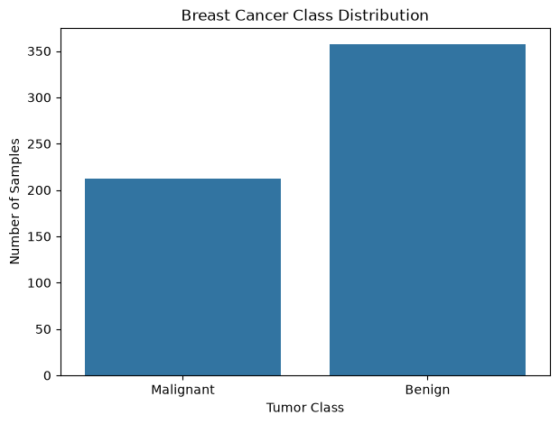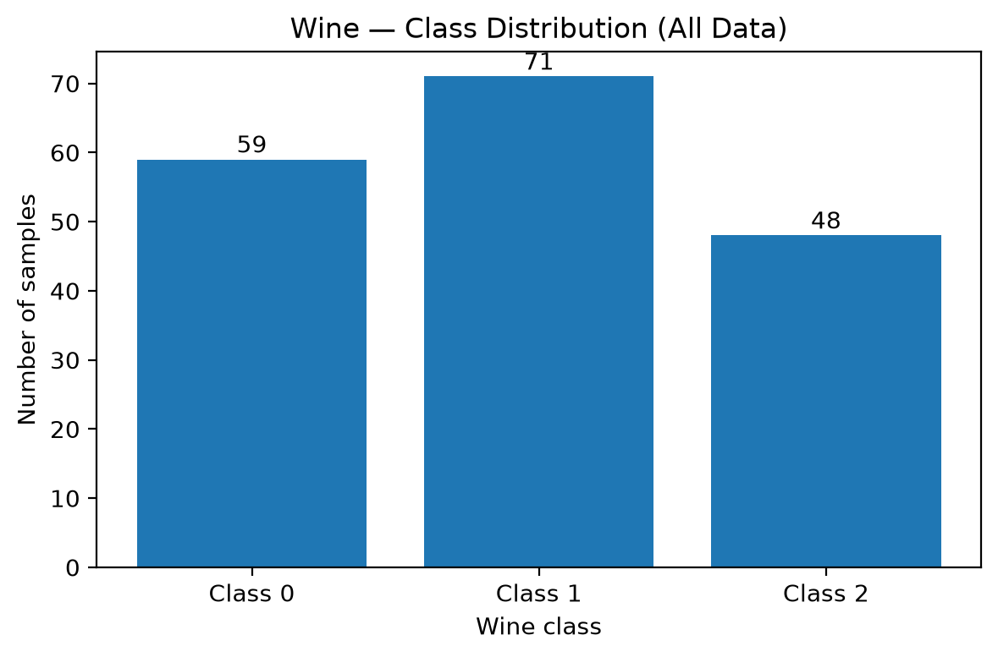
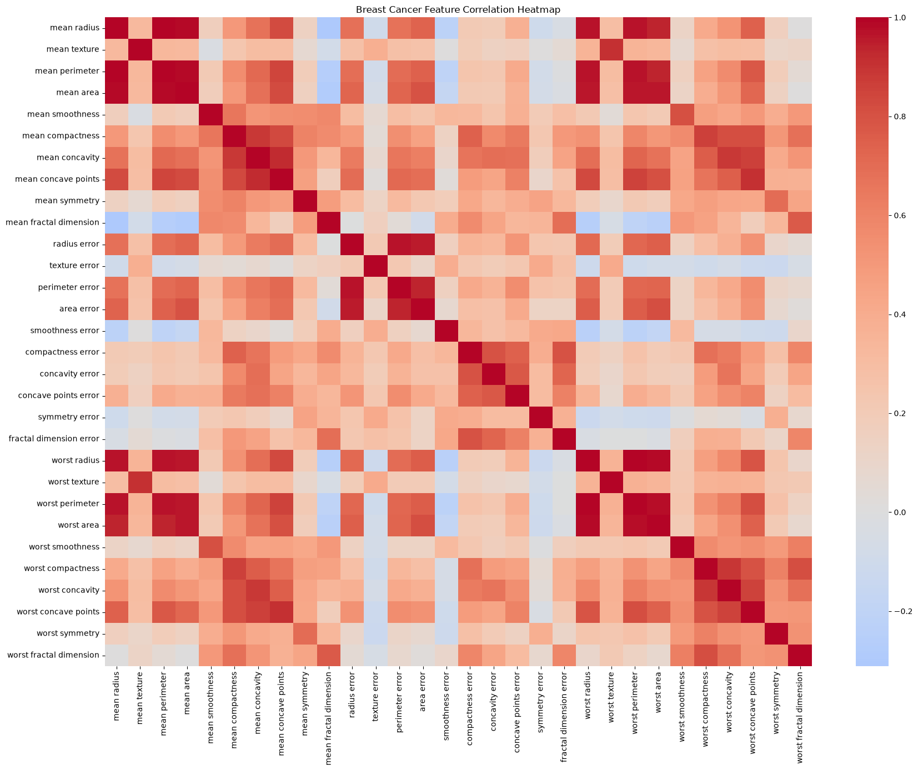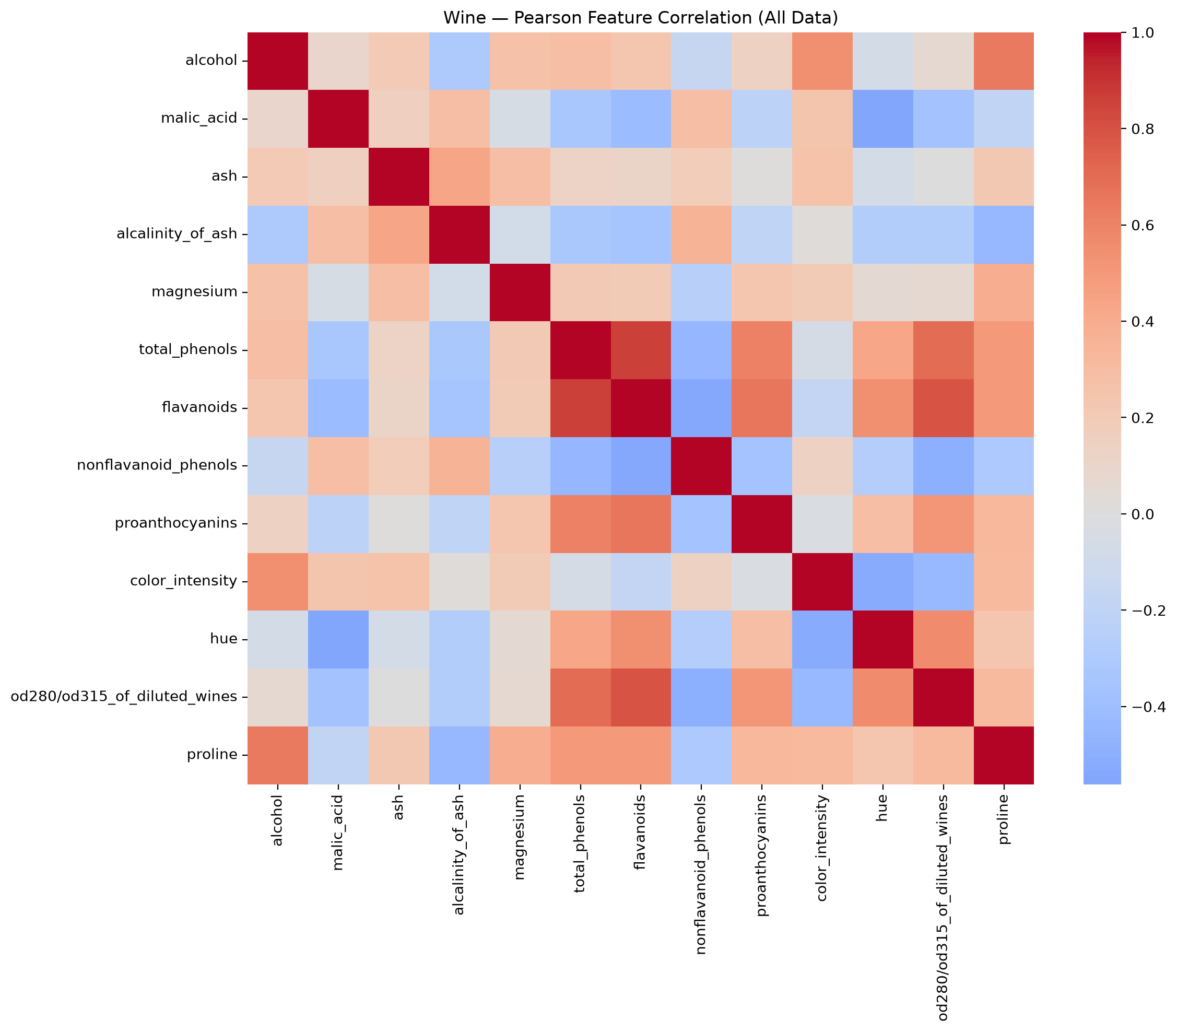
Table 3. Strongest Correlation Pairs

Dataset | Feature 1 | Feature 2 | Pearson r
Breast cancer | Mean radius | Mean perimeter | 0.997855
Breast cancer | Worst radius | Worst perimeter | 0.993708
Breast cancer | Mean radius | Mean area | 0.987357
Wine | total_phenols | flavanoids | 0.864564
Wine | flavanoids | od280/od315_of_diluted_wines | 0.787194
Wine | total_phenols | od280/od315_of_diluted_wines | 0.699949

3.3 Boxplots

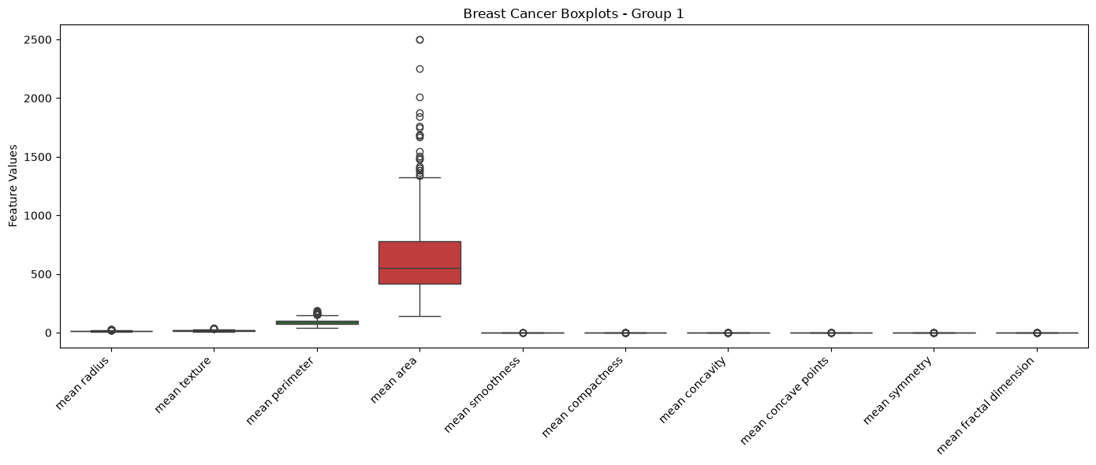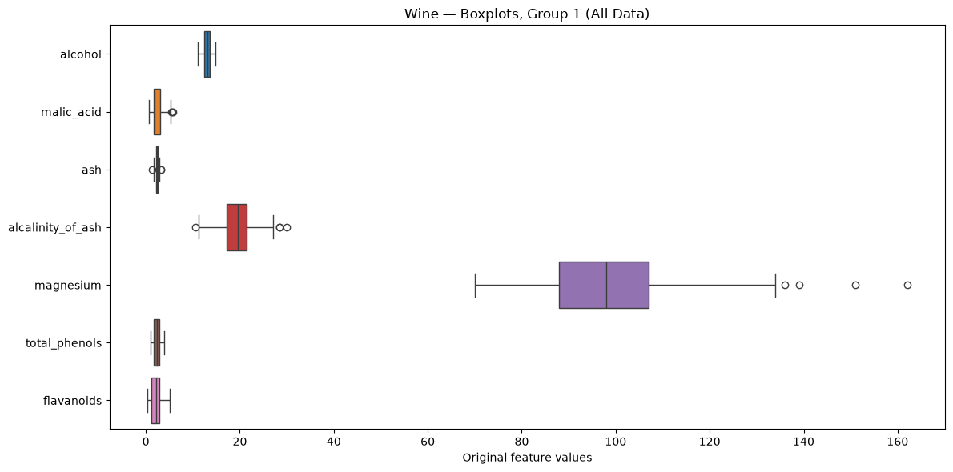
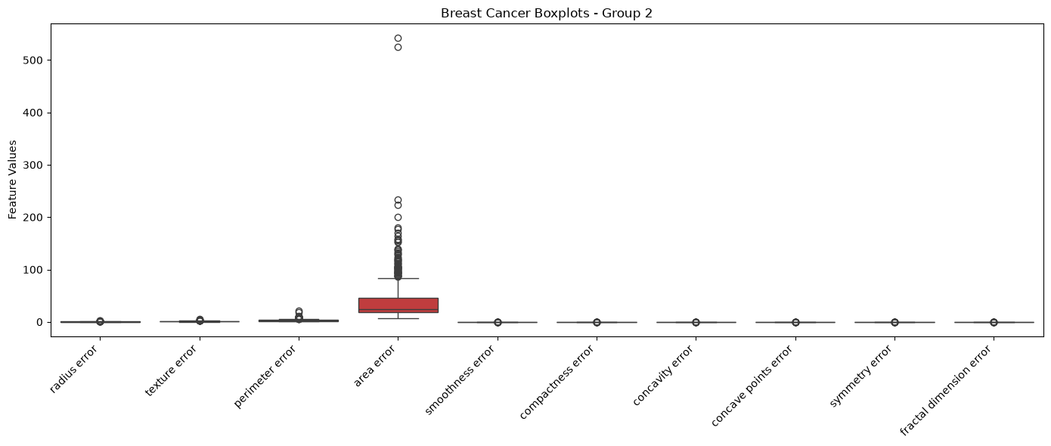

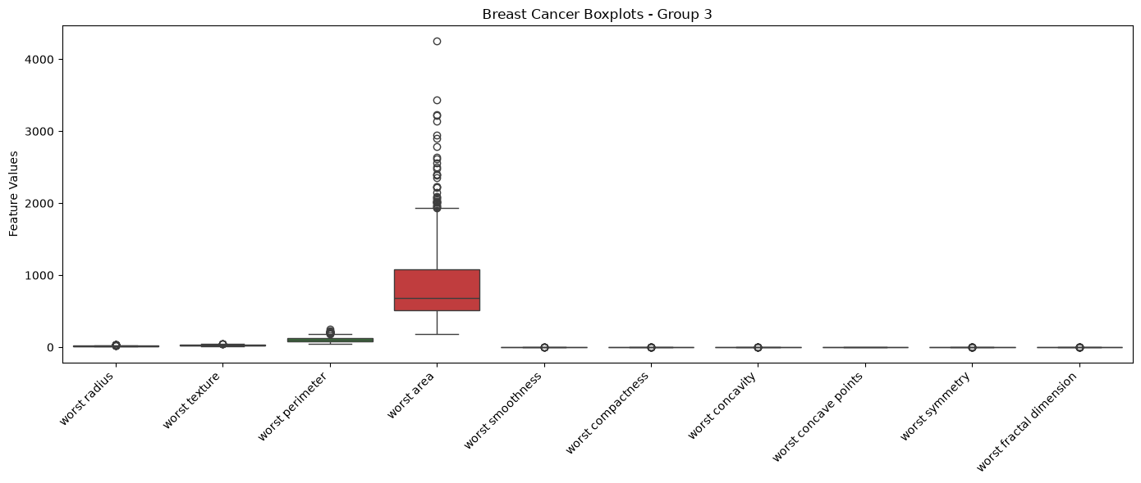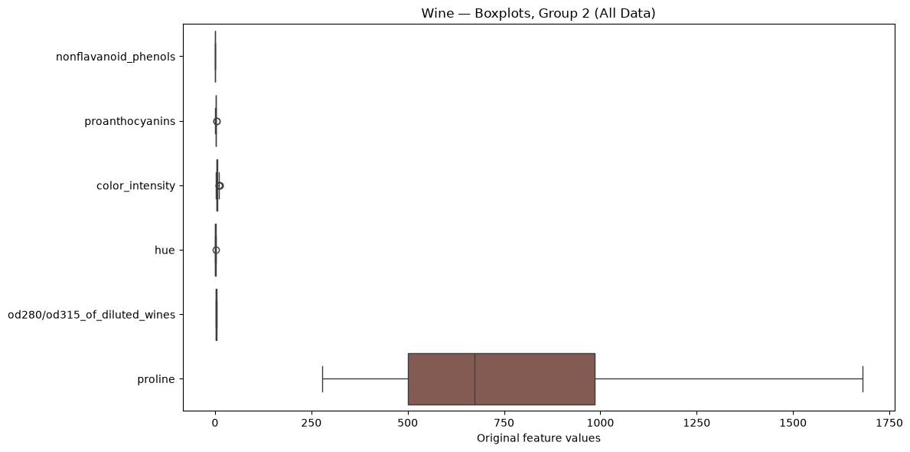

4. Splitting the Datasets

4.1 Fixed test set and repeated train/validation split
I wanted split the dataset into training, validation, and test setsto minimize the data leakage. 70% training, 10% validation, and 20% testing to prevent data leakage and evaluate the model fairly.
Table 4. Breast Cancer Split Summary
Seed | Split | Samples | Malignant | Benign
42 | Train | 398 | 149 | 249
42 | Validation | 57 | 21 | 36
42 | Test | 114 | 42 | 72
52 | Train | 398 | 149 | 249
52 | Validation | 57 | 21 | 36
52 | Test | 114 | 42 | 72
62 | Train | 398 | 149 | 249
62 | Validation | 57 | 21 | 36
62 | Test | 114 | 42 | 72

Table 5. Wine Split Summary
Seed | Split | Samples | Class 0 | Class 1 | Class 2
42 | Train | 124 | 41 | 50 | 33
42 | Validation | 18 | 6 | 7 | 5
42 | Test | 36 | 12 | 14 | 10
52 | Train | 124 | 41 | 50 | 33
52 | Validation | 18 | 6 | 7 | 5
52 | Test | 36 | 12 | 14 | 10
62 | Train | 124 | 41 | 50 | 33
62 | Validation | 18 | 6 | 7 | 5
62 | Test | 36 | 12 | 14 | 10

4.2 Split verification
I checked that the datasets doesn’t have any overlap.I kept using the same seeds to ensure a fair comparison between models.Because of the stratified splitting we kept the class distribution similar.

5. Data Preprocessing and Scaling

5.1 Handle missing values
The both datasets had 0 missing value so we don’t need.

5.2 Select one scaler
I used StandardScaler to scale the features so that they have a mean of 0 and a standard deviation of 1

5.3 Fit and apply the scaler correctly
Before Standardization:Breast Cancer
 | mean radius | mean texture | mean perimeter | mean area | mean smoothness | mean compactness | mean concavity | mean concave points | mean symmetry | mean fractal dimension | ... | worst radius | worst texture | worst perimeter | worst area | worst smoothness | worst compactness | worst concavity | worst concave points | worst symmetry | worst fractal dimension
301 | 12.46 | 19.89 | 80.43 | 471.3 | 0.08451 | 0.10140 | 0.06830 | 0.03099 | 0.1781 | 0.06249 | ... | 13.46 | 23.07 | 88.13 | 551.3 | 0.1050 | 0.2158 | 0.19040 | 0.07625 | 0.2685 | 0.07764
390 | 10.26 | 12.22 | 65.75 | 321.6 | 0.09996 | 0.07542 | 0.01923 | 0.01968 | 0.1800 | 0.06569 | ... | 11.38 | 15.65 | 73.23 | 394.5 | 0.1343 | 0.1650 | 0.08615 | 0.06696 | 0.2937 | 0.07722
420 | 11.57 | 19.04 | 74.20 | 409.7 | 0.08546 | 0.07722 | 0.05485 | 0.01428 | 0.2031 | 0.06267 | ... | 13.07 | 26.98 | 86.43 | 520.5 | 0.1249 | 0.1937 | 0.25600 | 0.06664 | 0.3035 | 0.08284
356 | 13.05 | 18.59 | 85.09 | 512.0 | 0.10820 | 0.13040 | 0.09603 | 0.05603 | 0.2035 | 0.06501 | ... | 14.19 | 24.85 | 94.22 | 591.2 | 0.1343 | 0.2658 | 0.25730 | 0.12580 | 0.3113 | 0.08317
446 | 17.75 | 28.03 | 117.30 | 981.6 | 0.09997 | 0.13140 | 0.16980 | 0.08293 | 0.1713 | 0.05916 | ... | 21.53 | 38.54 | 145.40 | 1437.0 | 0.1401 | 0.3762 | 0.63990 | 0.19700 | 0.2972 | 0.09075

After Standardization: Breast Cancer
 | mean radius | mean texture |  | mean perimeter | mean area | mean smoothness | mean compactness | mean concavity | mean concave points | mean symmetry | mean fractal dimension | ... | worst radius | worst texture | worst perimeter | worst area | worst smoothness | worst compactness | worst concavity | worst concave points | worst symmetry | worst fractal dimension
0 | -0.464835 | 0.176821 |  | -0.467521 | -0.518737 | -0.883771 | -0.073305 | -0.280632 | -0.466742 | -0.076775 | -0.069315 | ... | -0.573411 | -0.379056 | -0.561075 | -0.578285 | -1.226438 | -0.259443 | -0.416465 | -0.584935 | -0.339632 | -0.358158
1 | -1.084133 | -1.553003 |  | -1.065325 | -0.944480 | 0.250510 | -0.553959 | -0.868776 | -0.752546 | -0.009649 | 0.375173 | ... | -1.001136 | -1.547363 | -1.000394 | -0.854885 | 0.069897 | -0.573037 | -0.892843 | -0.723620 | 0.046080 | -0.381146
2 | -0.715369 | -0.014881 |  | -0.721221 | -0.693926 | -0.814026 | -0.520657 | -0.441841 | -0.889004 | 0.806456 | -0.044313 | ... | -0.653609 | 0.236588 | -0.611199 | -0.632617 | -0.345992 | -0.395869 | -0.116701 | -0.728397 | 0.196078 | -0.073535
3 | -0.298750 | -0.116370 |  | -0.277754 | -0.402988 | 0.855460 | 0.463223 | 0.051734 | 0.166020 | 0.820588 | 0.280719 | ... | -0.423295 | -0.098788 | -0.381515 | -0.507900 | 0.069897 | 0.049213 | -0.110760 | 0.154767 | 0.315465 | -0.055472
4 | 1.024295 | 2.012644 |  | 1.033914 | 0.932543 | 0.251244 | 0.481724 | 0.935926 | 0.845785 | -0.317013 | -0.531861 | ... | 1.086082 | 2.056753 | 1.127502 | 0.984118 | 0.326509 | 0.730725 | 1.637560 | 1.217669 | 0.099650 | 0.359420

Before Standardization:Wine
 | alcohol | malic_acid | ash | alcalinity_of_ash | magnesium | total_phenols | flavanoids | nonflavanoid_phenols | proanthocyanins | color_intensity | hue | od280/od315_of_diluted_wines | proline
163 | 12.96 | 3.45 | 2.35 | 18.5 | 106.0 | 1.39 | 0.70 | 0.40 | 0.94 | 5.28 | 0.68 | 1.75 | 675.0
148 | 13.32 | 3.24 | 2.38 | 21.5 | 92.0 | 1.93 | 0.76 | 0.45 | 1.25 | 8.42 | 0.55 | 1.62 | 650.0
116 | 11.82 | 1.47 | 1.99 | 20.8 | 86.0 | 1.98 | 1.60 | 0.30 | 1.53 | 1.95 | 0.95 | 3.33 | 495.0
122 | 12.42 | 4.43 | 2.73 | 26.5 | 102.0 | 2.20 | 2.13 | 0.43 | 1.71 | 2.08 | 0.92 | 3.12 | 365.0
115 | 11.03 | 1.51 | 2.20 | 21.5 | 85.0 | 2.46 | 2.17 | 0.52 | 2.01 | 1.90 | 1.71 | 2.87 | 407.0

After Standardization:Wine
 | alcohol | malic_acid | ash | alcalinity_of_ash | magnesium | total_phenols | flavanoids | nonflavanoid_phenols | proanthocyanins | color_intensity | hue | od280/od315_of_diluted_wines | proline
163 | -0.017514 | 1.089178 | -0.040117 | -0.308405 | 0.433224 | -1.342505 | -1.322275 | 0.352668 | -1.117639 | 0.125837 | -1.226754 | -1.223646 | -0.209375
148 | 0.439706 | 0.891779 | 0.072941 | 0.609409 | -0.505699 | -0.490993 | -1.259892 | 0.769946 | -0.571881 | 1.512255 | -1.811372 | -1.414652 | -0.291400
116 | -1.465379 | -0.772006 | -1.396814 | 0.395252 | -0.908094 | -0.412149 | -0.386537 | -0.481889 | -0.078939 | -1.344472 | -0.012548 | 1.097809 | -0.799954
122 | -0.703345 | 2.010370 | 1.391951 | 2.139100 | 0.164961 | -0.065237 | 0.164509 | 0.603035 | 0.237953 | -1.287073 | -0.147460 | 0.789262 | -1.226483
115 | -2.468723 | -0.734407 | -0.605407 | 0.609409 | -0.975160 | 0.344750 | 0.206097 | 1.354136 | 0.766105 | -1.366549 | 3.405216 | 0.421943 | -1.088682
We used StandardScaler to scale the data. The fit() method learns the mean and standard deviation from the training data, while transform() uses these values to scale the data. The fit_transform() method performs both operations together. We fitted the scaler only on the training data to prevent data leakage.

6. Preparing the Two Data Representations
I used the same original features: 30 for Breast Cancer and 13 for Wine. The unscaled data contains the original feature values, while the scaled data contains values transformed using StandardScaler. I used the same training, validation, and test splits for both representations. Our goal was to compare the effect of scaling on model performance.

7. Training the Classification Models

7.1 Required experiments
Algorithm | Parameters
Decision Tree | max_depth = 2, 3, 5, 10, None
KNN | k = 1, 3, 5, 7, 11
Gaussian Naive Bayes | Default parameters
Every model trained three seed(42,52,62) and two data types scaled and unscaled.

7.2 Experiment records
There were 132 classification runs in total: 66 for Breast Cancer and 66 for Wine. Three random seeds (42, 52, and 62) and two data representations (unscaled and scaled) were used. All model configurations and evaluation metrics were saved in classifier_runs.csv.
___________________________________________________________________

8. Measuring Validation Performance

8.1 Validation metrics
Accuracy =Percentage of correct predictions
Macro Precision = Average precision across all classes.
Macro Recall = Average recall across all classes.
Macro F1 = Average F1-score across all classes. It balances precision and recall.
ROC-AUC = Measures how well the model separates different classes.
The breast cancer was class 0 (malignant) is treated as the positive class.
Wine macro one-vs-rest and ROC-AUC is used fot three classes.

8.2 Model comparison and selection
Table 6. Breast Cancer Classifier Summary (22 rows)
Breast Cancer,breast_cancer_knn_k_3_unscaled,KNN,KNN_k_3,n_neighbors=3; weights=uniform; metric=euclidean,unscaled,0.958961474036851,0.0038380030946028733,0.9558002911418905,0.004233835589997872,0.9005847953216374,0.04051580836418426,0.8997535997535997,0.04202263510353771,0.8849206349206349,0.04665863498533664,0.8910484577975389,0.04490265098020662,0.9298941798941799,0.023485821302334245
Table 7. Wine Classifier Summary (22 rows)
Wine,wine_knn_k_11_scaled,KNN,KNN_k_11,n_neighbors=11; weights=uniform; metric=euclidean,scaled,0.9650537634408604,0.004656050557980849,0.9655894140010441,0.004817296801186958,0.9814814814814815,0.03207501495497924,0.9814814814814815,0.03207501495497916,0.9841269841269842,0.027492869961410732,0.9813519813519814,0.032299315758860164,1.0,0.0
Wine,wine_knn_k_5_scaled,KNN,KNN_k_5,n_neighbors=5; weights=uniform; metric=euclidean,scaled,0.9758064516129034,0.0,0.9761735203275084,0.0005244381441172056,0.9814814814814815,0.03207501495497924,0.9814814814814815,0.03207501495497916,0.9841269841269842,0.027492869961410732,0.9813519813519814,0.032299315758860164,1.0,0.0
Wine,wine_knn_k_7_scaled,KNN,KNN_k_7,n_neighbors=7; weights=uniform; metric=euclidean,scaled,0.9596774193548386,0.008064516129032251,0.9602878350489781,0.00795557900109027,0.9814814814814815,0.03207501495497924,0.9814814814814815,0.03207501495497916,0.9841269841269842,0.027492869961410732,0.9813519813519814,0.032299315758860164,1.0,0.0
Wine,wine_knn_k_1_scaled,KNN,KNN_k_1,n_neighbors=1; weights=uniform; metric=euclidean,scaled,1.0,0.0,1.0,0.0,0.9629629629629629,0.03207501495497922,0.9682539682539684,0.027492869961410718,0.9682539682539684,0.027492869961410718,0.9658119658119659,0.02960770611228846,0.974867724867725,0.02176518871945015
Wine,wine_gaussiannb_default_scaled,GaussianNB,GaussianNB,defaults,scaled,0.9838709677419355,0.0,0.9839597741928293,0.0004905313811381448,0.9629629629629629,0.03207501495497922,0.9675925925925926,0.02891202777036295,0.9656084656084657,0.03004713410476335,0.963843563843564,0.031359017217619245,1.0,0.0
Wine,wine_gaussiannb_default_unscaled,GaussianNB,GaussianNB,defaults,unscaled,0.9838709677419355,0.0,0.9839597741928293,0.0004905313811381448,0.9629629629629629,0.03207501495497922,0.9675925925925926,0.02891202777036295,0.9656084656084657,0.03004713410476335,0.963843563843564,0.031359017217619245,1.0,0.0
Wine,wine_dt_depth_10_scaled,DecisionTree,DecisionTree_depth_10,max_depth=10,scaled,1.0,0.0,1.0,0.0,0.9444444444444443,0.05555555555555558,0.9614197530864198,0.0371333623935678,0.9407407407407408,0.061195228303178896,0.9461560044893379,0.05451533111886869,0.9552188552188552,0.045735197923285204
Wine,wine_dt_depth_10_unscaled,DecisionTree,DecisionTree_depth_10,max_depth=10,unscaled,1.0,0.0,1.0,0.0,0.9444444444444443,0.05555555555555558,0.9614197530864198,0.0371333623935678,0.9407407407407408,0.061195228303178896,0.9461560044893379,0.05451533111886869,0.9552188552188552,0.045735197923285204
Wine,wine_dt_depth_3_scaled,DecisionTree,DecisionTree_depth_3,max_depth=3,scaled,0.9919354838709676,0.0,0.9925844436295481,0.0,0.9444444444444443,0.05555555555555558,0.9614197530864198,0.0371333623935678,0.9407407407407408,0.061195228303178896,0.9461560044893379,0.05451533111886869,0.9611411736411736,0.043103293291824975
Wine,wine_dt_depth_3_unscaled,DecisionTree,DecisionTree_depth_3,max_depth=3,unscaled,0.9919354838709676,0.0,0.9925844436295481,0.0,0.9444444444444443,0.05555555555555558,0.9614197530864198,0.0371333623935678,0.9407407407407408,0.061195228303178896,0.9461560044893379,0.05451533111886869,0.9611411736411736,0.043103293291824975
Wine,wine_dt_depth_5_scaled,DecisionTree,DecisionTree_depth_5,max_depth=5,scaled,1.0,0.0,1.0,0.0,0.9444444444444443,0.05555555555555558,0.9614197530864198,0.0371333623935678,0.9407407407407408,0.061195228303178896,0.9461560044893379,0.05451533111886869,0.9552188552188552,0.045735197923285204
Wine,wine_dt_depth_5_unscaled,DecisionTree,DecisionTree_depth_5,max_depth=5,unscaled,1.0,0.0,1.0,0.0,0.9444444444444443,0.05555555555555558,0.9614197530864198,0.0371333623935678,0.9407407407407408,0.061195228303178896,0.9461560044893379,0.05451533111886869,0.9552188552188552,0.045735197923285204
Wine,wine_dt_depth_None_scaled,DecisionTree,DecisionTree_depth_None,max_depth=None,scaled,1.0,0.0,1.0,0.0,0.9444444444444443,0.05555555555555558,0.9614197530864198,0.0371333623935678,0.9407407407407408,0.061195228303178896,0.9461560044893379,0.05451533111886869,0.9552188552188552,0.045735197923285204
Wine,wine_dt_depth_None_unscaled,DecisionTree,DecisionTree_depth_None,max_depth=None,unscaled,1.0,0.0,1.0,0.0,0.9444444444444443,0.05555555555555558,0.9614197530864198,0.0371333623935678,0.9407407407407408,0.061195228303178896,0.9461560044893379,0.05451533111886869,0.9552188552188552,0.045735197923285204
Wine,wine_knn_k_3_scaled,KNN,KNN_k_3,n_neighbors=3; weights=uniform; metric=euclidean,scaled,0.967741935483871,0.008064516129032251,0.9687098431914581,0.007513479029704416,0.9444444444444443,0.05555555555555558,0.9497354497354498,0.051638151576569126,0.9523809523809524,0.04761904761904763,0.9457394457394458,0.055809447687069885,1.0,0.0
Wine,wine_dt_depth_2_scaled,DecisionTree,DecisionTree_depth_2,max_depth=2,scaled,0.935483870967742,0.00806451612903232,0.9364664570113455,0.010609109788555289,0.8518518518518517,0.03207501495497914,0.8723544973544973,0.0214003831843432,0.8486772486772488,0.04949565065686492,0.8481475314808647,0.036475495516826724,0.9049704924704924,0.021898359511196237
Wine,wine_dt_depth_2_unscaled,DecisionTree,DecisionTree_depth_2,max_depth=2,unscaled,0.935483870967742,0.00806451612903232,0.9364664570113455,0.010609109788555289,0.8518518518518517,0.03207501495497914,0.8723544973544973,0.0214003831843432,0.8486772486772488,0.04949565065686492,0.8481475314808647,0.036475495516826724,0.9049704924704924,0.021898359511196237
Wine,wine_knn_k_1_unscaled,KNN,KNN_k_1,n_neighbors=1; weights=uniform; metric=euclidean,unscaled,1.0,0.0,1.0,0.0,0.7037037037037037,0.03207501495497922,0.6886243386243386,0.023942529732481566,0.6835978835978836,0.022297679900217474,0.6713860213860214,0.02259234749578541,0.7653614903614904,0.018119564871346524
Wine,wine_knn_k_5_unscaled,KNN,KNN_k_5,n_neighbors=5; weights=uniform; metric=euclidean,unscaled,0.7876344086021505,0.009312101115961698,0.7739221579544194,0.009106443406521938,0.7037037037037037,0.03207501495497922,0.7280423280423279,0.07220186933405638,0.6862433862433863,0.02936865415106438,0.6667073667073667,0.039943041508146815,0.8644733353066686,0.011513647872265801
Wine,wine_knn_k_3_unscaled,KNN,KNN_k_3,n_neighbors=3; weights=uniform; metric=euclidean,unscaled,0.8360215053763441,0.01231875186816085,0.8293740825044281,0.013388821072046591,0.6666666666666666,0.055555555555555566,0.6613756613756614,0.049616400353203874,0.6518518518518519,0.04783899820112471,0.6455729455729456,0.04287729743632916,0.833285541618875,0.031092444833054192
Wine,wine_knn_k_7_unscaled,KNN,KNN_k_7,n_neighbors=7; weights=uniform; metric=euclidean,unscaled,0.7903225806451614,0.021336704121488637,0.7804101007866467,0.023096892539263805,0.6666666666666666,0.0,0.647089947089947,0.022522536141579595,0.6544973544973546,0.015252418312592072,0.6355891022557689,0.03162089085420923,0.8458583083583084,0.008446144887506439
Wine,wine_knn_k_11_unscaled,KNN,KNN_k_11,n_neighbors=11; weights=uniform; metric=euclidean,unscaled,0.739247311827957,0.009312101115961698,0.7309222818912741,0.008257820459341422,0.6296296296296297,0.03207501495497916,0.6148148148148148,0.012731438534937524,0.6137566137566138,0.021077866970414978,0.6004773004773004,0.0009644242584191677,0.8216269841269841,0.0254152507403112

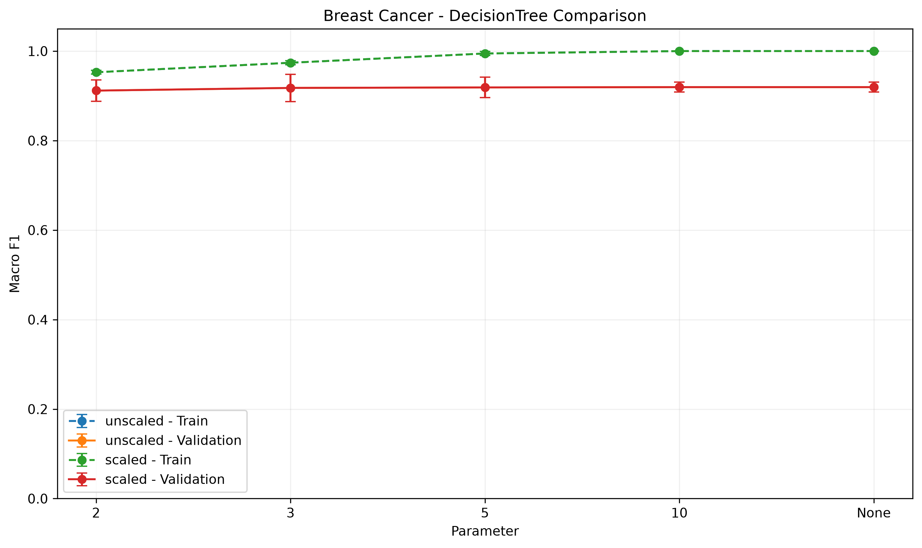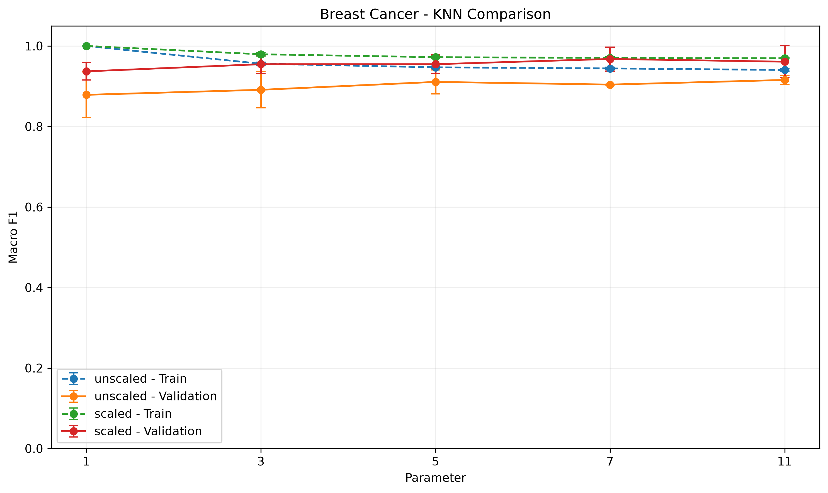

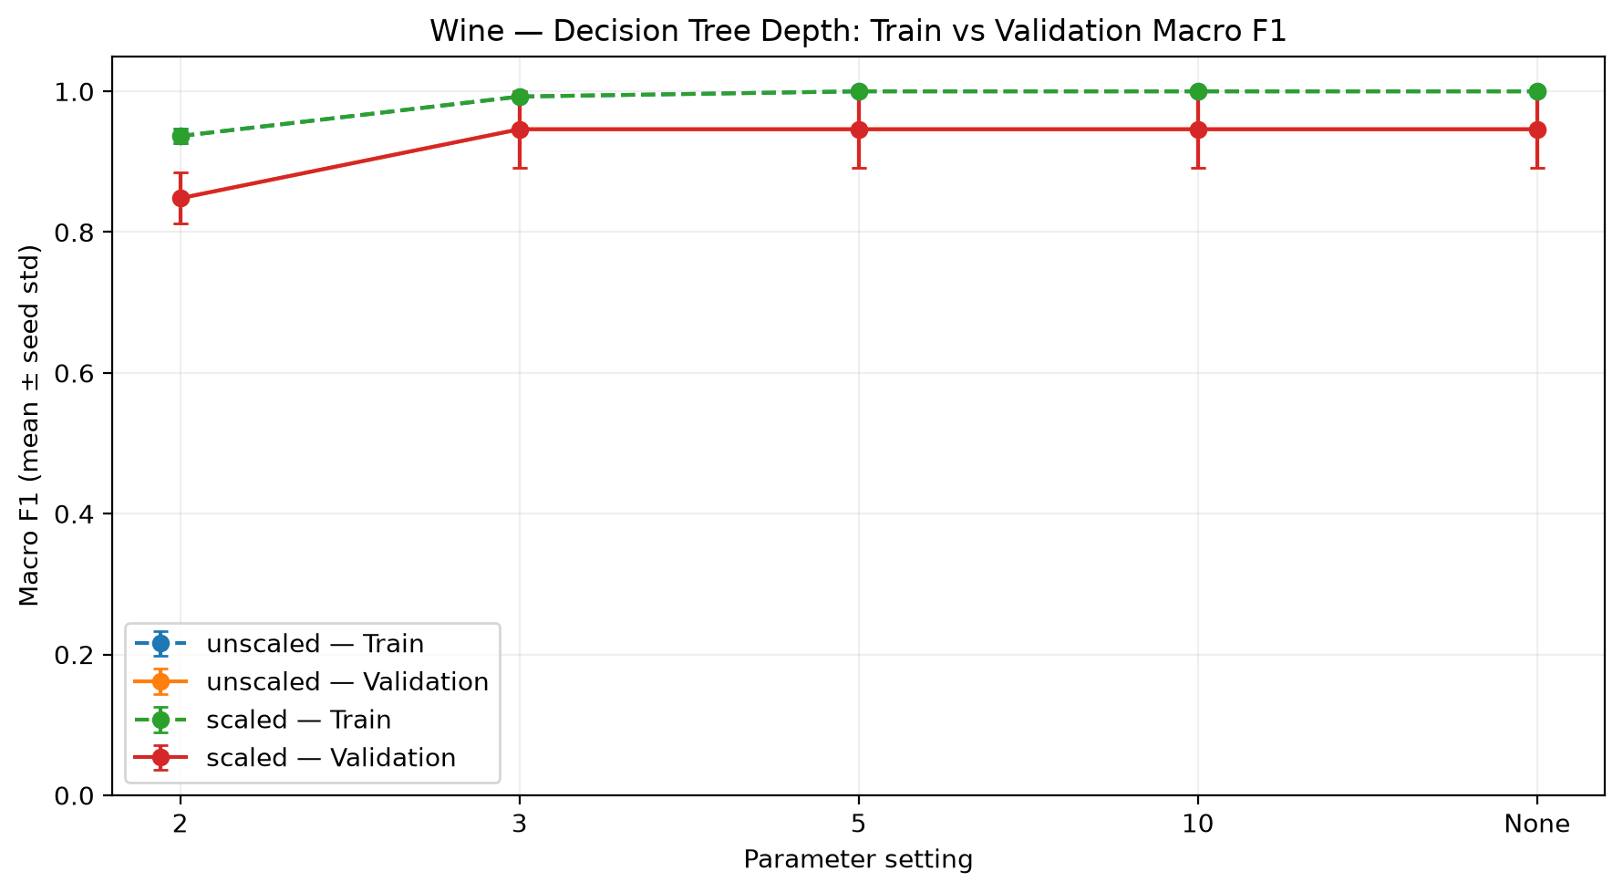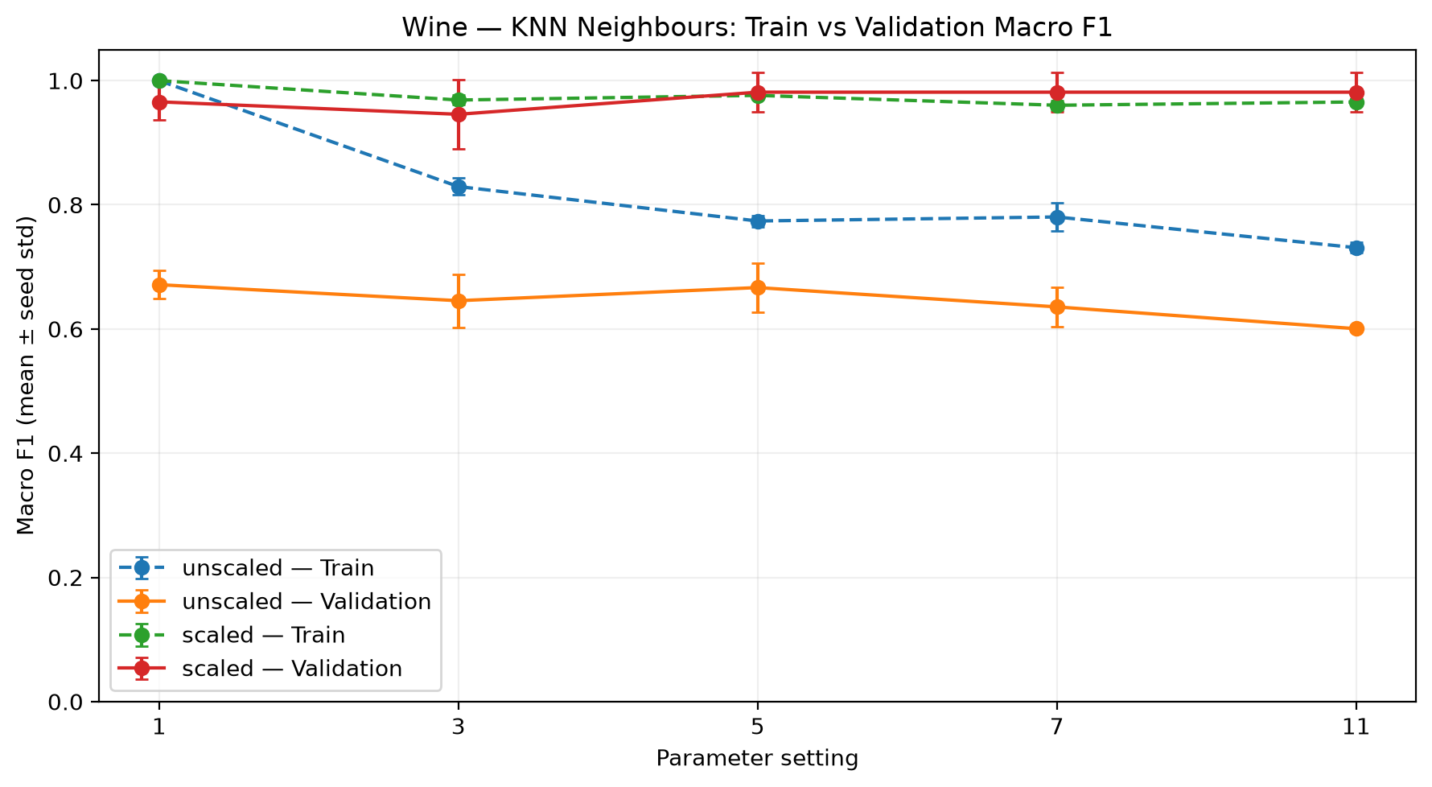
1.The Selected Models
Breast Cancer; KNN,k=7,Scaled Mean validation macrof1=0.9677

Wine;KNN,k=11,Scaled,Mean validation macro f1 = 0.9814
Selection Criterion => The highest mean validation f1 , not test accuracy.
2.Scaling
Breast cancer => unscaled knn k=7 f1=>0.9040, scaled,0.9677
Parameters;Increasing Decision Tree and KNN count did not always improve performance.
Conclusion=>Scaling improved KNN performance but larger parameters were not always better.

9. Evaluating the Selected Models on the Test Sets

9.1 Final test results
Table 8. Final Classifier Test Results
Dataset | Selected Model | Accuracy | Macro F1 | ROC-AUC
Breast Cancer | Scaled KNN k=7 | 0.9737 | 0.9713 | 0.9888
Wine | Scaled KNN k=11 | 1.0000 | 1.0000 | 1.0000
Resource:classifier_test.csv

1.Breast Cancer
Malignant 1.00 0.93 0.96 42
Benign 0.96 1.00 0.98 72

accuracy 0.97 114
macro avg 0.98 0.96 0.97 114
weighted avg 0.97 0.97 0.97 114

2.Wine
Per-class classification report:
precision recall f1-score support

class_0 1.00 1.00 1.00 12
class_1 1.00 1.00 1.00 14
class_2 1.00 1.00 1.00 10

accuracy 1.00 36
macro avg 1.00 1.00 1.00 36
weighted avg 1.00 1.00 1.00 36

Difference: test macro F1 minus validation mean macro F1 = 0.01864801864801857
These results were obtained from the fixed test sets. I did not use the test data for model selection.

9.2 Confusion matrices and manual checks
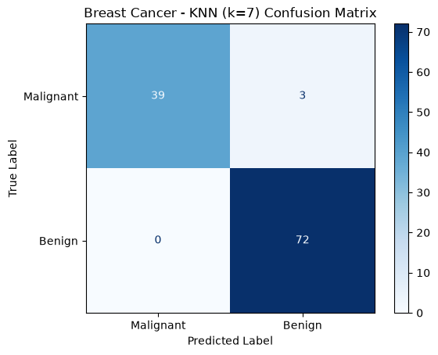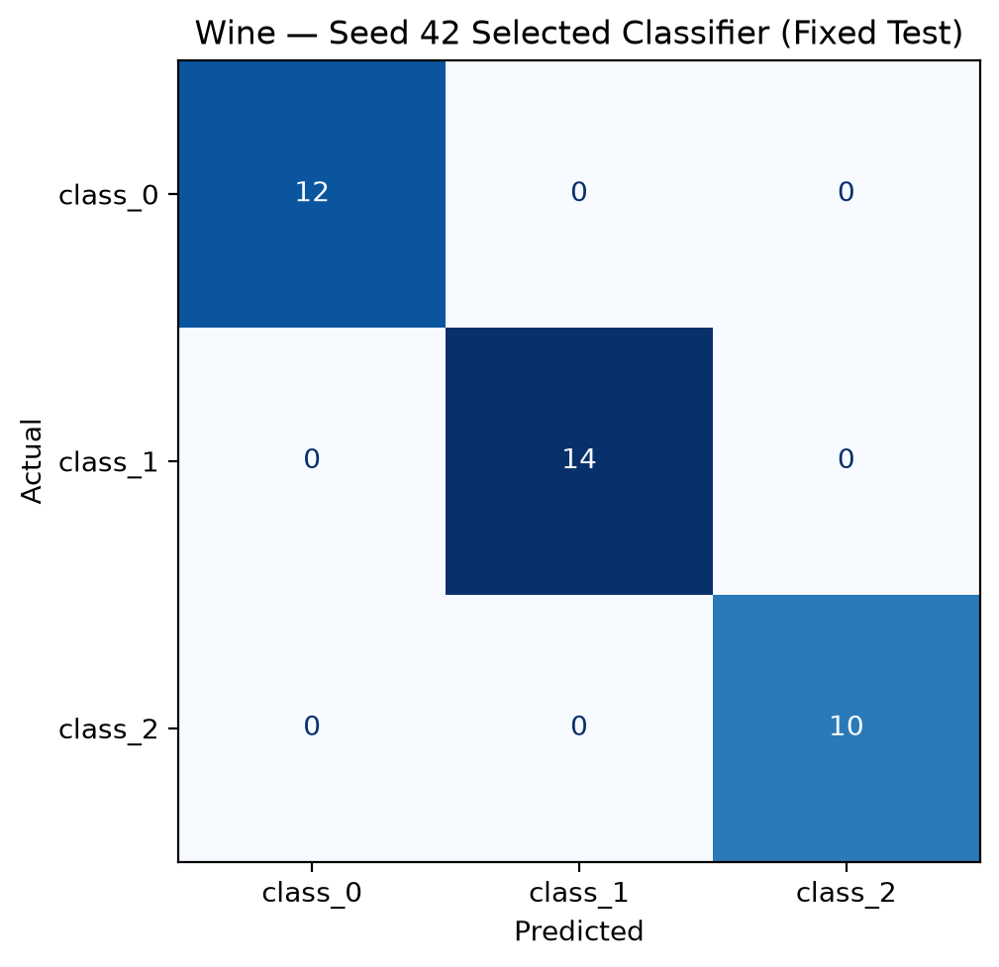
Metric | Breast Cancer (Malignant) | Wine (Class 0)
TP | 39 | 12
FP | 0 | 0
FN | 3 | 0
TN | 72 | 24
Precision | 1.0000 | 1.0000
Recall | 0.9286 | 1.0000
F1-score | 0.9630 | 1.0000
Breast Cancer: Out of 42 malignant cases, 39 were correctly predicted as malignant, while 3 were incorrectly predicted as benign.
Wine: All 12 samples belonging to class 0 were correctly classified by the model.

9.3 ROC curves
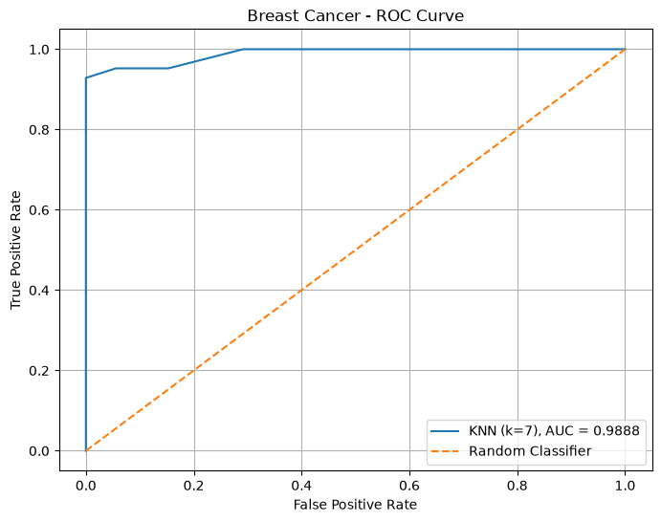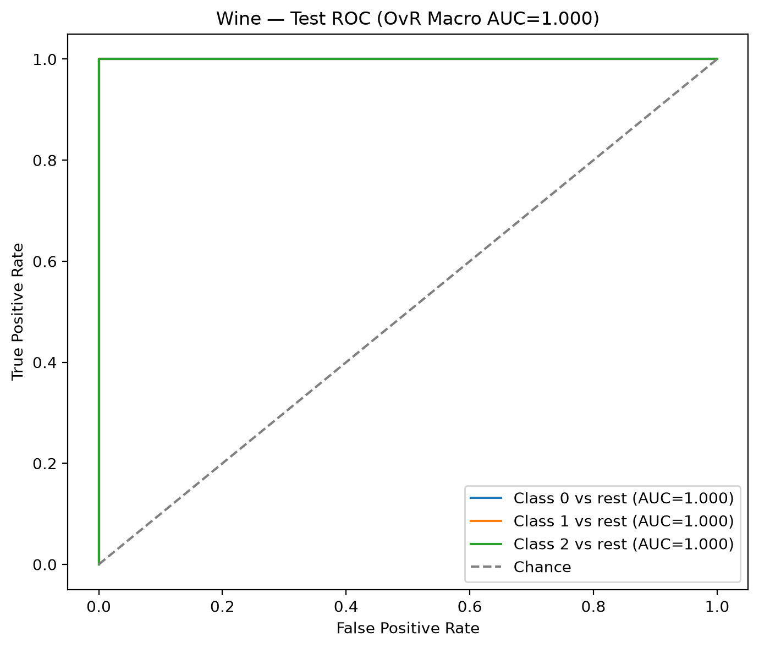
Breast Cancer=> ROC-AUC 0.9888
Wine=>ROC-AUC 1.0000
The ROC curve shows the relationship between the True Positive Rate and the False Positive Rate. Changing the decision threshold changes the balance between false positives and false negatives.
Breast Cancer has an AUC of 0.9888, indicating strong discrimination between malignant and benign classes. Wine has a Macro OvR AUC of 1.0000 on the test set.

9.4 Error analysis
Breast Cancer
There were 114 test samples the model incorrectly predicted 3 malignant cases as benign
False negatives are particularly important for cancer detection.

Wine
There were 36 test samples the model predicted all samples correctly
Perfect accuracy does not guarantee perfect generilaziton.I use small datasets which may limit how well results generalize to new data.

10. K-Means Clustering

10.1 Training and validation
n_clusters=2 (Breast Cancer)
n_clusters=3 (Wine)
n_init=10
seeds=[42, 52, 62]
I used both scaled and unscaled data representations and performed six K-Means runs for each dataset.Table 9. K-Means Summary
dataset,representation,inertia_mean,inertia_std,ari_mean,ari_std,silhouette_mean,silhouette_std,silhouette_valid_seeds
Breast Cancer,scaled,7948.108670200784,47.57426830920166,0.5812545112727957,0.14237768793512956,0.31208646113886335,0.05472533814926329,3
Breast Cancer,unscaled,51270883.70899662,1949606.9972283873,0.5043486495309917,0.10642336805912421,0.6773250879405,0.03343974890811668,3
Wine,scaled,879.1403866631493,9.860948390380132,1.0,0.0,0.27507731516789297,0.024779696413614733,3
Wine,unscaled,1348308.4989863879,43580.90975877303,0.3613372200641031,0.06798375472947762,0.576517302158987,0.10142458189232634,3

10.2 Final clustering evaluation
Table 10. K-Means Test Results
1.K means Test Result
dataset,representation,inertia_mean,inertia_std,ari_mean,ari_std,silhouette_mean,silhouette_std,silhouette_valid_seeds
Breast Cancer,scaled,7948.108670200784,47.57426830920166,0.5812545112727957,0.14237768793512956,0.31208646113886335,0.05472533814926329,3
Breast Cancer,unscaled,51270883.70899662,1949606.9972283873,0.5043486495309917,0.10642336805912421,0.6773250879405,0.03343974890811668,3
Wine,scaled,879.1403866631493,9.860948390380132,1.0,0.0,0.27507731516789297,0.024779696413614733,3
Wine,unscaled,1348308.4989863879,43580.90975877303,0.3613372200641031,0.06798375472947762,0.576517302158987,0.10142458189232634,3

2.Contingency Tables
dataset,seed,representation,ari,silhouette,cluster_counts
Breast Cancer,42,unscaled,0.5584884553059529,0.7119990457943489,0:86; 1:28
Breast Cancer,42,scaled,0.7353808445227874,0.3250621931086193,0:74; 1:40
Wine,42,unscaled,0.3733228463033219,0.49288000001742077,0:14; 1:10; 2:12
Wine,42,scaled,0.9087939960390535,0.27111968980089884,0:13; 1:13; 2:10

Unscaled Breast Cancer
Predicted Cluster | 0 | 1
True Class
Benign | 72 | 0
Malignant | 14 | 28

Scaled Breast Cancer
Predicted Cluster | 0 | 1
True Class
Benign | 69 | 3
Malignant | 5 | 37
Unscaled Wine
Predicted Cluster | 0 | 1 | 2
True Class
0 | 2 | 10 | 0
1 | 5 | 0 | 9
2 | 7 | 0 | 3

Scaled Wine
Predicted Cluster | 0 | 1 | 2
True Class
0 | 12 | 0 | 0
1 | 1 | 13 | 0
2 | 0 | 0 | 10
Arı = Measurement between predicted clusters and true classes.
Silhouette=Measures how well the clusters are separated.
Inertia=Measures the sum of squared distances to cluster centers.
Scaling=Improved test ARI for both datasets
Important=Inertia values from scaled and unscaled data should not be directly compared.

10.3 Cluster visualisations
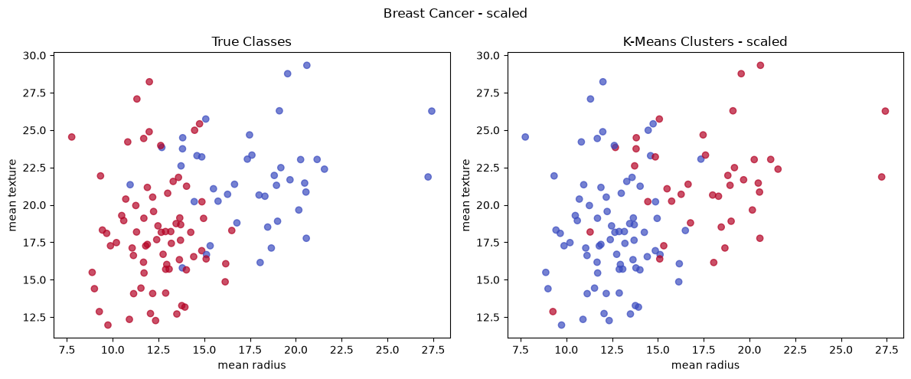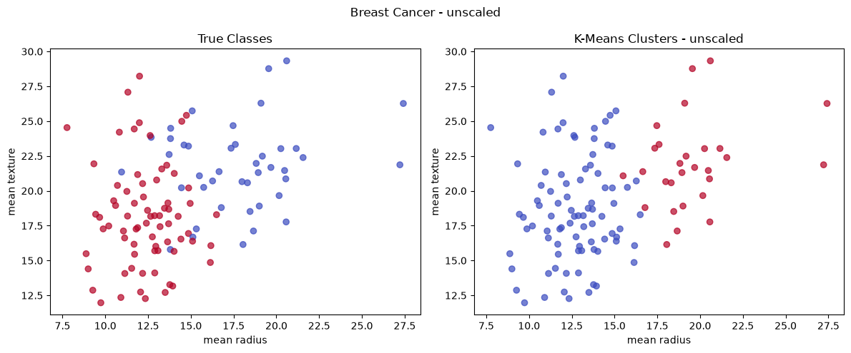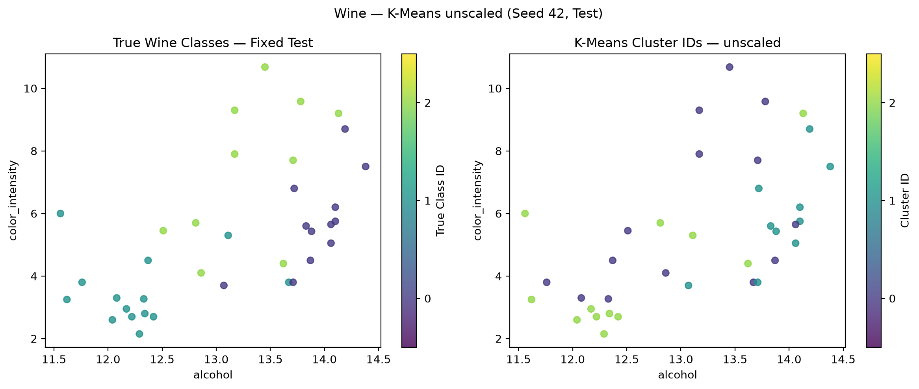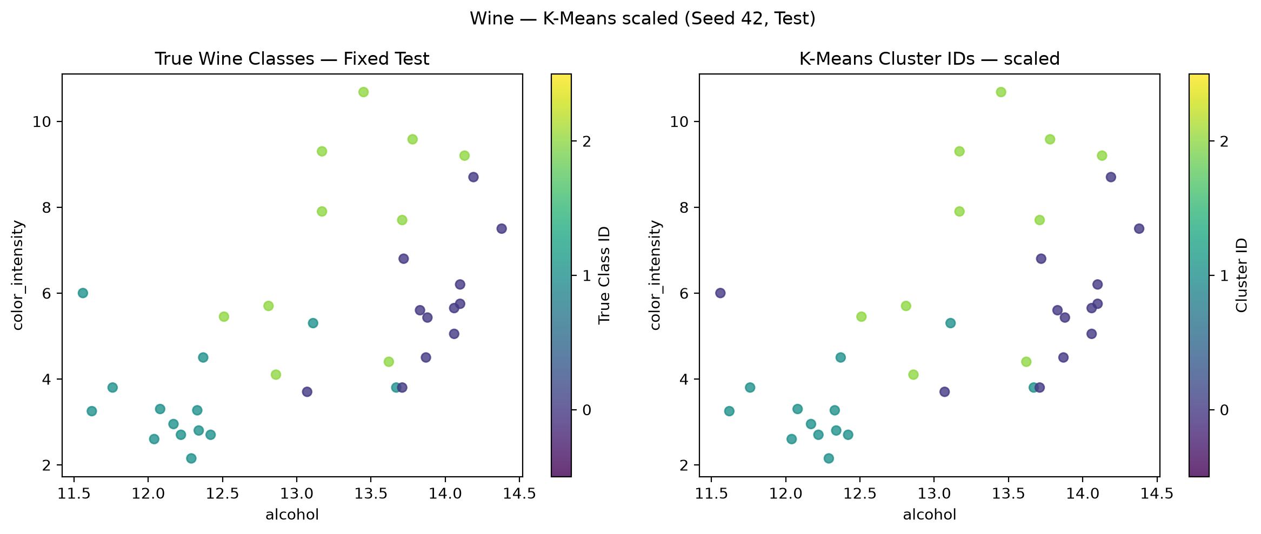
The four graphs compare the true classes with the predicted K-Means clusters on the test sets. The models used all features for training, but the graphs display only two original features. Scaling improved the test ARI from 0.5585 to 0.7354 for Breast Cancer and from 0.3733 to 0.9088 for Wine.

11. Comparing the Two Datasets
1. Was the same classifier and representation selected for both datasets?
Yes, scaled KNN was selected for both datasets. Breast Cancer used k=7, while Wine used k=11.
2. Which algorithm was most affected by scaling?
KNN benefited significantly from scaling. For Breast Cancer, the mean validation Macro-F1 increased from 0.9040 to 0.9677 for k=7.
3. Did deeper trees or larger k values always improve performance?
No. Increasing tree depth or the number of neighbors did not always improve validation performance. Results also varied across the three random seeds.
4. How did classification errors differ between the datasets?
Breast Cancer had three malignant cases incorrectly classified as benign. Wine had no classification errors among its 36 test samples.
5. How did K-Means results differ between the datasets?
Scaling improved test ARI for both datasets. Breast Cancer increased from 0.5585 to 0.7354, while Wine increased from 0.3733 to 0.9088. Wine showed stronger agreement between clusters and true classes after scaling.
6. What would you change in future work?
I would test the models on larger independent datasets to evaluate their generalization performance.

12. Required Run and Output Inventory
Table 11. Submission Outputs
Output | Expected | Actual
Classification runs | 132 | 132
K-Means runs | 12 | 12
Total model fits | 144 | 144
classifier_summary.csv | 44 | 44
classifier_test.csv | 2 | 2
kmeans_summary.csv | 4 | 4
kmeans_test.csv | 4 | 4
CSV files | 6 | 6
PNG figures | At least 18 | 22

Appendix (if needed)
3.1 Descriptive Statistisc Breast Cancer
mean | median | min | max | std | Q1 | Q3
mean radius | 14.127292 | 13.370000 | 6.981000 | 28.11000 | 3.524049 | 11.700000 | 15.780000
mean texture | 19.289649 | 18.840000 | 9.710000 | 39.28000 | 4.301036 | 16.170000 | 21.800000
mean perimeter | 91.969033 | 86.240000 | 43.790000 | 188.50000 | 24.298981 | 75.170000 | 104.100000
mean area | 654.889104 | 551.100000 | 143.500000 | 2501.00000 | 351.914129 | 420.300000 | 782.700000
mean smoothness | 0.096360 | 0.095870 | 0.052630 | 0.16340 | 0.014064 | 0.086370 | 0.105300
mean compactness | 0.104341 | 0.092630 | 0.019380 | 0.34540 | 0.052813 | 0.064920 | 0.130400
mean concavity | 0.088799 | 0.061540 | 0.000000 | 0.42680 | 0.079720 | 0.029560 | 0.130700
mean concave points | 0.048919 | 0.033500 | 0.000000 | 0.20120 | 0.038803 | 0.020310 | 0.074000
mean symmetry | 0.181162 | 0.179200 | 0.106000 | 0.30400 | 0.027414 | 0.161900 | 0.195700
mean fractal dimension | 0.062798 | 0.061540 | 0.049960 | 0.09744 | 0.007060 | 0.057700 | 0.066120
radius error | 0.405172 | 0.324200 | 0.111500 | 2.87300 | 0.277313 | 0.232400 | 0.478900
texture error | 1.216853 | 1.108000 | 0.360200 | 4.88500 | 0.551648 | 0.833900 | 1.474000
perimeter error | 2.866059 | 2.287000 | 0.757000 | 21.98000 | 2.021855 | 1.606000 | 3.357000
area error | 40.337079 | 24.530000 | 6.802000 | 542.20000 | 45.491006 | 17.850000 | 45.190000
smoothness error | 0.007041 | 0.006380 | 0.001713 | 0.03113 | 0.003003 | 0.005169 | 0.008146
compactness error | 0.025478 | 0.020450 | 0.002252 | 0.13540 | 0.017908 | 0.013080 | 0.032450
concavity error | 0.031894 | 0.025890 | 0.000000 | 0.39600 | 0.030186 | 0.015090 | 0.042050
concave points error | 0.011796 | 0.010930 | 0.000000 | 0.05279 | 0.006170 | 0.007638 | 0.014710
symmetry error | 0.020542 | 0.018730 | 0.007882 | 0.07895 | 0.008266 | 0.015160 | 0.023480
fractal dimension error | 0.003795 | 0.003187 | 0.000895 | 0.02984 | 0.002646 | 0.002248 | 0.004558
worst radius | 16.269190 | 14.970000 | 7.930000 | 36.04000 | 4.833242 | 13.010000 | 18.790000
worst texture | 25.677223 | 25.410000 | 12.020000 | 49.54000 | 6.146258 | 21.080000 | 29.720000
worst perimeter | 107.261213 | 97.660000 | 50.410000 | 251.20000 | 33.602542 | 84.110000 | 125.400000
worst area | 880.583128 | 686.500000 | 185.200000 | 4254.00000 | 569.356993 | 515.300000 | 1084.000000
worst smoothness | 0.132369 | 0.131300 | 0.071170 | 0.22260 | 0.022832 | 0.116600 | 0.146000
worst compactness | 0.254265 | 0.211900 | 0.027290 | 1.05800 | 0.157336 | 0.147200 | 0.339100
worst concavity | 0.272188 | 0.226700 | 0.000000 | 1.25200 | 0.208624 | 0.114500 | 0.382900
worst concave points | 0.114606 | 0.099930 | 0.000000 | 0.29100 | 0.065732 | 0.064930 | 0.161400
worst symmetry | 0.290076 | 0.282200 | 0.156500 | 0.66380 | 0.061867 | 0.250400 | 0.317900
worst fractal dimension | 0.083946 | 0.080040 | 0.055040 | 0.20750 | 0.018061 | 0.071460 | 0.092080
3.1 Descriptive Statistisc Wine
 | mean | median | min | max | std | Q1 | Q3
alcohol | 13.000618 | 13.050 | 11.03 | 14.83 | 0.811827 | 12.3625 | 13.6775
malic_acid | 2.336348 | 1.865 | 0.74 | 5.80 | 1.117146 | 1.6025 | 3.0825
ash | 2.366517 | 2.360 | 1.36 | 3.23 | 0.274344 | 2.2100 | 2.5575
alcalinity_of_ash | 19.494944 | 19.500 | 10.60 | 30.00 | 3.339564 | 17.2000 | 21.5000
magnesium | 99.741573 | 98.000 | 70.00 | 162.00 | 14.282484 | 88.0000 | 107.0000
total_phenols | 2.295112 | 2.355 | 0.98 | 3.88 | 0.625851 | 1.7425 | 2.8000
flavanoids | 2.029270 | 2.135 | 0.34 | 5.08 | 0.998859 | 1.2050 | 2.8750
nonflavanoid_phenols | 0.361854 | 0.340 | 0.13 | 0.66 | 0.124453 | 0.2700 | 0.4375
proanthocyanins | 1.590899 | 1.555 | 0.41 | 3.58 | 0.572359 | 1.2500 | 1.9500
color_intensity | 5.058090 | 4.690 | 1.28 | 13.00 | 2.318286 | 3.2200 | 6.2000
hue | 0.957449 | 0.965 | 0.48 | 1.71 | 0.228572 | 0.7825 | 1.1200
od280/od315_of_diluted_wines | 2.611685 | 2.780 | 1.27 | 4.00 | 0.709990 | 1.9375 | 3.1700
proline | 746.893258 | 673.500 | 278.00 | 1680.00 | 314.907474 | 500.5000 | 985.0000

