**THE TECHNICAL UNIVERSITY OF KENYA**

**S.C.I.T: COMPUTER TECHNOLOGY YEAR 2 TERM 4**

**IBL 1. SOFTWARE DEVELOPMENT PROJECT**

**EZEKIEL NJERI : SCCI/01047/2021**

**PROJECT TITLE : DAILY DIARY**

Project uses waterfall methodology and:

The purpose of the journal is to record memories and events that strike and that one would like to keep with them.

Daily Diary will include a mix of written entries, drawings, and photographs.Record any insights or ideas you have, and document any challenges or obstacles you face.

Organization The journal will be organized by date, with each entry corresponding to a specific day. I will also include sections for goals and reflections, where I can track my progress and reflect on my experiences over time

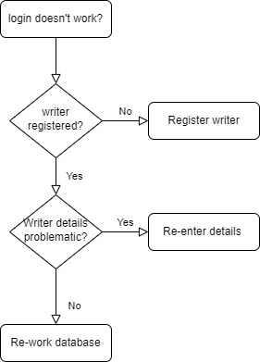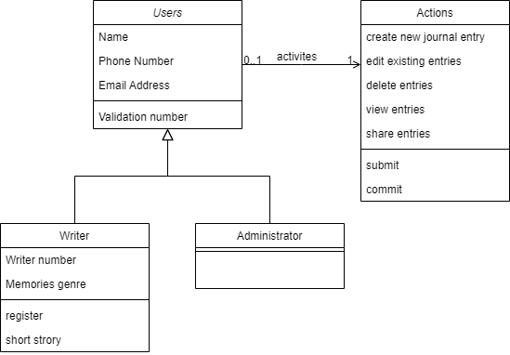

%3CmxGraphModel%3E%3Croot%3E%3CmxCell%20id%3D%220%22%2F%3E%3CmxCell%20id%3D%221%22%20parent%3D%220%22%2F%3E%3CmxCell%20id%3D%222%22%20value%3D%22Review%22%20style%3D%22ellipse%3BwhiteSpace%3Dwrap%3Bhtml%3D1%3B%22%20vertex%3D%221%22%20parent%3D%221%22%3E%3CmxGeometry%20x%3D%22350%22%20y%3D%22340%22%20width%3D%22110%22%20height%3D%2240%22%20as%3D%22geometry%22%2F%3E%3C%2FmxCell%3E%3C%2Froot%3E%3C%2FmxGraphModel%3E%3CmxGraphModel%3E%3Croot%3E%3CmxCell%20id%3D%220%22%2F%3E%3CmxCell%20id%3D%221%22%20parent%3D%220%22%2F%3E%3CmxCell%20id%3D%222%22%20style%3D%22rounded%3D0%3BorthogonalLoop%3D1%3BjettySize%3Dauto%3Bhtml%3D1%3BexitX%3D0.5%3BexitY%3D0.5%3BexitDx%3D0%3BexitDy%3D0%3BexitPerimeter%3D0%3BentryX%3D1%3BentryY%3D0.5%3BentryDx%3D0%3BentryDy%3D0%3BendArrow%3Dnone%3BendFill%3D0%3B%22%20edge%3D%221%22%20parent%3D%221%22%3E%3CmxGeometry%20relative%3D%221%22%20as%3D%22geometry%22%3E%3CmxPoint%20x%3D%22550%22%20y%3D%22490%22%20as%3D%22targetPoint%22%2F%3E%3CmxPoint%20x%3D%22780%22%20y%3D%22595%22%20as%3D%22sourcePoint%22%2F%3E%3C%2FmxGeometry%3E%3C%2FmxCell%3E%3C%2Froot%3E%3C%2FmxGraphModel%