BLOOD BANK MANAGEMENT SYSTEM

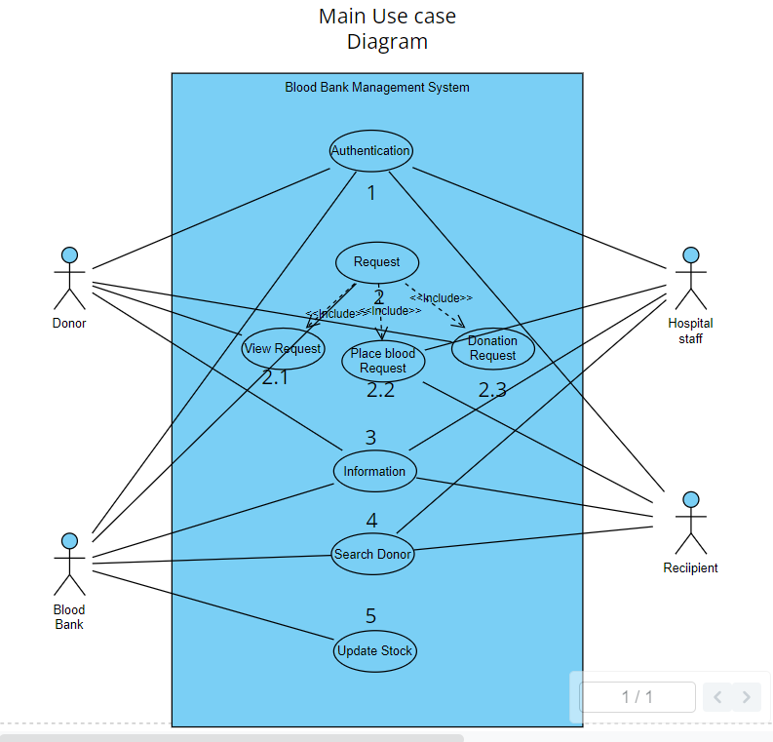

**Introduction:**

The Blood Bank management system consists of the following main use cases.

* Authentication
* Request. (Request management)
* Information. (Contains information about actors)
* Search Donor
* Update stock.

# Use Case Name: Authentication

# 

## Actors

* + - Donor: A person willing to donate blood.
    - Hospital Staff: Medical professionals from hospitals who request blood.
    - Recipient: Individuals or patients in need of blood.
    - Blood Bank: The organization responsible for storing and managing blood donations

## Basic Flow

### Donor Authentication (Registration)

* + - * The Donor accesses the Blood Bank Management System.
      * The system prompts the Donor to enter their email and mobile number and other relevant information
      * The Donor enters their email and mobile number.
      * The system verifies the entered information:
      * If the email and mobile number are not found in the system, the system displays an error message, and the Donor must re-enter their information.
      * If the email and mobile number match a donor record in the system, the system proceeds to Donor functions.

### Donor Authentication (Login)

* + - * If Donor is already registered proceed to login using email and phone number
      * The system verifies the entered information:
      * If the email and mobile number are not found in the system, the system displays an error message, and the Donor must re-enter their information

## Hospital Staff Authentication

### Hospital Staff Authentication (Registration)

* + - * Hospital Staff access the Blood Bank Management System.
      * The system prompts the Hospital Staff to enter their email and mobile number.
      * The Hospital Staff enters their email and mobile number.
      * The system verifies the entered information:
      * If the email and mobile number are not found in the system, the sys- tem displays an error message, and the Hospital Staff must re-enter their information.
      * If the email and mobile number match a hospital staff record in the system, the system proceeds to Hospital Staff functions.

### Hospital Staff Authentication (Login)

* + - * If Hospital Staff is already registered proceed to login using email and phone number
      * If the email and mobile number are not found in the system, the sys- tem displays an error message, and the Hospital Staff must re-enter their information.

## Recipient Authentication

### Recipient Authentication (Registration)

* + - * Recipients access the Blood Bank Management System.
      * The system prompts the Recipient to enter their email and mobile number.
      * The Recipient enters their email and mobile number.
      * The system verifies the entered information:
      * If the email and mobile number are not found in the system, the system displays an error message, and the Recipient must re-enter their informa- tion.
      * If the email and mobile number match a recipient record in the system, the system proceeds to Recipient functions.

### Recipient Authentication (Login)

* + - * If Recipient is already registered proceed to login using email and phone no
      * If the email and mobile number are not found in the system, the system displays an error message, and the Recipient must re-enter their informa- tion.

## Blood Bank Authentication

### Blood Bank Authentication (Registration)

* + - * Blood Bank staff access the Blood Bank Management System.
      * The system prompts the Blood Bank staff to enter their email and mobile number.
      * The Blood Bank staff enters their email and mobile number.
      * The system verifies the entered information:
      * If the email and mobile number are not found in the system, the system displays an error message, and the Blood Bank staff must re-enter their information.
      * If the email and mobile number match a Blood Bank staff record in the system, the system proceeds to Blood Bank staff functions.

### Blood Bank Authentication (Login)

* + - * If Blood Bank is already registered proceed to login using email and phone no
      * If the email and mobile number are not found in the system, the system displays an error message, and the Blood Bank staff must re-enter their information.

# Use Case: Request Management

# 

## Actors

* + - Donor: A person willing to donate blood.
    - Hospital Staff: Medical professionals from hospitals who request blood.
    - Recipient: Individuals or patients in need of blood.
    - Blood Bank: The organization responsible for storing and managing blood donations

## Basic Flow

### View request (actors:all)

* + - * The actors enters the blood bank management system and clicks on view request.
      * The view request shows both online and offline request that were placed by the user.
      * The blood Bank management system also shows the requests that were fulfilled and pending.

### Place request

* + - * Request for blood (only for Hospital staff and Recipients)

1. The actors enters the blood bank management system and clicks on place request.
2. The actors have to enter information regarding the blood group, quantity and other relevant information
3. After entering the information the actors clicks on the place request.
4. The blood bank receives the information and tries to fulfill the re- quest.
5. If the request is fulfilled the blood bank stock inventory is updated. Otherwise it goes to the pending state.
   * + - Request for Donation (only for donors)

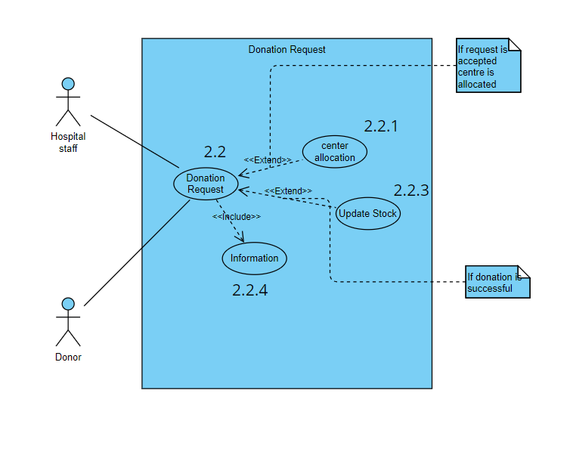

1. The donor enters the blood bank management system and clicks on place request for donation.
2. The actors have to enter information regarding the blood group, quantity and other relevant information like past diseases etc.
3. The blood bank staff checks the information and decides whether the request can be accepted or not.
4. If the request is accepted then a center and time is allocated to the donor.
5. If donation is successful then the blood bank stock is updated.

·

# Use Case: Information Use Case

# 

## Actor

* + - Donor: A person willing to donate blood.
    - Hospital Staff: Medical professionals from hospitals who request blood.
    - Recipient: Individuals or patients in need of blood.
    - Blood Bank: The organization responsible for storing and managing blood donations

## Basic Flow

* + - All the actors enters their Basic information like name, email, phone no. During registration.
    - Except “Past diseases” and “Blood Group” which is exclusively for Donors.

# Use Case: Search Donor

## Actors

* + - Donor: A person willing to donate blood.
    - Hospital Staff: Medical professionals from hospitals who request blood.
    - Recipient: Individuals or patients in need of blood.
    - Blood Bank: The organization responsible for storing and managing blood donations

## Basic Flow

* + - 1. Hospital Staff Initiates Donor Search: A member of the hospital staff logs into the Blood Bank Management System.
    - Hospital Staff Selects ”Search Donor” Option: From their dashboard, the hospital staff selects the ”Search Donor” option.
    - Hospital Staff Specifies Search Criteria: The system presents the hospital staff with a search form that includes criteria such as:

1. Blood Type Needed
2. Donor’s Location (optional)
3. Availability (if the donor is currently eligible to donate)
4. Compatibility (e.g., Rh factor matching)
   * + Hospital Staff Enters Search Criteria: The hospital staff enters the specific criteria into the search form based on the recipient’s requirements.
     + Hospital Staff Initiates Search: After entering the search criteria, the hos- pital staff initiates the search.
     + Blood Bank Management System Retrieves Matching Donors: The system processes the search criteria and retrieves a list of potential blood donors who match the specified criteria.
     + Hospital Staff Reviews Search Results: The system presents the hospital staff with a list of matching donors, including their contact information and eligibility status.
     + Hospital Staff Contacts Potential Donors: The hospital staff contacts the potential donors from the list to inquire about their availability and will- ingness to donate blood.
     + Blood Donor Responds: Donors who are contacted respond to the hospital staff, indicating whether they are available and willing to donate.
     + Recipient Receives Blood Donation: If a donor confirms their availability and willingness to donate, the recipient is informed, and arrangements are made for the blood donation to take place at the hospital.
     + Recipient Receives Blood Transfusion: The recipient receives the required blood transfusion based on the successful coordination with the willing donor.
     + Use Case Ends: The hospital staff, recipient, and donor can continue their respective activities, and the system keeps track of the donor search history.

# Use Case Name: Update Stock

## Actors

* + - Blood Bank Staff: The personnel responsible for managing the blood bank’s inventory.
    - Hospital Staff: Employees from hospitals who provide information about new blood requirements and successful blood donations.
    - Blood Bank Management System: The software system used for managing the blood inventory.

## Basic Flow

* + - Blood Bank Staff Initiates Stock Update: A member of the blood bank staff logs into the Blood Bank Management System.
    - Blood Bank Staff Selects ”Update Stock” Option: From their dashboard, the blood bank staff selects the ”Update Stock” option.
    - Blood Bank Staff Submits Stock Update: After entering the relevant in- formation, the blood bank staff submits the stock update.
    - Blood Bank Management System Updates Inventory:The system processes the submitted information and updates the blood inventory accordingly:

1. It increments the quantity of the specified blood type with the re- ceived quantity.
2. It decrements the quantity of the specified blood type with any ex- pired or transferred units.
   * + Blood Bank Staff Receives Confirmation Message: The system generates a confirmation message to inform the blood bank staff that the inventory update has been successfully processed.
     + Hospital Staff Initiates Blood Request: A member of the hospital staff logs into the Blood Bank Management System.
     + Hospital Staff Selects ”Blood Request” Option: From their dashboard, the hospital staff selects the ”Blood Request” option.
     + Hospital Staff Submits New Blood Request: The hospital staff submits a new blood request, specifying the required blood type and the quantity needed for their patients.
     + Blood Bank Management System Processes Request: The system receives the blood request and verifies if the requested blood type and quantity are available in the inventory.
     + Blood Bank Management System Updates Inventory for Blood Transfer: If the requested blood type and quantity are available, the system auto- matically reserves the units for the hospital and decrements the inventory accordingly.
     + Hospital Staff Receives Confirmation of Blood Reservation: The system generates a confirmation message for the hospital staff, confirming the reservation of the requested blood units.
     + Use Case Ends: The blood bank staff and hospital staff can continue managing inventory updates and blood requests as needed.