Curriculum Vitae |  | 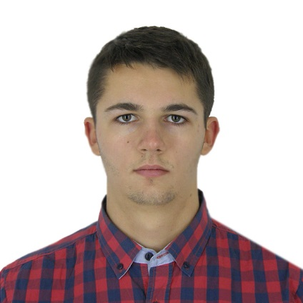
Personal information
First name / Surname |  | Anatoliy Mazur
Mobile |  | +38 0631815019
E-mail |  | mail4tolik@gmail.com
Nationality |  | Ukrainian
Place and date of birth |  | Lviv, Ukraine -30 March 1996
Professional experience
Dates |  | June 2016 – September 2016 (3 months)
Company |  | American Pools (Maryland, USA)
Occupation and activities |  | Lifeguard
Dates |  | June 2017 – August 2017 (2 months)
Company |  | EPAM (Lviv, Ukraine)
Occupation and activities |  | Student in Front-end JS course  I had experience with HTML, HTML5, CSS, Responsive Design, Preprocessors, CSS and HTML frameworks, basics of JS, DOM, Node.js, AJAX.
Education
Dates |  | September 2014 – July 2018 (Bachelor degree)
Name of the course |  | Institute of Computer Sciences and Information Technologies
University |  | Lviv National Polytechnic University (Lviv, Ukraine)
Personal skills and competences
Languages |  | - English (Upper-Intermediate) IELTS exam (13/05/2013): Overall Score 7.  - Russian (Fluent)  - Ukrainian (native)
Hobbies and Interests |  | - Travelling  - Social life  - Gym
Portfolio |  | - http://pamyat.zzz.com.ua/ - practice work in the University, all Front-end.  - https://github.com/Souverin/Homework - My homework in Epam

