- RAG
Resources:
Project Structure:
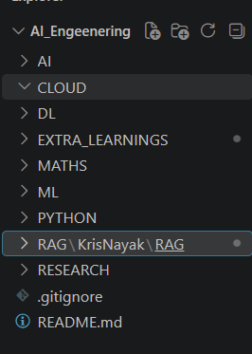
Queries:
- Why my environment is not visible in the notebook?
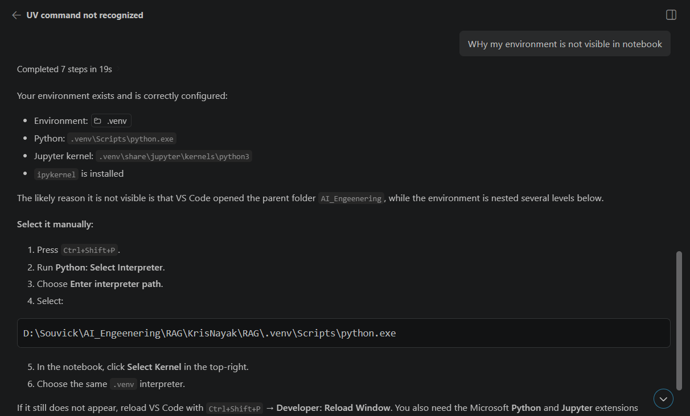
- Why from langchain.text_splitter import() is not working?
