PROJECT REPORT
Movie Recommendation System
A Content-Based Recommender with a Streamlit Web Interface
Data Analytics with AI Internship
Submitted by: Souvik Saha
Date: 24-09-2026

Table of Contents
1. Abstract
2. Introduction
3. Dataset Description
4. Tools and Technologies
5. System Design and Methodology
6. Data Preprocessing
7. Exploratory Data Analysis
8. Model Building
9. Application Implementation
10. Results and Evaluation
11. Testing and Issues Resolved
12. Limitations
13. Future Scope
14. Conclusion
15. References
Appendix A: Setup and Run Instructions

1. Abstract
Choosing what to watch is difficult when thousands of titles are available. This project builds a content-based movie recommendation system that suggests movies similar to one the user already likes. Using the TMDB 5000 Movies dataset (4,803 movies), each movie is described by a text profile made of its keywords, plot overview, lead actors, director and genres. The text is cleaned, stemmed and converted into a bag-of-words matrix, and movies are ranked by cosine similarity.
The system is delivered as a Streamlit web application that lets users search for a movie, view its details, get six similar movies with a match score, open a trailer search, and keep a watchlist. On a check across 4,775 movies, 91.7% of recommendations shared at least one genre with the query movie, against 49.8% for random picks. Each recommendation takes about 6 ms to compute.

2. Introduction

2.1 Background
Recommender systems help users navigate large catalogues and are used by streaming, e-commerce and music platforms. Two broad approaches exist: collaborative filtering, which uses the behaviour of many users, and content-based filtering, which uses the attributes of the items themselves. Content-based filtering works without any user history, so it can recommend from the very first search.

2.2 Problem Statement
Given a movie chosen by the user, recommend a small set of other movies that are most similar in content, and present them in an interactive interface that is easy to use without any technical knowledge.

2.3 Objectives
- Clean and combine the TMDB movie and credit data into a single analysis-ready table.
- Explore the dataset to understand genres, ratings, release years and data quality.
- Build a content-based recommender using text vectorization and cosine similarity.
- Evaluate the recommendations against a random baseline.
- Deliver the system as a Streamlit application contained in a single Python file.

2.4 Scope
The system recommends only from the 4,803 movies in the dataset, using their metadata. It does not use user ratings, viewing history or accounts. It is a learning project and is not intended as a production streaming service.

3. Dataset Description
The project uses the TMDB 5000 Movie Dataset, published on Kaggle and generated from The Movie Database (TMDB) API. It contains two CSV files that describe the same 4,803 movies.
Table 1: Dataset files
File | Rows | Columns | Columns used in this project
tmdb_5000_movies.csv | 4,803 | 20 | id, title, overview, genres, keywords, release_date, runtime, vote_average, popularity, tagline
tmdb_5000_credits.csv | 4,803 | 4 | movie_id, cast, crew

The movies span 1916 to 2017. The genres, keywords, cast and crew columns store lists as text (JSON-like strings) and must be parsed before use. Data quality was checked before modelling:
Table 2: Data quality findings and how each was handled
Finding | Count | Handling
Missing overview | 3 | Replaced with an empty string
Missing release date | 1 | Displayed as N/A
Missing runtime | 2 | Displayed as N/A
Missing tagline | 844 | Hidden in the interface when empty
Missing homepage | 3,091 | Column not used
Movies with no keywords | 412 | Still recommended using overview, cast, director and genres
Movies with no director listed | 30 | Director omitted from the tags
Movies with zero votes | 62 | Kept; excluded only from rating charts
Duplicate titles (e.g. Batman, The Host) | 3 | Movies identified by unique id, not title

4. Tools and Technologies
Table 3: Technologies used
Technology | Purpose
Python 3.10+ | Programming language for data preparation, model and application
pandas, NumPy | Data loading, merging, cleaning and numerical operations
scikit-learn | CountVectorizer (text to vectors) and cosine_similarity
NLTK (PorterStemmer) | Stemming words to their root form
Streamlit | Web interface: search, cards, buttons, sidebar
requests + TMDB API | Optional movie posters, fetched by movie id
Jupyter Notebook | Initial data exploration and prototyping
matplotlib | Charts used in this report

5. System Design and Methodology
The system follows a straightforward pipeline, shown in Figure 1. Data is prepared once when the application starts and cached, so later searches respond immediately.
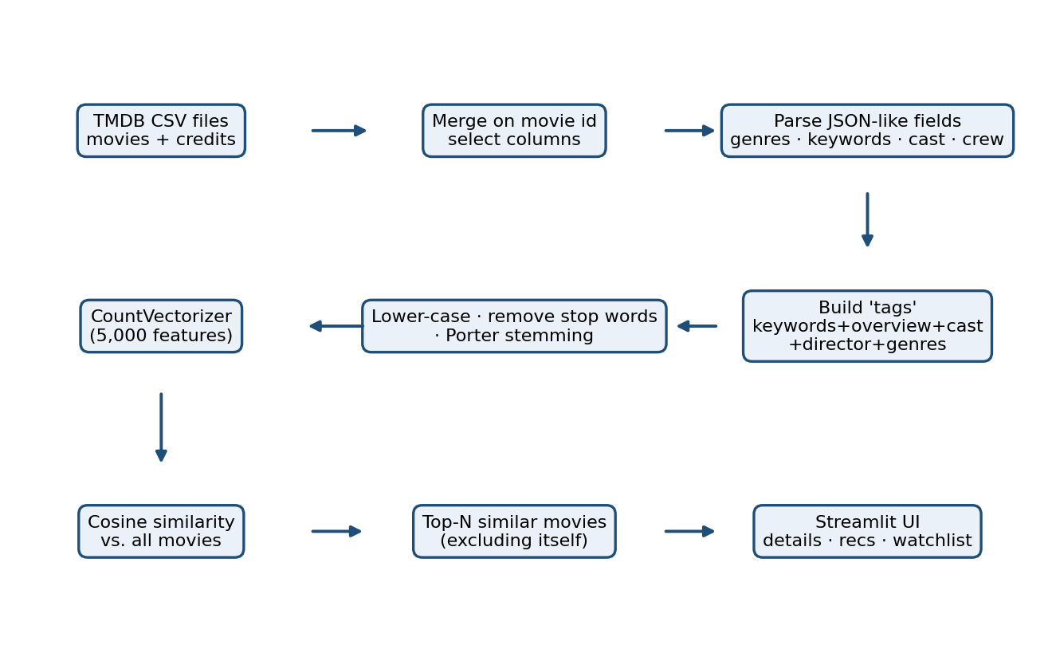
Figure 1: End-to-end pipeline of the recommendation system
Why content-based filtering? The dataset holds rich descriptive information but no user ratings, so collaborative filtering is not possible. Content-based filtering also explains its results naturally: two movies are similar because they share themes, people and genres.

6. Data Preprocessing
Table 4: Preprocessing steps
# | Step | Detail and reason
1 | Merge the two files | Joined on the unique movie id. Joining on title created duplicate rows (4,809 instead of 4,803).
2 | Parse list columns | genres, keywords, cast and crew were converted from text to Python lists using ast.literal_eval.
3 | Select relevant people | Top three cast members and the director only, to keep the profile focused.
4 | Remove spaces inside names | "Sam Worthington" becomes "SamWorthington" so each person is one token and two people sharing a first name are not confused.
5 | Combine into tags | keywords + overview + cast + director + genres joined into one text field per movie.
6 | Lower-case | Ensures "Action" and "action" are the same word.
7 | Remove stop words | Common words (the, was, his) carry no meaning for similarity.
8 | Stemming | Porter stemmer reduces words to a root (dancing, dance to danc), so related forms match.

The order of steps 7 and 8 matters. Stemming turns "was" into "wa" and "his" into "hi", which are no longer recognised as stop words. Stop words are therefore removed before stemming. Example of a final tag string for the movie Avatar (shortened):
cultureclash futur spacewar spacecoloni societi spacetravel ... samworthington zoesaldana sigourneyweav jamescameron action adventur fantasi sciencefict
After processing, each movie has on average 42.7 tokens in its profile.

7. Exploratory Data Analysis
Exploratory analysis was carried out to understand the catalogue that the recommender draws from. The dataset uses 20 genres and contains 9,813 distinct keywords.
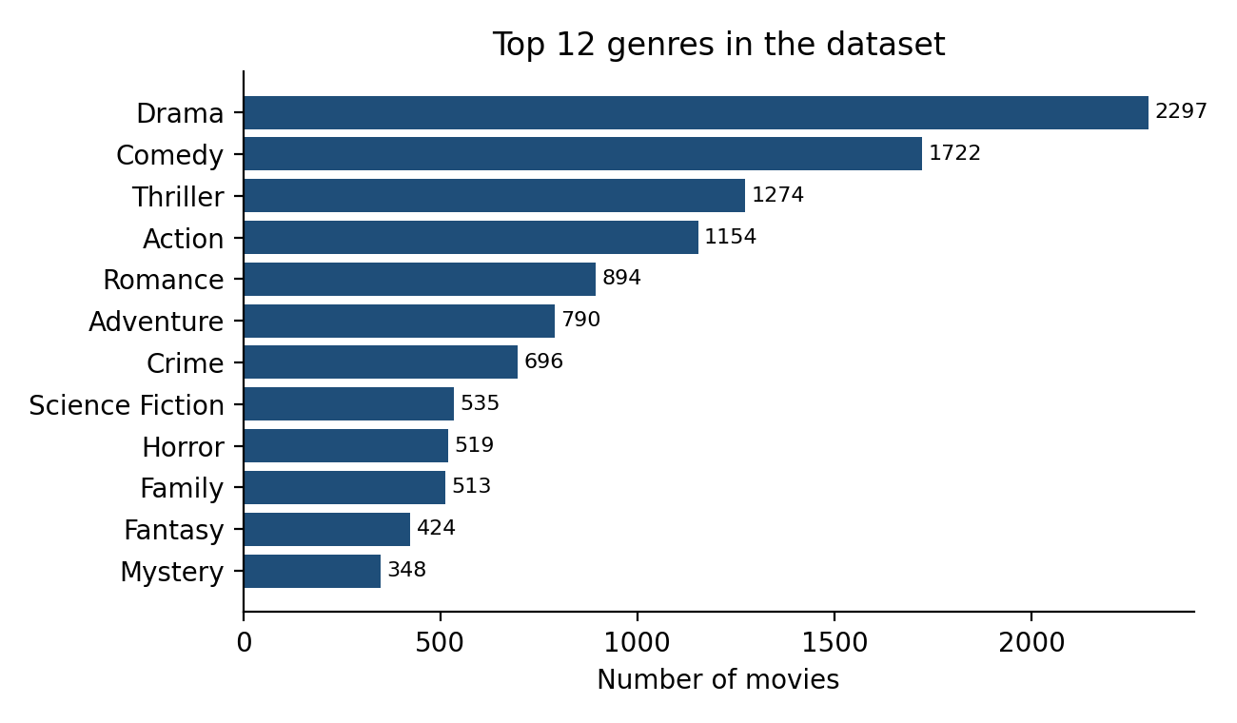
Figure 2: Most common genres (a movie can have several)
Drama (2,297 movies) and Comedy (1,722) dominate, followed by Thriller and Action. Because many movies carry several genres, genre labels alone are too coarse to separate movies well, which is why keywords, cast and plot text are added to the profile.
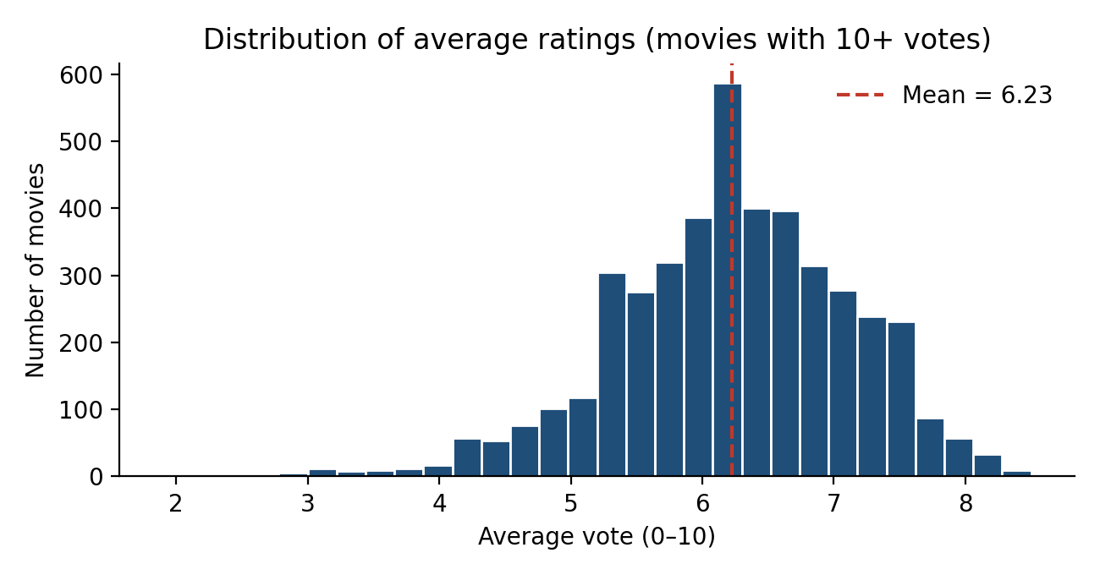
Figure 3: Distribution of average ratings for movies with at least 10 votes
Ratings are roughly bell-shaped with a mean of 6.23 across 4,392 movies that have 10 or more votes. Very few movies score below 4 or above 8, so the ratings shown next to recommendations differ only modestly between movies.
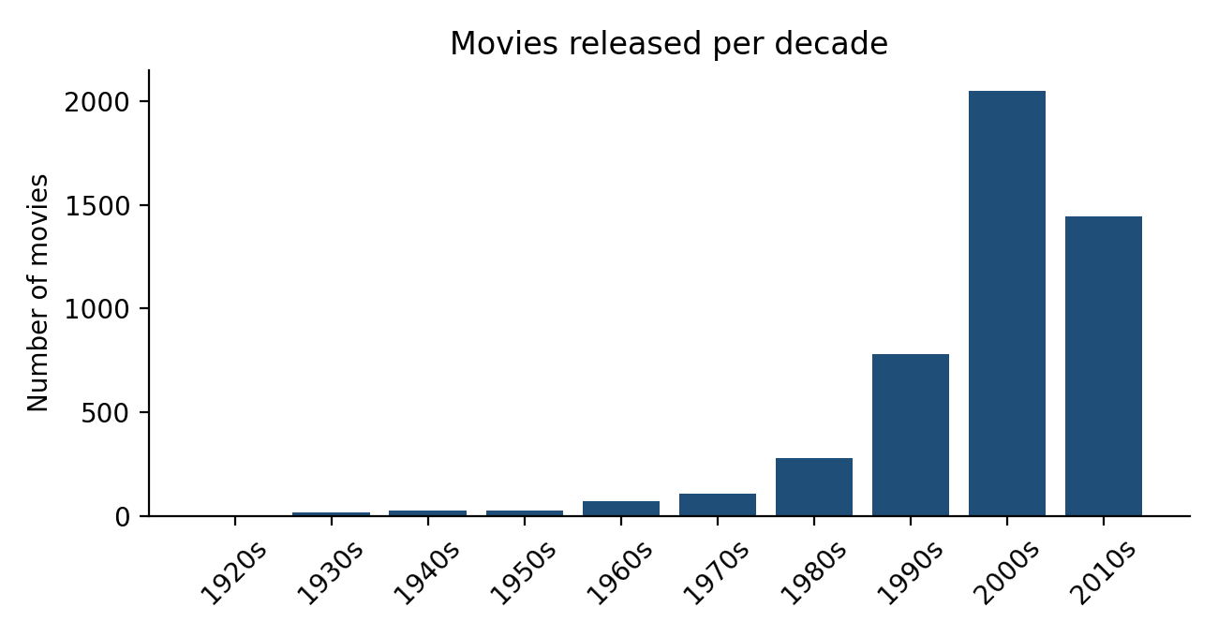
Figure 4: Number of movies released in each decade
The catalogue is heavily weighted towards recent decades: 2,048 movies come from the 2000s and 1,446 from the 2010s, while each decade before 1980 has fewer than 110. Recommendations therefore lean towards modern films.
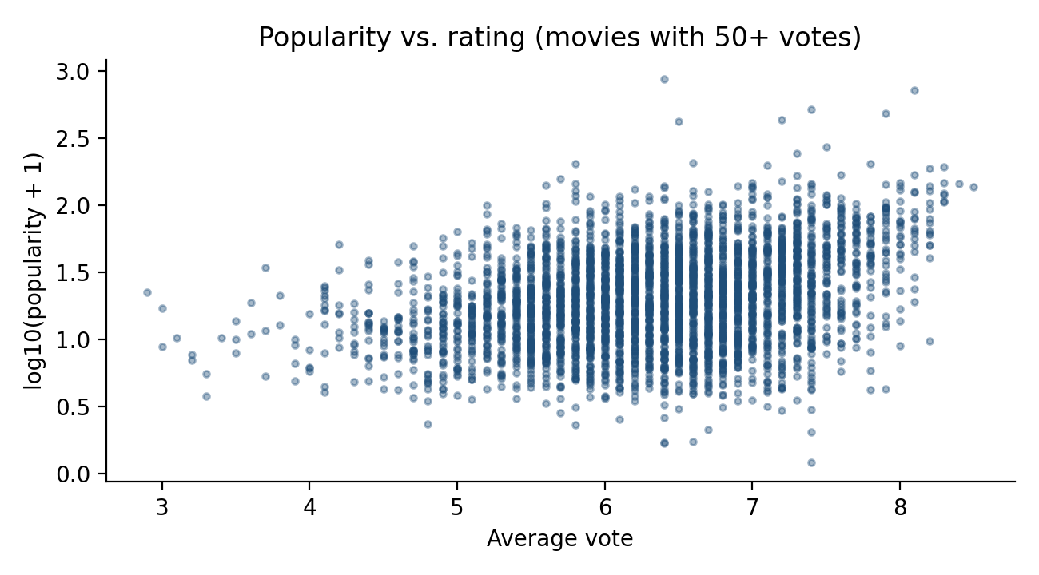
Figure 5: Popularity (log scale) against average rating
Popularity and rating are positively but only moderately related (correlation 0.32), so popular movies are not always the best rated. Other observations: 93.8% of movies are originally in English, the median runtime is 103 minutes, and the most frequent director is Steven Spielberg (27 movies).

8. Model Building

8.1 Vectorization
Each movie's tag text is converted into a numeric vector with scikit-learn's CountVectorizer, limited to the 5,000 most frequent words, with English stop words removed. Every vector position is the number of times a word appears in that movie's profile.
The result is a 4,803 × 5,000 matrix in which only 0.58% of the entries are non-zero. It is therefore stored as a sparse matrix, which needs very little memory.

8.2 Cosine similarity
Two movies are compared by the angle between their vectors. A score of 1 means identical word profiles and 0 means nothing in common:
similarity(A, B) = (A · B) / (‖A‖ × ‖B‖)
Cosine similarity is suitable because it depends on the direction of the vectors and not their length, so a movie with a long overview is not favoured over one with a short overview.

8.3 Generating recommendations
When a movie is selected, its similarity to all other movies is calculated on demand and the six highest scores are returned. The movie itself is excluded. Computing similarity on demand, rather than storing the full 4,803 × 4,803 matrix (about 185 MB), keeps the application small and fast: a query takes about 6 ms.

9. Application Implementation
The entire system is contained in one Python file, organised in clearly commented sections:
Table 5: Structure of the application file
Section | Contents
1. Data preparation | Loading, merging, parsing, tag creation, stemming, vectorization (cached with st.cache_resource)
2. Recommendation logic | recommend() returns the top-N similar movies; search_movies() finds matching titles
3. Posters | fetch_poster() gets a poster from the TMDB API using the movie id (cached, optional)
4. UI components | header(), movie_card(), movie_details() and callbacks for selection and the watchlist
5. Application | main() connects the search box, results, details, recommendations and sidebar

Main features
- Search by title, case-insensitive. When several movies match, a dropdown lists them with their release year, which separates films such as Batman (1989) and Batman (1966).
- Details panel with rating, runtime, genres, tagline, overview, director, stars and a trailer search link.
- Six recommendations shown as cards with rating, genres and a match percentage. Clicking View details on any card jumps to that movie, so users can keep exploring.
- Popular picks on the home screen before any search.
- Watchlist kept in the sidebar during the session.
- Optional posters. With a free TMDB API key the app shows posters; without it a placeholder is used and everything else works.
- Clear error message if the dataset files are missing.

[Insert screenshot: home screen with the search box and Popular picks]
Figure 6: Home screen

[Insert screenshot: search results with the movie details panel]
Figure 7: Movie details for a selected movie

[Insert screenshot: Recommended Movies row with match percentages and the sidebar watchlist]
Figure 8: Recommendations and watchlist

10. Results and Evaluation

10.1 Sample recommendations
Table 6: Top six recommendations for three query movies (match % in brackets)
Rank | Batman Begins | Toy Story | The Godfather
1 | The Dark Knight (39%) | Toy Story 3 (44%) | The Godfather: Part II (39%)
2 | The Dark Knight Rises (33%) | Toy Story 2 (43%) | Blood Ties (31%)
3 | Batman v Superman: Dawn of Justice (31%) | Small Soldiers (17%) | Easy Money (30%)
4 | Batman & Robin (28%) | Stuart Little 2 (16%) | Amidst the Devil's Wings (29%)
5 | Amidst the Devil's Wings (28%) | Rio (16%) | Nine Queens (28%)
6 | Batman (27%) | The Lego Movie (16%) | The Godfather: Part III (27%)

The results are sensible. Batman Begins returns the other Batman films, Toy Story returns its two sequels followed by other family films, and The Godfather returns its two sequels. Some results, such as "Amidst the Devil's Wings" for Batman Begins, are driven by shared keywords and cast rather than an obvious relationship.

10.2 Quantitative check
No user feedback is available, so a proxy check was used: for each of the 4,775 movies that have at least one genre, the six recommendations were compared with six randomly chosen movies.
Table 7: Recommendations versus a random baseline
Metric | Random baseline | This model
Average genre overlap (Jaccard index) | 0.17 | 0.52
Recommendations sharing at least one genre | 49.8% | 91.7%
Recommendations by the same director | 0.07% | 2.4%
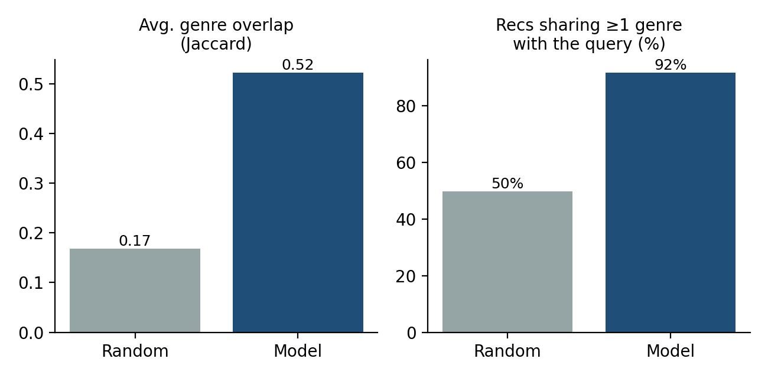
Figure 9: Genre-based comparison with random recommendations
The model is about three times better than random on genre overlap (0.52 against 0.17). Important caveat: genres are one of the ingredients of the tags, so this check confirms that the model behaves as designed but is not an independent measure of recommendation quality. The absolute similarity scores are modest (the top match averages 0.3), which is normal for sparse word-count vectors.

11. Testing and Issues Resolved

11.1 Issues found in the first prototype
Reviewing the initial notebook and application code revealed several problems that were corrected in the final version:
Table 8: Issues found and fixes applied
Issue | Fix
Merging on title produced 4,809 rows (spurious duplicates) | Merge on the unique id; the result has the correct 4,803 rows
Stemming was applied after the vectors were built, so it had no effect on similarity | Stemming moved before vectorization
Stemmed stop words ("was" to "wa") distorted scores; an unrelated movie (10th & Wolf) was recommended for Batman Begins | Stop words removed before stemming
The selected movie appeared in its own recommendations (list slice started at 0) | The query movie is excluded from results
Looking up movies by title picked the wrong film when titles repeat | Movies are selected by row index and shown with their year
Precomputed similarity file of about 185 MB, too large to share or deploy | Sparse matrix with on-demand similarity; no pickle files needed
Stored selection could cause an error after a new search | Selection is reset whenever the search text changes

11.2 Functional testing
The final application was tested with the full dataset by simulating user actions:
Table 9: Functional test cases
Test | Expected behaviour | Result
Open the app | Six popular movies are displayed | Pass
Search "Batman Begins" | Details shown; six recommendations; movie not among them | Pass
Search "batman" | Dropdown lists several films, including both 1989 and 1966 Batman | Pass
Click View details on a recommendation | Details and search box update to that movie | Pass
Search text with no match | Friendly warning, no error | Pass
Change the search after selecting a movie | New results appear without error | Pass
Clear the search box | Returns to popular picks | Pass
Add a movie to the watchlist | Movie appears in the sidebar | Pass
Run without a TMDB API key | Placeholder shown instead of posters; all else works | Pass
Run without the CSV files | Clear error message explaining how to fix it | Pass

12. Limitations
- Word overlap, not meaning. The model matches shared words and names, so it can miss movies that are similar in theme but described differently. For example, the top matches for Inception (about 20% similarity) include 12 Rounds and Duplex, which are not obviously related.
- No personalisation. Recommendations depend only on the chosen movie, not on the user's taste or history.
- Dated and skewed data. The dataset ends in 2017, is 94% English-language, and is concentrated in the 2000s and 2010s.
- Limited evaluation. The genre-based check is partly circular, and no user study was conducted.
- Session-only watchlist. The watchlist is lost when the browser session ends.
- Posters need an API key. Without one, a placeholder is shown.

13. Future Scope
- Replace CountVectorizer with TF-IDF or sentence embeddings so that meaning, not just word overlap, drives similarity.
- Build a hybrid recommender by adding rating data (for example MovieLens) and collaborative filtering.
- Add filters for genre, year, language and minimum rating.
- Explain each recommendation by showing the shared keywords, cast or director.
- Store the watchlist permanently and add user accounts.
- Deploy the application on Streamlit Community Cloud and collect user feedback for a proper evaluation.

14. Conclusion
This project delivered a working content-based movie recommender, from raw data to an interactive web application. The dataset was merged and cleaned, explored, converted into text profiles, and used to rank similar movies with cosine similarity. The recommendations were clearly better than random on the proxy metrics (91.7% against 49.8% genre agreement) and are returned in milliseconds.
Reviewing and testing the prototype also produced practical lessons: merge on unique identifiers rather than titles, apply text-cleaning steps in the right order, and avoid storing large precomputed matrices when they can be computed on demand. The result is a compact single-file project that is easy to run, explain and extend.

15. References
- TMDB 5000 Movie Dataset, Kaggle. https://www.kaggle.com/datasets/tmdb/tmdb-movie-metadata
- The Movie Database (TMDB) API documentation. https://developer.themoviedb.org/
- Streamlit documentation. https://docs.streamlit.io/
- scikit-learn documentation: CountVectorizer and cosine_similarity. https://scikit-learn.org/
- NLTK documentation: Porter stemmer. https://www.nltk.org/
- Porter, M. F. (1980). An algorithm for suffix stripping. Program, 14(3), 130–137.
- Ricci, F., Rokach, L., & Shapira, B. (Eds.). Recommender Systems Handbook. Springer.

Appendix A: Setup and Run Instructions
Files required in one folder: the application file (YourName_MovieRecommender.py), tmdb_5000_movies.csv and tmdb_5000_credits.csv (a data sub-folder also works), and requirements.txt.
pip install -r requirements.txt
streamlit run YourName_MovieRecommender.py
The first launch takes roughly 20 seconds while the model is built; it is cached afterwards. For posters, paste a free TMDB API key into the sidebar box or set the TMDB_API_KEY environment variable.

