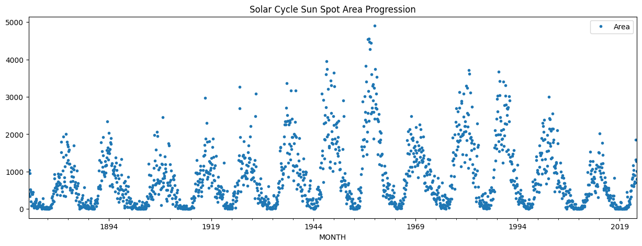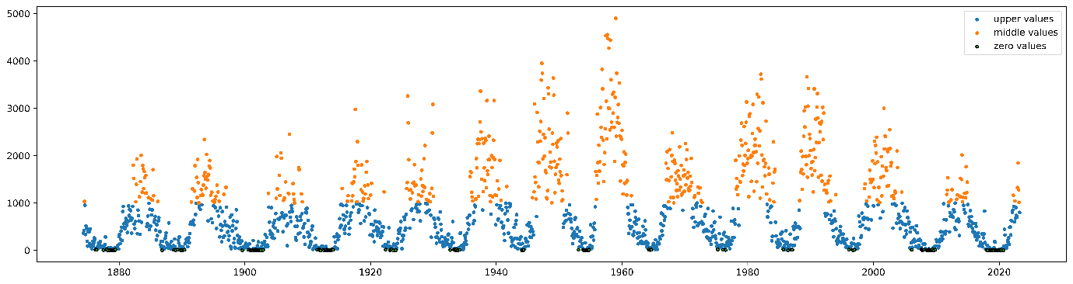

|  |  |  |  |  |  |  |  |
| --- | --- | --- | --- | --- | --- | --- | --- |
| Method | Train-Test Split | Window Size | R2 Score | MAPE | RMSE | Peak | Time |
| Support Vector Regressor | 90-10 | 96 | 0.6347 |  | 184.43 | 639.20 | Dec-23 |
| Linear Regression(Ridge Model) | 90-10 | 96 | 0.6062 |  | 195.80 | 1272.25 | Dec-23 |
| Stochastic Gradient Descent | 90-10 | 96 | 0.6267 |  | 191.81 | 1254.66 | Dec-23 |
| XGBoost | 90-10 | 96 | 0.7159 |  | 186.62 | 1735.79 | Oct-23 |
| Random Forest | 90-10 | 96 | 0.7579 | 0.5969 | 174.65 | 1864.68 | Jan-24 |
| CatBoost | 90-10 | 96 | 0.6248 | 0.6592 | 190.81 | 1127.90 | Mar-24 |
| Histogram Gradient Boosting | 90-10 | 96 | 0.7169 | 0.7269 | 173.17 | 1718.32 | May-24 |
| Light Gradient Boosting Machine | 90-10 | 96 | 0.7439 | 0.6149 | 182.46 | 2074.05 | Dec-24 |
|  |  |  |  |  |  |  |  |
|  |  |  |  |  |  |  |  |
|  |  |  |  |  |  |  |  |

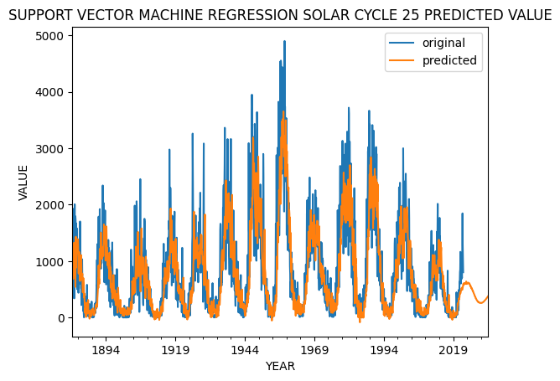

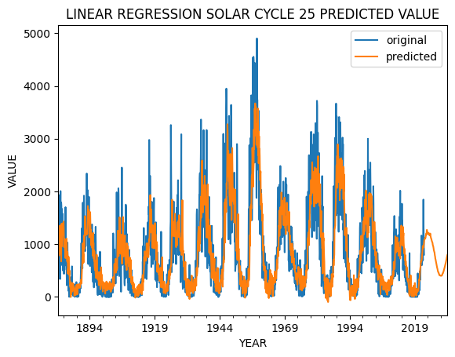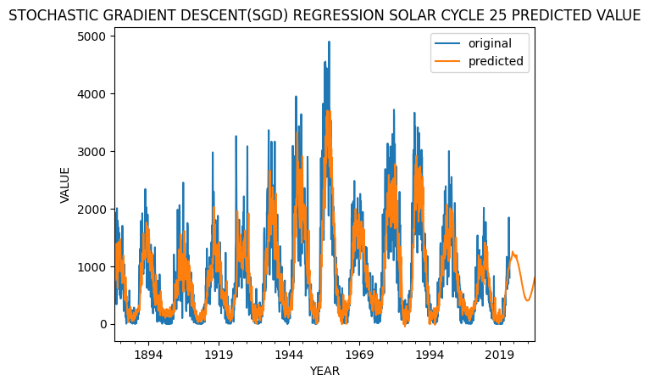 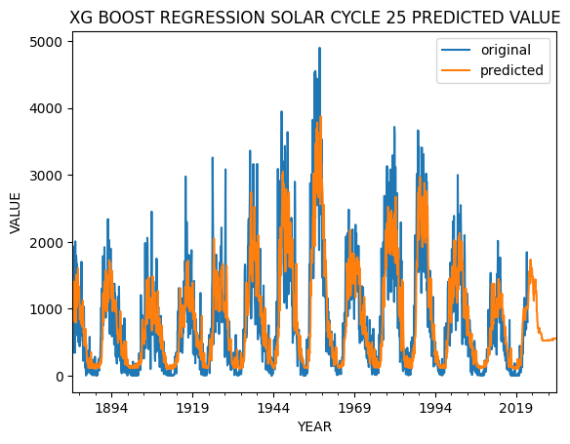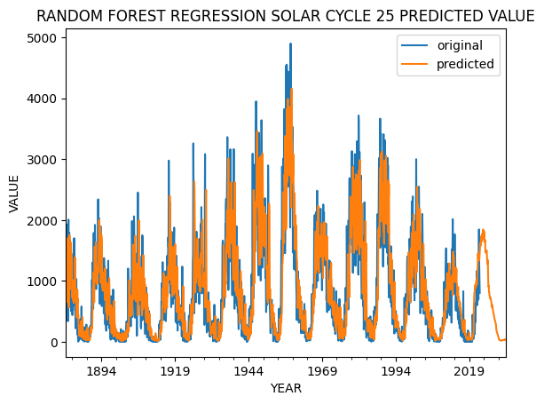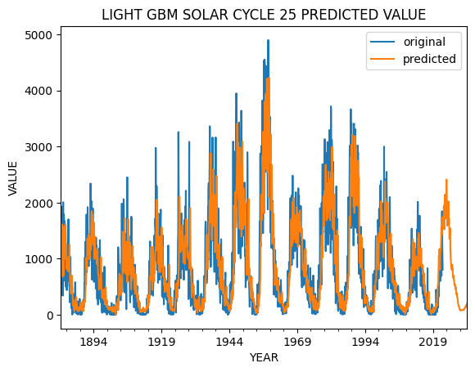

|  |  |  |  |  |  |  |  |
| --- | --- | --- | --- | --- | --- | --- | --- |
| Method | Train-Test Split | Window Size | R2 Score | MAPE | RMSE | Peak | Time |
| Random Forest | 1874-2008:2008-2023 | 96 | 0.7768 | 0.5731 | 167.58 | 1944.86 | May-24 |
| 1874-1996:1996-2023 | 96 | 0.6604 | 0.5304 | 225.92 | 1944.92 | Jan-24 |
| 1874-1996:1996-2023 | 120 | 0.6829 | 0.5234 | 238.45 | 1171.60 | Jul-23 |
| 1874-1986:1986-2023 | 96 | 0.6955 | 0.4839 | 295.87 | 1802.55 | Jan-24 |

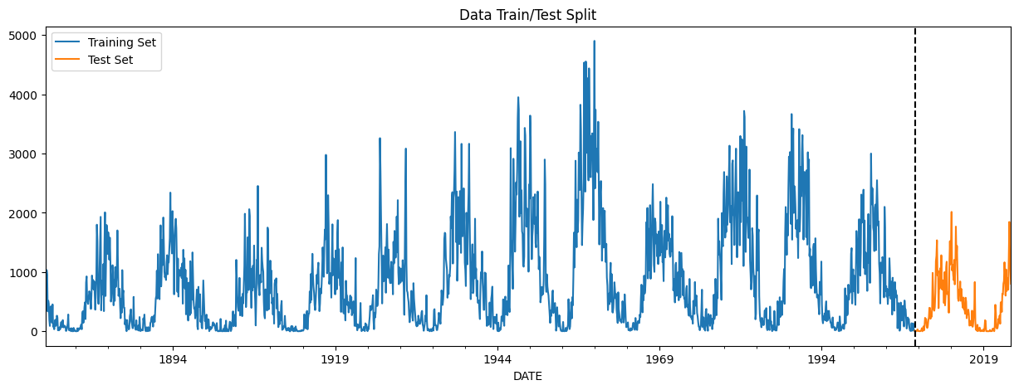 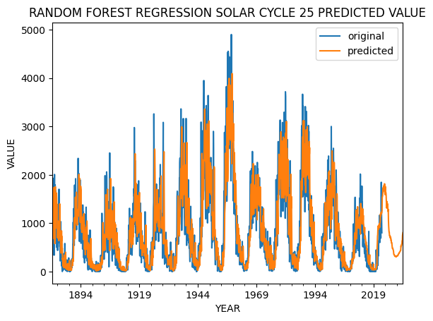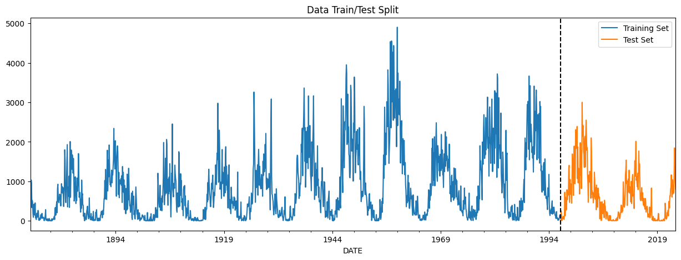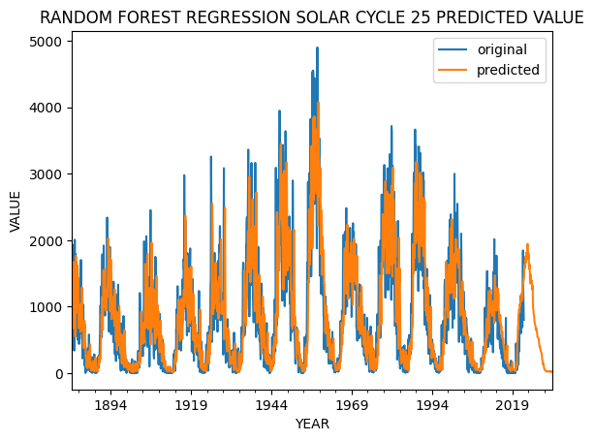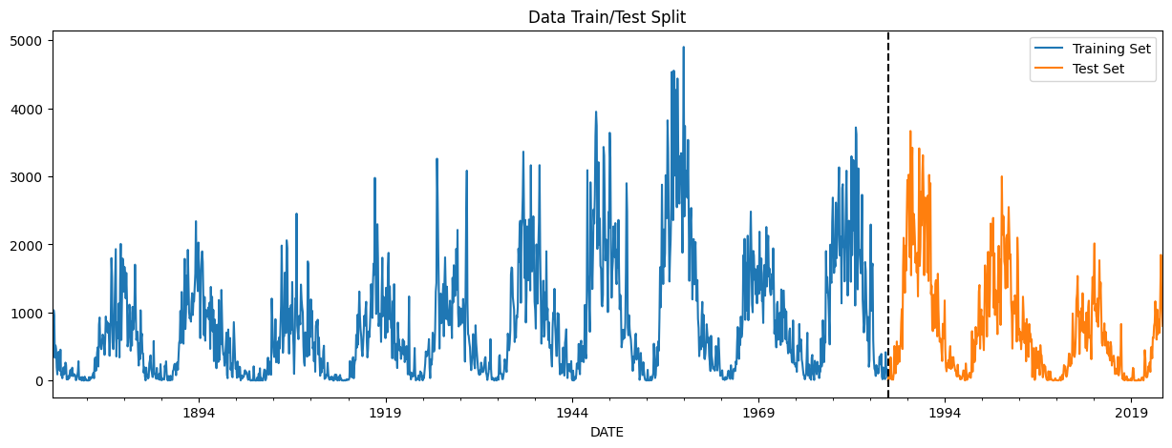 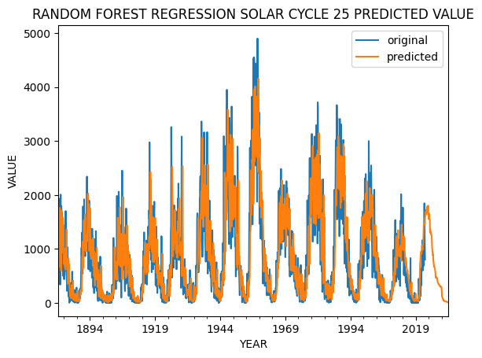

|  |  |  |  |  |  |  |  |
| --- | --- | --- | --- | --- | --- | --- | --- |
| Method | Train-Test Split | Window Size | R2 Score | MAPE | RMSE | Peak | Time |
| Random Forest | 1874-2008:2008-2023 | 96 | 0.7566 | 0.5847 | 173.42 | 1736.49 | Jun-24 |
| 1874-2018:2018-2033 | 96 | 0.9938 | 0.0494 | 18.33 | 911.45 | Jul-36 |
| XGBOOST | 1874-2008:2008-2023 | 96 | 0.7121 | 0.6167 | 180.53 | 1587.82 | May-24 |
| 1874-2018:2018-2033 | 96 | 0.9848 | 0.0683 | 24.06 | 907.08 | Aug-36 |
| Light Gradient Boosting Machine | 1874-2008:2008-2023 | 96 | 0.7381 | 0.6485 | 173.69 | 1527.49 | Apr-24 |
| 1874-2018:2018-2033 | 96 | 0.9276 | 0.1843 | 48.10 | 959.61 | Jun-36 |
| Ridge Regression | 1874-2008:2008-2023 | 96 | 0.6374 | 7.4531 | 194.93 | 1356.98 | May-24 |
| 1874-2018:2018-2033 | 96 | 0.9993 | 0.0085 | 5.69 | 1241.58 | Sep-34 |
| Histogram Gradient Boosting | 1874-2008:2008-2023 | 96 | 0.7397 | 0.6194 | 173.39 | 1793.89 | Apr-24 |
| 1874-2018:2018-2033 | 96 | 0.9814 | 0.0598 | 21.34 | 896.35 | Dec-39 |

