Assessment document for Souvik Roy

API Test:

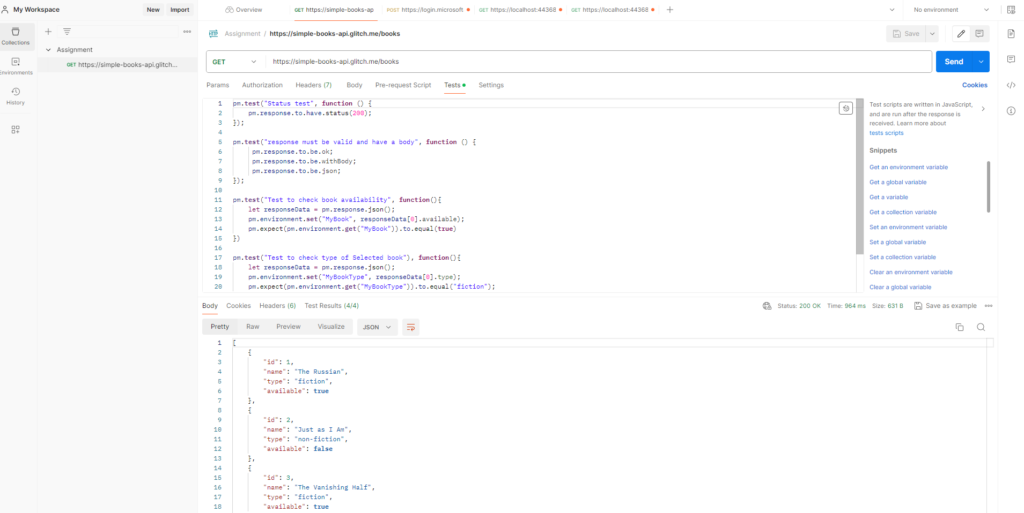

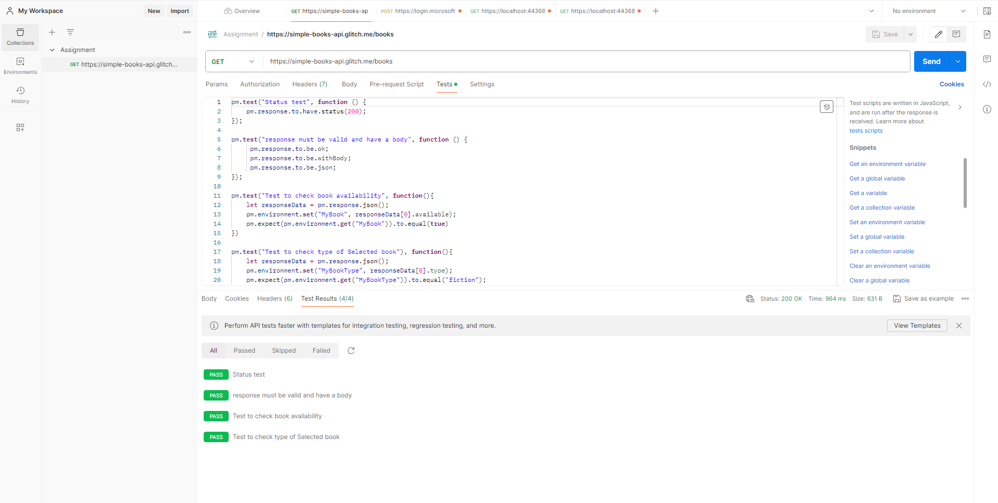

Request Type – GET

Request URL - <https://simple-books-api.glitch.me/books>

Response Body - [

    {

        "id": 1,

        "name": "The Russian",

        "type": "fiction",

        "available": **true**

    },

    {

        "id": 2,

        "name": "Just as I Am",

        "type": "non-fiction",

        "available": **false**

    },

    {

        "id": 3,

        "name": "The Vanishing Half",

        "type": "fiction",

        "available": **true**

    },

    {

        "id": 4,

        "name": "The Midnight Library",

        "type": "fiction",

        "available": **true**

    },

    {

        "id": 5,

        "name": "Untamed",

        "type": "non-fiction",

        "available": **true**

    },

    {

        "id": 6,

        "name": "Viscount Who Loved Me",

        "type": "fiction",

        "available": **true**

    }

]

Test Script –

pm.**test**("Status test", **function** () {

    pm.response.to.have.status(200);

});

pm.**test**("response must be valid and have a body", **function** () {

     pm.response.to.be.ok;

     pm.response.to.be.withBody;

     pm.response.to.be.json;

});

pm.**test**("Test to check book availability", **function**(){

    let responseData **=** pm.response.json();

    pm.environment.**set**("MyBook", responseData[0].available);

    pm.expect(pm.environment.**get**("MyBook")).to.equal(**true**)

})

pm.**test**("Test to check type of Selected book"), **function**(){

    let responseData **=** pm.response.json();

    pm.environment.**set**("MyBookType", responseData[0].type);

    pm.expect(pm.environment.**get**("MyBookType")).to.equal("fiction");

}

Test Result:

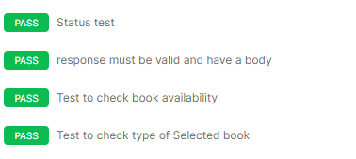

UI test result Below

Video attached with mail

Github link for project:

<https://github.com/Souvik3103/SpecFlowProject>

Project Name: SpecFlowProject1.csproj

UI Test(Specflow & NUnit):

Feature File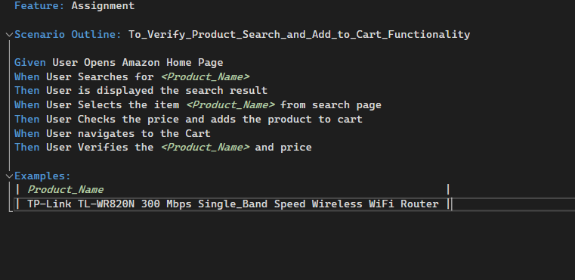

Output: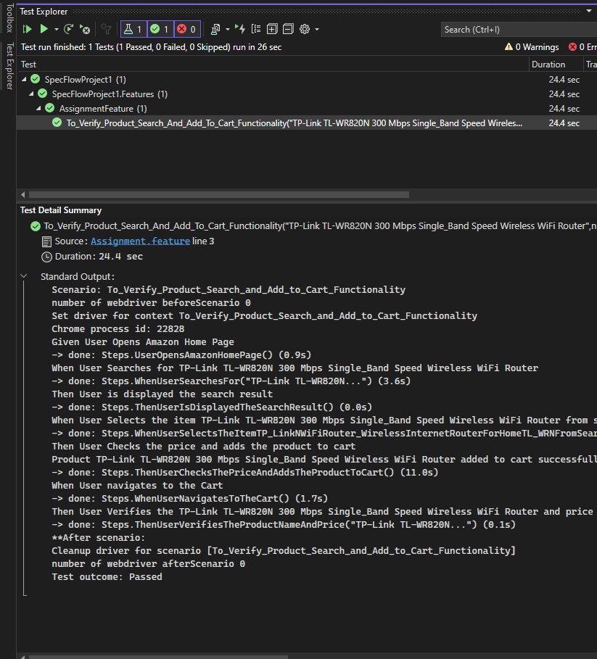

API Test (Rest Sharp & Specflow)

API test result Below

Video attached with mail

Github link for project:

<https://github.com/Souvik3103/SpecFlowProject>

Project Name: RestSharpAPIProject.csproj.csproj

