StormSense
Every UI Part & Data Point Explained — All 8 Views
Full sidebar coverage: Dashboard, Radar & Satellite Feeds, District Advisories,
AI Nowcast & Benchmark, XAI Feature Attribution, GIS Spatial Layers,
Calibrated Thresholds, Data Ingestion Streams

How To Use This Document
This covers all 8 views in the left sidebar (Command Center + System & Verification groups), captured live from the running application in both Live and Historical mode. For each view, the meaningful cards/fields/controls are explained: what they show, how StormSense computes or fetches them, and whether each value is an observation, forecast, model output, derived aggregate, proxy, or static/unavailable.
Revision note: this update reflects a repair pass made after the previous version of this document was written. Four things changed in the app and are reflected below: (1) the Radar & Satellite Feeds page had temporarily grown a large 'Cyclone Remal case-study hub' card that duplicated the Dashboard's forecast map under a different name -- it has been removed and the page restored to its original two-panel layout, now showing genuinely OBSERVED rainfall rather than a relabelled forecast; (2) the hazard-card meters on the Dashboard were a single fixed colour regardless of severity -- they now run a real green-to-red scale; (3) Temperature/Humidity/Wind at Live forecast horizons, previously blank, are now populated from the project's own (pre-existing but previously unused) OpenWeather integration; (4) the same fields in Historical mode are now populated from genuinely observed ERA5 reanalysis at each Remal horizon, rather than left blank. Screenshots in this revision are small, cropped to the specific card or panel being described, rather than full-page captures.

VIEW 1: Dashboard
The main operational view. Shows the mode badge, horizon selector, KPI cards, the interactive map, the Current Location card, District Bulletins, and a live/historical status banner. Each element below is shown as its own small, cropped screenshot rather than one full-page capture.

Item #01: Mode Badge & Horizon Selector
Where: Dashboard header
What you are looking at: A pill (LIVE MONITORING / HISTORICAL CASE STUDY) plus four buttons: NOW, +2h, +4h, +6h.
What the value means: Controls which dataset (live vs frozen 2024 Remal) and which forecast lead the entire page reads.
How StormSense gets it: window.stormSenseMode and window.currentLeadHours drive every subsequent API call as ?mode=..&lead=..
Data kind: UI control state (not weather data)
Source: [A] weather-app/js/app.js
Limitation: Switching mode resets the horizon context; the two states never merge.
Judge note: "This one switch is what keeps 2024 and 2026 data from ever appearing together."

Item #02: Interactive Nowcasting Map
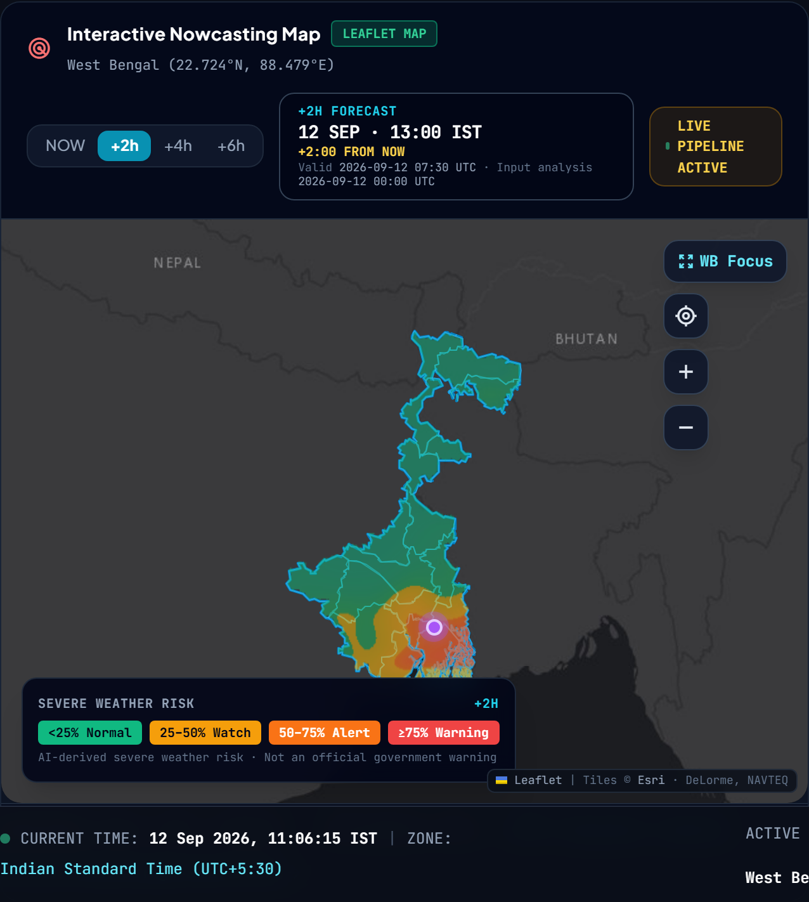
Where: Dashboard, centre
What you are looking at: A Leaflet map of West Bengal with a colour overlay: 4-band green/yellow/orange/red at a forecast horizon, or a yellow/orange/red rainfall-intensity layer at Live NOW.
What the value means: At +2h/+4h/+6h: the model's severe-weather probability field (forecast). At Live NOW: real interpolated station rainfall, coloured by INTENSITY (pale yellow for a trace, through amber and orange, to red at 10 mm/h) so heavy rain is visually distinguishable from a trace -- a single-hue blue ramp previously made 0.1 mm and 10 mm look identical. At Historical NOW: the real ERA5 t=0 rainfall analysis (observation, not forecast), kept on a separate blue/teal ramp so an observation is never mistaken for the green-to-red forecast risk field.
How StormSense gets it: /api/nowcast/risk-surface (forecast) or /api/observations/surface (live NOW, rain_1h_mm variable) or /api/historical/analysis-surface (historical NOW), rendered as a PNG image overlay.
Data kind: Mixed: Model Forecast (horizons) / Observation (NOW, both modes)
Source: [A] risk_surface.py, observation_surface.py
Limitation: 0.25-degree grid resolution (~25-28km cells) -- smoothed for display, not street-level detail. The live NOW layer only reaches red once observed rainfall is genuinely near 10 mm/h; on a quiet day it will legitimately stay pale yellow.
Judge note: "The map never shows a blank state -- every NOW/+2/+4/+6 combination in both modes has a real, correctly labelled layer, and rainfall intensity is now visually readable at a glance."

Item #03: KPI Cards (Thunderstorm / Heavy Rainfall / Flash-Flood / Overall Hazard)
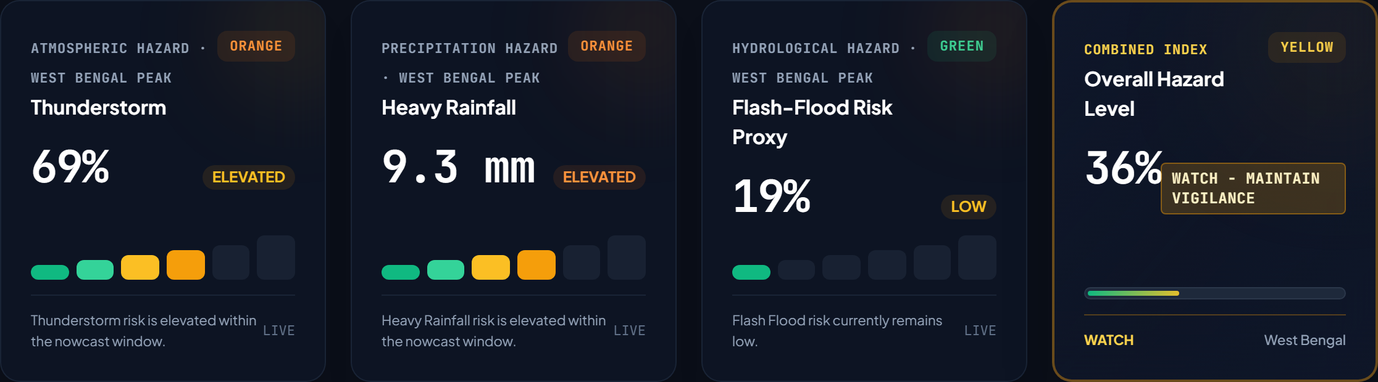
Where: Dashboard, top row
What you are looking at: Four cards with a value and a risk-level badge (Normal/Watch/Alert/Warning), each with a 6-segment meter beneath it.
What the value means: The PEAK (single highest grid cell) value across the whole state at the selected horizon -- not a state-wide average. The meter's 6 segments run a fixed severity SCALE, green through yellow, amber, orange, to red; how many segments are lit (not their colour) shows how far the value sits on that scale, so a 19% reading lights only the first green segment while a 100% reading lights the meter through to red.
How StormSense gets it: Maximum across all 825 grid cells for the current lead/mode, from get_summary() in nowcast_service.py. The meter segment colours are a fixed client-side ramp keyed to the same 0-25-50-75-100 thresholds as the badge, so the meter and the badge can never disagree.
Data kind: Model output (aggregated: maximum)
Source: [A] nowcast_service.py, app.js: paintHazardBars()
Limitation: A 100% peak means one cell is at 100%, not the whole state.
Judge note: "These are peak values on a fixed green-to-red scale -- always the single worst grid cell, and the meter always agrees with the badge above it."

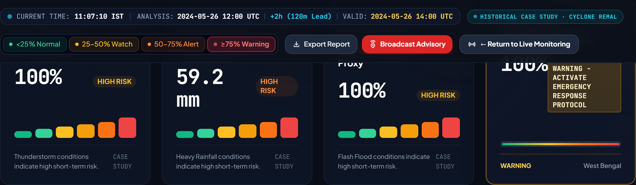
Historical mode, Cyclone Remal +2h: all four hazards at their case-study peak, the meters lit fully through to red.

Item #04: Current Location Card -- Upper Risk Section
Where: Dashboard, right column
What you are looking at: Thunderstorm %, Heavy Rainfall mm, Flash-Flood % for the user's exact coordinate (geolocated or default).
What the value means: The model's forecast for that specific 0.25-degree grid cell -- never a nearby city's value.
How StormSense gets it: /api/nowcast/point?lat=..&lon=..&lead=.. finds the nearest grid cell and reads its output directly.
Data kind: Model output (forecast) / baseline at NOW
Source: [A] get_point_inspection()
Limitation: Grid resolution means "exact coordinate" really means "nearest 25-28km cell".
Judge note: "This always uses YOUR coordinate's own grid cell, never a substituted city."

Item #05: Current Location Card -- Lower Physical Conditions
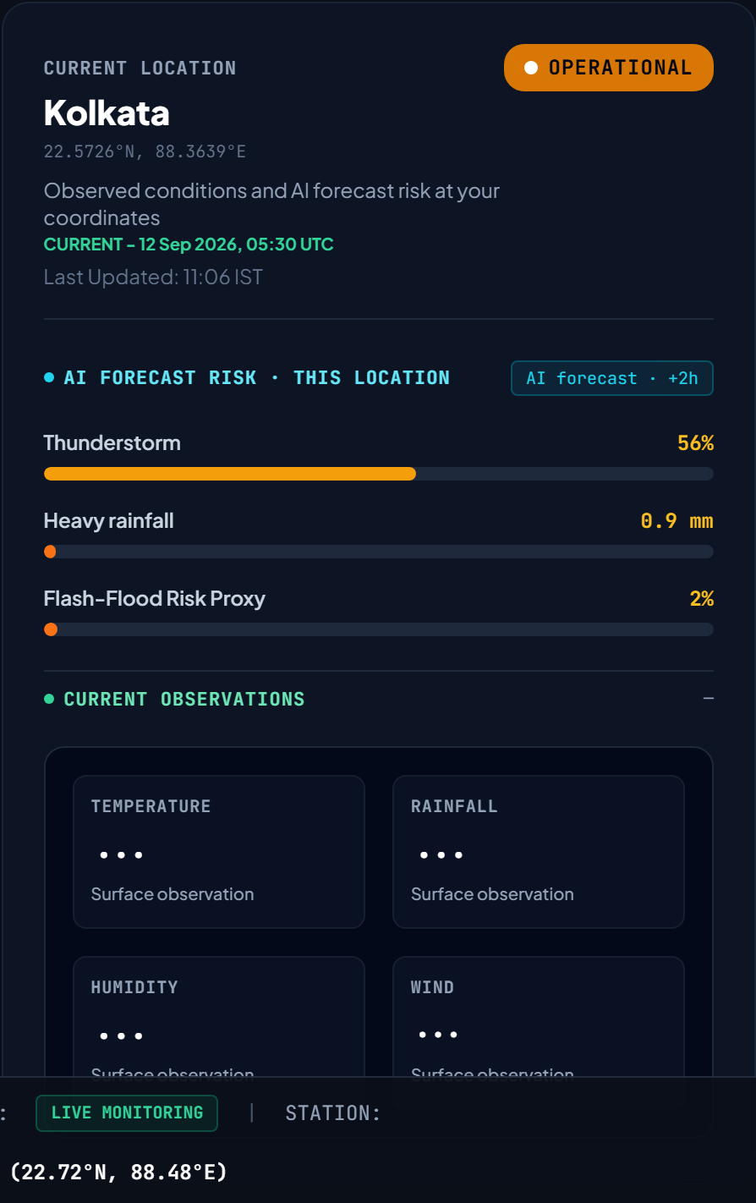
Where: Dashboard, right column, below risk section
What you are looking at: Temperature, Rainfall, Humidity, Wind, each with a small source line underneath.
What the value means: At NOW: real station observations. At a forecast horizon (Live mode): Rainfall is the StormSense model's own 3h-accumulation output; Temperature, Humidity and Wind come from a SECOND, separate source, OpenWeather's forecast product, because SevereWeatherNetV2 has only two output heads (severe-weather probability and rainfall) and has no head for these three variables at any lead time. The source line under each card names which of the two it is, so the two are never presented as one thing.
How StormSense gets it: Live horizons call /api/forecast/conditions (new), which reads OpenWeather's 5-day/3-hour forecast (already integrated in this project via openweather.py) and interpolates between the two real published points bracketing the requested lead -- it never invents a value. Historical horizons instead read genuinely OBSERVED ERA5 reanalysis states at t0+2h/+4h/+6h, since Cyclone Remal is a past event and those conditions were actually measured; labelled 'ERA5 observed', never as a model prediction.
Data kind: Mixed: Observation (NOW) / Model Forecast (Rainfall) / Third-party Forecast (Live T-RH-Wind) / Observed Reanalysis (Historical T-RH-Wind)
Source: [A] main.py: forecast_conditions(), nowcast_service.py: era5_surface_by_lead
Limitation: OpenWeather's forecast is 3-hourly, so a live +4h reading is interpolated between real 3h and 6h points rather than an exact +4h publication; the response states the real bracketing points.
Judge note: "Rainfall is always ours; Temperature, Humidity and Wind are always someone else's -- the label under each card says which, every time."

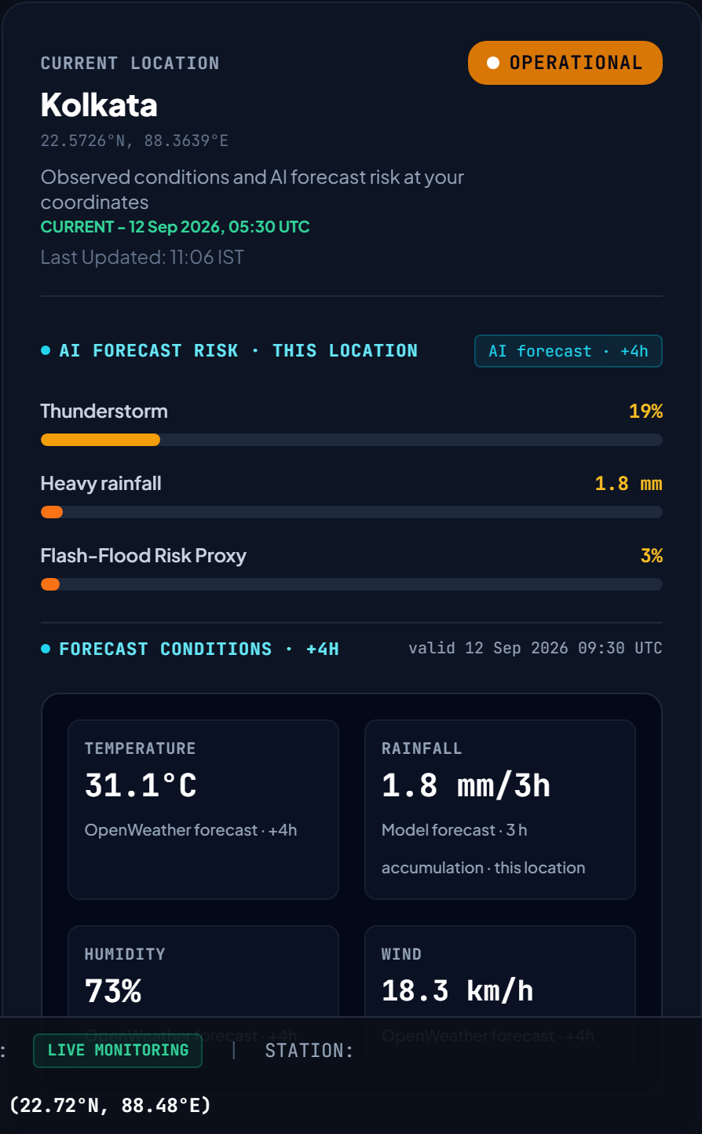
Live mode, +4h: Rainfall reads 'Model forecast', Temperature/Humidity/Wind read 'OpenWeather forecast · +4h'.
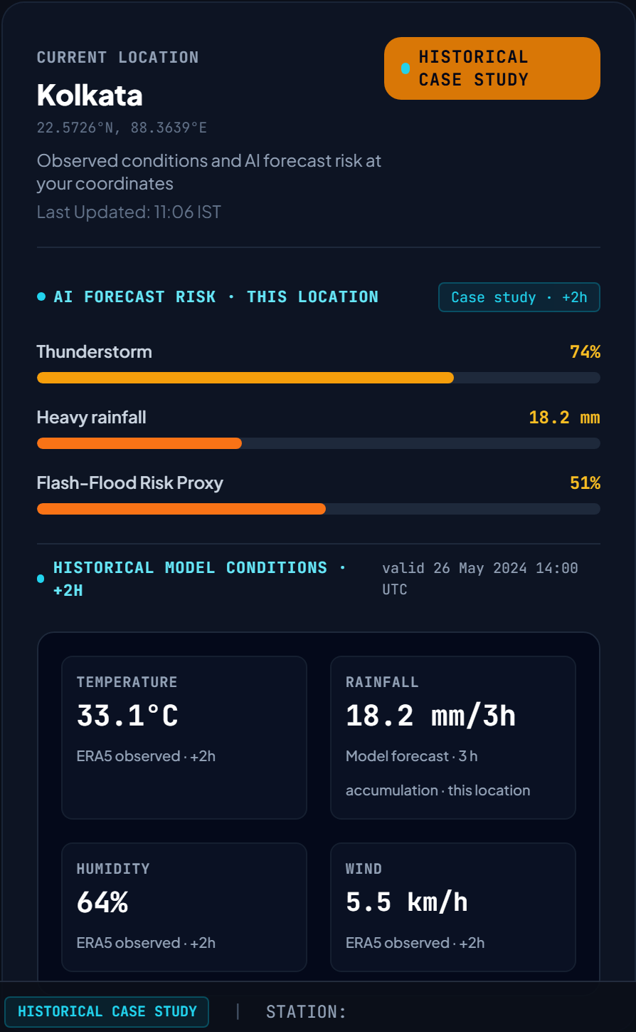
Historical mode (Cyclone Remal), +2h: all four fields sourced from ERA5 -- Rainfall labelled 'Model forecast' (StormSense's own +2h prediction) and Temperature/Humidity/Wind labelled 'ERA5 observed · +2h' (what was actually measured at that hour in 2024).

Item #06: 0-6 Hour Forecast Strip
Where: Dashboard, below KPI cards
What you are looking at: Five mini-cards, +2h through +6h, each with severe %, rainfall, and flood-proxy %.
What the value means: All 5 lead times from ONE model run, so the strip cannot disagree with the map or KPI cards.
How StormSense gets it: The full 'timeline' array inside one /api/nowcast/summary response.
Data kind: Model output (forecast, 5 horizons at once)
Source: [A] get_summary() -> timeline
Limitation: Risk can rise then fall between horizons -- expected model behaviour, not an error.
Judge note: "All five come from one inference call, so the strip, the map, and the KPIs are always consistent."

Item #07: District Bulletins (Active High-Risk Areas)
Where: Dashboard, bottom strip
What you are looking at: A scrolling list of the highest-risk districts at the current horizon, with a short auto-generated advisory sentence.
What the value means: The same per-district max/p90 aggregation used on the full District Advisories page, condensed to a top-N list.
How StormSense gets it: get_district_advisories(), filtered/sorted for the dashboard summary.
Data kind: Model output (aggregated per district)
Source: [A] nowcast_service.py
Limitation: Text sentences are template-generated from real numbers, not independently written commentary.
Judge note: "Every word in these bulletins traces back to a real number -- nothing is hand-written per event."

VIEW 2: Radar & Satellite Feeds
Shows the live third-party radar (Live mode) or the observed ERA5 rainfall analysis for Cyclone Remal (Historical mode) alongside the INSAT-3DR satellite archive panel. This view was restored to its original two-panel layout in this revision: an earlier session had temporarily replaced it with a large 'Cyclone Remal case-study hub' card, which has been removed so this page shows only what it always showed -- the spatial panel and the satellite archive panel, side by side.
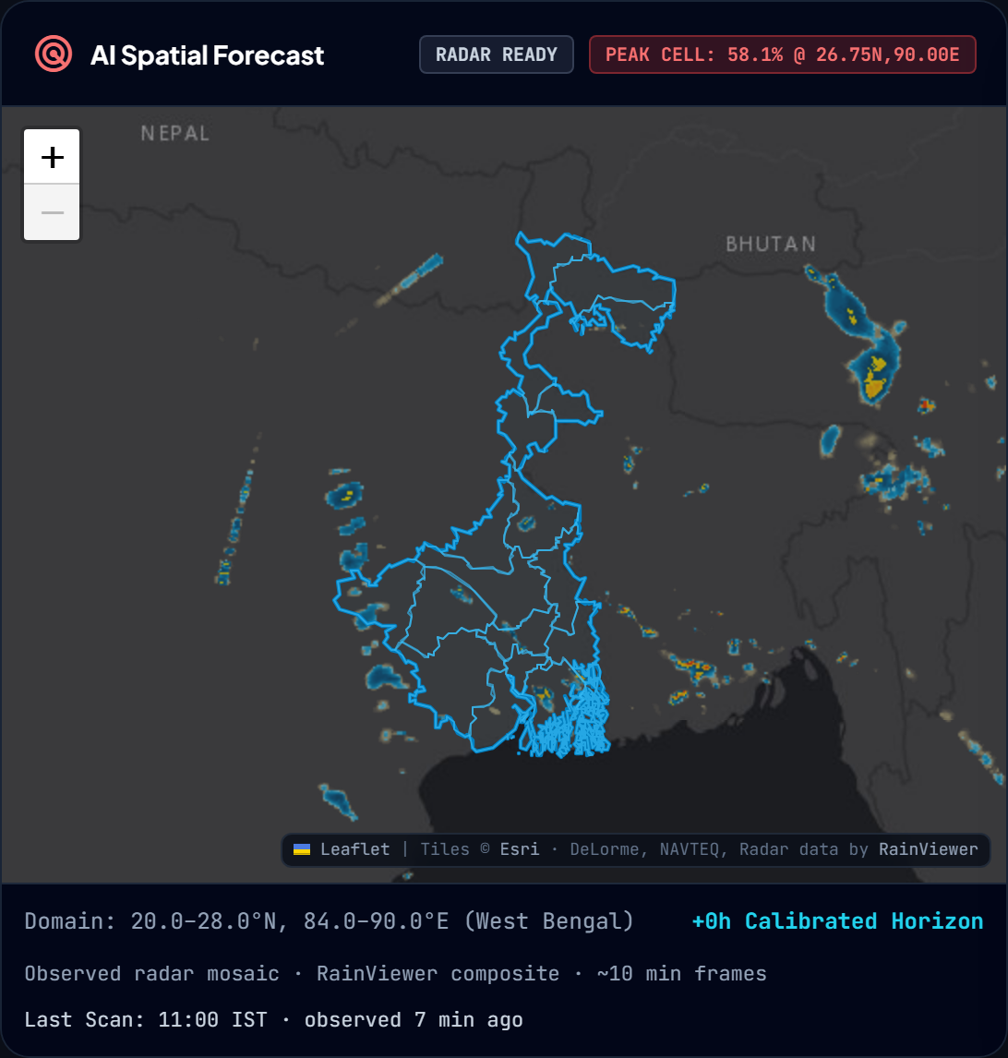
Live mode: RainViewer radar panel, titled 'AI Spatial Forecast & Live Radar'.
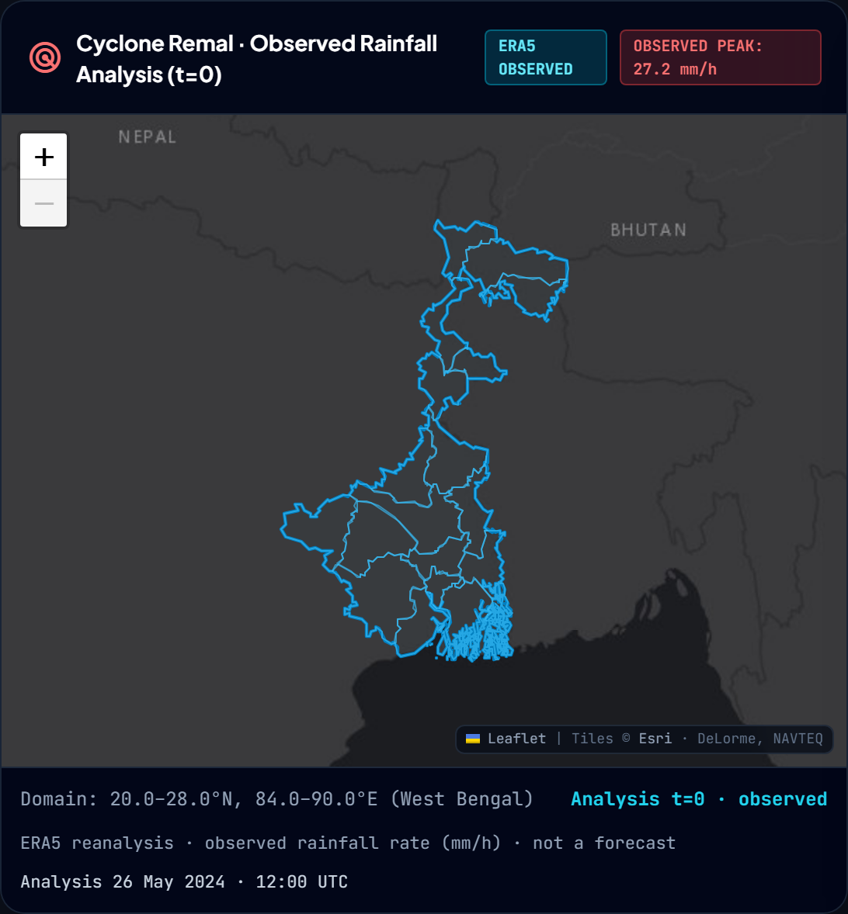
Historical mode: same panel, now titled 'Cyclone Remal · Observed Rainfall Analysis (t=0)' with an 'ERA5 OBSERVED' badge and the domain's real observed rainfall peak.

Item #08: Live Radar Map (RainViewer)
Where: Radar & Satellite Feeds, Live mode
What you are looking at: A colour precipitation overlay refreshing periodically, with a status badge and 'Last Scan' time.
What the value means: REAL observed radar reflectivity (dBZ) from RainViewer's public composite mosaic -- not AI-generated.
How StormSense gets it: Fetches api.rainviewer.com for the latest frame, loads Leaflet tiles from RainViewer's tile server. Runs only in Live mode.
Data kind: Observation (radar)
Source: [A] loadRainViewerRadar() in app.js
Limitation: Typically ~8-10 minutes old by display time; this age is shown, not hidden.
Judge note: "This is genuine third-party radar, never our AI heatmap -- it never appears on the historical page."

Item #09: Historical Observed Rainfall Panel
Where: Radar & Satellite Feeds, Historical mode
What you are looking at: The same panel that shows live radar in Live mode, now titled 'Cyclone Remal · Observed Rainfall Analysis (t=0)' with a badge reading 'ERA5 OBSERVED' and a peak value in mm/h -- a DIFFERENT product from the Dashboard's forecast map, deliberately: this page must not just repeat what the Dashboard already shows.
What the value means: The real ERA5 reanalysis rainfall field at the case study's analysis time (26 May 2024, 12:00 UTC) -- an OBSERVATION of what actually fell, not a probability and not the model's forecast. The Dashboard's map, by contrast, shows the model's severe-weather probability forecast for the selected horizon. Putting the same forecast field on both pages under different names was corrected in this revision; this panel is now genuinely a different quantity, in mm/h on a blue-to-white intensity ramp distinct from both the forecast risk ramp and the live rainfall-intensity ramp.
How StormSense gets it: /api/historical/analysis-surface?variable=rain_mm, generated by generate_analysis_surface_png() from the same ERA5 input window the case study loads. The render ceiling is set to the field's own observed peak (not a fixed default) so a real but modest storm signature is not washed out to near-invisibility.
Data kind: Observation (ERA5 reanalysis) -- explicitly not radar, not a forecast
Source: [A] risk_surface.py: generate_analysis_surface_png(), main.py: /api/historical/analysis-surface
Limitation: No archived Doppler radar for Cyclone Remal exists anywhere in this project; this panel does not attempt to substitute one, and says so via its own badge and footer text rather than by relabelling the forecast field as a stand-in.
Judge note: "This is not radar and not a forecast -- it's what ERA5 reanalysis says actually fell at the case study's start time, on its own colour scale."

Item #10: INSAT-3DR Satellite Archive Panel
Where: Radar & Satellite Feeds, right column (both modes)
What you are looking at: Cards describing satellite channels: Thermal IR, Water Vapor, Hydro-Estimator, Cloud Top Pressure, with archive status.
What the value means: A REAL, on-disk, episodic ISRO INSAT-3DR Level-2B archive -- confirmed by opening the actual HDF5 files, not a live feed.
How StormSense gets it: src/inference/insat_archive.py reads real HDF5 files; for the Remal window it reports 'unavailable' because the nearest real acquisition is 21-35 hours away.
Data kind: Historical Archive (episodic) -- NOT live satellite
Source: [A] insat_archive.py, verified HDF5 metadata
Limitation: Archive does not cover every date; for Remal specifically it is honestly reported as too distant to show as contemporaneous.
Judge note: "This is a real archive we can open and read -- we chose not to mislabel a 27-May file as a 26-May observation."

VIEW 3: District Advisories
One advisory card per West Bengal district (23 districts total; sidebar badge shows a filtered count e.g. '12 Districts' for districts currently meeting an alert threshold).

Item #11: District Advisory Cards
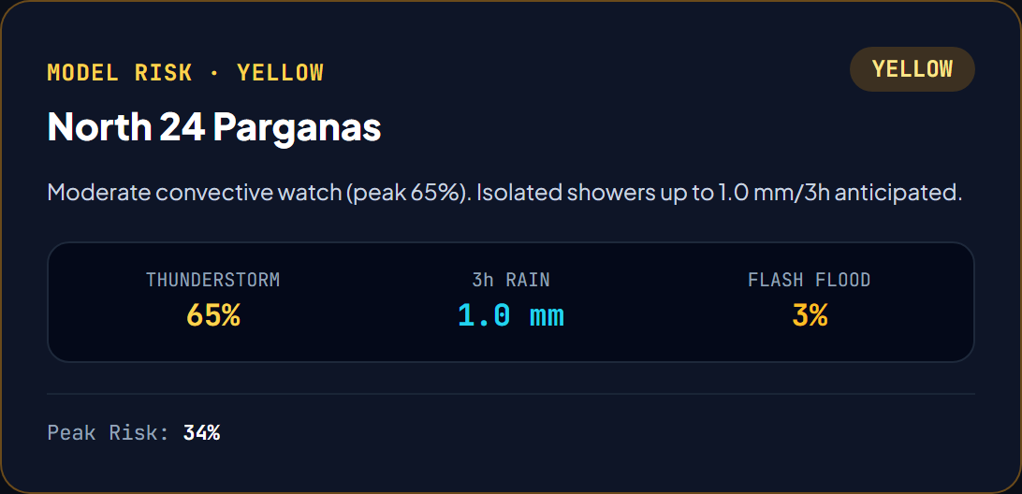
Where: District Advisories view
What you are looking at: One card per district: risk badge, Thunderstorm %, 3h Rain (mm), Flash-Flood %, and an auto-generated advisory sentence.
What the value means: The MAXIMUM and 90th-percentile model values across all grid cells inside that district's real polygon boundary, at the selected lead time.
How StormSense gets it: get_district_advisories() maps each district polygon to its grid cells (precomputed at startup) then takes np.max()/np.percentile(90) over the model's arrays for those cells.
Data kind: Model output (aggregated per district)
Source: [A] nowcast_service.py: get_district_advisories()
Limitation: Neighbouring coastal districts can show near-identical values during a widespread system (e.g. a cyclone) because they share overlapping grid cells -- physically expected.
Judge note: "Every district number traces to real grid cells inside that district's actual polygon -- verified, not copy-pasted from a state-wide figure."

Item #12: Sidebar District Count Badge
Where: Left sidebar, next to 'District Advisories'
What you are looking at: A small number (e.g. '12 Districts').
What the value means: Count of districts currently at or above an alert-worthy risk level at the active horizon -- not the total district count (23).
How StormSense gets it: Computed client-side from the same district array used to build the cards.
Data kind: Derived (count of model output)
Source: [A] app.js
Limitation: Changes with horizon and mode -- it is a live count, not a fixed label.
Judge note: "This badge count updates with the horizon -- it's not a static '23 districts' label."

VIEW 4: AI Nowcast & Benchmark
Compares the current StormSense model (V2) against an earlier baseline model (V1) and a Persistence baseline, using real held-out 2024 ERA5 test metrics. Also shows a horizon selector and the Atmospheric Instability State panel.

Item #13: Benchmark Horizon Selector & Lead Badge
Where: AI Nowcast & Benchmark, top
What you are looking at: Buttons (2/4/6h) and a badge showing 'Lead Time: +Nh'.
What the value means: Selects which lead time's metrics/comparison the rest of the view displays.
How StormSense gets it: Sets window.currentBenchmarkLead; badge text is written dynamically by setText("benchmark-lead-badge", ...) so it can never freeze on a stale horizon.
Data kind: UI control
Source: [A] app.js
Limitation: A prior version had this hardcoded to '+2 Hours' regardless of selection -- fixed and now dynamically bound.
Judge note: "This label is written every time the horizon changes -- it cannot silently go stale."

Item #14: 3-Way Model Comparison (StormSense V2 vs Earlier Model Baseline vs Persistence)
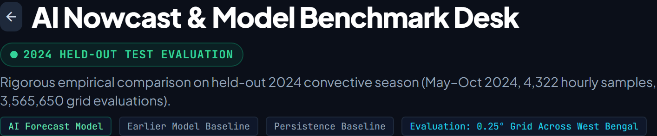
Where: AI Nowcast & Benchmark, comparison cards
What you are looking at: CSI, PR-AUC, POD, FAR, Brier score, rainfall MAE for each of the three models, plus 'relative gain over V1' percentages.
What the value means: Real, held-out 2024 ERA5 test-set metrics -- e.g. mean CSI 0.307, PR-AUC 0.484, POD 0.543, FAR 0.589 for the current model; +59.2% PR-AUC gain over the earlier baseline.
How StormSense gets it: /api/benchmark/models, which reads outputs/metrics/test_evaluation.json (and the earlier baseline's own metrics file) -- these are pre-computed evaluation results, not live-recomputed.
Data kind: Model output evaluation (held-out test metrics)
Source: [A] main.py: benchmark endpoint; outputs/metrics/test_evaluation.json
Limitation: These are 2024 ERA5 held-out numbers -- LIVE (GFS-based) skill is measurably weaker due to a real GFS/ERA5 distribution shift, disclosed separately (see reports/gfs_production_backtest.json).
Judge note: "These are our best validated numbers, not live performance -- if asked for live skill, the honest answer is it's lower, and we measured that gap directly."

Item #15: V1/V2/V2(Calibrated) internal model names
Where: Not shown
What you are looking at: N/A -- internal-only.
What the value means: Public UI intentionally hides internal checkpoint version names (V1/V2/V2 Calibrated) and shows 'Earlier Model Baseline' / 'AI Forecast Model' instead.
How StormSense gets it: A deliberate terminology rule enforced across the frontend.
Data kind: Static UI policy
Source: [A] app.js, verified 0 occurrences of 'V1'/'V2' in public-facing text
Limitation: None -- this is a labelling choice, not a data limitation.
Judge note: "We deliberately keep internal version names out of the public UI; the underlying checkpoint is v2_calibrated_best.pt."

Item #16: Evolution Timeline Chart
Where: AI Nowcast & Benchmark, chart area
What you are looking at: A line/area chart showing how risk evolves across the 5 forecast horizons for the selected location/district.
What the value means: The same 5-horizon timeline array used in the Dashboard's forecast strip, charted instead of shown as cards.
How StormSense gets it: Same /api/nowcast/summary timeline data, rendered with a charting routine in app.js.
Data kind: Model output (forecast, 5 horizons)
Source: [A] app.js
Limitation: Same data as the dashboard strip -- shown differently, not independently computed.
Judge note: "This chart and the dashboard strip literally read the same array -- they cannot disagree."

Item #17: Atmospheric Instability State Panel
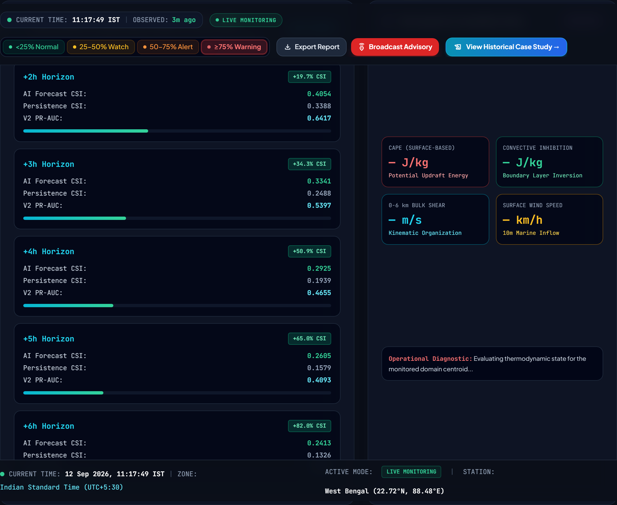
Where: AI Nowcast & Benchmark, lower section
What you are looking at: CAPE, CIN, bulk wind shear, surface wind, with a 'convective risk' text badge (e.g. MODERATE RISK) and a Source: line.
What the value means: In Live mode: genuine live GFS-derived CAPE/CIN and a HONESTLY labelled 1000-700 hPa ('~0-3 km') shear -- NOT full 0-6 km shear, because live ingestion only carries wind at those 3 pressure levels. In Historical mode: genuine ERA5-derived values including real 0-6 km shear.
How StormSense gets it: Live: _compute_live_thermo() in nowcast_service.py, from the real GFS analysis. Historical: the ERA5 sounding at t=0.
Data kind: Model input diagnostic (real atmospheric analysis, not a forecast)
Source: [A] nowcast_service.py: _compute_live_thermo(), test_live_thermo_reports_shear_layer_truthfully
Limitation: Live shear vertical extent is limited to ~0-3km by what the live pipeline ingests -- disclosed via bulk_shear_0_6km_status text, not hidden.
Judge note: "We could have mislabeled live shear as '0-6km' -- we deliberately did not, and there's a regression test enforcing that."

VIEW 5: XAI Feature Attribution

Item #18: XAI Factor Cards
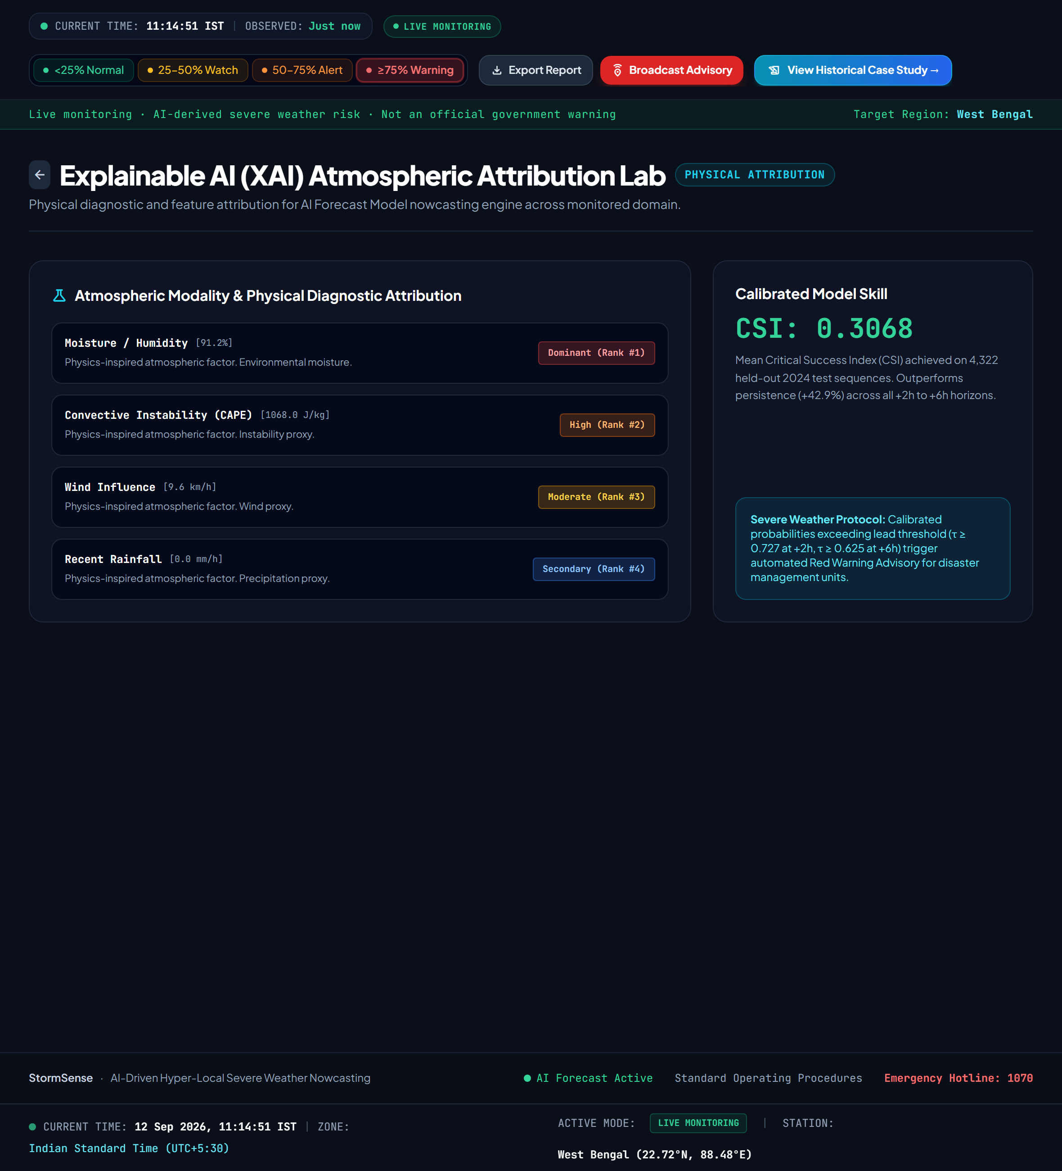
Where: XAI Feature Attribution view
What you are looking at: Ranked cards: Convective Instability (CAPE), Moisture/Humidity, Wind Influence, Recent Rainfall, each with a % contribution and an 'impact' tag (Dominant/High/Moderate/Secondary).
What the value means: A RULE-BASED explanation of which real atmospheric ingredient the system's own physics-based scoring weighs most heavily -- NOT a learned explanation of the neural network's internal weights.
How StormSense gets it: calculate_xai_factors() computes a fixed weighted formula per factor from the same real inputs the model consumes (e.g. rainfall_score = rain_1h*5 + rain_3h*2 + rain_6h), then normalizes to percentages and ranks them.
Data kind: Derived / Physics-inspired heuristic -- explicitly NOT true ML explainability
Source: [A] src/inference/xai.py (docstring: 'NOT an ML model explanation')
Limitation: No SHAP, LIME, gradients, or attention weights -- cannot prove the network internally weighted things this way.
Judge note: "If asked 'is this explaining the neural network', the honest answer is no -- it's a physics-based score on the same real inputs, and our code says so explicitly."

Item #19: Method / Parameters Labels
Where: XAI view, card footer
What you are looking at: Small text: 'Physics-based rules (not learned attribution)' and 'Rule-Based Physics Proxy'.
What the value means: A deliberate, permanent disclosure that this is not SHAP/LIME/gradient-based attribution.
How StormSense gets it: Hardcoded honesty labels returned directly by calculate_xai_factors()'s response envelope.
Data kind: Static disclosure text (accurate description of a real limitation)
Source: [A] xai.py: attribution_method field
Limitation: None -- this is the correct, honest description, not a limitation to fix.
Judge note: "This label is not marketing copy -- it's an accurate technical disclosure baked into the API response itself."

VIEW 6: GIS Spatial Layers
Unchanged in this revision. Toggle-able static layers: terrain elevation and real station locations.
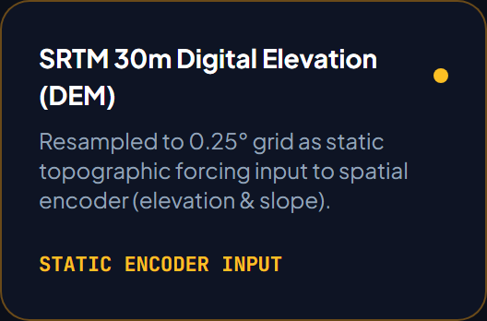
The SRTM DEM layer card.

Item #20: Static Encoder Input / DEM Layer Toggle
Where: GIS Spatial Layers view
What you are looking at: A toggle/card labelled 'STATIC ENCODER INPUT' referencing SRTM elevation.
What the value means: Controls whether the map shows the static Digital Elevation Model (DEM) layer that the model's spatial encoder uses as a terrain input.
How StormSense gets it: DEM is loaded once from a cached SRTM elevation array and reused for both live and historical inference -- it never changes.
Data kind: Static Input (never live or forecast)
Source: [A] nowcast_service.py: _get_static_dem_meters()
Limitation: Static means literally unchanging across all runs -- it is terrain, not a weather variable.
Judge note: "Elevation doesn't change, so this layer is identical whether you're in Live or Historical mode -- by design."

Item #21: Surface Weather Stations Layer
Where: GIS Spatial Layers view
What you are looking at: A toggle/card labelled 'Surface Weather Stations' with a 'TELEMETRY ACTIVE' status badge.
What the value means: Shows the real 24 OpenWeatherMap station markers used for the Live NOW observation layer, so users can see exactly where 'observed' data actually comes from.
How StormSense gets it: Same station list backing /api/observations/current, drawn as map markers.
Data kind: Observation (station locations, real)
Source: [A] observation_surface.py
Limitation: 24 stations for ~89,000 km² is sparse -- a storm cell between stations can be missed entirely, which is why interpolation is disclosed elsewhere in the UI.
Judge note: "These are the real 24 stations -- we show their locations specifically so it's clear where the NOW layer is measured versus interpolated."

VIEW 7: Calibrated Thresholds
Unchanged in this revision. Shows the per-lead-time probability thresholds stored in the model checkpoint, and the public 4-band risk legend.

Item #22: Per-Lead Calibrated Threshold Table
Where: Calibrated Thresholds view
What you are looking at: A table/card set labelled 'SCIENTIFIC CALIBRATION' listing a probability threshold for each lead time (e.g. +2h: 0.727, +3h: 0.679, +4h: 0.673, +5h: 0.637, +6h: 0.625).
What the value means: The exact decision threshold used to convert a raw model probability into a binary 'severe / not severe' classification at that specific lead time -- tuned separately per horizon on validation data, not a single fixed cutoff.
How StormSense gets it: threshold_per_lead, stored directly inside the trained checkpoint (v2_calibrated_best.pt) and read by predictor.py.
Data kind: Model artifact (calibration parameter, not weather data)
Source: [A] predictor.py: self.threshold_per_lead, checkpoint metadata
Limitation: These thresholds were tuned on 2023 validation data -- they are fixed at inference time, not adaptively recalculated per request.
Judge note: "Each lead time has its own tuned threshold -- this is why the same 60% probability might count as 'alert' at +2h but not at +6h."

Item #23: Public Risk Legend (Normal/Watch/Alert/Warning bands)
Where: Calibrated Thresholds view + header pills everywhere
What you are looking at: Four colour bands: <25% Normal, 25-50% Watch, 50-75% Alert, ≥75% Warning.
What the value means: A SEPARATE, simpler public-facing scale from the per-lead classifier thresholds above -- used purely for the UI's colour-coding, verified to match the code's _level_for_prob() function exactly.
How StormSense gets it: _level_for_prob() in nowcast_service.py, applied identically to every displayed probability across the whole site.
Data kind: Static UI classification scale (not an official warning category)
Source: [A] nowcast_service.py: _level_for_prob(); test_legend_bands_match_classifier_thresholds
Limitation: This is an internal StormSense colour convention, NOT an official IMD (India Meteorological Department) warning category -- never presented as one.
Judge note: "These 4 colour bands are our own UI convention for readability, not an official government warning scale."

VIEW 8: Data Ingestion Streams
Unchanged in this revision. Status cards for each real data source feeding the model: gridded atmospheric analysis, surface observations, and the static DEM.
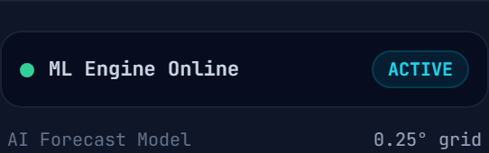
The AI Forecast Model engine status card.

Item #24: AI Forecast Model / Model Engine Status Card
Where: Data Ingestion Streams view
What you are looking at: A card labelled 'AI Forecast Model' / 'Model Engine' with a status such as 'LOADED'.
What the value means: Confirms the trained SevereWeatherNetV2 checkpoint has loaded successfully into memory and inference is possible.
How StormSense gets it: Reflects whether NowcastService's internal predictor object initialized without error at server startup.
Data kind: System status (real, not simulated)
Source: [A] nowcast_service.py startup path
Limitation: Does not indicate model ACCURACY -- only that the checkpoint file loaded.
Judge note: "'LOADED' means the trained weights are in memory and ready -- it says nothing about how good the forecast is."

Item #25: Gridded Atmospheric Analysis / Surface Obs Feed Cards
Where: Data Ingestion Streams view
What you are looking at: Cards for 'Gridded Atmospheric Analysis' and 'Surface Observation Feed' with an 'INGESTION ACTIVE' badge and a live timestamp.
What the value means: Real-time health status of the two live data pipelines: the GFS fetch (feeding the model) and the OpenWeatherMap station fetch (feeding the NOW observation layer).
How StormSense gets it: Backend health check reading live_status/live_fetch_error from NowcastService and the station-observation cache's last-successful-fetch time.
Data kind: System status (derived from real pipeline state)
Source: [A] main.py: /api/data-health, /api/mode/status
Limitation: 'Active' reflects the LAST successful fetch -- if a fetch fails, the system keeps serving the last good data and flags staleness rather than breaking (see is_live_stale()).
Judge note: "This shows real pipeline health, including honest staleness flags if a fetch has failed -- it's not a static 'always green' indicator."

Item #26: SRTM 30m DEM / NASA-USGS Topography Card
Where: Data Ingestion Streams view
What you are looking at: A card labelled 'SRTM 30m DEM' / 'NASA / USGS Topography' marked as a 'Static Modality'.
What the value means: Confirms the static elevation dataset (used for terrain-aware flash-flood scoring) is loaded -- distinguished explicitly from the live/dynamic feeds above it.
How StormSense gets it: Same DEM array referenced in the GIS view; shown here as an ingestion-status entry rather than a map layer.
Data kind: Static Input (confirmed loaded, never live)
Source: [A] nowcast_service.py: _get_static_dem_meters()
Limitation: Explicitly tagged 'Static Modality' in the UI so it is never confused with a live feed.
Judge note: "This card is intentionally separated from the live feeds above it -- terrain doesn't need a live connection."

Item #27: "Historical Mode Only" Tag
Where: Data Ingestion Streams view, on relevant cards
What you are looking at: A small tag reading 'Historical Mode Only' next to certain data sources (e.g. the ERA5 reanalysis cache).
What the value means: Marks which ingestion sources are used exclusively for the frozen Cyclone Remal case study and never touched in Live mode.
How StormSense gets it: A static UI label applied to sources whose backend code path only executes when mode=historical.
Data kind: Static UI disclosure (accurate description of code-level mode gating)
Source: [A] nowcast_service.py: _init_operational_state() vs refresh_live_state()
Limitation: None -- this label correctly reflects a real, code-enforced separation, not just a UI convention.
Judge note: "This tag is literally true at the code level -- that data path only runs for the historical case study."

