Project Title: _DoConnect_____________
Your Name: ___Souvik Ghosh________________
Date: _08/09/25
Batch Name: C3
Instructor Details: Mrs.Ramesh Nediyadath

Content Page-No

- Acknowledgement 3
- Problem Definition and Objectives 4
- Frontend & Backend Architecture 5-6
- Component Breakdown & API Design 7-13
- State Management 14
- Database Diagram 15
- Tables Creation 16-17
- Bibliography 18

Acknowledgement

I would like to express my heartfelt gratitude to the Great Learning Team for providing me with the opportunity and resources to successfully complete my capstone project, “DoConnect”.
A special note of thanks goes to my mentor, Mr. Ramesh Nadiyadath, for his invaluable guidance, encouragement, and constant support throughout the project. His insights and feedback have been instrumental in helping me understand complex concepts and refine my work into its present form.
I would also like to thank my peers and instructors for their collaboration and knowledge-sharing, which motivated me to continuously improve and learn during this journey.
This project has been a great learning experience, helping me enhance my technical skills, problem-solving abilities, and overall understanding of real-world software development.

Problem Definition and Objectives
Problem Statement:
In today’s fast-paced digital era, individuals often seek quick and reliable answers to their queries. Traditional search engines provide vast information but often lack community-driven validation and personalization. There is a growing need for an interactive platform where users can post questions, receive relevant answers, and engage in knowledge-sharing communities.
Project Goals and Objectives:
- Develop an easy-to-use web platform that enables users to post questions and receive answers from peers.
- Allow users to contribute by answering questions, thereby building a collaborative community.
- Implement a structured and searchable Q&A system for better accessibility.
- Ensure secure authentication and user management to maintain quality interactions.
- Provide a responsive and scalable design for smooth user experience across devices.

Frontend & Backend Architecture
Technology Stack Overview:
- Frontend: Angular for building a dynamic, component-based, and responsive user interface with built-in routing and service-based architecture.
- Backend: ASP.NET Core Web API to handle business logic, user authentication, and communication between frontend and database.
- Database: SQL Server for structured data storage, including user details, questions, and answers.
System Design Diagram (High-level):
- Frontend (Angular):
  - User Interface (posting questions, viewing answers)
  - Angular Services (for API communication and data handling)
  - Routing (Angular Router for navigation between pages)
  - State Management (handled via RxJS observables and services)
- Backend (ASP.NET Core Web API):
  - REST API Endpoints (for questions, answers, user authentication, and profile management)
  - Authentication & Authorization (JWT tokens for secure access)
  - Business Logic Layer (handles question posting, answer submission, and user roles)
- Database (SQL Server):
  - Tables for Users, Questions, Answers, Tags, and Votes
  - Indexing for optimized search queries
  - Relationship constraints to maintain data integrity

Component Breakdown & API Design
Breakdown of major components in frontend
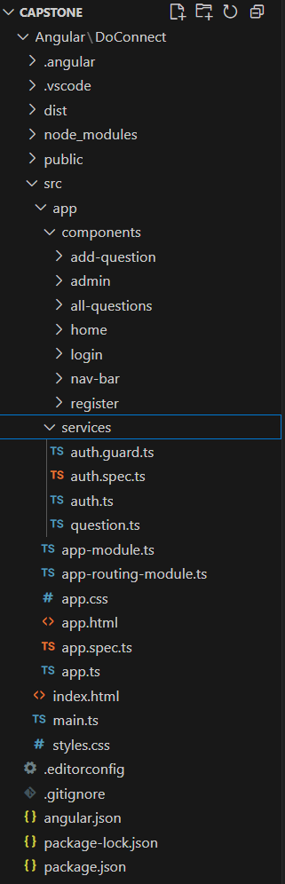

Routing
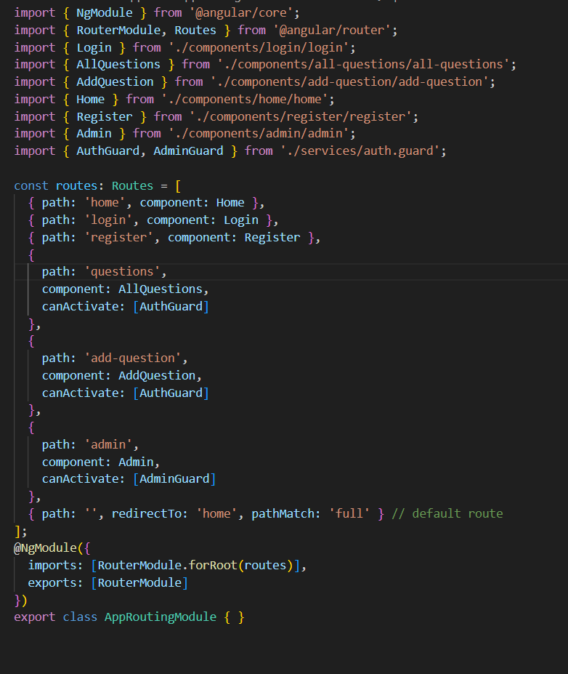

UI components
Registration Page
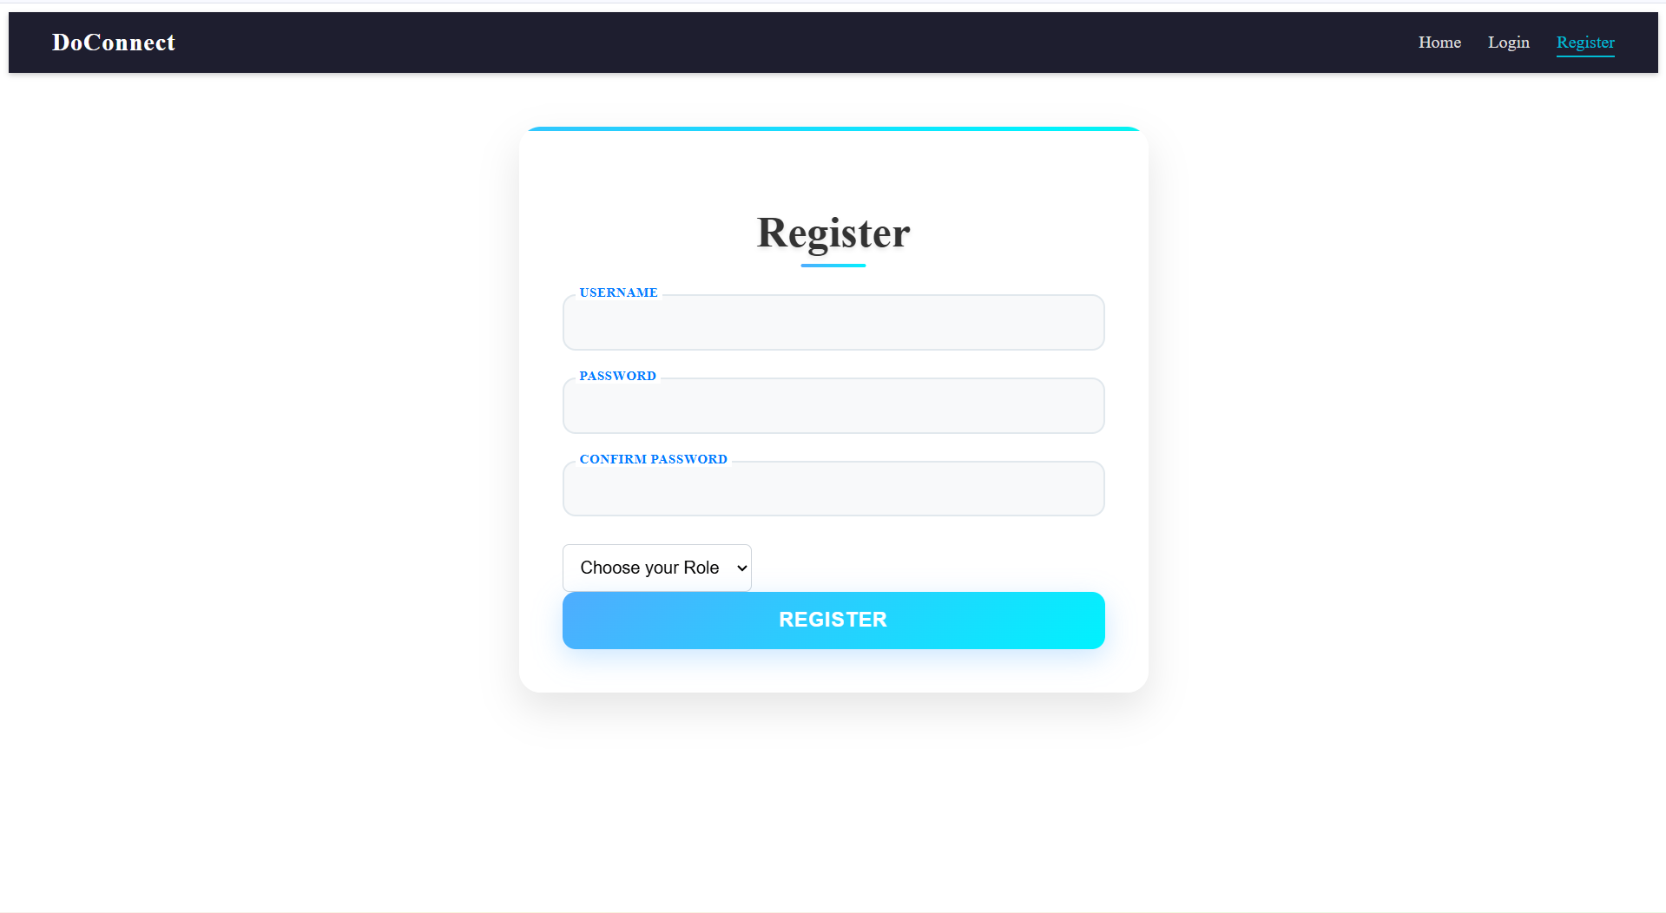
- User While Registration can choose their Role
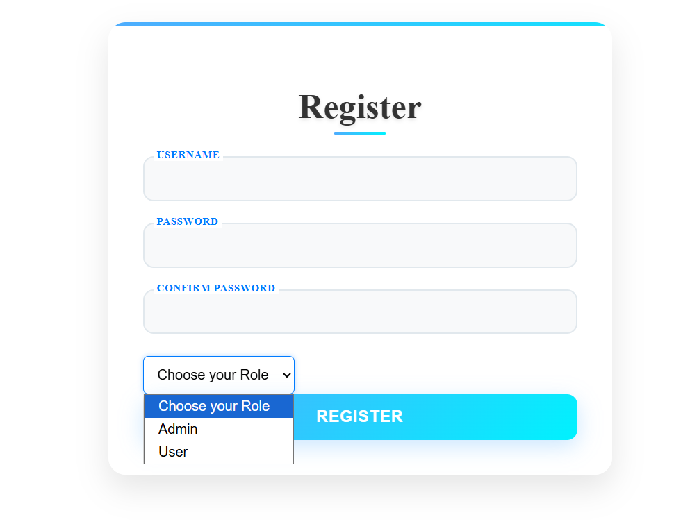

Login Page
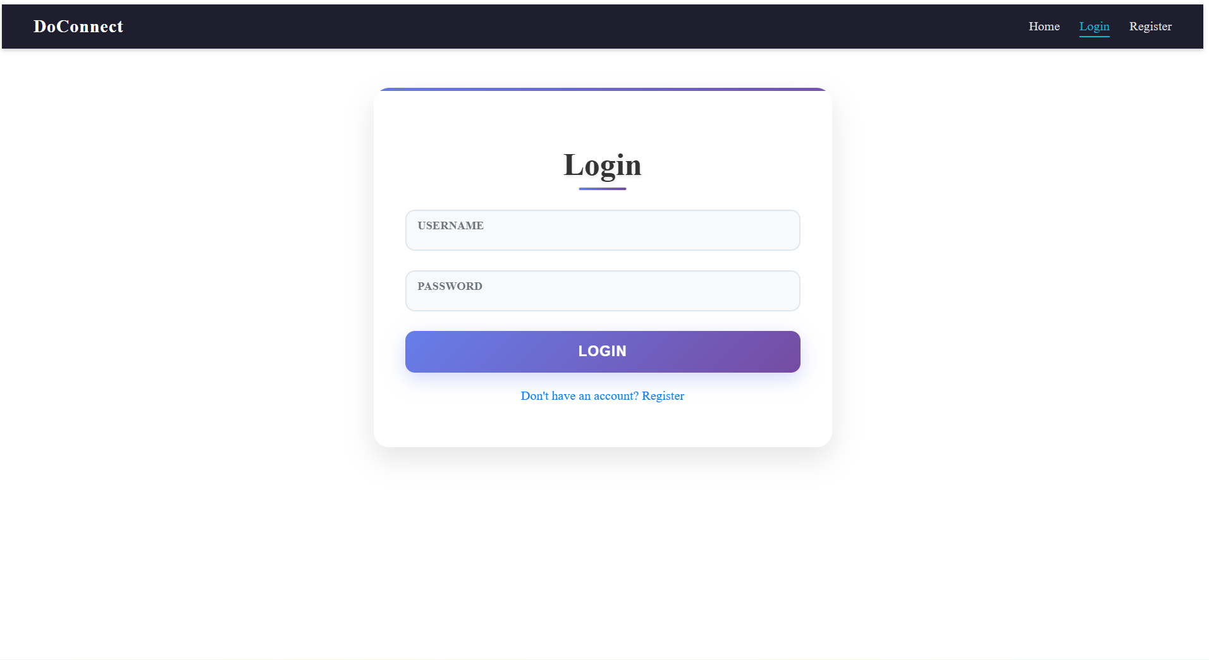

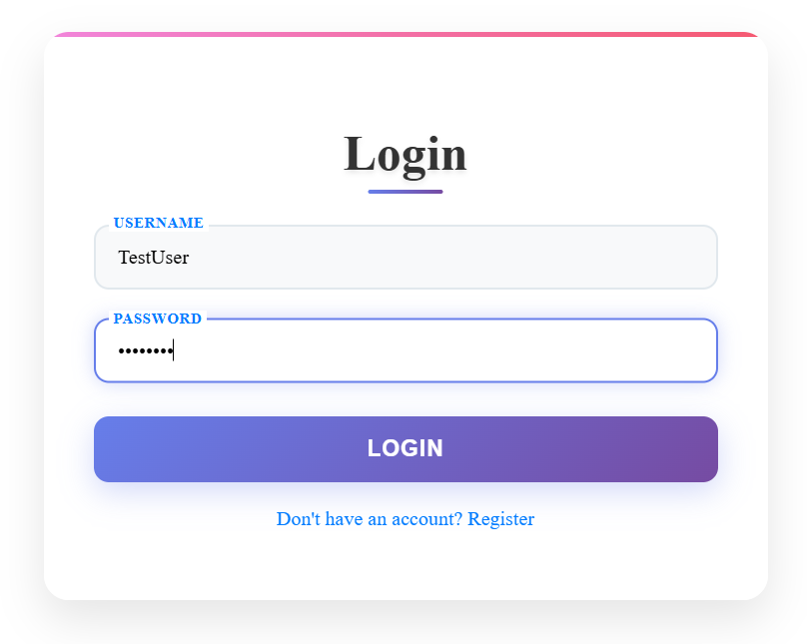
All-Question Page
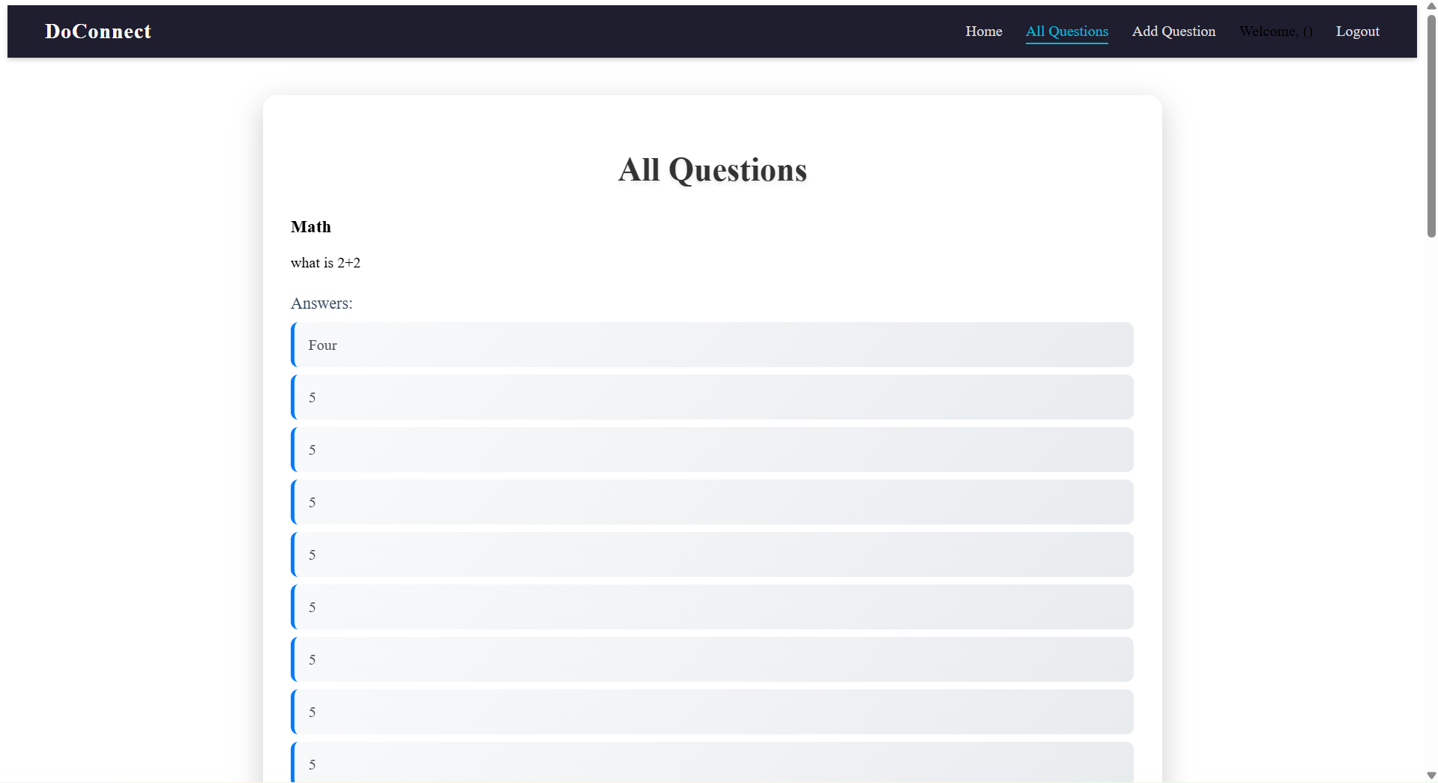
- In the All-Question Page Users Can see and post Answers
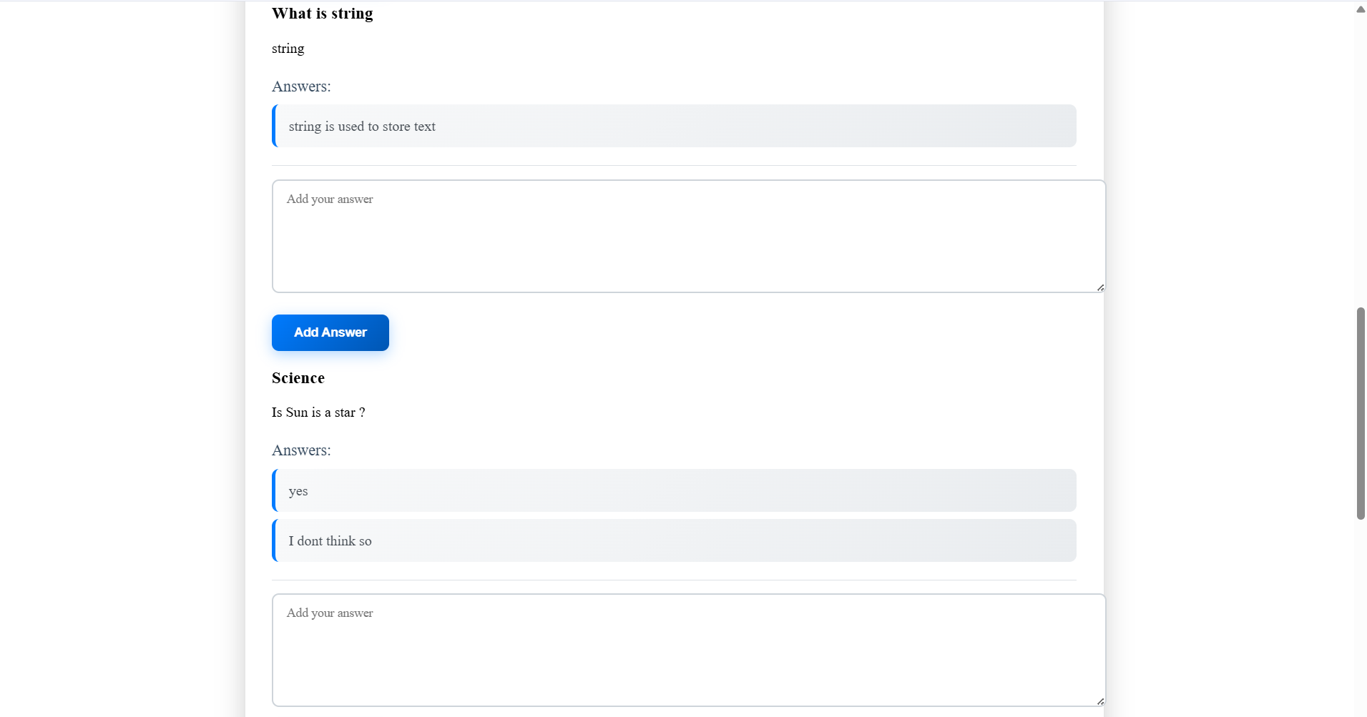

Add-Question Page
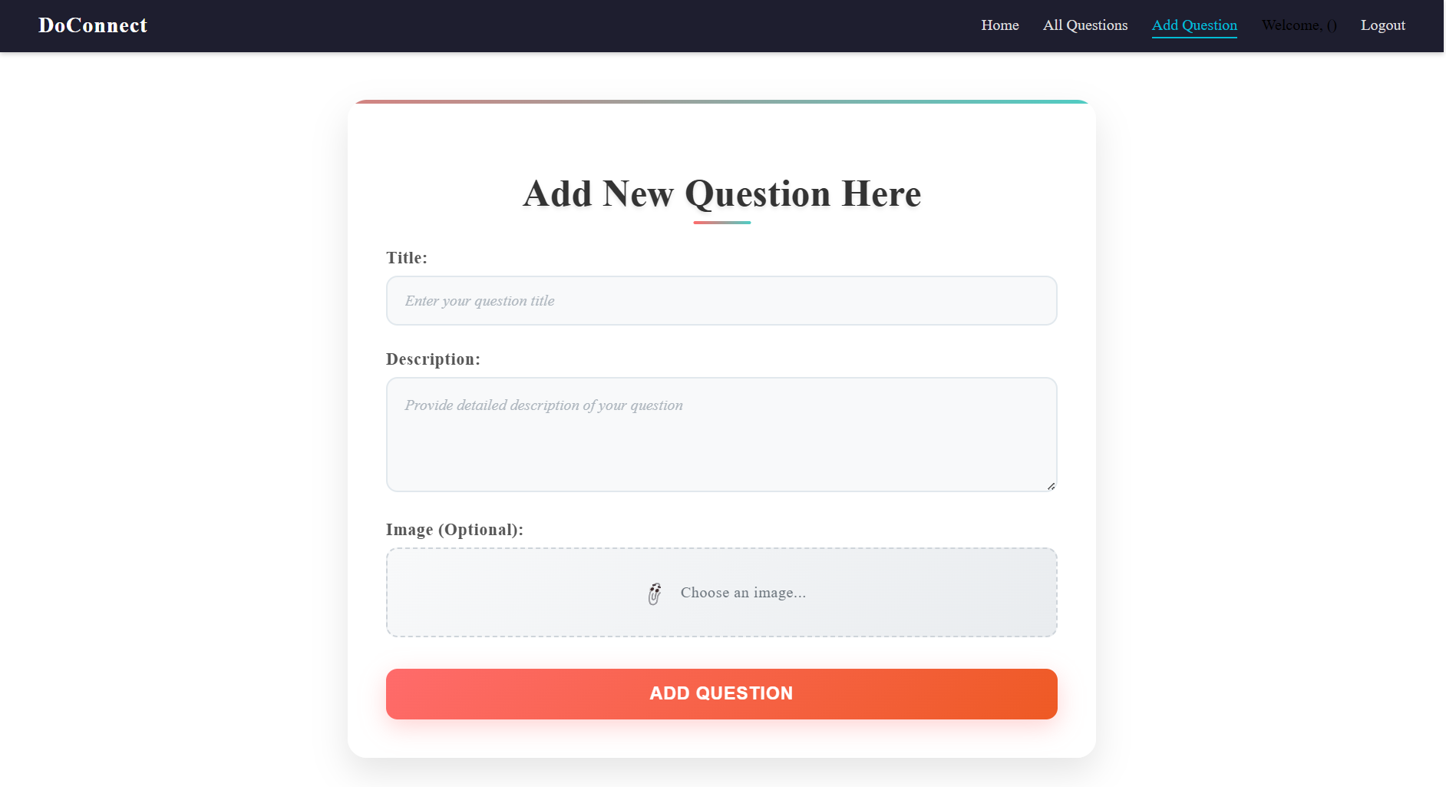
- We Can ask questions using Images

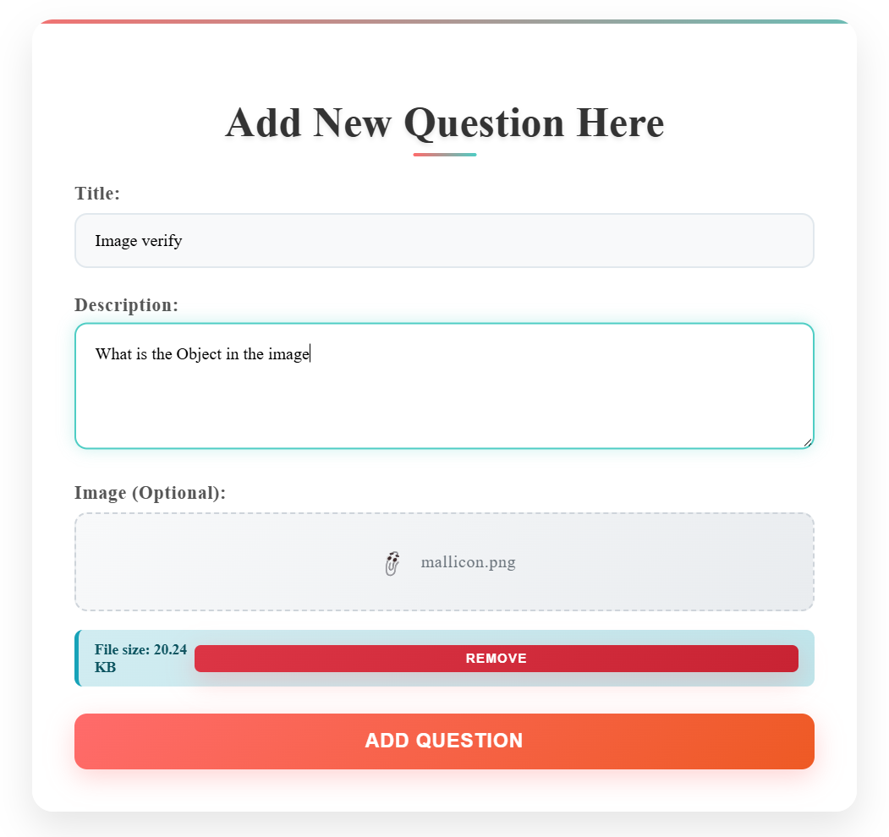
- After add question, It Goes For Approval
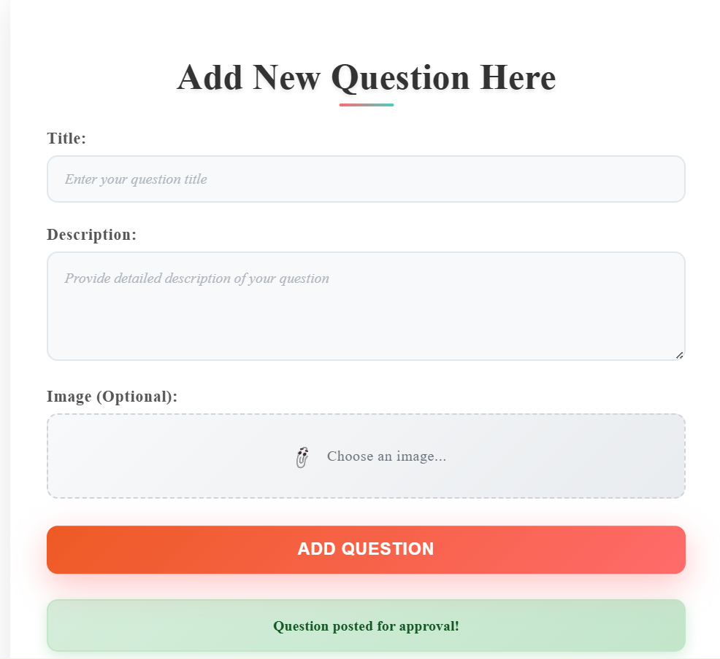

Admin-Dashboard
- Admin can Approve questions from here
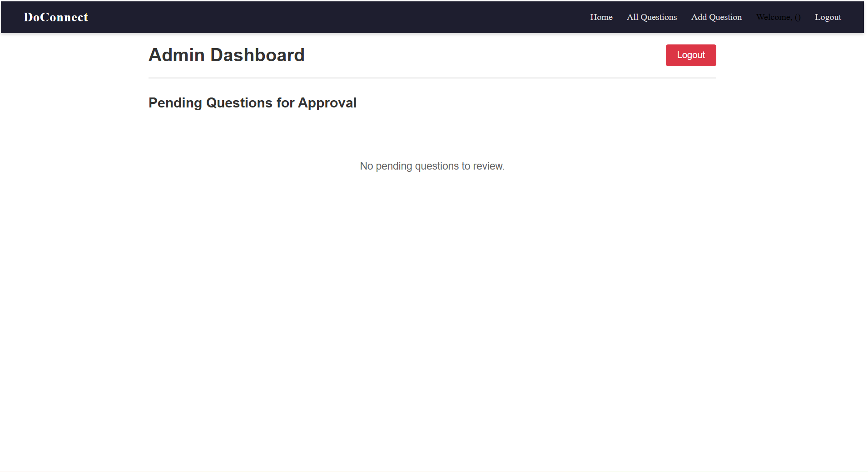
- Admin can Approve answers from here
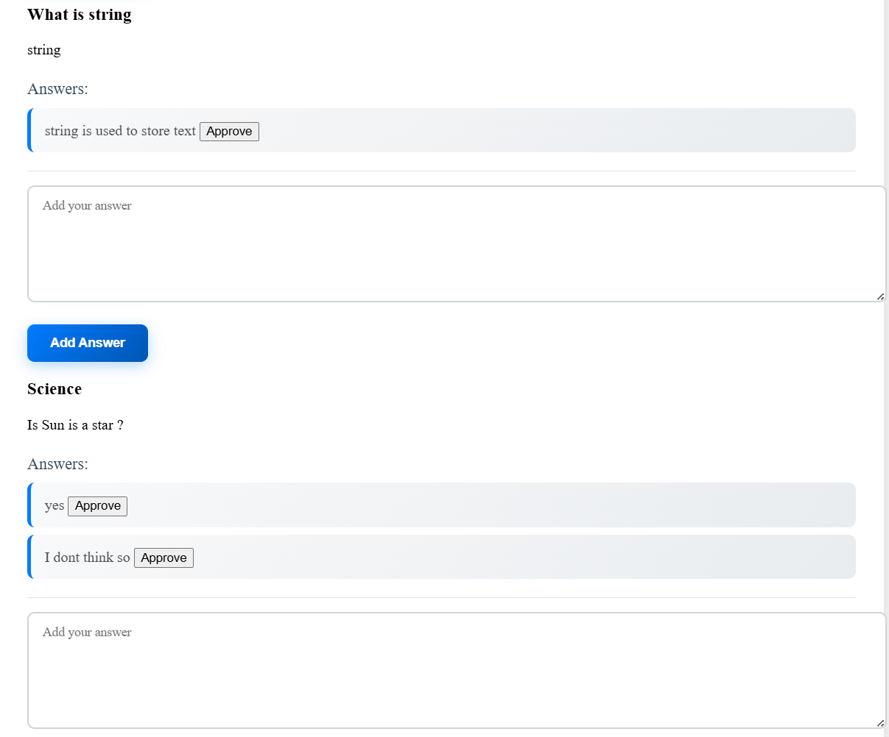

State Management
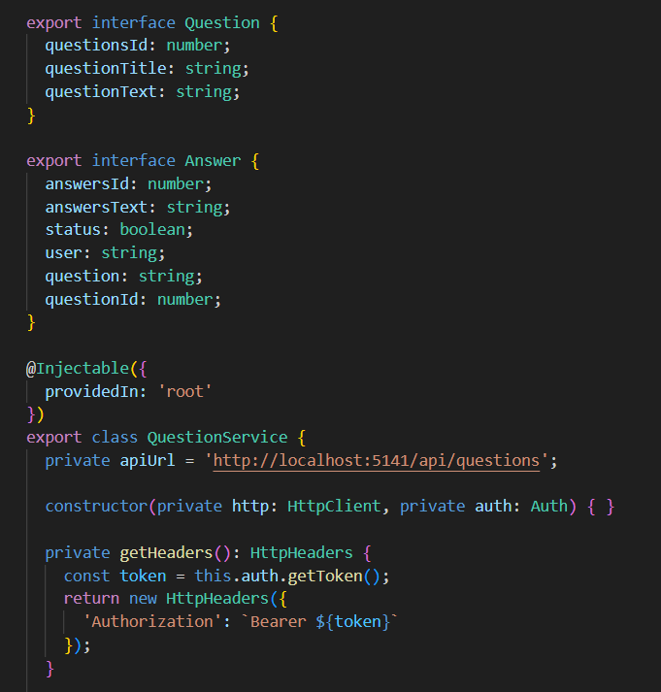

Database Diagram

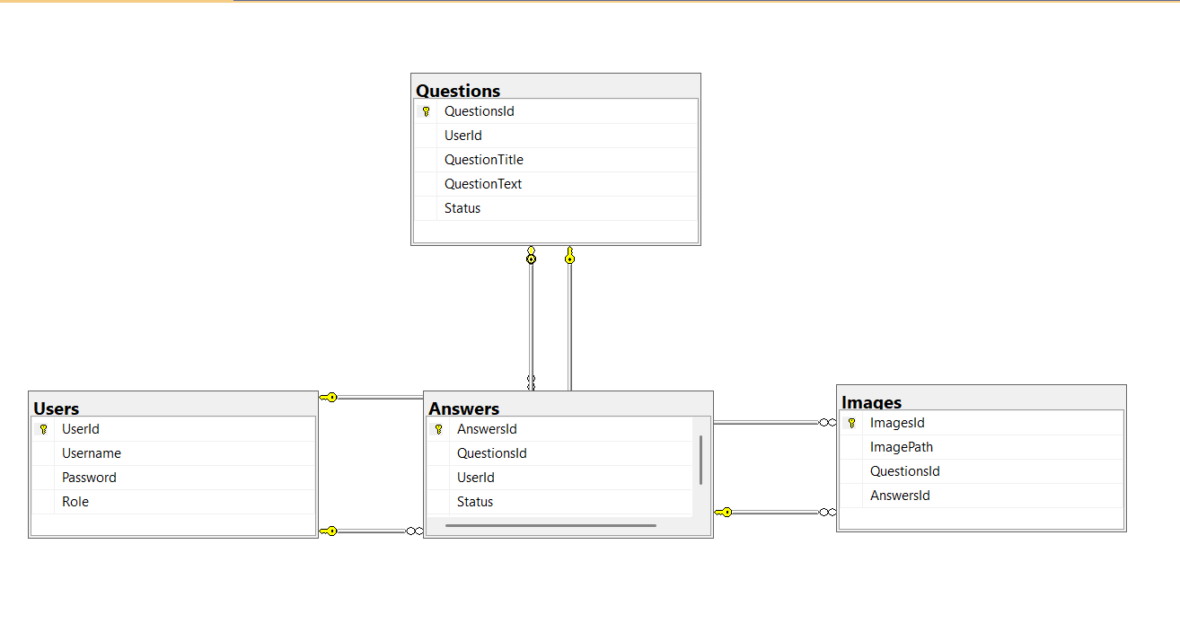

User-Table
Username with [Hashed] Password and Roles
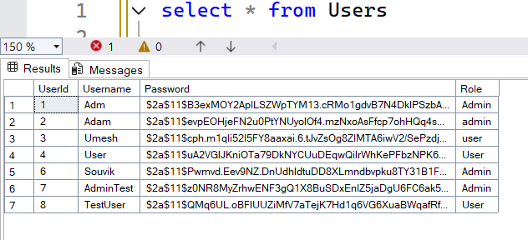
Answer-Table
Answer-Table with AnswerId,QuestionsId,UserId,Status and Answer
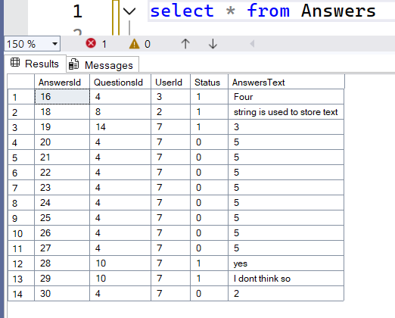
Question-Table
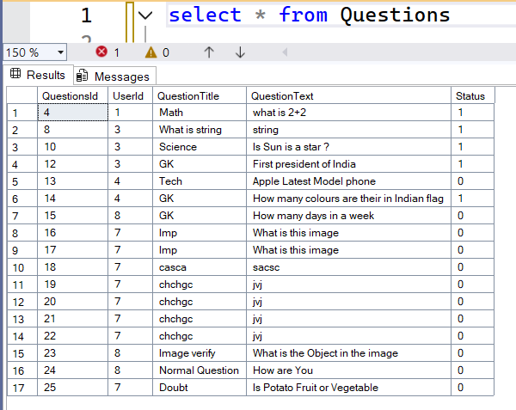

Image-Table
- Image path are stored in the database

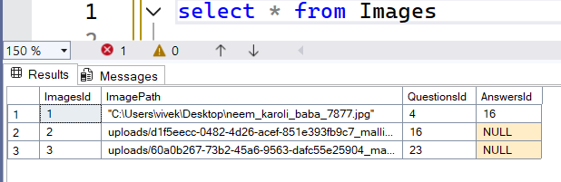

Bibliography

- ChatGPT (OpenAI) – Assisted in refining project documentation, drafting problem statements, and providing guidance on software architecture and optimization techniques.
- Blackbox AI – Used occasionally for error handling suggestions and debugging minor issues in Angular and ASP.NET Core code.
- Bootstrap (CSS Framework) – Utilized for responsive design, layout structuring, and styling components across the DoConnect platform.
- Angular Official Documentation – Reference for frontend component design, routing, and state management.
https://angular.io/docs
- ASP.NET Core Web API Documentation – Reference for backend API design and authentication mechanisms.
https://learn.microsoft.com/en-us/aspnet/core/
- Microsoft SQL Server Documentation – Used for database schema design, query optimization, and indexing strategies.
https://learn.microsoft.com/en-us/sql/sql-server/

