Exam Score Prediction – Documentation

1. Overview
This project implements a professional Machine Learning pipeline to predict student exam scores based on academic, behavioral, and environmental factors. Multiple regression models are trained and evaluated to identify the best-performing model.

2. Technologies Used
- Python
- NumPy & Pandas (Data Processing)
- Scikit-learn (Machine Learning)
- Matplotlib & Seaborn (Visualization)

3. Data Preprocessing
• Dataset is loaded from CSV
• Duplicate records are removed
• Irrelevant columns such as student_id and gender are dropped
• Categorical variables are encoded numerically
• Sleep quality is one-hot encoded
• Final dataset is converted into a numerical ML-ready format

4. Train-Test Split & Scaling
• Dataset is split into training and testing sets (70% / 30%)
• StandardScaler is applied to normalize feature values
• Scaling improves model performance and stability

5. Model Training
The following regression models are trained:
- Linear Regression
- Ridge Regression
- Lasso Regression
- K-Nearest Neighbors Regressor
- Random Forest Regressor

6. Model Evaluation
Each model is evaluated using:
- R² Score
- Mean Absolute Error (MAE)
- Root Mean Squared Error (RMSE)
The model with the highest R² score is selected as the best model.

7. Visualization
A scatter plot is generated to compare actual vs predicted exam scores for the best-performing model.
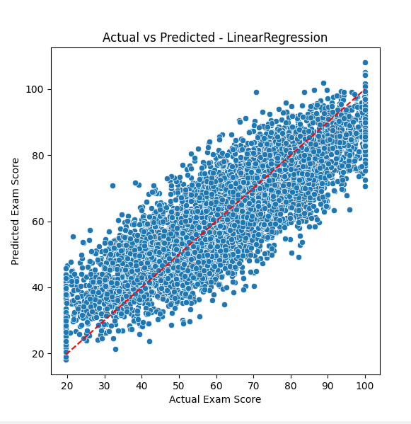

8. Flowchart
Start
↓
Load Dataset (CSV)
↓
Data Cleaning & Encoding
↓
Train-Test Split
↓
Feature Scaling
↓
Train ML Models
↓
Evaluate Models
↓
Select Best Model
↓
Visualize Predictions
↓
End

9. Conclusion
This pipeline demonstrates a complete and structured ML workflow. It ensures clean data handling, fair model comparison, and meaningful visualization, making it suitable for academic and real-world prediction systems.

