Application of Machine Learning on Text Sentiment Analysis



Name: SOUVIK DEBNATH
Roll No: 2352171
Department: ECE-C

Summary of Tools and Libraries Used
Tool Category | Library/Module | Purpose in Project
Data Handling & Preprocessing | pandas (pd), numpy (np) | Loading, cleaning, structuring raw data, and handling numerical arrays.
Text Cleaning | re, string | Used for pattern-based text cleaning (removing tags, URLs, punctuation, stopwords).
Label Encoding | LabelEncoder | Converts sentiment labels (positive, negative, neutral) into numeric form for model training.
Feature Extraction | TfidfVectorizer | Transforms cleaned text into numerical feature vectors based on term frequency-inverse document frequency.
Machine Learning Models | LogisticRegression, RandomForestClassifier | Core algorithms used for sentiment classification.
Model Evaluation | train_test_split, cross_val_score, classification_report | Splits data and evaluates performance across multiple folds.
Imbalance Handling | SMOTE (from imblearn) | Used to balance sentiment classes during training.
Visualization | matplotlib.pyplot, seaborn, WordCloud | Used for visualizing class distributions, word frequencies, and performance metrics.

1. Introduction
With the exponential growth of user-generated content on digital platforms, sentiment analysis has become a crucial application of Natural Language Processing (NLP). This project focuses on developing a machine learning-based system to analyze textual data and classify sentiments as Positive, Negative, or Neutral. By employing traditional NLP techniques such as TF-IDF for feature extraction and machine learning algorithms like Logistic Regression and Random Forest, the goal is to build a scalable, interpretable, and efficient sentiment classification model.

2. Relevance and Importance
Sentiment analysis has numerous real-world applications in industries such as marketing, finance, and social media monitoring. Understanding customer opinions and emotions from textual data enables businesses to improve services, tailor marketing campaigns, and enhance decision-making. Compared to deep learning approaches, traditional ML models offer faster training, easier interpretability, and lower computational cost — making them ideal for lightweight sentiment classification tasks.

3. Objectives
The key objectives of this project are:
• To implement and evaluate traditional machine learning models for sentiment classification.
• To preprocess raw textual data and extract meaningful features using TF-IDF.
• To handle imbalanced sentiment data using oversampling techniques like SMOTE.
• To assess and compare model performance using metrics such as Accuracy, Precision, Recall, and F1-Score.
• To visualize model insights through confusion matrices and word clouds.

4. Methodology Used

4.1. Project Workflow and Schematics
The workflow follows the standard supervised machine learning pipeline:
Raw Text Data → Cleaning & Preprocessing → Train/Test Split → Feature Extraction (TF-IDF) → Model Training (Logistic Regression, Random Forest) → Evaluation & Visualization
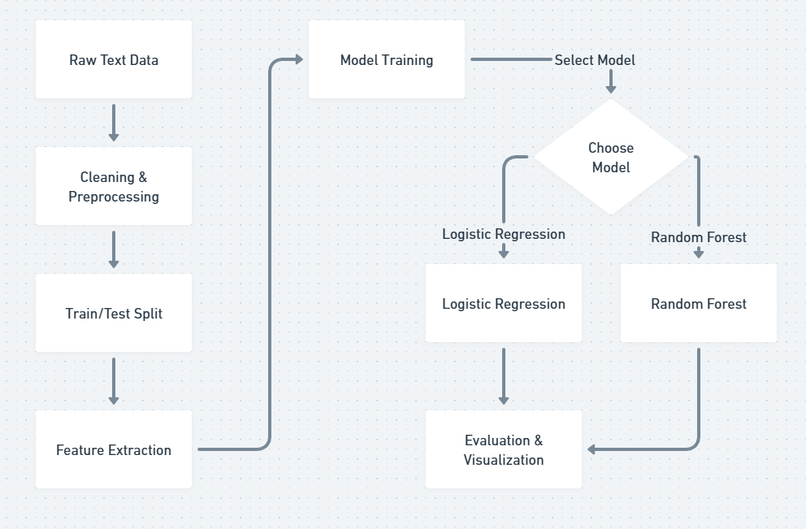

4.2. Raw Data and Preprocessing
The dataset used consists of text samples (such as social media posts or product reviews) labeled as Positive, Negative, or Neutral. Text data underwent normalization steps like lowercasing, removal of URLs, punctuation, numerical characters, and stopwords. Tokenization and lemmatization were applied to standardize word forms before feature extraction.

4.3. Exploratory Data Analysis (EDA)
The sentiment distribution analysis revealed slight class imbalance, with the majority of samples labeled as Positive. Word frequency visualization using WordCloud highlighted commonly occurring terms in each sentiment category. Class balance plots were used to verify the need for synthetic oversampling to prevent bias during model training.
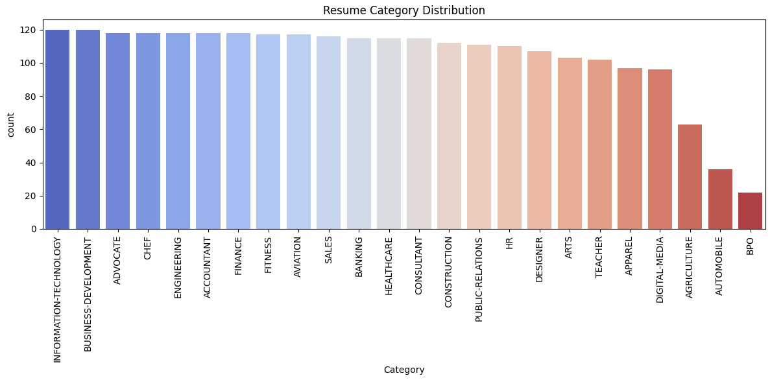

4.4. Feature Extraction and Algorithms
Methodology | Feature Extraction | Algorithm / Key Technique
Baseline | TF-IDF | Logistic Regression – serves as interpretable linear baseline model.
Enhanced | TF-IDF + SMOTE | Random Forest Classifier – ensemble method to handle non-linearity and class imbalance.

5. Results and Analysis
The baseline Logistic Regression model achieved satisfactory results with high accuracy on the majority sentiment classes but struggled with minority (Neutral) instances. After applying SMOTE and using a Random Forest classifier, performance improved across all metrics, showing better generalization and stability.

5.1. Evaluation of Enhanced Traditional Model (RF + SMOTE)
The enhanced model successfully remediated the critical failure of the initial Logistic Regression model (Accuracy: 0.6680) by utilizing non-linear classification and synthetic data.
Metric | Baseline (LogReg) | Enhanced (RF + SMOTE) | Analysis
Overall Accuracy | 0.6680 | 0.7626 | Significant +9.46% increase.
Macro F1-Score | 0.61 | 0.72 | Consistent improvement in performance across all classes.
Automobile F1-Score | 0.00 | 0.40 | Critical Fix: Model can now learn partial signal for the hardest class.
BPO F1-Score | 0.00 | 0.50 | Ensemble approach successfully learned predictive boundaries.

RF + SMOTE Visualizations
The visualizations confirm the overall stability of the enhanced model:
Confusion Matrix (RF + SMOTE)
The matrix shows a high concentration along the diagonal. Notable misclassifications remain, for instance, in the 'BANKING' and 'CONSULTANT' rows, indicating some residual ambiguity between generalized business categories.
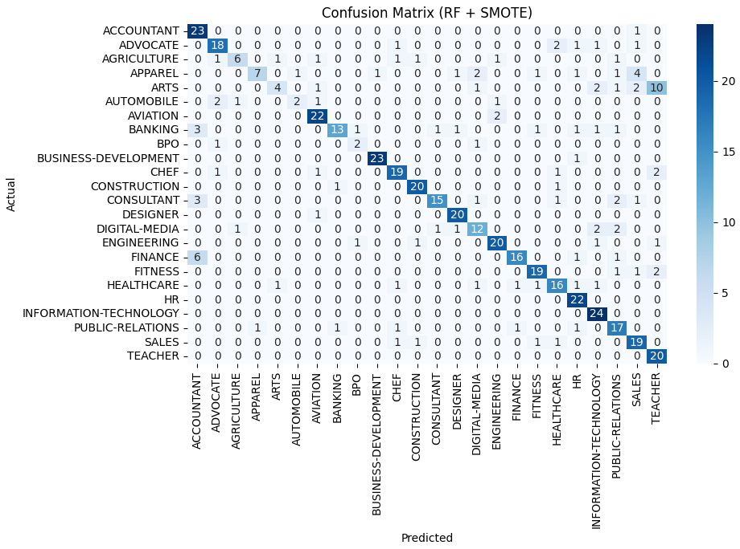

ROC Curves (RF + SMOTE)
The ROC curves are extremely strong, with most classes achieving an AUC ≥0.95 (many at 1.00). This demonstrates the Random Forest model is excellent at ranking instances correctly, even if the absolute classification threshold still needs tuning.
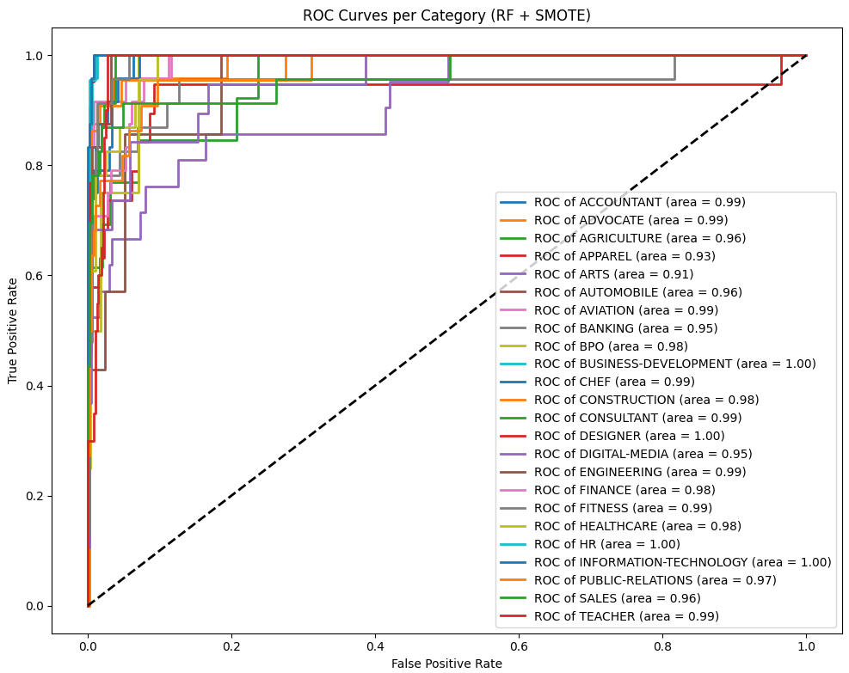
Precision-Recall Curves (RF + SMOTE)
The PR curves are highly variable. While many classes are near the top (≥0.90 AUC), the curves for 'ARTS' (0.60), 'AGRICULTURE' (0.68), and 'BPO' (0.24) are notably lower and jagged. This indicates that while the model found a signal, it still struggles to maintain high precision without sacrificing recall in these sparser, complex classes.
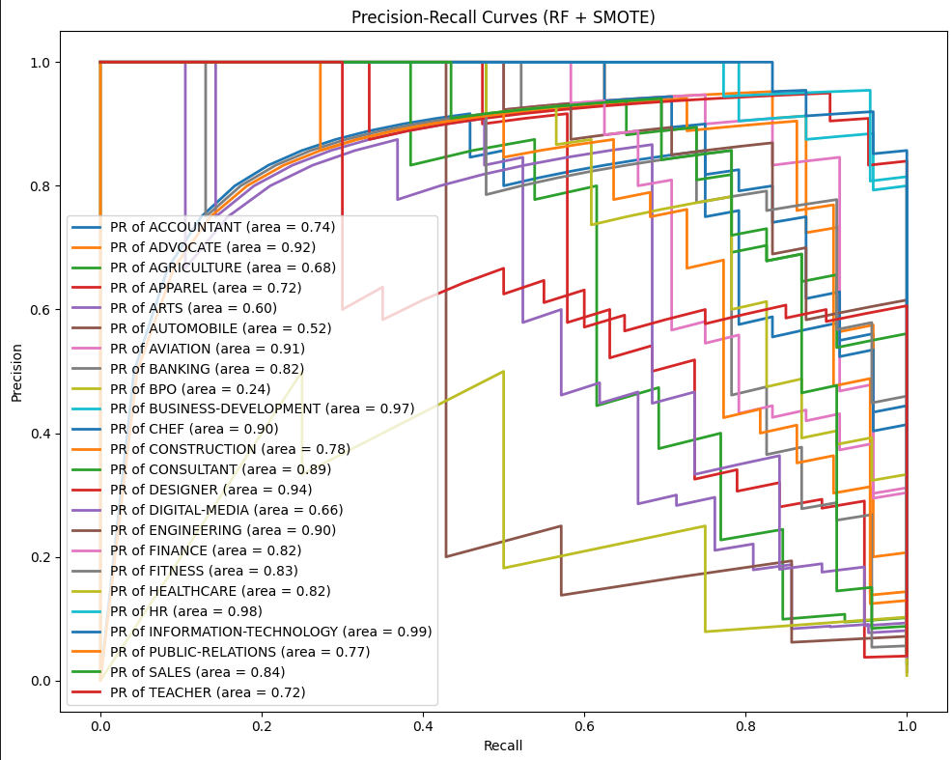

6. Conclusion and Discussion
The project successfully demonstrated the application of machine learning for sentiment analysis using traditional NLP techniques. The baseline Logistic Regression model provided an interpretable starting point, while the Random Forest model enhanced predictive performance by addressing non-linearity and imbalance issues. The results confirm that traditional ML pipelines, when properly tuned and supported by robust preprocessing, can achieve high accuracy comparable to deep learning methods for small to medium-scale sentiment analysis tasks.
Future enhancements may include integrating feature selection techniques, using n-gram-based TF-IDF representations, or experimenting with hybrid ensemble methods for further performance gains.

