Experiment 3: Creation of a Simple Network Topology Using
Open-Source Network Virtualization Tools
Objective
To create and configure a simple network topology using an open-source network
virtualization tool and verify communication between the virtual network nodes.
Task
• Ubuntu Linux Virtual Machine
• VirtualBox
• Mininet
• Create simple Network Topology
• ping and basic Linux networking commands
• After completion, stop the netwo

Mininet installation
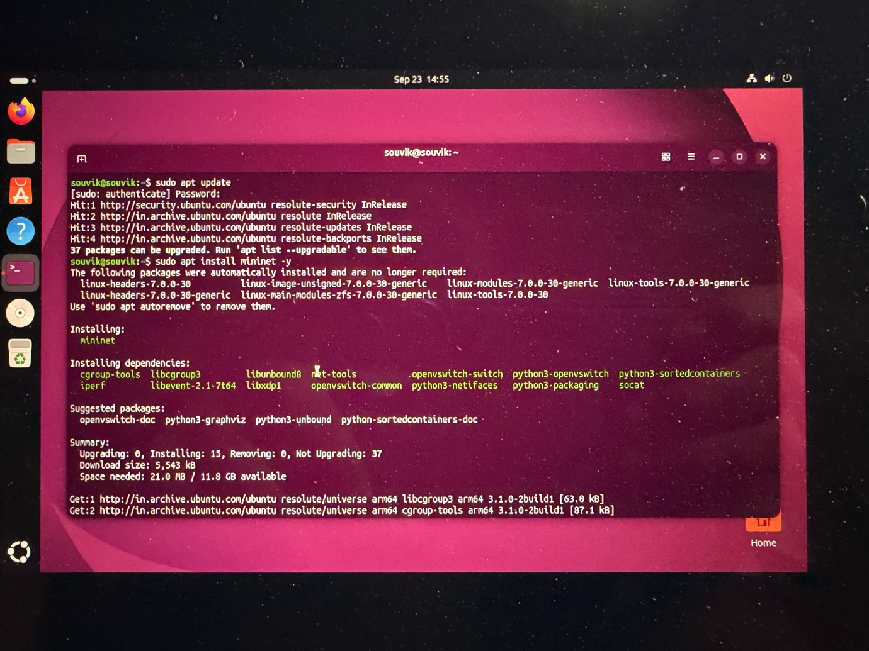

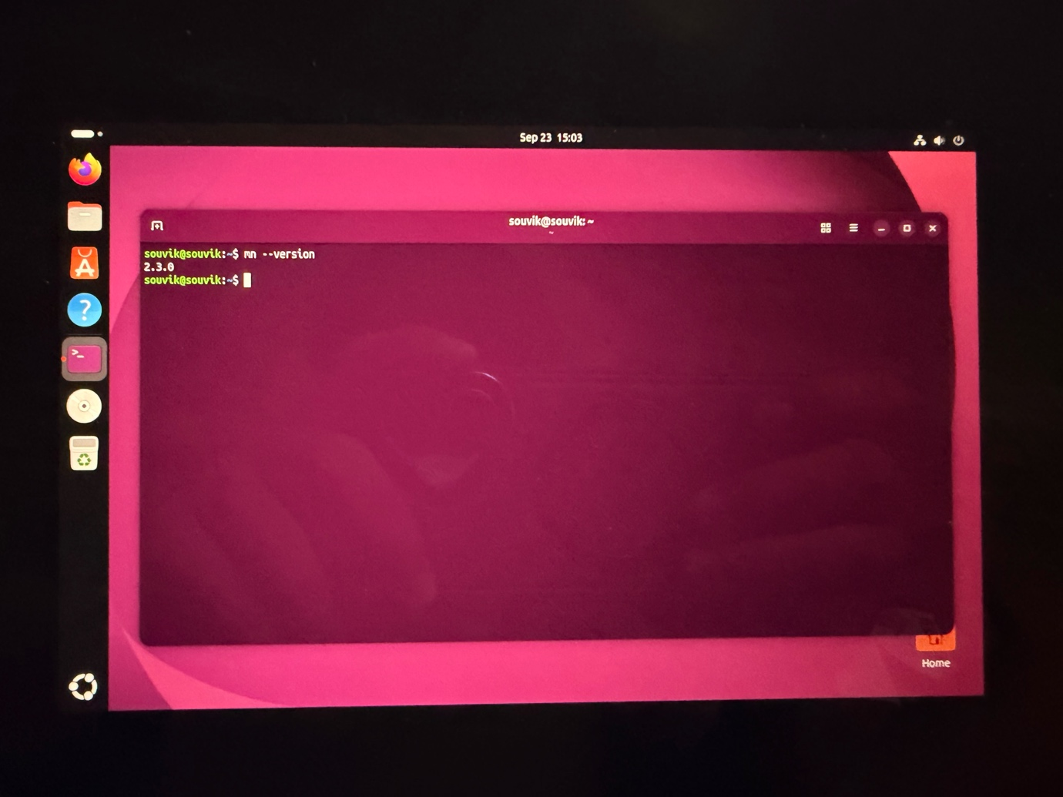
MN Version Check

Topology
Star topology
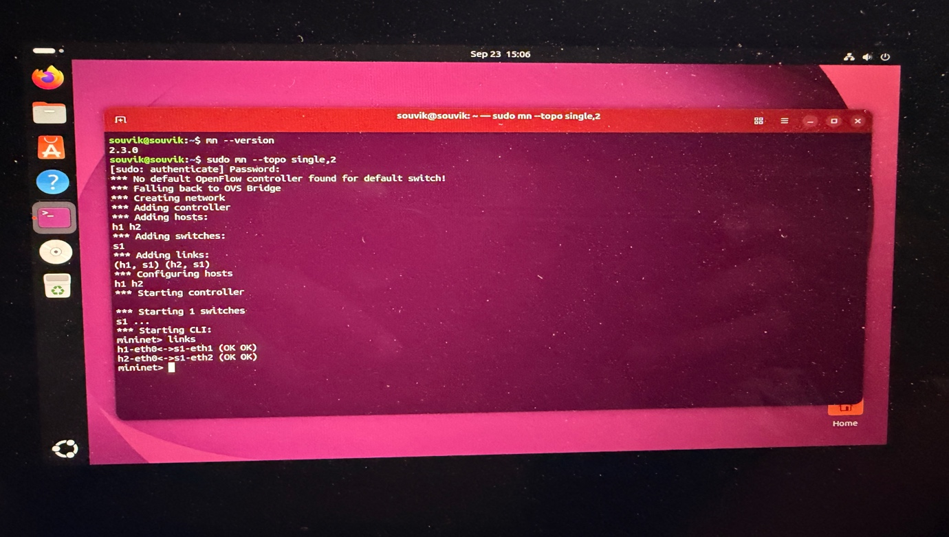
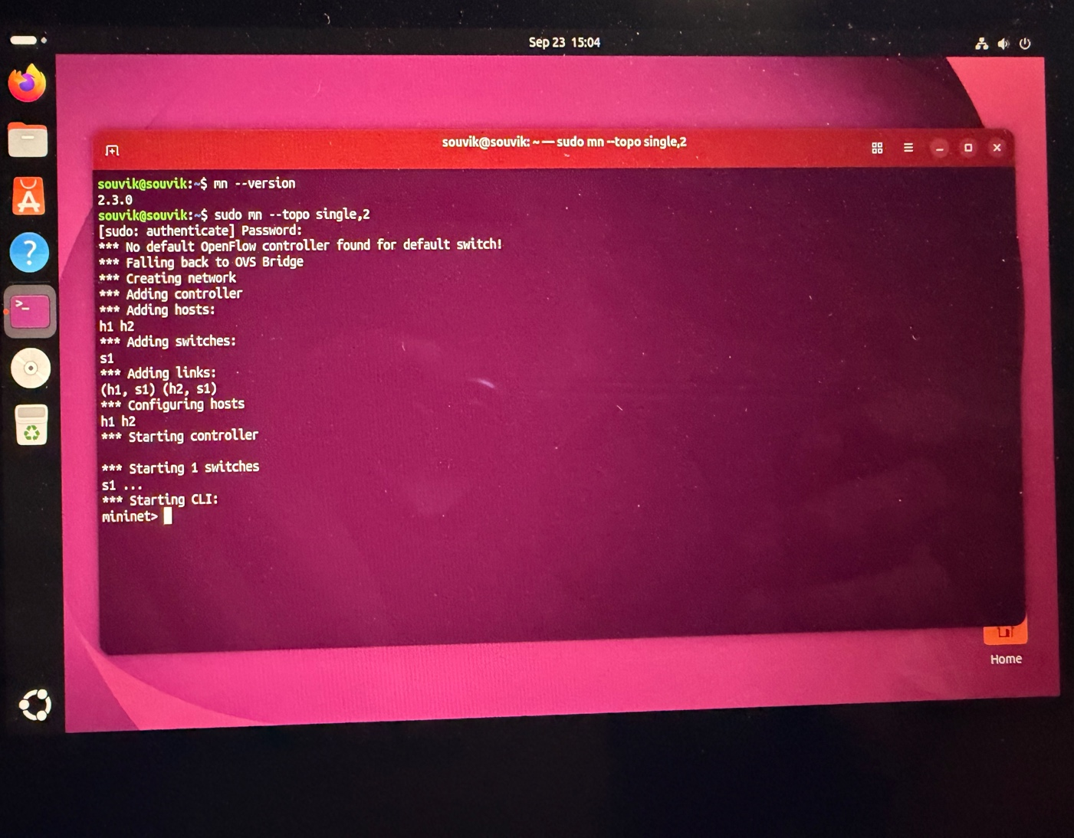

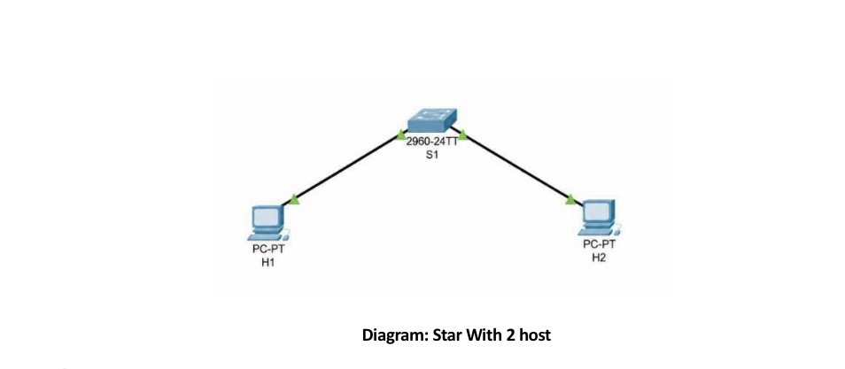

Star with 4 hosts

