Experiment 2: Client-Server Communication Between Two Virtual Machines

Configure two virtual machine instances in VirtualBox to establish client-server communication and implement a basic TCP-based chat application between the two virtual machines.

Objective

- Create/prepare two Ubuntu Virtual Machines in VirtualBox.

- Configure both VMs on the same virtual network.

- Assign/check the IP address of both VMs.

- Test connectivity using the ping command.

- Designate one VM as the Server.

- Designate the other VM as the Client.

- Create a TCP server program on the Server VM.

- Create a TCP client program on the Client VM.

- Establish a connection between the two VMs.

- Send and receive messages through the chat application.

- Demonstrate the working chat application.

- Capture screenshots of configuration, connectivity and chat communication.

- Creating and preparing two Ubuntu Virtual Machines in VirtualBox

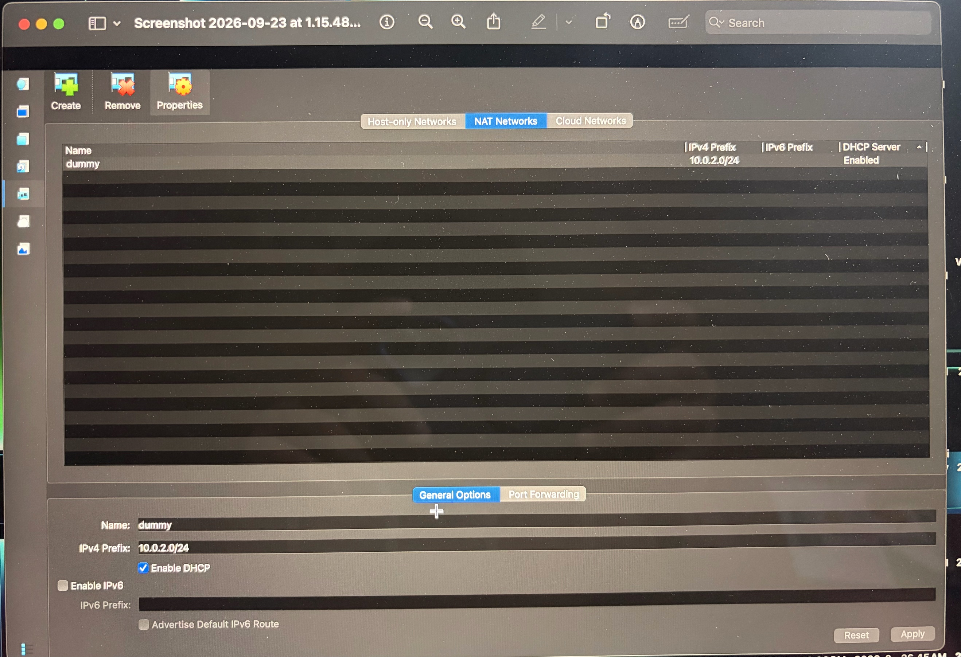

- Configure both VMs on the same virtual network.

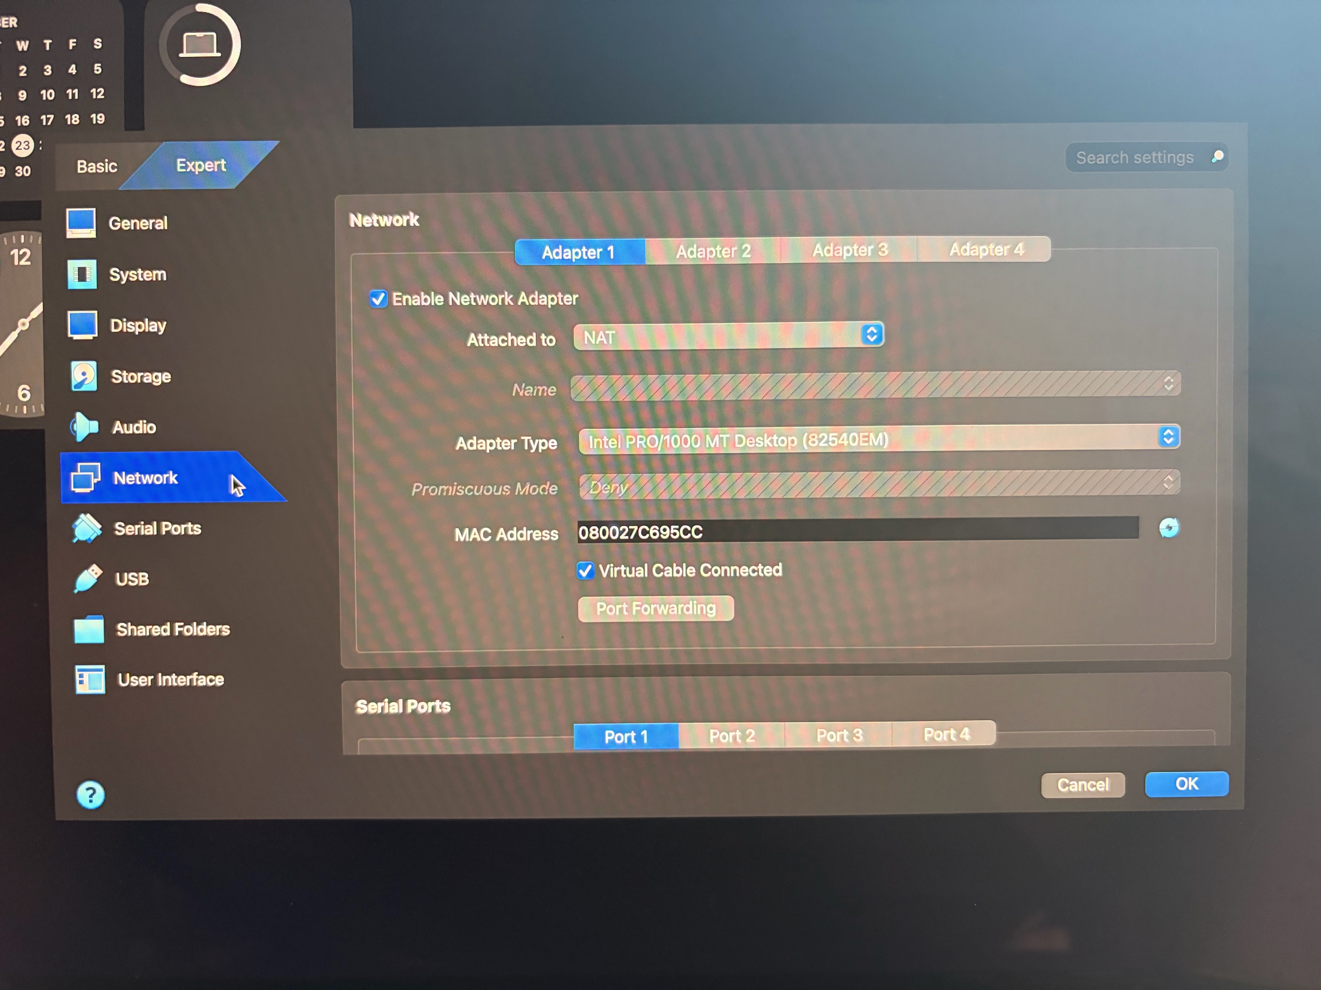

- Checking the IP address of both VMs.

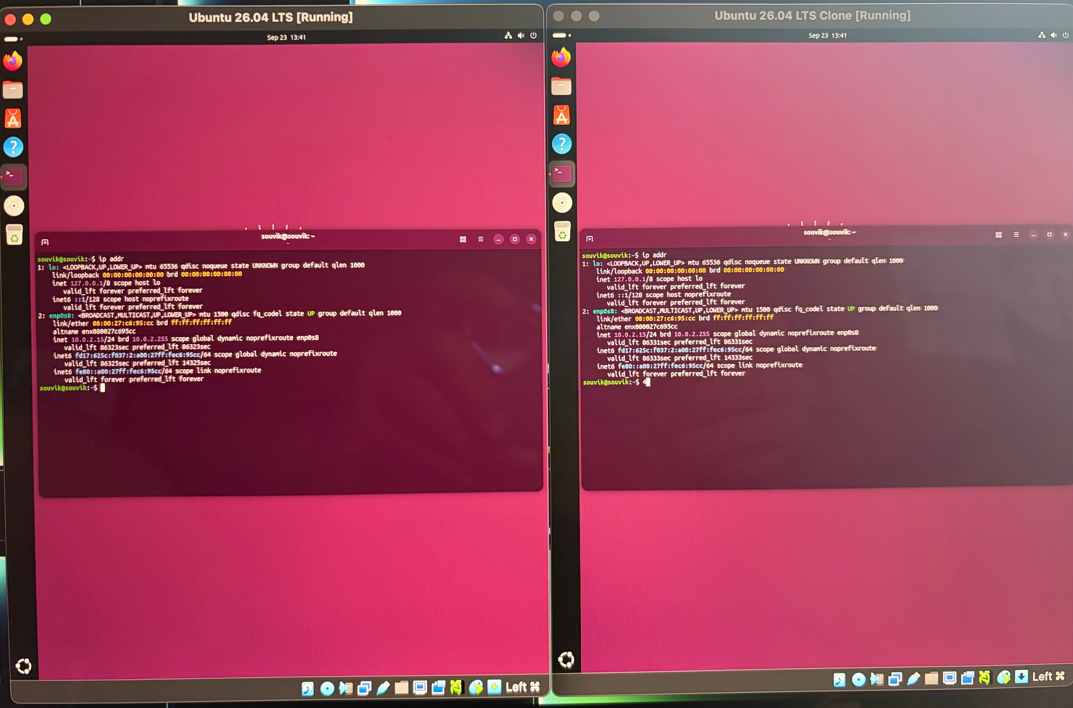

- Testing connectivity using the ping command
