ASSIGNMENT-01
Installation and Configuration of Ubuntu Virtual Machine Using Oracle VirtualBox

Step 01-Install and open Oracle VirtualBox and upload the ISO file.
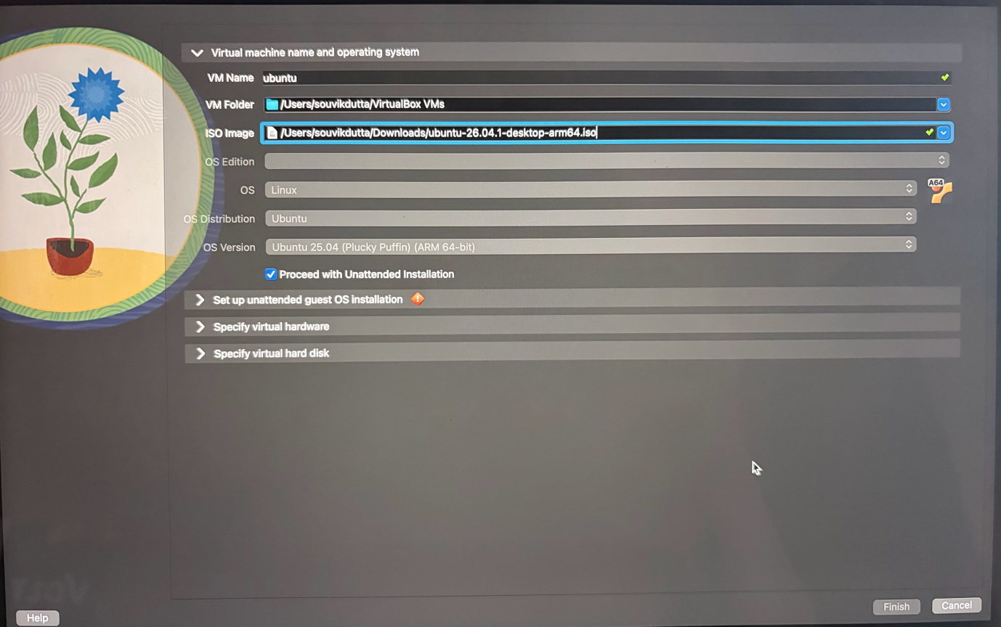

Step 02- Set the Base Memory, Number of CPUs and Disk Size according to the System.
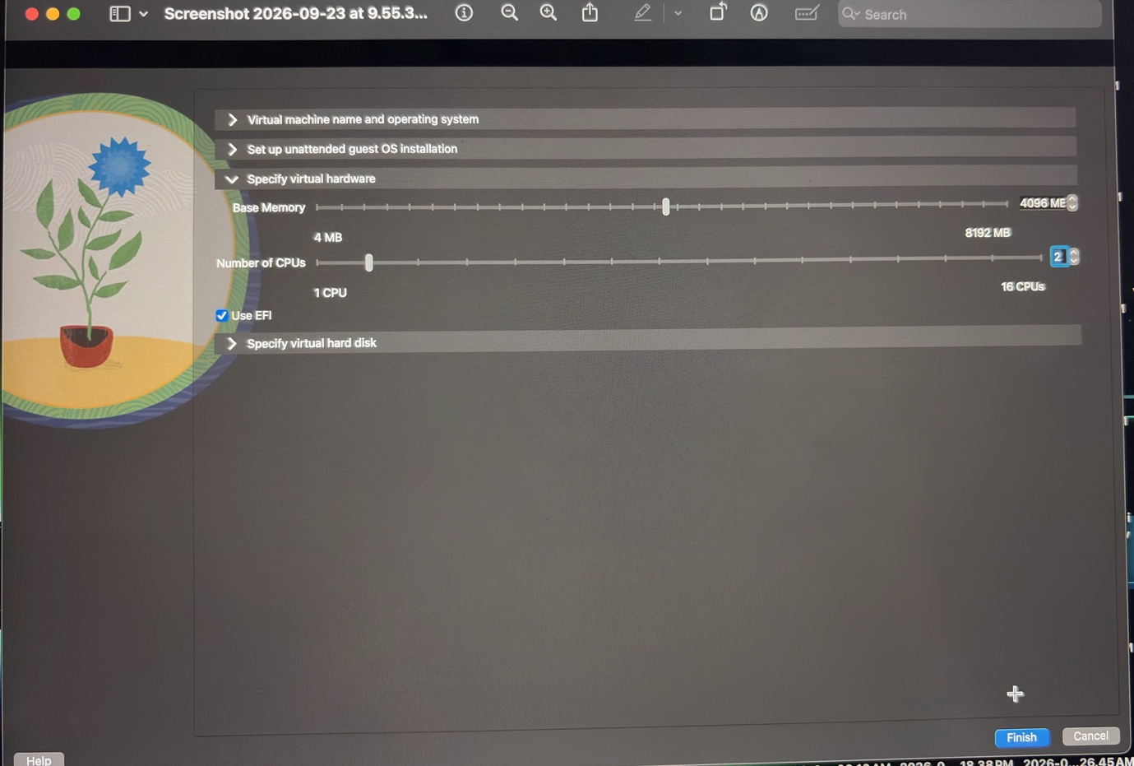


Step 03-Ubuntu Home Screen

