Final Report
Artificial Intelligence

Name:- Souvik Aditya
Roll number- 53
Registration N.o:- 11809075
Section:- K18KK

Abstract:-
This project is basically based upon facial recognition, but except of just recognizing face, it also serves the purpose of saving the image data of different entities which can be further used for verification and authentication in various software having implementations on various Realtime fields of Industrial as well as public sectors.

Related work:-
Before we get into face recognition first I prepared my code to reshape the images of a persons face in the required dimension and turning it into a greyscale image.
This has two benefits, the new image formed is much smaller in size, which in turn helps to maintain a big dataset and hence save storage space.
Secondly, matching the digital matrix of a greyscale image is more accurate and faster then working with a RGB image matrix (which is more complex and 3-layered).

Implementation:-
It is implemented using python code and it contains separately three python files. One helps to create the dataset by turning on the camera and recording a person’s face. In this code I also make sure that proper data set is recorded for each and every entry. I’ve achieved that by saving each file name according to the name entered by the user. (with the help of string catenation)
It’s future scope of implementations lies in detecting face for ticket booking, authentication and automate other daily verification processes.

Important libraries used:-
All the libraries mentioned bellow are part of Python only.
- OS library:- to operate through all the files and drectories in PC.
- PIL library:- It’s python’s dedicated library for image reading and loading.
- Numpy:- helps to convert the image matrix into ann advanced numpy array, so that we can perform various numerical function upon it
- OpenCv:- python’s library for computer vison, helps in camera controlling and image manipulation.

Team responsibilities:- Went solo.
Outputs:-
When data set is created
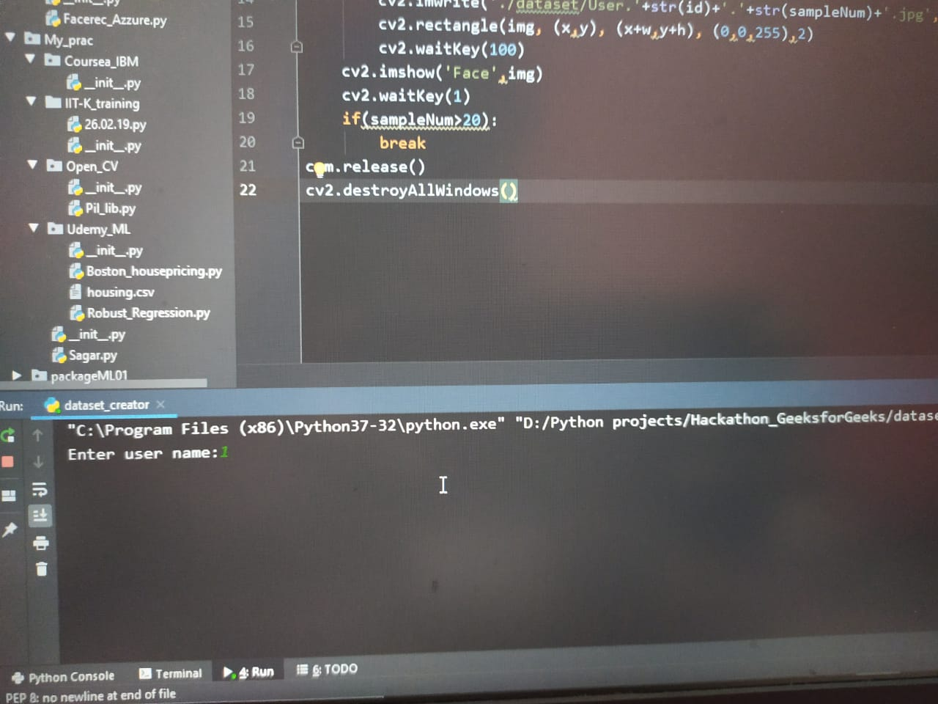
When the model is trained:-
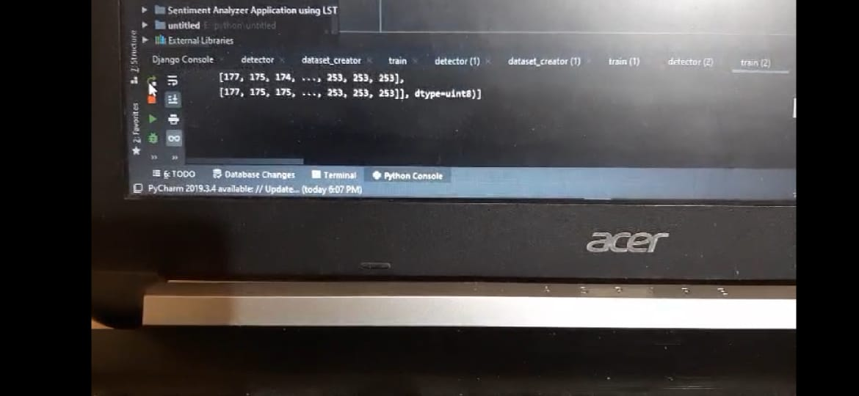

When the final detection is done:-
