Experiment-1

1. WAP to display the use of arithmetic, logical and relational operators on two variables:

Code:

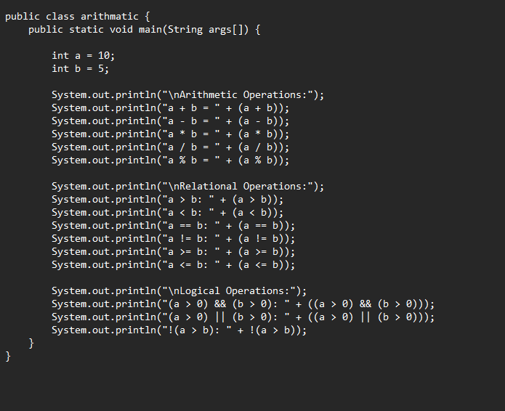

Output:

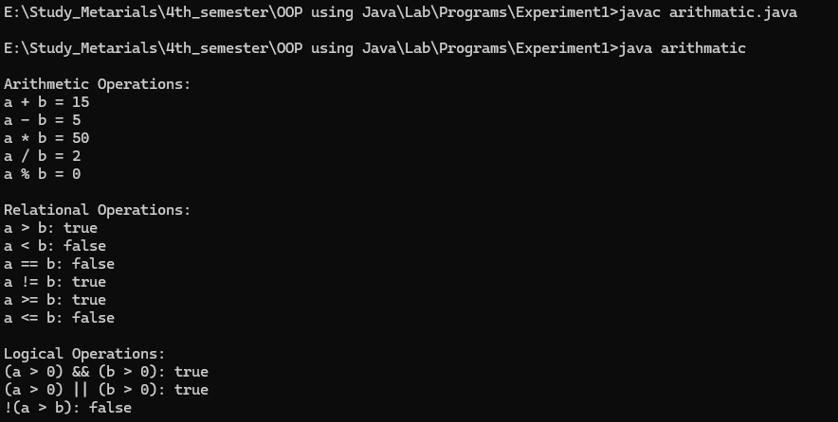

2. WAP to swap two numbers using third variables and without using third variables:

Code:

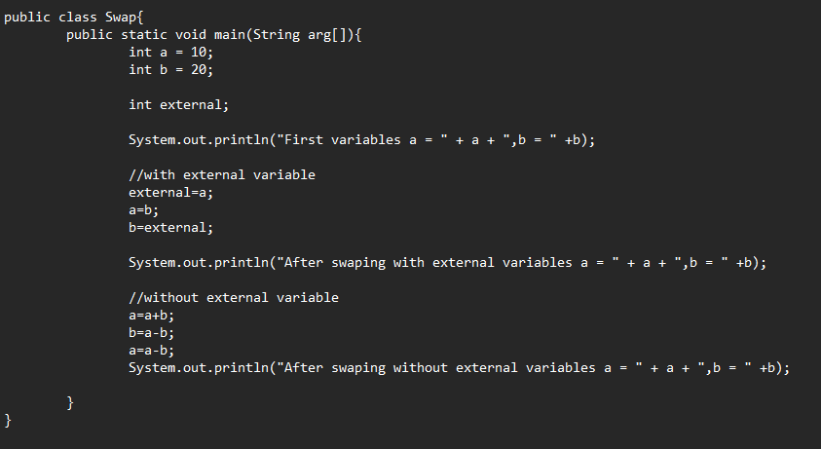

Output:

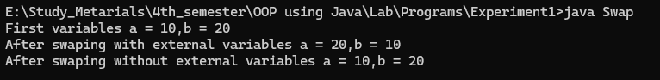

3. WAP to print ASCII values of numbers and different characters:

Code:

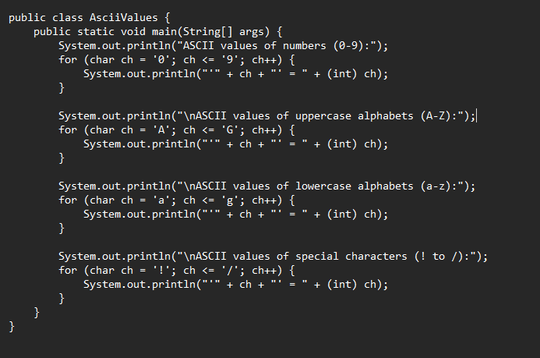

Output:

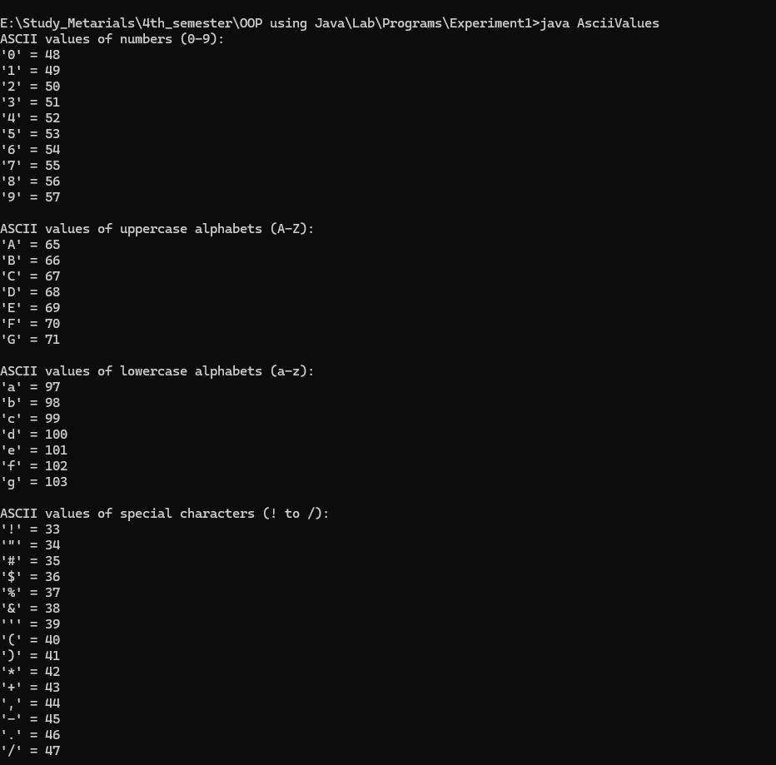

4. WAP for calculator to perform addition, subtraction, multiplication, division using Number class and object:

Code:

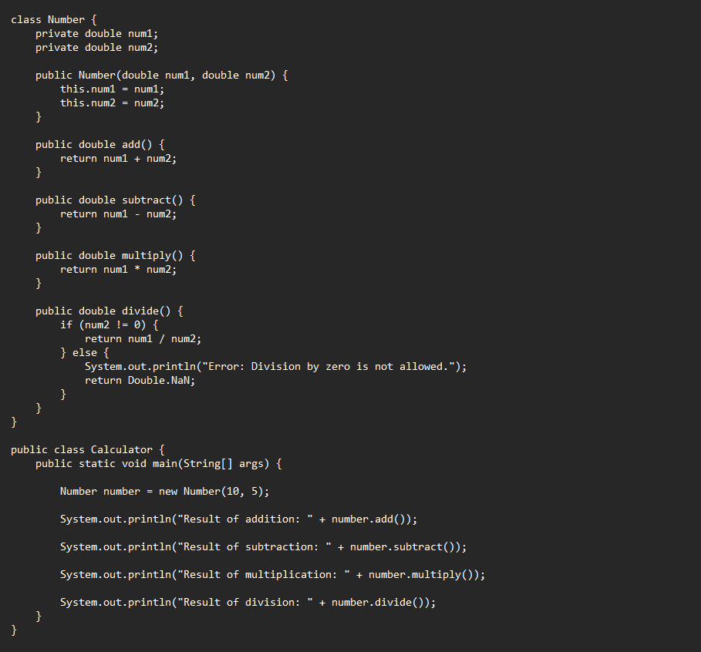

Output:

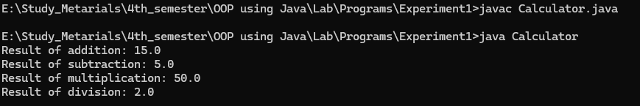

5. WAP to print all the default values and size (in bytes) of different primitive datatypes in java:

Code:

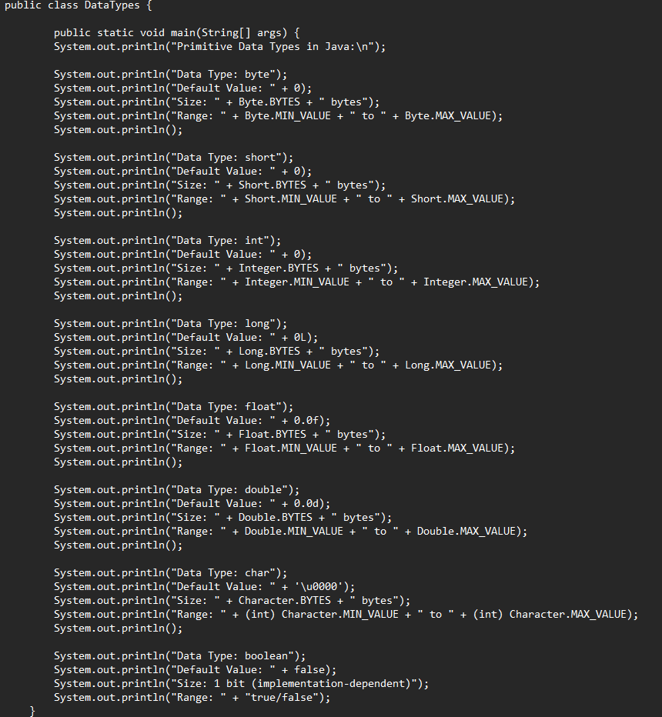

Output:

