Programming for Problem Solving Case Study

Student Record System
Group: 10(A)/3

Presented By:
Team Member 1 Name: Mekehkor S Tokpah, Regd No: 2301020607
Team Member 2 Name: Aditya Prasad, Regd No: 2301020707
Team Member 3 Name: Souvikarjun Deb, Regd No: 2301020745
Team Member 4 Name: AKSHAT GUPTA, Regd No: 2301020767
Team Member 5 Name: KAUSHIK ANAND, Regd No: 2301020768
Team Member 5 Name: BISHAL RAJDEV BARIK, Regd No: 2301020768
Under the Guidance of:
Name: Dr.Deepak Ku. Rakesh


Content
- Abstraction
- Introduction
- Problem Statement
- Model and Screenshots of Coding
- Results
- Conclusion
- References

Abstract
Student Management System (SMS) is software application for the education that can be used to managed student information and data. This system is designed for primary school to help administrators and teachers in the management of students. Students Management System consists of four modules including Teachers, Students and Parents Profile, Student Exam Results, Comment Reply and SMS notification. Teachers can use this system to register information of student and managing parents and student profile. Teachers can view results of the students in graph format to know their performance. Besides that, teachers also can send the student results to parents through Short Message Service (SMS). For the parents, they can login to system and view their children examination results and also graph for know their performance. This system also provides a communication platform for parents and teachers. Thus, by using this system can benefits to administrators, teachers and parents.

Introduction
In this 21'st century, all is about technology. The schools and education nowadays also already changed. Not only for University and secondary school, primary school also must have their own management system. But the current management system primary school is already defined as old generation management system and it already cannot satisfy the user needed. As a result, a system called Student Management System will be developing as an upgrade version of the old system or to replace manual system to solve problem that facing when was using the old system or manual system. Student Management System (SMS) is a software application for education that use to managed students information and data. Also known as student information system (SIS), student information management system (SIMS), or school management system (SMS). I 2 This design of this system is web-based type, so the user also can directly use the system by connect to internet The users of this system are given to three groups, which are administrators, teachers and parents. The functions of administrators and teachers are read, write and edit, while the parents their functions are only read and write. Through this system, administrators and teachers can manage all student data and information easily' and the parents also can easily know their children performance easily. Besides that, this system added new technologies, which are using the Web Service to send the SMS (Short Message Service). Through this Web Service, teachers can send the exam result to children parents, so the parents can know the exam or test result of their children. Another technologies is the system will auto generates warning letter also by checking the attendance of students. This new system will replace the current system that is used in primary school and surely this system will improve the student management system of the school and efficiency of the job.

Problem statement
Using manual system to manage the students which are records all information and in the book or paper was causing the job of the teachers becomes more and troublesome. The record in the have a possibility missing or destroy when happen any accident. While now already have the school use the computer to manage the student information, but both of the systems they use are already out-dated. The system they use all are standalone and separately, one system only have one function. This was cause teacher harder to use all the system on the same time. The separately system without connection with each other also cause the same data and information the needed key in in every system. Besides that, the system that using also does not have the communicate Platform for the parents to communicate with the parents. This will cause the interaction between teachers and parents become less. 3 Failed in test or scores dropped are causing the student were scared to telling their parents. Added some of the parents are busy with their own carrier, both of them may indifferent their child's results. Besides that, also have some student prevent their parents to know their test result, they may cheated their parents with multiple reason like teacher haven't given back the report card or others to avoid their parents know the result. This was causing the parents does not know their children exam or test results. Every students learning ability are different, some of them are good, some of them weak. So the results that gets also different. As a teacher, they need to know every exam results of each student to know which subject is the weakness of students. But all the students results are record in the paper, teachers is harder to know the performance of the students if not through data or graphical image. This is because through the graph, teacher can know is that any improvement of students in term of the status, progress or performance.

Model and Screenshots of Coding
The operations that can be performed using the Student
record System are:

- Add the Student details
- Retrieve the Student data with a roll number
- Retrieve the Student data with a first name
- Total number of Students registered in a particular course
- Delete a Student data
- Update a Student data
- Total number of Students

1.Adding the required header files:

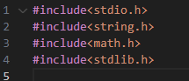

2.Defining the Structure Student Info and the Counter Variable:
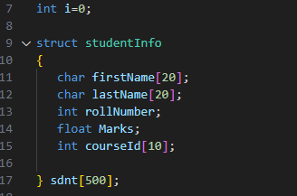

3.addStudent():
This method enables the addition of the details of a new Student. It gets the input data from the user and adds the same data into the Student record system by storing it within the system. It also checks the uniqueness of the roll number while adding the details of the Student, as the roll number of any student must be uniquely defined. Let us get into a program which details the method " addStudent() ".

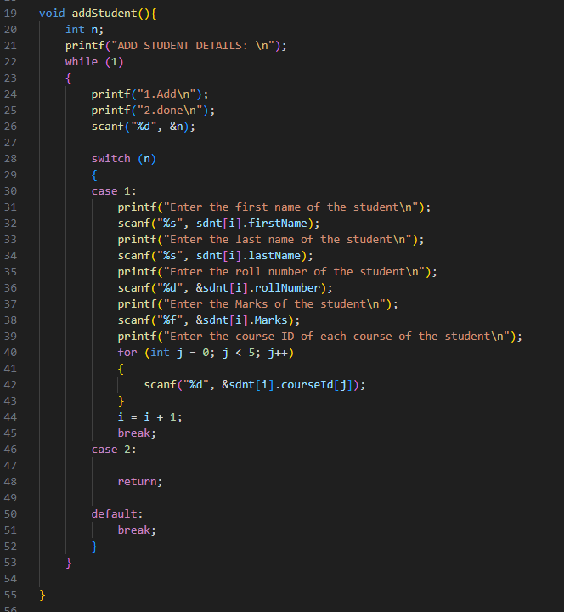

4. findByRollNumber():
This method is used to find the entire details of a specified student with their roll number as an input which is uniquely defined anyway. It takes the input of the roll number of the student in order to find the details of the student carrying that specified roll number ( through the input ). This is the main reason for giving unique roll numbers to each student so that their identity can be protected and the data can be retrieved easily just by using the roll number. Let us understand this concept through a program which details the method "findByRollNumber()".
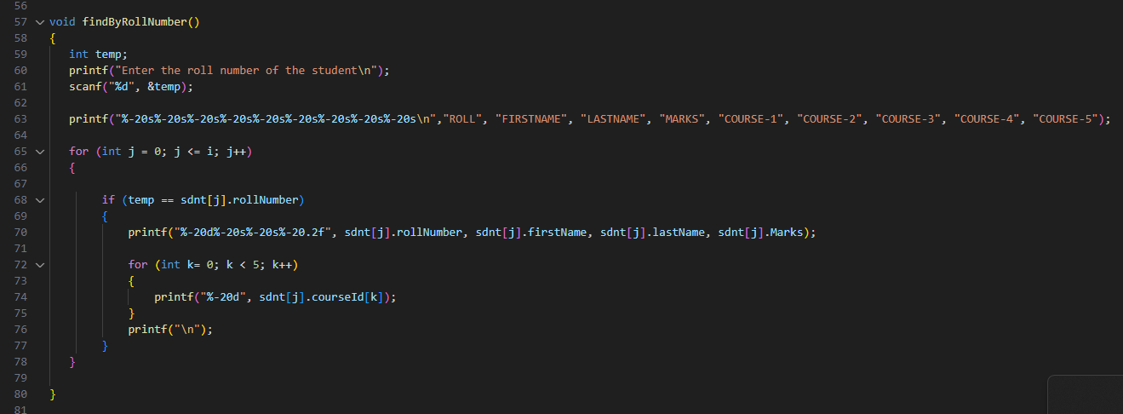

5. findByName():
This method is used to find the entire details of a specified student with their first name as input. So, the method " findByName() " takes the input of the first name of the student in order to find the details of the student carrying that specified first name ( through the input ). Let us understand this concept through a program which details the " findByName() " method.
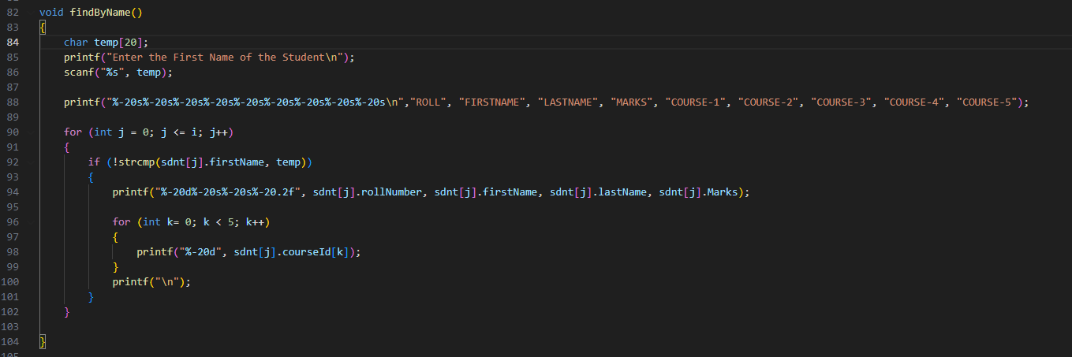

6. find_using_course():
This method is used to find the details of the total students registered in a particular course with the course ID as input. So, the " findCourse_Student() " method takes the input of the course id and then prints all the details of the student who are enrolled in the course mentioned through the input. Let us understand this concept of finding the details through a program which details the method " findByName() ".
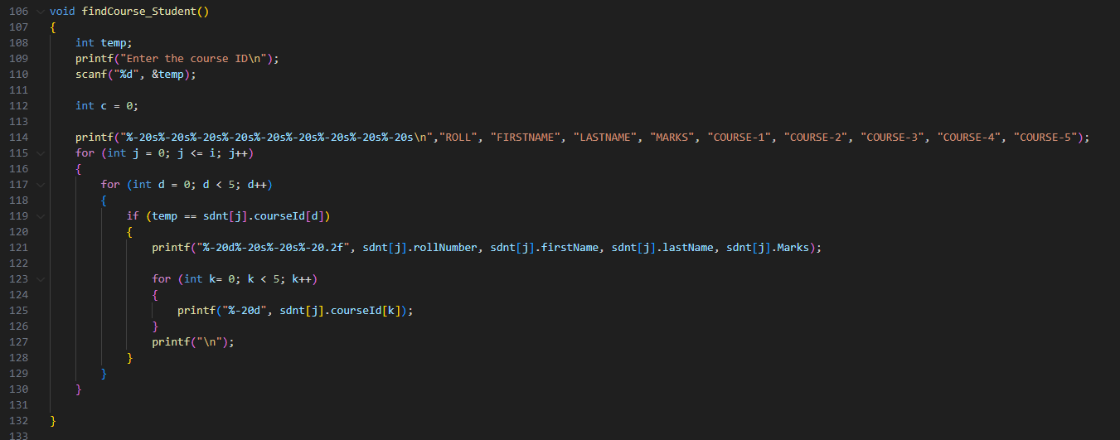

7. totalCount():
The method that helps in printing or acknowledging the user about the total number of students present within the database and also the number of students that can be taken as a new admission by considering the maximum number of students is the " totalCount() " method. So, this method tells the user how many students are already existing and how many new students can be taken by considering the maximum number of students that can exist within the institute.
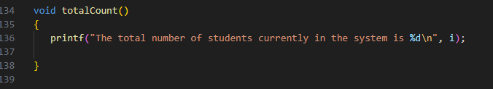

8. deleteStudent():
This method is used to delete the details of the student by referring to a roll number which is taken as an input. So, the " deleteStudent() " method takes the input of the roll number of the student whose data is supposed to be deleted and then deletes all the details or the data of the student who bares the roll number mentioned through the input. Let us understand this concept of finding the details through a program which details the method "deleteStudent()”

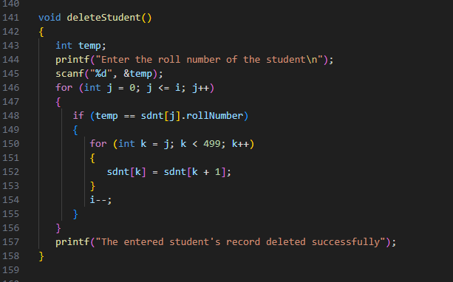
9. updateStudent():
This method is used to update the details of the student by referring to a roll number which is taken as an input. So, the" updateStudent() " method takes the input of the roll number of the student whose data is supposed to be updated and then updates all the details or the data of the student who bares the roll number mentioned through the input.Sometimes, you need not update all the details, but only some of the details should be updated. In such cases also, this method can be used. Let us understand this concept of finding the details through a program which details the method " updateStudent() ".
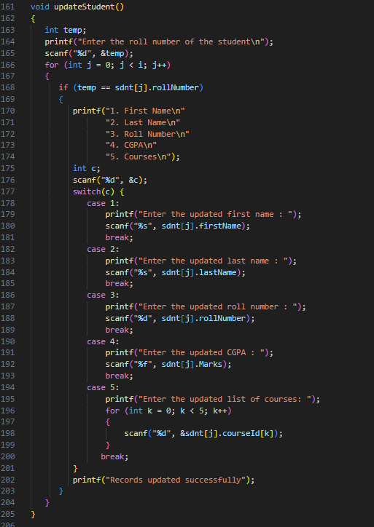

10. The main() Function:
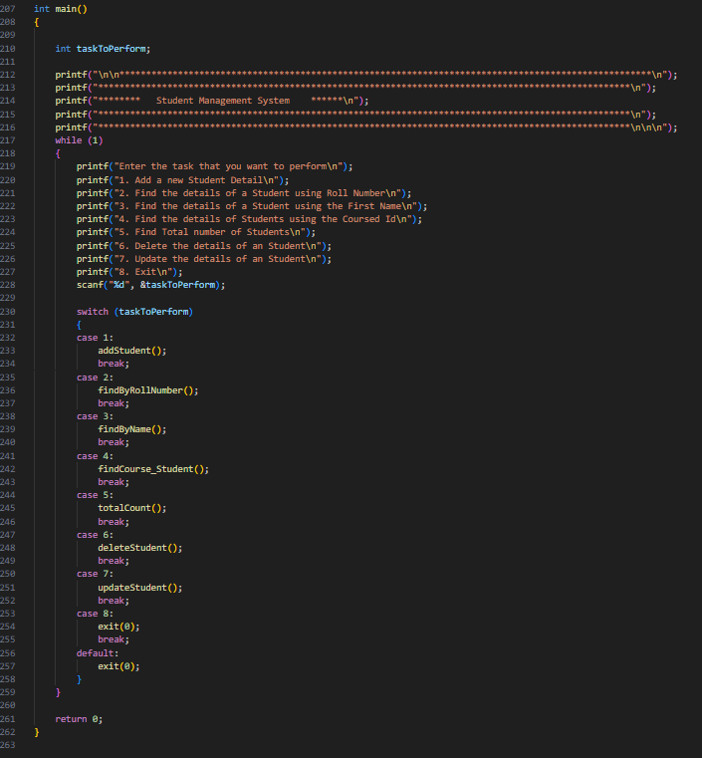
Results
The outputs are Stated bellow:

****************************************************************************************************
****************************************************************************************************
******** Student Management System ******
****************************************************************************************************
****************************************************************************************************

Enter the task that you want to perform
1. Add a new Student Detail
2. Find the details of a Student using Roll Number
3. Find the details of a Student using the First Name
4. Find the details of Students using the Coursed Id
5. Find Total number of Students
6. Delete the details of an Student
7. Update the details of an Student
8. Exit
1
ADD STUDENT DETAILS:
1.Add
2.done
1
Enter the first name of the student
Student_1
Enter the last name of the student
Std
Enter the roll number of the student
10
Enter the Marks of the student
8.9
Enter the course ID of each course of the student
123
321
231
132
213
1.Add
2.done
2
Enter the task that you want to perform
1. Add a new Student Detail
2. Find the details of a Student using Roll Number
3. Find the details of a Student using the First Name
4. Find the details of Students using the Coursed Id
5. Find Total number of Students
6. Delete the details of an Student
7. Update the details of an Student
8. Exit
2
Enter the roll number of the student
10
ROLL FIRSTNAME LASTNAME MARKS COURSE-1 COURSE-2 COURSE-3 COURSE-4 COURSE-5
10 Student_1 Std 8.90 123 321 231 132 213
Enter the task that you want to perform
1. Add a new Student Detail
2. Find the details of a Student using Roll Number
3. Find the details of a Student using the First Name
4. Find the details of Students using the Coursed Id
5. Find Total number of Students
6. Delete the details of an Student
7. Update the details of an Student
8. Exit
3
Enter the First Name of the Student
Strudent_1
ROLL FIRSTNAME LASTNAME MARKS COURSE-1 COURSE-2 COURSE-3 COURSE-4 COURSE-5
Enter the task that you want to perform
1. Add a new Student Detail
2. Find the details of a Student using Roll Number
3. Find the details of a Student using the First Name
4. Find the details of Students using the Coursed Id
5. Find Total number of Students
6. Delete the details of an Student
7. Update the details of an Student
8. Exit
4
Enter the course ID
123
ROLL FIRSTNAME LASTNAME MARKS COURSE-1 COURSE-2 COURSE-3 COURSE-4 COURSE-5
10 Student_1 Std 8.90 123 321 231 132 213
Enter the task that you want to perform
1. Add a new Student Detail
2. Find the details of a Student using Roll Number
3. Find the details of a Student using the First Name
4. Find the details of Students using the Coursed Id
5. Find Total number of Students
6. Delete the details of an Student
7. Update the details of an Student
8. Exit
5
The total number of students currently in the system is 1
Enter the task that you want to perform
1. Add a new Student Detail
2. Find the details of a Student using Roll Number
3. Find the details of a Student using the First Name
4. Find the details of Students using the Coursed Id
5. Find Total number of Students
6. Delete the details of an Student
7. Update the details of an Student
8. Exit
6
Enter the roll number of the student
10
The entered student's record deleted successfullyEnter the task that you want to perform
1. Add a new Student Detail
2. Find the details of a Student using Roll Number
3. Find the details of a Student using the First Name
4. Find the details of Students using the Coursed Id
5. Find Total number of Students
6. Delete the details of an Student
7. Update the details of an Student
8. Exit
1
ADD STUDENT DETAILS:
1.Add
2.done
1
Enter the first name of the student
Hello
Enter the last name of the student
World
Enter the roll number of the student
12
Enter the Marks of the student
8.7
Enter the course ID of each course of the student
123
321
231
132
312
1.Add
2.done
2
Enter the task that you want to perform
1. Add a new Student Detail
2. Find the details of a Student using Roll Number
3. Find the details of a Student using the First Name
4. Find the details of Students using the Coursed Id
5. Find Total number of Students
6. Delete the details of an Student
7. Update the details of an Student
8. Exit
7
Enter the roll number of the student
12
1. First Name
2. Last Name
3. Roll Number
4. CGPA
5. Courses
4
Enter the updated CGPA : 7.6

Conclusion
It's usually a good idea to go with a student information system that's built on a current system architecture to keep up with changing needs. This system should include wellorganized data coding and clearly defined business applications. The system's overview elucidates the convenience of exact data delivery at the tip of your fingertips, increasing student retention and teaching them how to manage their time effectively. The proposed method is efficient and user-friendly, based on the results of the experiments and tests. In comparison to current methods of managing academic institutions, this project, which produces centralised software, makes work administration and management easier and gives full information about the issue of users' interest with just one mouse click. An easy-to-use user interface centralised software can be offered to the educational institution, allowing all services linked with the university to interact with one another and share data. The user will be able to access the resources from afar because this is a ReST API . Because the application is built with a microservice architecture and agile methodology, services can be added in the future.
References
- Student management system - report by PUI HOCK YOUNG.[http://umpir.ump.edu.my/id/eprint/13410/1/FSKKP%20-%20PUI%20HOCK%20YOUNG.PDF]
- JAVAPRINT [https://www.javatpoint.com/student-record-system-in-c]
- Scaler Topics [https://www.scaler.com/topics/student-record-management-system-c-project/]

